Integrated National Energy and Climate Plan of the Republic of Serbia
For the period up to 2030 with a vision to 2050
Final Version

Belgrade, December 2023

Contents

ABBREVIATIONS AND ACRONYMS 4
LIST OF FIGURES 7
LIST OF TABLES 11
1 OVERVIEW AND PROCESS FOR ESTABLISHING THE PLAN 14
1.1 Executive Summary (overview/scope of the plan) 14
1.2 Overview of current policy situation 19
1.3 Consultations and involvement of national and Union entities and their outcome 42
1.4 Regional cooperation in preparing the plan 46
2 NATIONAL OBJECTIVES AND TARGETS 47
2.1 Climate change, emissions and reduction of greenhouse gases 48
2.2 Renewable energy sources 49
2.3 Improvement in energy efficiency 52
2.4 Energy security 53
2.5 Internal energy market 54
2.6 Research, innovation and competitiveness 54
3 POLICIES AND MEASURES 56
3.1 Dimension Decarbonisation 56
3.2 Dimension Energy Efficiency 98
3.3 Dimension Energy Security 143
3.4 Dimension Internal Energy Market 153
3.5 Dimension Research, Innovation and Competitiveness 185
4 CURRENT SITUATION AND PROJECTIONS WITH EXISTING POLICIES AND MEASURES 203
4.1 Projected evolution of main exogenous factors influencing energy system and GHG emission developments 204
4.2 Dimension Decarbonisation 208
4.3 Dimension Energy Efficiency 219
4.4 Dimension Energy Security 230
4.5 Dimension Internal Energy Market 238
4.6 Dimension Research, Innovation and Competitiveness 248
5 IMPACT ASSESSMENT OF PLANNED POLICIES AND MEASURES 252
5.1 Impacts of planned policies and measures described on energy system and GHG emissions and removals 252
5.2 Macroeconomic and, to the extent feasible, the health, environmental, employment and education, skills and social impacts, of the planned policies and measures 284
5.3 Overview of investment needs 288
5.4 Impacts of planned policies and measures on other Contracting Parties of the Energy Community and Member States of the European Union, and regional cooperation 294
I. Annex: Summary Table of Measures with implementation cost 296
II. Annex: Detailed analysis of the power system operation 308
III. Annex: QUANTITATIVE ANALYSIS TOOLS 313
IV. Annex: LIST OF PROJECTS FROM INFRASTRUCTURE PLAN 321
V. Annex: Detailed tables 322

ABBREVIATIONS AND ACRONYMS
AERS | Energy Agency of the Republic of Serbia
AL | Albania
ASEAN | Association of Southeast Asian Nations
BA | Bosnia and Herzegovina
BG | Bulgaria
BUR | Biennial Update Report
CACM | Capacity Allocation and Congestion Management
CBAM | Carbon Border Adjustment Mechanism
CCGT | Combined cycle power plant
CCUS | Carbon capture, storage and utilisation
CEKOR | Center for ecology and sustainable development
COP21 | Paris climate conference
CP | Contracting Party
DSO | Distributed System Operator
EBRD | European Bank for Reconstruction and Development
EE | Energy Efficiency
EEFIG | Energy Efficiency Financial Institutions Group
EnC | Energy Community
ENTSO-E | European Network of Transmission System Operators for Electricity
ENTSOG | European Network of Transmission System Operators for Gas
EPEX SPOT | European Power Exchange
EMS | “Elektromreža Srbije“
EPS | ”Elektroprivreda Srbije”
ESCO | Energy Service Companies
ETS | Emissions Trading System
EU | European Union
GDP | Gross Domestic Product
GFEC | Gross Final Energy Consumption
GHG | Greenhouse Gas
GVA | Gross Value Added
GWP | Global warming potential
HR | Croatia
IAEA | International Atomic Energy Agency
ICT | Information and Communication Technology
IFI | International Financing Institution
INDC | Intended National Determined Contribution
JCR | Joint Research Center
JSC | Joint Stock Company
LDV | Light Duty Vehicle
LULUCF | Land Use, Land-Use Change and Forestry
MaaS | Mobility as a Service
MC-EnC | Ministerial Council - Energy Community
MK | North Macedonia
ME | Montenegro
MoCTI | Ministry of Construction, Transport and Infrastructure
MoME | Ministry of Mining and Energy
INECP | Integrated National Energy and Climate Plan
NEEAP | National Energy Efficiency Action Plan
NEMO | Nominated Electricity Market Operators
NIS | NIS a.d. Novi Sad
NREAP | National Renewable Energy Action Plan
NTC | Net Transfer Capacity
nZEB | Near-zero energy buildings
O&M | Operation and maintenance
OHL | Overhead line
ORF-EE | Open Regional Fund for South East Europe – Energy Efficiency
PCI | Project of Common Interest
PF4EE | Private Finance for Energy Efficiency
PLIMA | Project Library and Interactive Map Application
PM | Policy measure
RES | Renewable Energy Sources
RS | Republic of Serbia
SDAC | Single Day-Ahead Coupling
SAIDI | System Average Interruption Duration Index
SAIFI | System Average Interruption Frequency Index
SANU | Serbian Academy of Sciences and Arts
SEE | South-East Europe
SEEPEX | SEEPEX a.d. Belgrade
SET | Strategic Energy Technology
SIDMC | Single Intraday Market Coupling
SME | Small and medium-sized enterprises
SMR | Small Modular Reactors
SORS | Statistical office of the Republic of Serbia
SS | Sub-station
SSP | Shared Socioeconomic Pathways
TRINITY | TRansmission system enhancement of regIoNal borders by means of IntellIgenT market technologY
TS | Transformer Substation
TSO | Transmission system operator
TYNDP | Teen Year Network Development Plan
UNDP | United Nations Development Programme
UNFCCC | United Nations Framework Convention on Climate Change
WAM | Scenario with the additional measures
WEM | Scenario with the existing measures
WG | Working Group

LIST OF FIGURES
Figure 1.1: Population in 2019, in million (source: Eurostat) 20
Figure 1.2: Real GDP growth rate in 2019, in % (source: Eurostat) 20
Figure 1.3: Long-term unemployment rate in 2019, in % (source: Eurostat) 21
Figure 1.4: Primary energy consumption per capita in 2019, in toe/capita (source: Eurostat) 21
Figure 1.5: CO2-eq emissions per capita for 2019, in million tonnes of CO2 (Source: Global Carbon Project) 22
Figure 1.6: Share of RES in gross final energy consumption for 2019, in % (source: Eurostat) 22
Figure 1.7: RES share in electricity production for 2019, in % (source: Eurostat) 23
Figure 1.8: Primary energy consumption for 2019 relative to 2005, in % (source: Eurostat) 23
Figure 1.9: Final energy consumption in households per capita for 2019, in kgoe (source: Eurostat) 24
Figure 1.10: Energy productivity for 2019, in EUR/kgoe (source: Eurostat) 24
Figure 1.11: Import dependence for 2019, in % (source: Eurostat) 25
Figure 1.12: Population unable to keep home adequately warm for 2019, in % (source: Eurostat) 25
Figure 1.13: Gross domestic expenditure on R&D for 2019, in % (source: Eurostat) 26
Figure 1.14: Governance of the preparation and development of the Integrated National Energy and Climate Plan 41
Figure 1.15: Structure of the Working Groups per entities involved 43
Figure 1.16: Involvement of project participants per dimension 44
Figure 4.1: Interconnections between modelling tools for the development of the INECP 204
Figure 4.2: Historical data of GDP and population over 2010-2020 (Sources: Statistical Office of the Republic of Serbia, Ministry of Finance, National Bank) 205
Figure 4.3: Evolution of GDP (in constant Euro 2015) and population until 2050 (Sources: Statistical Office of the Republic of Serbia, Ministry of Finance, National Bank, projections based on SSP) 205
Figure 4.4: Evolution of GVA for different sectors of economic activity until 2050 (Sources: Statistical Office of the Republic of Serbia, Ministry of Finance, National Bank, projections based on SSP) 206
Figure 4.5: Evolution of value added of other industrial subsectors until 2050 (Sources: projections based on the SSP scenarios) 206
Figure 4.6: Total GHG emissions (with and without LULUCF) over 2010-2019 208
Figure 4.7: CO2 emissions by sector over 2020-2050 in the scenario with existing measures (WEM) 209
Figure 4.8: CH4 emissions by sector over 2020-2050 in the scenario with existing measures (WEM) 210
Figure 4.9: N2O emissions by sector over 2020-2050 in the scenario with existing measures (WEM) 211
Figure 4.10: Total GHG emissions 2020-2050 in the scenario with existing measures (WEM) 211
Figure 4.11: GHG emissions 2020-2050 from non-energy related sectors in the scenario with existing measures (WEM) 212
Figure 4.12:CO2 emissions intensity per unit of GDP (kg CO2 from energy sources / € GDP) over 2020-2050 in the scenario with existing measures (WEM) 212
Figure 4.13: Gross electricity production over 2010-2020 (Source: Eurostat, 2023) 213
Figure 4.14: Gross heat production over 2010-2020 (Source: Eurostat, 2023) 213
Figure 4.15: Shares of energy from RES over 2010-2020 (Source: Eurostat, 2023) 214
Figure 4.16: Share of RES in gross final energy consumption over 2020-2050 in the scenario with existing measures (WEM) 214
Figure 4.17: Share of RES in total electricity production over 2020-2050 in the scenario with existing measures (WEM) 215
Figure 4.18: Installed capacity per technology in the power sector over 2020-2050 in the scenario with existing measures (WEM) 216
Figure 4.19: Installed RES capacity per technology over 2020-2050 in the scenario with existing measures (WEM) 217
Figure 4.20: Share of RES in Heating and Cooling over 2020-2050 in the scenario with existing measures (WEM) 218
Figure 4.21: Share of RES in transportation (without multipliers) over 2020-2050 in the scenario with existing measures (WEM) 218
Figure 4.22: Electricity consumption from RES in transport over 2020-2050 in the scenario with existing measures (WEM) 219
Figure 4.23: Gross inland consumption over 2010-2020 (Source: Eurostat, 2023) 220
Figure 4.24: Primary and final energy consumption over 2010-2020 (Source: Eurostat, 2023) 220
Figure 4.25: Final energy consumption by fuel over 2010-2020 (Source: Eurostat, 2023) 221
Figure 4.26: Final energy consumption by end-use sector over 2010-2020 (Source: Eurostat, 2023) 221
Figure 4.27: Primary and final energy consumption over 2020-2050 in the scenario with existing measures (WEM) 222
Figure 4.28: Final energy consumption by fuel over 2020-2050 in the scenario with existing measures (WEM) 223
Figure 4.29: Final energy intensity over 2020-2050 in the scenario with existing measures (WEM) 223
Figure 4.30: Gross inland consumption by fuel over 2020-2050 in the scenario with existing measures (WEM) 224
Figure 4.31: Final energy consumption by end-use sector over 2020-2050 in the scenario with existing measures (WEM) 224
Figure 4.32: Final energy consumption by fuel in the industrial sector over 2020-2050 in the scenario with existing measures (WEM) 225
Figure 4.33: Final energy consumption per sub-sector in the industrial sector over 2020-2050 in the scenario with existing measures (WEM) 225
Figure 4.34: Final energy consumption by energy source in the transport sector over 2020-2050 in the scenario with existing measures (WEM) 226
Figure 4.35: Final energy consumption per sub-sector in the transport sector over 2020-2050 in the scenario with existing measures (WEM) 227
Figure 4.36: Final energy consumption by energy source in the services sector over 2020-2050 in the scenario with existing measures (WEM) 228
Figure 4.37: Final energy consumption by energy source in the residential sector over 2020-2050 in the scenario with existing measures (WEM) 229
Figure 4.38: Final energy consumption by energy source in the agriculture / forestry sector over 2020-2050 in the scenario with existing measures (WEM) 229
Figure 4.39: Primary production over 2010-2020 (Source: Eurostat, 2023) 231
Figure 4.40: Transformation input over 2010-2020 (Source: Eurostat, 2023) 231
Figure 4.41: Transformation output over 2010-2020 (Source: Eurostat, 2023) 232
Figure 4.42: Energy import dependency over 2020-2050 in the scenario with existing measures (WEM) 232
Figure 4.43: Import dependency of oil and oil products, natural gas and electricity over 2020-2050 in the scenario with existing measures (WEM) 233
Figure 4.44: Primary production over 2020-2050 in the scenario with existing measures (WEM) 234
Figure 4.45: Energy imports per fuel over 2020-2050 in the scenario with existing measures (WEM) 234
Figure 4.46: Energy exports per fuel over 2020-2050 in the scenario with existing measures (WEM) 235
Figure 4.47: Imports, exports and net imports over 2020-2050 in the scenario with existing measures (WEM) 235
Figure 4.48: Transformation input in electricity sector over 2020-2050 in the scenario with existing measures (WEM) 236
Figure 4.49: Transformation output in electricity sector over 2020-2050 in the scenario with existing measures (WEM) 236
Figure 4.50: Total electricity network losses over 2020-2050 in the scenario with existing measures (WEM) 237
Figure 4.51: Total gas network losses over 2020-2050 in the scenario with existing measures (WEM) 237
Figure 4.52: ENTSO-e TYNDP 2020 identification of system needs for 2030 and 2040 (source: ENTSO-E) 239
Figure 4.53: Cross-border capacities increases by 2025 (source: ENTSO-E) 239
Figure 4.54: Electricity transmission network project corridors (source: EMS) 240
Figure 4.55: The Electric Power System of Serbia (source: EMS) 241
Figure 4.56: Average annual retail prices in the competitive electricity, excluding VAT and duties free (source: AERS) 243
Figure 4.57: Average annual retail prices in the regulated market, excluding VAT and duties free (source: AERS) 244
Figure 4.58: Average approved natural gas public supply price in RSD/m³ (source: AERS) 244
Figure 4.59: Average weighted retail price in the regulated market in RSD/m3(source: AERS) 245
Figure 4.60: Estimated average electricity supply cost in the scenario with existing measures (WEM) 246
Figure 4.61: Natural gas average annual import prices in the scenario with existing measures (WEM) 246
Figure 4.62: Breakdown of R&D organizations per sector (source: Statistical Office of the Republic of Serbia) 248
Figure 4.63: Breakdown of R&D organizations per fields of science (source: Statistical Office of the Republic of Serbia) 249
Figure 4.64: Number of employees engaged in R&D activities (source: Statistical Office of the Republic of Serbia) 249
Figure 4.65: Breakdown of research works by fields of science and type (source: Statistical Office of the Republic of Serbia) 250
Figure 4.66: Breakdown of innovative enterprises per industry (source: Intellectual Property Office of the Republic of Serbia) 250
Figure 5.1: Total GHG emissions (including agriculture, waste and LULUCF) 253
Figure 5.2: Total GHG emissions (including agriculture, waste and LULUCF) reductions as percentages with respect to 1990 254
Figure 5.3: GHG emissions from energy use, processes, and fugitive per sector 255
Figure 5.4: GHG emissions from energy use, processes, and fugitive reductions as percentages with respect to 1990 256
Figure 5.5: GHG emissions (from energy use, processes, and fugitive) per sector 257
Figure 5.6: GHG emissions from agriculture (non-energy related), waste and LULUCF 258
Figure 5.7: Total CO2 emissions per sector 258
Figure 5.8: Total CH4 emissions per sector 259
Figure 5.9: Total N2O emissions per sector 260
Figure 5.10: Share of RES in GFEC 261
Figure 5.11: Share of RES in Electricity Generation 261
Figure 5.12: Share of RES in Transport (without multipliers) 262
Figure 5.13: Share of RES in Heating 262
Figure 5.14: Installed RES capacity per technology 263
Figure 5.15: Electricity generation by source in Scenario S 265
Figure 5.16: Electricity consumption from RES in transport 266
Figure 5.17: Installed capacity per technology in the district heating sector 267
Figure 5.18: Primary Energy Consumption 268
Figure 5.19: Final Energy Consumption 268
Figure 5.20: FEC Industry by energy source 269
Figure 5.21: FEC Residential by energy source 269
Figure 5.22: FEC Services by energy source 270
Figure 5.23: FEC Transport by Fuel 271
Figure 5.24: FEC Agriculture by Fuel 271
Figure 5.25: Final energy intensity 272
Figure 5.26: Gross inland consumption by fuel 273
Figure 5.27: Refurbishment in residential buildings 274
Figure 5.28: Refurbishment in commercial buildings 275
Figure 5.29: Unit consumption of commercial buildings 276
Figure 5.30: Unit consumption of residential dwellings 276
Figure 5.31: Annual capacity additions of heat pumps per sector, technology, and scenario until 2030 and capacity additions for five-year periods after 2030 277
Figure 5.32: Annual capacity additions of heat pumps per sector, technology, and scenario (with differences from WEM) until 2030 and for five-year periods after 2030 277
Figure 5.33: Number of EVs 278
Figure 5.34: Energy Import Dependency 279
Figure 5.35: Primary production 280
Figure 5.36: Energy imports per fuel 280
Figure 5.37: Energy exports per fuel 281
Figure 5.38: Imports, exports and net imports 282
Figure 5.39: Transformation input in electricity sector 282
Figure 5.40: Transformation output in electricity sector 283
Figure 5.41: Total electricity network losses 283
Figure 5.42: Total gas network losses 284
Figure 5.43: Impact of scenarios S and S-N implementation on the GDP of Serbian economy over the 2025-2050 period 285
Figure 5.44: Impact of Scenarios’ S and S-N implementation on the unemployment rate of Serbian economy over the 2025-2050 period 286
Figure 5.45: Impact on employment by sector under the implementation of Scenario S 287
Figure 5.46: Estimation of the number of jobs created in scenario S due to the deployment of new RES capacity for solar PV, wind and biomass 287
Figure 5.47: Evolution of the average electricity supply cost in scenario S 288
Figure 5.48: Distribution of implementation costs per dimension 289
Figure 5.49: Distribution of implementation costs per WEM /WAM 290
Figure 5.50: Distribution of implementation costs per for public and private (own resources) investments 291
Figure III.1: Overview of the reference energy system for the SEMS model 314
Figure III.2: Residential sector typologies according to TABULA 315
Figure III.3: Key model outputs by category 318
Figure III.4: Geographical scope of regional model 319
Figure III.5: Hourly results for RS01, MC year 2, week n.10 320

LIST OF TABLES
Table 2.1: Annual trajectory of GHG emissions reduction 49
Table 2.2: Annual trajectory of RES share 49
Table 2.3: Annual trajectory of FEC and PEC 52
Table 3.1: New and cumulative final energy savings in the period 2024-2030 98
Table 3.2: Selected alternative measures for the achievement of Article 7’s target in the period 2024-2030 98
Table 4.1: Numerical evolution of GDP and population over 2020-2050 (Sources: Statistical Office of the Republic of Serbia, Ministry of Finance, National Bank, projections based on SSP) 205
Table 4.2: Overnight investment costs projection for renewable energy technologies 208
Table 4.3: Thermal capacities of interconnecting transmission lines by borders 238
Table 5.1: Carbon pricing projections 252
Table 5.2: Installed RES capacity per technology per scenario 263
Table 5.3: Dimension of Measures and implementation costs (Extended table with measures and their respective costs is included in Annex I) 290
Table 5.4: Indicative Overview of Serbia's green transition support programs 291
Table 5.5: List of most important regional cooperation-related projects 295
Table I.1: Decarbonisation policy measures 296
Table I.2: Energy Efficiency policy measures 299
Table I.3: Energy Security policy measures 303
Table I.4: Internal Energy Market policy measures 304
Table I.5: Research, Innovation and Competitiveness policy measures 306
Table II.1: Scenario S average general results for Target Year 2030 308
Table II.2: Scenario S PSP average annual results for Target Year 2030 309
Table II.3: Scenario S average general results for Target Year 2040 309
Table II.4: Scenario S PSP average annual results for Target Year 2040 309
Table II.5: Capacities under supply security considerations 310
Table II.6: Generation under supply security considerations 310
Table II.7: Capacity factors under supply security considerations 311
Table III.1: Construction periods for residential typologies 315
Table IV.1: Table of additional Projects from the Infrastructure Development Plan of the Republic Serbia 321
Table V.1: Energy Industry - emissions in ktons of CO2-eq 322
Table V.2: Power Sector - emissions in ktons of CO2-eq 322
Table V.3: Manufacturing industries and construction: Energy Use, Fugitive and Process Emissions - emissions in ktons of CO2-eq 322
Table V.4: Transport - emissions in ktons of CO2-eq 322
Table V.5: Residential Sector - emissions in ktons of CO2-eq 322
Table V.6: Commercial Sector - emissions in ktons of CO2-eq 323
Table V.7: Other Sectors: Energy Use, Fugitive and Process Emissions - emissions in ktons of CO2-eq 323
Table V.8: Electricity Generation per source (TWh) 323
Table V.9: Final Energy Consumption [ktoe] 324
Table V.10: Primary Energy Supply [ktoe] 324
Table V.11: Primary Energy Consumption [ktoe] 324
Table V.12: Energy Import Dependency [%] 324
Table V.13: Electricity Import Dependency [%] 324
Table V.14: Total Emissions (including agriculture, waste and LULUCF) in ktons of CO2eq 325
Table V.15: % reduction of total emissions with respect to the 1990 level 325
Table V.16: Share of RES in Gross Final Energy Consumption [%] 325
Table V.17: Share of RES in Electricity Generation [%] 325
Table V.18: Share of RES in Transport (without multipliers) [%] 325
Table V.19: Share of RES in Transport (with multipliers) [%] 325
Table V.20: Share of RES in Heating [%] 326
Table V.21: Installed Capacity of Wind Power Plants [GW] 326
Table V.22: Installed Capacity of PV Power Plants [GW] 326
Table V.23: Final Energy Consumption by Fuel [ktoe] 326
Table V.24: Final Energy Consumption per Sector - Industry [ktoe] 327
Table V.25: Final Energy Consumption per Sector - Transport [ktoe] 327
Table V.26: Final Energy Consumption per Sector - Services [ktoe] 327
Table V.27: Final Energy Consumption per Sector - Residential [ktoe] 327
Table V.28: Final Energy Consumption per Sector - Agriculture [ktoe] 328

SECTION A: NATIONAL PLAN

OVERVIEW AND PROCESS FOR ESTABLISHING THE PLAN

Executive Summary (overview/scope of the plan)

Political, economic, environmental, and social context of the plan
In March 2012, the European Council granted the Republic of Serbia candidate country status, while the decision of the European Council from June 2013 launched accession negotiations with the Republic of Serbia. In 2014, the Berlin Process was launched, as an initiative aiming at stepping up regional cooperation in the Western Balkans region and aiding the integration of countries into the European Union (EU). By gradually harmonizing national legal framework with the EU acquis, the Republic of Serbia performed numerous legislative alignments in the areas of climate change, environment and energy.
Due to the need to establish the global framework to avoid dangerous climate change by limiting global warming to well below 2°C and the pursuing efforts to limit it to 1.5°C, the multilateral climate change process was initiated in 2015. Thus, at the Paris climate conference (COP21), the Paris Agreement was adopted as a first-ever universal legally binding international treaty on climate change. Prior to the COP21, the Republic of Serbia had submitted Intended National Determined Contribution (INDC) to the United Nations Framework for Convention on Climate Change (UNFCCC), declaring the country’s contribution to the global efforts for greenhouse gas (GHG) emissions reduction through: “GHG emission reduction by 9,8% until 2030 compared to base-year (1990) emissions“. Following that, the Republic of Serbia ratified the Paris Agreement in 2017. Second National Determined Contribution (NDC) was submitted in August 2022, defining the reduction of 13.2% compared to 2010 level i.e. 33,3% compared to 1990 by 2030 (without LULUCF).
In November 2020, the Republic of Serbia signed the Sofia Declaration on the Green Agenda for the Western Balkans at the Western Balkans Summit under the framework of the Berlin Process initiative and committed to work towards the 2050 target of a carbon-neutral continent together with the European Union. At the beginning of 2021, the Republic of Serbia introduced the reforms of the national legal framework regarding energy and climate change, as the starting point for the energy transition process towards climate neutral development. A more complete harmonisation has been made with the regulations of the Third Energy Package of the EU energy legislation and certain provisions of the EU package Clean Energy for All Europeans. The Republic of Serbia adopted a new legislative package consisting of Amendments to Law of Energy, Law on Energy Efficiency and Rational Use of Energy, Law on Use of Renewable Energy Sources, Amendments to Law on Use of RES, Amendments to Law on Mining and Geological Research, as well as the Law on Climate Change.
Support of Serbia’s obligations under the Paris Agreement represents the first goal of the Low Carbon Development Strategy of the Republic of Serbia set for the period 2023-2030 with projections until 2050, which is adopted based on Low on Climate Change with the goal of determining strategic directions of action and public policy of reducing GHG emissions at the level of the entire economy. Presenting possibilities and recommendations for alignment of GHG emissions with the levels in the EU is the second goal of the Strategy. Activities for the implementation of actions and achievement of the Strategy’s objectives will be defined in the Action plan for the implementation of the Low Carbon Development Strategy for the period 2024-2030, as well as in the INECP.
At the Berlin Process Western Balkans Summit 2022, Serbia signed a joint Declaration on Energy Security and Green Transition in the Western Balkans which emphasizes the commitment to improving regional cooperation in the process of clean energy transition in line with Paris Agreement and the European Green Deal. At the 20th Ministerial Council of the Energy Community meeting in 2022, where Serbia participated, the Decision amending Decision 2021/14/MC-EnC has been adopted, including a set of ambitious 2030 targets for GHG emissions reduction, energy efficiency and increased RES share.
Following up on the obligation to adopt the Integrated National Energy and Climate Plan in accordance to the amendments to the Law on Energy, as well as in response to the Recommendation of the Ministerial Council of the Energy Community on preparing for the development of Integrated National Energy and Climate Plans by the Contracting Parties of the Energy Community and relevant Policy Guidance by the Energy Community Secretariat, the Republic of Serbia prepared Integrated National Energy and Climate Plan (INECP) covering the period from 2021 to 2030. Furthermore, in 2021 the Ministerial Council of the Energy Community incorporated Regulation (EU) 2018/1999 in the Energy Community acquis and amending Annex I of the Treaty.
Finally, it is important to point out that in December 2022 the Annex I to the Treaty Establishing the Energy Community has been amended and it incorporated next legislation in the Energy Community acquis: Directive (EU) 2018/2001, Directive (EU) 2018/2002, Regulation (EU) 2018/1999, Delegated Regulation (EU) 2020/1044, Implementing Regulation (EU) 2020/1208, as well as Regulation (EU) 2019/942, Regulation (EU) 2019/943, Regulation (EU) 2015/1222, Regulation (EU) 2016/1719, Regulation (EU) 2017/2195, Regulation (EU) 2017/2196, Regulation (EU) 2017/1485.
The quantitative analysis of the scenario projections for the impact assessment of the policies and measures which was performed in the process of developing the INECP of the Republic of Serbia, a suite of three modelling tools was used:
- the Serbian Energy Modelling System (SEMS), based on the TIMES framework, covering the development of the whole of the energy system,
- a macro-economic analysis tool based on the Mitigation, Adaptation and New Technologies Applied General Equilibrium (MANAGE) Model, and
- a High-RES penetration power system analysis tool based on the ANTARES software.
Details on the modelling suite implementation are given in Annex III.

Strategy relating to the five dimensions of the Energy Union
The Integrated National Energy and Climate Plan has to take a holistic approach and address the five dimensions in an integrated way, as per provisions of the Rulebook on the detailed content and guidelines for determining the national goals of the Integrated National Energy and Climate Plan, the method of its preparation and reporting on its implementation:
- Decarbonisation that presents specific area regarding the aim to present the country’s commitment towards the climate action and decarbonising the economy, with specific focus on the increased use of renewable energy sources and reduction of carbon footprint.
- Greenhouse Gas (GHG) Emissions that presents specific sub-area regarding the aim to present the country’s commitment towards reduction of energy-related and non-energy-related emissions.
- Renewable Energy Sources (RES) that presents specific sub-area regarding the aim to present the country’s commitment towards boosting the deployment of renewables by keeping up with increasing energy consumption and addressing the transformation issue of the existing energy system in terms of technology transition.
- Energy Efficiency that presents specific sub-area regarding the aim to present the country’s commitment towards increased energy efficiency across all sectors, with emphasis on industrial, transport, construction, and agriculture sectors.
- Energy Security that presents specific area regarding the aim to present the country’s commitment towards diversifying sources of energy and ensuring security of supply through solidarity and cooperation between EU and Energy Community (EnC) countries.
- Internal Energy Market that presents specific area regarding the aim to present the country’s commitment towards creation of fully integrated and functional market, enabling the free flow of energy through the Energy Community and European Union by the adequate infrastructure and without technical or regulatory barriers.
- Research, Innovation and Competitiveness that presents specific area regarding the aim to present the country’s commitment towards supporting breakthroughs in low-carbon and clean energy technologies.

Strategic policy within the decarbonisation dimension includes definition of the national targets regarding the decarbonisation with the focus on the greenhouse gas (GHG) emissions reduction and share of energy from renewable sources in gross final consumption of energy. Based on the current situation, planned policy measures in the energy field, which generates about 80% of GHG emissions in the Republic of Serbia, will have a major contribution to decarbonisation process. Updated Serbia’s Nationally Determined Contribution to the Paris Agreement is submitted to UNFCCC and National Emission Reduction Plan shall be implemented in practice for sulphur dioxide, nitrogen oxide and industrial dust. The majority of the policy measures are intended for the energy sector such as promotion of renewable energy sources and energy efficiency, which implementation will lead to overall GHG emissions reduction.
Definition of the national targets regarding the energy efficiency dimension which focuses on the improvement of energy efficiency can be expressed either through primary or final energy consumption, primary or final energy savings, or through energy intensity, as well as through the cumulative amount of end-use energy savings. It is important to provide indicative milestones of the long-term strategy for the renovation of the national stock of residential and non-residential buildings, both public and private, the roadmap with domestically established measurable progress indicators, an evidence-based estimate of expected energy savings and wider benefits, and the total floor area to be renovated or equivalent annual energy savings in accordance with long-term strategy for renovation of national stock of residential and non-residential buildings.
In the building sector a well-balanced mixture of policy measures, financing, fiscal and regulatory measures, will be implemented in order to support the energy renovation of the building stock and to attain the specified renovation rate. Financial support is necessary to be provided for fostering the energy upgrade of the residential and non-residential buildings. Furthermore, the most cost-effective individual heating and cooling technologies will be promoted through specialised instruments. For the case of the non-residential buildings, the planned programs will focus on measures for energy efficiency improvements taking into consideration their energy saving potential and economic effects. In the transport sector, the main instrument of support will be the provision of tax incentives for the purchase of energy-efficient vehicles in passenger and freight transport, as well as the extension of public transport infrastructure and infrastructure for promoted types of alternative fuels. Energy efficiency projects in the industrial sector will be implemented through targeted support schemes through various financial and fiscal instruments, applying the best available technologies and by establishing energy-efficient industrial-business zones. Specialized financial incentives will be applied in the agricultural sector to improve the energy efficiency of agricultural machinery and infrastructure, to promote the production and exploitation of biomass and other RES, and to provide advisory services to farmers.
The energy security dimension aims to define national targets related to increasing the diversification of energy sources and supply from third countries the purpose of which may be to reduce energy import dependency, increasing the flexibility of the national energy system and addressing constrained or interrupted supply of an energy source for the purpose of improving the resilience of regional and national energy systems. Based on the current situation, diversification of sources of natural gas supply is of utmost importance. Another component is the upgrade of existing storage capacities or construction of new. Diversification of energy sources is addressed also in other dimensions such as promotion of RES production alternatives and assurance of security of supply through higher interconnections and fostering of market integration.
Concerning internal energy market, Serbia shall strive on the level of electricity interconnectivity, key electricity and gas transmission infrastructure projects, modernisation projects and main infrastructure projects envisaged other than Projects of Common Interest (PCIs). Furthermore, national objectives related to other aspects of the internal energy market such as increasing system flexibility, in particular related to the promotion of competitively determined electricity prices in line with relevant sectoral law, market integration and coupling, aimed at increasing the tradeable capacity of existing interconnectors, smart grids, aggregation, demand response, storage, distributed generation, mechanisms for dispatching, re-dispatching and curtailment, and real-time price signals. The country will ensure achievement of national objectives with regard to electricity system adequacy, as well as for the flexibility of the energy system with integration of renewable energy production, while maintaining a low level of energy poverty and developing a program for vulnerable costumers.
In terms of research, innovation and competitiveness dimension, definition of the targets regarding the energy security has to focus on national objectives and funding targets for public and private research and innovation, as well as national 2050 objectives related to the promotion of clean energy technologies. Within research and innovation, an indicative number of proposed policy measures is provided to: increase the number of innovative start-ups, high-tech and intensive sectors in line with the Strategy for Smart Specialisation, improve effectiveness of research by placing an emphasis on results and providing incentives, develop skills that boost the commercial viability and to support the cooperation between research institutes and businesses in the technology transfer and exploitation of research results. Total expenditures for research and development activities in 2020 amounted to 0.91% of Gross Domestic Product (GDP). The Republic of Serbia shall strive for research and innovation as an opportunity to enhance the competitiveness of its national economy, transforming it into a driver for economic growth and job creation.

Key objectives and priorities of the plan
The main pillars of the INECP comprise an increased penetration of RES in Serbia’s energy mix along with targeted energy efficiency measures aiming to reduce the final energy consumption by increasing energy performance. This clean energy transition pathway tends to enhance the country’s energy security, safeguards its energy dependency while ensuring a realistic reduction of lignite use, contributing to a meaningful reduction of the GHG emissions by 2030.
The increased penetration of RES will constitute one of the most important objectives of the INECP for the Republic of Serbia reaching 33.6% share in the gross final energy consumption. RES will be considered as the major domestic source of electricity production with a share reaching 45% of the gross final electricity consumption in 2030 achieved mainly through the most cost-effective exploitation of the available potential for the case of wind and photovoltaic energy.
The efficient and regionally integrated operation of the new day-ahead electricity market, including the importance of merging the regional electricity market with the European electricity market, the simplification and acceleration of the licensing procedure, the digitization of the energy system, the enhancement and expansion of the existing electricity grid and its interconnections, the market uptake of energy storage, distributed RE and demand response resources as well as the gradual electrification and the energy coupling of final consumption sectors are considered as prerequisites for the maximum penetration of RES.
The increased interest of investors in Wind and PV installations, which is evident by the large number of applications, will ensure that the required new capacities will be installed by 2030 and the increase of the share from 30% in 2021 to 45% in 2030 can be achieved.
Another priority is the promotion of electromobility, which will rely considerably on the electricity production by RES, while considerable energy savings will be delivered contributing simultaneously to the attainment of the energy efficiency targets. Finally, the further exploitation of RES for the coverage of the thermal and cooling needs in buildings, the penetration of RES distributed technologies for electricity production and the promotion of advanced biofuels in transport sector consist additional priorities within the framework of the INECP for the further deployment of RES.
In addition, the promotion of energy efficiency comprises a fundamental priority highlighting the necessity of implementing policies and measures that in turn demonstrate the most economically and socially effective approach for all end-uses. The final energy consumption in 2030 will amount to at most 9.6 Mtoe, while the primary energy consumption will be equal to at most 14.68 Mtoe in 2030. It should be noted that the improvement of the energy efficiency delivers additional multiple benefits, such as the reduction of the GHG emissions, the reduction of the energy costs, the improvement of the comfort conditions in buildings, the increase of the value added and employment and the improvement of businesses’ competitiveness, reduction of poverty and increase in the value of housing stock.
The renovation of the buildings will contribute meaningfully to the fulfilment of the energy efficiency targets. Targeted policies and measures will be initiated to foster a renovation rate equal to 1% approximately on annual basis for the case of the residential buildings (according to the provisions of the Long Term Buildings Renovation Strategy), 3% for the public buildings and 2.3% for the other non-residential buildings. Similarly, policies and measures are foreseen also for the industrial and transport sectors focusing on the promotion of the most cost-effective technologies and vehicles respectively.
Emphasis will be given on the optimal use of available public and own financial sources ensuring the maximization of the triggered benefits to the final consumers taking due consideration the specificities of each category of final consumers and of the characteristics of the energy sector.
Another essential objective within the framework of the INECP is the ambitious, as well as realistic, programme for reducing the share of lignite in electricity production, i.e., lignite phase-out, by up to 25% in 2030 compared to 2019. The lignite phase-out in the Republic of Serbia will be implemented with targeted initiatives including the adoption of integrated programmes for supporting the lignite-producing areas and ensuring the smooth transition to the post-lignite era.
All the specified objectives of the INECP will consequently contribute to the meaningful reduction of the GHG emissions by 2030 attaining a GHG emission reduction equal to 13.2% compared to 2010 level i.e. 33.3% compared to 1990 by 2030 (excluding land use, land use change and forestry). The target for the overall emissions reduction for 2030 is 40.3% compared to the 1990 levels (including LULUCF). Generally, the Republic of Serbia has decided to support the transition towards a climate neutral economy in order to improve the competitiveness of the economy, to increase the employment, to strengthen the role of consumers and to improve the overall operational framework of competitive energy markets increasing the social welfare.
In this context, additional national objectives are also being developed, taking into consideration the existing potential, the technical specificities and the qualitative characteristics of the Serbian energy sector and economy.
More specifically, the following qualitative objectives have been determined:
- Strengthen interconnectivity and security of energy supply
- Liberalize and increase competitiveness of the energy markets
- Facilitate the optimal development and operation of the energy system and energy infrastructures
- Protect and strengthen the role of consumers
- Alter the current consumption patterns and promote energy-efficient and low- emission fuels in end-users
- Strengthen the competitiveness of the national economy
- Promote the research and innovation in environmental and energy issues
It should be noted that the mobilization of significant investment funds both from the own resources and public funds and the combination of specialized financing mechanisms is considered as a prerequisite for the achievement of the established targets allowing the cost- and time-effective implementation of the foreseen policies and measures.

Overview of current policy situation

National and Union energy system and policy context of the national plan
In this section an overview of the current energy system and policy context in the country is presented. Due to the effect of the COVID-19 epidemic on the economic growth, consumption of energy and other energy related indicators, in 2019 is taken as a reference to avoid any misinterpretation of the results and comparison between the countries. Moreover, selected neighbouring countries from Energy Community and European Union (Albania, Bosnia and Herzegovina, Bulgaria, Croatia, Montenegro and North Macedonia) and EU average values are used for comparison purposes, which should provide a better understanding of Serbia’s current state in relation to other countries.
The population of the Republic of Serbia is estimated at 6.964 million people in 2019, which sets Serbia in the second place among the selected 7 countries used for comparison purposes in this section (see Figure 1.1). In terms of the real GDP growth, it was 4.3% in 2019 which is the highest growth compared to the GDP growth of other countries (see Figure 1.2). The capital investments proposed with the set of policies and measures presented in this INECP in Chapter 3 should be also taken into account as the opportunity for setting an additional value to the GDP and supporting the process for country’s economic growth.
Figure 1.1: Population in 2019, in million (source: Eurostat)
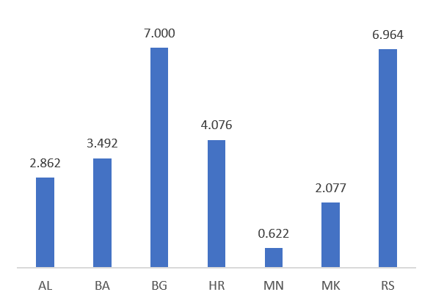
Figure 1.2: Real GDP growth rate in 2019, in % (source: Eurostat)
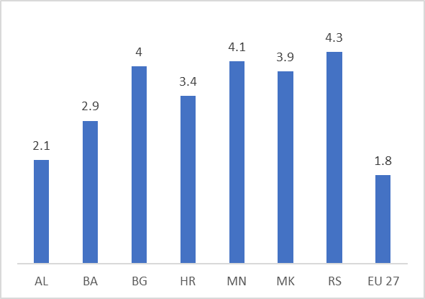
The long-term unemployment rate in Serbia is at the level of 5.5% in 2019 and continuously decreases. In comparison to the selected countries (see Figure 1.3), Serbia has the third smallest long-term unemployment rate, closer to the EU countries, while all other countries are above 12%.
Figure 1.3: Long-term unemployment rate in 2019, in % (source: Eurostat)
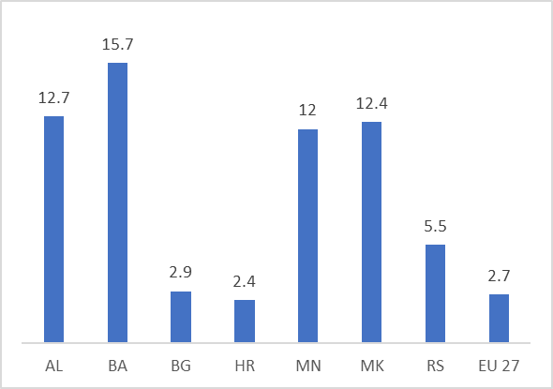
The primary energy consumption per capita in Serbia is around 2.12 toe/capita, meaning that in average each citizen in Serbia consumes 24.6 MWh, which is 30% lower than the EU 27 average (see Figure 1.4). All observed countries, except Bulgaria, have a lower consumption per capita than Serbia. One of the key factors for that is due to the fact that 66.4% of electricity production in Serbia came from lignite-based power plants in 2019 and therefore thermal/lignite power plants require higher primary energy in comparison to other generation mix. For example, in Albania most of the electricity is generated from hydro power plants leading to lower primary energy consumption.
Figure 1.4: Primary energy consumption per capita in 2019, in toe/capita (source: Eurostat)
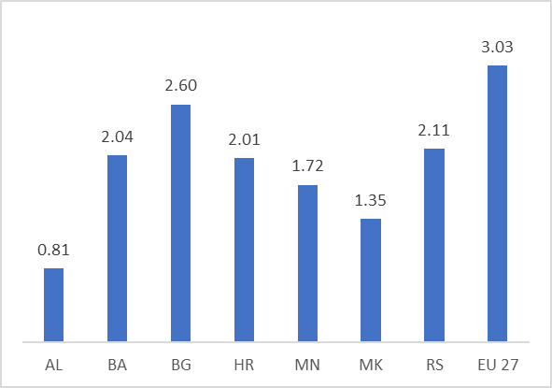
CO2 emissions
In Serbia each citizen is responsible for 7.8 t CO₂-eq (see Figure 1.5) that is the highest value compared to the selected neighbouring countries and slightly lower than the EU 27 average. Lower value can be seen in the case of Albania as the country produces most of its electricity from hydro.
Figure 1.5: CO2-eq emissions per capita for 2019, in million tonnes of CO2 (Source: Global Carbon Project)
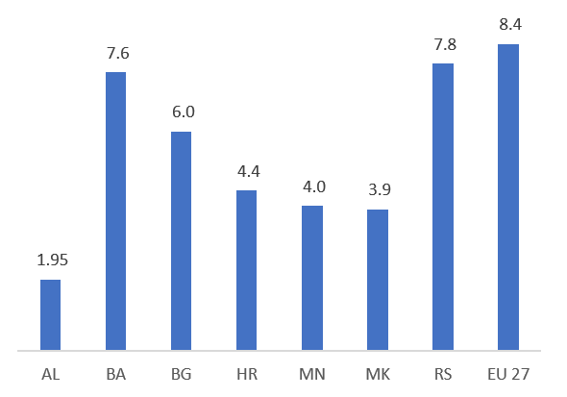
Decarbonisation - Renewable energy sources
In 2019, renewable energy sources in Serbia reached 21.4 % in gross final energy consumption, while reached a 26.3%, following to a statistic revision of energy balance in 2020. This share is higher than the level of the RES share in EU 27 (see Figure 1.6). However, in comparison to the other countries, Serbia has the second lowest share of RES following North Macedonia. The RES target for Serbia is set at 27% in 2020, according to Decision D/2018/2/MC-EnC of the Energy Community Ministerial Council. Although renewable energy capacities are increasing, RES share trend is countered due to rising energy consumption in the recent years.

Figure 1.6: Share of RES in gross final energy consumption for 2019, in % (source: Eurostat)
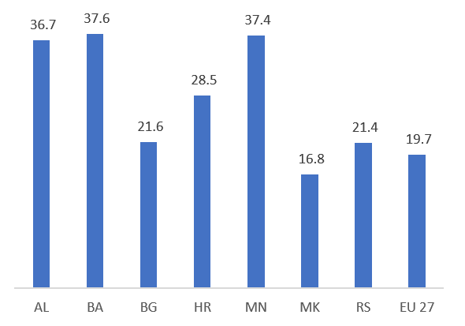
The RES share in Serbia’s electricity production has been stable over the past decade. More specifically, the RES share in electricity production for 2019 is 30.1% (see Figure 1.7), which is 4.5% lower than the EU 27. In comparison to the other countries, Serbia has a higher share only from Bulgaria and North Macedonia, whereas the remaining countries have a significantly higher share due to their installed capacity mix.
Figure 1.7: RES share in electricity production for 2019, in % (source: Eurostat)
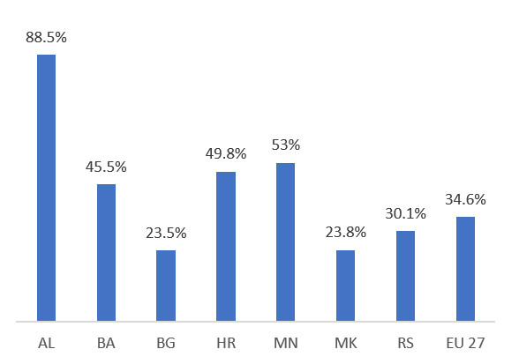
Energy Efficiency
The primary energy consumption for 2019 relative to 2005 is shown in Figure 1.8. According to the available data, Serbia has managed to decrease its consumption by 6.7%, which is the third lowest value among the selected countries. In comparison to the EU 27, Serbia is lagging by 4.2%. All the countries except Albania and Montenegro have a negative trend of primary energy consumption.

Figure 1.8: Primary energy consumption for 2019 relative to 2005, in % (source: Eurostat)
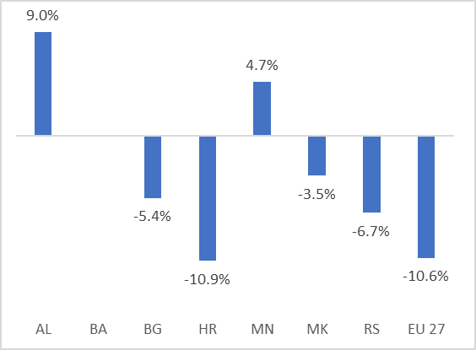
Households in Serbia consumed 411 kgoe on average in 2019, which is 25% lower than the EU 27 average. The final energy consumption in households per capita in Serbia is the third highest in comparison to the other countries (see Figure 1.9).
Figure 1.9: Final energy consumption in households per capita for 2019, in kgoe (source: Eurostat)
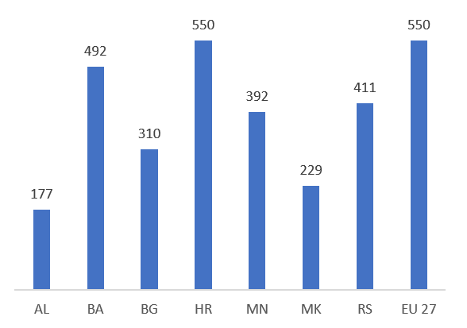
Energy productivity indicator is used to represent the economic output that is produced per unit of gross available energy. The gross available energy represents the quantity of energy products necessary to meet all the demand of entities in Serbia is presented in Figure 1.10.
Figure 1.10: Energy productivity for 2019, in EUR/kgoe (source: Eurostat)
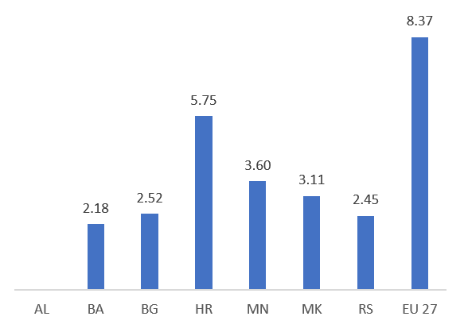
Energy Security
The energy security of supply in Serbia, measured using as import dependency (Figure 1.11), scores high with 35.6 % and shows a very good performance compared to the EU 27 for 2019. Countries such as Albania, Montenegro and Bosnia and Herzegovina are around 30% of import dependency, whereas, on the other side, Croatia and North Macedonia score higher than 55%.
Figure 1.11: Import dependence for 2019, in % (source: Eurostat)
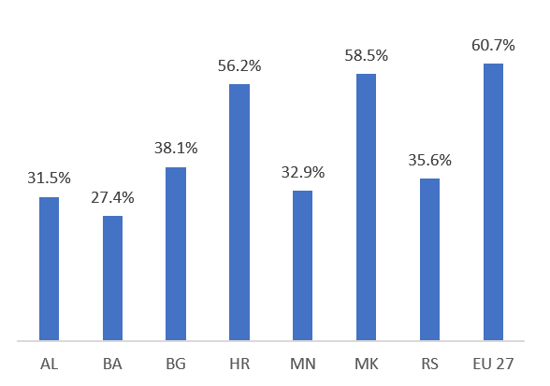
Internal Energy Market
One of the indicators for the level of energy poverty can be reflected through the ability of people to keep their homes warm. When it comes to the development of the internal energy market, this indicator is very important and should be taken into account. As can be seen in Figure 1.12, around 10% of the population in Serbia cannot maintain their houses warm and this is the second-best value in comparison to the selected countries. The situation in the EU 27 is a bit better with 6.9%.
Figure 1.12: Population unable to keep home adequately warm for 2019, in % (source: Eurostat)
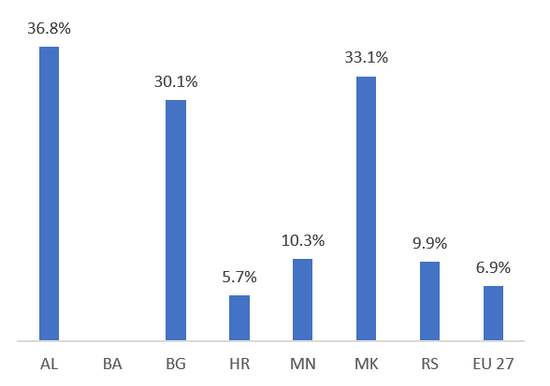
Research, Innovation and Competitiveness
In terms of the Research and Development allocation of funds in the gross domestic expenditure, Serbia allocated 0.89% in 2019 (see Figure 1.13); an allocation which is surpassed only in Croatia. Serbia allocates two times less funds than the EU 27 average, which stands at 2.2% for 2019.
Figure 1.13: Gross domestic expenditure on R&D for 2019, in % (source: Eurostat)
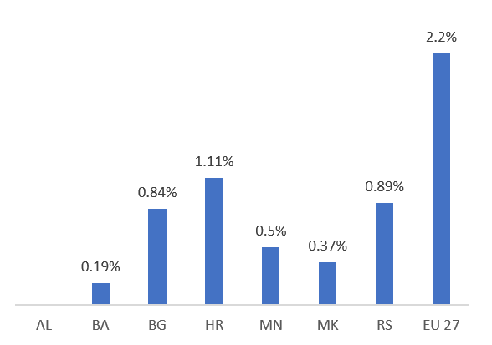

Current energy and climate policies and measures relating to the five dimensions of the Energy Union
Decarbonisation – GHG Emissions
The decarbonization dimension is articulated in two key axes, i.e. reduction of emissions and renewable energy sources. The Law on Environmental Protectionpresents the main legislative basis regarding the environmental issues, while the newly adopted Law on Climate Changedeals with the climate change issues exclusively. Through the implementation of the Law on Climate Change, that applies to the emissions of carbon dioxide (CO2), methane (CH4), nitrous oxide (N2O), fluorocarbons (HFCs), perfluorocarbons (PFCs), sulphur hexafluoride (SF6) and nitrogen trifluoride (NF3), the Republic of Serbia should establish a system for reducing greenhouse gas emissions and ensure adaptation to changed climate conditions. Also, in 2010, the Law on Meteorological and Hydrological Activities was adopted, which regulated the issues of systematic meteorological and hydrological measurements and observations, monitoring and research of the state and changes in weather, climate, water resources and the regime of surface and underground water, solar radiation, energy potential of the sun, wind and water on the territory of the Republic of Serbia, which is of importance for planning the development on the use of hydropower, solar and wind energy as the basic types of RES
Regarding the emissions, Republic of Serbia adopted the National Emission Reduction Plan in 2020 as an important step towards the emissions reduction from large combustion plants and showed the country’s commitment to become harmonized with the EU acquis in the areas of climate change, environment and energy. Furthermore, the Initial National Communication (INC) of the Republic of Serbia, as well as the Second National Communication (SNC) and the First Biennial Update Report (FBUR), represent important national reporting documents to the UNFCCC and a basis for future actions, research, and policies in the area of climate change, national capacity building and improvement of knowledge and sustainable development of the country. In order to fulfil the UNFCCC reporting requirements, Serbia submitted its First National Communication (NC1) in 2010, First Biennial Update Report (BUR1) in 2016 and Second National Communication (NC2) in 2017. The preparation of the Second Biennial Update Report (BUR2) and Third National Communication (NC3) are currently ongoing.
The Republic of Serbia ratified the Paris Agreement in 2017. First National Determined Contribution was submitted in 2015, while Second National Determined Contribution (NDC) was submitted in August 2022, presenting higher ambitious and defining the intended reduction of emissions for 33.3% by 2030 compared to 1990 (without LULUCF).
In 2020, Industrial Policy Strategy of the Republic of Serbia from 2021 to 2030 was adopted, containing a comprehensive reform step in the area of industrial development, which is one of the six key areas identified in the EU industrial development area.
Another important document is the Strategy for Cleaner Production in the Republic of Serbia, which elaborates a concept of sustainable development through encouraging the implementation of cleaner production, increasing energy efficiency and efficiency of natural resources use, as well as through reducing the amount of waste generation.
In September 2015 United Nations General Assembly adopted Resolution A/RES/70/1 – Transforming our world: the 2030 Agenda for Sustainable Development. Three dimensions of the 2030 Agenda are economic growth, social inclusion, and environmental protection. It contains 17 Sustainable Development Goals (SDGs) which came into effect in January 2016, among which some of them are affordable and clean energy, decent work and economic growth, sustainable cities and communities, climate action and others. In December 2015 inter-Ministerial Working Group for the implementation of the 2030 Agenda for Sustainable Development was established with the task of coordinating the work of all Ministries and State institutions. National Strategic Framework was mapped against SDGs in Serbia and the 2030 Agenda document, while progress on the SDGs is measured by relevant national indicators that are produced and collected by Statistical Office of the Republic of Serbia.
At COP 26 in November 2021 in Glasgow, Serbia joined Global Methane Pledge. Participants of the Pledge agreed to take actions to contribute collectively to reducing global anthropogenic methane emissions across all sectors by at least 30% below 2020 levels by 2030, while recognizing Paris agreement goal of limiting warming to 1.5°C. Participants committed to take domestic actions for reducing emissions from energy, waste and agricultural sectors, through standards improvement, technological innovation and incentives and partnerships with farmers. Serbia still has to transpose this commitment in the national legislation.
In October 2022, the Joint Declaration of Intent on the “Strategic Cooperation on Climate Action” was signed between the Ministry of European Integration of the Republic of Serbia and the Federal Ministry for Economic Cooperation and Development of the Federal Republic of Germany. The goal of the Climate Partnership is to support the decarbonization process through greater integration of RES and the promotion of energy efficiency, as well as a socially just green transition. A task team was also established with the goal of providing support for the implementation of the Climate Partnership, through enhanced coordination of financial and technical support for development cooperation.
Decarbonisation –RES
In 2013, Republic of Serbia prepared its first National Renewable Energy Action Plan (NREAP), pursuant to the Article 4 of Directive 2009/28/EC that requires the adoption of NREAP, setting out the country’s national targets for the share of energy from renewable sources consumed in transport, electricity and heating and cooling in 2020 and listing adequate measures to be taken to achieve those national overall targets. Republic of Serbia developed First Progress Report on promotion and use of energy from renewable energy sources (Progress Report) in 2014, Second Progress Report in 2016, Third Progress Report in 2018 and Fourth Progress Report in 2020, following the requirements of the Article 22 of Directive 2009/28/EC regarding the reporting obligation on renewable energy. The RES share in the Gross Final Energy Consumption (GFEC) was 21.44% in 2019 in comparison to the set target of 27% in 2020.
The adoption of the Energy Law in 2014 aimed at harmonising the energy legislation of the Republic of Serbia with the Third Energy Package. In 2016, Republic of Serbia adopted a package of secondary legislation governing renewable energy sources and setting out the support scheme for renewable energy. Adoption of the necessary by-laws to allow for a full implementation of incentive measures for the renewable energy source projects consists of the Decree on Conditions and Procedure for Obtaining the Status of a Privileged Power Producer, Preliminary Privileged Power Producer and Producer from Renewable Energy Sources, the Decree on Incentive Measures for Electricity Generation from Renewable Energy Sources and from High-Efficiency Cogeneration of Heat and Power, Decree on the Power Purchase Agreement, Decree on compensation for the incentive of privileged producers of electricity. This set of regulations, known as Power Purchase Agreement (PPA) Package, has fostered further development of the renewable energy capacity. In 2020, the total renewable energy source capacity reached 514.61 MW, out of which 398 MW represents wind capacity. The adoption of the following by-laws completes the regulatory framework for the implementation of incentive measures provided in the Law on the Use of RES: Regulation on the model contract on market premium, Decree on market premium and feed-in tariff and Regulation on the assuming of balance responsibility and the model contract on the assuming of balance responsibility.
The Decree on Incentive Measures for the Electricity Generation from Renewable Energy Sources and High-efficiency Cogeneration of Heat and Power was initially valid until the end of 2018, and extended until the end of 2019. Following its expiration on 31 December 2019, the previously applicable feed-in tariff-based incentives are no longer available to power producers that acquired the status of a privileged power producer. Nevertheless, feed-in tariff system remains active for producers already participating it, while for newcomers there will be available either feed-in tariffs or market premiums, depending on the installed capacity. In line with a proposal from the Energy Community Secretariat, the Government of the Republic of Serbia has decided to start the development of an auction-based incentives model and finally defining it in the Law on use of Renewable Energy Sources adopted in April 2021 and amendments of the Law on Use of RES.
In April 2021, Republic of Serbia adopted a Law on Use of Renewable Energy Sources for the first time. In parallel, amendments to the Law on Energy were adopted.
The Law on Use of Renewable Energy Sources (hereafter: Law on RES) envisages the development of a new incentive system for electricity generation from RES in the form of market premiums, but at the same time enables another incentive pricing scheme in the form of limited feed-in-tariff, in the separate quotas and auction processes (right to both forms of incentives is obtained within the auction process). Thus, a much more favourable regulatory framework creating an enabling environment for investments in various-scale electricity generation RES plants from RES of various capacities has been set up, while the fostering progress regarding investments of small capacity is still foreseen through the implementation of the feed in tariff supporting mechanism (projects with installed capacities under 3 MW solar wind and under 0.5 MW for power plants using other RES). Finally, the Law on Use of RES initiated additional market possibilities towards the higher market penetration of RES, such as facilitating the establishment of RES energy communities and providing an opportunity of becoming the prosumer.
The Law on Use of RES defines biofuels as liquid or gaseous fuels for transport produced from biomass, while biomass is defined as the biodegradable part of the product, waste and residues of biological origin from agriculture (including plant and animal material), forestry and related industries, as well as a biodegradable part of industrial and household waste, in accordance with the regulations governing waste management. Furthermore, Law on Energy also defines the concepts of biomass, biofuels and bioliquids in similar manner. In order to reach the planned share of renewables in the final energy consumption in transport, incentives can be provided to the biofuels producers only for units producing advanced biofuels. For the first time, the use of electricity generated from RES in transport sector is defined.
Furthermore, the status of biofuels, bioliquids and fuels from biomass is defined in the Law on RES. In the case that biofuels, bioliquids and fuels from biomass not produced from waste comply with sustainability criteria and achieve savings in greenhouse gas emissions, the energy generated from respective fuels may be considered as RES in the gross energy consumption used in all forms of transport and subject to incentives in line with Law on RES. The Law on RES prescribes two types of incentives: (i) incentives for use of innovative technologies and new RES including renewable hydrogen as a storage option, and (ii) incentives for the production of biofuels. Renewable hydrogen can be used in the heat and transport sectors, as well as replacement for natural gas.
The Directive (EP) 2009/28 which refers to renewable energy sources aiming at the reduction of greenhouse gases, in its segment related to the mandatory content of biofuels in motor fuels is implemented in the local legislation as of 2019 since the following documents were adopted: Decree on Biofuel Market Share, Rulebook on Technical and Other Requirements for Biofuels and Bioliquids and Decree on Biofuels Sustainability Criterion. Rulebook on Calculation of Renewable Energy Sources Share was adopted in 2020.
Amendments to the Law on Energy from 2021 introduced hydrogen production as motor fuel, and production and mixing of bioliquids. It was specified that there is an energy activity for the trade of oil, oil derivatives, biofuels, bioliquids, compressed natural gas, liquefied natural gas and hydrogen. Hydrogen and liquefied natural gas have been introduced into the extended concept of motor fuels, which makes it possible to trade ecologically acceptable fuels at stations for supplying means of transport, that is, to use them as energy sources in traffic.
Additional incentive measures are prescribed for the use of RES in the heating sector. Energy entities that perform the activity of production, distribution and supply of customers with heat energy can acquire incentive measures if they use highly efficient cogeneration, waste heat or renewable energy sources. Incentive measures in the heat sector are prescribed and provided by the local self-governments.

Energy Efficiency
The Law on Energy Efficiency and Rational Use of Energy (LEERUE) adopted in 2021, replaced the Law on Efficient Use of Energy (LEUE) which was in force in the period 2013-2021. LEERUE was adopted with the aim of harmonizing with the new regulation in the field of energy efficiency in EU, which was adopted in the meantime, as well as with the aim of improving certain provisions of LEUE. Today, LEERU presents a key legislative framework for the area of energy efficiency, establishing the terms and conditions for efficient use of energy and energy resources, policy of efficient energy use; energy management system; energy efficiency policy measures: energy use in buildings, in energy activities and with final customers, for energy plants and energy services; energy labelling and requirements concerning eco-design; funding, incentives and other measures in the field. The purpose of this law is creating conditions for efficient energy use and improvement of energy efficiency, which contributes to: energy savings, energy supply security; reduced environmental impact and climate change impact of the energy sector; sustainable use of natural and other resources; increased competitiveness of the economy; improved conditions for economic development and reduction of energy poverty.
With the aim of financing energy efficiency, the law created the legal basis for the establishment of Directorate for Financing and Promoting Energy Efficiency and further regulates conditions for contracting of energy services (ESCO).
LEERUE is to a great deal compliant with the Energy Efficiency Directive 2012/27/EU (ЕЕD) and compliance is additionally achieved after the adoption of the following by-laws: Decree on the obligations of the guaranteed supplier and on the obligations of the Authorized Contracting Party with regard to financial incentives for high-efficiency cogeneration, Decree on the minimum energy efficiency requirements that must be met by new and reconstructed energy facilities, Decree on the obligors of the energy management system, and Decree on the contract model on the feed-in tariff for the sale of electricity produced in a micro-cogeneration unit or small cogeneration. For full compliance missing still acts on Plan of rehabilitation of CG buildings and Study on comprehensive assessments on potentials for efficient heating and cooling which should be adopt by Q1 next year. In accordance with these provisions, among other things, it is foreseen that in the period after 2021, the targets in the field of energy efficiency will be defined through INECP, instead of through energy efficiency plans, namely, the indicative target for energy efficiency, the cumulative energy savings target, as well as the energy efficiency target in central government buildings.
LEERUE and following bylaw regulation are aligned with the Regulation (ЕU) 2017/1369 establishing a framework for energy efficiency labelling and repealing Directive 2010/30/ЕU and with the Directive 2009/125/ЕC establishing eco-design requirements for the products which affect energy consumption. In addition, LEERUE transposed the part of Directive 2010/31/ЕU on energy efficiency of buildings into the legal system of the Republic of Serbia, with accompanying amendments, which refer to auditing of heating and air conditioning systems.
In the previous period, the Republic of Serbia has adopted four National Energy Efficiency Action Plans (NEEAPs) for the periods of 2010 – 2012, 2013 – 2015, 2016 – 2018 and 2019 – 2021, respectively. These documents in the previous period set targets for energy efficiency improvements and defined measures for the achievement thereof. The latest Fourth Action Plan for Energy Efficiency (4th EEAP) of the Republic of Serbia for the period until 2021 was prepared in accordance with the requirements of adapted Directive 2012/27/EU adopted by the Ministerial Council of the Energy Community.
The LPC from 2009 defines the obligation to issue a certificate, i.e. the obligation to design, build, use and maintain a building in a manner that ensures prescribed energy performance. Furthermore, the Law on Amendments to the Law on Planning and Construction (LPC) was adopted in 2018, prescribing the obligation to issue certificates on the energy performance of buildings, the so-called energy passports through the Central Register of Energy Passports (CREP), establishing a database of Energy Passports for the territory of the Republic of Serbia, which includes 11.789 certificates of energy performance of buildings from 2013 until November 14, 2023. In addition, amendments to the LPC made in 2020 establish a legal basis for the development and adoption of the Long-Term Strategy for Encouraging Investment in the Renovation of the National Buildings Fund of the Republic of Serbia until 2050, which was adopted in the first quarter of 2022. Additionally, according to the Law on Housing and Building Maintenance, sustainable housing development constitutes one of the key principles for improving the quality of housing, through the corresponding improvement of energy efficiency. Finally, the Rulebook on energy efficiency of buildings regulates technical requirements, as well as the Rulebook on conditions, content and manner of issuing energy performance certificates for buildings. In 2023, the Ministry of Construction, Transport and Infrastructure proposed the Draft Law on Amendments to the Law on Planning and Construction, and the Government approved the Proposal for that law and forwarded it to the National Assembly for consideration and adoption. In the proposal of the Law, considerable attention is devoted to the further improvement of energy efficiency: Articles 12 and 13 of the Energy Performance of Buildings Directive 2010/31/EU are directly transposed and the preparation of the National methodology for calculating the energy characteristics of buildings is foreseen. Also, the Proposal of the Law foresees the prescription of the validity period of energy passports - 10 years, as well as the obligation to attach an energy certificate when certifying a contract on the sale of real estate or concluding a lease contract.
The new Law on Public Procurement was adopted in 2020 and provides the price-quality relationship including qualitative, environmental and/or social criteria, as well as the implementation of a cost-effectiveness approach, such as life cycle cost of goods, services or works. In this context, the country adopted the Public Procurement Development Program in the Republic of Serbia for the period 2019-2023, which provides specific priorities on public procurement system taking into account the relevant EU strategy and focusing on green and social field.
In addition, the Law on Fees for Use of Public Goodsstipulates a fee for the improvement of energy efficiency to the energy entities that perform energy activities of electricity supply, natural gas supply and public supply of natural gas, as well as to the energy entities that perform the energy activity of production of oil products and trade in oil, oil products, biofuels, etc. In 2019, the Ministry of Mining and Energy adopted the relevant Rulebook on the form of registration of records of taxpayers for energy efficiency improvement fees, on the form for monthly and annual calculation of the amount of energy/ energy carriers supplied to consumers or placed on the market in the Republic of Serbia, i.e. imported into the territory of the Republic of Serbia, the form for the monthly and annual calculation for the payment of fees, the form for the payment reports, as well as the method of submitting these forms for the records of entities liable to pay energy efficiency improvement fee from July 2019.
In 2017, the Degree on establishment of implementation of Energy Sector Development Strategy of the Republic of Serbia until 2025 for the period from 2017 to 2023 was adopted. This program sets energy efficiency targets in accordance with the EED Directive until 2020, including the target for cumulative energy savings and an indicative target in the form of the maximum allowed consumption of final or primary energy.
On the basis of LEUE, in the period from 2014-2021, incentives for the improvement of energy efficiency were provided within the Budget Fund for Energy Efficiency, a budget line whose funds were managed by the Ministry of Mining and Energy. In that period, 7 public calls for the allocation of funds for the improvement of energy efficiency in buildings of public importance at the local level were implemented, through which 107 projects with a total value of about 14.4 million EUR were realized (participation of Budget Fund approx. 8.9 million EUR) and in accordance with the regulations on establishing the Program for financing activities and measures to improve the efficient use of energy, which the Government of the Republic of Serbia adopts every year on the proposal of the Ministry of Mining and Energy (MoME). In this context, significant activities related to the renovation of buildings in the country were carried out by various local institutions, as well as with the help of International Financial Institutions and donors.
One of the most significant innovations brought by LEERUE is the legal basis for the establishment of the Directorate for Financing and Promoting Energy Efficiency (EE Directorate). The EE Directorate was established at the end of 2021 as a separate legal body within the MoME, to carry out executive and expert operations related to the financing of efficient energy use, and its operation started in February 2022. The tasks of the EE Directorate are laid down in the Article 73 of the LEERUE. This facilitated the launching of pilot projects for the allocation of funds to citizens in 2021 in cooperation with local self-governments, whereby incentives up to 50% are provided by the MoME and local self-government units (25% each) and citizens approx. 50%:
- for energy rehabilitation of residential buildings, family houses and apartments 67 LSG ; approx. 5000 households; Amount of subsidies from MoME and LSG: 461 million dinars; Expected energy savings: approx. 36 million KWh. Estimated reduction of CO2 emissions: 12,154.90 t)
- for installation of solar panels: 37 LSG; 500 households; Amount of subsidies from MoME and LSG: approx. 200 million dinars; Expected energy savings: 3.000.000 KWh annually. Expected reduction of CO2 emissions: 3300 tons annually.
This made the allocation of significantly larger funds for financing energy efficiency from the Budget of RS for 2022 possible, amounting to approx. 2 billion RSD or approx. 17 million. EUR, out of which approximately 10 million EUR is collected annually from compensation charges. In 2022, on the basis of these funds and in cooperation with 151 LSGs, the process of awarding incentives to citizens for the renovation of residential apartments, family houses and residential buildings and installation of solar panels is being implemented: 20,000 households; Amount of subsidies of MoME and LSG: approx. 2 billion dinars; On the basis of the level of regional development, the least developed LSG will participate with a minimum of 30%, while other LSG will participate with a minimum of 50%. Expected energy savings: 196,276,070 kWh per year. The expected reduction in CO2 emissions is 87,913 tons annually. In 2022, the 8th public call for improvement of energy efficiency of public buildings in LSG was implemented, which was the first to be implemented by the EE Directive, for which the EE Directive provided about 690 million dinars for the financing of 38 buildings of public importance; Expected energy savings of 9 million kWh per year; reduction of CO2 emissions approx. 4500 tons per year. Energy rehabilitation will be carried out.
Based on these funds, World Bank loan was secured in the amount of 50 million dollars for the implementation of the project "Clean energy and energy efficiency for citizens in Serbia" project, which will put special focus on socially vulnerable categories and provide 50 million EUR from EBRD loan for implementation of the project "Energy rehabilitation of residential and public buildings connected to the district heating system", which will focus on multi-apartment buildings with high consumption of heat energy, connected to district heating systems, in order to support the transition to billing on the basis of energy consumption. It is expected that through these projects, subsidies will be provided for around 100,000 households.

Internal Energy Market
The legislative and regulatory framework for the development and regulation of the internal energy market in the Republic of Serbia is determined by the Law on Energy.
The Electricity Transmission Network Ten Year Network Development Plan (Ten-year transmission system development plan of the Republic of Serbia) is prepared by the Transmission System Operator (TSO “Elektromreža Srbije“ - EMS), which is also responsible for the operation, maintenance and construction of the electricity transmission network according to the Law on Energy and the Transmission Grid Code adopted in April 2020. The Electricity Distribution System Operator (DSO “Elektrodistribucija Srbije d.o.o. Beograd EPS”), which ownership from Public Enterprise "Elektroprivreda Srbije" (EPS) was transferred to Republic of Serbia in 2020, is in charge of TYNDP distribution network preparation as well as its operation and maintenance according to the Law on Energy and the Distribution System Grid Code adopted in July 2017, with amendments adopted in February 2019. With regard to the electricity interconnectivity level as per the EU 2020 and EU 2030 interconnectivity criteria, the Electricity Interconnection Targets in the Energy Community Contracting Parties study from February 2021 highlights that Serbia is achieving and overachieving set targets.
On December 29, 2020, the Government of the Republic of Serbia, and the Public Enterprise "Elektroprivreda Srbije" concluded the Agreement on the transfer of shares in the Distribution System Operator "EPS Distribucija" Ltd Belgrade from the Public Enterprise "Elektroprivreda Srbije" Belgrade to the Republic of Serbia. By the decision of the Agency for Economic Registers number BD 99765/2020 of December 31, 2020, the registration was carried out according to which the Republic of Serbia was incorporated as a member of the company with a share of 100% of the capital.
By adopting the Law on Energy in 2014, Republic of Serbia transposed the majority of the Gas Directive and the Gas Regulation provisions. During 2021-2022, the Energy Agency of the Republic of Serbia changed and supplemented the regulations, under its own competencies and according to the indicated needs, for the purpose of more efficient market functioning, better protection of end customers and other participants in the market.
The detailed gas regulation is defined by the Transmission Network Code, while the Ten-Year Development Plan of Yugorosgaz for period 2021-2030 and Ten-Year Development Plan of Transportgas Srbija for period 2020-2029 present key development documents prepared by market participants.
Organised day-ahead market/power exchange in Serbia (JSC “SEEPEX”) was established in February 2016 on the basis of partnership between EMS and European Power Exchange (EPEX SPOT), pursuant to Law on Energy and after adopting the amendments to the Law on VAT and the new licensing rules in 2015. The successful launch of the Serbian Day-Ahead Market is important for the power market in the South Eastern Europe since it is the first organised market in the region.
At the end of 2014, the Government of the Republic of Serbia adopted a Conclusion accepting the Baseline for Restructuring JP Srbijagas, which determined that the operators of the transport and distribution system should be legally separated entities from JP Srbijagas. In 2020, the Government approved an Action Plan for the Implementation of Activities for the Purpose of Reorganization of PE “Srbijagas”, which stipulates the separation of its gas transport and gas distribution activities, in line with the EU obligations. In accordance with the plan, the ownership of the Transportgas Srbija company was transferred from Srbijagas to the Government in May 2021.
Pursuant to the Energy Law, the conditions for the entitlement to guaranteed supply of electricity were modified. In line with this, as of 2015, the right to guaranteed supply is exercised only by households and small customers up to 30.000 kWh, at prices of electricity for guaranteed supply, which are according to the Law on Energy determined by the methodology adopted by the Energy Agency, which also gives consent to the decision on the price of electricity. More specifically, households and small customers have the right to remain with the guaranteed supplier and be supplied in line with existing contracts, but they also have the option to contract with any licenced electricity supplier in the open market. In the gas sector, all final natural gas customers are entitled to select their supplier freely in the market. Households and small natural gas customers up to 100.000 m³ are entitled since 2015, but they are also still entitled to public supply. In line with energy policy goals, the development of competition in the oil, oil derivatives, biofuels and compressed natural gas sectors was stimulated in the Republic of Serbia in order to increase the efficiency of this sector via market mechanisms. In a narrow sense of energy activity regulation, regulated prices in this sector are established only for natural monopolistic activities of oil transportation via oil pipelines, i.e. oil products transport via product lines.
Pursuant to the Law on Amendments to Law of Energy from 2021, a Nominated Electricity Market Operator was appointed in June 2022 and should be responsible for the implementation of the Day-Ahead and Intraday markets with neighbouring organised markets gaining, thus, a central role in enabling and coordinating the market coupling process. Guarantees of origin will contribute towards attracting investments in renewable sources. To this end, Republic of Serbia has implemented a functional Guarantees of origin system and EMS JSC became a full membership of in the Association of Issuing Bodies (AIB). This will allow for cross-border trade of Guarantees of origin with the EU, which shall be continued after the RED II is transposed and implemented in all EU countries from July 2021.
Additionally, the Law on Amendments to the Law on Use of RES provide a better environment for the modernisation of the traditional and centralised power generation system through the introduction of the concept of prosumers, RES energy communities and aggregators as decentralised actors in the future energy market. By empowering end-users to transform their role from passive energy consumers to active market participants through renewable self-generation, the Law on use of Renewable Energy Resources promotes the overall idea of local generation opportunities for own needs, with the ability to connect to the grid and deliver energy surplus into the network.
Pursuant to the Law on Energy, more attention is given to energy poverty, which is marked as one of the key threats within the energy transition. Republic of Serbia sets more emphasis on this issue for the first time by amending accordingly the Law on Energy. In that sense, the term “energy poverty” has been legally recognised, while the opportunities addressed to vulnerable customers have been expanded, covering heating sector as well. For example, the Decree on energy vulnerable customer that sets up the eligibility criteria for acquiring the status of energy vulnerable customer of electricity or natural gas, has been improved by the new Decree on energy vulnerable customer adopted in December 2022, which for the first time introduces aid for heating and foresee a significant increase in the number of customers eligible for aid. To acquire the status, one needs to submit at first a request to the municipality unit responsible for social welfare activities.

Energy Security
The core elements in the legislation of the Republic of Serbia that regulate energy security are the Law on Energy and Law on Commodity Reserves. While the Law on Energy regulates the whole spectrum of energy sector covering all energy sources, the Law on Commodity Reserves is relevant for the regulation of the formation and use of mandatory reserves of the oil and oil products, as a part of implementation of the Directive 2009/119/EC that imposes an obligation to maintain minimum stocks of crude oil and/or petroleum products by no later than 1 January 2023. In order to establish the full legal framework for the transposition of this Directive, several additional regulations and by-laws need to be adopted by the Government of the Republic of Serbia and the Ministry of Mining and Energy. The amendments to the Regulation on security of supply and the Regulation on access to transport systems related to mandatory gas reserves and certification of storage operators have been adopted as mandatory for implementation in the Energy Community.
In accordance to the Law on Energy, the Government adopts the Energy Balance on the proposal of the Ministry of Mining and Energy (MoME), by the end of December of the ongoing year for the next year, where the annual energy needs, expressed on a monthly basis, necessary to ensure reliable, secure and quality customer supply are determined. In addition, the Law on Critical Infrastructure has identified key sectors where critical infrastructure is needed and the energy sector is listed as the first one.
The Government of the Republic of Serbia prescribes the conditions for delivery and supply of electricity, oil and natural gas, as well as the measures to be taken if the security of energy and energy sources supply is endangered due to market or system disturbances. To this end, Republic of Serbia has well established the delivery of electricity and natural gas and security of supply secondary legislation through two major decrees; i.e. the Decree on Conditions for Delivery and Supply of Electricity and the Decree on Conditions of Natural Gas Delivery and Supply. Moreover, the country is fully aligned with the EU acquis on emergency oil stocks in the framework of security of supply on, defined by Decree on determining the Program of measures in case the security of energy and energy supply is endangered (Emergency plan) and Decree on the procurement plan and criteria for the formation of mandatory oil reserves. In 2021, the Government adopted the Decree on Amendments to the Decree on the Plan and Criteria for the Formation of Mandatory Reserves of Oil and Oil Derivatives which defines that crude oil for the purposes of forming mandatory reserves is procured in a quality whose parameters meet the conditions established by the Rules on the operation of the oil transport system by oil pipeline, as well as that mandatory reserves can be renewed by exchange, sale and purchase. Also, the Rulebook on establishing the Annual Program for the formation and maintenance of mandatory oil reserves for 2021 was adopted.
In accordance to the provisions of Article 315 of the Law on Energy stipulating the adoption of a Preventive Action Plan and Emergency Plan in order to ensure the security of natural gas supply, as well as in accordance to the provisions of the Decree on establishment of Preventive action plan for safeguarding of security of natural gas supply and Decree on establishment of Emergency plan for safeguarding of security of natural gas supply, Republic of Serbia has developed the Emergency Plan for safeguarding of security of natural gas supply and Preventive Action Plan for safeguarding of security of natural gas supply. The Emergency plan determines measures and energy service companies that will be responsible for ensuring the security of the transmission system and the security of supply of certain groups of end customers, as well as the quantity and capacity of natural gas in case of general shortage of natural gas. The Preventive Action plan contains a risk assessment in terms of achieving security of supply in addition to measures on how to mitigate the identified risks related to the required transportation capacity in order to meet the total demand for natural gas and to secure the supply of certain groups of final customers of natural gas.
Pursuant to Article 18, paragraph 3 of the Law on Commodity Reserves, the MoME adopts Rulebook on determining the Annual Program for the Formation and Maintenance of Mandatory Reserves of Petroleum and Petroleum Products for 2020on the regular annual basis. To this end, Serbia adopted a long-term plan to establish and maintain emergency oil stocks in 2018 and the Emergency Response Planin 2019. The latter lays out the procedures and steps to be undertaken by the main entities in Serbia responsible for taking action during an oil supply crisis. Those include the procedures and criteria for the identification of a supply disruption and the normalization of supply to the Serbian market. It also appoints the authorities being responsible for eliminating supply disruptions such as Governmental institutions in charge of energy and public and private entities in the oil and gas industry. In 2019, the Ministry of Mining and Energy submitted the Security of Supply Statement 2018 to the Energy Community Secretariat.
The Working Group (WG) for the review and monitoring the situation regarding security of energy and fuels supply in the Republic of Serbia has been appointed by the Ministry of Mining and Energy and operates since 2005. It consists of the representatives of Ministry in charge of energy, Energy Agency of the Republic of Serbia (AERS), JSC EPS, JSC EMS, PE Srbijagas, JSC NIS, Serbian Association of heating plants, Provincial Secretariat for Energy and Mineral Resources, Energy Administration of the Belgrade city, and "JKP Beogradske elektrane Beograd”. Its mandate is to monitor the security of energy and energy sources supply, propose appropriate measures, prepare the basis for a report on the security of electricity and natural gas supply and propose measures in case of compromised security of customer supply or energy system operation, due to insufficient supply on the energy market or the occurrence of other extraordinary circumstances.
Other relevant bodies in charge of energy security are the Administration for energy reserves within the MoME and the specifically formed Group for central storage body, as well as the Department for Energy within the Republic Directorate for Commodity Reserves. In line with the by-laws, Republic of Serbia has established the National Emergency Strategy Organization (NESO) that represents the general framework for dealing with crisis situations in the oil sector, chaired by the State Secretary of the MoME and consisted of representatives from the Oil and Gas Sector within the MoME, as well as representatives from the Republic Directorate for Commodity Reserves, the Republic Bureau of Statistics, Ministry of Trade, Tourism and Telecommunications, Ministry of Finance, Ministry of Interior, Ministry of Construction, Transport and Infrastructure and oil companies operating on the market of the Republic of Serbia.
In accordance with the Articles 111 and 250 of the Law on Energy, the transmission system operators for electricity and natural gas are obliged to submit a ten-year (transmission) network development plan for which they are in charge to the Regulator for approval. Regarding the network development planning in the natural gas sector, there are two crucial ones, i.e. Transport System Development Plan of Transportgas for period 2020-2029 and Transport System Development Plan of Yugorosgaz covering period 2021-2030. With respect to the electricity sector, Transmission System Development Plan for period 2021-2030 presents the development planning of EMS, while Distribution System Development Plan for period 2021-2030 has been approved as well. Furthermore, in accordance with the Article 325 of the Law on Energy, energy entities that transport oil by pipelines are obliged to adopt five-year development plans.
The Government of the Republic of Serbia in June 2023 has adopted Conclusion on the acceptance of the Starting points of the Plan for the development of energy infrastructure and energy efficiency measures for the period up to 2028 with projections up to 2030, which defines key goals in all areas of the energy sector: electricity production, transmission and distribution network, natural gas sector, oil and oil derivatives sector and energy efficiency. The main goal of the plan is to define the basic directions of strategic development that will be part of the new Energy Sector Development Strategy of the Republic of Serbia, which is planned to be adopted by the end of 2023. The emphasis of the plan is on understanding the degree of realization of projects foreseen by the valid Energy Sector Development Strategy of the Republic of Serbia until 2025 with projections until 2030, on the identification of new projects and consumption projections until 2040 with projections until 2050.
Regarding the emerging security issue, cyber security in energy sector is effectively implemented through the concept of information and communication (ICT) systems of special importance, set by the Law on Information Security in 2016 as the comprehensive overall legal and institutional framework for cybersecurity. Alongside with the Law, the Decree on determining the List of activities in areas where activities of general interest are performed and in which information and communication systems of special importance are used emphasizes the energy sector as being one of those essential areas and lists activities such as electricity generation, transmission and distribution; exploration, exploitation, refining, transport and distribution of oil and oil derivatives; exploration, exploitation, refining, transport and distribution of natural gas and liquefied gas; coal production and processing. The Strategy for Development of Information Security in the Republic of Serbia for the period 2017 – 2020 is linked to the implementation of Directive 2016/1148/EC (NIS Directive), introduces the principles and defines the objectives in security of the ICT systems of special importance, as well as fights against cybercrime. However, there were no energy-specific policies identified in the Strategy.
Risk assessment is defined in the Law on Information Security and in the Regulation on More Detailed Contents of Enhancement on Security of ICT of Special Significance.It is performed by the national computer emergency response team (SRB-CERT), responsible for the energy sector, operating within the Regulatory Agency for Electronic Communications and Postal Services. One of the main drawbacks of the risk assessment is the lack of consideration of cross-border component.
Starting in 2019, inspection and supervision of information and communications technologies (ICT) has been performed on an annual basis by the Department for Information Security and Electronic Business within the Sector of Information Society and Information Security of the Ministry of Trade, Tourism and Telecommunications. In 2020, inspection and supervision were carried out for “Elektromreža Srbije“ - EMS, Srbijagas and NIS, while during the 2021 they have to be done for Public Utility Company Beogradske elektrane (2021 Q1), Transportgas (2021 Q3) and Elektrodistribucija Srbije (2021 Q4).
In Serbia, the Law prohibiting construction of nuclear power plants in the Federal Republic of Yugoslavia is in force, which prohibits making investment decisions, preparation of investment programmes and technical documentation for the construction of nuclear power plants, nuclear fuel fabrication facilities and the facilities to reprocess spent nuclear fuel for nuclear power plants. The provisions of the Law do not pertain to any scientific research and development activities, mining and geological research activities, geological and seismic research, and staff education in the field of nuclear energy development.
Research, Innovation and Competitiveness
Republic of Serbia’s strategic and legislative framework in the area of science, research and innovation is in line with the EU Acquis Communautaire. In 2016, Serbia opened the Negotiating Chapter 25: Science and Research within the pre-accession negotiation process with the European Union and then temporarily provisionally closed it, becoming the first chapter the Serbia successfully closed in negotiations with the EU. In the same year, the Strategy of Scientific and Technological Development of the Republic of Serbia for the period from 2016 to 2020 – “Research for Innovation” was adopted. Also, the Smart Specialization Strategy of Serbia (4S) development process was formally initiated in late 2016 by the Ministry of Education, Science and Technological Development and the Public Policy Secretariat of the Republic of Serbia, as a starting transformative step. Following that, Serbia became the first non-EU country to join the Platform of Countries and Regions that have entered into the Smart Specialization Strategy and finally, Serbia has applied new paradigm of innovation policy and smart specialisation development approach, by the adoption of Smart Specialization Strategy of Serbia (4S) for the period 2020 to 2027 in 2020.
The general vision of this strategic document is to support the development of a smart and creative Republic of Serbia, highly competitive in the world, recognized by its knowledge-based innovations, partnerships from domestic ecosystem and creativity of individuals in areas of sustainable high-technology production of high value-added food for the future, sophisticated software solutions for global market and inter-sectoral-based industrial innovations. General vision means that as of 2027, the Serbian economy will - to a great extent - be based on knowledge and innovations and include crucial priority strategy areas supported to create greater competitiveness and better positions in global supply chains. Thus, the key pillars of this strategy are science, competitiveness, education, communication and digitalization, and agriculture.
In the period from the adoption of the strategy titled "Research for Innovation", a number of envisaged measures were implemented, such as an adoption of the Law on the Science Fundin 2018 and the Law on Science and Research in 2019, that has made key steps in reforming the system of organization and financing of science. Those laws enabled implementation of a new model of financing research activities through institutional and competitive project financing. The establishment and operation of the Science Fund of the Republic of Serbia regulates and improves the area of support for scientific research, while the institutional support of the Government through the Innovation Fund has as goal to enable cooperation between investors and international donors to provide greater funding, to foster university-business cooperation in order to translate scientific achievements into real economy, and to encourage small and medium-sized enterprises engaged in innovation activities.
Following that, the Strategy of Scientific and Technological Development of the Republic of Serbia for the period from 2021 to 2025 “The Power of Knowledge”, was prepared by the Ministry of Education, Science and Technological Development and adopted in 2021. An integral part of this strategy is the three-year period Action Plan for 2021-2023. The strategy aims to enable the acceleration of Serbia’s development and the country’s integration into the European research space through the upgrade of the science-technology and innovation system. The Industrial Policy Strategy from 2021 to 2030 that replaced the previous Strategy for the Development of Industry is extremely relevant to 4S and the overall objective of the new strategy is to raise competitiveness of the industry of the Republic of Serbia with a focus on industry-led development, which implies advanced production and high value-added services.
Focusing on the national capacities and current state of development, Republic of Serbia has around 2,000 researchers per one million inhabitants, which is higher than other countries of the Western Balkans region, but less than developed EU countries in the region. In total, there are around 15,000 researchers officially and this number has been constantly rising. Given that the greatest number of researchers are in the public sector, such as institutions of higher education and institutes, the number of researchers has been stagnant since 2016 and even a mild decrease has been registered.
More than half of business entities in Serbia have been characterized as innovative with a significant upward trend in the number of innovative enterprises in the last couple of years. Enterprises, on the other hand, invest very little in R&I, while innovations are generally incremental in nature with very few businesses that have made radical innovations and developed a worldwide product. This situation in the business sector is also reflected in the relatively low number of patents compared to other countries. Anyway, there has been a growing trend in the number of innovators among business entities since 2012. The largest share of innovators' businesses is in the Information and Communication sector and in the Manufacturing industry, while in the case of energy sector, the share of innovators’ businesses was over 42% in period 2012-2018. On the other hand, the number of patent applications is at a low level, but the number of patents granted for inventions by domestic inventors abroad on the basis of international and/or European patent applications has grown over the last couple of years.
In 2015, a partnership of the Government, the City of Belgrade and the University of Belgrade established the first Science and Technological Park, located in Belgrade, as a measure to stimulate scientific and innovation development. Additional science and technology parks have been constructed in three more cities – Nis, Novi Sad and Cacak. In 2018, with a view to implementing positive changes to the European scientific community, the Platform for Open Science was adopted in Serbia. At national level in the energy and climate area, within the Sector for technological development, technology transfer and innovation system of the Ministry of Education, Science and Technological Development, there is an Energy, Mining and Energy Efficiency area as one of the key fields. Another body that exists under the Ministry of Education, Science and Technological Development is the National Council for Scientific and Technological Development. Besides that, there are many other institutions and bodies that are contributing to the development of the research and innovation issues, such as the Serbian Academy of Sciences and Arts (SANU) and the Center for Promotion of Science, with different responsibilities and objectives. However, most of them don’t have specific targets and objectives regarding the research and innovation in the field of energy, as is also the case with the above-mentioned strategies, while there are no specific calls in the fields of Energy and Environment (and/or Climate Change). In any case, many institutes and faculties are very active in conducting and performing research and innovation in energy technologies. Regarding the competitiveness, relevant institutions are the Chamber of Commerce and Industry of Serbia, Development Agency of Serbia and Commission for Protection of Competition.
The Republic of Serbia is successfully conducting international cooperation, mainly through bilateral cooperation programs, cooperation within the region/macro region, and EU programs. An agreement signed in 2014 by the Government of Serbia and the European Union enabled participation of the former in the Horizon 2020 program. As a result of that, the participation of Serbian scientific teams significantly expanded in the projects financed by Horizon 2020. According to the data from January 2020, 446 institutions from the Republic of Serbia participate in the program as part of 311 projects approved for financing, where 149 participants are from the private sector. The majority of projects are in the area of food, about 20%, followed by the energy and information technology.
Additionally, the Republic of Serbia is extremely active in the implementation of the EU Strategy for the Danube Region where it coordinates the Priority Area 7 “To develop the Knowledge Society (research, education and ICT)”. The Republic of Serbia is currently coordinating the pillar connecting the region with the EU Strategy for the Adriatic-Ionian Region, an initiative that has the objective to promote economic and social prosperity and growth in the region by improving its attractiveness, competitiveness and cohesion. The Republic of Serbia is also active in the European Strategic Forum for Research Infrastructure (ESFRI) and in four consortiums of the European Research Infrastructure Consortium (ERIC): CERIC (Central European Research Infrastructure Consortium), DARIAH (Digital Research Infrastructure for the Arts and Humanities), ESS (European Social Survey) and CESSDA (Consortium of European Social Science Data Archives). Moreover, Serbia has developed intensive cooperation at several levels with Joint Research Center (JCR) of the European Commission, and it also demonstrates a high level of activity in EUREKA and COST programs. Finally, the Common Regional Market Action Plan for 2021-2024, prepared by Central European Free Trade Agreement (CEFTA) Secretariat contains expectations and plans regarding the regional mobility of researchers, knowledge sharing and cooperation in the field of innovation, as one of the key pillars.

Key issues of cross-border relevance
The Republic of Serbia is member of the Central and South Eastern Europe energy connectivity (CESEC), an organisation that works to accelerate the integration of central eastern and south eastern European gas and electricity markets, together with all other EnC Contracting Parties and nine EU Member States, i.e. Austria, Bulgaria, Croatia, Greece, Hungary, Italy, Romania, Slovakia (Slovakia is no longer a member of CESEC since 2021) and Slovenia. Furthermore, the Republic of Serbia participates and contributes to the Regional Meetings and Workshops, as well as the Regional Exchange events organized by the GIZ Open Regional Fund - Energy Efficiency (ORF-EE) in order to facilitate a discussion on modelling approaches, data availability and quality, challenges, best practices, cross-sectoral and regional issues.
More specifically, the Ministry of Energy and Mining participates in the listed Energy Community technical working groups:
- Energy Efficiency Coordination Group,
- Renewable Energy Coordination Group,
- Security of Supply Coordination Group,
- Coordination Group of Distribution System Operators for Electricity,
- Coordination Group for Cyber security and Critical Infrastructure,
- PECI electricity and gas Coordination Groups.
EMS is a full member of the European Network of Transmission System Operators for Electricity (ENTSO-E). “Elektromreža Srbije“ - EMS is also one of the founders of the first Regional Security Coordinator in the Southeast Europe, company Security Coordination Centre SCC Ltd. Belgrade, and stakeholder together with JSC “Crnogorski Elektroprenosni Sistem” (CGES) that is TSO from Montenegro and “Nezavisni Operator Sistema u Bosni i Hercegovini” (NOSBiH) that is ISO from Bosnia and Herzegovina.
The Energy Agency of the Republic of Serbia participates in the work of the Energy Community Regulatory Board, is part of the advisory body of the Ministerial Council of the Energy Community, and in the work of the Electricity and Natural Gas Forums, as well as in the Balkan Forum. The Energy Agency of the Republic of Serbia is a fully empowered member of the Energy Regulators Regional Association (ERRA), a specialized association of regulators with the aim to improve collaboration, experience exchange, and capacity building of member regulators. The Energy Agency of the Republic of Serbia also participates, as an observer, in the work of the Council of European Energy Regulators (CEER). By joining this Council, the Energy Regulatory Commission gains experience in implementing the Third Package of Legislation and the challenges that EU Member States face in creating a single, competitive, efficient and sustainable internal energy market in the European Union, as well as with new packages of the European legislation.
SEEPEX is participant to the TRINITY project (transmission system enhancement of regional borders by means of intelligent market technology), the main goal of which is to enhance cooperation and coordination among the Transmission System Operators of South-Eastern Europe (SEE) in order to support the integration of the electricity markets in the region, while promoting higher penetration of clean energy sources. TRINITY addresses the EU’s Research Horizon Framework 2020 Programme within the call “Building a low-carbon, climate resilient future: secure, clean and efficient energy”. SEEPEX is the leader of Work Package 3: TRINITY SEE Cross-Border Market Coupling Framework that aims to demonstrate benefits of a coordinated work of the intra-day electricity market, common regional capacity reserve market, bilateral trade and guarantees of origin market, taking into consideration EU and non-EU countries.

Governance structure of implementing national energy and climate policies
The process of developing and preparing the Integrated National Energy and Climate Plan has been implemented within the framework of the project “Further Development Energy Planning Capacity“, launched in February 2021. Following the identification of the relevant institutions, bodies and companies, the Working Groups have been established (see Chapter 1.3.ii).
The Government of the Republic of Serbia represents the national adoption authority for a period of up to ten years, as per the Law on Energy, while the Ministry of Mining and Energy is responsible for the preparation of the INECP in cooperation with other relevant ministries. During the development and preparation of the INECP, the Consultant provided technical support to the Ministry of Mining and Energy, as well to the other institutions and bodies involved in the process, in terms of transfer knowledge based on the extensive international experience, implementation of best solutions and specific expertise that would facilitate and accelerate the process. Finally, the responsibility over the project progress is assigned to the Project Steering Committee, which is the implementation and monitoring body consisting of various governmental institutions.
Figure 1.14: Governance of the preparation and development of the Integrated National Energy and Climate Plan
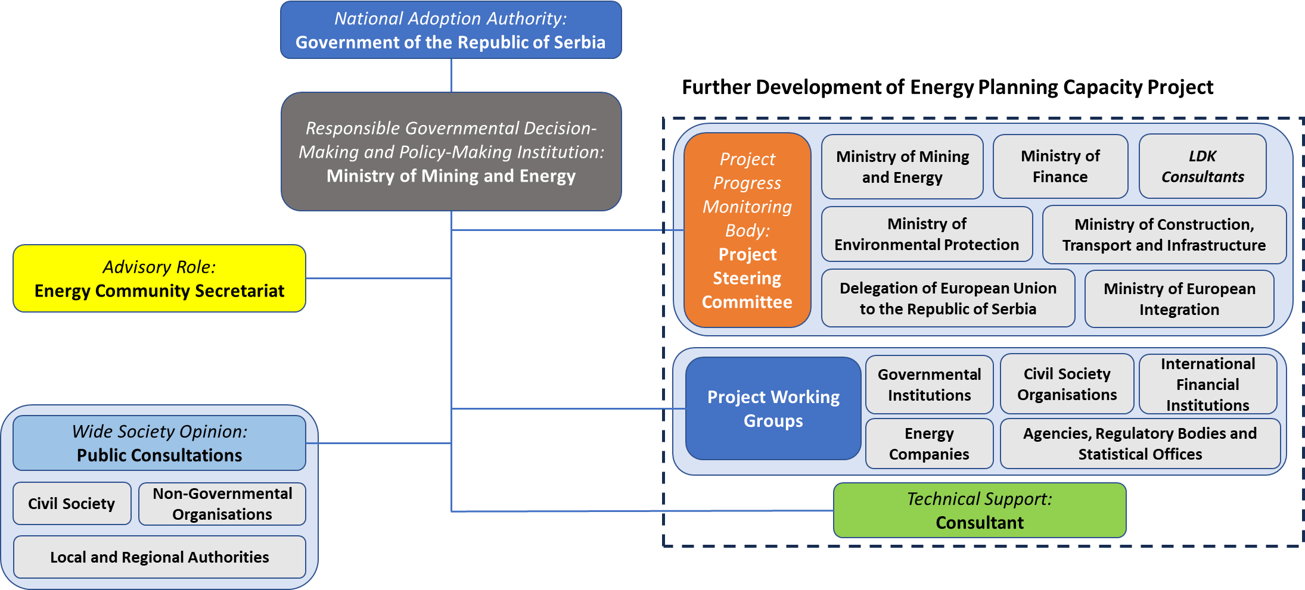
The advisory role of the Energy Community has been exerted to a certain extent, mainly during the official consultations of the Republic of Serbia with the Energy Community Secretariat on Draft INECP and while providing the recommendations for the finalization of the document. However, from the early phase of the development and preparation of INECP, the Energy Community has been regularly following the overall progress, primarily through the various Energy Community working groups and other relevant communication platforms and mechanisms.
The Ministry of Environmental Protection is responsible for monitoring and reporting policy measures arising from the adopted Low carbon Development Strategy of the Republic of Serbia for the period 2023-2030 with projections by 2050. It is also responsible for the creation of a national cross-sectoral Climate Change Adaptation Plan with an Action Plan, based on a project financed from EU IPA fonds. The Environmental Protection Agency, as a body within the Ministry of Environmental Protection, with the capacity of a legal entity, performs professional tasks related to the development, harmonization, and management of the national information system for environmental protection, which includes the inventory of gases with the greenhouse effect.
MOME conducts auctions for incentives for renewable energy sources process based on available quotas prescribed by the Government. The database for energy audits and the energy management system (SEMIS) is organized, implemented, and monitored by MOME, as well as the implementation of the energy management system goals. Main activities of MOME in the field of energy efficiency (EE), as a state administration body competent for energy efficiency, are creating policy, regulatory and incentive conditions for the rational use of energy and increasing EE.
The unit for urban development within the Ministry of Construction, Transport, and Infrastructure (MCTI) is responsible for monitoring the implementation of the targets and measures established by the Sustainable Urban Development Strategy of the Republic of Serbia until 2030 and the three-year action plans at the national level. Certificate on the energy performance of buildings is issued through the Central Register of Energy Passports (CREP), which is administrated and maintained by MCTI.
The Electricity Transmission Network Ten Year Network Development Plan (TYNDP) is prepared by the Transmission System Operator (EMS), which is also responsible for the operation, maintenance, and construction of the electricity transmission network according to the Law on Energy and the Transmission Grid Code.
The Electricity Distribution System Operator (DSO “Elektrodistribucija Srbije”) is responsible for the TYNDP distribution network preparation as well as its operation and maintenance according to the Law on Energy and the Distribution System Grid Code.
The Energy Agency of the Republic of Serbia (“AERS”) is an independent, regulatory body established pursuant to the Law on Energy with primary task to develop and enhance the electricity and gas market based on the principles of non-discrimination and effective competition by creating a stable regulatory framework. The most important Energy Agency jurisdiction areas are certification and licencing of transmission/transport system operator, price regulation and energy market monitoring.

Consultations and involvement of national and Union entities and their outcome

Involvement of the National Assembly
The provisions of the Energy Law do not envisage the participation of the Parliament in the process of preparation or adoption of the Integrated National Energy and Climate Plan of the Republic of Serbia. In accordance with the Article 8a of the Law on Energy, the Integrated National Energy and Climate Plan of the Republic of Serbia shall be adopted by the Government of the Republic of Serbia. On February 8, 2022, the process of creating INECP was presented before the Parliamentary Forum for Energy Policy of Serbia.

Consultations of stakeholders, including the social partners, and engagement of civil society and the general public
Since February 2021, the Ministry of Mining and Energy has been working on the development of INECP within the project "Further Development of Energy Planning Capacities", which is financed entirely from the IPA fund of the European Union.
Basic information about the project within which the development of INECP is planned, was published on the EUzaTEBE portal: Further development of capacity for energy planning (euzatebe.rs). Information about the beginning of the process of developing the Integrated National Energy and Climate Plan of the Republic of Serbia for the period up to 2030 with a vision up to 2050 was published on the website of the Ministry of Mining and Energy on April 20, 2021, after the Initial Meeting and the First Meeting of the Project Steering Committee, which informed the public that the project, among other things, envisages the implementation of public consultations and consultations with the Energy Community Secretariat, the preparation and adoption of the Strategic Environmental Impact Assessment Report and the adoption of INECP by the Government of Serbia.
In order to supervise and monitor the implementation of this project in accordance with the Terms of Reference, two multi-sector Working Groups were formed, in which, in addition to representatives of the Ministry of Mining and Energy, a large number of relevant ministries and institutions, public and private companies, civil society organizations were included, while the activities were monitored by representatives of the Energy Community, the European Commission, the EU Delegation to RS, the EBRD and the Japanese Business Alliance. Specifically, WG1 was modelling-orientated and responsible for analytical work, while WG2 was policy-orientated and tasked with the drafting of the Integrated National Energy and Climate Plan (INECP). The overall process of the development and preparation of the INECP was coordinated by the Ministry of Mining and Energy, being the leading Ministry for document preparation and key beneficiary of the above-mentioned project.
Figure 1.15: Structure of the Working Groups per entities involved
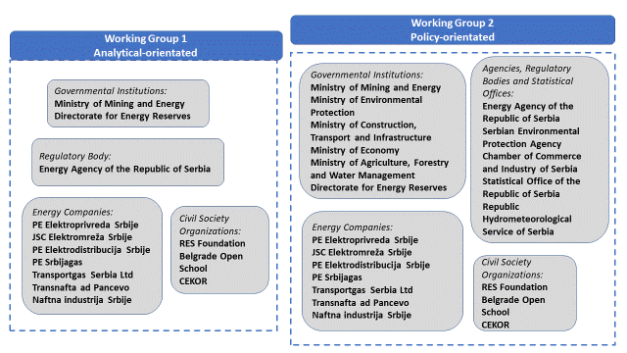
Initially, the Working Groups consisted of 19 national stakeholders and a total of 83 representatives. The stakeholders include: 6 governmental institutions (5 Ministries and Directorate for Energy Reserves), 6 stakeholders representing agencies, regulators and a statistical office, and 7 energy companies. In order to ensure that representatives of the civil society participate regularly in the development and preparation process of the INECP, the working groups have been subsequently expanded. Public call to civil society organizations for membership in the working groups of the Ministry of Mining and Energy was initiated in 2021. Thus, the representatives of the RES Foundation, Belgrade Open School (BOS) and Center for ecology and sustainable development (CEKOR) joined WG1 and WG2 as regular members.
Additionally, in order to secure high quality of planning, mitigate gaps and fully mobilize existing national capacities, the overall process is constantly supported by a number of relevant bodies, such as various business associations, research institutions and others, on ad hoc basis for particular issues. The concept of the decision-making process, discussion sessions and overall communication is realized through the Working Group meetings that have been held regularly, but also through the introduction of the regularly conducted so-called “dimensional meetings”, dedicated to each of the five dimensions (i.e. Decarbonization, Energy Efficiency, Internal Energy Market, Energy Security, and Research, Innovation and Competitiveness) and with aim to elaborate each dimension in detail. Due to the limited timeframe for the elaboration of the INECP and the rather demanding organizational effort, there is no strict definition or establishment of sub-groups along the five dimensions of the Energy Union, but their participation has been unofficially allocated as per their responsibility and relevance.
The detailed scheme of the relevant participants per dimension within the project is presented in the following figure:
Figure 1.16: Involvement of project participants per dimension
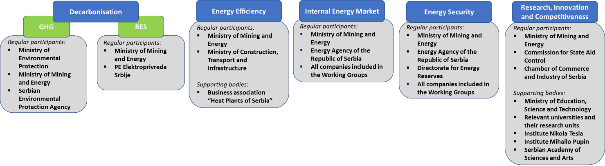
The institutions that represent supporting bodies in the project, which are not members of the Working Group, are mainly active in the dimensions of energy efficiency and research, innovation and competitiveness. In the period from April to July 2021, a large amount of data was collected in the format of input data for energy modelling tools. The Ministry of Mining and Energy was collecting the opinions of various educational institutions, scientific institutes and associations on specific topics, in accordance with their responsibilities and relevance, such as University of Belgrade, University of Novi Sad, University of Nis and University of Kragujevac. The same procedure applies for the Electrical Engineering Institute Nikola Tesla and Institute Mihailo Pupin, as well as the Serbian Academy of Sciences and Arts (SANU). Additionally, the business association “Heat Plants of Serbia” has been participating in the meetings regarding the district heating, while the Belgrade Metro and Train Company has delivered appropriate data and information on the ongoing project and planned activities regarding the development of the railway transport in the city of Belgrade. Moreover, during the analysis of the energy poverty situation in the Republic of Serbia and preparation of the INECP, the study of the non-governmental organization RES Foundation on the energy poverty in the Republic of Serbia in 2021 was taken into consideration. Additionally, following institutions were contacted and consulted: The Faculty of Mechanical Engineering, University of Belgrade, Faculty of Forestry, University of Belgrade, Faculty of Electrical Engineering, University of Belgrade, Faculty of Technology and Metallurgy, University of Belgrade, Faculty of Mechanical Engineering, University of Niš, Faculty of Agriculture, University of Novi Sad, Faculty of Engineering, University of Kragujevac, Institute of Nuclear Sciences “Vinca”, University of Belgrade, Faculty of Technical Sciences, University of Novi Sad, Ministry of Agriculture, Forestry and Water Management.
Finally, during the preparation of draft INECP, a series of bilateral and multilateral meetings has been held with various stakeholders. Thus, efforts made resulted in 11 Working Group meetings and about 50 bilateral meetings, as the inclusiveness has been governance’s priority.
In the period from August 9, 2022, to September 5, 2022, the Ministry of Mining and Energy conducted early public consultations during which the interested public was invited to send their comments, questions and suggestions to the published working scenarios that were prepared for the preparation of the INECP. The subject of early public consultations were: Scenario 1, Scenario 2, Scenario 3 and Scenario S, with a note that no comments and questions were submitted on Scenario 6 (Fit for 55) because it was done solely for the purpose of insight into what would happen if the goals of the Republic of Serbia were equal to the objectives of the EU.
The Ministry of Mining and Energy organized public consultations for the professional public and other interested parties to submit their comments and suggestions on the Integrated National Energy and Climate Plan of the Republic of Serbia for the period up to 2030 in the period from June 13, 2023, to July 28, 2023. including the perspective to 2050. The public hearing was conducted as follows:
- in the form of a presentation and consultation at a public hearing that was held at the Serbian Chamber of Commerce on July 11, 2023, from 10:00 a.m. to 1:00 p.m. in Belgrade;
- in the form of a presentation and consultation at a public hearing that was held in the Regional Chamber of Commerce, Novi Sad, on July 12, 2023, from 11:00 a.m. to 2:00 p.m. in Novi Sad;
- in the form of a presentation and consultation at a public hearing that was held at the Niš Regional Chamber of Commerce on July 14, 2023, from 11:00 a.m. to 2:00 p.m. in Niš.
Draft INECP was put up for public consultations, providing the opportunity to the wider public, civil society, non-governmental institutions, local and regional authorities, and any other interested party to comment, as part of ensuring transparency within the planning process. In parallel the consultations with the Energy Community Secretariat were held. The major conclusions of the planning were conducted at the local level, such as the Green City Action Plan of the City of Belgrade and the Sustainable Energy and Climate Action Plan of the City of Belgrade for the period until 2030, have been taken into consideration in the early phase of the development and preparation of the Integrated National Energy and Climate Plan, due to the need for achieving comprehensiveness and compatibility of the national-level and local-level planning.
During the public consultation process, objections, proposals and suggestions are received by multiple stakeholders, consisted of various ministries, state institutions, governmental agencies, civil society organizations, environmental organizations, public and private companies, private persons and others. After the end of the public consultation, the Working Group considered and addressed all the received comments, proposals and suggestions. On the INECP 549 comments were received and on SEA of INECP 67 comments. Wide range of comments and suggestions received significantly enhances the INECP and SEA of INECP, and these recommendations are ensuring that the INECP is comprehensive, robust, and in line with national and international energy and climate objectives.

Consultations of other Energy Community Contracting Parties and European Union Member States
Since the European Union Member States have finalized and adopted their INECPs until 2021, the Republic of Serbia had an opportunity to access each plan with a special focus on those prepared by the neighbouring countries. First and foremost, the Republic of Serbia assessed the INECPs of countries with common borders, such as Croatia, Bulgaria, Romania and Hungary. At the same time, the Republic of Serbia considered all European INECPs. Moreover, transboundary consultations were done with Croatia, Bulgaria, Romania, Hungary, Bosnia and Hercegovina, North Macedonia, Montenegro and Albania.

- Consultations with the Energy Community Secretariat
Since the beginning of the development and preparation of the Draft INECP of the Republic of Serbia, the Energy Community Secretariat has been closely following the progress of the overall process, providing the necessary support as needed. Formally, this involvement of the EnC Secretariat is realized through the work of Ministerial Council of the EnC, as well as within the various existing thematic coordination groups, platforms and initiatives at the level of the Energy Community, but also other regional energy-related and climate-related formats where Energy Community actively participates.
The EnC Secretariat has sent 31 recommendations for the revision of the Draft INECP. All recommendations have been considered thoroughly and further revisions have been implemented in this final version. For all recommendations there are justifications how they are considered.
As it concerns the key indicators for 2030, as set by the Ministerial Council of December 2022 (Decision 2022/02/MC-EnC) while the GHG emissions reduction target remains unchanged, the FEC has been slightly reduced and the PEC has slightly increased, the gap of the RES percentage in GFEC remains unchanged as the least target to be achieved. A detailed justification is provided in Chapter 2 to explain the specific national circumstances to justify the gap between the ambition in the draft NECP and the target set by EnC Secretariat, as well as concerning the increase of the target for the share of renewable energy sources in heating and cooling, including district heating.
Also, in the analysis has been considered a gradual introduction of carbon pricing in the sectors that are expected to be influenced by CBAM, but taking into consideration the uncertainty on the mode of implementation of carbon pricing, while CBAM regulation was adopted in May 2023 by EU and it is not possible to include relevant precise information in NECP.
However, the modernisation of coal mining is coupled with a modernisation of the older power plants, so that they can be compatible with projected gradual reduction of generation from lignite and the Large Combustion Plant Directive requirements. Also, the planned decreasing engagement of Thermal Power Plants and investments in gas infrastructure to ensure the smooth energy transition in Serbia are considered key and significant transitional measures, providing Security of Supply.

Regional cooperation in preparing the plan

Elements subject to joint or coordinated planning with other Energy Community Contracting Parties and European Union Member States
From the point of view of the Republic of Serbia, the recognised elements of cross-border significance are:
- integration of energy markets,
- major infrastructure projects close to the national border and cross-border infrastructure projects,
- international scientific and research cooperation, and
- other activities that may affect other EnC Contracting Parties and EU Member States.

Explanation of how regional cooperation is considered in the plan
The Consultation with the region was implemented in parallel with the public consultation of the Draft Plan. However, the period was extended and for more than 4 months until the preparation of the final version of INECP. During the Consultation period, only one comments has been received by The Ministry of Environment, Waters and Forests of Romania on the Strategic Environmental Impact Assessment of INECP and relevant clarifications have been provided accordingly.

NATIONAL OBJECTIVES AND TARGETS
The comprehensive approach of the Integrated National Energy and Climate Plan necessitates addressing its five dimensions in a coordinated manner, setting the following objectives, targets and contributions:
As regards the Decarbonisation dimension:
- A binding national target for reducing net greenhouse gasses emissions in 2030, compared to 1990 levels.
- An economy wide target for the contribution of renewable energy sources in the gross final energy consumption of the country in 2030.
As regards the Energy Efficiency dimension
- A national energy efficiency target for 2030 expressed as primary energy consumption and final energy consumption.
- Cumulative end-use energy savings to be achieved over the period 2025-2030 as defined under point (b) of Article 7(1) on the energy saving obligations pursuant to Directive 2012/27/EU as adapted and adopted by the Energy Community Ministerial Council Decisions 2015/08/MC-EnC, 2021/14/MC-EnC and 2022/02/MC-EnC.
As regards the Energy Security dimension
- National objectives increasing the diversification of energy sources and supply from third countries, the purpose of which shall be to reduce energy import dependency, increasing the flexibility of the national energy system, and addressing constrained or interrupted supply of an energy source, for the purpose of improving the resilience of regional and national energy systems.
As regards the Internal market dimension:
- Objectives related to the level of electricity interconnectivity, key electricity and gas transmission infrastructure projects, national objectives related to aspects of internal energy market (fostering regional energy cooperation and increasing regional market integration).
As regards the Research, Innovation and Competitiveness dimension:
- National objectives for public and private research and innovation related to the Energy Union priorities.
Governance mechanism for the implementation of the INECP, maximizing synergies between measures and efficient use of their budget
It should be noted that the development of a governance framework, to monitor and assess in a cohesive manner the attainment of the specified targets and the implementation of the policy measures as described in details in Chapter 3 will be occurred through the operation of the monitoring and governance mechanism, which will be developed in compliance with the provisions of the national legislation, including the conduction of detailed expert control and the imposition of penalties for non-compliant cases.
This governance framework aims to ensure the centralized and integrated monitoring of the implementation of policy measures and ensure the stakeholders’ contribution during their implementation with a view to attaining the INECP objectives.
This governance framework will help facilitate cooperation and communication between stakeholders in each and across the five different dimensions, thus ensuring maximum synergies between the policy measures implemented under all dimensions for the INECP.
A Working Group for Energy and Climate chaired by The Ministry of Mining and Energy should play an important role in developing and implementing this governance framework, with the following functions among others:
- Formulating the national priorities and the methodology and guidelines for energy planning, as well as updating the NECP.
- Analyzing and updating the energy system development scenarios.
- Planning and promoting proposals for energy policies and actions and making recommendations on taking corrective measures in the event of deviations.
- Providing guidelines to institutional bodies.
Furthermore, stakeholders should take into account the provisions of the NECP in their own development policies in order to contribute towards the smooth and effective implementation of the policy measures laid down in the NECP.
To that end, a coordination mechanism will be developed, consisting of committees or groups intended to ensure the relevance of other related national strategies, such as waste management, circular economy and climate change adaptation.
The implementation of the governance framework will result in ensuring continuity of the policies and measures to be implemented and consistency of both public and private institutional bodies involved in the implementation of these policies and measures.
A fundamental component of the governance framework will be the development of integrated monitoring mechanism for the policies and measures under implementation. This mechanism will include procedures for ongoing monitoring of both the attainment of the individual NECP objectives and the performance and impact of each policy measure individually, including by the use of relevant critical performance indicators.
Naturally, in the course of implementing the NECP, account will be taken of any deviations, firstly for the above bodies to take possible corrective measures and secondly to ensure the security of supply in the Republic of Serbia.
A relevant model will be used in designing and implementing financing mechanisms and programmes. These financing mechanisms and programmes will be designed including, inter alia, maximising the expected leverage of resources, using available public funds more efficiently, adopting innovative funding tools, ensuring more active mobilisation of the domestic financial sector and maximising synergies between different policy objectives.
The following sub-chapters present the policy objectives and targets for each one of the above-mentioned dimensions for the Republic of Serbia.

Climate change, emissions and reduction of greenhouse gases
A central target has been set for reducing the GHG emissions by 40.3% in 2030 compared to 1990 including agriculture, waste and LULUCF. This target is in line with Article 4 of Decision no. 2022/02/MC-EnC of the Energy Community Ministerial Council, point (13). This is also consistent with the targets set in the recently updated Nationally Determined Contribution (NDC). A well-balanced mixture of policies and measures will be initiated in order to mitigate the GHG emissions in all supply and demand sectors.
The annual trajectory from 2025 until 2030 for reaching the national contribution can be seen in the following Table.

Table 2.1: Annual trajectory of GHG emissions reduction
 | 2025 | 2026 | 2027 | 2028 | 2029 | 2030
Reduction w.r.t. 1990 | -30.7% | -32.0% | -32.5% | -33.7% | -36.0% | -40.3%
Priority is also given on the climate change adaptation, as Republic of Serbia according to the Law on Climate Change started drafting the Climate Change Adaptation Programme with Action Plan, which will specify the general objectives, identify the sectors most affected by climate change, and measures to adapt to changed climate conditions within the framework set by the United Nations Convention on Climate Change, EU directives and international experience.
Finally, the promotion of the circular economy and bioeconomy will be fostered also contributing to the attainment of the climate change mitigation objective. The shift to a circular pattern can lead to a significant reduction in GHG emissions through the recycling and re-use of materials, the more efficient use of resources and more eco-friendly product design, as well as the introduction of new circular business models, especially in industry, transport and the built environment.

Renewable energy sources
According to Article 2 of Decision no. 2022/02/MC-EnC of the Energy Community Ministerial Council, point (5), a national contribution target of 40.7% for RES in the Gross Final Energy Consumption was decided for the Republic of Serbia.
The current INECP specifies the national contribution target for the RES share in the gross final energy consumption to at least 33.6% in 2030. Additional objectives have been set per sector and the share of RES in electricity generation shall reach at least 45.2%, the share of RES in covering heating and cooling demand 41.4%, and the share of RES in the transport sector to reach 7% (with multipliers) & 3.2% (without multipliers) in alignment with the relevant EU calculation methodology.
The annual trajectory of the targets until 2030 can be seen in the following table.
Table 2.2: Annual trajectory of RES share
 | 2025 | 2026 | 2027 | 2028 | 2029 | 2030
Share of RES in GFEC | 29.8% | 30.6% | 31.2% | 31.9% | 32.6% | 33.6%
RES in Electricity | 34.7% | 36.7% | 38.0% | 39.8% | 41.5% | 45.2%
RES in Heating and Cooling | 41.1% | 41.5% | 41.2% | 41.1% | 41.0% | 41.4%
RES in transportation | 1.8% | 2.1% | 2.3% | 2.6% | 2.9% | 3.2%
Contribution of biofuels in the RES in transportation share | 1.3% | 1.5% | 1.6% | 1.8% | 2.0% | 2.1%

The deviation of the national contribution target from the Ministerial Decision (MD) is justified according to specific circumstances foreseen under Article 6 of the MD and more specifically under the criteria of Article 31 of the Governance Regulation as follows:
- According to criterion (ii) economic conditions and potential, including GDP per capita; potential for cost-effective renewable energy deployment,

- The analysis indicated that the achievement of the national contribution proposed by the MD, would require an unrealistic increase in the use of heat pumps in households and in the tertiary sector, reaching 11.1 GWth by 2030, corresponding to 444 thousand units, which means an unrealistic addition of 1.6 GWth, almost 63 thousand units per year until 2030, while according to the current trends only 4 thousand heat pumps were sold in Serbia in 2021, and we can expect that around 30 to 40 thousand heat pumps could be installed annually in the next 7 years. In the INECP proposed national contribution the installation of heat pumps reaches 7 GWth (282 thousand units) by 2030 corresponding to an average annual addition of about 40 thousand units, a number still realistically ambitious. An average Seasonal Performance Factor (SPF) of 3.3 is considered by 2030, which is closer to the average efficiency of current trends for the equipment, while the higher target would require SPF at the level of 5, which is a performance that can be achieved by high-end products only.
- The MD proposed national contribution would imply a high level of export of electricity which can be considered unsuitable to a rational planning of the use of the natural resources of Serbia. The analysis indicated net exports at the level of 5TWh by 2030 which is rather high and cannot be justified by relevant studies. The INECP analysis projects 0.7TWh of net exports by 2030, indicating a power system which is self-sufficient.
- The MD proposed national contribution, would require at least 88 ktoe of eligible biofuels and the introduction of 89 thousand electric vehicles in 2030. The INECP national contribution includes a more realistic assumption for biofuels (49ktoe by 2030) and the introduction of EVs reaching 44 thousand by 2030.
- The MD proposed national contribution would require higher capacities of variable renewable technologies in the network, which would require higher balancing reserve (more than the available in the market for 2030) and expose the system to risk. The analysis showed that this would further require the installation of hydro pump storage stations at an over optimistic timeframe, requiring that Bistrica will be operational by 2028 and Djerdap 3 by 2030. In the INCEP analysis a more realistic schedule is applied with Bistrica operational by 2032 and Djerdap 3 by 2035, providing the additional flexibility and balancing requirements for the system.
- According to criterion (iii) geographical, environmental and natural constraints, including those of non-interconnected areas and regions:
- The MD national contribution would require the use of biomass above the resources that can be exploited in a sustainable manner in Serbia. The necessary primary production of biomass to reach this target was estimated to be 1.9 Mtoe by 2030 which is above the level the estimated sustainable potential for agricultural and forest biomass (current studies put the technical potential at the level of 1.9-2.0Mtoe but sustainability criteria considerations reduce this level). The INECP national contribution requires a primary production of 1.7Mtoe of biomass in 2030, close to today’s level, but consumed in more efficient devices.
For the specific case of the target in the heating and cooling sector, it should be noted that the indicative targets from Article 23 of RED II, are not binding and the EnC members are not obliged to monitor the growth of 1,1% RES per year in the heating and cooling sector. Achieving an average growth rate of 1.1% per year would require the over-optimistic assumptions described above regarding the sustainable potential of biomass and the rate of introduction and SPF of heat pumps. With the more realistic assumptions applied for the calculation of the INECP national contribution, an average annual growth rate of 0.6% per year until 2030 is achieved.
The above considerations indicate that the national contribution of 33,6% of RES in GFEC as documented in this INECP is acceptable, achievable but also very ambitious to be met in the short time period until 2030.
However, intensive discussions with all relevant stakeholders and taking into account the “Basic Principles of Energy Infrastructure Development Plan and Energy Efficiency Measures for the period until 2028 with projections until 2030“ (Goverment’s Conclusion on adoption 05 no. 312-5262/2023-1 from 15/6/2023) - “EIDP&EEM”, a further update has been implemented with:
- The introduction of a gas fired power plant operating by 2029, which supports the reduction of generation from lignite but also offers the necessary stability to the power system. This led to a slight reduction of the share of RES in electricity generation.
- A reduced operation of the lignite fired plants (reduced by 25% in 2030 compared to 2021) as a result of the gas fired plant.
- Incorporating a more realistic cost of investing in transmission system expansion in the case of introducing more variable RES in electricity generation.
- A more realistic penetration of biofuels in transportation (reducing the total amount of biofuels in 2030 from 70ktoe to 49ktoe) and a more realistic introduction of electric vehicles (reducing the total number of EVs in 2030 from 77.6 thousand to 44.8 thousand), which led to a slightly lower share of RES in transportation.
This analysis led to a share of 33.6% of RES in the GFEC as an acceptable and achievable target aligned with the same level of ambition for the reduction of greenhouse gas emissions which remains at the same level as before, consistent with the country’s Low Carbon Development Strategy. The sectoral shares were reviewed to be 45.2% RES in electricity generation, 3.2% RES in transportation (without multipliers) and 41.4% RES in heating.
The specified objectives for the penetration of RES are related directly to the evolution of final consumption necessitating the achievement of the relevant energy efficiency targets. Apparently, the key pillar for fulfilling the national objective for the penetration of RES is the contribution of RES in the electricity consumption, which highly demands for the timely and efficient implementation of the planned policies and measures.
Despite the fact that the target can be assessed as ambitious, it can be assessed also as realistic taking into consideration both the technical and economic potential and the entrepreneurial interest already expressed.
The electrification and the coupling of the final consumption sectors are also promoted in order to increase the share of RES in the final energy consumption. Initially, the gradual electrification of the transport sector comprises a major challenge until 2030. More specifically, a considerable penetration of electric vehicles is expected to substantially influence a number of dimensions in the INECP. The aim is to achieve this penetration at the most cost-effective approach for the national economy, while ensuring that certain prerequisites for the electrification of the transport sector, such as the simultaneous development of the charging infrastructure and the adoption of the regulatory framework are timely fulfilled.
Moreover, the sector coupling will contribute to the maximization of the RES in the different end-uses and, apparently, the electrification of different end-uses is an essential component in achieving this aim. The role of heat pumps, along with the energy storage systems and the self-consumption schemes, is critical for the fulfilment of the sector coupling. Similarly, the mixing of hydrogen or biomethane into the natural gas network will contribute also to sector coupling.
An objective has also been set for promoting RES technologies in buildings through self-consumption schemes. More specifically, the installed capacity of the RES technologies for electricity production (mainly Roof top photovoltaic systems) are expected to reach up to 0.5 GW in 2030 being capable of covering approximately 5% of the electricity consumption in residential sector.
New innovative RES technologies for electricity production will be promoted also within the INECP through pilot projects in order to assess their effectiveness, such as: small wind turbines, use of renewable hydrogen production for storing electricity generated from variable RES, etc.
The use of RES for covering the heating and cooling demand will be achieved mainly through the large installation of heat pumps (approximately 7 GWth), while the role of solar thermal systems, geothermal energy, and biomass is also essential.
The proposed target under Article 2 Decision no. 2022/02/MC-EnC for increasing the utilization of RES in heating and cooling by 1.1% in 2030 is not realistic and feasible to be achieved, since it can be attained mainly through the massive deployment of heat pumps. However, the existing biomass potential has almost been exploited and the other remaining RES technologies don’t have meaningful prospects for further penetration.
Moreover, the further utilization of RES in the district heating networks will be achieved mainly through biomass (2.7 ktoe), while the gradual exploitation of other RES is intended, such as biomethane, hydrogen and geothermal energy. In accordance with the Energy Law and Rulebook on the detailed content and guidelines for determining the national goals of the Integrated National Energy and Climate Plan, the method of its preparation and reporting on its implementation, there is obligation to revise INECP every 4 years. In the process of the revision of INECP, target for RES in heating and cooling will be analysed in order to include biomethane and other RES for heating and cooling.
More detailed analysis regarding the potential of sustainable biomass and biogas is required in order to see the potential of increasing the contribution of bioenergy in the longer term. Currently the use of biomass is mainly in appliances with very low efficiency (wood stoves) therefore large quantities of biomass are consumed to cover the heating demand, having as a result unrealistically high shares of RES calculations.
Furthermore, new technologies will be considered for the period towards 2050 (for example centralised heat pump) which are currently very expensive and are not introduced in the solution.
Finally, the contribution of electric vehicles is expected to be substantial for the further promotion of RES. It should be noted that 44.8 thousand electric vehicles (both passenger and light-duty) approximately will be registered until 2030. Last but not least, the contribution of biofuels will remain dominant, with a particularly increasing share of advanced biofuels until 2030 (49 ktoe without assuming the foreseen multipliers).

Improvement in energy efficiency
An objective with significant importance within the INECP is the improvement of energy efficiency managing to restrain the final energy consumption at a level that doesn’t exceed 9.7 Mtoe in 2030. The same tendency is observed also for the case of primary energy consumption, which should be less than 14.68 Mtoe in 2030.
These targets are in line with Article 3 of Decision no. 2022/02/MC-EnC of the Energy Community Ministerial Council, point (4), where the differences are in the sense of statistical error.
The annual trajectory for achieving the targets of 2030 can be seen in Table 2.3.
Table 2.3: Annual trajectory of FEC and PEC
(Mtoe) | 2025 | 2026 | 2027 | 2028 | 2029 | 2030
Final Energy Consumption | 9.3 | 9.3 | 9.4 | 9.5 | 9.6 | 9.7
Primary Energy Consumption | 15.15 | 15.09 | 15.11 | 15.06 | 14.83 | 14.68
An additional energy saving target has been specified according to the provisions of Article 7 of Directive 2012/27/EU. Moreover, specifically, 506 ktoe of cumulative final energy savings should be achieved by the implementation of energy efficiency measures over the period 2024-2030.
The need to renovate the existing building stock is indisputable, leading not only to significant energy and cost savings but improving simultaneously the comfort, safety and health conditions in the renovated buildings. The renovation rates, estimated within the framework of the Long-term Strategy for Encouraging Investments in Renovation of the National Building Stock of the Republic of Serbia by 2050 for the case of the residential and non-residential buildings, respectively, have been taken into consideration within the framework of the INECP until 2030 in order to ensure their full alignment and to facilitate the sufficient renovation of the building stock.
Finally, the implementation of the planned policies and measures in the end-users for improving the energy efficiency requires the design of efficient financing mechanisms in order to increase and maximize the current levels of own funds leverage. The active involvement of the financial sector and the promotion of innovative financing instruments, including the promotion of energy performance contracts and energy services, are critical parameters for attaining this objective. The Energy Efficiency Directorate will play a special role for the creation and implementation of financing mechanism. The capacities of the Directorate should be strengthened in the coming period, and its legal status should be further improved. This will enable the implementation of adequate financial mechanisms for the promotion of EE. The Directorate is already implementing activities for the financing of energy efficiency improvements in households and in public sector buildings at the local level as previously described.

Energy security
The diversification of energy sources and fuel supplying countries is the main objective of the INECP for the dimension of energy security. More specifically, policies and measures will be launched to strengthen the diversification of energy sources in order to prevent the dependence on just one fuel or just one country. The achieved diversification will increase the competitiveness between fuels and suppliers from third countries leading to reduced energy prices, enhancing the security of supply and also protecting the supply of energy in the event of an energy crisis at regional level.
Obviously, the optimal utilization of domestic energy sources should be ensured to enhance the energy security. The identification of the existing potential and the most cost-effective utilization of domestic energy sources is essential target within the framework of the INECP. Emphasis will be given on the utilization and use of RES potential, both for electricity production and for direct use in end-uses contributing substantially towards energy security.
Strengthening the geopolitical role of the Republic of Serbia constitutes another vital objective. Therefore, it is urgent to complete the existing interconnections and to design new international interconnections with pipelines from neighbouring countries. Furthermore, these actions will also contribute to the diversification of energy sources and supply routes from third countries. Several cross-border / international natural gas transportation projects will be promoted, enhancing the diversification of energy sources and, in conjunction with the promotion of natural gas storage projects, ensuring the adequacy in the case of a natural gas shortage.
The stabilization of the energy dependency rate is another important objective within the INECP. The current energy dependency is relatively low and it is imperative to restrain it in similar levels due to the high penetration of petroleum products and, to a lesser degree, natural gas. Consequently, the energy dependency should not surpass the level of 41% in 2030.
Finally, another objective is to ensure the required electricity system adequacy in order to attain a minimum level of reliability for covering the demand for electricity, in conjunction with the decision to reduce the electricity production by lignite plants. To attain this objective, it will be necessary to adopt mechanisms for strengthening the flexibility of the system with additional electricity production capacity or promoting a demand response scheme.

Internal energy market
The market integration and the establishment of competitive energy markets will be promoted within the dimension of internal energy market. The required reforms will be initiated for harmonizing the domestic markets in electricity and natural gas with the EU directives and regulations on the respective markets.
The coupling of the energy markets will, due to improved energy flows via the interconnections (minimum cross-zonal capacity target of 70%), help to increase the liquidity of the interconnected markets and enable the participation of RES in the cross-border trade of electricity.
The participation in the new energy markets will allow RES to have the incentive and the capability to balance their production closer to real time, thus reducing the needs and the associated costs for reserves and increasing the system security.
Another objective is also to strengthen the role of electricity market consumers by increasing demand-side participation in the electricity market and to promote the deployment of storage systems that will ensure lower energy prices and will strengthen the penetration of RES and electricity system adequacy.
The digitization of the energy system is a prerequisite for the development of properly operational and competitive domestic energy markets and for the optimal implementation and use of all technological applications and market mechanisms that can be developed in the context of the energy markets. Emphasis will be placed, through the operators’ development programmes, on planning and implementing the relevant infrastructure projects, information systems, control centres and metering devices that will allow for the complete transition from the current energy system to a fully digitized one, also ensuring the secure management of the consumer data.
The alleviation of energy poverty is perceived also as an objective taking into account that it has worsened gradually due to the energy crisis. The reduction of energy poverty by 75% in 2030 compared to 2020 has been set as national target.
Finally, the contribution of self-consumption and local energy community schemes is twofold, as they will contribute both to the implementation of RES and energy efficiency investments, as presented previously, and to the more active participation of the local community strengthening of the role of consumers. The quantitative objective has been specified to install and operate new self-consumption scheme with an installed capacity equal to 0.5 GW (mainly Roof top photovoltaic systems) in 2030.

Research, innovation and competitiveness
The promotion of research and innovation will continue to be a priority through supporting innovative technologies, which will contribute to the fulfilment of the energy and climate targets. The annual expenditure for the further support of the research and technological development is expected to double in 2030 compared to 2020.
The improvement of the energy intensity and greenhouse gas emissions intensity will manage to increase the competitiveness of Serbian economy. More specifically, the adoption of targeted energy efficiency policies and measures will contribute to both to reduce energy costs and to enhance the competitiveness of the various economic sectors.
In view of the commitment of the Government of Serbia under the Sofia declaration, the potential of Carbon Capture, Utilisation and Storage (CCUS) options should be investigated in detail for the longer-term period. The aim would be to capture unavoidable carbon dioxide emissions and utilize them further in industrial applications or store them. An analysis of the potential of CO2 storage options in Serbia would be necessary and further research and demonstration activities would be implemented. The expected adoption of the Directive 2009/31/EC on the geological storage of carbon dioxide by the Ministerial Council of the EnC, will set the scene for the future implementation of CCUS projects in the region and in Serbia in particular.
The reduction of the energy cost will make the energy products more accessible to all consumers. The design of the required policies and measures will take into account the purchasing power of consumers and their special groups, as well as any specificities related to local characteristics, such as those of rural areas. Maintaining an average cost of energy products below the European average end-user level has been set as a goal within the INECP.
The domestic added value of the energy sector will be increased with the identification and promotion of innovative applications and services in the energy sector with high domestic added value increasing the gross domestic product and enhancing the sustainability of the energy sector. In addition, this objective also ensures an increase in the number of direct and indirect jobs due to activities in the energy sector.
Finally, the policies and measures, which will be integrated into the Just Transition Action Plan, will be implemented in the areas that will be affected most by the transition to a low-carbon economy. The challenges faced in the lignite-dependent areas during the transition to a low-carbon economy can be tackled with tailored solutions to support the structural transformation and to accelerate the process of economic diversification and technological transition. The aim is to elaborate a sustainable even regional development strategy, focusing on sectors with dynamic prospects in terms of output, employment and income indicators.

POLICIES AND MEASURES
The main existing and planned policies and measures to achieve the objectives and targets presented in Chapter 2, are analysed in the following sections. The analysis includes among others, details on quantified objectives, the timeframe for the implementation, the progress indicators, implementing and monitoring entities, estimated implementation costs and appropriate financing sources where feasible.

Dimension Decarbonisation

GHG emissions and reduction

Policies and measures to achieve the target set under Regulation (EU) 2018/842 as referred in point 2.1 and policies and measures to comply with Regulation (EU) 2018/841, covering all key emitting sectors and sectors for the enhancement of removals, with an outlook to the long-term vision and goal to become a low-carbon economy with a 50 years perspective and achieving a balance between emissions and reduction in accordance with the Paris Agreement
The INECP envisages a number of decarbonisation-related policy measures in terms of energy and non-energy related GHG emissions. The existing and planned policy measures in the energy field, which generates about 80% of GHG emissions in the Republic of Serbia, will have a major contribution to decarbonisation process. Existing measures for decarbonisation will be extended until 2030 and will complement the measures supporting RES sector transformation and other dimensions of the Energy Union, including energy efficiency, the internal energy market and energy security.
Work on improving greenhouse gas inventories and updating Serbia’s Nationally Determined Contribution to the Paris Agreement is progressing. Alignment of legislation on monitoring, reporting and verification of GHG emissions in line with the EU Emissions Trading System (ETS) and Effort Sharing Regulation is implemented through the Law on Climate Change. Based on Article 58, Paragraph 8 of the Law on Climate Change (Official Gazette of the RS, No. 26/21) the Ministry of Environmental Protection adopted Rulebook on the content of the National Inventory of Greenhouse Gases and the National Report on the Inventory of Greenhouse Gases (Official Gazette of the RS, No. 55/23). According to the Rulebook the content of the Inventory is aligned with the Paris Agreement and the IPCC guidelines related to the preparation of the GHG inventory. Inventory contains data on activities, which are required for the assessment of source GHG emissions and removal by sinks in accordance with the IPCC Guidelines. The Republic of Serbia needs to strengthen its administrative and technical capacity at all levels and further increase investments towards green energy transition.
Regulatory Measures
Apart from proposed policy measures regarding energy and non-energy related GHG emission reduction targets, 6 policy measures are also proposed in order to improve the existing regulatory framework and aware the public for the environmental impact of energy consumption with the aim of motivating, stimulating and informing them to change their behaviour and continue to engage.

Policy measure code: | PM_D1 | Title: | Introduction of carbon pricing on energy
Main objective: | Carbon emissions reduction
Quantified objective: | Contribution to the objective of reduction of GHG emissions by 33.3% (without LULUCF) by 2030 compared to 1990 levels
Description: | PM_D1, with implementation of the ETS or other instruments of carbon pricing, will speed up the phasing-out of conventional fuels. The funds collected from carbon pricing will be used to stimulate the investments in RES, increase the penetration of energy efficiency measures and mitigate social and economic consequences of decarbonisation. The establishment of a mechanism on carbon pricing will decrease or eliminate costs of implementation of the EU Carbon Border Adjustment Mechanism, which entered into force in its transitional phase as of 1 October 2023.
Implementation Timeframe | 2024-2030 including the preparation period
Type of measure | Reform
Sectors covered/affected | All INECP subject fields
Implementing Entity | - Ministry of Finance  - Ministry of Mining and Energy  - Ministry of Environmental Protection
Monitoring Entity | - Ministry of Finance  - Ministry of Environmental Protection  - Ministry of Mining and Energy  - Public utility companies  - Private investors
Progress indicators | Annual emissions reduction (Gg CO₂-eq)
Other relevant Energy Union dimension(s) affected
Union policy which resulted in the implementation of the PaM
Relevant National Planning Document (Legal, Regulatory Acts etc) | - Low-carbon Development Strategy for the period 2023-2030 with projections until 2050
Implementation cost | 0.2 M€
Financing source(s) | EU and other funds, public funds

Policy measure code: | PM_D2 | Title: | Monitoring and revision of the Low-carbon Development Strategy and implementation of the Climate Change Adaptation Programme with Action Plan
Main objective: | Carbon emissions reduction
Quantified objective: | Contribution to the objective of reduction of GHG emissions by 33.3% (without LULUCF) by 2030 compared to 1990 levels
Description: | PM_D2 will facilitate the process of monitoring and revision of the adopted Low-Carbon Development Strategy, taking into account its main goals that are the fulfilment of obligations under the Paris Agreement and the proposal of recommendations for the alignment of Serbia’s GHG emissions pathway to the EU’s in an affordable and social way. In addition, according to the Climate Change Law, Serbia will complete and implement the Climate Change Adaptation Programme with Action Plan, which will specify the general objectives, identify the sectors most affected by climate change, and measures to adapt to changed climate conditions within the framework set by the United Nations Convention on Climate Change, EU directives and international experience. In addition, adaptation measures envisaged for implementation at state level should also be planned and implemented at local level. It is necessary to strengthen institutions that will implement activities at local level and generally monitor and supervise the implementation of these local plans, projects, etc. in the field of energy and climate.
Implementation Timeframe | 2023-2030
Type of measure | Reform
Sectors covered/affected | All INECP subject fields
Implementing Entity | - Ministry of Environmental Protection
Monitoring Entity | - Ministry of Environmental Protection  - Ministry of Mining and Energy  - Other relevant institutions
Progress indicators | Annual emissions reduction (Gg CO₂-eq)
Other relevant Energy Union dimension(s) affected
Union policy which resulted in the implementation of the PaM | - Regulation 2018/1999
Relevant National Planning Document (Legal, Regulatory Acts etc) | - Law on Climate Change  - Low-carbon Development Strategy for the period 2023-2030 with projections until 2050
Implementation cost | 1.4 M€
Financing source(s) | EU and other funds, public funds

Policy measure code: | PM_D3 | Title: | Promoting circular economy
Main objective: | GHG emissions reduction
Quantified objective: | Reduce GHG emissions in the waste sector by 13% by 2030, compared to 2010
Description: | PM_D3 will promote actions in accordance with the Circular economy development programme in the Republic of Serbia for the period 2022-2024 aiming at shifting to a circular pattern that can lead to a significant reduction in GHG emissions through recycling and reuse of materials, more efficient use of resources and more eco-friendly product design, as well as through the introduction of new ‘circular’ business models, especially in industry, transport and the built environment. A series of actions for the development of financial instruments, planning and establishment of a regulatory framework will also be examined.
Implementation Timeframe | 2024-2030
Type of measure | Reform
Sectors covered/affected | All INECP subject fields
Implementing Entity | - Ministry of Environmental Protection
Monitoring Entity | - Ministry of Environmental Protection  - Agency for Environmental Protection
Progress indicators | Annual emissions reduction (Gg CO2-eq)
Other relevant Energy Union dimension(s) affected
Union policy which resulted in the implementation of the PaM | - Regulation 2018/1999
Relevant National Planning Document (Legal, Regulatory Acts etc) | - Circular Economy Development Programme in the Republic of Serbia 2022-2024  - Waste Management Programme of the Republic of Serbia for the period 2022-2031
Implementation cost | 4.5 M€
Financing source(s) | EU and other funds, public funds

Policy measure code: | PM_D4 | Title: | Organizing awareness campaigns for better information dissemination about climate change
Main objective: | GHG emissions reduction
Quantified objective: | Contribution to the objective of reduction of GHG emissions by 33.3% (without LULUCF) by 2030 compared to 1990 levels
Description: | PM_D4 will promote the organisation of information and awareness-raising activities and consultations about climate change. These will be focused on behavioural changing through initiatives in the areas of teaching, education and awareness raising, with particular attention being paid to the importance of raising awareness on the environmental impact of consumption and with the aim of motivating, stimulating, and informing the public to change their behaviour and continue to engage. For instance, education of residents is necessary to reduce CH4 emissions from animal enteric fermentation, use of fertilizers, management of emissions from fertilizers, and to reduce emissions of nitrogen oxides from the soil. It is necessary to educate farmers for the use of harvest residues and residues from forestry for heating and meeting other energy needs in agriculture.
Implementation Timeframe | 2024-2030
Type of measure | Reform
Sectors covered/affected | All INECP subject fields
Implementing Entity | - Ministry of Environmental Protection  - Ministry of Education, Science and Technological Development  - Ministry of Labour, Employment, Veteran and Social Affairs  - Chamber of Commerce and Industry
Monitoring Entity | - Ministry of Environmental Protection
Progress indicators | Estimated mitigation impact by 2030 (Gg CO2-eq)
Other relevant Energy Union dimension(s) affected
Union policy which resulted in the implementation of the PaM | - Regulation 2018/1999
Relevant National Planning Document (Legal, Regulatory Acts etc) | - Low-carbon Development Strategy for the period 2023-2030 with projections until 2050
Implementation cost | Under examination
Financing source(s) | EU and other funds, public funds

Policy measure code: | PM_D6 | Title: | Monitoring and revision of Just Transition Action Plan
Main objective: | Carbon emissions reduction
Quantified objective: | Contribution to the objective of reduction of GHG emissions by 40.3% by 2030 compared to 1990 levels
Description: | PM_D6 will aim at the revival of the local economy, the securing of jobs and the creation of new ones, through a flexible developmental transformation of the areas involved. The Just Transition Action Plan will identify the pillars of development, which will contribute on the achievement of the goals, while emphasis will be given on the improvement of infrastructure and the alternative utilization of lands, currently occupied by lignite mines. In addition, stakeholder consultation and engagement in the preparation of the plans, including with social partners and civil society, is of crucial importance. It will also include tax incentives, along with the subsidies, to attract investments, the creation of spatial plans and measures of remediation and recultivation in order to identify the available land uses after the closure of lignite mines and the timetables for the implementation of investments. The Just Transition Action Plan will include recommendations for enhanced institutional and governance structures, required policy reforms to support a Just Transition and a pipeline of potential targeted investments.  For example, the Just Transition Action Plan may include policy and investment recommendations such as the amendment of the Gas Transmission Code regarding the injection of hydrogen and renewable gases into the national natural gas network, development of the necessary infrastructure from the TSO and DSOs, preparedness plans of the mobility & industry sector for the uptake of hydrogen, etc.  This PM refers to the monitoring and Revision of the Action Plan that will be prepared by the “Just Transition Diagnostics” document that is still in the preparation process. The Implementation cost of the measures of the Action Plan is under examination and it is not part of the implementation cost of this measure.
Implementation Timeframe | 2024-2030
Type of measure | Reform
Sectors covered/affected | All INECP subject fields
Implementing Entity | - Ministry of Mining and Energy
Monitoring Entity | - Ministry of Environmental Protection  - Ministry of Mining and Energy  - Ministry of Labor, Employment, Veteran and Social Policy  - Ministry of Education  - Ministry of Economy  - Chamber of Commerce and regional chambers of commerce  - Local self-government units  - Social and Economic Council
Progress indicators | - Emissions per capita tCO2e/capita  - Carbon intensity of the economy tCO2e/GDP (MioEUR’13)  - Energy related CO2 intensity of GDP tCO2/GDP (MioEUR’13)
Other relevant Energy Union dimension(s) affected
Union policy which resulted in the implementation of the PaM | - Regulation 2018/1999
Relevant National Planning Document (Legal, Regulatory Acts etc) | - Low-carbon Development Strategy for the period 2023-2030 with projections until 2050
Implementation cost | 2.0 M€
Financing source(s) | EU and other funds, public funds
Energy Sector
GHG emissions in the energy sector (generation of electricity and heat, petroleum processing, production of solid energy resources) are determined by the quantity of energy used in processes and the unit emission factor of energy sources. GHG emissions can be reduced by decreasing the quantity of consumed energy, by increasing the use of renewable energy sources, and by replacing fossil fuels.
The majority of the policy measures with an impact on decarbonisation intended for the energy sector are included, among others, in the dimensions of renewable energy sources, energy efficiency, the internal energy market and energy security, as the changes in these dimensions lead to overall GHG emissions reduction.
Industrial Sector
As regards industrial pollution and risk management the integrated permits system was incorporated in the Law on Integrated Pollution Prevention and Control from 2004, introducing into the legislation of the Republic of Serbia one of the key directives Council Directive 96/61/EC of 24 September 1996 (IPPC Directive). The Law is applied to installations and activities which are classified according to the level of pollution and risk such activities pose to the human health and the environment. Over time, the application of this law revealed problems and unwillingness of operators to respond to the requirement introduced by this law (extensive documentation that must be prepared and obtained, which requires large funds and prior to that significant material investments in equipment innovation and harmonization of applied technologies using the best available techniques), as well as problems obtaining the necessary permits, decisions, consents or approvals. Furthermore, responsible institutions faced the lack of necessary capacities. All of this often led to incomplete permit requests (requests were being submitted only due to deadlines), which together with the duration of procedure, waiting for necessary documentation from other institutions and supplementation of requests, represented the reason for long duration of procedures and relatively small number of issued permits compared to the number of operators and aligned deadlines of their obtainment. In the meantime, procedure for the preparation of the new law on industrial emissions started, along with by-laws for the alignment with the Industrial Emissions Directive 2010/75/EnC, which is expected to be ready for adoption procedure by the end of 2024. The Republic of Serbia needs to increase capacities for managing the integrated permitting processes, while the country should tackle industrial pollution by enforcing the polluters’ pay-principle in order to encourage the industry to invest in green solutions.
Furthermore, regarding buildings in the industrial and service sectors, demand for cooling during the summer needs to be reduced (thermal renovation and efficiency standards for new buildings). Support will be possible under the funding policy in place for phasing out the use of fluorinated gases with a high global warming potential (GWP) (e.g. refrigeration and air-conditioning units) at an earlier stage. It will also be ensured (e.g. through contact with trade associations in the refrigeration and air-conditioning industry and providing information about new refrigerants) that Serbian companies or persons working at such companies have the necessary knowledge regarding alternative refrigerants and skills for working with such refrigerants.
Policy measure code: | PM_D5 | Title: | Implementation of best available technologies in production processes in specific industries
Main objective: | GHG emissions reduction
Quantified objective: | Contribution to the objective of reduction of GHG emissions by 33.3% (without LULUCF) by 2030 compared to 1990 levels
Description: | PM_D5 will facilitate non-energy related GHG emission reductions by the modernization of industrial process technologies and increased material efficiency for the prevention of pollutants in air, water, soil in production and processing of metals, industrial metals, chemical industry, waste management, chemical industry, waste management, food processing plants etc. with application of best available technologies (BAT) in accordance with BREF documents for specific areas of industrial production.
Implementation Timeframe | 2024-2030
Type of measure | Investment
Sectors covered/affected | Industry
Implementing Entity | - Ministry of Environmental Protection  - Ministry of Economy  - Chamber of Commerce and Industry
Monitoring Entity | - Ministry of Environmental Protection  - Ministry of Finance
Progress indicators | Annual emissions reduction (Gg CO2-eq)
Other relevant Energy Union dimension(s) affected | - Energy Efficiency
Union policy which resulted in the implementation of the PaM | - Regulation 2018/1999  - Industrial Emissions Directive 2010/75/EnC
Relevant National Planning Document (Legal, Regulatory Acts etc) | - Low-carbon Development Strategy for the period 2023-2030 with projections until 2050
Implementation cost | 29 M€
Financing source(s) | EU and other funds, public funds

Policy measure code: | PM_D5.1 | Title: | Measures for the reduction of emissions of fluorinated gases with greenhouse effect in the refrigeration and air conditioning equipment
Main objective: | Reduction of emissions of Fluorinated gases with greenhouse effect
Quantified objective: | Contribution to the objective of reduction of GHG emissions by 33.3% (without LULUCF) by 2030 compared to 1990 levels
Description: | PM_D5.1 will enable reduction of fluorinated gases by preventing leaks and emissions, as well as control of fluorinated gases use. Indicative measures include:  - Reduction of the consumption of fluorinated gases with greenhouse effect (HFC) in accordance with the established deadlines and obligations according to the ratified Kigali amendment  - Implementation and improvement of established system for training and certification of refrigeration and air-conditioning repair technicians.
Implementation Timeframe | 2024-2030
Type of measure | Investment
Sectors covered/affected | Industrial, services
Implementing Entity | - Ministry of Environmental Protection
Monitoring Entity | - Ministry of Environmental Protection  - Agency for Environmental Protection
Progress indicators | Annual reduction of fluorinated GHG consumption (HFC) (Gg CO2-eq)
Other relevant Energy Union dimension(s) affected
Union policy which resulted in the implementation of the PaM | - Regulation 2018/1999  - Regulation 517/2014
Relevant National Planning Document (Legal, Regulatory Acts etc) | - Air Protection Law  - Air Protection Programme of the Republic of Serbia for the period 2022-2030 with an Action Plan  - Law on Ratification of Amendment to the Montreal Protocol on Substances that Deplete the Ozone Layer (Kigali Amendment)  - Low-carbon Development Strategy for the period 2023-2030 with projections until 2050
Implementation cost | Implementation costs are not known
Financing source(s) | EU and other funds, public funds
Waste Management Sector
The Ministry of Environmental Protection published the Roadmap for the Circular Economy in Serbiain 2020, which confirms the strategy to harmonise Serbian and EU waste legislation, in particular the waste management framework, landfill, packaging and plastics directives. The Roadmap contains recommendations on the sustainable use of resources, waste prevention and circular product design, as well as more specific measures for manufacturing, agricultural, packaging and construction waste.
Furthermore, in February 2022, the Waste Management Programme of the Republic of Serbia for the period 2022-2031 was adopted and the Action Plan for the period 2022-2024 for the Implementation of Waste Management Programme was adopted in May 2022.
All in all, the Republic of Serbia has a good level of alignment with the EU acquis. More specifically, Serbia developed and adopted the Waste Management Programme of the Republic of Serbia for the period 2022-2031 and in September 2023 the Sludge Management Programme for the Republic of Serbia for the period 2023-2032. The by-law on treatment of the equipment and waste containing polychlorinated biphenyl, currently in the adoption procedure, will fully transpose the relevant EU directive. Serbia proceeded with the permanent disposal of historic hazardous waste. Additional economic instruments for special waste streams need to be developed. The proportion of recycled waste in overall waste management is still low, e.g. 3% for municipal waste, based on European Commission’s data. Serbia needs to redouble its efforts to close its non-compliant landfills and invest in waste reduction, separation and recycling. A new sanitary landfill in Vinča was built in the second phase of disposal of municipal waste. Plant for energy utilization of municipal waste and landfill gas was constructed which is currently in the phase of licence obtainment.
Policy measure code: | PM_D14 | Title: | Improvement of wastewater treatment and discharge system
Main objective: | GHG emissions reduction
Quantified objective: | Contribution to the objective of reduction of GHG emissions by 33.3% (without LULUCF) by 2030 compared to 1990 levels
Description: | PM_D14 will facilitate actions, such as the construction of wastewater treatment facilities, for improving the wastewater treatment and disposal, as wastewater can be a source of methane (CH₄) when treated or disposed anaerobically or, when dissolved, CH₄ enters aerated treatment systems.
Implementation Timeframe | 2024-2030
Type of measure | Investment
Sectors covered/affected | Waste
Implementing Entity | - Ministry of Environmental Protection  - Ministry of Construction, Transportation and Infrastructure  - Ministry of Agriculture, Forestry and Water Economy
Monitoring Entity | - Ministry of Environmental Protection  - Ministry of Construction, Transportation and Infrastructure  - Ministry of Agriculture, Forestry and Water Economy
Progress indicators | Annual increase in wastewater treatment plants
Other relevant Energy Union dimension(s) affected
Union policy which resulted in the implementation of the PaM | - Regulation 2018/1999  - Directive 91/271/EEC
Relevant National Planning Document (Legal, Regulatory Acts etc) | - Water Management Strategy of the territory of the Republic of Serbia until 2034  - Water Management Plan of the territory of the Republic of Serbia until 2027  - Water Law
Implementation cost | 90 M€
Financing source(s) | EU and other funds, public funds

Policy measure code: | PM_D15 | Title: | Improvement of municipal waste management system, through increased recycling rates, reduced disposal of biodegradable waste on landfills and unsanitary landfills
Main objective: | GHG emissions reduction
Quantified objective: | Reduce GHG emissions in the waste sector by 13% by 2030 compared to 2010, reduction of biodegradable waste at landfills by 50% by 2032 and by 35% by 2039
Description: | PM_D15 will promote actions concerning the integrated management of organic waste and include its separate collection and treatment, either aerobic or anaerobic, which may produce compost, digestion or other material and/or energy recovery. In addition, it is planned to strengthen and upgrade the recycling infrastructure in order to fully cover the needs of the country. As part of a comprehensive waste management plan, a number of waste treatment plants are expected to be constructed in order to reduce processing residues, aiming at diverting from landfill a percentage of at least 90% of the total municipal waste.
Implementation Timeframe | 2024-2034
Type of measure | Investment
Sectors covered/affected | Waste
Implementing Entity | - Ministry of Environmental Protection
Monitoring Entity | - Ministry of Environmental Protection
Progress indicators | Annual amount of emissions reduction from improved waste management practices (Gg CO₂-eq)
Other relevant Energy Union dimension(s) affected
Union policy which resulted in the implementation of the PaM | - Regulation 2018/1999
Relevant National Planning Document (Legal, Regulatory Acts etc) | - Waste Management Programme of the Republic of Serbia for the period 2022-2031
Implementation cost | 80 M€
Financing source(s) | EU and other funds, public funds

Policy measure code: | PM_D16 | Title: | Higher percentage of municipal solid waste treated by biological treatment options
Main objective: | GHG emissions reduction
Quantified objective: | Reduce GHG emissions in the waste sector by 13% by 2030 compared to 2010
Description: | PM_D16 will promote the municipal waste treatment through biological treatment options, namely composting and anaerobic digestion of organic waste, such as food waste, garden (yard) and park waste and sludge. The end-products of the biological treatment can, depending on its quality, be recycled as fertiliser and soil amendment, or be utilized at the landfill as recultivation layer.
Implementation Timeframe | 2024-2030
Type of measure | Investment
Sectors covered/affected | Waste
Implementing Entity | - Ministry of Environmental Protection
Monitoring Entity | - Ministry of Environmental Protection
Progress indicators | Annual amount of emissions reduction (Gg CO₂-eq) and annual amount of CH4 (Gg) captured
Other relevant Energy Union dimension(s) affected
Union policy which resulted in the implementation of the PaM | - Regulation 2018/1999
Relevant National Planning Document (Legal, Regulatory Acts etc) | - Waste Management Programme of the Republic of Serbia for the period 2022-2031
Implementation cost | 85 M€
Financing source(s) | EU and other funds, public funds

Policy measure code: | PM_D17 | Title: | Utilisation of the entire amount of methane (CH₄) generated from all the dumped quantities of waste that end up in sanitary landfills
Main objective: | CH₄ emissions reduction
Quantified objective: | Contribution to the objective of reduction of GHG emissions by 33.3% (without LULUCF) by 2030 compared to 1990 levels
Description: | PM_D17 will facilitate the process in which the methane produced from the landfills can be sustainably utilized as a source of energy.
Implementation Timeframe | 2023-2030
Type of measure | Investment
Sectors covered/affected | Waste
Implementing Entity | - Ministry of Environmental Protection
Monitoring Entity | - Ministry of Environmental Protection
Progress indicators | Reduction of emissions (Gg CO₂-eq)
Other relevant Energy Union dimension(s) affected
Union policy which resulted in the implementation of the PaM | - Regulation 2018/1999
Relevant National Planning Document (Legal, Regulatory Acts etc) | - Waste Management Programme of the Republic of Serbia for the period 2022-2031
Implementation cost | 48 M€
Financing source(s) | EU and other funds, public funds

Policy measure code: | PM_D18 | Title: | Promotion of composting in both centralised and household perspectives
Main objective: | GHG emissions reduction
Quantified objective: | Reduce GHG emissions in the waste sector by 13% by 2030 compared to 2010
Description: | PM_D18 will promote the production of compost as a large part of waste is organic and suitable for conversion into compost. Good composting practices minimize greenhouse gas emissions. The use of compost provides numerous greenhouse gas benefits, both directly through carbon sequestration and indirectly through improved soil health, reduced soil loss, increased water infiltration and storage, and reduction in other inputs. Home composting can be assisted based on the number of compost bins distributed. Waste Management Programme of the Republic of Serbia for the period 2022-2031 envisages (a) at municipal level the construction of smaller compost bins and at household level the introduction of home composting in rural and semi-rural areas, (b) home composting will be established in suburban/rural households in all municipalities of the waste management regions by 2032.
Implementation Timeframe | 2024-2031
Type of measure | Investment
Sectors covered/affected | Waste
Implementing Entity | - Ministry of Environmental Protection
Monitoring Entity | - Ministry of Environmental Protection
Progress indicators | Annual amount of produced compost (kt) and emissions reduction (Gg CO₂-eq) Reduction of emissions (Gg CO₂-eq)
Other relevant Energy Union dimension(s) affected
Union policy which resulted in the implementation of the PaM | - Regulation 2018/1999
Relevant National Planning Document (Legal, Regulatory Acts etc) | - Waste Management Programme of the Republic of Serbia for the period 2022-2031
Implementation cost | 60 M€
Financing source(s) | EU and other funds, public funds

Agriculture and LULUCF
- Agriculture
CH₄ is the main GHG emitted by the agricultural sector from enteric fermentation and manure management. Very small amounts of N2O are also emitted from manure management and fertiliser use. Various policies and measures are being implemented as agricultural practices, which reduce the GHG emissions profile of the local agricultural sector. N₂O emissions from the use of fertiliser are expected to decrease over time as improved cultivation practices are adopted.
In the Republic of Serbia, agricultural policy is based on the Act on Agriculture and Rural Development and the Act on Incentives in Agriculture and Rural Development. However, none of these two acts enable the regulation of the agricultural products market and the introduction of new market regulation mechanisms, which are necessary to help Serbian agriculture maintain steady development. Market mechanisms in the Republic of Serbia are not in accordance with the common EU market organization. Serbia lacks a similar unique legal framework to implement most measures of market regulation.
In order to harmonize further with mechanisms in the EU, the Serbian National Assembly adopted the Bill on the Regulation of the Agricultural Products Market. The Bill regulates the requirements and measures for the regulation of the agricultural products market.
Beyond this, and as regards specifically the GHG emissions, manure management is set to improve through the enactment of the proposed policy measure PM_D11, which requires both an investment in new infrastructure and a change in current operations.
- Land Use, Land Use Change and Forestry
According to the Statistical Office, Serbia has 2,261,386 ha of forest, while the ownership share in 2020 was 43% (state ownership) and 57% (private ownership).
Article 3 of the Serbian Forest Law defines the objectives of Forest Landscape Restoration as follows: “This Law shall ensure the conditions for sustainable management of forests and forest lands as goods of public interest, in a manner and to an extent which conserves and enhances their productivity, biological diversity, ability to regenerate and vitality, and increases their potential for the mitigation of climate change and their economic, ecologic and social functions, without inflicting damage to the surrounding ecosystems”.
The general condition of state forests is considered unsatisfactory, reflecting low volume production, low forest cover, an unfavourable age-class structure and poor health. In the Forest Development Strategy of the Republic of Serbia, guiding principle 3.9 suggests preventing forest degradation primarily by applying the mechanism of environmental impact assessment and by fostering intersectoral cooperation in solving of such conflicts. The same document suggests efforts to maintain and increase the area covered by forests by reclamation, afforestation and forest cultivation on the abandoned, degraded and treeless land and advocates intersectoral cooperation to prevent further forest degradation.
The Forest Law and all other planning documents focus on restoration at the level of forests and forest land. No planning documents operate at a landscape level, making it difficult to articulate and implement Forest Landscape Restoration on the ground. An objective exists to increase forest cover to 41.4% by 2050, primarily by establishing 1,000,000 ha of new plantations.
The Republic of Serbia seeks to enhance removals or reduce emissions in the LULUCF sector. In view of this, afforestation projects have been undertaken in recent years, which had an effect on the area covered by permanent vegetation, particularly trees. However, the CO₂ removals as a result of such policy actions, have not been estimated, given that the scale of projects and the scale of removals would be very limited.
Policy measure code: | PM_D7 | Title: | Sustainable forest management (forest land remaining forest land)
Main objective: | Carbon emissions reduction
Quantified objective: | Contribution to the objective of reduction of GHG emissions by 40.3% (with LULUCF) by 2030 compared to 1990 levels
Description: | PM_D7 aims to reverse the loss of forest cover through sustainable forest management, including a ban on forest cut in all protected natural resources, protection, restoration, afforestation and reforestation and increase efforts to prevent forest degradation, convert coppice forests to tall forests, control invasive species and afforestation with autochthonous species, restoration of moist habitats of lowland forests and expansion of riparian zones along watercourses.
Implementation Timeframe | 2024-2030
Type of measure | Investment
Sectors covered/affected | Agriculture and LULUCF
Implementing Entity | - Ministry for Agriculture, Forestry and Water Management  - Research institutions, Organisations responsible for the forest management, Private forest owners
Monitoring Entity | - Ministry of Environmental Protection  - Ministry for Agriculture, Forestry and Water Management
Progress indicators | Forest area (ha), forest planted/covered with new seedlings (ha) and number of seedlings planted and alive
Other relevant Energy Union dimension(s) affected
Union policy which resulted in the implementation of the PaM | - Regulation 2018/1999
Relevant National Planning Document (Legal, Regulatory Acts etc) | - Low-carbon Development Strategy for the period 2023-2030 with projections until 2050
Implementation cost | 354 M€
Financing source(s) | EU and other funds, public funds

Policy measure code: | PM_D8 | Title: | Waste lands conversion to croplands
Main objective: | Carbon emissions reduction
Quantified objective: | Contribution to the objective of reduction of GHG emissions by 33.3% (without LULUCF) by 2030 compared to 1990 levels
Description: | PM_D8 will facilitate conversion of non-irrigated lands (heaths) on inclined terrains into perennial grassland (pastures, meadows), which will significantly decrease intensity of soil organic matter depletion and emission of soil carbon and will lead to carbon sink. This measure is easy to be implemented, since it does not require a special technical capacities and know-how. However, its implementation should be supported by incentives, especially in the first years of conversion, to enable farmers to convert these waste lands (heaths) into arable land.
Implementation Timeframe | 2024-2030
Type of measure | Investment
Sectors covered/affected | Agriculture and LULUCF
Implementing Entity | - Ministry for Agriculture, Forestry and Water Management
Monitoring Entity | - Ministry of Environmental Protection  - Ministry for Agriculture, Forestry and Water Management
Progress indicators | Area converted on yearly base (ha/year), percentage of soil organic matter increase and carbon sink per ha
Other relevant Energy Union dimension(s) affected
Union policy which resulted in the implementation of the PaM | - Regulation 2018/1999
Relevant National Planning Document (Legal, Regulatory Acts etc) | - Low-carbon Development Strategy for the period 2023-2030 with projections until 2050
Implementation cost | 8.5 M€
Financing source(s) | EU and other funds, public funds

Policy measure code: | PM_D9 | Title: | Increase the tree-planted areas (groves / parks / green roofs, sanitary protection zones around mines and industrial buildings, wind protection belts and green zones next to highways)
Main objective: | Carbon emissions reduction
Quantified objective:
Description: | PM_D9 will promote the increase of tree-planted areas in the country, including groves, parks, green roofs, sanitary protection zones around mines and industrial buildings, wind protection belts and green zones next to highways. This can be done through numerous related initiatives and information campaigns for citizens, explaining the environmental benefits in terms of the reduction of CO2 emissions, as well as through the provision of financial incentives. A potential provision of legal obligations for investors will be explored in order to regenerate green areas. The construction of sanitary and wind protection zones around mines, industrial facilities that are significant emitters of waste gases, along highways and traffic roads, are of high importance for adapting to climate change.
Implementation Timeframe | 2024-2030
Type of measure | Investment and reform
Sectors covered/affected | Agriculture and LULUCF
Implementing Entity | - Ministry of Environmental Protection  - Ministry of Agriculture, Forestry and Water Economy  - Ministry of Construction, Transport and Infrastructure
Monitoring Entity | - Ministry of Environmental Protection
Progress indicators | Number of groves / parks / green roofs that have been added on annual base, emissions reduction (Gg CO₂-eq)
Other relevant Energy Union dimension(s) affected
Union policy which resulted in the implementation of the PaM | - Regulation 2018/1999
Relevant National Planning Document (Legal, Regulatory Acts etc) | - Sustainable Urban Development Strategy of the Republic of Serbia until 2030
Implementation cost | 6.5 M€
Financing source(s) | EU and other funds, public funds

Policy measure code: | PM_D10 | Title: | Measures for the reduction of CH₄ emissions from the enteric fermentation of animals
Main objective: | CH₄ emissions reduction
Quantified objective: | Contribution to the objective of reduction of GHG emissions by 40.3% (with LULUCF) by 2030 compared to 1990 levels
Description: | PM_D10 will facilitate the reduction of CH₄ emissions through the modification of the feed composition and nutrition practice in livestock. It is a cost-effective measure, as it does not require subsidies or incentives. Practical training and demonstration for farmers will be sufficient.
Implementation Timeframe | 2024-2030
Type of measure | Reform
Sectors covered/affected | Agriculture and LULUCF
Implementing Entity | - Ministry for Agriculture, Forestry and Water Management  - Directorate for Agrarian payments  - Veterinary Directorate  - Chamber of Commerce and Industry  - Research institutions
Monitoring Entity | - Ministry of Environmental Protection  - Ministry for Agriculture, Forestry and Water Management
Progress indicators | Number of farms (dairy cows and other animals as a percentage of the total population) used total mixed ration (TMR) modified feed and nutrition management on biannual base, CH₄ emissions reduction (Gg CO₂-eq)
Other relevant Energy Union dimension(s) affected
Union policy which resulted in the implementation of the PaM | - Regulation 2018/1999
Relevant National Planning Document (Legal, Regulatory Acts etc.) | - Low-carbon Development Strategy for the period 2023-2030 with projections until 2050
Implementation cost | 0.5 M€
Financing source(s) | EU and other funds, public funds

Policy measure code: | PM_D11 | Title: | Improvement of manure management for the reduction of CH₄ and N₂O emissions
Main objective: | CH₄ and N₂O emissions reduction
Quantified objective: | Contribution to the objective of reduction of GHG emissions by 40.3% (with LULUCF) by 2030 compared to 1990 levels
Description: | PM_D11 will facilitate the reduction of both CH₄and indirect nitrous oxide (N₂O) emissions through the improvement of manure management by anaerobic digestion.
Implementation Timeframe | 2024-2030
Type of measure | Investment
Sectors covered/affected | Agriculture and LULUCF
Implementing Entity | - Ministry for Agriculture, Forestry and Water Management  - Directorate for Agrarian payments  - Veterinary Directorate  - Chamber of Commerce and Industry  - Research institutions
Monitoring Entity | - Ministry of Environmental Protection  - Ministry for Agriculture, Forestry and Water Management
Progress indicators | Number of farms (dairy cows and other animals as a percentage of the total population) used modified manure management on 2-5 years base, CH₄ and N₂Oemissions reduction (Gg CO₂-eq)
Other relevant Energy Union dimension(s) affected
Union policy which resulted in the implementation of the PaM | - Regulation 2018/1999
Relevant National Planning Document (Legal, Regulatory Acts etc) | - Low-carbon Development Strategy for the period 2023-2030 with projections until 2050
Implementation cost | 9 M€
Financing source(s) | EU and other funds, public funds

Policy measure code: | PM_D12 | Title: | Measures for the reduction of direct and indirect N₂O emissions from managed soils
Main objective: | N₂O emissions reduction
Quantified objective: | Contribution to the objective of reduction of GHG emissions by 40.3% (with LULUCF) by 2030 compared to 1990 levels
Description: | PM_D12 will facilitate the N₂O emission reduction from managed soils through the following indicative ways:  - Use less nitrogen fertiliser.  - Use split applications of nitrogen fertilisers.  - Use legume crops or pastures in the rotation instead of nitrogen fertiliser.  - Use minimum tillage for cropping.  - Prevent waterlogging.  - Use nitrification inhibitors.
Implementation Timeframe | 2024-2030
Type of measure | Investment
Sectors covered/affected | Agriculture and LULUCF
Implementing Entity | - Ministry for Agriculture, Forestry and Water Management  - Directorate for Agrarian payments  - Administration for Agricultural land  - Farmers  - Research institutions
Monitoring Entity | - Ministry of Environmental Protection  - Ministry for Agriculture, Forestry and Water Management
Progress indicators | Annual N₂Oemissions reduction (Gg CO₂-eq)
Other relevant Energy Union dimension(s) affected
Union policy which resulted in the implementation of the PaM | - Regulation 2018/1999
Relevant National Planning Document (Legal, Regulatory Acts etc) | - Low-carbon Development Strategy for the period 2023-2030 with projections until 2050
Implementation cost | 6 M€
Financing source(s) | EU and other funds, public funds

Policy measure code: | PM_D13 | Title: | Measures for reducing emissions from fertilizers use
Main objective: | NO2 emissions reduction
Quantified objective: | Contribution to the objective of reduction of GHG emissions by 40.3% (with LULUCF) by 2030 compared to 1990 levels
Description: | PM_D13 will facilitate the reduction of ammonia and nitrous oxide emissions resulting from the use of fertilizers through the application of new technologies such as:  - foliar application;  - coated soluble granules to allow controlled release of nutrients in the root zone;  - urea deep placement;  - adding inhibitors to slow the conversion of urea fertilizer to ammonia;  - adding soluble fertilizer to irrigation water to deliver nutrients to the root zone in a more precise and timely manner.
Implementation Timeframe | 2024-2030
Type of measure | Investment
Sectors covered/affected | Agriculture and LULUCF
Implementing Entity | - Ministry for Agriculture, Forestry and Water Management  - Agricultural Advisory Service  - Directorate for Agrarian Payments  - Administration for Agricultural land  - Chamber of Commerce and Industry  - Farmers
Monitoring Entity | - Ministry of Environmental Protection  - Ministry for Agriculture, Forestry and Water Management
Progress indicators | Annual amount of emissions reduction from fertilizers use (Gg CO2-eq)
Other relevant Energy Union dimension(s) affected
Union policy which resulted in the implementation of the PaM | - Regulation 2018/1999
Relevant National Planning Document (Legal, Regulatory Acts etc) | - Low-carbon Development Strategy for the period 2023-2030 with projections until 2050
Implementation cost | 28 M€
Financing source(s) | EU and other funds, public funds

Regional cooperation in this area
Western Balkans Green Fund Project
The “Western Balkans Green Fund” Project offers an opportunity for the Republic of Serbia to play a leading role in the development of projects of Western Balkan region related to their Nationally Determined Commitments and climate adaptation objectives, and allows Serbian undertakings to access more tender opportunities within the region.
The Western Balkans is an emerging region of SE Europe where some of the challenges and risks are still rooted in extreme climatic events and environmental pollution. Such risks, however, may also encourage the introduction of new, efficient technologies and methods to ensure a greener and more sustainable future in the Western Balkan region. The project supports the transformation process, aiming at the inclusion of Serbian companies, and may provide assistance in meeting the EU accession obligations of countries in the Western Balkan region, in addition to enhancing the provision of services with high added value and the trade in goods.

Without prejudice to the applicability of state aid rules, financing measures, including EU support and the use of EU funds, in this area at national level, if applicable
A significant part of the funding for the implementation of the aforementioned proposed policy measures, especially in the areas of waste, rural development and forestry, is expected to come from EU funds.

Renewable energy

Policies and measures to achieve the national contribution to the binding EU level 2030 target for renewable energy and trajectories as presented in 2.2 including sector- and technology-specific measures
Electricity
The support scheme, which is foreseen within the Law on the Use of Renewable Energy Sources, will be continued for renumerating the produced electricity from renewable energy technologies. Operational aid will be provided in the form of a market premium to renewable energy projects, while the conduction of auctions along with the strategic partnerships will ensure that the operational aid will be provided with an open, transparent, competitive, non-discriminatory and cost-effective manner avoiding unnecessary distortions of electricity markets as well as taking into account possible system integration costs and the required grid stability. Simultaneously, the renewable energy stations should have specific obligations in regards their participation in the electricity as will be depicted within the legislative framework, which will be adapted in order to be fully aligned with the provisions of Directive (EU) 2019/944 for the common rules in order to function the internal electricity market and the Regulation (EU) 943/2019/943 for specifying balancing responsibilities of the participants. The gradual obligation of the renewable energy stations will be foreseen in accordance to the installed capacity and technical maturity of the stations, while the operation of aggregators will be examined also as alternative option for fulfilling their balancing responsibilities. Generally, the significant regulatory and implementation challenges in regards the compliance with the balancing responsibilities should be addressed effectively in the coming period ensuring the smooth penetration of renewable technologies for electricity production.
Additional financial and fiscal incentives will be provided to innovative and demonstration projects for electricity production under the precondition that they are capable of leading to a considerable increase of the national value added and addressing significant local energy needs. The support of small decentralized renewable energy systems will be also examined within the framework of the established monitoring mechanism at least on annual basis taking into consideration the potential benefits to the electricity grids due to the avoided investments for the adaptation, enhancement and expansion of the grid networks.
The guarantees of origin scheme will foster the further deployment of renewable energy technologies as a supplementary environmental mechanism informing the final customers about the share or quantity of the energy from renewable sources in an energy supplier's energy mix and in the energy supplied to consumers under contracts marketed with reference to the consumption of energy from renewable sources with objective, transparent and non-discriminatory criteria.
Finally, the adaptation, enhancement and expansion of the electricity grid networks will be facilitated in order to avoid congestions and to enable the optimal penetration of the planned renewable energy plants. The distribution and transmission codes will be revised accordingly, while the design of the required investments in electricity grid networks will continue to be carried out taking into account the planned integration of new renewable energy plants.
Policy measure code: | PM_D19 | Title: | Provision of operation aid for electricity production from renewable stations based on auctions and strategic partnerships
Main objective: | Increase share of RES in electricity
Quantified objective: | at least 3.1 GW of wind parks and photovoltaic plants
Description: | PM_D19 will continue the implementation of a support scheme for the production of electricity from renewable energy sources according to the provisions of the Law on the use of renewable energy sources.  Operational aid will be provided through the developed support scheme in the form of a market premium, so as to foster the electricity production from renewable technologies. Up to 1.3 GW is envisaged in three-year auction plan by 2025 and up to 2 GW from strategic partnerships. The conduction of auctions along with the strategic partnerships will ensure that the operational aid will be provided with an open, transparent, competitive, non-discriminatory and cost-effective manner avoiding unnecessary distortions of electricity markets as well as taking into account possible system integration costs and the required grid stability. Moreover, the sustainability of the financial support will be ensured, while the publication of a long-term schedule of auctions and quotas will provide the required stability for the investors, who are willing to participate into the planned auctions.  It should be noted that the three-year incentive plan, which is foreseen in article 13 of the Law on Rational Use of Energy will be drafted taking into account the planned RES investments including detailed information about the estimated timing and the anticipated capacities.
Implementation Timeframe | 2023-2030
Type of measure | Investment
Sectors covered/affected | Electricity
Implementing Entity | - Ministry of Mining and Energy
Monitoring Entity | - Government of the Republic of Serbia
Progress indicators | - Installed capacity and produced RES electricity
Other relevant Energy Union dimension(s) affected | - Energy efficiency (the promoted RES technologies will deliver also primary energy savings contributing to the achievement of the relevant targets)  - Energy security (the penetration of RES technologies will reduce the energy import dependency from third countries and increase the deployment of domestic energy sources)
Union policy which resulted in the implementation of the PaM | - Directive 2018/2001/ΕU
Relevant National Planning Document (Legal, Regulatory Acts etc) | - Law on the use of renewable energy sources
Implementation cost | 3.0 B€
Financing source(s) | Own funds that will be compensated through the operational aid

Policy measure code: | PM_D20 | Title: | Development of the legislative framework for the participation of the RES producers in electricity market
Main objective: | Increase share of RES in electricity
Quantified objective: | Harmonizing balancing capacity and demand and reduction of the respective costs
Description: | PM_D20 will foster the imposition of balancing obligation to renewable energy stations so as to participate in the electricity market. The legislative framework for the participation of the renewable energy producers in electricity market will be effectively adapted, while the impact of the balancing responsibilities will be examined for the different types of renewable stations taking into consideration their installed capacity and their technical maturity. Moreover, the provided capability to fulfil the obligation by aggregators will be examined focusing on all the operational aspects so as to be applied with accuracy and transparency.
Implementation Timeframe | 2023-2026
Type of measure | Regulatory
Sectors covered/affected | Electricity
Implementing Entity | - Ministry of Mining and Energy
Monitoring Entity | - Government of the Republic of Serbia
Progress indicators | - Development of legislative and regulatory framework
Other relevant Energy Union dimension(s) affected | - Energy efficiency (the promoted RES technologies will deliver also primary energy savings contributing to the achievement of the relevant targets)  - Energy security (the penetration of RES technologies will reduce the energy import dependency from third countries and increase the deployment of domestic energy sources)  - Internal energy market (the penetration of RES technologies will reinforce the market integration and coupling and ensure electricity system adequacy and flexibility)
Union policy which resulted in the implementation of the PaM | - Directive 2018/2001/ΕU
Relevant National Planning Document (Legal, Regulatory Acts etc) | - Law on Energy  - Law on the use of renewable energy sources
Implementation cost | 0.2 M€
Financing source(s) | EU and other funds, public funds

Policy measure code: | PM_D21 | Title: | Supporting electricity production from renewable stations that will not participate into the auctions including the deployment of renewables power purchase agreements
Main objective: | Increase share of RES in electricity
Quantified objective: | Up to 0.5 GW of photovoltaic systems will be supported by PM_D21 in combination with PM_D26
Description: | PM_D21 will foresees the potential provision of operational aid to the renewable energy sources, which will not participate into the planned auctions within the framework of PM_D19, primarily for small scale-decentralized RES systems in full compliance with the public procurement procedures. The economic support will be differentiated for each renewable energy source separately according to their operational characteristics in order to ensure that a fair and transparent profitability will be given to the investors. A monitoring mechanism will be applied for determining the provided support for each renewable energy technology separately according to the evolution of their cost and the technological improvements and for assessing the effectiveness of the provided incentives. The support to small decentralized renewable energy systems will be designed taking into consideration the potential benefits to the electricity grids, due to the avoided investments for the adaptation, enhancement and expansion of the grid networks, and supporting households as micro-investors.  Finally, the legislative framework for the conclusion of bilateral contracts for renewable power purchase agreements among RES suppliers and final energy consumers will be completed in order to sell produced electricity for a predefined period facilitating the further deployment of renewable energy. Towards this direction, targeted economic incentives will be explored also for the uptake of renewables power purchase agreements. Moreover, additional tools will be developed in order to facilitate the conclusion of the power purchase agreements (e.g. platform for arranging and monitoring the contracts, template for the contract, guidelines etc.), while the scheme of the guarantees of origin will be expanded to cover them and to provide an additional profit.  Finally, the potential regulatory and administrative barriers will be assessed so as to remove unjustified barriers to and foster their unhampered deployment. Last but not least, it will be ensured that the renewables power purchase agreements are not subject to disproportionate or discriminatory procedures or charges.
Implementation Timeframe | 2025-2030
Type of measure | Investment, Regulatory
Sectors covered/affected | Electricity
Implementing Entity | - Ministry of Mining and Energy
Monitoring Entity | - Government of the Republic of Serbia
Progress indicators | - Installed capacity and produced RES electricity
Other relevant Energy Union dimension(s) affected | - Energy efficiency (the promoted RES technologies will deliver also primary energy savings contributing to the achievement of the relevant targets)  - Energy security (the penetration of RES technologies will reduce the energy import dependency from third countries and increase the deployment of domestic energy sources)
Union policy which resulted in the implementation of the PaM | - Directive 2018/2001/ΕU
Relevant National Planning Document (Legal, Regulatory Acts etc) | - Law on Energy  - Law on the use of renewable energy sources
Implementation cost | 0.7 B€
Financing source(s) | EU and other funds, public funds and own funds

Policy measure code: | PM_D22 | Title: | Provision of economic support to innovative and demonstration pilot RES projects
Main objective: | Increase share of RES in electricity
Quantified objective: | Contribution to measure PM_D21
Description: | PM_D22 will provide financial and fiscal incentives, such as investment aid, tax exemptions or reductions, tax refunds, to innovative and demonstration projects under the precondition that they lead to a considerable increase of the national value added and address significant local energy needs. The installation of floating photovoltaics and vertical wind turbines, the promotion of small wind turbines, the construction of concentrated solar power plants and the development enhanced geothermal systems comprise indicative innovative and demonstration pilot RES projects, which should be examined. The support of small decentralized renewable energy systems will be also examined taking into consideration the potential benefits to the electricity grids.
Implementation Timeframe | 2025-2030
Type of measure | Investment
Sectors covered/affected | Electricity
Implementing Entity | - Ministry of Mining and Energy  - Ministry of Finance  - Ministry of Science, Technological Development and Innovation
Monitoring Entity | - Government of the Republic of Serbia
Progress indicators | - Installed capacity and produced RES electricity
Other relevant Energy Union dimension(s) affected | - Energy efficiency (the promoted RES technologies will deliver also primary energy savings contributing to the achievement of the relevant targets)  - Energy security (the penetration of RES technologies will reduce the energy import dependency from third countries and increase the deployment of domestic energy sources)
Union policy which resulted in the implementation of the PaM | - Directive 2018/2001/ΕU
Relevant National Planning Document (Legal, Regulatory Acts etc) | - Law on the use of renewable energy sources
Implementation cost | Be integrated into PM_D21
Financing source(s) | EU and other funds, public funds

Policy measure code: | PM_D23 | Title: | Fostering the further utilization of guarantees of origin for energy from RES in all end-uses
Main objective: | Increase share of RES in electricity, heating and cooling and transport
Quantified objective: | Contribution to the expected RES penetration for electricity production, heating and cooling and transport
Description: | PM_D23 will improve the guarantees of origin scheme, which is foreseen within the Law on the use of renewable energy sources, as a supplementary environmental mechanism informing the final customers about the share or quantity of the energy from renewable sources in an energy supplier's energy mix and in the energy supplied to consumers under contracts marketed with reference to the consumption of energy from renewable sources with objective, transparent and non-discriminatory criteria. The existing legislative framework will be expanded so as to cover not only the produced electricity from RES stations, but the utilized RES in heating, cooling and transport. The operation of the registry of guarantees of origin will be continued enhanced facilitating the provision of information to all citizens. Moreover, an auction scheme will be launched giving the opportunity to the interested enterprises to purchase guarantees of origin.
Implementation Timeframe | 2025-2028
Type of measure | Reform
Sectors covered/affected | All end-use sectors
Implementing Entity | - Ministry of Mining and Energy
Monitoring Entity | - Government of the Republic of Serbia
Progress indicators | - Issued guarantees of origin
Other relevant Energy Union dimension(s) affected | - Energy efficiency (the promoted RES technologies will deliver also primary energy savings contributing to the achievement of the relevant targets)  - Energy security (the penetration of RES technologies will reduce the energy import dependency from third countries and increase the deployment of domestic energy sources)  - Internal energy market (the penetration of RES technologies will reinforce marker integration and coupling)
Union policy which resulted in the implementation of the PaM | - Directive 2018/2001/ΕU
Relevant National Planning Document (Legal, Regulatory Acts etc) | - Law on the use of renewable energy sources
Implementation cost | 0.1 M€
Financing source(s) | EU and other funds and public funds

Policy measure code: | PM_D28 | Title: | Adaptation, enhancement and expansion of the grid networks for avoiding congestions and enabling the optimal penetration of RES
Main objective: | Increase share of RES in electricity
Quantified objective: | Contribution to the smooth and efficient operation
Description: | PM_D28 will facilitate the adaptation, enhancement and expansion of the grid networks in order to avoid congestions and to enable the optimal penetration of the planned renewable energy stations taking into consideration their variability according to the respective forecasts. Moreover, the operators of the electricity grid will continue to take into account the planned integration of new renewable energy stations during their decisions for the adaptation, enhancement and expansion of the electricity grid networks, while the cost of the required investments will be recovered through the electricity tariffs. Finally, reactive power control and other services will be promoted also due to the fact that they have become increasingly important for ensuring system stability with fossil fuel phase out and renewable energy scale up.
Implementation Timeframe | 2025-2030
Type of measure | Reform
Sectors covered/affected | Electricity
Implementing Entity | - Elektrodistribucija Srbije d.o.o. Beograd EPS  - “Elektromreža Srbije“ - EMS
Monitoring Entity | - Government of the Republic of Serbia
Progress indicators | - Adapted, enhanced and expanded grid networks  - Developed legislative and regulatory framework
Other relevant Energy Union dimension(s) affected | - Energy efficiency (the promoted RES technologies will deliver also primary energy savings contributing to the achievement of the relevant targets)  - Energy security (the penetration of RES technologies will reduce the energy import dependency from third countries and increase the deployment of domestic energy sources)  - Internal energy market (the penetration of RES technologies will reinforce marker integration and coupling)
Union policy which resulted in the implementation of the PaM | - Directive 2018/2001/ΕU
Relevant National Planning Document (Legal, Regulatory Acts etc) | - Energy Law  - Law on Planning and Construction
Implementation cost | Under examination
Financing source(s) | Under examination

Policy measure code: | PM_D45 | Title: | Updating and optimizing the spatial planning framework
Main objective: | Increase share of RES in electricity
Quantified objective: | Contribution to the smooth and efficient operation
Description: | PM_D45, with reference to Article 15.3 of RED II, will examine the update, simplification and optimization of the existing spatial planning framework through the adoption of the respective law so as to become more transparent and effective avoiding subjectivity about the selected criteria during the conduction of the spatial planning. Specifically, the different categories of areas, in which the installation of renewable energy projects will be fully or partially excluded, have to be known in advance within a transparent framework. Moreover, the preconditions for the potential installation of renewable energy projects will be determined taking into account different criteria for the designation of the suitable areas, such as the physiognomy, the environmental protection, the actual technical and economic potential for the exploitation of renewable energy sources and the anthropogenic activities for each installation area separately. It should be noted that the adopted legislative framework will be in compliance with the “do not significant harm” principle, while a mechanism for examining and resolving potential disputes will be established.
Implementation Timeframe | 2025
Type of measure | Reform
Sectors covered/affected | Electricity
Implementing Entity | - Ministry of Construction, Transport and Infrastructure
Monitoring Entity | - Government of the Republic of Serbia
Progress indicators | - Developed legislative and regulatory framework
Other relevant Energy Union dimension(s) affected | - Energy efficiency (the promoted RES technologies will deliver also primary energy savings contributing to the achievement of the relevant targets)  - Energy security (the penetration of RES technologies will reduce the energy import dependency from third countries and increase the deployment of domestic energy sources)
Union policy which resulted in the implementation of the PaM | - Directive 2018/2001/ΕU
Relevant National Planning Document (Legal, Regulatory Acts etc)
Implementation cost | 0.1 M€
Financing source(s) | EU and other funds, public funds

Heating and Cooling
The renewable energy technologies for heating and cooling will be promoted through the integration of specific provisions and requirements into the Rulebook on Energy Efficiency in Buildings encouraging an increase in the number of nearly zero-energy buildings by applying cost-effective packages of measures. The mandatory installation of renewable energy technologies will be examined both for the case of new and renovated buildings, while the potential determination of minimum renewable energy participation in all buildings will be explored taking into consideration both the economic viability of the renewable energy technologies and the delivered energy savings. Moreover, targeted fiscal and economic incentives will be provided for the installation of the most cost-effective renewable energy technologies for heating and cooling.
These policy measures will be designed accordingly so as to maximize the synergies with the respective measures in the energy efficiency dimension.
Policy measure code: | PM_D29 | Title: | Promotion of RES for heating and cooling in new and renovated buildings
Main objective: | Increase share of RES in heating and cooling
Quantified objective: | Contribution to the quantified objective of PM_D30
Description: | PM_D29 will facilitate the penetration of renewable energy technologies for heating and cooling through the integration of specific provisions and requirements into the Rulebook on energy efficiency of buildings so as to facilitate the most cost-effective increase of the zero energy buildings. The mandatory installation of renewable energy technologies will be examined both for the case of new and renovated buildings, while the potential determination of minimum renewable energy participation in public buildings will be explored taking into consideration both the economic viability of the renewable energy technologies and the delivered energy savings.
Implementation Timeframe | 2025-2027
Type of measure | Regulatory
Sectors covered/affected | Heating and cooling
Implementing Entity | - Ministry of Construction, Transport and Infrastructure
Monitoring Entity | - Government of the Republic of Serbia
Progress indicators | - Produced RES heating and cooling
Other relevant Energy Union dimension(s) affected | - Energy efficiency (the promoted RES technologies will deliver also final and primary energy savings contributing to the achievement of the relevant targets)  - Energy security (the penetration of RES technologies will reduce the energy import dependency from third countries and increase the deployment of domestic energy sources)  - Internal energy market (the promoted energy efficiency technologies will contribute to the alleviation of energy poverty)
Union policy which resulted in the implementation of the PaM | - Directive 2018/2001/ΕU
Relevant National Planning Document (Legal, Regulatory Acts etc) | - Law on Energy Efficiency and Rational Use of Energy  - Rulebook on Energy Efficiency in Buildings
Implementation cost | Budget incorporated into energy efficiency dimension measures (PM_EE1-PM_EE8)
Financing source(s) | EU and other funds, public funds and own funds

Policy measure code: | PM_D30 | Title: | Provision of fiscal and economic incentives to foster RES in heating and cooling
Main objective: | Increase share of RES in heating and cooling
Quantified objective: | 1476 ktoe of biomass, 4 ktoe of geothermal energy, 25 ktoe of solar thermal energy and 145 ktoe of ambient heat
Description: | PM_D30 will provide fiscal and economic incentives for the cost-effective support of renewable energy technologies for heating and cooling according to the provisions of Articles 71 and 74 of the Law on the use of renewable energy sources. The selection of the most effective technologies will be performed taking into account the available technical and economic potential and the technical peculiarities of each end-use sector separately. The role of the local self-governments, which are also responsible for the implementation of incentive measures, will be enabled.
Implementation Timeframe | 2025-2030
Type of measure | Investment
Sectors covered/affected | Heating and cooling
Implementing Entity | - Ministry of Mining and Energy
Monitoring Entity | - Government of the Republic of Serbia
Progress indicators | - Produced RES heating and cooling
Other relevant Energy Union dimension(s) affected | - Energy efficiency (the promoted RES technologies will deliver also final and primary energy savings contributing to the achievement of the relevant targets)  - Energy security (the penetration of RES technologies will reduce the energy import dependency from third countries and increase the deployment of domestic energy sources)
Union policy which resulted in the implementation of the PaM | - Directive 2018/2001/ΕU
Relevant National Planning Document (Legal, Regulatory Acts etc) | - Law on the use of renewable energy sources  - Law on Energy Efficiency and Rational Use of Energy  - Rulebook on Energy Efficiency in Buildings
Implementation cost | Budget incorporated into energy efficiency dimension measures (PM_EE1-PM_EE8) - 2518 M€ for heat pumps and 637 M€ for solar thermal systems
Financing source(s) | EU and other funds, public funds and own funds
Transport
The production of domestic biofuels (mainly advanced) will be promoted through the provision of subsidies and fiscal incentives. Mandatory quota for the suppliers and blending thresholds for the case of biodiesel and biogasoline will be imposed in order to foster the further consumption of biofuels.
Furthermore, special emphasis will be given on the promotion of electromobility. Specifically, the required legislative framework will be adopted, while the design and deployment of the required infrastructure for charging the electric vehicles will be ensured. Finally, a combination of financial and fiscal incentives will be utilised for the further penetration of electric vehicles supplementary to the regulatory and infrastructural ones focusing on energy-intensive categories, such as taxes, light-heavy duty vehicles etc. Last but not least, biomethane and green hydrogen constitute alternative options for the further deployment of RES in transport sectors mainly through the implementation of demonstration projects.

Policy measure code: | PM_D32 | Title: | Fostering the production of advanced biofuels for use in transport sector
Main objective: | Increase share of RES in transport
Quantified objective: | 49 ktoe of biofuels without the effect of multipliers (58 million lt of biofuels). The foreseen biofuels consist of both imported biodiesel and bioethanol and domestically produced biodiesel and bioethanol.
Description: | PM_D32 will foster the production of domestic biofuels according to the requirements of the Directive 2018/2001/ΕU through the provision of subsidies and fiscal incentives.
Implementation Timeframe | 2025-2030
Type of measure | Investment
Sectors covered/affected | Transport
Implementing Entity | - Ministry of Mining and Energy
Monitoring Entity | - Government of the Republic of Serbia
Progress indicators | - Produced biofuels
Other relevant Energy Union dimension(s) affected | - Energy security (the penetration of RES technologies will reduce the energy import dependency from third countries and increase the deployment of domestic energy sources)
Union policy which resulted in the implementation of the PaM | - Directive 2018/2001/ΕU
Relevant National Planning Document (Legal, Regulatory Acts etc) | - Law on the use of renewable energy sources
Implementation cost | 100 M€
Financing source(s) | EU and other funds, public funds and own funds

Policy measure code: | PM_D33 | Title: | Fostering the consumption of biofuels in transport sector
Main objective: | Increase share of RES in transport
Quantified objective: | Contribution to the quantified objective of PM_D32
Description: | PM_D33 will promote the further consumption of biofuels through the imposition of mandatory quota for the suppliers and blending thresholds for the case of biodiesel and bio gasoline taking into consideration the minimum technical limits, which can be considered as acceptable for the current vehicle stock. The cultivation of fast-growing energy plants for the production of biofuels, which can be used in transport sector, will be explored.
Implementation Timeframe | 2025-2030
Type of measure | Reform
Sectors covered/affected | Transport
Implementing Entity | - Ministry of Mining and Energy
Monitoring Entity | - Government of the Republic of Serbia
Progress indicators | - Consumed biofuels
Other relevant Energy Union dimension(s) affected | - Energy security (the penetration of RES technologies will reduce the energy import dependency from third countries and increase the deployment of domestic energy sources)
Union policy which resulted in the implementation of the PaM | - Directive 2018/2001/ΕU
Relevant National Planning Document (Legal, Regulatory Acts etc) | - Law on the use of renewable energy sources
Implementation cost | 0.5 M€ for preparing the required legislative framework
Financing source(s) | EU and other funds, public funds

Policy measure code: | PM_D34 | Title: | Development of the required infrastructure for recharging electric vehicles
Main objective: | Increase share of RES in transport
Quantified objective: | 6.8 thousand installed public chargers
Description: | PM_D34 will facilitate the adoption of the legislative framework for the promotion of electromobility. Moreover, the design and deployment of the required infrastructure for charging the electric vehicles will be carried out with the provision of economic support for the installation of public chargers. Potential incentives will be explored to boost the consumption of RES in electromobility during the deployment of the required recharging infrastructure. The cost of this measure refers only to the installation of chargers and not to the possible needs for strengthening the distribution network in order to accommodate these chargers. This requires detailed distribution network level studies in order to calculate the necessary upgrades, if any.
Implementation Timeframe | 2025-2030
Type of measure | Investment and Regulatory
Sectors covered/affected | Transport
Implementing Entity | - Ministry of Construction, Transport and Infrastructure  - Elektrodistribucija Srbije d.o.o. Beograd EPS
Monitoring Entity | - Government of the Republic of Serbia
Progress indicators | - Consumed electricity in transport sector  - Number of electric vehicles and electric LDV
Other relevant Energy Union dimension(s) affected | - Energy efficiency (the promoted electric vehicles will deliver also final and primary energy savings contributing to the achievement of the relevant targets)  - Energy security (the penetration of RES technologies will reduce the energy import dependency from third countries and increase the deployment of domestic energy sources)
Union policy which resulted in the implementation of the PaM | - Directive 2018/2001/ΕU
Relevant National Planning Document (Legal, Regulatory Acts etc) | - Law on the use of renewable energy sources
Implementation cost | 85 M€
Financing source(s) | EU and other funds, public funds and own funds

Policy measure code: | PM_D35 | Title: | Provision of fiscal and economic incentives to foster the further deployment of electric vehicles
Main objective: | Increase share of RES in transport
Quantified objective: | 20.5 thousand electric vehicles, 18.9 thousand electric LDV and 2.4 thousand electric buses  88 ktoe of electricity
Description: | PM_D35 foresees the provision of subsidies and fiscal incentives for the further penetration of electric vehicles focusing on energy-intensive categories, such as taxes, light-heavy duty vehicles etc. The existing subsidies will be improved to contribute effectively to the achievement of the target. The planned incentives will be distinguished for the acquisition and the operation of electric vehicles. Indicative measures include the provision of purchase price grants, reduced registration and utilization costs through tax exemptions and reductions, the initiation of special pricing policy in insurance programs, reduced tolls, the free entrance and parking to the urban centres and the allowance to use specific parking areas.
Implementation Timeframe | 2025-2030
Type of measure | Reform
Sectors covered/affected | Transport
Implementing Entity | - Ministry of Mining and Energy  - Ministry of Construction, Transport and Infrastructure
Monitoring Entity | - Government of the Republic of Serbia
Progress indicators | - Consumed electricity in transport sector  - Promoted electric vehicles
Other relevant Energy Union dimension(s) affected | - Energy efficiency (the promoted electric vehicles will deliver also final and primary energy savings contributing to the achievement of the relevant targets)  - Energy security (the penetration of RES technologies will reduce the energy import dependency from third countries and increase the deployment of domestic energy sources)
Union policy which resulted in the implementation of the PaM | - Directive 2018/2001/ΕU
Relevant National Planning Document (Legal, Regulatory Acts etc) | - Law on Tax on the Use, Possession and Carrying of Goods
Implementation cost | Budget incorporated into energy efficiency dimension measures (PM_EE12, PM_EE14, PM_EE18) - 570 M€ for electric vehicles, 1596 M€ for electric LDV and 505 M€ for electric buses
Financing source(s) | EU and other funds, public funds and own funds
Cross-cutting
The promotion of energy storage technologies will be fostered. Specifically, the legislative framework will be adopted for the installation of energy storage stations, while different support instruments will be assessed for the case of the decentralised energy storage units under the prerequisite that the self-consumption of the produced energy from the renewable energy sources will be maximized and the energy efficiency will be promoted.
Furthermore, the production and utilization of biomethane and renewable hydrogen will be boosted with the design and implementation of demonstration projects aiming at the meaningful reduction of their production cost and the improvement of their technical feasibility in regards to their transportation with the existing natural gas network. Simultaneously, the appropriate legislative framework will be adopted for the development of the required infrastructure increasing the further consumption of biomethane and renewable hydrogen in all end-use sectors. The construction of dedicated infrastructures for large-scale storage and transportation of pure hydrogen, going beyond point-to-point pipelines within industrial clusters, will be explored.
Finally, the existing public procurement procedures will be improved so as to facilitate the further deployment of renewable energy sources through the specification of mandatory quotas for specific renewable energy technologies ensuring that a specific number of renewable technologies will be utilised.
Generally, the previously mentioned policy measures will accelerate the transition towards a more integrated energy system. The use of renewable and low-carbon fuels, including hydrogen, for end-use applications, is imperative in the case that the direct heating or electrification are not feasible.
Policy measure code: | PM_D37 | Title: | Development of the legislative framework for the promotion of energy storage technologies
Main objective: | Increase share of RES in electricity increase share of and RES in heating and cooling
Quantified objective: | Contribution to the expected RES penetration for electricity production
Description: | PM_D37 will facilitate the development of the legislative framework for the different types of energy storage technologies. Investment aid will be provided for the central energy storage stations focusing not only to the adoption of the required licencing procedures, but to the potential provision of operating aid as economic support. For the case of decentralized energy storage plants specific subsidies and fiscal incentives will be assessed under the preconditions that the self-consumption of the produced energy from the renewable energy sources will be maximized and the energy efficiency will be promoted.
Implementation Timeframe | 2025-2030
Type of measure | Reform
Sectors covered/affected | Electricity, Heating and Cooling
Implementing Entity | - Ministry of Mining and Energy
Monitoring Entity | - Government of the Republic of Serbia
Progress indicators | - Installed capacity  - Developed legislative and regulatory framework
Other relevant Energy Union dimension(s) affected | - Energy efficiency (the promoted RES technologies will deliver also primary energy savings contributing to the achievement of the relevant targets)  - Energy security (the installation of storage technologies will facilitate the further penetration of RES stations reducing the energy import dependency from third countries and increase the deployment of domestic energy sources)  - Internal energy market (the penetration of storage technologies will ensure electricity system adequacy and flexibility)
Union policy which resulted in the implementation of the PaM | - Directive 2018/2001/ΕU
Relevant National Planning Document (Legal, Regulatory Acts etc) | - Law on Energy  Law on the use of renewable energy sources
Implementation cost | 1 M€
Financing source(s) | own funds

Policy measure code: | PM_D38 | Title: | Supporting demonstration projects for the promotion of biomethane and renewable hydrogen
Main objective: | Increase share of RES in electricity, increase share of RES in heating and cooling and increase share of RES in transport
Quantified objective: | 87 ktoe of biomethane
Description: | PM_D38 will finance the design and implementation of demonstration projects for the production and utilization of biomethane and renewable hydrogen so as to be consumed in all end-use sectors contributing to the meaningful reduction of their production cost and improving their technical feasibility in regard to Hydrogen and biomethane transportation with the existing natural gas network.
Implementation Timeframe | 2025-2030
Type of measure | Investment
Sectors covered/affected | Electricity, Heating and cooling, Transport
Implementing Entity | - Ministry of Mining and Energy
Monitoring Entity | - Government of the Republic of Serbia
Progress indicators | - Consumed biomethane and renewable hydrogen
Other relevant Energy Union dimension(s) affected | - Energy security (the penetration of RES fuels will reduce the energy import dependency from third countries and increase the deployment of domestic energy sources)
Union policy which resulted in the implementation of the PaM | - Directive 2018/2001/ΕU
Relevant National Planning Document (Legal, Regulatory Acts etc)
Implementation cost | 35 M€
Financing source(s) | EU and other funds, public funds and own funds

Policy measure code: | PM_D39 | Title: | Development of the required legislative framework and the required infrastructure for the deployment of biomethane and renewable hydrogen
Main objective: | Increase share of RES in electricity, increase share of RES in heating and cooling and increase share of RES in transport
Quantified objective: | Contribution to the quantified objective of PM_D38
Description: | PM_D39 will adopt the legislative framework (e.g., licensing, technical guidelines) and facilitate the deployment of the required infrastructure for allowing the use and consumption of biomethane and renewable hydrogen in the end-use sectors. Indicatively, the following aspects will be examined:  - Identification of the most suitable business model for the further exploitation of hydrogen and biomethane.  - Specification of the licencing and permitting procedures of the plants for the production of renewable hydrogen and biomethane including the provisions of the planning and construction legislative framework.  - Promotion of the sustainability and certification of the produced renewable hydrogen and biomethane.  - Definition of the technical specifications for the transmission, storage and ejection of the produced renewable hydrogen and biomethane into the natural gas infrastructure.  - Determination of the conditions for the third-party access to natural gas infrastructure.  - Adoption of the duties and responsibilities of the administrators of the natural gas distribution networks.  - Exploitation of the available potential in the biological treatment plants and the organic residue of municipal waste.  The construction of dedicated infrastructures for large-scale storage and transportation of pure hydrogen, going beyond point-to-point pipelines within industrial clusters, will be explored.
Implementation Timeframe | 2025-2030
Type of measure | Reform
Sectors covered/affected | Electricity, Heating and cooling, Transport
Implementing Entity | - Ministry of Mining and Energy
Monitoring Entity | - Government of the Republic of Serbia
Progress indicators | - Developed legislative and regulatory framework
Other relevant Energy Union dimension(s) affected | - Energy security (the penetration of RES technologies will reduce the energy import dependency from third countries and increase the deployment of domestic energy sources)
Union policy which resulted in the implementation of the PaM | - Directive 2018/2001/ΕU
Relevant National Planning Document (Legal, Regulatory Acts etc) | - Law on Planning and Construction
Implementation cost | 0.8 M€
Financing source(s) | EU and other funds, public funds

Policy measure code: | PM_D43 | Title: | Promotion of RES through public procurement procedures
Main objective: | Increase share of RES in electricity, increase share of RES in heating and cooling and increase share of RES in transport
Quantified objective: | Contribution to the expected RES penetration for electricity production, heating and cooling and transport
Description: | PM_D43 will facilitate the further deployment of renewable energy sources through the existing public procurement procedures demonstrating simultaneously the exemplary role of the public sector. The appropriate legislative framework will be improved ensuring the promotion of renewable technologies through public procurement procedures. Furthermore, specific obligations will be imposed to public authorities in the form of mandatory quotas for the promotion of specific renewable energy technologies for all sectors of the final energy consumption.
Implementation Timeframe | 2025-2030
Type of measure | Investment and Reform
Sectors covered/affected | Electricity, Heating and cooling, Transport
Implementing Entity | - Ministry of Finance  - Ministry of Mining and Energy
Monitoring Entity | - Government of the Republic of Serbia
Progress indicators | - Share of RES energy in the total amount of energy procured through the public procurement procedure
Other relevant Energy Union dimension(s) affected | - Energy efficiency (the promoted RES technologies will deliver also final and primary energy savings contributing to the achievement of the relevant targets)  - Energy security (the penetration of RES technologies will reduce the energy import dependency from third countries and increase the deployment of domestic energy sources)
Union policy which resulted in the implementation of the PaM | - Directive 2018/2001/ΕU
Relevant National Planning Document (Legal, Regulatory Acts etc)
Implementation cost | Budget incorporated into energy efficiency dimension measures (PM_EE33)
Financing source(s) | EU and other funds, public funds and own funds

Specific measures on financial support, including EU support and the use of EU funds, for the promotion of the production and use of energy from renewable sources in electricity, heating and cooling, and transport
Targeted financial measures and support scheme will be launched for supporting the renewable energy for electricity, heating and cooling and transport. The key financial instruments, which will be utilised for financing the foreseen renewable energy investments, include:
- Domestic and international financial resources (indicative list in Chapter 5.4).
- The Special RES Account with specific sources of financial revenues for remunerating the produced renewable energy within the framework of the designed support schemes.
- National operational programmes in the period 2021-2027.
- Resources from national and EU research programmes, as well as resources for the implementation of innovative and pilot applications in the context of international collaborations.

Specific measures to introduce a one-stop-shop, streamline administrative procedures, provide information and training, and empower renewable self-consumers and energy communities
The existing authorization, certification, permit-granting and licensing procedures will be examined in order to update, simplify and optimize them so as to become more operational and transparent facilitating the further deployment of renewable energy sources.
Moreover, the grid connection procedures will be improved and simplified for specific categories of renewable energy projects. The existing methodology and specific allocation rules for the foreseen grid connection costs will continue to be applied providing transparency to the potential investors.
The establishment of a one-stop shop will be examined so as to provide the required information and technical guidance to the interested investors facilitating the realization of the planned investments.
The renewables self-consumers (producer-customer) will be supported through a specialised support scheme with the inclusion of targeted financial and fiscal incentives. The foreseen charges and fees will become non-discriminatory and proportionate, while the potential other barriers will be addressed effectively. Furthermore, the role and operation of both the renewable energy communities and the citizen energy communities will be strengthened with the initiation of targeted fiscal and economic incentives.
A registry will be developed in order to provide information to all citizens about the net benefits, cost and energy efficiency of the installed renewable energy stations for electricity production. Moreover, the registry of guarantees of origin will act as an additional information point for all citizens.
Finally, information, awareness-raising, guidance or training programmes will be carried out in order to inform citizens of how to exercise their rights as active customers, and of the benefits and practicalities, including technical and financial aspects. The provision of clear and easily accessible information is essential to enable citizens to change energy consumption patterns and switch to solutions that support an integrated energy system.
Policy measure code: | PM_D24 | Title: | Updating, simplifying and optimizing the authorization, certification, permit-granting and licensing procedures - Establishment of One stop shop
Main objective: | Increase share of RES in electricity
Quantified objective: | Contribution to the expected RES penetration for electricity production
Description: | PM_D24 will examine the update, simplification and optimization of the existing authorization, certification, permit-granting and licensing procedures so as to become more operational and to lead to the implementation of the required renewable energy stations for achieving the national targets, the active public participation, the effective protection of public interest, the smooth integration into the networks and the increased social acceptability. Moreover, the different entrepreneurial, environmental and social parameters will be combined and integrated in a fair and transparent framework. The main objective of the measure is to accelerate the completion and commercialization of the planned investments and to create reliable conditions for the potential investors in order to mobilize new investments. Finally, the potential establishment of a one-stop shop will be examined so as to provide the required information and technical guidance to the interested investors facilitating the realization of the planned investments (following to Article 16 or RED II).
Implementation Timeframe | 2025-2026
Type of measure | Reform
Sectors covered/affected | Electricity
Implementing Entity | - Ministry of Mining and Energy  - Ministry of Construction, Transport and Infrastructure
Monitoring Entity | - Government of the Republic of Serbia
Progress indicators | - Developed legislative and regulatory framework
Other relevant Energy Union dimension(s) affected | - Energy efficiency (the promoted RES technologies will deliver also primary energy savings contributing to the achievement of the relevant targets)  - Energy security (the penetration of RES technologies will reduce the energy import dependency from third countries and increase the deployment of domestic energy sources)
Union policy which resulted in the implementation of the PaM | - Directive 2018/2001/ΕU
Relevant National Planning Document (Legal, Regulatory Acts etc) | - Law on Energy  - Law on Planning and Construction
Implementation cost | 0.2 M€
Financing source(s) | EU and other funds, public funds

Policy measure code: | PM_D25 | Title: | Updating, simplifying and optimizing the grid connection procedures and setting detailed methodology and allocation rules for RES grid connection costs
Main objective: | Increase share of RES in electricity
Quantified objective: | Contribution to the expected RES penetration for electricity production
Description: | PM_D25 will further update, simplify and optimize the grid connection procedures for the renewable energy stations. A simple-notification procedure will be examined for installations or aggregated production units provided that grid stability, grid reliability and grid safety are maintained. Finally, the existing methodology and allocation rules for the foreseen grid connection costs will continue to be utilised providing transparency to the potential investors taking into consideration the various characteristics during the connection of the renewable systems with the transmission and distribution grids.
Implementation Timeframe | 2025-2027
Type of measure | Reform
Sectors covered/affected | Electricity
Implementing Entity | - Energy Agency of the Republic of Serbia  - Elektrodistribucija Srbije d.o.o. Beograd
Monitoring Entity | - Government of the Republic of Serbia
Progress indicators | - Developed legislative and regulatory framework
Other relevant Energy Union dimension(s) affected | - Energy efficiency (the promoted RES technologies will deliver also primary energy savings contributing to the achievement of the relevant targets)  - Energy security (the penetration of RES technologies will reduce the energy import dependency from third countries and increase the deployment of domestic energy sources)
Union policy which resulted in the implementation of the PaM | - Directive 2018/2001/ΕU
Relevant National Planning Document (Legal, Regulatory Acts etc) | - Law on the use of renewable energy sources
Implementation cost | 0.1 M€
Financing source(s) | EU and other funds, public funds

Policy measure code: | PM_D26 | Title: | Fostering the self-consumption of the produced electricity
Main objective: | Increase share of RES in electricity
Quantified objective: | Contribution to measure PM_D21
Description: | PM_D26 will support renewables self-consumers (producer-customer) for the installation of decentralized renewable energy systems with the initiation of a dedicated support scheme including the provision of financial and fiscal incentives. The implementation of the measure will take into considerations the provisions of the relevant legislation. The design of the support scheme will be carried out taking into account the triggered benefits due to the deployment of decentralized renewable energy systems and the increase of prosumerism. Moreover, non-discriminatory and proportionate charges and fees will be applied to renewables self-consumers, while transparent and fair allocation rules will be specified in the case that the renewables self-consumers are located in the same building. Finally, an analysis will be occurred in order to identify potential barriers, while specific policies and measures will be initiated for addressing them in the case that their existence will be justified ensuring simultaneously that renewables self-consumers contribute in an adequate and balanced way to the overall cost sharing of the system when electricity is fed into the grid.
Implementation Timeframe | 2025-2030
Type of measure | Investment
Sectors covered/affected | Electricity
Implementing Entity | - Ministry of Mining and Energy
Monitoring Entity | - Government of the Republic of Serbia
Progress indicators | - Installed capacity and produced RES electricity
Other relevant Energy Union dimension(s) affected | - Energy efficiency (the promoted RES technologies will deliver also primary energy savings contributing to the achievement of the relevant targets)  - Energy security (the penetration of RES technologies will reduce the energy import dependency from third countries and increase the deployment of domestic energy sources)
Union policy which resulted in the implementation of the PaM | - Directive 2018/2001/ΕU
Relevant National Planning Document (Legal, Regulatory Acts etc) | - Law on the use of renewable energy sources  - Law on Energy Efficiency and Rational Use of Energy
Implementation cost | Be integrated into PM_D21
Financing source(s) | EU and other funds, public funds

Policy measure code: | PM_D27 | Title: | Operating publicly accessible registries for RES electricity producers
Main objective: | Increase share of RES in electricity
Quantified objective: | Contribution to the expected RES penetration for electricity production
Description: | PM_D27 foresee the improvement of the existing registries by the competent authorities as foreseen by the respective legislation for providing information to all citizens about the net benefits, cost and energy efficiency of the installed renewable energy stations for electricity production.
Implementation Timeframe | 2025-2026
Type of measure | Reform
Sectors covered/affected | Electricity
Implementing Entity | - Ministry of Mining and Energy
Monitoring Entity | - Government of the Republic of Serbia
Progress indicators | - Developed registry
Other relevant Energy Union dimension(s) affected | - Energy efficiency (the promoted RES technologies will deliver also primary energy savings contributing to the achievement of the relevant targets)  - Energy security (the penetration of RES technologies will reduce the energy import dependency from third countries and increase the deployment of domestic energy sources)
Union policy which resulted in the implementation of the PaM | - Directive 2018/2001/ΕU
Relevant National Planning Document (Legal, Regulatory Acts etc) | - Law on the use of renewable energy sources
Implementation cost | 0.5 M€
Financing source(s) | EU and other funds, public funds

Policy measure code: | PM_D36 | Title: | Promotion of renewable energy communities
Main objective: | Increase share of RES in electricity and increase share of RES in heating and cooling
Quantified objective: | Contribution to measure PM_D21
Description: | PM_D36 will strengthen the role and operation of both the renewable energy communities and the citizen energy communities through the design and implementation of specialized financial instruments. Specifically, dedicated fiscal and economic incentives will be provided so as to foster the further deployment of renewable energy sources, such as wind parks and photovoltaic stations. Moreover, PM_D36 can contribute also to the promotion of decentralized renewable energy systems additionally to PM_D21.
Implementation Timeframe | 2025-2030
Type of measure | Investment
Sectors covered/affected | Electricity, Heating and Cooling
Implementing Entity | - Ministry of Mining and Energy
Monitoring Entity | - Government of the Republic of Serbia
Progress indicators | - Installed capacity and produced RES electricity, heating and cooling
Other relevant Energy Union dimension(s) affected | - Energy efficiency (the promoted RES technologies will deliver also final and primary energy savings contributing to the achievement of the relevant targets)  - Energy security (the penetration of RES technologies will reduce the energy import dependency from third countries and increase the deployment of domestic energy sources)  - Internal energy market (the promoted RES technologies will contribute to the alleviation of energy poverty)
Union policy which resulted in the implementation of the PaM | - Directive 2018/2001/ΕU
Relevant National Planning Document (Legal, Regulatory Acts etc) | - Law on the use of renewable energy sources
Implementation cost | Be integrated into PM_D21
Financing source(s) | EU and other funds, public funds

Policy measure code: | PM_D42 | Title: | Conduction of information and training activities to all to all relevant actors for the use of RES
Main objective: | Increase share of RES in electricity, increase share of RES in heating and cooling and increase share of RES in transport
Quantified objective: | Contribution to the expected RES penetration for electricity production, heating and cooling and transport
Description: | PM_D42 will promote the conduction of information, awareness-raising, guidance or training programmes in order to inform citizens of how to exercise their rights as active customers, and of the benefits and practicalities, including technical and financial aspects, of developing and using energy from renewable sources, including by renewables self-consumption or in the framework of renewable energy communities. Guidance will be available to all relevant actors focusing explicitly on planners and architects so as to consider the optimal combination of energy from renewable sources when planning, designing, building and renovating industrial, commercial or residential areas. Emphasis will be given on improving the social acceptance of the renewable energy sources for electricity production.
Implementation Timeframe | 2025-2030
Type of measure | Reform
Sectors covered/affected | Electricity, Heating and cooling, Transport
Implementing Entity | - Ministry of Mining and Energy
Monitoring Entity | - Government of the Republic of Serbia
Progress indicators | - Affected stakeholders
Other relevant Energy Union dimension(s) affected | - Energy efficiency (the promoted RES technologies will deliver also final and primary energy savings contributing to the achievement of the relevant targets)  - Energy security (the penetration of RES technologies will reduce the energy import dependency from third countries and increase the deployment of domestic energy sources)
Union policy which resulted in the implementation of the PaM | - Directive 2018/2001/ΕU
Relevant National Planning Document (Legal, Regulatory Acts etc)
Implementation cost | 0.2 M€
Financing source(s) | EU and other funds, public funds

Policy measure code: | PM_D44 | Title: | Development of a scheme for the qualification, accreditation and certification of RES professionals
Main objective: | Increase share of RES in electricity, increase share of RES in heating and cooling and increase share of RES in transport
Quantified objective: | Contribution to the expected RES penetration for electricity production, heating and cooling and transport
Description: | PM_D44 will facilitate the establishment of a new qualification, accreditation, or certification scheme for all RES professionals. Specialized training programs will be organized, tools will be developed, and technical support will be provided within the framework of the current measure.  The provision of clear and easily accessible information about the certified RES installers is essential to enable citizens for the further penetration of RES systems and to improve social acceptance of RES technologies.
Implementation Timeframe | 2025-2028
Type of measure | Reform
Sectors covered/affected | Electricity, Heating and cooling, Transport
Implementing Entity | - Ministry of Mining and Energy
Monitoring Entity | - Government of the Republic of Serbia
Progress indicators | - Affected stakeholders
Other relevant Energy Union dimension(s) affected | - Energy efficiency (the promoted RES technologies will deliver also final and primary energy savings contributing to the achievement of the relevant targets)  - Energy security (the penetration of RES technologies will reduce the energy import dependency from third countries and increase the deployment of domestic energy sources)
Union policy which resulted in the implementation of the PaM | - Directive 2018/2001/ΕU
Relevant National Planning Document (Legal, Regulatory Acts etc)
Implementation cost | 0.2 M€
Financing source(s) | EU and other funds, public funds

Assessment of the necessity to build new infrastructure for district heating and cooling produced from renewable energy sources
The further penetration of renewable energy technologies into the existing and planned district heating networks will be supported through the provision of specific financial aid for the required investment cost. Furthermore, the potential imposition of a mandatory quota in the utilization of renewable energy sources as fuel in the district heating networks will be scrutinized. Finally, the initiation of modern low-temperature district heating systems will be promoted connecting local demand with renewable and waste energy sources, as well as the wider electric and gas grid contributing to the optimisation of supply and demand across energy carriers.
Policy measure code: | PM_D31 | Title: | Facilitating the penetration of RES into district heating networks
Main objective: | Increase share of RES in heating and cooling
Quantified objective: | 2.65 ktoe of biomass  19.06 ktoe of solar energy
Description: | PM_D31 will support the further penetration of renewable energy technologies into the existing and planned district heating networks through the provision of specific economic incentives. Moreover, the potential imposition of a mandatory quota in the utilization of renewable energy sources as fuel in the district heating networks will be scrutinized. Finally, the initiation of modern low-temperature district heating systems will be examined connecting local demand with all renewable and waste energy sources, as well as the wider electric and gas grid contributing to the optimisation of supply and demand across energy carriers. The utilization of centralised heat pumps as pilot projects will be explored also under the prerequisite that their investment cost will be decreased.
Implementation Timeframe | 2025-2030
Type of measure | Investment
Sectors covered/affected | Heating and cooling
Implementing Entity | - Ministry of Mining and Energy  - Local self-governments
Monitoring Entity | - Government of the Republic of Serbia
Progress indicators | - Produced RES heating and cooling
Other relevant Energy Union dimension(s) affected | - Energy efficiency (the promoted RES technologies will deliver also primary energy savings contributing to the achievement of the relevant targets)  - Energy security (the penetration of RES technologies will reduce the energy import dependency from third countries and increase the deployment of domestic energy sources)
Union policy which resulted in the implementation of the PaM | - Directive 2018/2001/ΕU
Relevant National Planning Document (Legal, Regulatory Acts etc) | - Law on the use of renewable energy sources
Implementation cost | 8 M€ for biomass  443 M€ for solar energy
Financing source(s) | EU and other funds, public funds and own funds

Specific measures on the promotion of the use of energy from biomass, especially for new biomass mobilisation
Specialized support programmes will be designed and implemented targeting to the development of efficient supply chains of residual biomass and biodegradable material, which is required for the achievement of the specified targets. Additional measures will be examined so as to increase the quantities of biomass, which will be utilized for energy production, such as the potential imposition of gate fee.
Finally, a holistic framework will be set-up for fulfilling the sustainability and greenhouse gas emissions saving criteria for the different types of biomass according to the provision of the Directive 2018/2001/EU including the establishment and operation of a monitoring, control and verification mechanism ensuring and justifying the fulfilment with the defined criteria.
Policy measure code: | PM_D40 | Title: | Development of effective supply chains for the exploitation of the available potential of biofuels, bioliquids and biomass
Main objective: | Increase share of RES in electricity, increase share of RES in heating and cooling and increase share of RES in transport
Quantified objective: | Contribution to the expected penetration of biofuels, bioliquids and biomass
Description: | PM_D40 will apply specialized support programs both for the development of efficient supply chains of residual biomass and biodegradable material and the support of the most effective and environmental-friendly bioenergy applications. More specifically, the required equipment and infrastructure will be supported economically in different stages of the supply chain, such as indicatively the feedstock production and the felling/processing, transportation, collection and storage of the collected residual biomass. Moreover, the potential imposition for collecting the biomass in the form of gate-fee levy will be examined in order to increase the quantities of biomass, which will be utilized for energy production. In any case, the compliant biofuels, bioliquids and biomass fuels with the sustainability and greenhouse gas emissions saving criteria will be supported, as foreseen by the Directive 2018/2001/ΕU.
Implementation Timeframe | 2025-2030
Type of measure | Investment
Sectors covered/affected | Electricity, Heating and cooling, Transport
Implementing Entity | - Ministry of Mining and Energy  - Ministry of Agriculture, Forestry and Water Economy
Monitoring Entity | - Government of the Republic of Serbia
Progress indicators | - Promoted biofuels, bioliquids and biomass
Other relevant Energy Union dimension(s) affected | - Energy efficiency (the promoted RES technologies will deliver also primary energy savings contributing to the achievement of the relevant targets)  - Energy security (the penetration of RES technologies will reduce the energy import dependency from third countries and increase the deployment of domestic energy sources)
Union policy which resulted in the implementation of the PaM | - Directive 2018/2001/ΕU
Relevant National Planning Document (Legal, Regulatory Acts etc)
Implementation cost | Be integrated into PM_D29 and PM_D33
Financing source(s) | EU and other funds, public funds and own funds

Policy measure code: | PM_D41 | Title: | Specification of the sustainability and greenhouse gas emissions saving criteria for biofuels, bioliquids and biomass fuels including the required monitoring and verification activities
Main objective: | Increase share of RES in electricity, increase share of RES in heating and cooling and increase share of RES in transport
Quantified objective: | Contribution to the expected penetration of biofuels, bioliquids and biomass
Description: | PM_D41 will develop a holistic framework for fulfilling the sustainability and greenhouse gas emissions saving criteria for the different types of biomass according to the provision of the Directive 2018/2001/EU. Moreover, a monitoring, control and verification mechanism will be established ensuring and justifying the fulfilment with the defined criteria.
Implementation Timeframe | 2025
Type of measure | Reform
Sectors covered/affected | Electricity, Heating and cooling, Transport
Implementing Entity | - Ministry of Mining and Energy
Monitoring Entity | - Government of the Republic of Serbia
Progress indicators | - Developed legislative and regulatory framework
Other relevant Energy Union dimension(s) affected | - Energy efficiency (the promoted RES technologies will deliver also primary energy savings contributing to the achievement of the relevant targets)  - Energy security (the penetration of RES technologies will reduce the energy import dependency from third countries and increase the deployment of domestic energy sources)
Union policy which resulted in the implementation of the PaM | - Directive 2018/2001/ΕU
Relevant National Planning Document (Legal, Regulatory Acts etc) | - Law on the use of renewable energy sources
Implementation cost | 0.2 M€
Financing source(s) | EU and other funds, public funds

Except the measures presented in the previous tables, the following measures related to the other dimensions also affect the decarbonisation dimension and contribute to the achievement of the decarbonisation targets:
- Dimension energy efficiency: PM_EE1– PM_EE46
- Dimension energy security: PM_ES2, PM_ES3, PM_ES3.1 and PM_ES8
- Dimension internal energy market: PM_IEM8 (PM_IEM8.1 – PM_IEM8.8), PM_IEM17, PM_IEM20, PM_IEM29, PM_IEM30 and PM_IEM36

Dimension Energy Efficiency

Energy efficiency obligation schemes and alternative measures under Article 7 of Directive 2012/27/EU
The target under Article 7 of Directive (EU) 2012/27, as amended by Directive (EU) 2018/2002, will be attained through the implementation of alternative policy measures. The planned alternative measures should deliver 2023 ktoe of cumulative final energy savings in the period 2024-2030, which correspond to 506 ktoe of new final energy savings in the examined period. The calculation of the energy saving target was estimated taking into account the average final energy consumption of the period 2018-2020 (9,031 ktoe based on EUROSTAT’s data) assuming energy saving factor equal to 0.8% in the period 2024-2030.
The evolution of the required new and cumulative final energy savings is presented in Table 3.1 on annual basis.
Table 3.1: New and cumulative final energy savings in the period 2024-2030
Year | 2021 | 2022 | 2023 | 2024 | 2025 | 2026 | 2027 | 2028 | 2029 | 2030 | End-use energy savings (ktoe)
End-use energy savings (ktoe) |  |  |  |  |  |  |  |  |  | 72.25
 |  |  |  |  |  |  |  |  | 72.25 | 72.25
 |  |  |  |  |  |  |  | 72.25 | 72.25 | 72.25
 |  |  |  |  |  |  | 72.25 | 72.25 | 72.25 | 72.25
 |  |  |  |  |  | 72.25 | 72.25 | 72.25 | 72.25 | 72.25
 |  |  |  |  | 72.25 | 72.25 | 72.25 | 72.25 | 72.25 | 72.25
 |  |  |  | 72.25 | 72.25 | 72.25 | 72.25 | 72.25 | 72.25 | 72.25
 |  |  | 0 | 0 | 0 | 0 | 0 | 0 | 0 | 0
 |  | 0 | 0 | 0 | 0 | 0 | 0 | 0 | 0 | 0
 | 0 | 0 | 0 | 0 | 0 | 0 | 0 | 0 | 0 | 0
Total | 0 | 0 | 0 | 72.25 | 144.50 | 217.75 | 289.00 | 361.25 | 433.50 | 506.75 | 2022.99

The alternative measures, which will contribute to the fulfilment of Article 7’s target in the period 2024-2030, are presented in Table 3.2 taking into consideration the contribution of each measure as presented in the following sections of the INECP. It should be noted that only the energy efficiency interventions, which will be occurred after 2024, has been taking into consideration for calculating their contribution, where it should be borne in mind that in accordance with the Decision D/2021/14/MC-EnC of the Ministerial Council of the Energy Community in order to achieve the goals based on Article 7, the savings generated in the specified period as a result of the implemented measures can be taken into account in the period from 2021 to 2024.
Table 3.2: Selected alternative measures for the achievement of Article 7’s target in the period 2024-2030
Alternative measures | Annual savings (ktoe)
Promotion of EE measures in industrial sector (PM_EE21, PM_EE22 and PM_EE23) | 273
Promotion of electric passenger vehicles (PM_EE13) | 4
Promotion of electric LDV (PM_EE14) | 12
Promotion of electric buses (PM_EE18) | 17
Upgrade of building envelope in residential sector (PM_EE1) | 35
Upgrade of building envelope in tertiary sector (PM_EE2 and PM_EE3) | 37
Installation of heat pumps (PM_EE1, PM_EE2 and PM_EE3) | 86
Energy upgrading of street lighting (PM_EE30) | 17
Promotion of energy efficiency lighting and appliances (PM_EE9) | 18
Promotion of energy efficiency in agricultural sector (PM_EE24 and PM_EE25) | 8
Total | 506
It should be noted that the delivered energy savings by energy efficiency measures in the period 2021-2024 are eligible and will be taken into account for the attainment of the specified target, as will be resulted by the implementation of the monitoring, control and verification activities during accomplishment of the reporting requirements.

Long-term strategy for Encouraging Investment in the Renovation of the National Buildings Fund of the Republic of Serbia until 2050 including policies and measures to stimulate cost-effective deep and staged deep renovations
A well-balanced mixture of policy measures, financing, fiscal and regulatory, will be implemented in order to support the energy renovation of the building stock and to attain the specified renovation rate. All the planned measures will be systematised in the Long-Term Strategy for Encouraging Investment in the Renovation of the National Buildings Fund of the Republic of Serbia until 2050, and are intended for residential and non-residential buildings, both public and private.
Financial support will be provided for fostering the improvement of energy performance and energy modernisation of the residential and non-residential buildings . The design and provision of the dedicated financial incentives will facilitate the deep energy upgrade of the residential buildings both attaining the optimum cost-effectiveness ratio and increasing the level of leverage. Furthermore, the most cost-effective individual heating and cooling technologies will be promoted through specialized instruments. Additional financial and fiscal measures will be initiated, such as the adoption of targeted tax deductions, credit lines and soft-interest loans in the case that the contribution of the planned subsidies is not sufficient. For the case of the non-residential buildings, the planned programs will focus on targeted final energy consumption sectors taking into consideration their energy saving potential. Emphasis will be given on measures for the further penetration of solar thermal systems such as the mandatory installation in new buildings and in buildings undergoing major renovation as defined in Directive 2010/31/EU.
Moreover, the coherence and compliance of the legislative framework with the provisions of the Directive 2018/844/EU will be ensured as will be amended by the Directive 2018/844/EU, while the foreseen minimum requirements will be incorporated in the Regulation on Energy Efficiency of Buildings so as to increase the number of near-zero energy buildings. The inspections of the heating and air-conditioning systems will be conducted according to the respective provisions. The adoption of specific regulatory measures will be examined through the examination of different alternatives. Specific programmes will be implemented for exceeding the energy requirements beyond the minimum ones through the initiation of regulatory measures and additional fiscal and financial measures.
Finally, the role of the Energy Performance Certificates will be enhanced aiming at their transformation into renovation passports so as to fully aligned with the provisions of the revised Directive 2018/844/EU and to facilitate the implementation of the most cost-effective interventions. Moreover, the role of the energy management systems can be also essential to the attainment of the energy efficiency targets. Obviously, all the before-mentioned priorities will be taken into consideration during the update of the legislative framework at national level (e.g., Rulebook on Energy Efficiency in Buildings) in order to ensure the attainment of the specified targets.

Policy measure code: | PM_EE1 | Title: | Supporting financially the energy renovation of residential buildings
Main objective: | Implementation of the following articles of the Directive (EU) 2012/27/EU, as amended by Directive (EU) 2018/2002:  - Article 3  - Article 4  - Article 7
Quantified objective: | - 131 thousand energy-renovated residential buildings (final energy savings 35 ktoe delivered by interventions in the building envelope)  - 14.3 million m² of energy-renovated residential buildings  - 2 GWth new capacity of heat pumps (final energy savings 34 ktoe)
Description: | PM_EE1 will provide subsidies for the energy renovation of the existing residential buildings. The design and provision of the dedicated financial incentives will facilitate the more extensive energy renovation of the residential buildings through the rehabilitation of the building envelope and technical systems attaining the optimum cost-effectiveness ratio and increasing the share of the own funds, which will be utilized. Emphasis will be given on the promotion of heat pumps through specialized actions. Additional financial and fiscal measures will be initiated, such as the adoption of targeted tax deductions, credit lines and soft-interest loans in the case that the contribution of the planned subsidies is not sufficient. Special focus will be given on the energy renovation of the buildings in the Just Transition areas. The planned measure will be utilised so as to combat energy poverty also.
Implementation Timeframe | 2025-2030
Type of measure | Investment
Sectors covered/affected | Residential
Implementing Entity | - IFIs  - Ministry of Mining and Energy  - Ministry of Construction, Transport and Infrastructure  - Donors
Monitoring Entity | - Government of the Republic of Serbia
Progress indicators | - Energy renovated buildings  - Total surface area of energy-renovated residential buildings  - Installed capacity of heat pumps
Other relevant Energy Union dimension(s) affected | - Decarbonisation (the delivered energy savings will decrease the consumed quantities of fossil fuels leading to the respective GHG emission reduction & the utilised RES technologies will increase the RES share in heating and cooling)  - Energy Security (the delivered energy savings will decrease the consumed quantities of the imported fossil fuels reducing energy import dependency from third countries)  - Internal energy market (the promoted energy efficiency technologies will contribute to the alleviation of energy poverty)
Union policy which resulted in the implementation of the PaM | - Directive (EU) 2010/31  - Directive (EU) 2012/27  - Directive (EU) 2018/2002  - Directive (EU) 2018/844
Relevant National Planning Document (Legal, Regulatory Acts etc) | - Law on Energy Efficiency and Rational Use of Energy  - 4th NEEAP  - Long Term Renovation Strategy
Implementation cost | 1,711 M€ (801 M€ for interventions in the building envelope and 910 M€ for heat pumps)
Financing source(s) | EU and other funds, grants, public funds and own funds, funds of international financial institutions

Policy measure code: | PM_EE2 | Title: | Support financially the energy renovation of public buildings
Main objective: | Fulfilment Implementation of the following articles of the Directive (EU) 2012/27/EU, as amended by Directive (EU) 2018/2002:  - Article 3  - Article 4  - Article 5  - Article 7
Quantified objective: | - 1,206 thousand m² energy-renovated public buildings (final energy savings 5 ktoe delivered by interventions in the building envelope)  - 1.3 GWth new capacity of heat pumps (final energy savings 27 ktoe)
Description: | PM_EE2 will promote the energy renovation of the public buildings highlighting the exemplary role of the public sector. The most cost-effective interventions will be supported for the rehabilitation of the building envelope and technical systems attaining the optimum cost-effectiveness ratio as prioritized within the framework of the energy management systems, which will be developed by the responsible authorities in accordance with the Law on Energy Efficiency and Rational Use of Energy. The achievement of the target for the energy renovation of buildings owned and used by the central administration (central government buildings – CGB) in accordance with article 5 of Directive (EU) 2012/27 of 3% annually will be achieved with the most cost-effective approach, while the potential more ambitious targets, related to the renovation of the specific percentage of heated and cooled state-owned buildings used by the public administration will be examined. Special focus will be given on the energy renovation of the buildings in the Just Transition areas.
Implementation Timeframe | 2025-2030
Type of measure | Investment
Sectors covered/affected | Public
Implementing Entity | - Ministry of Mining and Energy  - Ministry of Finance  - Provincial Secretariat of Vojvodina  - Ministry of Construction, Transport and Infrastructure
Monitoring Entity | - Government of the Republic of Serbia
Progress indicators | - Total surface area of energy-renovated public buildings  - Installed capacity of heat pumps
Other relevant Energy Union dimension(s) affected | - Decarbonisation (the delivered energy savings will decrease the consumed quantities of fossil fuels leading to the respective GHG emission reduction & the utilised RES technologies will increase the RES share in heating and cooling)  - Energy Security (the delivered energy savings will decrease the consumed quantities of the imported fossil fuels reducing energy import dependency from third countries)
Union policy which resulted in the implementation of the PaM | - Directive (EU) 2010/31  - Directive (EU) 2012/27  - Directive (EU) 2018/2002  - Directive (EU) 2018/844
Relevant National Planning Document (Legal, Regulatory Acts etc) | - Law on Energy Efficiency and Rational Use of Energy  - 4th NEEAP  - Long Term Renovation Strategy
Implementation cost | 1,016 M€ (191 M€ for interventions in the building envelope and 825 M€ for heat pumps)
Financing source(s) | EU and other funds, public funds. Possibility of application of ESCO model of financing.

Policy measure code: | PM_EE3 | Title: | Support financially the energy renovation of non-residential buildings (not public)
Main objective: | Implementation of the following articles of the Directive (EU) 2012/27/EU, as amended by Directive (EU) 2018/2002:  - Article 3  - Article 4  - Article 7
Quantified objective: | - 7,681 thousand m² energy-renovated non-residential buildings (final energy savings 32 ktoe delivered by interventions in the building envelope)  - 3.8 GWth new capacity of heat pumps (final energy savings 25 ktoe)
Description: | PM_EE3 will foresee the provision of subsidies for the energy renovation of non-residential buildings, with the exemption of public buildings, emphasising on the reduction of the heating and cooling demand in the service sector. The design and provision of dedicated financial incentives will enable more extensive energy rehabilitation of non-residential buildings through cost-optimal interventions to improve the energy efficiency of buildings and technical systems with the highest potential for energy savings. Additional financial and fiscal measures will be initiated, such as the adoption of targeted tax deductions and the unhampered access to the required funds through credit lines, guarantees and soft-interest loans in the case that the contribution of the planned subsidies is not sufficient. Special focus will be given on the energy renovation of the buildings in the Just Transition areas.
Implementation Timeframe | 2025-2030
Type of measure | Investment
Sectors covered/affected | Commercial, industrial
Implementing Entity | - Ministry of Construction, Transport and Infrastructure  - Ministry of Mining and Energy  - IFIs
Monitoring Entity | - Government of the Republic of Serbia
Progress indicators | - Total surface area of energy renovated non-residential (non-public) buildings  - Installed capacity of heat pumps
Other relevant Energy Union dimension(s) affected | - Decarbonisation (the delivered energy savings will decrease the consumed quantities of fossil fuels leading to the respective GHG emission reduction & the utilised RES technologies will increase the RES share in heating and cooling)  - Energy Security (the delivered energy savings will decrease the consumed quantities of the imported fossil fuels reducing energy import dependency from third countries)
Union policy which resulted in the implementation of the PaM | - Directive (EU) 2010/31  - Directive (EU) 2012/27  - Directive (EU) 2018/2002  - Directive (EU) 2018/844
Relevant National Planning Document (Legal, Regulatory Acts etc) | - Law on Energy Efficiency and Rational Use of Energy  - 4th NEEAP  - Long Term Renovation Strategy  - Rulebook on Energy Efficiency in Buildings  - Rulebook on conditions, content and method of issuing certificates on energy properties of buildings
Implementation cost | 1,601 M€ (817 € for interventions in the building envelope and 783M€ for heat pumps)
Financing source(s) | EU and other funds, public funds and own funds. Possibility of application of ESCO model of financing.

Policy measure code: | PM_EE4 | Title: | Completion of legislative framework in alignment with Directive 2018/844/EU and regulatory measures to promote nearly-zero energy buildings (nZEBs)
Main objective: | Implementation of the following articles of the Directive (EU) 2012/27, as amended by Directive (EU) 2018/2002:  - Article 3  - Article 4
Quantified objective: | Contribution to PM_EE1-PM_EE3
Description: | PM_EE4 will ensure the coherence and compliance of the legislative framework with the provision of the Directive (EU) 2018/844. The minimum requirements will be incorporated in the Rulebook on Energy Efficiency of Buildings increasing the number of nearly-zero energy buildings. The inspections of the heating and air-conditioning systems will be conducted according to the respective provisions adopted on the basis of the Law on Energy Efficiency and Rational Use of Energy. Moreover, the adoption of specific regulatory measures will be scrutinized through the examination of different alternatives such as, for example: i) where applicable, buildings housing public authorities to be renovated to achieve the best possible energy class of the building energy performance certificate, ii) all new buildings or building units rented or purchased by central government bodies to be nearly-zero energy buildings, taking into the account the availability and the rental price of such buildings at the market and iii) the mandatory installation of specific technologies in new buildings (such as heat pumps, solar thermal system) and those undergoing major renovation as defined in Directive 2010/31/EU.
Implementation Timeframe | 2025
Type of measure | Reform
Sectors covered/affected | Residential, public, commercial
Implementing Entity | - Ministry of Construction, Transport and Infrastructure
Monitoring Entity | - Government of the Republic of Serbia
Progress indicators | - Developed legislative and regulatory framework
Other relevant Energy Union dimension(s) affected | - Decarbonisation (the delivered energy savings will decrease the consumed quantities of fossil fuels leading to the respective GHG emission reduction & the utilised RES technologies will increase the RES share in heating and cooling)  - Energy Security (the delivered energy savings will decrease the consumed quantities of the imported fossil fuels reducing energy import dependency from third countries)
Union policy which resulted in the implementation of the PaM | - Directive (EU) 2010/31  - Directive (EU) 2012/27  - Directive (EU) 2018/2002  - Directive (EU) 2018/844
Relevant National Planning Document (Legal, Regulatory Acts etc) | - Decree on energy efficiency of buildings  - 4th NEEAP (Draft)  - Long Term Renovation Strategy  - Law on Planning and Construction  - Rulebook on Energy Efficiency in Buildings  - Rulebook on conditions, content and method of issuing certificates on energy properties of buildings
Implementation cost | Be integrated into PM_EE1, PM_EE2 and PM_EE3
Financing source(s) | EU and other funds, public funds and own funds

Policy measure code: | PM_EE5 | Title: | Financial support for the construction and energy renovation of buildings exceeding minimum energy requirements
Main objective: | Implementation of the following articles of the Directive (EU) 2012/27/EU, as amended by Directive (EU) 2018/2002:  - Article 3  - Article 4  - Article 5  - Article 7
Quantified objective: | Contribution to PM_EE1-PM_EE3
Description: | PM_EE5 will foster the conduction of energy efficiency interventions providing incentives so as to exceed energy requirements beyond the minimum ones both for new buildings and energy renovated residential and non residential buildings through the initiation of regulatory measures (such as the increase of the allowed building area with higher energy performance than the minimum ones and the obligation to examine at the stage of preparing a building permit design the use of high-efficiency alternative energy and heat supply systems) and additional fiscal and financial measures. It should be noted that the measure can target also to the promotion of passive buildings. Dedicated pilot projects will be designed in the beginning in order to ensure the readiness of the involved professionals. It should be noted that the potential use of low-carbon construction materials will be examined facilitating the transformation of the buildings into zero-emission buildings for their whole life-cycle.
Implementation Timeframe | 2025-2030
Type of measure | Investment
Sectors covered/affected | Residential, public, commercial
Implementing Entity | - Ministry of Construction, Transport and Infrastructure  - Ministry of Mining and Energy – EE Directorate  - IFI
Monitoring Entity | - Government of the Republic of Serbia
Progress indicators | - Total surface area of energy renovated buildings exceeding minimum energy requirements  - Total surface area of new buildings exceeding minimum energy requirements  - Installed capacity of heat pumps
Other relevant Energy Union dimension(s) affected | - Decarbonisation (the delivered energy savings will decrease the consumed quantities of fossil fuels leading to the respective GHG emission reduction & the utilised RES technologies will increase the RES share in heating and cooling)  - Energy Security (the delivered energy savings will decrease the consumed quantities of the imported fossil fuels reducing energy import dependency from third countries)
Union policy which resulted in the implementation of the PaM | - Directive (EU) 2010/31  - Directive (EU) 2012/27  - Directive (EU) 2018/2002  - Directive (EU) 2018/844
Relevant National Planning Document (Legal, Regulatory Acts etc) | - Lack of national definition of nearly zero energy buildings (NZEBs)  - Notification under the Article 5 of the Directive (EU) 2012/27 on Energy Efficiency  - Exemplary role of public bodies’ buildings
Implementation cost | Be integrated into PM_EE1, PM_EE2 and PM_EE3
Financing source(s) | EU and other funds, public funds and own funds

Policy measure code: | PM_EE6 | Title: | Mandatory installation of solar thermal systems in new buildings and in buildings undergoing major energy renovation
Main objective: | Implementation of the following articles of the Directive (EU) 2012/27/EU, as amended by Directive (EU) 2018/2002:  - Article 3  - Article 4  - Article 5  - Article 7
Quantified objective: | 1.8 GW capacity of solar thermal systems (primary energy savings 41 ktoe)
Description: | PM_EE6 will facilitate the mandatory installation of solar thermal systems in new buildings and those undergoing major renovation, as defined in Directive 2010/31/EU, facilitating simultaneously the further deployment of renewable energy. The planned measure will be utilised so as to combat energy poverty also.
Implementation Timeframe | 2025-2030
Type of measure | Regulatory
Sectors covered/affected | Residential, public, commercial
Implementing Entity | - Ministry of Construction, Transport and Infrastructure  - Ministry of Mining and Energy
Monitoring Entity | - Government of the Republic of Serbia
Progress indicators | - Installed capacity of solar thermal systems
Other relevant Energy Union dimension(s) affected | - Decarbonisation (the delivered energy savings will decrease the consumed quantities of fossil fuels leading to the respective GHG emission reduction & the utilised RES technologies will increase the RES share in heating and cooling)  - Energy Security (the delivered energy savings will decrease the consumed quantities of the imported fossil fuels reducing energy import dependency from third countries)
Union policy which resulted in the implementation of the PaM | - Directive (EU) 2010/31  - Directive (EU) 2012/27  - Directive (EU) 2018/2002  - Directive (EU) 2018/844
Relevant National Planning Document (Legal, Regulatory Acts etc)
Implementation cost | 637 M€
Financing source(s) | EU and other funds, public funds and own funds

Policy measure code: | PM_EE7 | Title: | Enhancing the role of the energy performance certificates
Main objective: | Implementation of the following articles of the Directive (EU) 2012/27/EU, as amended by Directive (EU) 2018/2002:  - Article 3  - Article 4
Quantified objective: | Contribution to PM_EE1-PM_EE3
Description: | The role of energy performance certificates of buildings will be improved, while they will be accompanied by the renovation passports providing recommendation for the most cost-effective energy rehabilitation measures. The main objective of the measure is both to ensure the full compliance with the provisions of the revised Directive 2018/844/EU and to facilitate the identification and implementation of the most cost-effective interventions. The renovation passports will describe a sequence of renovation steps so as to transform the building into a zero-emission building, estimate the expected benefits in terms of energy savings, savings on energy bills and operational greenhouse emission reductions as well as wider benefits related to health and comfort and the improved adaptive capacity of the building to climate change and contain information about potential financial and technical support. Moreover, the existing system for the permanent monitoring and control of the energy performance of buildings certificates will be improved covering also the issued renovation passports.
Implementation Timeframe | 2026
Type of measure | Reform
Sectors covered/affected | Residential, public, commercial
Implementing Entity | - Ministry of Construction, Transport and Infrastructure
Monitoring Entity | - Government of the Republic of Serbia
Progress indicators | - Developed legislative and regulatory framework
Other relevant Energy Union dimension(s) affected | - Decarbonisation (the delivered energy savings will decrease the consumed quantities of fossil fuels leading to the respective GHG emission reduction & the utilised RES technologies will increase the RES share in heating and cooling)  - Energy Security (the delivered energy savings will decrease the consumed quantities of the imported fossil fuels reducing energy import dependency from third countries)
Union policy which resulted in the implementation of the PaM | - Directive (EU) 2010/31  - Directive (EU) 2012/27  - Directive (EU) 2018/2002  - Directive (EU) 2018/844
Relevant National Planning Document (Legal, Regulatory Acts etc) | - Long Term Renovation Strategy  - Law on Planning and Construction  - Rulebook on Energy Efficiency in Buildings  - Rulebook on conditions, content and method of issuing certificates on energy properties of buildings
Implementation cost | Be integrated into PM_EE1, PM_EE2 and PM_EE3
Financing source(s) | EU and other funds, public funds and own funds

Policy measure code: | PM_EE8 | Title: | Overcoming split incentive barrier
Main objective: | Implementation of the following articles of the Directive (EU) 2012/27/EU, as amended by Directive (EU) 2018/2002:  - Article 3  - Article 7
Quantified objective: | Contribution to PM_EE1-PM_EE3
Description: | PM_EE8 will remove the potential regulatory and non-regulatory barriers to energy efficiency, without prejudice to the basic principles of the property and tenancy law regarding the split of incentives between the owner and the tenant of a building or among owners. It will be ensured that the involved parties will not be deterred from making efficiency-improving investments that they would otherwise have made due to the fact that they will not individually obtain the full benefits or by the absence of rules for dividing the costs and benefits between them. A targeted study will be commissioned in order to identify and assess the potential barriers proposing policy recommendations. Moreover, the decision- making processes in multi-owner properties will be simplified. Such measures to remove barriers may include providing incentives, repealing or amending legal or regulatory provisions, or adopting guidelines and interpretative communications, or simplifying administrative procedures.
Implementation Timeframe | 2025-2026
Type of measure | Reform
Sectors covered/affected | Residential, commercial
Implementing Entity | - Ministry of Construction, Transport and Infrastructure  - Ministry of Mining and Energy
Monitoring Entity | - Government of the Republic of Serbia
Progress indicators | - Developed legislative and regulatory framework
Other relevant Energy Union dimension(s) affected | - Decarbonisation (the delivered energy savings will decrease the consumed quantities of fossil fuels leading to the respective GHG emission reduction & the utilised RES technologies will increase the RES share in heating and cooling)  - Energy Security (the delivered energy savings will decrease the consumed quantities of the imported fossil fuels reducing energy import dependency from third countries)
Union policy which resulted in the implementation of the PaM | - Directive (EU) 2012/27  - Directive (EU) 2018/2002
Relevant National Planning Document (Legal, Regulatory Acts etc) | - Law on Housing and Building Maintenance  - Long Term Renovation Strategy
Implementation cost | Be integrated into PM_EE1, PM_EE2 and PM_EE3
Financing source(s) | EU and other funds, public funds and own funds

Description of policy and measures to promote energy services in the public sector and measures to remove regulatory and non-regulatory barriers that impede the uptake of energy performance contracting and other energy efficiency service models
A holistic framework will be established for the promotion of energy services emphasizing on the removal of the potential barriers. The existing standard contracts will be promoted along with guidelines, which will be developed, facilitating the design and implementation of energy efficiency projects through Energy Performance Contracts.
Targeted pilot projects will be designed for the renovation of the public buildings and the upgrade of the street-lighting through energy performance contracts also in order to create the required conditions for the promotion of energy services in public sector. The compliance with the public procurement procedures will has be ensured according to the provisions of the Law on EE and Rational Use of Energy incorporating the developed contracts and the formulated guidelines in order to facilitate the implementation of the planned programs.
Moreover, targeted financing programs will be initiated in specific final energy consumption sectors, such as industrial and commercial sectors taking into consideration the results of the pilot projects. Additional financing instruments will be applied, such as the provision of low-interest loans or guarantees to energy saving service providers in order to facilitate the smooth access to financing and the implementation of energy efficiency projects in the tertiary and industrial sectors.
Finally, different authorities will be appointed for monitoring the legislation on energy performance contracts ensuring the eradication of potential market barriers, undertaking the role of an independent mechanism, such as an ombudsman for the efficient handling of complaints and out-of-court settlement of disputes arising from energy service contracts and undertaking the role of an independent market intermediary in order to stimulate the market development on the demand and supply sides according to the provisions of the EED.
Policy measure code: | PM_EE26 | Title: | Promotion of energy services and energy performance contracts through targeted financing programs
Main objective: | Implementation of the following articles of the Directive (EU) 2012/27/EU, as amended by Directive (EU) 2018/2002:  - Article 3  - Article 7
Quantified objective: | Contribution to all final energy consumption measures
Description: | PM_EE26 will promote energy services through targeted financing programs in specific final energy consumption sectors. Specifically, energy efficiency projects will be implemented through energy performance contracts in industrial and commercial. Consequently, specialized financing mechanisms will be applied, such as the provision of low-interest loans or guarantees to energy service providers in order to facilitate the smooth access to financing. Moreover, targeted pilot projects will be designed for the renovation of the public buildings for which the application of agreement models prescribed by the Law on Energy Efficiency and Rational Use of Energy is mandatory in order to create the required conditions for the promotion of energy services in public sector. Finally, the energy upgrade of the street lighting can be achieved also through the provision of energy services.
Implementation Timeframe | 2025-2030
Type of measure | Reform
Sectors covered/affected | Public, commercial, industrial
Implementing Entity | - Ministry of Mining and Energy
Monitoring Entity | - Government of the Republic of Serbia
Progress indicators | - Number of energy service contracts
Other relevant Energy Union dimension(s) affected | - Decarbonisation (the delivered energy savings will decrease the consumed quantities of fossil fuels leading to the respective GHG emission reduction & the utilised RES technologies will increase the RES share in heating and cooling)  - Energy Security (the delivered energy savings will decrease the consumed quantities of the imported fossil fuels reducing energy import dependency from third countries)
Union policy which resulted in the implementation of the PaM | - Directive (EU) 2012/27  - Directive (EU) 2018/2002
Relevant National Planning Document (Legal, Regulatory Acts etc) | - Law on Energy Efficiency and Rational Use of Energy
Implementation cost | Budget incorporated into all final energy consumption measures
Financing source(s) | EU and other funds, public funds and own funds

Policy measure code: | PM_EE27 | Title: | Promotion of energy services and energy services contracts through supplementary activities
Main objective: | Implementation of the following articles of the Directive (EU) 2012/27, as amended by Directive (EU) 2018/2002:  - Article 3
Quantified objective: | Contribution to PM_EE1-PM_EE3
Description: | PM_EE27 will create a holistic framework for the promotion of energy services removing the potential barriers. Firstly, the existing standard contracts will be promoted, while targeted guidelines will be developed in order to facilitate the design and implementation of energy efficiency projects through Energy Performance Contracts.  The implementation of the new rulebook on contract models and the rulebook on minimum requirements for buildings applying the contract on efficient energy supply will be fostered according to the provisions of Articles 43-47 of the Law on Energy Efficiency and Rational Use of Energy.  The conduction of technical training programmes and the provision of technical assistance will familiarize the involved parties leading to successful case studies. The existing public procurement procedures will be applied, while the existing legislative framework will be improved so as to become more effective. Finally, different authorities will be appointed for i) monitoring the legislation on energy performance contracts ensuring the eradication of potential market barriers, ii) undertaking the role of an independent mechanism, such as an ombudsman for the efficient handling of complaints and out-of-court settlement of disputes arising from energy service contracts and iii) undertaking the role of an independent market intermediary in order to stimulate the market development on the demand and supply sides.
Implementation Timeframe | 2025-2026
Type of measure | Reform
Sectors covered/affected | Public, commercial, industrial
Implementing Entity | - Ministry of Mining and Energy – EE Directorate  - Public private partnership commission
Monitoring Entity | - Government of the Republic of Serbia
Progress indicators | - Number of energy services contracts
Other relevant Energy Union dimension(s) affected | - Decarbonisation (the delivered energy savings will decrease the consumed quantities of fossil fuels leading to the respective GHG emission reduction & the utilised RES technologies will increase the RES share in heating and cooling)  - Energy Security (the delivered energy savings will decrease the consumed quantities of the imported fossil fuels reducing energy import dependency from third countries)
Union policy which resulted in the implementation of the PaM | - Directive (EU) 2012/27  - Directive (EU) 2018/2002
Relevant National Planning Document (Legal, Regulatory Acts etc) | - Law on Energy Efficiency and Rational Use of Energy
Implementation cost | Be integrated into PM_EE1, PM_EE2 and PM_EE3
Financing source(s) | EU and other funds, public funds

Other planned policies, measures and programmes to achieve the indicative national energy efficiency target for 2030 as well as other objectives presented in 2.2
Transport sector
The promotion of energy efficient vehicles through the provision of specific tax advantages will be the main instrument for increasing the energy efficiency in transport sector. In the case that the fiscal measures are not sufficient to the fulfilment of the established targets, financial incentives will be provided to end-users so as to foster considerably the replacement of the conventional vehicles with new energy efficient ones. Furthermore, stricter minimum requirements will be imposed regarding the applied emission standards in imported used passenger cars ensuring the achievement of acceptable energy efficiency levels compared to the new energy efficient one.
Priority will be given on the promotion of energy efficiency of the freight transport with initiatives, such as the replacement of the vehicle fleets and the facilitation of the modal shift to other means of transport. To this direction, a holistic framework will be developed for the promotion of modal shift both for passenger and freight transport enabling ‘Mobility as a Service’ (MaaS) with the exploitation of the available data, the information and communication technologies and artificial intelligence for smarter mobility.
Furthermore, the promotion of alternative fuels will be supported with the development of the required infrastructure for all the promoted types of alternative fuels maximizing the synergies with the policy measures, which have been integrated into the RES dimension. It should be noted that emphasis will be given on the targeted deployment of electromobility so as to attain the target in regards the penetration of electric vehicles.
The continuous enhancement and extension of the relative infrastructure for public transport will be ensured, while the exemplary role of the public sector will be reinforced with dedicated measures, such as indicatively the determination of a compulsory quota of vehicles with higher energy efficiency in public agencies and organisations by setting higher energy efficiency limits.
The development of sustainable regional or municipal mobility plans will facilitate the implementation of the above-mentioned measures at local and regional level, while existing various measures for the promotion of energy efficient tyres for all types of vehicles will be continued, such as the promotion of energy efficient tyres and lubricants, the regular technical inspections of vehicles in compliance with specific quality requirements, the promotion of fuel additives, the establishment of a framework for fuel labelling and fuel quality monitoring.
Finally, targeted measures will be implemented aiming at the promotion of energy efficiency in inland waterways and rail transport both for the freight and passenger transport through the provision of either financial, fiscal or regulatory measures.
Policy measure code: | PM_EE10 | Title: | Promotion of energy efficient passenger and light-heavy duty vehicles
Main objective: | Implementation of the following articles of the Directive (EU) 2012/27/EU, as amended by Directive (EU) 2018/2002:  - Article 3  - Article 7
Quantified objective: | 102.1 thousand gasoline and hybrid passenger vehicles (final energy savings 5 ktoe)
Description: | PM_EE10 will target to the promotion of energy efficiency in transport sector through the compliance with the Regulation (EU) 2019/631 setting emission performance standards for new passenger cars and new light commercial vehicles respectively. Moreover, the promotion of energy efficient vehicles will be achieved also through the provision of specific tax advantages for mobilizing the purchase of energy efficient vehicles including the vehicles that consume alternative fuels. The taxation framework of the transport sector will be streamlined selecting the most effective forms of tax in order to balance the total cost of ownership and promoting the energy efficiency of vehicles and the use of low-emission fuels. The selection of the most effective form of taxation will be resulted by the assessment of various types, such as indicatively the introduction of vehicle excise duty based on CO2 emissions, the vehicle circulation tax, the excise tax on road transport fuels exceeding the minimum levels as required in Directive 2003/96/EC, the establishment of road charges for heavy-duty vehicles etc.
Implementation Timeframe | 2025-2030
Type of measure | Investment
Sectors covered/affected | Transport
Implementing Entity | - Ministry of Mining and Energy
Monitoring Entity | - Government of the Republic of Serbia
Progress indicators | - Number of energy efficient vehicles
Other relevant Energy Union dimension(s) affected | - Decarbonisation (the delivered energy savings will decrease the consumed quantities of fossil fuels leading to the respective GHG emission reduction)  - Energy Security (the delivered energy savings will decrease the consumed quantities of the imported fossil fuels reducing energy import dependency from third countries)
Union policy which resulted in the implementation of the PaM | - Directive (EU) 2012/27  - Directive (EU) 2018/2002  - Regulation (EU) 2019/631
Relevant National Planning Document (Legal, Regulatory Acts etc) | - 4th NEEAP
Implementation cost | 3.803 B€
Financing source(s) | own funds

Policy measure code: | PM_EE11 | Title: | Ensuring the energy efficiency in imported used passenger cars
Main objective: | Implementation of the following articles of the Directive (EU) 2012/27/EU, as amended by Directive (EU) 2018/2002:  - Article 3  - Article 7
Quantified objective: | Contribution to PM_EE10, PM_EE12 and PM_EE14
Description: | PM_EE11 will impose stricter minimum requirements regarding the applied emission standards in imported passenger cars, which are used, ensuring the achievement of acceptable energy efficiency levels compared to the new energy efficient one.
Implementation Timeframe | 2025-2030
Type of measure | Reform
Sectors covered/affected | Transport
Implementing Entity | - Ministry of Mining and Energy
Monitoring Entity | - Government of the Republic of Serbia
Progress indicators | - Number of energy efficient vehicles
Other relevant Energy Union dimension(s) affected | - Decarbonisation (the delivered energy savings will decrease the consumed quantities of fossil fuels leading to the respective GHG emission reduction)  - Energy Security (the delivered energy savings will decrease the consumed quantities of the imported fossil fuels reducing energy import dependency from third countries)
Union policy which resulted in the implementation of the PaM | - Directive (EU) 2012/27  - Directive (EU) 2018/2002
Relevant National Planning Document (Legal, Regulatory Acts etc) | - 4th NEEAP
Implementation cost | Be integrated into PM_EE10, PM_EE12 and PM_EE14
Financing source(s) | own funds

Policy measure code: | PM_EE12 | Title: | Financing programs for the promotion of energy efficiency passenger vehicles
Main objective: | Implementation of the following articles of the Directive (EU) 2012/27/EU, as amended by Directive (EU) 2018/2002:  - Article 3  - Article 7
Quantified objective: | 20.5 thousand electric vehicles (final energy savings 9 ktoe)
Description: | PM_EE12 will provide subsidies for the purchase of energy efficient passenger vehicles so as to replace conventional ones in the case that the fiscal measures are not sufficient to the fulfilment of the established targets. The provided subsidies will consider as eligible the vehicles that consume alternative fuels.
Implementation Timeframe | 2025-2030
Type of measure | Investment
Sectors covered/affected | Transport
Implementing Entity | - Ministry of Mining and Energy
Monitoring Entity | - Government of the Republic of Serbia
Progress indicators | - Number of passenger vehicles
Other relevant Energy Union dimension(s) affected | - Decarbonisation (the delivered energy savings will decrease the consumed quantities of fossil fuels leading to the respective GHG emission reduction & the promoted electric vehicles will increase the RES share in transport)  - Energy Security (the delivered energy savings will decrease the consumed quantities of the imported fossil fuels reducing energy import dependency from third countries)
Union policy which resulted in the implementation of the PaM | - Directive (EU) 2012/27  - Directive (EU) 2018/2002
Relevant National Planning Document (Legal, Regulatory Acts etc) | - Strategy Implementation Programme (2017)
Implementation cost | 570 M€
Financing source(s) | EU and other funds, public funds and own funds

Policy measure code: | PM_EE13 | Title: | Development of the required infrastructure for the promotion of alternative fuels
Main objective: | Implementation of the following articles of the Directive (EU) 2012/27/EU, as amended by Directive (EU) 2018/2002:  - Article 3  - Article 7
Quantified objective: | Contribution to PM_EE10, PM_EE12 and PM_EE14
Description: | PM_EE13 will promote the further penetration of alternative fuels with the development of the required infrastructure according to the provisions of Directive 2014/94/EU. Especially for the case of electromobility, an electrification action plan for passenger and freight transport, roads and infrastructure will be compiled emphasizing also on the development of the legal framework and the exploitation of various financial instruments.
Implementation Timeframe | 2025-2030
Type of measure | Investment
Sectors covered/affected | Transport
Implementing Entity | - Ministry of Mining and Energy
Monitoring Entity | - Government of the Republic of Serbia
Progress indicators | - Number of infrastructures
Other relevant Energy Union dimension(s) affected | - Decarbonisation (the delivered energy savings will decrease the consumed quantities of fossil fuels leading to the respective GHG emission reduction & the promoted electric vehicles will increase the RES share in transport)  - Energy Security (the delivered energy savings will decrease the consumed quantities of the imported fossil fuels reducing energy import dependency from third countries)
Union policy which resulted in the implementation of the PaM | - Directive (EU) 2012/27  - Directive (EU) 2018/2002  - Directive 2014/94/EU
Relevant National Planning Document (Legal, Regulatory Acts etc) | - Strategy Implementation Programme (2017)
Implementation cost | Be integrated into PM_EE10, PM_EE12 and PM_EE14
Financing source(s) | EU and other funds, public funds

Policy measure code: | PM_EE14 | Title: | Promotion of energy efficiency of the freight transport
Main objective: | Implementation of the following articles of the Directive (EU) 2012/27/EU, as amended by Directive (EU) 2018/2002:  - Article 3  - Article 7.
Quantified objective: | 18.9 thousand electric LD vehicles (final energy savings 23 ktoe)
Description: | PM_EE14 will foster the promotion of energy efficiency of the freight transport with various initiatives such as the replacement of the conventional light-duty and heavy-duty vehicles with new more energy efficient and the facilitation of the freight transport through specialized taxation measures. A specialized action plan will be prepared identifying the most effective activities, while special focus will be given on how the logistics sector will become more sustainable.
Implementation Timeframe | 2025-2030
Type of measure | Investment
Sectors covered/affected | Transport
Implementing Entity | - Ministry of Mining and Energy
Monitoring Entity | - Government of the Republic of Serbia
Progress indicators | - Number of Light Duty and Heavy-Duty vehicles
Other relevant Energy Union dimension(s) affected | - Decarbonisation (the delivered energy savings will decrease the consumed quantities of fossil fuels leading to the respective GHG emission reduction & the promoted electric vehicles will increase the RES share in transport)  - Energy Security (the delivered energy savings will decrease the consumed quantities of the imported fossil fuels reducing energy import dependency from third countries)
Union policy which resulted in the implementation of the PaM | - Directive (EU) 2012/27  - Directive (EU) 2018/2002
Relevant National Planning Document (Legal, Regulatory Acts etc) | - 4th NEEAP
Implementation cost | 1.596 B€
Financing source(s) | EU and other funds, public funds and own funds

Policy measure code: | PM_EE15 | Title: | Promotion of modal shift both for passenger and freight transport - Enabling ‘Mobility as a Service’ (MaaS)
Main objective: | Implementation of the following articles of the Directive (EU) 2012/27/EU, as amended by Directive (EU) 2018/2002:  - Article 3  - Article 7
Quantified objective: | Contribution to PM_EE10, PM_EE12 and PM_EE14
Description: | PM_EE15 will foresee the development of a holistic framework for the promotion of modal shift both for passenger and freight transport. A dedicated action plan will be compiled facilitating the implementation of integrated modal shift measures and enabling ‘Mobility as a Service’ (MaaS) with the exploitation of the available data, the information and communication technologies and artificial intelligence for smarter mobility. Moreover, measures will be implemented for increasing significantly the proportion of cyclists and improving the conditions for walking including the development of the required infrastructure. Finally, the provision of carpooling and car sharing services will be also promoted.
Implementation Timeframe | 2025-2030
Type of measure | Reform
Sectors covered/affected | Transport
Implementing Entity | - Ministry of Mining and Energy
Monitoring Entity | - Government of the Republic of Serbia
Progress indicators | - Affected passenger and freight transport (passenger-km and tonne-km)
Other relevant Energy Union dimension(s) affected | - Decarbonisation (the delivered energy savings will decrease the consumed quantities of fossil fuels leading to the respective GHG emission reduction)  - Energy Security (the delivered energy savings will decrease the consumed quantities of the imported fossil fuels reducing energy import dependency from third countries)
Union policy which resulted in the implementation of the PaM | - Directive (EU) 2012/27  - Directive (EU) 2018/2002
Relevant National Planning Document (Legal, Regulatory Acts etc) | - 4th NEEAP  - Sustainable Urban Development Strategy of the Republic of Serbia until 2030
Implementation cost | Be integrated into PM_EE10, PM_EE12 and PM_EE14
Financing source(s) | EU and other funds, public funds and own funds

Policy measure code: | PM_EE16 | Title: | Promotion of energy efficiency in inland waterways transport
Main objective: | Implementation of the following articles of the Directive (EU) 2012/27/EU, as amended by Directive (EU) 2018/2002:  - Article 3  - Article 7
Quantified objective: | Contribution to fulfilling the expected final energy consumption levels in transport sector
Description: | PM_EE16 will aim at the promotion of energy efficiency in inland waterways transport both for the freight and passenger transport through the provision of either financial, fiscal or regulatory measures. The existing fleet and port infrastructure will be modernized, while emphasis will be given on the development of energy management systems and the promotion of renewable energy sources in ports. Finally, the further penetration of alternative fuels and renewable gases will be explored both in fleets and ports including also the development of the respective infrastructure for their distribution and consumption.
Implementation Timeframe | 2025-2030
Type of measure | Investment
Sectors covered/affected | Transport
Implementing Entity | - Ministry of Mining and Energy
Monitoring Entity | - Government of the Republic of Serbia
Progress indicators | - Affected passenger and freight transport
Other relevant Energy Union dimension(s) affected | - Decarbonisation (the delivered energy savings will decrease the consumed quantities of fossil fuels leading to the respective GHG emission reduction & the promoted RES will increase the RES share in transport)  - Energy Security (the delivered energy savings will decrease the consumed quantities of the imported fossil fuels reducing energy import dependency from third countries)
Union policy which resulted in the implementation of the PaM | - Directive (EU) 2012/27  - Directive (EU) 2018/2002  - Directive (EU) 2014/94
Relevant National Planning Document (Legal, Regulatory Acts etc) | - Strategy on waterborne transport development of The Republic of Serbia, 2015 - 2025  - Sustainable Urban Development Strategy of the Republic of Serbia until 2030
Implementation cost | under examination
Financing source(s) | EU and other funds, public funds and own funds

Policy measure code: | PM_EE17 | Title: | Promotion of energy efficiency in rail transport
Main objective: | Implementation of the following articles of the Directive (EU) 2012/27/EU, as amended by Directive (EU) 2018/2002:  - Article 3  - Article 7
Quantified objective: | Contribution to fulfilling the expected final energy consumption levels in transport sector
Description: | PM_EE17 will target to the modernization and extension of the existing railway infrastructure through the provision of either financial, fiscal or regulatory measures. The improvement of the existing railway network and the construction of new railways will be carried out, along with the electrification railway network in parts that it is feasible to be accomplished. New energy efficient trains will be purchased substituting the conventional ones. Moreover, the rail network will be connected to production centres and ports, while smart digital systems for rail traffic management will be installed. In regards the promotion of modal shift, the use of forms of mass transport by railway will be developed and encouraged, both in intercity and in the area of centres and their metropolitan areas, by developing the city-suburban railway system, in such a way that work, business and mixed zones are accommodated in the planning documents near the railway, and that the railway traffic synchronizes and integrates with other types of traffic into the public transport system.
Implementation Timeframe | 2025-2030
Type of measure | Investment
Sectors covered/affected | Transport
Implementing Entity | - Ministry of Mining and Energy
Monitoring Entity | - Government of the Republic of Serbia
Progress indicators | - Affected passenger and freight transport
Other relevant Energy Union dimension(s) affected | - Decarbonisation (the delivered energy savings will decrease the consumed quantities of fossil fuels leading to the respective GHG emission reduction & the promoted electric trains will increase the RES share in transport)  - Energy Security (the delivered energy savings will decrease the consumed quantities of the imported fossil fuels reducing energy import dependency from third countries)
Union policy which resulted in the implementation of the PaM | - Directive (EU) 2012/27  - Directive (EU) 2018/2002
Relevant National Planning Document (Legal, Regulatory Acts etc) | - Sustainable Urban Development Strategy of the Republic of Serbia until 2030
Implementation cost | 256 M€
Financing source(s) | EU and other funds, public funds

Policy measure code: | PM_EE18 | Title: | Continuous enhancement and extension of the relative infrastructure for public transport
Main objective: | Implementation of the following articles of the Directive (EU) 2012/27/EU, as amended by Directive (EU) 2018/2002:  - Article 3  - Article 7
Quantified objective: | 2.4 thousand electric buses (final energy savings 17 ktoe)
Description: | PM_EE18 will support the enhancement and extension of the relative infrastructure for public transport contributing to the target for cleaner mobility. New energy efficient vehicles will be purchased substituting the conventional ones, while energy recovery systems will be installed. Moreover, the exemplary role of the public sector will be reinforced with measures, such as indicatively the determination of a compulsory quota of vehicles with higher energy efficiency in public agencies and organizations by setting higher energy efficiency limits. Finally, smart digital systems for road traffic management will be installed.
Implementation Timeframe | 2025-2030
Type of measure | Investment
Sectors covered/affected | Transport
Implementing Entity | - Ministry of Mining and Energy  - Local self-governments
Monitoring Entity | - Government of the Republic of Serbia
Progress indicators | - Number of energy efficient buses
Other relevant Energy Union dimension(s) affected | - Decarbonisation (the delivered energy savings will decrease the consumed quantities of fossil fuels leading to the respective GHG emission reduction & the promoted electric vehicles will increase the RES share in transport)  - Energy Security (the delivered energy savings will decrease the consumed quantities of the imported fossil fuels reducing energy import dependency from third countries)
Union policy which resulted in the implementation of the PaM | - Directive (EU) 2012/27  - Directive (EU) 2018/2002
Relevant National Planning Document (Legal, Regulatory Acts etc) | - 4th NEEAP  - Sustainable Urban Development Strategy of the Republic of Serbia until 2030
Implementation cost | 505 M€
Financing source(s) | EU and other funds, public funds

Policy measure code: | PM_EE19 | Title: | Development of sustainable regional or municipal mobility plans
Main objective: | Implementation of the following articles of the Directive (EU) 2012/27/EU, as amended by Directive (EU) 2018/2002:  - Article 3
Quantified objective: | Contribution to PM_EE10, PM_EE12 and PM_EE14
Description: | PM_EE19 will facilitate the development of sustainable regional or municipal mobility plans leading to the completion of the holistic framework for the implementation of the above-mentioned measures at local and regional level taking into consideration the local peculiarities, the design elements from all the above-mentioned measures and the existing spatial planning requirements according to the legislative framework.
Implementation Timeframe | 2025-2027
Type of measure | Reform
Sectors covered/affected | Transport
Implementing Entity | - Ministry of Mining and Energy  - Local self-governments
Monitoring Entity | - Government of the Republic of Serbia
Progress indicators | - Affected passenger and freight transport
Other relevant Energy Union dimension(s) affected | - Decarbonisation (the delivered energy savings will decrease the consumed quantities of fossil fuels leading to the respective GHG emission reduction)  - Energy Security (the delivered energy savings will decrease the consumed quantities of the imported fossil fuels reducing energy import dependency from third countries)
Union policy which resulted in the implementation of the PaM | - Directive (EU) 2012/27  - Directive (EU) 2018/2002
Relevant National Planning Document (Legal, Regulatory Acts etc) | - Sustainable Urban Development Strategy of the Republic of Serbia until 2030  - Law on Planning and Construction
Implementation cost | Be integrated into PM_EE10, PM_EE12 and PM_EE14
Financing source(s) | EU and other funds, public funds

Policy measure code: | PM_EE20 | Title: | Supplementary actions for the promotion of energy efficiency in transport sector
Main objective: | Implementation of the following articles of the Directive (EU) 2012/27/EU, as amended by Directive (EU) 2018/2002:  - Article 3
Quantified objective: | Contribution to PM_EE10, PM_EE12 and PM_EE14
Description: | PM_EE20 will foresee existing various measures for the promotion of energy efficient tyres for all types of vehicles such as the promotion of energy efficient tyres and lubricants, the regular technical inspections of vehicles in compliance with specific quality requirements, the promotion of fuel additives, the establishment of a framework for fuel labelling and fuel quality monitoring.
Implementation Timeframe | 2025-2030
Type of measure | Reform
Sectors covered/affected | Transport
Implementing Entity | - Ministry of Mining and Energy
Monitoring Entity | - Government of the Republic of Serbia
Progress indicators | - Affected passenger and freight transport
Other relevant Energy Union dimension(s) affected | - Decarbonisation (the delivered energy savings will decrease the consumed quantities of fossil fuels leading to the respective GHG emission reduction)  - Energy Security (the delivered energy savings will decrease the consumed quantities of the imported fossil fuels reducing energy import dependency from third countries)
Union policy which resulted in the implementation of the PaM | - Directive (EU) 2012/27  - Directive (EU) 2018/2002
Relevant National Planning Document (Legal, Regulatory Acts etc) | - 4th NEEAP
Implementation cost | Be integrated into PM_EE10, PM_EE12 and PM_EE14
Financing source(s) | EU and other funds, public funds and own funds

Industrial sector
Support schemes will be designed for the implementation of energy efficiency projects in the industrial sector combining various financial instruments, such as direct financial support, low-interest loans, tax deductions, credit lines and guarantees.
The further deployment of the best available technologies will be supported in compliance with the respective legislation, while the development of the appropriate monitoring and surveillance mechanism will contribute to the fulfilment of this target. Moreover, the application of the eco-design requirements will ensure the penetration of energy efficient technologies and equipment.
Furthermore, various supplementary actions will be implemented through the provision of financial and fiscal incentives in order to promote the energy efficiency in industrial sector, such as the establishment of industrial-business zones served by centralized CHP and central heat generation and distribution systems, the deployment of cogeneration systems, the promotion of circular economy including the exploitation of waste heat and the extended digitalization of the industrial processes.
Finally, the further exploitation of renewables for electricity, heating and cooling production and the promotion of other alternative fuels will contribute to the improvement of energy efficiency maximizing the synergies with the policy measures, which have been integrated into the RES dimension.
Policy measure code: | PM_EE21 | Title: | Support schemes for the promotion of energy efficiency in industrial sector
Main objective: | Implementation of the following articles of the Directive (EU) 2012/27/EU, as amended by Directive (EU) 2018/2002:  - Article 3  - Article 7
Quantified objective: | Contribution to fulfilling the expected final energy consumption levels in industrial sector
Description: | PM_EE21 will initiate a targeted support scheme for the implementation of energy efficiency projects in industrial sector combining various financial and fiscal instruments, such as direct financial support, low-interest loans, tax deductions, credit lines and guarantees.  The implementation of PM_EE21 is linked also with PM_EE28, which foresees the mandatory conduction of energy audits and development of energy management systems in order to identify the most cost-effective energy efficiency interventions for being supported economically.
Implementation Timeframe | 2025-2030
Type of measure | Investment
Sectors covered/affected | Industrial
Implementing Entity | - Ministry of Mining and Energy
Monitoring Entity | - Government of the Republic of Serbia
Progress indicators | - Number of industrial plants that underwent improvement of energy efficiency
Other relevant Energy Union dimension(s) affected | - Decarbonisation (the delivered energy savings will decrease the consumed quantities of fossil fuels leading to the respective GHG emission reduction & the utilised RES technologies will increase the RES share in heating and cooling)  - Energy Security (the delivered energy savings will decrease the consumed quantities of the imported fossil fuels reducing energy import dependency from third countries)
Union policy which resulted in the implementation of the PaM | - Directive (EU) 2012/27  - Directive (EU) 2018/2002
Relevant National Planning Document (Legal, Regulatory Acts etc) | - 4th NEEAP
Implementation cost | 3.366 B€
Financing source(s) | EU and other funds, public funds and own funds

Policy measure code: | PM_EE22 | Title: | Regulatory measures for the promotion of energy efficiency in industrial sector
Main objective: | Implementation of the following articles of the Directive (EU) 2012/27/EU, as amended by Directive (EU) 2018/2002:  - Article 3
Quantified objective: | Contribution to the quantified objective of PM_EE21
Description: | PM_EE22 will facilitate the further deployment of the best available technologies in compliance with the respective legislation (Industrial Emission Directive), while the development of the appropriate monitoring and surveillance mechanism will be considered as a vital prerequisite for the implementation of the measure. Moreover, the application of the eco-design requirements will ensure the penetration of energy efficient technologies and equipment. The measure must be in corelation with PM EE 28.
Implementation Timeframe | 2025-2027
Type of measure | Regulatory
Sectors covered/affected | Industrial
Implementing Entity | - Ministry of Mining and Energy
Monitoring Entity | - Government of the Republic of Serbia
Progress indicators | - Developed legislative and regulatory framework
Other relevant Energy Union dimension(s) affected | - Decarbonisation (the delivered energy savings will decrease the consumed quantities of fossil fuels leading to the respective GHG emission reduction & the utilised RES technologies will increase the RES share in heating and cooling)  - Energy Security (the delivered energy savings will decrease the consumed quantities of the imported fossil fuels reducing energy import dependency from third countries)
Union policy which resulted in the implementation of the PaM | - Directive (EU) 2012/27  - Directive (EU) 2018/2002
Relevant National Planning Document (Legal, Regulatory Acts etc) | - 4th NEEAP  - Industrial Policy Strategy of the Republic of Serbia from 2021 to 2030  - Sustainable Urban Development Strategy of the Republic of Serbia until 2030  - Law on Energy Efficiency and Rational Use of Energy
Implementation cost | Budget incorporated into PM_EE21
Financing source(s) | EU and other funds, public funds and own funds

Policy measure code: | PM_EE23 | Title: | Supplementary actions for the promotion of energy efficiency in industrial sector
Main objective: | Implementation of the following articles of the Directive (EU) 2012/27/EU, as amended by Directive (EU) 2018/2002:  - Article 3
Quantified objective: | Contribution to the quantified objective of PM_EE21
Description: | PM_EE23 will boost the implementation of various measures for the promotion of energy efficiency in industrial sector such as the establishment of industrial-business zones served by centralized CHP and central heat generation and distribution systems, the deployment of cogeneration systems, the promotion of circular economy including the exploitation of waste heat and the extended digitalization of the industrial processes. The further exploitation of renewables for electricity, heating and cooling production and the promotion of other alternative fuels will contribute to the improvement of energy efficiency maximizing the synergies with the RES dimension. The promotion of the planned interventions will be achieved either through the development of the appropriate infrastructure or the provision of financial and fiscal incentives.
Implementation Timeframe | 2025-2030
Type of measure | Investment
Sectors covered/affected | Industrial
Implementing Entity | - Ministry of Mining and Energy
Monitoring Entity | - Government of the Republic of Serbia
Progress indicators | - Number of industrial units
Other relevant Energy Union dimension(s) affected | - Decarbonisation (the delivered energy savings will decrease the consumed quantities of fossil fuels leading to the respective GHG emission reduction & the utilised RES technologies will increase the RES share in heating and cooling)  - Energy Security (the delivered energy savings will decrease the consumed quantities of the imported fossil fuels reducing energy import dependency from third countries)
Union policy which resulted in the implementation of the PaM | - Directive (EU) 2012/27  - Directive (EU) 2018/2002
Relevant National Planning Document (Legal, Regulatory Acts etc) | - 4th NEEAP  - Industrial Policy Strategy of the Republic of Serbia from 2021 to 2030  - Sustainable Urban Development Strategy of the Republic of Serbia until 2030
Implementation cost | Budget incorporated into PM_EE21
Financing source(s) | EU and other funds, public funds and own funds

Agricultural sector
Specialised financial incentives will be designed for increasing the energy efficiency in agricultural machineries, irrigation systems, livestock farming and greenhouses, and fisheries. Moreover, the further penetration of RES and the production and exploitation of biomass respectively will be encouraged, while the provision of advisory services and the conduction of energy audits to farmers will be foreseen in order to improve the existing level of knowledge in the agricultural sector.
Policy measure code: | PM_EE24 | Title: | Support schemes for the promotion of energy efficiency in agricultural sector
Main objective: | Implementation of the following articles of the Directive (EU) 2012/27/EU, as amended by Directive (EU) 2018/2002:  - Article 3  - Article 7
Quantified objective: | Contribution to fulfilling the expected final energy consumption levels in agricultural sector
Description: | PM_EE24 will provide financial incentives for increasing energy efficiency in agricultural machineries, irrigation systems, livestock farming and greenhouses, and fisheries. Moreover, the further penetration of renewables for the generation of electricity and thermal energy and the production and exploitation of biomass respectively will be encouraged. The existing measures regarding the lending of the abandoned agricultural land for the further deployment of renewables, the financial support for the on-site consumption of the produced electricity and thermal energy by renewables and the provision of incentives for the connection of the agricultural farms and businesses with the district heating systems will be continued, where feasible, ensuring the improved cost-effectiveness. In the case that the contribution of the financial aid is not sufficient for fulfilling the established targets, additional financial, regulatory and fiscal measures must be planned. The most cost-effective measures must be initiated setting as priority the adoption of targeted tax deductions, the mandatory replacement of certain technologies and the provision of tools facilitating the access to the required funds such as credit lines, guarantees and soft loans.
Implementation Timeframe | 2025-2030
Type of measure | Investment
Sectors covered/affected | Agriculture
Implementing Entity | - Ministry of Agriculture, Forestry and Water Economy  - IPARD program
Monitoring Entity | - Government of the Republic of Serbia
Progress indicators | - Number of affected agricultural units
Other relevant Energy Union dimension(s) affected | - Decarbonisation (the delivered energy savings will decrease the consumed quantities of fossil fuels leading to the respective GHG emission reduction & the utilised RES technologies will increase the RES share in heating and cooling)  - Energy Security (the delivered energy savings will decrease the consumed quantities of the imported fossil fuels reducing energy import dependency from third countries)
Union policy which resulted in the implementation of the PaM | - Directive (EU) 2012/27  - Directive (EU) 2018/2002
Relevant National Planning Document (Legal, Regulatory Acts etc) | - 4th NEEAP  - Law on Agricultural Land  - Rulebook on the Conditions and Procedure for Leasing and Lending State-Owned Agricultural Land  - Regulation on the Incentives for Investment in the Processing and Marketing of Agricultural and Food Products in the Sector of Production of Strong Alcoholic Beverages  - Regulation on the Incentives for Investment in Processing and Marketing of Agricultural and Food Products in the Sector of Wine Production  - Regulation on the Incentives for Investment in Tangible Property of Agricultural Farms for the Procurement of New Machines and Equipment for Improving Primary Production of Plants  - Rulebook on the Incentives for Investment in Tangible Property of Agricultural Farms for the Procurement of New Machines and Equipment for Improvement of Primary Agricultural Production in Livestock Farming Rulebook on the Incentives for Programmes for Income Diversification and Improving the Quality of Life in Rural Areas Through Support to Young Farmers
Implementation cost | 2.678 B€
Financing source(s) | EU and other funds, public funds and own funds

Policy measure code: | PM_EE25 | Title: | Advisory services and energy audits for farmers
Main objective: | Implementation of the following articles of the Directive (EU) 2012/27/EU, as amended by Directive (EU) 2018/2002:  - Article 3  - Article 7
Quantified objective: | Contribution to the quantified objective of PM_EE24
Description: | PM_EE25 will encourage the provision of advisory services and the conduction of energy audits to the performed agricultural activities in order to improve the existing level of knowledge in the agricultural sector.
Implementation Timeframe | 2025-2030
Type of measure | Investment
Sectors covered/affected | Agriculture
Implementing Entity | - Ministry of Agriculture, Forestry and Water Economy
Monitoring Entity | - Government of the Republic of Serbia
Progress indicators | - Number of affected agricultural units
Other relevant Energy Union dimension(s) affected | - Decarbonisation (the delivered energy savings will decrease the consumed quantities of fossil fuels leading to the respective GHG emission reduction & the utilised RES technologies will increase the RES share in heating and cooling)  - Energy Security (the delivered energy savings will decrease the consumed quantities of the imported fossil fuels reducing energy import dependency from third countries)
Union policy which resulted in the implementation of the PaM | - Directive (EU) 2012/27  - Directive (EU) 2018/2002
Relevant National Planning Document (Legal, Regulatory Acts etc) | - 4th NEEAP
Implementation cost | Budget incorporated into PM_EE24
Financing source(s) | EU and other funds, public funds and own funds

Cross-cutting
Various awareness-raising activities will be organised for enhancing the existing level of knowledge of all end-users. Priority should be given also on the substitution of inefficient appliances and technologies with new energy efficient ones along with the effective application of energy labelling and eco-design Directives.
The conduction of energy audits and the development of energy management systems in all end-use sectors including non-SMEs and households will be fostered. Moreover, the implementation of the derived recommendations both by the energy audits and the energy management systems will be supported either through the provision of financial aid or through the mandatory implementation under the prerequisite that specific preconditions are fulfilled.
The smooth and efficient application of green public procurement procedures will be ensured, while the energy efficiency in street lighting through the installation of energy efficient luminaries will continue to be improved through specialised financial support schemes through public funds additionally to the energy performance contracts.
The promotion of energy efficiency in water sector will be assisted focusing on the examination of the energy-water nexus, the implementation of water management techniques, the installation of water-efficient end-use equipment and the conduction of other energy conservation measures in compliance with the Principle "Energy efficiency first".
Improvement of the existing and, when needed, establishment of new qualification, accreditation and certification schemes for all the energy efficiency professionals (providers of energy services, energy, advisors energy managers and installers of energy-related building elements) will be carried out accompanied by specialised training programs, the development of tools and the provision of technical support.
Moreover, regulatory measures and financing programs will be initiated for promoting/modernizing high efficient CHP units and district heating/cooling networks. Finally, the technical and administrative capacity of the involved policy makers will be reinforced in order to facilitate the effective design, implementation, monitoring and evaluation of the energy efficiency measures through specialized trainings, sophisticated tools and materials.
Last but not least, the model of smart and carbon neutral cities until 2030 will be promoted through the establishment of a holistic approach considering the planning and implementation of policy measures in the building, transport and network sectors.
Policy measure code: | PM_EE9 | Title: | Promotion of energy efficient appliances in households
Main objective: | Implementation of the following articles of the Directive (EU) 2012/27/EU, as amended by Directive (EU) 2018/2002:  - Article 3  - Article 7
Quantified objective: | Contribution to fulfilling the expected final energy consumption levels in residential sector
Description: | PM_EE9 will promote the substitution of inefficient appliances and technologies with new energy efficient ones in the case that the application of the Energy Labelling and Eco-Design Directives is not adequate through measures, such as the provision of subsidies of the existing inefficient electric appliances with new more efficient. The planned measure will be utilised so as to combat energy poverty also.
Implementation Timeframe | 2025-2030
Type of measure | Investment
Sectors covered/affected | Residential, commercial
Implementing Entity | - Ministry of Mining and Energy
Monitoring Entity | - Government of the Republic of Serbia
Progress indicators | - Number of substituted energy efficiency appliances
Other relevant Energy Union dimension(s) affected | - Decarbonisation (the delivered energy savings will decrease the consumed quantities of fossil fuels leading to the respective GHG emission reduction)  - Energy Security (the delivered energy savings will decrease the consumed quantities of the imported fossil fuels reducing energy import dependency from third countries)
Union policy which resulted in the implementation of the PaM | - Directive (EU) 2012/27  - Directive (EU) 2018/2002
Relevant National Planning Document (Legal, Regulatory Acts etc) | - 4th NEEAP (Draft)
Implementation cost | 1,494 M€
Financing source(s) | EU and other funds, public funds and own funds

Policy measure code: | PM_EE28 | Title: | Mandatory conduction of energy audits and development of energy management systems
Main objective: | Implementation of the following articles of the Directive (EU) 2012/27/EU, as amended by Directive (EU) 2018/2002:  - Article 3  - Article 7  - Article 8
Quantified objective: | Contribution to fulfilling the expected final energy consumption levels
Description: | PM_EE28 will foresee the continuation of the mandatory development of energy management systems and the conduction of energy audits to the obligated parties for Energy Management System (e.g. big energy consumers from industrial and commercial sector, as well as public sector). The potential expansion of the measure to additional designated parties will be scrutinized including the application of Directive (EU) 2012/27 requirements in regards to the energy audits implementation. The aim of the measure is the identification of the most cost-effective energy efficiency interventions, while their financing will be aligned with the planned support scheme. In the following period, obligated parties for developing Energy Management System will have to appoint the required number of energy managers and plan/implement measures to reduce energy consumption in accordance with the requirements set by the Government, as well as to report to the Ministry on the implemented measures. If necessary, in the coming period the regulatory framework for the implementation of the Energy Management System will be improved. In order to monitor the implementation of the implemented measures, the Ministry of Mining and Energy will ensure the operation of the necessary information systems. Finally, the appointment of energy managers will be mandatory for the public and municipal buildings facilitating among other duties the monitoring of the final energy consumption, the identification of the most-cost effective energy efficiency interventions, the surveillance of the implemented works for the energy renovation of the buildings and the development of energy management systems.
Implementation Timeframe | 2025-2030
Type of measure | Reform and Investment
Sectors covered/affected | Public, commercial, industrial
Implementing Entity | - Ministry of Mining and Energy
Monitoring Entity | - Government of the Republic of Serbia
Progress indicators | - Number of conducted energy audits
Other relevant Energy Union dimension(s) affected | - Decarbonisation (the delivered energy savings will decrease the consumed quantities of fossil fuels leading to the respective GHG emission reduction & the utilised RES technologies will increase the RES share in heating and cooling)  - Energy Security (the delivered energy savings will decrease the consumed quantities of the imported fossil fuels reducing energy import dependency from third countries)
Union policy which resulted in the implementation of the PaM | - Directive (EU) 2012/27  - Directive (EU) 2018/2002
Relevant National Planning Document (Legal, Regulatory Acts etc) | - Law on Energy Efficiency and Rational Use of Energy  - 4th NEEAP
Implementation cost | Budget incorporated into all end-use measures – savings under consideration
Financing source(s) | EU and other funds, public funds and own funds

Policy measure code: | PM_EE29 | Title: | Promotion of energy audits in SMEs and in households
Main objective: | Implementation of the following articles of the Directive (EU) 2012/27/EU, as amended by Directive (EU) 2018/2002:  - Article 3  - Article 7  - Article 8
Quantified objective: | Contribution to PM_EE1 – PM_EE3
Description: | PM_EE29 will support financially the conduction of energy audits in all final energy consumption sectors including SMEs and households will be fostered. Especially for the case of households, a pilot program will be launched covering the implementation cost in order to increase their awareness and to promote their further conduction according to the provisions of the EED. A similar program can be initiated also for the case of SMEs covering partly the implementation cost. Furthermore, the derived recommendations can be supported either through the provision of financial aid.
Implementation Timeframe | 2025-2030
Type of measure | Investment
Sectors covered/affected | Commercial, residential
Implementing Entity | - Ministry of Mining and Energy  - Ministry of Construction, Transport and Infrastructure
Monitoring Entity | - Government of the Republic of Serbia
Progress indicators | - Number of conducted energy audits
Other relevant Energy Union dimension(s) affected | - Decarbonisation (the delivered energy savings will decrease the consumed quantities of fossil fuels leading to the respective GHG emission reduction & the utilised RES technologies will increase the RES share in heating and cooling)  - Energy Security (the delivered energy savings will decrease the consumed quantities of the imported fossil fuels reducing energy import dependency from third countries)
Union policy which resulted in the implementation of the PaM | - Directive (EU) 2012/27  - Directive (EU) 2018/2002
Relevant National Planning Document (Legal, Regulatory Acts etc) | - Law on Energy Efficiency and Rational Use of Energy  - 4th NEEAP  - Long Term Renovation Strategy
Implementation cost | Be integrated into PM_EE1 and PM_EE3
Financing source(s) | EU and other funds, public funds

Policy measure code: | PM_EE30 | Title: | Financing programs for the energy upgrading of street lighting
Main objective: | Implementation of the following articles of the Directive (EU) 2012/27/EU, as amended by Directive (EU) 2018/2002:  - Article 3  - Article 7
Quantified objective: | Final energy savings (17 ktoe)
Description: | PM_EE30 will facilitate the energy efficiency improvement of the street lighting through public funds and specialized financial support schemes, such as low-interest loans and guarantees in conjunction with the activities for the promotion of energy performance contracts within the context of PM_EE26 and when needed through provision of subsidies according to the existing scheme.
Implementation Timeframe | 2025-2030
Type of measure | Investment
Sectors covered/affected | Public
Implementing Entity | - Ministry of Mining and Energy  - ESCOs  - Local self-governments
Monitoring Entity | - Government of the Republic of Serbia
Progress indicators | - Number of renovated street lighting systems
Other relevant Energy Union dimension(s) affected | - Decarbonisation (the delivered energy savings will decrease the consumed quantities of fossil fuels leading to the respective GHG emission reduction)  - Energy Security (the delivered energy savings will decrease the consumed quantities of the imported fossil fuels reducing energy import dependency from third countries)
Union policy which resulted in the implementation of the PaM | - Directive (EU) 2012/27  - Directive (EU) 2018/2002
Relevant National Planning Document (Legal, Regulatory Acts etc) | - 4th NEEAP
Implementation cost | 1.669 B€
Financing source(s) | EU and other funds, public funds, providers of energy services

Policy measure code: | PM_EE31 | Title: | Conduction of awareness raising activities
Main objective: | Implementation of the following articles of the Directive (EU) 2012/27/EU, as amended by Directive (EU) 2018/2002:  - Article 3  - Article 7  - Article 17
Quantified objective: | Contribution to fulfilling the expected final energy consumption levels
Description: | PM_EE31 will promote the conduction of awareness raising and dissemination activities in all final energy consumption sectors with focus on households. In building sector specialized awareness-raising and dissemination activities will be organized both for the consumers and the involved engineers, while the establishment of one-stop shop will be assessed including the option also to provide financial support and undertake the implementation of the energy efficiency interventions on behalf of the interested end-users. Moreover, the development of databases with information about the building stock and the implemented energy efficiency interventions and voluntary certification schemes of ecological, green and sustainable buildings can improve the current level of knowledge and awareness. In transport sector, thematic campaigns should be conducted, while the eco-driving will be also promoted. In agricultural sector, the farmers will be educated for all the agricultural technologies within the whole chain of the agricultural products, while special emphasis must be given on the operation of irrigation pumping stations. In commercial and industrial sectors, the conduction of energy audits will increase the current level of knowledge. Targeted awareness raising and educational activities will be organised also for the employees in the public buildings. Furthermore, the concept of carbon footprint and impact of energy efficiency measures throughout the entire life cycle of the promoted technologies and equipment should be promoted for familiarizing the involved stakeholders with the full impact of energy efficiency. Finally, targeted studies will be carried out so as to assess the energy saving potential in various economic activities in the service sector and to disseminate the obtained results aiming at the mobilization of additional investments.
Implementation Timeframe | 2025-2030
Type of measure | Reform
Sectors covered/affected | All final energy consumption sectors
Implementing Entity | - Ministry of Mining and Energy
Monitoring Entity | - Government of the Republic of Serbia
Progress indicators | - Number of affected end-users
Other relevant Energy Union dimension(s) affected | - Decarbonisation (the delivered energy savings will decrease the consumed quantities of fossil fuels leading to the respective GHG emission reduction & the utilised RES technologies will increase the RES share totally)  - Energy Security (the delivered energy savings will decrease the consumed quantities of the imported fossil fuels reducing energy import dependency from third countries)
Union policy which resulted in the implementation of the PaM | - Directive (EU) 2012/27  - Directive (EU) 2018/2002
Relevant National Planning Document (Legal, Regulatory Acts etc) | - 4th NEEAP (Draft)  - Long Term Renovation Strategy
Implementation cost | Budget incorporated into all end-use measures
Financing source(s) | EU and other funds, public funds and own funds

Policy measure code: | PM_EE32 | Title: | Promotion of energy-efficient products through the implementation of energy labelling and eco-design Directives
Main objective: | Implementation of the following articles of the Directive (EU) 2012/27/EU, as amended by Directive (EU) 2018/2002:  - Article 3
Quantified objective: | Contribution to PM_EE1 – PM_EE3 and PM_EE10
Description: | PM_EE32 will ensure the effective implementation of energy labelling and eco-design Directives. It is necessary to strengthen the capacity of the institutions responsible for market monitoring, which are the implementing entities for the current measure. It is also necessary to strengthen the capacity of conformity assessment bodies and conduct promotional and educational campaigns for all interested parties, including general public.
Implementation Timeframe | 2025-2030
Type of measure | Reform
Sectors covered/affected | All final energy consumption sectors
Implementing Entity | - Ministry of Mining and Energy
Monitoring Entity | - Government of the Republic of Serbia
Progress indicators | - Number of energy efficiency appliances and equipment
Other relevant Energy Union dimension(s) affected | - Decarbonisation (the delivered energy savings will decrease the consumed quantities of fossil fuels leading to the respective GHG emission reduction)  - Energy Security (the delivered energy savings will decrease the consumed quantities of the imported fossil fuels reducing energy import dependency from third countries)
Union policy which resulted in the implementation of the PaM | - Directive (EU) 2012/27  - Directive (EU) 2018/2002
Relevant National Planning Document (Legal, Regulatory Acts etc) | - Law on Energy Efficiency and Rational Use of Energy  - 4th NEEAP (Draft)
Implementation cost | Be integrated into PM_EE1, PM_EE2, PM_EE3, PM_EE10 and measures for industrial sector
Financing source(s) | EU and other funds, public funds and own funds

Policy measure code: | PM_EE33 | Title: | Promotion of green public procurements
Main objective: | Implementation of the following articles of the Directive (EU) 2012/27/EU, as amended by Directive 2018/2002:  - Article 3  - Article 6
Quantified objective: | Contribution to PM_EE2, PM_EE4, PM_EE5, PM_EE6, PM_EE7, PM_EE12, PM_EE14 and PM_EE18
Description: | PM_EE33 will facilitate the smooth and efficient application of green public procurement procedures. The life cycle energy consumption will be utilized as the basic criterion for the promotion of highly energy-efficient technologies and services demonstrating simultaneously the exemplary role of the public sector.
Implementation Timeframe | 2025-2030
Type of measure | Reform
Sectors covered/affected | Public
Implementing Entity | - Ministry of Mining and Energy  - Ministry of Finance
Monitoring Entity | - Government of the Republic of Serbia
Progress indicators | - Number of energy efficiency appliances, equipment and devices being financed within the framework of the green public procurements
Other relevant Energy Union dimension(s) affected | - Decarbonisation (the delivered energy savings will decrease the consumed quantities of fossil fuels leading to the respective GHG emission reduction & the utilised RES technologies will increase the RES share totally)  - Energy Security (the delivered energy savings will decrease the consumed quantities of the imported fossil fuels reducing energy import dependency from third countries)
Union policy which resulted in the implementation of the PaM | - Directive (EU) 2012/27  - Directive (EU) 2018/2002
Relevant National Planning Document (Legal, Regulatory Acts etc) | - Law on Energy Efficiency and Rational Use of Energy and relevant by-law  - 4th NEEAP
Implementation cost | Be integrated into PM_EE2, PM_EE4, PM_EE5, PM_EE6, PM_EE7, PM_EE12, PM_EE14 and PM_EE18
Financing source(s) | EU and other funds, public funds

Policy measure code: | PM_EE34 | Title: | Regulatory measures and financing programs for promoting/modernizing high efficient CHP units and district heating/cooling networks
Main objective: | Implementation of the following articles of the Directive (EU) 2012/27/EU, as amended by Directive (EU) 2018/2002:  - Article 3  - Article 14
Quantified objective: | 23 MW (Electricity output: 31 ktoe, Heat output for district heating: 6 ktoe, Industrial heat output: 13 ktoe)
Description: | PM_EE34 will launch financial programs for the installation of new and the modernization of existing high efficient CHP units and district heating/cooling networks.  For the case of the new high efficient CHP units, planned incentives will be carried out in alignment with the Law on Energy Efficiency and Rational Use of Energy.  Furthermore, energy plants, which are being built of refurbished, must fulfil prescribed minimal energy efficiency requirements according of the Law on Energy Efficiency and Rational Use of Energy.  Emphasis will be given on exploiting waste heat mainly by the industrial activities in the materialised high efficient CHP units and district heating/cooling networks. The foreseen investments will be designed in conjunction with the respective one within the framework of PM_EE23.
Implementation Timeframe | 2025-2030
Type of measure | Reform and Investment Implementation
Sectors covered/affected | All final energy consumption sectors
Implementing Entity | - Ministry of Mining and Energy  - Local self-governments  - Heating plants
Monitoring Entity | - Government of the Republic of Serbia
Progress indicators | - Installed capacity of new high efficient CHP units in accordance with the Law on Energy Efficiency and Rational Use of Energy  - Installed capacity of modernized CHP units and district heating/cooling networks
Other relevant Energy Union dimension(s) affected | - Decarbonisation (the delivered energy savings will decrease the consumed quantities of fossil fuels leading to the respective GHG emission reduction & the utilised RES technologies will increase the RES share in heating and cooling)  - Energy Security (the delivered energy savings will decrease the consumed quantities of the imported fossil fuels reducing energy import dependency from third countries)
Union policy which resulted in the implementation of the PaM | - Directive (EU) 2012/27  - Directive (EU) 2018/2002
Relevant National Planning Document (Legal, Regulatory Acts etc) | - Law on Energy Efficiency and Rational Use of Energy  - 4th NEEAP
Implementation cost | 35m €
Financing source(s) | EU and other funds, public funds and own funds

Policy measure code: | PM_EE35 | Title: | Improvement and further development of a scheme for the qualification, accreditation and certification of energy efficiency professionals
Main objective: | Implementation of the following articles of the Directive (EU) 2012/27/EU, as amended by Directive (EU) 2018/2002:  - Article 3  - Article 16
Quantified objective: | Contribution to fulfilling the expected final energy consumption levels
Description: | PM_EE35 will include improvement of the existing and, if necessary, establishment of new qualification, accreditation, or certification schemes for all energy efficiency professionals (e.g. providers of energy services, energy advisors, energy managers, responsible engineers of the energy efficiency of buildings and installers of energy related budling elements that are related to the improvement of the energy performance of a building, developers of design and technical documentation).  Specialized training programs will be organized, tools will be developed and technical support will be provided within the framework of the current measure.  Finally, it will be examined the expansion of the measure so as to cover the accreditation and certification of the energy efficiency equipment and technologies, which are produced from domestic SMEs so as to overcome the high expenses and to increase the perceived quality to the end-users.
Implementation Timeframe | 2025-2028
Type of measure | Reform
Sectors covered/affected | All final energy consumption sectors
Implementing Entity | - Ministry of Mining and Energy  - Ministry of Construction, Transport and Infrastructure  - Chamber of Engineers of Serbia  - Competent Universities of the RS  - Regional Centres for Energy Efficiency
Monitoring Entity | - Government of the Republic of Serbia
Progress indicators | - Number of affected energy efficiency professionals with improved skills
Other relevant Energy Union dimension(s) affected | - Decarbonisation (the delivered energy savings will decrease the consumed quantities of fossil fuels leading to the respective GHG emission reduction & the utilised RES technologies will increase the RES share in heating and cooling)  - Energy Security (the delivered energy savings will decrease the consumed quantities of the imported fossil fuels reducing energy import dependency from third countries)
Union policy which resulted in the implementation of the PaM | - Directive (EU) 2012/27  - Directive (EU) 2018/2002  - Directive (EU) 2010/31  - Directive (EU) 2018/844
Relevant National Planning Document (Legal, Regulatory Acts etc) | - Law on Energy Efficiency  - Law on Planning and Construction  - Rational Use of Energy 4th NEEAP
Implementation cost | Budget incorporated into all end-use measures – under consideration
Financing source(s) | EU and other funds, public funds and own funds

Policy measure code: | PM_EE36 | Title: | Promotion of energy efficiency in water supply, distribution and consumption
Main objective: | Implementation of the following articles of the Directive (EU) 2012/27/EU, as amended by Directive (EU) 2018/2002:  - Article 3  - Article 7
Quantified objective: | Under examination
Description: | PM_EE36 will promote energy efficiency in water sector mainly through the provision of economic incentives either in the form of subsidies or soft loans. The measure will focus on the identification of the relationship between the water used for energy production (energy-water nexus), the implementation of water management techniques, the installation of water-efficient end-use equipment and the conduction of other energy conservation measures in compliance with the Principle "Energy efficiency first". A targeted action plan will be prepared for identifying the most cost-effective equipment and technologies in order to promote the energy efficiency in water supply, distribution and consumption.
Implementation Timeframe | 2025-2030
Type of measure | Investment
Sectors covered/affected | All final energy consumption sectors
Implementing Entity | - Ministry of Mining and Energy
Monitoring Entity | - Government of the Republic of Serbia
Progress indicators | - Modernised water network  - Number of energy-water nexus projects
Other relevant Energy Union dimension(s) affected | - Decarbonisation (the delivered energy savings will decrease the consumed quantities of fossil fuels leading to the respective GHG emission reduction)  - Energy Security (the delivered energy savings will decrease the consumed quantities of the imported fossil fuels reducing energy import dependency from third countries)
Union policy which resulted in the implementation of the PaM | - Directive (EU) 2012/27  - Directive (EU) 2018/2002
Relevant National Planning Document (Legal, Regulatory Acts etc) | - Sustainable Urban Development Strategy of the Republic of Serbia until 2030  - Other strategic documents in the field of environmental protection
Implementation cost | Under examination
Financing source(s) | Under examination

Policy measure code: | PM_EE37 | Title: | Strengthening the technical and administrative capacity of the involved policy makers
Main objective: | Implementation of the following articles of the Directive (EU) 2012/27/EU, as amended by Directive (EU) 2018/2002:  - Article 3
Quantified objective: | Contribution to fulfilling the expected final energy consumption levels
Description: | PM_EE37 will reinforce on continuous basis the technical and administrative capacity of the involved policy makers in order to facilitate the effective design, implementation, monitoring and evaluation of the energy efficiency measures. Specialized trainings will be organized and sophisticated tools and materials will be prepared ensuring that the existing level of knowledge and the required skills are sufficient. Training can include requirements for the preparation of project/technical documentation in order to increase the quality and the utilization of the projects for the deep renovation of the buildings, but also preparation of technical documentation and design brief for their implementation. Finally, tools will be further improved and, when needed, developed for monitoring the achievement of the established targets and the performance of the implemented policies and measures including the compliance with the energy efficiency first principle.
Implementation Timeframe | 2025-2026
Type of measure | Reform
Sectors covered/affected | All final energy consumption sectors
Implementing Entity | - Ministry of Mining and Energy  - Ministry of Construction, Transport and Infrastructure
Monitoring Entity | - Government of the Republic of Serbia
Progress indicators | - Number of affected policy makers with improved skills
Other relevant Energy Union dimension(s) affected | - Decarbonisation (the delivered energy savings will decrease the consumed quantities of fossil fuels leading to the respective GHG emission reduction & the utilised RES technologies will increase the RES share totally)  - Energy Security (the delivered energy savings will decrease the consumed quantities of the imported fossil fuels reducing energy import dependency from third countries)
Union policy which resulted in the implementation of the PaM | - Directive (EU) 2010/3  - Directive (EU) 2012/27  - Directive (EU) 2018/2002  - Directive (EU) 2018/844
Relevant National Planning Document (Legal, Regulatory Acts etc) | - Long Term Renovation Strategy
Implementation cost | Budget incorporated into all end-use measures
Financing source(s) | EU and other funds, public funds and own funds

Policy measure code: | PM_EE41 | Title: | Promotion of smart and carbon neutral cities
Main objective: | Implementation of the following articles of the Directive (EU) 2012/27/EU, as amended by Directive (EU) 2018/2002:  - Article 3
Quantified objective: | Contribution to fulfilling the expected final energy consumption levels
Description: | PM_EE41 will promote the model of smart and carbon neutral cities until 2030 through the provision of financial support to specific investments in all end-use sectors. In this context, both buildings and vehicles, as independent entities, will be capable of communicating and interacting through support structures based on the use of smart information and communication technologies contributing to the alleviation of the adverse impacts triggered by the urbanization. The massive deployment of smart meters is considered as a prerequisite for the realization of the smart and carbon neutral cities. It should be noted that the promotion of smart and carbon neutral cities will be accomplished in compliance with the provisions of the planning and construction legislative framework including targeted spatial interventions in order to achieve better microclimatic conditions.
Implementation Timeframe | 2025-2030
Type of measure | Investment
Sectors covered/affected | All final energy consumption sectors
Implementing Entity | - Ministry of Mining and Energy  - Ministry of Construction, Transport and Infrastructure
Monitoring Entity | - Government of the Republic of Serbia
Progress indicators | - Number of involved cities
Other relevant Energy Union dimension(s) affected | - Decarbonisation (the delivered energy savings will decrease the consumed quantities of fossil fuels leading to the respective GHG emission reduction)  - Energy Security (the delivered energy savings will decrease the consumed quantities of the imported fossil fuels reducing energy import dependency from third countries)  - Internal energy market (the installation of smart meters will enable the market integration and coupling)
Union policy which resulted in the implementation of the PaM | - Directive (EU) 2012/27  - Directive (EU) 2018/2002
Relevant National Planning Document (Legal, Regulatory Acts etc) | - Law on Planning and Construction  - Sustainable Urban Development Strategy of the Republic of Serbia until 2030
Implementation cost | Budget incorporated into all end-use measures
Financing source(s) | EU and other funds, public funds and own funds

Policy measure code: | PM_EE45 | Title: | Preparation of the comprehensive assessment for promoting efficiency in heating and cooling
Main objective: | Implementation of the following articles of the Directive (EU) 2012/27/EU, as amended by Directive (EU) 2018/2002:  - Article 3  - Article 14
Quantified objective: | Contribution to fulfilling the expected final energy consumption levels and promoting efficient heating and cooling technologies
Description: | PM_EE45 will prepare the comprehensive heating and cooling assessment so as to identify the most efficient heating and cooling alternatives as resulted by the conduction of the Cost-Benefit Analysis according to the requirements of the directive on the basis of climate conditions, economic feasibility and technical suitability. The findings of the comprehensive assessment will be streamlined and aligned with the priorities of the NECP. Emphasis will be given on identifying the potential for the application of high-efficiency cogeneration and/or efficient district heating and cooling from waste heat in the case that the expected benefits exceed the respective costs. The preparation of the strategy will be occurred with the participation of the relevant stakeholders, while it will include the policies and measures, which ensure that the potential identified in the comprehensive assessments will be exploited. Finally, the preparation of local heating and cooling plans will be examined.
Implementation Timeframe | 2025
Type of measure | Reform
Sectors covered/affected | All final energy consumption sectors
Implementing Entity | - Ministry of Mining and Energy
Monitoring Entity | - Ministry of Mining and Energy
Progress indicators | - Adoption of the heating and cooling assessment
Other relevant Energy Union dimension(s) affected | - Decarbonisation (the delivered energy savings will decrease the consumed quantities of fossil fuels leading to the respective GHG emission reduction & the utilised RES technologies will increase the RES share totally)  - Energy Security (the delivered energy savings will decrease the consumed quantities of the imported fossil fuels reducing energy import dependency from third countries)
Union policy which resulted in the implementation of the PaM | - Directive (EU) 2012/27  - Directive (EU) 2018/2002
Relevant National Planning Document (Legal, Regulatory Acts etc) | - Energy Law  - Law on Energy Efficiency and Rational Use of Energy
Implementation cost | 0.5 million €
Financing source(s) | Public funds

Policy measure code: | PM_EE46 | Title: | Monitoring the provisions for metering billing information
Main objective: | Implementation of the following articles of the Directive (EU) 2012/27/EU, as amended by Directive (EU) 2018/2002:  - Articles 9-11
Quantified objective: | Contribution to fulfilling the expected final energy consumption levels and raising awareness about metering and billing information
Description: | PM_EE46 will enhance and improve the current provisions of the Law on Energy Efficiency and Rational Use of Energy about the metering and billing information. The current provisions will be monitored continuously and potentially updated in order to ensure that, in so far as technically possible, financially reasonable, and proportionate to the potential energy savings, the metering information of all distributed energy carriers will reflect the actual energy consumption including the multi-apartment and multi-purpose buildings. Emphasis will be given also on the remote reading information. Regarding the billing information, it will be ensured that it is reliable, accurate and based on actual consumption, where that is technically possible and economically justified. Finally, it will be ensured that the final customers will receive all their bills and billing information for energy consumption free of charge and that final customers have access to their consumption data in an appropriate manner and free of charge.
Implementation Timeframe | 2025-2030
Type of measure | Reform
Sectors covered/affected | All final energy carriers that are distributed by networks
Implementing Entity | - Ministry of Mining and Energy
Monitoring Entity | - Ministry of Mining and Energy
Progress indicators | - Developed regulatory framework
Other relevant Energy Union dimension(s) affected | - Internal energy market (the provision of accurate metering and billing information will facilitate the protection of the energy consumers)
Union policy which resulted in the implementation of the PaM | - Directive (EU) 2012/27  - Directive (EU) 2018/2002
Relevant National Planning Document (Legal, Regulatory Acts etc) | - Energy Law  - Law on Energy Efficiency and Rational Use of Energy
Implementation cost | 0.5 million €
Financing source(s) | Public funds

Description of measures to develop measures to utilise energy efficiency potentials of gas and electricity infrastructure
The energy efficiency of the electricity and gas infrastructures will be improved by the measures, which will be conducted by the respective operators within the framework of their development programmes in compliance with the energy efficiency first principle. Targeted technical measures will be initiated for reducing the losses in transmission and distribution network, load management, improving the network interoperability.
Moreover, reports will be prepared on annual basis describing analytically the performed actions, while the incentives will be given on both natural gas and electricity transmission and distribution network operators in order to have a higher return on the invested capital if they attain specific energy efficiency targets.
Finally, the massive installation of smart meters will be ensured facilitating the provision of demand response services, while the necessary legislative framework will be adopted in order to foster the dynamic pricing and tariffs.
Policy measure code: | PM_EE40 | Title: | Deployment of smart meters (synergies with energy market dimension)
Main objective: | Implementation of the following articles of the Directive (EU) 2012/27/EU, as amended by Directive (EU) 2018/2002:  - Article 3
Quantified objective: | Contribution to fulfilling the expected final energy consumption levels
Description: | PM_EE40 will facilitate the deployment of smart meters through the identification of the most effective business model and the development of the required infrastructure.
Implementation Timeframe | 2025-2030
Type of measure | Investment
Sectors covered/affected | All final energy consumption sectors
Implementing Entity | - Ministry of Mining and Energy
Monitoring Entity | - Government of the Republic of Serbia
Progress indicators | - Number of installed smart meters
Other relevant Energy Union dimension(s) affected | - Decarbonisation (the delivered energy savings will decrease the consumed quantities of fossil fuels leading to the respective GHG emission reduction)  - Energy Security (the delivered energy savings will decrease the consumed quantities of the imported fossil fuels reducing energy import dependency from third countries)  - Internal energy market (the installation of smart meters will enable the market integration and coupling)
Union policy which resulted in the implementation of the PaM | - Directive (EU) 2012/27  - Directive (EU) 2018/2002
Relevant National Planning Document (Legal, Regulatory Acts etc) | - Energy Law
Implementation cost | Budget incorporated into all end-use measures
Financing source(s) | EU and other funds, public funds and own funds

Policy measure code: | PM_EE42 | Title: | Promotion of measures for improving energy efficiency in electricity infrastructure
Main objective: | Implementation of the following articles of the Directive (EU) 2012/27/EU, as amended by Directive (EU) 2018/2002:  - Article 3
Quantified objective: | Reduction of the losses equal to 3.7% and 5.6% in 2030 compared to 2023 in the transmission and distribution network respectively.
Description: | PM_EE42 will promote measures for increasing the energy efficiency of the electricity infrastructures, which will be conducted by the respective operators within the framework of their development programmes. Targeted technical measures will be initiated for reducing the losses in transmission and distribution network, load management, improving the network interoperability and facilitating the penetration of decentralised electricity generation installations. Electricity infrastructure operators will be obliged to prepare reports on annual basis describing analytically the performed actions, while the required measures and investments will be specified for the materialization of the most cost-effective energy efficiency interventions in the network infrastructure including a timetable for their implementation. Moreover, incentives will be given to electricity transmission and distribution network operators in order to have a higher return on the invested capital if they attain specific energy efficiency targets. Obviously, in the case that the energy efficiency targets will not be achieved a reduction to the return on the invested capital must be foreseen. Moreover, the energy efficiency first principle will be used for taking the most effective decision in regards to the design and operation of the energy transmission and distribution networks contributing meaningfully to the fulfilment of the established energy efficiency targets.
Implementation Timeframe | 2025-2030
Type of measure | Reform
Sectors covered/affected | All final energy consumption sectors
Implementing Entity | - Ministry of Mining and Energy  - Energy Agency of the Republic of Serbia
Monitoring Entity | - Government of the Republic of Serbia
Progress indicators | - Modernised electricity network
Other relevant Energy Union dimension(s) affected | - Decarbonisation (the delivered energy savings will decrease the consumed quantities of fossil fuels leading to the respective GHG emission reduction)  - Energy Security (the delivered energy savings will decrease the consumed quantities of the imported fossil fuels reducing energy import dependency from third countries)
Union policy which resulted in the implementation of the PaM | - Directive (EU) 2012/27  - Directive (EU) 2018/2002
Relevant National Planning Document (Legal, Regulatory Acts etc) | - 4th NEEAP  - Sustainable Urban Development Strategy of the Republic of Serbia until 2030
Implementation cost | Under examination
Financing source(s) | Under examination

Policy measure code: | PM_EE43 | Title: | Promotion of measures for improving energy efficiency in natural gas infrastructure
Main objective: | Implementation of the following articles of the Directive (EU) 2012/27/EU, as amended by Directive (EU) 2018/2002:  - Article 3
Quantified objective: | Reduced losses
Description: | PM_EE43 will promote measures for increasing the energy efficiency of the gas infrastructures, which will be conducted by the respective operators within the framework of their development programmes. Targeted technical measures will be initiated for reducing the losses in transmission and distribution network and for improving the load management. Gas infrastructure operators will be obliged to prepare reports on annual basis describing analytically the performed actions, while the required measures and investments will be specified for the materialization of the most cost-effective energy efficiency interventions in the network infrastructure including a timetable for their implementation. Moreover, incentives will be given on natural gas transmission and distribution network operators in order to have a higher return on the invested capital if they attain specific energy efficiency targets. Obviously, in the case that the energy efficiency targets will not be achieved a reduction to the return on the invested capital must be foreseen. Moreover, the energy efficiency first principle will be used for taking the most effective decision in regards to the design and operation of the energy transmission and distribution networks contributing meaningfully to the fulfilment of the established energy efficiency targets. Finally, the proposed measures will facilitate also the reduction of emissions with the greenhouse effect (methane), while new technologies for the identification of emissions will be promoted during their implementation.
Implementation Timeframe | 2025-2030
Type of measure | Reform
Sectors covered/affected | All final energy consumption sectors
Implementing Entity | - Ministry of Mining and Energy  - Energy Agency of the Republic of Serbia
Monitoring Entity | - Government of the Republic of Serbia
Progress indicators | - Modernised natural gas network
Other relevant Energy Union dimension(s) affected | - Decarbonisation (the delivered energy savings will decrease the consumed quantities of fossil fuels leading to the respective GHG emission reduction)  - Energy Security (the delivered energy savings will decrease the consumed quantities of the imported fossil fuels reducing energy import dependency from third countries)
Union policy which resulted in the implementation of the PaM | - Directive (EU) 2012/27  - Directive (EU) 2018/2002
Relevant National Planning Document (Legal, Regulatory Acts etc) | - 4th NEEAP  - Law on Energy Efficiency and Rational Use of Energy  - Sustainable Urban Development Strategy of the Republic of Serbia until 2030
Implementation cost | Under examination
Financing source(s) | Under examination

Policy measure code: | PM_EE44 | Title: | Promotion of demand response and dynamic pricing and tariffs
Main objective: | Implementation of the following articles of the Directive (EU) 2012/27/EU, as amended by Directive (EU) 2018/2002:  - Article 3
Quantified objective: | Contribution to fulfilling the expected final energy consumption levels
Description: | PM_EE44 will adopt the legislative framework for the provision of demand response services and the establishment of dynamic pricing and tariffs in compliance with the provisions of the EED leading to effective electricity balancing and peak load management additionally to the delivery of final energy savings.
Implementation Timeframe | 2025-2030
Type of measure | Reform
Sectors covered/affected | All final energy consumption sectors
Implementing Entity | - Ministry of Mining and Energy  - Energy Agency of the Republic of Serbia
Monitoring Entity | - Government of the Republic of Serbia
Progress indicators | Developed legislative and regulatory framework
Other relevant Energy Union dimension(s) affected | - Decarbonisation (the delivered energy savings will decrease the consumed quantities of fossil fuels leading to the respective GHG emission reduction & the utilised RES technologies will increase the RES share totally)  - Energy Security (the delivered energy savings will decrease the consumed quantities of the imported fossil fuels reducing energy import dependency from third countries)
Union policy which resulted in the implementation of the PaM | - Directive (EU) 2012/27  - Directive (EU) 2018/2002
Relevant National Planning Document (Legal, Regulatory Acts etc) | - Energy Law  - Law on Energy Efficiency and Rational Use of Energy
Implementation cost | Budget incorporated into all end-use measures
Financing source(s) | EU and other funds, public funds and own funds

Financing measures, including EU support and the use of EU funds, in the area at national level
The main challenges, which are derived by the design and implementation of the envisaged financial measures will be addressed, such as the maximization of the expected leverage, the most cost-effective exploitation of the available fund, the exploitation of additional financing tools and the active mobilization of the domestic financial sector. For the purpose of the implementation of activities for financing and promotion of energy efficiency at the national level, the EE Directorate was established as a separate legal entity within the Ministry of Mining and Energy. The Directorate awards incentives in accordance with the Financing Program adopted by the Government every year at the proposal of the Ministry of Mining and Energy and the EE Directorate. Activities carried out by the Directorate are financed from the Budget, donations and loans from international financial institutions. Improvement of EE Directorate operation is essential for the effective implementation of the planned financial measures with special focus on building sector.
In the following period, EE Directive should provide support for the implementation of innovative pilot energy efficiency projects for the promotion of sustainable green solutions including the area of buildings, and above of all, it is important to work on the establishment of the new financing mechanisms. In that sense, technical assistance will be provided for capacity building of EE Directorate which will include support for the accreditation of EE Directorate for utilization of EU and other funds and consideration of possibilities for upgrading of the legal status of Directorate into the independent National Energy Efficiency Fund, which would facilitate implementation of various financing mechanisms and accumulation of all available public financing streams into one achieving a considerably better level of coordination and effectiveness.
Finally, the bankability of the energy efficiency projects will be increased with the utilization of specialized tools and methodologies so as to minimize the existing levels of risk. The mobilization of the banking sector will be encouraged, while the conduction of specialized training will enhance the current level of knowledge and skills of the employees in the banking sector.
Policy measure code: | PM_EE38 | Title: | Development of sustainable and innovative financing of energy efficiency projects
Main objective: | Implementation of the following articles of the Directive (EU) 2012/27/EU, as amended by Directive (EU) 2018/2002:  - Article 3
Quantified objective: | Contribution to fulfilling the expected final energy consumption levels
Description: | PM_EE38 will address the main challenges, which are derived by the design and implementation of the envisaged financial measures such as the maximization of the expected leverage, the most cost-effective exploitation of the available fund, the adoption of innovative financing tools and the active mobilization of the domestic financial sector. All the available funds will be mobilized at national and EU levels including funds from other donors. The effective coordination of the available financial stream is essential for the effective implementation of the planned financial measures. The Directorate for financing and promoting energy efficiency will undertake the administration of the available funds (Budget Fund for Energy Efficiency) and implement other activities necessary for the utilization of other sources such as grants and/or loans by IFI, grants and/or loans by World Bank, EBRD, EU, etc. The first task of the EE Directory is to provide a wide availability of incentives for the realisation of energy efficiency measures in all segments of energy consumption with focus on building sector, however in the following period it should also implement innovative pilot energy efficiency project will be financed for the promotion of promoting sustainable green solutions including the area of buildings. Moreover, the provision of technical assistance will be foreseen for facilitating the financing of the energy efficiency projects. Support for the capacity building of EE Directorate should include also the support for the accreditation of EE Directorate for the utilization of EU and other funds and consideration of possibilities for upgrade of the legal status of Directory into the independent National Energy Efficiency Fund which would facilitate the implementation of various financing mechanisms and accumulation of all available public financing streams into one achieving a considerably better level of coordination and effectiveness. With the aim of improving cost-effectiveness of the implemented energy efficiency projects, other mechanisms which can contribute to the financing of energy efficiency will be considered, as well as how to avoid the potential overlaps of various energy efficiency subsidies schemes. The provided subsidies must be aligned with the regulation on state aid.
Implementation Timeframe | 2025-2030
Type of measure | Reform
Sectors covered/affected | All final energy consumption sectors
Implementing Entity | - Ministry of Mining and Energy  - Ministry of Construction, Transport and Infrastructure
Monitoring Entity | - Government of the Republic of Serbia
Progress indicators | - Financed energy efficiency projects
Other relevant Energy Union dimension(s) affected | - Decarbonisation (the delivered energy savings will decrease the consumed quantities of fossil fuels leading to the respective GHG emission reduction & the utilised RES technologies will increase the RES share totally)  - Energy Security (the delivered energy savings will decrease the consumed quantities of the imported fossil fuels reducing energy import dependency from third countries)
Union policy which resulted in the implementation of the PaM | - Directive (EU) 2012/27  - Directive (EU) 2018/2002
Relevant National Planning Document (Legal, Regulatory Acts etc) | - Law on Energy Efficiency and Rational Use of Energy  - Law on Planning and Construction
Implementation cost | Budget incorporated into all end-use measures
Financing source(s) | EU and other funds (e.g., World bank, EBRD, IFIs etc.), public funds and own funds

Policy measure code: | PM_EE39 | Title: | Improve the bankability of energy efficiency projects
Main objective: | Implementation of the following articles of the Directive (EU) 2012/27/EU, as amended by Directive 2018/2002:  - Article 3
Quantified objective: | Contribution to fulfilling the expected final energy consumption levels
Description: | PM_EE39 will improve the bankability of the energy efficiency projects with the utilization of specialized tools and methodologies so as to minimize the existing levels of risk. Moreover, the implementation of a quality assurance scheme and the establishment of a methodological approach for the standardization of the different steps during the evaluation of energy efficiency projects will facilitate the de-risking of the energy efficiency investments. The involvement of the banking sector is essential, while the design of new financial products specifically dedicated to the financing of the energy efficient projects will facilitate the financing of the energy efficiency projects. Specialized training will be organised in order to achieve the above-mentioned objectives.
Implementation Timeframe | 2025-2030
Type of measure | Reform
Sectors covered/affected | All final energy consumption sectors
Implementing Entity | - Ministry of Mining and Energy  - Ministry of Construction, Transport and Infrastructure
Monitoring Entity | - Government of the Republic of Serbia
Progress indicators | - Affected energy efficiency projects and employees in the banking sector
Other relevant Energy Union dimension(s) affected | - Decarbonisation (the delivered energy savings will decrease the consumed quantities of fossil fuels leading to the respective GHG emission reduction & the utilised RES technologies will increase the RES share totally)  - Energy Security (the delivered energy savings will decrease the consumed quantities of the imported fossil fuels reducing energy import dependency from third countries)
Union policy which resulted in the implementation of the PaM | - Directive (EU) 2012/27  - Directive (EU) 2018/2002
Relevant National Planning Document (Legal, Regulatory Acts etc) | - Law on Planning and Construction
Implementation cost | Budget incorporated into all end-use measures
Financing source(s) | EU and other funds, public funds and funds from own resources

Except the measures presented in the previous tables, the following measures related to the other dimensions also affect the energy efficiency dimension and contribute to the achievement of the energy efficiency targets:
- Dimension decarbonisation: PM_D29 – PM_D31, PM_D34, PM_35 and PM_D43
- Dimension internal energy market: PM_IEM11, PM_IEM13, PM_IEM17, PM_IEM20 and PM_IEM36

Dimension Energy Security
For the achievement of the target regarding the energy security, 12 policies and measures are defined. The following tables present details for each of them.

Policy measure code: | PM_ES2 | Title: | Enhancement of regional electricity and gas interconnections
Main objective: | Diversification of routes, reduce import dependency from a single route and single source, ability to cope with constrained or interrupted supply of an energy source, flexibility of the national energy system, fostering regional energy cooperation and increasing regional market integration.
Quantified objective: | Increased interconnection capacities. For further details please check the specific PMs in the next section “Dimension Internal Energy Market”.
Description: | PM_ES2 aligns with the EU Energy System Integration Strategy which aims for more physical links between energy carriers. This calls for a new, holistic approach for both large-scale and local infrastructure planning, including the protection and resilience of critical infrastructures. Furthermore, the strategy infers that infrastructure planning should facilitate the integration of various energy carriers and arbitrate between the development of new infrastructure or re-purposing of existing ones. In response Serbia should follow the developments in regards to the revision of the of the TEN-E and TEN-T regulations which will fully support a more integrated energy system, including through greater synergies between the energy and transport infrastructure. In addition, the country should follow-on with the developments in the EU and review the scope and governance of the TYNDP to ensure full consistency with the EU’s decarbonisation objectives and cross-sectoral infrastructure planning as part of the revision of the TEN-E Regulation and other relevant legislation.  ES2 for Electricity includes the Interconnection projects are included in the Serbian TYNDP 2021-2030, namely: 1) Transbalkan Corridor – first phase, 2) North Corridor, 3) Central-Balkan Corridor with an implementation horizon after 2030 and 4) Pannonian corridor with an implementation horizon after 2030 but not later than 2035 and the 400 kV OHL between Serbia and Croatia with an implementation horizon that extends beyond 2030. (Important note: the aforementioned electricity projects are discussed on an individual basis later on in the description of measures PM_IEM1 to PM_IEM6)  PM_ES2 for gas includes the cumulative interconnections may be considered as stemming from PLIMA and relevant to gas interconnections: Gas_10 (TRA-N-70) Interconnector Serbia-Croatia, Gas_11 (TRA-N-965) Interconnector Serbia-North Macedonia, G08 Serbia-Romania (not included in ENTSOG TYNDP 2020, TRA-N-1268 in TYNDP 2018).
Implementation Timeframe | 2021-2030
Type of measure | Investment
Sectors covered/affected | Electricity, Gas
Implementing Entity | - Ministry of Mining and Energy  - Ministry of Finance  - EMS  - Srbijagas  - Donors
Monitoring Entity | - Ministry of Mining and Energy  - Ministry of Construction, Transport and Infrastructure
Progress indicators | Interconnectivity targets
Other relevant Energy Union dimension(s) affected | - Internal energy market  - Decarbonisation
Union policy which resulted in the implementation of the PaM | - Directive 2009/72/EC  - Directive 2009/73/EC  - Regulation (EU) No 347/2013
Relevant National Planning Document (Legal, Regulatory Acts etc) | - Law on Energy  - Serbian TYNDP 2021-2030
Implementation cost | 187.2 M€
Financing source(s) | EU and other funds, public funds and own funds

Policy measure code: | PM_ES3 | Title: | Building capacities for electricity storage
Main objective: | Ability to cope with constrained or interrupted supply of an energy source, flexibility of the national energy system, development of low carbon new technologies
Quantified objective: | Storage capacity [MWh] cumulatively installed in the Serbian power system
Description: | PM_ES3 concerns energy storage which cumulatively address the aspects of security supply and smart system integration. The CEP and in particular the Electricity Directive (2019/944) and the Electricity Regulation (2019/943) and in particular the latter, aims at setting principles for well-functioning, integrated electricity markets, which allow, inter alias particular, for non-discriminatory market access for providers of demand response and energy storage services. Member States should also incentivise transmission and distribution system operators to procure flexibility services, including storage services, where this provides a better economic option compared to new grid infrastructure. However, a common approach that tackles the known barriers of energy storage (a) grid fees; (b) combining revenues from different services; (c) ownership of energy storage facilities; and (d) combining electricity with other forms of energy, is yet to be developed in Europe and subsequently in Serbia; e) pump up/storage hydropower plants as a specific form of electricity storage.
Implementation Timeframe | 2024-2030
Type of measure | Reform
Sectors covered/affected | Electricity
Implementing Entity | - Ministry of Mining and Energy  - EMS  - EPS  - Private sector
Monitoring Entity | - “Elektromreža Srbije“ - EMS
Progress indicators | Variable RE penetration, curtailed RES electricity
Other relevant Energy Union dimension(s) affected | - Internal energy market  - Decarbonisation
Union policy which resulted in the implementation of the PaM | - Directive (EU) 2019/944  - Regulation (EU) 2019/943
Relevant National Planning Document (Legal, Regulatory Acts etc) | Energy Law, Transmission Grid Code, TYNDP
Implementation cost | 1 M€
Financing source(s) | EU and other funds, public funds

Policy measure code: | PM_ES3.1 | Title: | Banatski dvor, natural gas storage expansion
Main objective: | Ability to cope with constrained or interrupted supply of an energy source, flexibility of the national energy system, fostering regional energy cooperation and increasing regional market integration.
Quantified objective: | Additional storage capacities of 0.75bcm
Description: | PM_ES3.1 Refers to the expansion of Banatski Dvor underground gas storage as per Memorandum of Understanding signed between JP Srbijagas and Gazprom in early 2019
Implementation Timeframe | 2023-2030
Type of measure | Investment
Sectors covered/affected | Gas
Implementing Entity | - Gas Storage Operator
Monitoring Entity | - Ministry of Mining and Energy  - Ministry of Finance  - Ministry of Construction, Transport and Infrastructure
Progress indicators | Storage capacity, injection and withdrawal rates
Other relevant Energy Union dimension(s) affected | - Internal energy market  - Decarbonisation
Union policy which resulted in the implementation of the PaM | - Directive 2009/73/EC  - Regulation (EU) No 347/2013
Relevant National Planning Document (Legal, Regulatory Acts etc) | - Law on Energy  - Srbijagas Investment Plan
Implementation cost | 100 M€
Financing source(s) | Levy on retail price of motor fuels

Policy measure code: | PM_ES3.2 | Title: | Creating mandatory reserves of oil and petroleum products
Main objective: | Ability to cope with constrained or interrupted supply of an energy source, flexibility of the national energy system
Quantified objective: | Available storage space for crude oil and oil products
Description: | The mandatory oil stocks of the Republic of Serbia will be established in oil products and crude oil, whereas at least one third of the stockholding obligation shall be in finished products of certain oil products (unleaded motor gasoline, Euro diesel, kerosene jet fuel and residual fuel oil). It is necessary to hold an additional 435,000 metric tons of oil products and 75,000 metric tons of crude oil.  This policy measure exclusively refers to the legal and regulatory reforms, which are necessary to create mandatory reserves of oil and petroleum products. Any additional investment costs essential for its implementation will be subjected to thorough scrutiny within the framework of comprehensive action plans.
Implementation Timeframe | June 2021 – December 2026
Type of measure | Reform
Sectors covered/affected | Oil
Implementing Entity | - Energy Reserves Directorate  - Transnafta ad Pancevo  - Private entities
Monitoring Entity | - Energy Reserves Directorate  - Ministry of Mining and Energy  - Ministry of Finance
Progress indicators | Available storage space for crude oil and oil products, Provision of oil products and crude oil
Other relevant Energy Union dimension(s) affected
Union policy which resulted in the implementation of the PaM | - Directive 2009/119/EC  - Energy Law  - Law on Commodity Reserves  - Action Plan for establishment and maintenance of emergency stocks of crude oil and oil products (2017 – 2022)  - Decree on the methodology of data collection and processing and calculation of average daily net imports, average daily consumption and amounts of required emergency stocks of crude oil and oil products  - Rulebook on defining the yearly programme of emergency oil (2019)  - Decree on the amount, method of calculation, payment and disposal of the fee for the establishment of emergency stocks of crude oil and oil products  - Rulebook on keeping a register of emergency stocks of oil and oil products and preparing of monthly statistical reports on the quantity, quality, composition and deployment of emergency and other stocks of crude oil and oil products  - Emergency Response Plan  - Draft Action Plan for Establishment and Maintenance of Emergency Stocks of Crude Oil and Oil Products (June 2021 – December 2026)
Relevant National Planning Document (Legal, Regulatory Acts etc) | - Action plan for establishment and maintenance of emergency stocks of crude oil and oil products
Implementation cost | 0.5 M€
Financing source(s) | Levy on retail price of motor fuels

Policy measure code: | PM_ES4 | Title: | Creating operational reserves of oil, coal and other energy derivatives
Main objective: | Ability to cope with constrained or interrupted supply of an energy source, flexibility of the national energy system
Quantified objective: | Level of operational reserves by supplier and type of energy product
Description: | This measure refers to the introduction of obligations of maintaining commercial reserves (obligations upon suppliers): Decree on operational stocks of oil, coal and other energy carriers (“Official Gazette of the Republic of Serbia", no. 79/21), adopted on 6 August 2021.
Implementation Timeframe | 2024
Type of measure | Reform
Sectors covered/affected | Oil and coal
Implementing Entity | - Energy entities that have the obligation to form operational reserves
Monitoring Entity | - Ministry of Mining and Energy
Progress indicators | Volume of energy product in stock by product
Other relevant Energy Union dimension(s) affected
Union policy which resulted in the implementation of the PaM | - Directive 2009/119/EC
Relevant National Planning Document (Legal, Regulatory Acts etc) | - Energy Law  - Law on Compulsory Reserves of Oil and Oil Derivatives  - Action Plan for establishment and maintenance of emergency stocks of crude oil and oil products (2017 - 2022)  - Decree on the plan and procurement criteria for the formation of emergency reserves (2016)  - Rulebook on defining the yearly programme of emergency oil (2019), Emergency response plan (2019)  - Decree on Operational reserves of Oil, Coal and Other Energy Derivatives (2021)
Implementation cost | 0.5 M€
Financing source(s) | Funds of obliged parties

Policy measure code: | PM_ES5 | Title: | Creating mandatory natural gas reserves
Main objective: | Ability to cope with constrained or interrupted supply of an energy source, Flexibility of the national energy system
Quantified objective: | Level of gas in storage to meet at least 30-day demand of consumers
Description: | In accordance with the Law on Energy, energy entities that perform the energy activity of natural gas supply are obliged to provide mandatory natural gas reserves that are at least equal to the thirty-day average needs of these customers in the current year.  This policy measure exclusively refers to the legal and regulatory reforms, which are necessary to create mandatory natural gas reserves. Any additional investment costs essential for its implementation will be subjected to thorough scrutiny within the framework of comprehensive action plans.
Implementation Timeframe | 2021-2030
Type of measure | Reform
Sectors covered/affected | Gas
Implementing Entity | - Suppliers
Monitoring Entity | - Energy Reserves Directorate  - Ministry of Mining and Energy
Progress indicators | Volume of energy product in stock
Other relevant Energy Union dimension(s) affected
Union policy which resulted in the implementation of the PaM | - Directive 2009/73/EC  - Directive 2017/1938  - Prevention and crisis plan (Government Regulation)
Relevant National Planning Document (Legal, Regulatory Acts etc) | - Law on Energy
Implementation cost | 0.5 M€
Financing source(s) | EU and other funds, public funds

Policy measure code: | PM_ES6 | Title: | Electricity Risk Preparedness plan
Main objective: | The goal of the Risk Preparedness Plan for the electricity sector is to identify the possible risks related to security of electricity supply and to investigate whether the existing and planned measures sufficiently cover said risks. The plan will give an overview of the national electricity crisis scenarios, as well as the relevant regional electricity crisis scenarios. This will foster regional energy cooperation and improve regional market integration.
Quantified objective: | These electricity crisis scenarios serve as a starting point for the identification of existing and planned preventive, preparedness, and emergency response measures in order to prevent, prepare for and manage electricity crises, both on a national and on a regional level.
Description: | PM_ES6 concerns the preparation and implementation of measures of a Risk Preparedness Plan in accordance to the provisions of Regulation (EU) 2019/941. The Risk Preparedness Regulation in Power Sector introduces important rules for the cooperation between Member States (and on Serbia when adopted by the Energy Community) with the aim to prevent, prepare for, and manage electricity crises. It also establishes common provisions for risk assessment, risk preparedness plans, managing electricity crises, evaluation and monitoring. The plan is based on regional and national electricity crisis scenarios and therefore comprises national, regional and where applicable, bilateral measures planned or taken to prevent, prepare for and mitigate electricity crises.
Implementation Timeframe | 2024-2025
Type of measure | Reform
Sectors covered/affected | Electricity
Implementing Entity | - Ministry of Mining and Energy  - AERS  - EMS
Monitoring Entity | - Ministry of Mining and Energy
Progress indicators | Risk Preparedness Regulation in Power Sector 2019/941 adopted and Risk Preparedness Plan prepared and approved
Other relevant Energy Union dimension(s) affected | - Internal Energy Market
Union policy which resulted in the implementation of the PaM | - Regulation (EU) 2019/941
Relevant National Planning Document (Legal, Regulatory Acts etc) | Energy Law
Implementation cost | 0.5 M€
Financing source(s) | EU and other funds, public funds

Policy measure code: | PM_ES7 | Title: | Update in Security of supply regulation (at least at a national level)
Main objective: | Ability to cope with constrained or interrupted supply of an energy source, Flexibility of the national energy system, fostering regional energy cooperation and improving regional market integration.
Quantified objective: | n.a.
Description: | The Decree on establishing the Crisis Plan to ensure security of natural gas supply and the Decree on establishing the Preventive Action Plan to ensure security of natural gas supply, adopted in 2018, are in line with the requirements of EU Regulation 994/2010 on measures to ensure security of natural gas supply.  In the coming period, these acts will be harmonized with the requirements of EU Regulation 2017/1938 on measures to ensure security of natural gas supply.  In order to achieve the objectives of the INECP, a temporary support measure through a capacity remuneration mechanism will be considered. This measure will remunerate eligible participants for their contribution to medium and long-term security of supply (i.e. being available to increase generation or reduce demand when needed).
Implementation Timeframe | 2021-2025
Type of measure | Reform
Sectors covered/affected | Electricity, Gas
Implementing Entity | - Ministry of Mining and Energy
Monitoring Entity | - Ministry of Mining and Energy
Progress indicators | Adoption of regulation, preparation of preventive and emergency action plan according to the updated regulation
Other relevant Energy Union dimension(s) affected | - Internal Energy Market  - Decarbonisation
Union policy which resulted in the implementation of the PaM
Relevant National Planning Document (Legal, Regulatory Acts etc) | - Law on Energy
Implementation cost | 0.5 M€
Financing source(s) | EU and other funds, public funds

Policy measure code: | PM_ES8 | Title: | Oil product pipeline from Pancevo refinery to Novi Sad, Sombor, Belgrade and Nis, through Smederevo and Jagodina
Main objective: | More efficient, cheaper, safer and more environmentally friendly supply of motor fuels to the market of the Republic of Serbia.
Quantified objective: | n.a.
Description: | Transnafta plans the construction of a pipeline for transport of oil derivatives (gasoline and diesel) in the territory of Serbia, starting from Pancevo refinery to Novi Sad, Sombor, Belgrade and Nis, through Smederevo and Jagodina. The pipeline system will include terminals with appropriate storage capacities, pumping stations (secondary and main pumps) and measuring points for commercial measurement of received and delivered quantities. The pipeline’s total length is 402km, while its total capacity is 4.3 Mt/year. The pipeline system is expected to create conditions for cheaper, safer, more secure and more environment friendly supply of the market in motor fuels.  The project includes three facilities:  Facility I: Pancevo – Smederevo section; Pancevo - Novi Sad section.  Facility II: Smederevo – Jagodina section; Jagodina – Nis section.  Facility III: Pancevo – Beograd section; Novi Sad - Sombor section.
Implementation Timeframe | 2021-2029
Type of measure | Investment
Sectors covered/affected | Oil
Implementing Entity | - Transnafta ad Pancevo
Monitoring Entity | - Ministry of Mining and Energy  - Ministy of Construction, Transport and Infrastructure
Progress indicators | Pipeline capacity by product, pipeline length, terminals
Other relevant Energy Union dimension(s) affected | - Decarbonisation
Union policy which resulted in the implementation of the PaM
Relevant National Planning Document (Legal, Regulatory Acts etc) | - Law on Energy
Implementation cost | 400 M€
Financing source(s) | EU and other funds, public funds and own funds

Policy measure code: | PM_ES9 | Title: | Development of a pumped storage project in Bistrica
Main objective: | More diverse energy mix, enabler for the penetration of RES with the ability to absorb redundant energy from uncontrollable RES, contribution to the necessary power adequacy of the system, development of clean low carbon new technologies
Quantified objective: | 600MW of additional generation capacity
Description: | In order to achieve the objectives of the INECP in the most cost-efficient manner and facilitate the penetration of RES, there is a need for energy storage systems to be built. More specifically, based on the performed studies and modelling results, the SEMS model considers that a new pumped storage project will be integrated in the system in 2031. This asset will also support the operation of the system since it will increase the volume of available regulation capacities in the system.
Implementation Timeframe | 2023-2031
Type of measure | Investment
Sectors covered/affected | Electricity
Implementing Entity | - EPS
Monitoring Entity | - Ministry of Mining and Energy  - Ministry of Construction, Transport and Infrastructure
Progress indicators | Volume of pumped storage capacity in the system
Other relevant Energy Union dimension(s) affected | - Internal Energy Market  - Decarbonisation
Union policy which resulted in the implementation of the PaM
Relevant National Planning Document (Legal, Regulatory Acts etc) | - Law on Energy
Implementation cost | 835 M€
Financing source(s) | EU and other funds, public funds and own funds

Policy measure code: | PM_ES10 | Title: | Development of additional dispatchable generation from natural gas
Main objective: | More diverse energy mix, enabler for the penetration of RES, contribution to the necessary power adequacy of the system
Quantified objective: | 350MW of additional generation capacity
Description: | In order to achieve the objectives of the INECP in the most cost-efficient manner and facilitate the penetration of RES, there is a need for additional dispatchable generation to be built. More specifically, based on the performed studies and modelling results, the SEMS model considers that a new gas power plant will be integrated in the system by 2028. This asset will also support the operation of the system since it will increase the volume of available regulation capacities in the system.
Implementation Timeframe | 2023-2028
Type of measure | Investment
Sectors covered/affected | Electricity
Implementing Entity
Monitoring Entity | - Ministry of Mining and Energy  - Ministry of Construction, Transport and Infrastructure
Progress indicators | Volume of dispatchable generation capacity in the system
Other relevant Energy Union dimension(s) affected | - Internal Energy Market  - Decarbonisation
Union policy which resulted in the implementation of the PaM
Relevant National Planning Document (Legal, Regulatory Acts etc) | - Law on Energy
Implementation cost | 300 M€
Financing source(s) | EU and other funds, public funds and own funds

Policy measure code: | PM_ES11 | Title: | Modernisation of the coal mining industry
Main objective: | Ability to cope with constrained or interrupted supply of an energy source, Flexibility of the national energy system
Quantified objective: | Sufficient level of coal in storage
Description: | In order to achieve the objectives of the INECP in the most cost-efficient manner and ensure a safe and reliable energy system, investments should be made to modernise the coal mining industry in Serbia. This will mitigate any concerns regarding constrained or interrupted supply of energy.  The modernisation of coal mining is coupled with a modernisation of the older power plants, so that they can be compatible with the Large Combustion Plant Directive requirements. Such transitional measures are necessary to ensure a smooth energy transition in Serbia.  More specifically, the modernisation of the coal mining industry includes investments in systems that lead to the reduction of harmful emissions and their associated negative impact on the environment due to more efficient and increased productivity. These investments will help with better product quality because of selective mining, homogenization and the introduction of an integral coal quality management system. These actions will ensure that the operation of the coal mining industry complies with the highest environmental standards, and facilitate the reduction of dust emissions, particulate matter, etc.
Implementation Timeframe | 2023-2030
Type of measure | Investment
Sectors covered/affected | Coal
Implementing Entity | - EPS
Monitoring Entity | - Energy Reserves Directorate  - Ministry of Mining and Energy
Progress indicators | Volume of energy product in stock
Other relevant Energy Union dimension(s) affected | - Decarbonisation
Union policy which resulted in the implementation of the PaM | - Prevention and crisis plan (Government Regulation)
Relevant National Planning Document (Legal, Regulatory Acts etc) | - Law on Energy
Implementation cost | 1.3 B€
Financing source(s) | Own funds

Except the measures presented in the previous tables, the following measures related to the other dimensions also affect the energy security dimension and contribute to the achievement of the energy security targets:
- Dimension internal energy market: PM_IEM2 - PM_IEM7, PM_IEM8 (PM_IEM8.1 –PM_IEM8.8), PM_IEM9 - PM_IEM14, PM_IEM16, PM_IEM18, PM_IEM20, PM_IEM21, PM_IEM31 and PM_IEM32
- Dimension research, innovation and competitiveness: PM_RIC10 – PM_RIC14

Dimension Internal Energy Market

Electricity interconnectivity

Policy measure code: | PM_IEM2 | Title: | Implementation of Transbalkan Corridor: OHL Obrenovac (RS) - Bajina Basta (RS)
Main objective: | Maintaining and achieving the interconnectivity targets; planning and implementation of electricity and gas transmission infrastructure projects (and, where relevant, modernization projects); ensuring the reliability of the customers’ power supply; creation of conditions for further industrial development of the areas where the project is located; integration of the desired level of RES; providing the necessary level of flexibility of the power system; which are necessary for the achievement of objectives and targets under the five dimensions of the Energy Union.
Quantified objective: | Interconnectivity targets maintained as they are foreseen until 2030, N-1 security criterion, other CBA indicators
Description: | PM_IEM2 corresponds to a set of infrastructure measures comprising the Transbalkan Corridor -Phase I as it its included in the Serbian TYNDP 2021-2030. The overall project cost is estimated at 58,24 million (EUR 40 million) and donations (EUR 13.1 million) were signed at the end of 2020 and the beginning of 2021.
Implementation Timeframe | 2021-2026
Type of measure | Investment
Sectors covered/affected | Electricity
Implementing Entity | - Ministry of Mining and Energy  - “Elektromreža Srbije“ - EMS
Monitoring Entity | - “Elektromreža Srbije“ - EMS
Progress indicators | Interconnectivity targets  The possibility of connecting additional RES capacities
Other relevant Energy Union dimension(s) affected | - Energy Security  - Decarbonisation
Union policy which resulted in the implementation of the PaM | - Directive 2009/72/EC  - Regulation (EU) 347/2013
Relevant National Planning Document (Legal, Regulatory Acts etc) | - TYNDP 2021-2030
Implementation cost | 89,68 M€
Financing source(s) | EU and other funds, public funds and own funds

Policy measure code: | PM_IEM3 | Title: | Implementation of Transbalkan Corridor: OHL B.Basta (RS) – Visegrad (BA) – Pljevlja (ME)
Main objective: | Maintaining and achieving the interconnectivity targets; planning and implementation of electricity and gas transmission infrastructure projects (and, where relevant, modernization projects); ensuring the reliability of the customers’ power supply; creation of conditions for further industrial development of the areas where the project is located; integration of the desired level of RES; providing the necessary level of flexibility of the power system; which are necessary for the achievement of objectives and targets under the five dimensions of the Energy Union.
Quantified objective: | Interconnectivity targets maintained as they are foreseen until 2030, N-1 security criterion, other CBA indicators
Description: | PM_IEM3 corresponds to a set of infrastructure measures comprising the Transbalkan Corridor -Phase I as it its included in the Serbian TYNDP 2021-2030. The overall project cost is estimated at 40,8 million. There is still no firm grant and loan agreement for the project. It is expected to be fully operational by 2027 (according to the current planning documents).
Implementation Timeframe | 2021-2030
Type of measure | Investment
Sectors covered/affected | Electricity
Implementing Entity | - Ministry of Mining and Energy  - “Elektromreža Srbije“ - EMS
Monitoring Entity | - “Elektromreža Srbije“ - EMS
Progress indicators | Interconnectivity targets  The possibility of connecting additional RES capacities
Other relevant Energy Union dimension(s) affected | - Energy Security  - Decarbonisation
Union policy which resulted in the implementation of the PaM | - Directive 2009/72/EC  - Regulation (EU) 347/2013
Relevant National Planning Document (Legal, Regulatory Acts etc) | - TYNDP 2021-2030
Implementation cost | 52,32 M€
Financing source(s) | EU and other funds, public funds and own funds

Policy measure code: | PM_IEM4 | Title: | Interconnection between Resita (RO) and Pancevo (RS) (PCI 3.22.1)
Main objective: | Maintaining and achieving the interconnectivity targets; planning and implementation of electricity and gas transmission infrastructure projects (and, where relevant, modernization projects); ensuring the reliability of the customers’ power supply; creation of conditions for further industrial development of the areas where the project is located; integration of the desired level of RES; providing the necessary level of flexibility of the power system; which are necessary for the achievement of objectives and targets under the five dimensions of the Energy Union.
Quantified objective: | Interconnectivity targets maintained as they are foreseen until 2030, N-1 security criterion, other CBA indicators
Description: | PM_IEM4 corresponds to a set of infrastructure measures comprising the Serbian - Romanian Interconnection as it its included in the Serbian TYNDP 2021-2030. The project has been completed on the Serbian side up to the Romanian border. Completion on the Romanian side still underway. It is necessary for the Romanian transmission system operator Transelectrica to implement the 400 kV TS Resica as well as a 400 kV OHL from TS Portile de Fier to TS Resica section from the border to TS Resita. The section of the 400 kV transmission line from the Romanian border to TS Resica has been completed.
Implementation Timeframe | Completed in 2017 (for the Serbian side)  2026-2030 (for the Romanian side)
Type of measure | Investment
Sectors covered/affected | Electricity
Implementing Entity | - Ministry of Mining and Energy  - “Elektromreža Srbije“ - EMS
Monitoring Entity | - “Elektromreža Srbije“ - EMS
Progress indicators | Interconnectivity targets
Other relevant Energy Union dimension(s) affected | - Energy Security  - Decarbonisation
Union policy which resulted in the implementation of the PaM | - Directive 2009/72/EC  - Regulation (EU) 347/2013
Relevant National Planning Document (Legal, Regulatory Acts etc) | - TYNDP 2021-2030
Implementation cost | Project completed from the Serbian end
Financing source(s) | None required

Policy measure code: | PM_IEM5 | Title: | Pannonian corridor
Main objective: | Maintaining and achieving the interconnectivity targets; planning and implementation of electricity and gas transmission infrastructure projects (and, where relevant, modernization projects); ensuring the reliability of the customers’ power supply; creation of conditions for further industrial development of the areas where the project is located; integration of the desired level of RES; providing the necessary level of flexibility of the power system; which are necessary for the achievement of objectives and targets under the five dimensions of the Energy Union.
Quantified objective: | Interconnectivity targets maintained as they are foreseen until 2030, N-1 security criterion, other CBA indicators
Description: | It corresponds to a set of infrastructural 400 kV transmission lines in the area of Vojvodina, which will further enable the integration of electricity from renewable sources, as well as increase the cross-border transmission capacity between Serbia and Hungary.
Implementation Timeframe | 2025 - 2030
Type of measure | Investment
Sectors covered/affected | Electricity
Implementing Entity | - Ministry of Mining and Energy  - EMS
Monitoring Entity | - EMS
Progress indicators | Interconnectivity targets  The possibility of connecting additional RES capacities
Other relevant Energy Union dimension(s) affected | - Energy Security  - Decarbonisation
Union policy which resulted in the implementation of the PaM | - Directive 2009/72/EC  - Regulation (EU) 347/2013
Relevant National Planning Document (Legal, Regulatory Acts etc) | TYNDP 2021-2030
Implementation cost | 108 M€
Financing source(s) | EU and other funds, public funds and own funds

Policy measure code: | PM_IEM6 | Title: | Central Balkan Corridor
Main objective: | Maintaining and achieving the interconnectivity targets; planning and implementation of electricity and gas transmission infrastructure projects (and, where relevant, modernization projects); ensuring the reliability of the customers’ power supply; creation of conditions for further industrial development of the areas where the project is located; integration of the desired level of RES; providing the necessary level of flexibility of the power system; which are necessary for the achievement of objectives and targets under the five dimensions of the Energy Union.
Quantified objective: | Interconnectivity targets maintained as they are foreseen until 2030, N-1 security criterion, other CBA indicators
Description: | The measure corresponds to a set of infrastructural 400 kV transmission lines in the area of central Serbia, which will enable the further integration of electricity from renewable sources, increase the reliability of supply and increase cross-border transmission capacity between Serbia, Bulgaria, Montenegro and Bosnia and Herzegovina.  It should be emphasized that the first section of this project is expected to be completed by 2030. This refers to the OHL 2x400kV SS Jagodina 4 – SS Požarevac 3, with building of SS 400kV Požarevac 3, which will represent the first phase of building of the new SS 400/110kV Požarevac 3.
Implementation Timeframe | 2023 - 2030
Type of measure | Investment
Sectors covered/affected | Electricity
Implementing Entity | - Ministry of Mining and Energy  - EMS
Monitoring Entity | - EMS
Progress indicators | Interconnectivity targets  The possibility of connecting additional RES capacities
Other relevant Energy Union dimension(s) affected | - Energy Security  - Decarbonisation
Union policy which resulted in the implementation of the PaM | - Directive 2009/72/EC  - Regulation (EU) 347/2013
Relevant National Planning Document (Legal, Regulatory Acts etc) | TYNDP 2021-2030
Implementation cost | 214,07 M€
Financing source(s) | EU and other funds, public funds and own funds

Policy measure code: | PM_IEM7 | Title: | RES integration cluster of projects – North Corridor
Main objective: | Maintaining and achieving the interconnectivity targets; planning and implementation of electricity and gas transmission infrastructure projects (and, where relevant, modernization projects); ensuring the reliability of the customers’ power supply; creation of conditions for further industrial development of the areas where the project is located; integration of the desired level of RES; providing the necessary level of flexibility of the power system; which are necessary for the achievement of objectives and targets under the five dimensions of the Energy Union.
Quantified objective: | Interconnectivity targets maintained as they are foreseen until 2030, N-1 security criterion, other CBA indicators
Description: | PM_IEM7 corresponds to a set of infrastructure measures complementing the BEOGRID cluster and together with the Serbian - Romanian Interconnection (expected to be ready by 2029) are collectively referred to as North Corridor in the Serbian TYNDP 2021-2030.  The BEOGRID cluster involves a set of infrastructure measures as they are included in the Serbian TYNDP 2021-2030 and is expected to be completed by 2028. The overall project comprises the Belgrade 50 substation 400/110 kV with associated 400 kV and 110 kV outlets and the overhead double line 400 kV TS from Belgrade 50 substation to the region of southern Banat (close to wind farm Cibuk).  Overall, the infrastructure works correspond to an overall investment of ca. 84 million EUR are expected to be fully in operation by 2030.
Implementation Timeframe | 2021-2029
Type of measure | Investment
Sectors covered/affected | Electricity
Implementing Entity | - Ministry of Mining and Energy  - EMS
Monitoring Entity | - EMS
Progress indicators | Interconnectivity targets  The possibility of connecting additional RES capacities
Other relevant Energy Union dimension(s) affected | - Energy Security  - Decarbonisation
Union policy which resulted in the implementation of the PaM | - Directive 2009/72/EC  - Regulation (EU) 347/2013
Relevant National Planning Document (Legal, Regulatory Acts etc) | - TYNDP 2021-2030
Implementation cost | 84 M€
Financing source(s) | EU and other funds, public funds and own funds

Energy transmission infrastructure

Policy measure code: | PM_IEM8 | Title: | Regional gas connection through the implementation of interconnection projects
Main objective: | Infrastructure, market integration aimed at increasing the tradeable capacity, consumer protection and improvement of competition, regional integration
Quantified objective: | Increased interconnection capacity
Description: | This includes the following interconnections: for gas includes the following interconnections may be considered as stemming from PLIMA and relevant to gas interconnections: Gas_10 (TRA-N-70) Interconnector Serbia-Croatia, Gas_11 (TRA-N-965) Interconnector Serbia-North Macedonia, G08 Serbia-Romania (not included in ENTSOG TYNDP 2020, TRA-N-1268 in TYNDP 2018) and Gastrans.
Implementation Timeframe | 2026-2030
Type of measure | Investment
Sectors covered/affected | Gas
Implementing Entity | - Transportgas
Monitoring Entity | - Ministry of Mining and Energy  - Ministy of Construction, Transport and Infrastructure  - Ministry of Finance  - Government of Serbia
Progress indicators | Final Investment Decision, building permit, commissioning date, commercial operation date
Other relevant Energy Union dimension(s) affected | - Energy security  - Decarbonisation
Union policy which resulted in the implementation of the PaM | - Regulation (EU) 2013/347
Relevant National Planning Document (Legal, Regulatory Acts etc) | - Energy Law
Implementation cost | 224 M€
Financing source(s) | EU and other funds, public funds and own funds

Policy measure code: | PM_IEM8.2 | Title: | Project for Serbia-Romania gas interconnection 85.5 km (out of which 12.8 km is on the territory of the Republic of Serbia), with a capacity of 1.2 billion m3/year
Main objective: | Infrastructure, market integration aimed at increasing the tradeable capacity, consumer protection and improvement of competition, regional integration
Quantified objective: | Increased interconnection capacity
Description: | As descried in the policy measure. This for G08 Serbia-Romania proposed project in the PLIMA Database (not included in ENTSOG TYNDP 2020, TRA-N-1268 in TYNDP 2018).
Implementation Timeframe | 2026-2030
Type of measure | Investment
Sectors covered/affected | Gas
Implementing Entity | - Transportgas
Monitoring Entity | - Ministry of Mining and Energy  - Ministy of Construction, Transport and Infrastructure  - Ministry of Finance  - Government of Serbia
Progress indicators | Final Investment Decision, building permit, commissioning date, commercial operation date
Other relevant Energy Union dimension(s) affected | - Energy security  - Decarbonisation
Union policy which resulted in the implementation of the PaM | - Directive 2009/73/EC  - Regulation (EU) No 347/2013
Relevant National Planning Document (Legal, Regulatory Acts etc) | - Energy Law
Implementation cost | 16 M€
Financing source(s) | EU and other funds, public funds and own funds

Policy measure code: |  | PM_IEM8.3 | Title: | Project for Serbia-Croatia gas interconnection (95 km, with a capacity of 1.5 billion m3/year)
Main objective: |  | Infrastructure, market integration aimed at increasing the tradeable capacity, consumer protection and improvement of competition, regional integration
Quantified objective: |  | Increased interconnection capacity
Description: |  | This is Gas_10 Interconnector Serbia-Croatia in the PLIMA database, ENTSOG TRA-N-70.
Implementation Timeframe |  | 2024-2029
Type of measure |  | Investment
Sectors covered/affected |  | Gas
Implementing Entity |  | - Transportgas
Monitoring Entity |  | - Ministry of Mining and Energy  - Ministry of Construction, Transport and Infrastructure  - Ministry of Finance  - Government of Serbia
Progress indicators |  | Final Investment Decision, building permit, commissioning date, commercial operation date
Other relevant Energy Union dimension(s) affected |  | - Energy security  - Decarbonisation
Union policy which resulted in the implementation of the PaM |  | - Directive 2009/73/EC  - Regulation (EU) No 347/2013
Relevant National Planning Document (Legal, Regulatory Acts etc) |  | - Energy Law
Implementation cost |  | 144 M€
Financing source(s) |  | EU and other funds, public funds and own funds

Policy measure code: | PM_IEM8.4 | Title: | Project for Serbia-BiH gas interconnection 90 km, with a capacity of 1.2 billion m3/year
Main objective: | Infrastructure, market integration aimed at increasing the tradeable capacity, consumer protection and improvement of competition, regional integration
Quantified objective: | Increased interconnection capacity
Description: | The construction of a new gas pipeline Indjija - Macvanski Prnjavor (Serbia-BiH interconnection) that will enable the continuation of gasification of the Macva district and strategic companies, considering that the old pipeline constructed in 1979 needs heavy rehabilitation.
Implementation Timeframe | 2023-2030
Type of measure | Investment
Sectors covered/affected | Gas
Implementing Entity | - Transportgas
Monitoring Entity | - Ministry of Mining and Energy  - Ministy of Construction, Transport and Infrastructure  - Ministry of Finance  - Government of Serbia
Progress indicators | Final Investment Decision, building permit, commissioning date, commercial operation date
Other relevant Energy Union dimension(s) affected | - Energy security  - Decarbonisation
Union policy which resulted in the implementation of the PaM | - Directive 2009/73/EC  - Regulation (EU) No 347/2013
Relevant National Planning Document (Legal, Regulatory Acts etc) | - Energy Law
Implementation cost | 47 M€
Financing source(s) | EU and other funds, public funds and own funds

Policy measure code: | PM_IEM8.5 | Title: | Distribution gas pipeline RG 11-02 Leskovac-Vladicin Han-Vranje 71 km
Main objective: | Infrastructure, market integration aimed at increasing the tradeable capacity, consumer protection and gasification of South Serbia
Quantified objective: | Increased interconnection capacity
Description: | Development of the transport gas pipeline network of 71km length, diameter DN 500 mm.
Implementation Timeframe | 2021-2026
Type of measure | Investment
Sectors covered/affected | Gas
Implementing Entity | - Transportgas, Jugorosgaz Transport
Monitoring Entity | - Ministry of Mining and Energy  - Ministry of Construction, Transport and Infrastructure  - Ministry of Finance  - Government of Serbia
Progress indicators | Final Investment Decision, building permit, commissioning date, commercial operation date
Other relevant Energy Union dimension(s) affected | - Energy security  - Decarbonisation
Union policy which resulted in the implementation of the PaM | - Directive 2009/73/EC  - Regulation (EU) No 347/2013
Relevant National Planning Document (Legal, Regulatory Acts etc) | - Energy Law
Implementation cost | 50 M€
Financing source(s) | EU and other funds, public funds and own funds

Policy measure code: | PM_IEM8.6 | Title: | Gas pipeline - interconnection with Montenegro
Main objective: | Infrastructure, market integration aimed at increasing the tradeable capacity, consumer protection and improvement of competition, regional integration
Quantified objective: | Increased interconnection capacity
Description: | Capacity 1.5 billion m3 / year. Construction of the gas pipeline - interconnection with Montenegro will contribute to the diversification of gas supply routes and will enable connection through another national gas system with the IAP gas pipeline.  The project contributes to increasing security of supply, market development and increasing competition in the natural gas market.  Diversification of natural gas supply sources in accordance with European rules; section length-114 km, diameter DN 500 mm, maximum inlet pressure 50 bar, minimum inlet pressure 16 bar, year of investment start 2024, planned year of commissioning 2028, planned annual quantity 1000 million Sm³ / year, max. daily (technical) capacity 2.7 million Sm³ / day
Implementation Timeframe | 2026-2030
Type of measure | Investment
Sectors covered/affected | Gas
Implementing Entity | - Transportgas
Monitoring Entity | - Ministry of Mining and Energy  - Ministry of Construction, Transport and Infrastructure  - Ministry of Finance  - Government of Serbia
Progress indicators | Final Investment Decision, building permit, commissioning date, commercial operation date
Other relevant Energy Union dimension(s) affected | - Energy security  - Decarbonisation
Union policy which resulted in the implementation of the PaM | - Directive 2009/73/EC  - Regulation (EU) No 347/2013
Relevant National Planning Document (Legal, Regulatory Acts etc) | - Energy Law
Implementation cost | 60 M€
Financing source(s) | EU and other funds, public funds and own funds

Policy measure code: | PM_IEM8.7 | Title: | Project for Serbia-Macedonia gas interconnection 70.7 km, with a capacity of 0.8 billion m3/year
Main objective: | Infrastructure, market integration aimed at increasing the tradeable capacity, consumer protection and improvement of competition, regional integration
Quantified objective: | Increased interconnection capacity
Description: | This is Gas_11 Serbia-Macedonia.
Implementation Timeframe | 2021-2030
Type of measure | Investment
Sectors covered/affected | Gas
Implementing Entity | - Transportgas
Monitoring Entity | - Ministry of Mining and Energy  - Ministry of Finance  - Ministry of Construction, Transport and Infrastructure
Progress indicators | Final Investment Decision, building permit, commissioning date, commercial operation date
Other relevant Energy Union dimension(s) affected | - Energy security  - Decarbonisation
Union policy which resulted in the implementation of the PaM | - Directive 2009/73/EC  - Regulation (EU) No 347/2013
Relevant National Planning Document (Legal, Regulatory Acts etc) | - Energy Law
Implementation cost | 20 M€
Financing source(s) | EU and other funds, public funds and own funds

Policy measure code: | PM_IEM8.8 | Title: | Project for Nis-Pristina gas pipeline construction 65 km, with a capacity of 0.8 billion m3/year
Main objective: | Infrastructure, market integration aimed at increasing the tradeable capacity, consumer protection and improvement of competition, regional integration
Quantified objective: | Increased interconnection capacity, decrease in the use of other fuels in the southern part of the Republic of Serbia
Description: | The construction of this gas pipeline will create conditions for the construction of distribution gas pipelines in the southern part of the Republic of Serbia and the Autonomous Province of Kosovo* and Metohija and the connection of industrial, communal and individual consumers to the gas pipeline system. This will enable the use of natural gas as an environmentally friendly energy source, and will significantly relieve the electricity capacity.  Gas interconnection Serbia-Montenegro- Section Nis (Doljevac) - Pristina, development plan 2021-2030
Implementation Timeframe | 2021-2030
Type of measure | Investment
Sectors covered/affected | Gas
Implementing Entity | - Transportgas
Monitoring Entity | - Ministry of Mining and Energy  - Ministry of Construction, Transport and Infrastructure  - Ministry of Finance  - Government of Serbia
Progress indicators | Final Investment Decision, building permit, commissioning date, commercial operation date
Other relevant Energy Union dimension(s) affected | - Energy security  - Decarbonisation
Union policy which resulted in the implementation of the PaM | - Directive 2009/73/EC  - Regulation (EU) No 347/2013
Relevant National Planning Document (Legal, Regulatory Acts etc) | - Energy Law
Implementation cost | 30 M€
Financing source(s) | EU and other funds, public funds and own funds

Policy measure code: | PM_IEM9 | Title: | Investments related to the digitalisation of the networks aiming at increasing RES integration and improvement of quality of supply
Main objective: | Increased system flexibility and quality of electricity supply, in particular through policies and measures related to market-based price formation in compliance with applicable law; market integration and coupling, aiming to increase the tradeable capacity of existing interconnectors, smart grids, aggregation, demand response, storage, distributed generation, mechanisms for dispatching, re-dispatching and curtailment and real-time price signals. This also includes the improvement of cybersecurity and resilience in the energy sector.
Quantified objective: | Increased quality of supply indicators, reduction of RES forecasting errors, improved cybersecurity indicators and KPIs
Description: | PM_IEM9 refers to a policy and financially-backed programme which should aim at the promotion of smart grids and in particular prioritise the application of IEC 61850, the designation of sensing points and forecasting tools for demand and RES forecasting at mid and short-term time scales, the monitoring of quality of supply parameters (sags, swells, etc), as well as, the dynamic line rating for lines and cabling at important nodes to the system. These measures are expected to improve observability of dynamic phenomena and improve the forecasting accuracy by the network operators. In addition, the measure envisages the installation of DLR and FACTS devices on the transmission network in parts that are considered to allow greater flexibility in the integration of renewable sources.  The above should also consider the improvement of cybersecurity and resilience in the energy sector, by establishing specific monitoring indicators and KPIs.
Implementation Timeframe | 2026-2030
Type of measure | Investment
Sectors covered/affected | Electricity
Implementing Entity | - Ministry of Mining and Energy  - EMS  - Elektrodistribucija Srbije d.o.o. Beograd EPS
Monitoring Entity | - EMS  - Elektrodistribucija Srbije d.o.o. Beograd EPS
Progress indicators | Quality of supply indicators (e.g. SAIDI, SAIFI, ENS)
Other relevant Energy Union dimension(s) affected | - Energy Security  - Decarbonisation  - Energy Efficiency
Union policy which resulted in the implementation of the PaM | - Directive 2009/72/EC  - Regulation (EU) 347/2013
Relevant National Planning Document (Legal, Regulatory Acts etc) | - Law on Energy  - Law on RES
Implementation cost | 10 M€
Financing source(s) | EU and other funds, public funds and own funds

Market integration

Policy measure code: | PM_IEM11 | Title: | Smart meters roll out in electricity Elektrodistribucija Srbije d.o.o. Beograd EPS
Main objective: | Increased system flexibility and quality of electricity supply, in particular through policies and measures related to market-based price formation in compliance with applicable law; market integration and coupling, aiming to increase the tradeable capacity of existing interconnectors, smart grids, aggregation, demand response, storage, distributed generation, mechanisms for dispatching, re-dispatching and curtailment and real-time price signals.
Quantified objective: | Increased quality of supply indicators, deployment smart grids, aggregation, demand response services as well as storage and distributed generation
Description: | PM_IEM11 concerns the roll-out of electricity smart meters in Serbia covering at least 80% of consumption (the target refers to electricity transmission and distribution networks where transmission roll-out has already been fully covered). The roll-out is expected to be implement following the preparation of a cost-benefit analysis (CBA) study. The roll-out is expected to bring benefits in both the energy market and energy efficiency dimensions.
Implementation Timeframe | 2021-2030
Type of measure | Investment
Sectors covered/affected | Residential, public, commercial, industrial
Implementing Entity | - Elektrodistribucija Srbije doo Beograd (EDS)  - Government
Monitoring Entity | - AERS  - Government
Progress indicators | Number of distribution network connections with a smart meter
Other relevant Energy Union dimension(s) affected | - Energy Efficiency  - Energy Security
Union policy which resulted in the implementation of the PaM | - Directive 2009/72/EC  - Directive (EU) 2019/944  - Regulation (EU) 2019/943
Relevant National Planning Document (Legal, Regulatory Acts etc) | - Law on Energy
Implementation cost | 32.2 M€
Financing source(s) | funds from own source

Policy measure code: | PM_IEM12 | Title: | Feasibility studies for smart meters roll out in natural gas distribution
Main objective: | Gas distribution infrastructure, consumer protection and improvement of competition, enable EE at the supply side (i.e. through the reduction of losses)
Quantified objective: | Decision to proceed with gas smart meters deployment at distribution level with an installation target for at least 85% of consumers
Description: | PM_IEM12 concerns the assessment (via all applicable studies to be conducted from the DSOs and onwards approved by AERS) regarding the economic feasibility of the roll-out of gas smart meters in Serbia aiming at a target of at least 85% of consumption (the target refers to gas distribution networks because smart meters were already installed at the gas transport systems).
Implementation Timeframe | 2021-2025
Type of measure | Reform
Sectors covered/affected | Gas
Implementing Entity | - Distribution system operators
Monitoring Entity | - AERS
Progress indicators | Number of Smart Meters on distribution
Other relevant Energy Union dimension(s) affected | - Energy Efficiency  - Energy Security
Union policy which resulted in the implementation of the PaM | - Directive 2009/72/EC
Relevant National Planning Document (Legal, Regulatory Acts etc) | - Law on Energy
Implementation cost | 1 M€
Financing source(s) | own funds

Policy measure code: | PM_IEM13 | Title: | Design and implement market and network data management model
Main objective: | Increased system flexibility and quality of electricity supply, in particular through policies and measures related to market-based price formation in compliance with applicable law; market integration and coupling, aiming to increase the tradeable capacity of existing interconnectors, smart grids, aggregation, demand response, storage, distributed generation, mechanisms for dispatching, re-dispatching and curtailment and real-time price signals.
Quantified objective: | Increased quality of supply indicators, deployment smart grids, aggregation, demand response services as well as storage and distributed generation
Description: | PM_IEM13 concerns the design and implementation of a data management model which is necessary for the operationalisation and improvement of energy services (e.g. energy efficiency, demand response, supplier switching). A centralized data hub aggregating energy data (market data, network data, other data) from both transmission and distribution would be preferable. Data operations within the energy data hub would include reading, validation, storage and exchange of relevant data between stakeholders.
Implementation Timeframe | 2021-2030
Type of measure | Reform
Sectors covered/affected | Electricity
Implementing Entity | - Ministry of Mining and Energy
Monitoring Entity | - Ministry of Mining and Energy
Progress indicators | Level (%) of energy metering data integration from both the TSO and DSO, number of supplier switches executed within the given timeframe
Other relevant Energy Union dimension(s) affected | - Energy efficiency  - Energy Security
Union policy which resulted in the implementation of the PaM | - Directive 2009/72/EC  - Directive (EU) 2019/944  - Regulation (EU) 2019/943
Relevant National Planning Document (Legal, Regulatory Acts etc) | - Law on Energy
Implementation cost | 0.4 M€
Financing source(s) | EU and other funds, public funds

Policy measure code: | PM_IEM14 | Title: | Promotion of demand response for the end-users by use of the dynamic tariff system
Main objective: | Increased system flexibility and quality of electricity supply, in particular through policies and measures related to market-based price formation in compliance with applicable law; market integration and coupling, aiming to increase the tradeable capacity of existing interconnectors, smart grids, aggregation, demand response, storage, distributed generation, mechanisms for dispatching, re-dispatching and curtailment and real-time price signals.
Quantified objective: | Increased quality of supply indicators, deployment smart grids, aggregation, demand response services as well as storage and distributed generation
Description: | PM_IEM14 comprises a policy measure aiming to align consumption patterns of electricity end-users in order to enable wider flexibility and optimal use of the electricity system. This measure (policy) is tightly associated and with the use of smart-meters and IoT as these are necessary in order to send real-time (or close to real-time) price signals and incentives end-users for demand response.
Implementation Timeframe | 2021-2030
Type of measure | Reform
Sectors covered/affected | Electricity
Implementing Entity | - Ministry of Mining and Energy
Monitoring Entity | - Ministry of Mining and Energy
Progress indicators | Percentage (%) of annual peak demand shifted to off-peak hours
Other relevant Energy Union dimension(s) affected | - Energy Efficiency  - Energy Security
Union policy which resulted in the implementation of the PaM | - Directive 2009/72/EC  - Directive (EU) 2019/944  - Regulation (EU) 2019/943
Relevant National Planning Document (Legal, Regulatory Acts etc) | - Law on Energy
Implementation cost | 0.2 M€
Financing source(s) | EU and other funds, public funds

Policy measure code: | PM_IEM15 | Title: | Equipping gas distribution systems with metering and data collection devices (measuring equipment, measuring and operational platform, SCADA) necessary for the functioning and development of the gas market
Main objective: | Consumer protection and improvement of competition, Enable EE at the supply side (i.e. through the reduction of losses)
Quantified objective: | Number of smart meters at distribution level
Description: | Prior to the decision on introduction of smart meters at gas distribution, a cost-benefit analysis will be conducted to show whether the introduction of smart meters is economically sound especially for households. The analysis to be done should be economic, not financial, that is, to provide data on benefits and costs for the whole society, and not only for the system operator. If the analysis shows that the introduction of smart meters is worthwhile, only than the plan for the introduction of smart meters should be made. This is in accordance with Directive 2009/73/EC
Implementation Timeframe | 2024-2030
Type of measure | Investment
Sectors covered/affected | Gas
Implementing Entity | - Gas distribution system operator
Monitoring Entity | - AERS
Progress indicators | Number of smart meters installed subject to a positive CBA
Other relevant Energy Union dimension(s) affected | - Energy Efficiency  - Energy Security
Union policy which resulted in the implementation of the PaM | - Directive 2009/73/EC
Relevant National Planning Document (Legal, Regulatory Acts etc) | - Energy Law
Implementation cost | 3.5 M€
Financing source(s) | own funds

Policy measure code: | PM_IEM17 | Title: | Development of the regulatory framework for the operation of the “producer-consumer” (prosumer) (Article 169 in accordance to the amendments of the Energy Law and Article 58 to 61 of the Law on the use of RES)
Main objective: | Increased system flexibility and quality of electricity supply, in particular through policies and measures related to market-based price formation in compliance with applicable law; market integration and coupling, aiming to increase the tradeable capacity of existing interconnectors, smart grids, aggregation, demand response, storage, distributed generation, mechanisms for dispatching, re-dispatching and curtailment and real-time price signals.
Quantified objective: | Increased quality of supply indicators, deployment smart grids, aggregation, demand response services as well as storage and distributed generation
Description: | PM_IEM17 concerns acting on regulatory, financial, technical and policy barriers that currently prevent the market update of self-consumption in Serbia. In light of changes introduced by new legislation bylaws need to be produced in order to implement the recent legal authorisation on prosumers. These shall include technical/quality standards, network connection conditions, tax regime, permitting process and complement and batteries implementation of the net-metering bylaws. The introduction of the bylaws for net-metering is already underway.
Implementation Timeframe | 2021-2026
Type of measure | Reform
Sectors covered/affected | Residential, public, commercial, industrial
Implementing Entity | - Ministry of Mining and Energy  - Elektrodistribucija Srbije d.o.o. Beograd  - EMS  - EPS
Monitoring Entity | - Ministry of Mining and Energy
Progress indicators | Number of connection applications by “producer-consumer” (prosumer) to the Elektrodistribucija Srbije d.o.o. Beograd EPS
Other relevant Energy Union dimension(s) affected | - Energy efficiency  - Decarbonization  - Energy Security
Union policy which resulted in the implementation of the PaM | - Directive 2009/72/EC  - Directive (EU) 2019/944  - Regulation (EU) 2019/943
Relevant National Planning Document (Legal, Regulatory Acts etc) | - Law on Energy  - Law on RES  - Decree on criteria, conditions and manner of calculation of receivables and liabilities between prosumers and suppliers  - Rulebook on calculation of the RES share  - Rulebook on the Method of Calculation and Showing all shares of energy sources in sold electricity
Implementation cost | 0.2 M€
Financing source(s) | EU and other funds, public funds

Policy measure code: | PM_IEM18 | Title: | Development of the regulatory framework for the operation of the “electricity storage” (Article 169 in accordance to the amendments of the Energy Law)
Main objective: | Increased system flexibility and quality of electricity supply, in particular through policies and measures related to market-based price formation in compliance with applicable law; market integration and coupling, aiming to increase the tradeable capacity of existing interconnectors, smart grids, aggregation, demand response, storage, distributed generation, mechanisms for dispatching, re-dispatching and curtailment and real-time price signals.
Quantified objective: | Increased quality of supply indicators, deployment smart grids, aggregation, demand response services as well as storage and distributed generation
Description: | PM_IEM18 regards the regulatory framework of electricity storage as a whole. The European CEP, approved in May 2019, allows transmission and distribution operators to own and operate storage only under exceptional circumstances, which have yet to be codified in national legislation. Electricity storage can provide services to electricity grids, including transmission and distribution deferral, together with flexibility and energy and capacity services in balancing markets.
Implementation Timeframe | 2021-2030
Type of measure | Reform
Sectors covered/affected | Residential, public, commercial, industrial
Implementing Entity | - Government  - Ministry of Mining and Energy  - ЕMS  - Distribution System Operator EDS  - EPS
Monitoring Entity | - Ministry of Mining and Energy
Progress indicators | Storage capacity (MWh) added at both the transmission and distribution grids as well as behind the meter.
Other relevant Energy Union dimension(s) affected | - Energy Security  - Decarbonisation  - Energy Efficiency
Union policy which resulted in the implementation of the PaM | - Directive 2009/72/EC  - Directive (EU) 2019/944  - Regulation (EU) 2019/943
Relevant National Planning Document (Legal, Regulatory Acts etc) | - Law on Energy
Implementation cost | 0.2 M€
Financing source(s) | EU and other funds, public funds

Policy measure code: | PM_IEM19 | Title: | Development of the regulatory framework for the operation of the “aggregator” (Article 169 in accordance to the amendments of the Energy Law)
Main objective: | Increased system flexibility and quality of electricity supply, in particular through policies and measures related to market-based price formation in compliance with applicable law; market integration and coupling, aiming to increase the tradeable capacity of existing interconnectors, smart grids, aggregation, demand response, storage, distributed generation, mechanisms for dispatching, re-dispatching and curtailment and real-time price signals
Quantified objective: | Increased quality of supply indicators, deployment smart grids, aggregation, demand response services as well as storage and distributed generation
Description: | PM_IEM19 the new Electricity Directive in the Clean Energy Package requires that all Member States (and Serbia once the Energy Community Treaty adopts the CP) should make sure that Independent Aggregators, which in turn comprise Market Participants with balance responsibility, operate in fair and equitable terms in the electricity market. This necessarily leads to the implementation of a balancing and settlement mechanism that involves two BRPs in one connection point. To role and function of the aggregator needs to be appropriately reflected in the market rules and network codes pursuant to the evolving EU experience and practices in regard of this aspect.
Implementation Timeframe | 2021-2030
Type of measure | Reform
Sectors covered/affected | Residential, commercial
Implementing Entity | - Ministry of Mining and Energy  - AERS  - EMS  - Distribution System Operator EDS
Monitoring Entity | - AERS
Progress indicators | Number of licensed (or commercially active) aggregators and percentage of consumption and RES production (MWh) they represent in the electricity market
Other relevant Energy Union dimension(s) affected | - Energy Security
Union policy which resulted in the implementation of the PaM | - Directive 2009/72/EC  - Directive (EU) 2019/944  - Regulation (EU) 2019/943
Relevant National Planning Document (Legal, Regulatory Acts etc) | - Law on Energy
Implementation cost | 0.2 M€
Financing source(s) | EU and other funds, public funds

Policy measure code: | PM_IEM20 | Title: | Development of the regulatory framework for the operation of the Renewable Energy Communities (RECs) and Citizen Energy Communities (CECs) (Article 62 to 66 and Article 77 of the Law on the use of RES)
Main objective: | Increased system flexibility and quality of electricity supply, in particular through policies and measures related to market-based price formation in compliance with applicable law; market integration and coupling, aiming to increase the tradeable capacity of existing interconnectors, smart grids, aggregation, demand response, storage, distributed generation, mechanisms for dispatching, re-dispatching and curtailment and real-time price signals,
Quantified objective: | Increased quality of supply indicators, deployment smart grids, aggregation, demand response services as well as storage and distributed generation
Description: | PM_IEM20 concerns the preparation of the relevant framework should unlock the collective participation and share of energy and financial benefits of consumer categories at a community level where energy carriers and services may be locally optimized and the excess or surplus is exchanged on a market-based framework with the wholesale and/or retail electricity markets. Under the current framework, the community may acquire the status of a temporary privileged producer, i.e. the status of privileged producer and the status of a producer of electricity from renewable energy sources and incentive measures in the field of heat energy. The community can be a participant in the electricity market as a producer of electricity from RES in the incentive system or within the role of prosumer. The challenges are related to the integration of RES into the system, in terms of expansion, network upgrades and modernisations. The above need to appropriately reflected in the market and network operation rules.
Implementation Timeframe | 2021-2030
Type of measure | Reform
Sectors covered/affected | Residential, public, commercial, industrial
Implementing Entity | - Ministry of Mining and Energy
Monitoring Entity | - AERS
Progress indicators | Number of licensed (or commercially active) RECs and CECs and percentage of consumption and RES production (MWh) they represent in the electricity market
Other relevant Energy Union dimension(s) affected | - Energy Efficiency  - Decarbonisation  - Energy Security
Union policy which resulted in the implementation of the PaM | - Directive 2009/72/EC  - Directive 2012/27/ΕU  - Directive 2018/2002/ΕU
Relevant National Planning Document (Legal, Regulatory Acts etc) | - Law on Energy  - Law on RES
Implementation cost | 0.2 M€
Financing source(s) | EU and other funds, public funds

Policy measure code: | PM_IEM21 | Title: | Implementation of EU Network Codes and Guidelines on electricity through appropriate amendments of the secondary legislation and adoption of additional rules, decisions and acts, where applicable.
Main objective: | Increased system flexibility and quality of electricity supply, in particular through policies and measures related to market-based price formation in compliance with applicable law; market integration and coupling, aiming to increase the tradeable capacity of existing interconnectors, smart grids, aggregation, demand response, storage, distributed generation, mechanisms for dispatching, re-dispatching and curtailment and real-time price signals,
Quantified objective: | Implementation of Energy Community Acquis Communautaire (including the Electricity Integration Package), increased market use of the interconnectors, price convergence with the neighbouring bidding zone, increased market-based integration of RES in the electricity mix, fulfilment of the minimum cross-zonal capacity target of 70%, ability to exchange balancing resources
Description: | PM_IEM21 aims at continuation of work towards the implementation of EU network codes and guidelines which in turn comprise the EU framework conditions of ensuring competition, affordability and security. They aim at the improvement electricity security and quality of supply while harmonizing system operators to market mechanisms. The EU Network Codes and Guidelines in conjunction with the Electricity Directive and Regulation under the CEP aim to deliver on Europe's clean energy transition through better and market-based integration of renewables. The Energy Community and the amendments to the Energy Law have currently set forth the requirement of the EU Regulation 2015/122 CACM, and it would also be advisable to voluntarily adopt the EU Regulation 2017/2195 EBGL (Article 93a) in accordance to the amendments of the Energy Law. This PM will also facilitate the implementation of the following EU regulations:  - 2017/1485 (SO GL)  - 2017/2196 (EN RC)  - 2016/1719 (FCA GL)  - 2019/942 (ACER)  - 2019/943 on the internal energy market for electricity
Implementation Timeframe | 2021-2030
Type of measure | Reform
Sectors covered/affected | Electricity
Implementing Entity | - AERS  - EMS  - Ministry of Mining and Energy  - Elektrodistribucija Srbije d.o.o. Beograd EPS  - SEEPEX
Monitoring Entity | - AERS
Progress indicators | New legal and regulatory framework adopted including through amendments to the existing network codes and market rules
Other relevant Energy Union dimension(s) affected | - Energy Security  - Energy Efficiency  - Decarbonisation
Union policy which resulted in the implementation of the PaM | - Directive 2009/72/EC  - Directive (EU) 2019/944  - Regulation (EU) 2019/943
Relevant National Planning Document (Legal, Regulatory Acts etc) | - Law on Energy  - Regulation on Network Code on High Voltage Direct Current connections (HVDC)  - Regulation on Network Code on Customer connections  - Regulation on Network Code on production connections
Implementation cost | 0.2 M€
Financing source(s) | EU and other funds, public funds

Policy measure code: | PM_IEM22 | Title: | Unbundling and Certification of Transmission System Operators
Main objective: | Infrastructure, policies and measures related to market-based price formation
Quantified objective: | Certification decisions issued
Description: | Transportgas Srbija, is unbundled from Srbijagas but not yet certified. Yugorosgaz Transport’s certification was revoked and its unbundling is still pending. Only Gastrans has been certified as an Independent Transmission Operator (ITO) with a 2020 decision of AERS. Overall, the unbundling and certifications of Srbijagas and Yugorosgaz are still pending while the Energy Community Secretariat challenges the certification of Gastrans. The issue of unbundling and certification shall need to be addressed
Implementation Timeframe | 2024
Type of measure | Reform
Sectors covered/affected | Gas
Implementing Entity | - Srbijagas  - Transportgas  - Jugorosgaz  - AERS
Monitoring Entity | - Ministry of Mining and Energy  - AERS
Progress indicators | Certification decision
Other relevant Energy Union dimension(s) affected
Union policy which resulted in the implementation of the PaM | - Directive 2009/73/EC
Relevant National Planning Document (Legal, Regulatory Acts etc) | - Energy Law  - Action Plan for Implementation of Activities for the Restructuring of PE Srbijagas and Yugorosgaz Transport
Implementation cost | 0.2 M€
Financing source(s) | EU and other funds, public funds

Policy measure code: | PM_IEM23 | Title: | Implementation of Regulation (EU) 2017/459
Main objective: | Infrastructure, policies and measures related to market-based price formation, market integration aimed at increasing the tradeable capacity, Consumer protection and improvement of competition, regional integration
Quantified objective: | Adoption of Regulation
Description: | As an Energy Community Contracting Party, Serbia was obliged to implement the Regulation by 28 February 2020. Implementation is still pending. The policy refers to the implementation of the regulation. Transposition and Implementation are still pending.
Implementation Timeframe | 2024
Type of measure | Reform
Sectors covered/affected | Gas
Implementing Entity | - AERS  - Transport system operators  - Ministry of Mining and Energy  - Government
Monitoring Entity | - AERS
Progress indicators | Transposition of Regulation, offer of capacity through auctions in a capacity booking platform
Other relevant Energy Union dimension(s) affected
Union policy which resulted in the implementation of the PaM | - Regulation (EU) 2017/459
Relevant National Planning Document (Legal, Regulatory Acts etc) | - Energy Law  - Action Plan for the Implementation of Activities aimed at Reorganizing PE Srbijagas
Implementation cost | 0.2 M€
Financing source(s) | EU and other funds, public funds

Policy measure code: | PM_IEM24 | Title: | Implementation of Regulation (EU) 2017/460
Main objective: | Infrastructure, policies and measures related to market-based price formation, market integration aimed at increasing the tradeable capacity, Consumer protection and improvement of competition, regional integration
Quantified objective: | Transposition of Regulation
Description: | As an Energy Community Contracting Party, Serbia was obliged to implement the Regulation by 28 February 2020. The policy refers to the implementation of the regulation. Transposition and Implementation are still pending. It is necessary to continue work on the process of implementing grid codes implementation.
Implementation Timeframe | 2024
Type of measure | Reform
Sectors covered/affected | Gas
Implementing Entity | - AERS  - Transport system operators  - Ministry of Mining and Energy  - Government
Monitoring Entity | - AERS
Progress indicators | Transposition of regulation, development and adoption of new tariff methodology, approval of tariffs based on new methodology
Other relevant Energy Union dimension(s) affected
Union policy which resulted in the implementation of the PaM | - Regulation (EU) 2017/460
Relevant National Planning Document (Legal, Regulatory Acts etc) | - Energy Law  - Action Plan for the Implementation of Activities aimed at Reorganizing PE Srbijagas
Implementation cost | 0.2 M€
Financing source(s) | EU and other funds, public funds

Policy measure code: | PM_IEM25 | Title: | Implementation of Regulation (EU) 2014/312
Main objective: | Infrastructure, policies and measures related to market-based price formation, market integration aimed at increasing the tradeable capacity, Consumer protection and improvement of competition, regional integration
Quantified objective: | Transposition of Regulation
Description: | As an Energy Community Contracting Party, Serbia was obliged to implement the Regulation by 12 December 2020. Implementation is still pending. The policy refers to the implementation of the regulation. Transposition and Implementation are still pending. It is necessary to continue work on the process of implementing grid codes implementation.
Implementation Timeframe | 2024
Type of measure | Reform
Sectors covered/affected | Gas
Implementing Entity | - AERS  - Transport system operators  - Ministry of Mining and Energy  - Government
Monitoring Entity | - AERS
Progress indicators | Transposition of regulation. Operation of a balancing platform (if interim measures are to be applied)
Other relevant Energy Union dimension(s) affected
Union policy which resulted in the implementation of the PaM | - Regulation (EU) 2014/312
Relevant National Planning Document (Legal, Regulatory Acts etc) | - Energy Law  - Action Plan for the Implementation of Activities aimed at Reorganizing PE Srbijagas
Implementation cost | 0.2 M€
Financing source(s) | EU and other funds, public funds

Policy measure code: | PM_IEM26 | Title: | Reform of the Wholesale market to foster competition
Main objective: | Policies and measures related to market-based price formation, Consumer protection and improvement of competition
Quantified objective: | Reduction in the spread between TTF and the import price of natural gas to Serbia, considering that import prices of natural gas not to be higher than TTF
Description: | A virtual trading point exists in theory but is not operational. AERS reports that the greatest share of natural gas, i.e. 1,691 million m3 (81%) of total quantities was sold to customers by PE Srbijagas in 2019. The second greatest share was sold by DC Novi Sad Gas and Yugorosgaz JSC. Liquidity in the market shall need to be created to foster competition, and in order to encourage competition, access to the wholesale market in Serbia should be enabled for a greater number of traders. Under this task, measures to enhance competition shall be explored and implemented. Implications from the implementation of PM_IEM25 on balancing and its impact on competition development shall be considered.
Implementation Timeframe | 2021-2030
Type of measure | Reform
Sectors covered/affected | Gas
Implementing Entity | - Energy entities  - AERS  - Ministry of Mining and Energy  - Government
Monitoring Entity | - AERS
Progress indicators | Number and diversity of supply sources, concentration in supply (HHI), residual supply index
Other relevant Energy Union dimension(s) affected
Union policy which resulted in the implementation of the PaM | - Directive 2009/73/EC
Relevant National Planning Document (Legal, Regulatory Acts etc) | - Energy Law
Implementation cost | 0.2 M€
Financing source(s) | EU and other funds, public funds

Policy measure code: | PM_IEM27 | Title: | Further development of Retail market opening
Main objective: | Consumer protection and improvement of competition
Quantified objective: | Consumer switching rates are improved
Description: | The vast majority of the market is supplied at non-regulated prices. All customers are eligible, yet the retail market is dominated by Srbijagas as noted under item M27. Customer protection measures are implemented.
Implementation Timeframe | 2021-2030
Type of measure | Reform
Sectors covered/affected | Gas
Implementing Entity | - Energy entities  - AERS  - Ministry of Mining and Energy  - Government
Monitoring Entity | - AERS
Progress indicators | Customer witching rates
Other relevant Energy Union dimension(s) affected
Union policy which resulted in the implementation of the PaM | - Directive 2009/73/EC
Relevant National Planning Document (Legal, Regulatory Acts etc) | - Energy Law
Implementation cost | 0.2 M€
Financing source(s) | EU and other funds, public funds

Policy measure code: | PM_IEM28 | Title: | Development of the Grid Code of Transportgas Serbia. Development of a grid code for Yugorosgaz Transport
Main objective: | Consumer protection and improvement of competition, Enable EE at the supply side (i.e. through the reduction of losses)
Quantified objective:
Description: | The Code of Transportgas Serbia needs to be developed and the code of Yugorosgaz Transport needs to be updates to align with all provisions of Regulation (EU) 715/2009 and also transpose Regulations (EU) 459/2017 and 312/2014.
Implementation Timeframe | 2021-2024
Type of measure | Reform
Sectors covered/affected | Gas
Implementing Entity | - Transportgas  - Jugorosgaz Transport
Monitoring Entity | - AERS
Progress indicators | Adoption of a Code for Transportgas Serbia and an updated code for Yugorosgaz Transport
Other relevant Energy Union dimension(s) affected
Union policy which resulted in the implementation of the PaM | - Regulation 2009/715  - Regulation (EU) 2017/459  - Regulation (EU) 2014/312
Relevant National Planning Document (Legal, Regulatory Acts etc) | - Energy Law  - Grid Code of Srbijagas
Implementation cost | 0.2 M€
Financing source(s) | EU and other funds, public funds

Policy measure code: | PM_IEM10 | Title: | Intensify gasification efforts in Serbia
Main objective: | Infrastructure at distribution level
Quantified objective: | Gasification at the south west part of Serbia and the south east part of Serbia, decrease of the use of other fuels in the southern part of the republic of Serbia
Description: | Three IPs are foreseen along the Gastrans pipeline to provide gas to the south-east areas of Serbia which currently have no access to gas infrastructure. The purpose of this measure shall be to develop a gasification plan for these regions.  Any additional investment costs essential for its implementation will be subjected to thorough scrutiny within the framework of comprehensive action plans.
Implementation Timeframe | 2022-2025
Type of measure | Reform
Sectors covered/affected | Gas
Implementing Entity | - Transportgas  - PC Srbijagas  - Jugorozgas
Monitoring Entity | - Ministry of Mining and Energy  - Ministry of Construction, Transport and Infrastructure, /Local Self-Government  - AERS
Progress indicators | Building and distribution licenses in new areas
Other relevant Energy Union dimension(s) affected | - Decarbonisation
Union policy which resulted in the implementation of the PaM | - The measure is generally aligned with all decarbonisation actions with natural gas being a transitional fuel
Relevant National Planning Document (Legal, Regulatory Acts etc) | - Energy Law  - Spatial plan of the special-purpose area of the network of main and branch gas pipelines in eastern Serbia
Implementation cost | 0.2 M€
Financing source(s) | EU and other funds, public funds

Policy measure code: | PM_IEM29 | Title: | Development of regulatory framework for biomethane
Main objective: | Consumer protection and improvement of competition, reduction of carbon footprint
Quantified objective: | Production of biomethane and other gases of reduced carbon content
Description: | In preparation to address the challenges of energy transition, legal and regulatory options to promote the injection of biomethane and other gases of reduced carbon content shall be considered. Such options may indicatively include support schemes, simplification of connection rules and costs, priority at injection, simpler balancing rules.
Implementation Timeframe | 2021-2030
Type of measure | Reform
Sectors covered/affected | Gas
Implementing Entity | - Ministry of Mining and Energy
Monitoring Entity | - Ministry of Mining and Energy
Progress indicators | Production of biomethane and other gases of reduced carbon content as a percentage of overall gas imports and national production
Other relevant Energy Union dimension(s) affected | - Decarbonisation
Union policy which resulted in the implementation of the PaM | - Directive 2009/73/EC
Relevant National Planning Document (Legal, Regulatory Acts etc) | - Energy Law
Implementation cost | 0.2 M€
Financing source(s) | EU and other funds, public funds

Policy measure code: | PM_IEM30 | Title: | Market coupling to the Single Day Ahead Market (SDAC)
Main objective: | Increased system flexibility and quality of electricity supply, in particular through policies and measures related to market-based price formation in compliance with applicable law; market integration and coupling, aiming to increase the tradeable capacity of existing interconnectors, smart grids, aggregation, demand response, storage, distributed generation, mechanisms for dispatching, re-dispatching and curtailment and real-time price signals.
Quantified objective: | Implementation of Energy Community Acquis Communautaire, increased market use of the interconnectors, price convergence with the neighbouring bidding zone, increased market-based integration of RES in the electricity mix
Description: | PM_IEM30 aims to further integrate the Serbian Day Ahead Market with the European Single Day-Ahead Coupling (SDAC). SDAC is to create a single pan European regional day-ahead electricity market. An integrated day-ahead market increases the overall efficiency of trading by promoting effective competition, increasing liquidity and enabling a more efficient utilisation of generation resources across Europe. Interim Coupling project aims to connect the 4M MC (Czech-Slovak-Hungarian-Romanian market coupling) with the Multi-Regional Coupling (MRC) by introducing Net Transmission Capacity (NTC) based implicit capacity allocation on six new borders: PL-DE, PL-CZ, PL-SK, CZ-DE, CZ-AT, HU-AT. The project represents an important step towards the extension of the European Single Day-Ahead Coupling foreseen by Regulation 2015/1222 (guideline on Capacity Allocation and Congestion Management/CACM).
Implementation Timeframe | 2021-2030
Type of measure | Reform
Sectors covered/affected | Electricity
Implementing Entity | - SEEPEX  - “Elektromreža Srbije“ – EMS  - Ministry of Mining and Energy  - The Government of the Republic of Serbia
Monitoring Entity | - Ministry of Mining and Energy
Progress indicators | Day ahead market coupling go-live date
Other relevant Energy Union dimension(s) affected | - Energy Security  - Decarbonisation
Union policy which resulted in the implementation of the PaM | - Directive 2009/72/EC  - Directive (EU) 2019/944  - Regulation (EU) 2019/943
Relevant National Planning Document (Legal, Regulatory Acts etc) | - Law on Energy
Implementation cost | 0.2 M€
Financing source(s) | EU and other funds, public funds

Policy measure code: | PM_IEM31 | Title: | Market coupling to the Single Intra Day Market (SIDC)
Main objective: | Increased system flexibility and quality of electricity supply, in particular through policies and measures related to market-based price formation in compliance with applicable law; market integration and coupling, aiming to increase the tradeable capacity of existing interconnectors, smart grids, aggregation, demand response, storage, distributed generation, mechanisms for dispatching, re-dispatching and curtailment and real-time price signals.
Quantified objective: | Implementation of Energy Community Acquis Communautaire, increased market use of the interconnectors, price convergence with the neighbouring bidding zone, increased market-based integration of RES in the electricity mix
Description: | PM_IEM31 can be regarded as a continuation of PM_IEM30. The Single Intraday Coupling (SIDC) creates a single EU regional intraday electricity market and complements the market coupling activities that may have been achieved under SDAC. The measure is dependent on PM_IEM16 i.e. the appointment of the Nominated Electricity Market Operator (NEMO) in Serbia.
Implementation Timeframe | 2021-2030
Type of measure | Reform
Sectors covered/affected | Electricity
Implementing Entity | - SEEPEX  - “Elektromreža Srbije“ – EMS  - Ministry of Mining and Energy  - The Government of the Republic of Serbia
Monitoring Entity | - Ministry of Mining and Energy
Progress indicators | Day ahead market coupling go-live date
Other relevant Energy Union dimension(s) affected | - Energy Security  - Decarbonisation
Union policy which resulted in the implementation of the PaM | - Directive 2009/72/EC  - Directive (EU) 2019/944  - Regulation (EU) 2019/943
Relevant National Planning Document (Legal, Regulatory Acts etc) | - Law on Energy
Implementation cost | 0.2 M€
Financing source(s) | EU and other funds, public funds

Energy poverty
A well-balanced mixture of policies and measures will be introduced to improve the alleviation of energy poverty. The official definition adopted will be reviewed to ensure the enhanced protection of the energy poor households, while an action plan will be prepared for the targeted and coordinated confrontation of energy poverty. The planned policies and measures will be specialised, while a holistic monitoring mechanism will be developed according to the adopted national definition including the required tools and indicators.
Specific regulatory measures will be adopted in order to protect energy poor households from potential disconnections from electricity and natural gas grids aiming at the short-term alleviation of the energy poverty. Moreover, additional financial incentives will be provided to energy poor households for purchasing the energy carriers, which will be consumed in order to cover their actual energy needs.
Targeted financial instruments will be designed so as to improve energy efficiency and foster the installation of RES in the buildings of the energy poor households contributing to the long-term alleviation of energy poverty. The access of energy poor households to alternative energy sources will be facilitated also for the considerable reduction of their energy expenses.
Finally, information, awareness-raising, guidance or training programmes will be carried out facilitating the implementation of the planned policies and measures and contributing to the effective alleviation of energy poverty. Emphasis will be given on the conduction of simplified energy audits, the deployment of smart meters and the provision of guidance and targeted energy advices to energy poor households.
Policy measure code: | PM_IEM32 | Title: | Preparation and adoption of an action plan to ensure achievement for energy poverty reduction
Main objective: | Alleviation of energy poverty
Quantified objective: | Reduction of energy poverty
Description: | PM_IEM32 will lead to the preparation and adoption of the action plan for the confrontation of energy poverty. The action plan will specialize the policies and measures, which will be introduced until 2030 with quantified objectives and the expected impacts. Moreover, a holistic monitoring mechanism will be developed according to the national definition and the developed indicators within the framework of PM_IEM33. Emphasis will be given on the continuous assessment of the planned policy measures so as to either improve them or to initiate new more effective. Finally, the responsible authorities will be appointed including detailed specification of their responsibilities and duties.
Implementation Timeframe | 2021-2030
Type of measure | Reform
Sectors covered/affected | Residential
Implementing Entity | - Ministry of Mining and Energy  - Ministry of Finance  - Ministry of Health  - Ministry of Labour, Employment, Veteran and Social Affairs  - National coalition for reduction of energy poverty
Monitoring Entity
Progress indicators | Prepared action plan
Other relevant Energy Union dimension(s) affected
Union policy which resulted in the implementation of the PaM | - Directive 2019/944/EU
Relevant National Planning Document (Legal, Regulatory Acts etc)
Implementation cost | 0.2 M€
Financing source(s) | EU and other funds, public funds

Policy measure code: | PM_IEM33 | Title: | Regulatory measures for the protection of energy poor households and provision of allowances for the short-term alleviation of the energy poverty (i.e. energy card or social tariff)
Main objective: | Alleviation of energy poverty
Quantified objective: | Reduction of energy poverty
Description: | PM_IEM33 will foresee the adoption of regulatory measures for protecting the energy poor households from potential disconnections from electricity and natural gas grids Moreover, the reduction of the monthly obligation for certain quantities of electricity or natural gas will be examined in conjunction with additional financial incentives, such as the introduction of social tariff and the provision of energy cards providing the capability to energy poor households about the energy carriers which will be consumed in order to cover their actual energy needs. It should be noted that the provisions of Article 5, paragraph 4 of the Directive 944/2019/EU will be taken in into consideration in regards to the public interventions in the price setting for the supply of electricity during the design of the social tariff scheme. Finally, the deployment of smart meters can allow the consumption of predefined quantities of energy carriers.
Implementation Timeframe | 2021-2030
Type of measure | Reform
Sectors covered/affected | Residential
Implementing Entity | - Ministry of Mining and Energy
Monitoring Entity
Progress indicators | Number of affected energy poor households
Other relevant Energy Union dimension(s) affected
Union policy which resulted in the implementation of the PaM | - Directive 2019/944/EU  - Directive 2019/692/EU
Relevant National Planning Document (Legal, Regulatory Acts etc) | - Degree on energy vulnerable customer
Implementation cost | Under examination
Financing source(s) | Under examination

Policy measure code: | PM_IEM34 | Title: | Preparation of special programs for the application of energy efficiency measures and the promotion of RES among energy vulnerable customers for the long-term confrontation of the energy poverty
Main objective: | Alleviation of energy poverty
Quantified objective: | Reduction of energy poverty
Description: | PM_IEM34 will provide subsides for improving the energy efficiency and fostering the installation of RES in the buildings of the energy poor households so as to combat the energy poverty on long-term basis. The energy efficiency measures includes both interventions in the building envelop and the installation of energy efficient systems (heating, cooling and domestic hot water) and equipment (i.e. lamps, electric appliances etc.). Regarding the selected types of RES, emphasis will be given in the installation of photovoltaic panels and solar thermal heaters. Finally, the measure will be designed appropriately in order to maximize the synergies with other policy measures in the field of energy efficiency and RES such as renewable and citizen energy communities.
Implementation Timeframe | 2021-2030
Type of measure | Reform
Sectors covered/affected | Residential
Implementing Entity | - Ministry of Mining and Energy  - Ministry of Finance  - Ministry of Health  - Ministry of Labour, Employment, Veteran and Social Affairs  - National coalition for reduction of energy poverty
Monitoring Entity
Progress indicators | Number of affected energy poor households
Other relevant Energy Union dimension(s) affected | - Energy efficiency  - Decarbonization
Union policy which resulted in the implementation of the PaM | - Directive 2019/944/EU  - Directive 2012/27/ΕU  - Directive 2018/2002/ΕU  - Directive 2018/2001/ΕU
Relevant National Planning Document (Legal, Regulatory Acts etc)
Implementation cost | Under examination
Financing source(s) | Under examination

Policy measure code: | PM_IEM35 | Title: | Facilitate access to alternative energy sources among energy vulnerable and other customers in order to reduce energy poverty
Main objective: | Alleviation of energy poverty
Quantified objective: | Reduction of energy poverty
Description: | PM_IEM35 will facilitate the access of energy poor households to alternative energy sources so as to reduce considerably the related energy expenses and consequently to confront the energy poverty. The existing district heating and natural gas networks can be expanded providing the opportunity to energy poor households to consume cheaper energy carriers.
Implementation Timeframe | 2021-2030
Type of measure | Investment
Sectors covered/affected | Residential
Implementing Entity | TBD with the Ministry of Mining and Energy
Monitoring Entity
Progress indicators | Number of affected energy poor households
Other relevant Energy Union dimension(s) affected
Union policy which resulted in the implementation of the PaM | - Directive 2019/944/EU  - Directive 2019/692/EU
Relevant National Planning Document (Legal, Regulatory Acts etc)
Implementation cost | Under examination
Financing source(s)

Policy measure code: | PM_IEM36 | Title: | Improvement of the tools and methodology for collecting data relevant to monitoring of energy poverty
Main objective: | Alleviation of energy poverty
Quantified objective: | Monitoring of energy poverty
Description: | PM_IEM36 will foresee the specification of the required data collection procedure in order to apply the developed monitoring procedure. Furthermore, specialized tool will be developed facilitating the monitoring of the energy poverty and the evaluation of the implemented policies and measures. Finally, progress reports will be prepared providing valuable insights to all interested stakeholders in regards to the progress towards the alleviation of the energy poverty.
Implementation Timeframe | 2021-2030
Type of measure | Investment
Sectors covered/affected | Residential
Implementing Entity | TBD with the Ministry of Mining and Energy
Monitoring Entity
Progress indicators | Developed tools and monitoring methodology
Other relevant Energy Union dimension(s) affected
Union policy which resulted in the implementation of the PaM | - Directive 2019/944/EU
Relevant National Planning Document (Legal, Regulatory Acts etc)
Implementation cost | 1.5 M€
Financing source(s) | EU and other funds, public funds

Policy measure code: | PM_IEM37 | Title: | Awareness and information measures for the alleviation of energy poverty
Main objective: | Alleviation of energy poverty
Quantified objective: | Reduction of energy poverty
Description: | PM_IEM37 will foster the conduction of information, awareness-raising, guidance or training programmes in order to facilitate the implementation of the planned policies and measures and to contribute to the effective alleviation of energy poverty. The designed measures will not focus only on energy poor households allowing the participation of all the interested stakeholders. The conduction of simplified energy audits will constitute as the main instrument for dissemination resulting to specialized energy advices, while the most effective low-cost interventions can be financed by a targeted financial instrument. The deployment of smart meters will facilitate the provision of guidance and targeted energy advices to energy poor households. Finally, emphasis will be given on the training of the energy professionals about several issues such as the identification of the energy poor households, the avoidance of phenomena such as stigmatization, gender equality etc.
Implementation Timeframe | 2021-2030
Type of measure | Reform
Sectors covered/affected | Residential
Implementing Entity | TBD with the Ministry of Mining and Energy
Monitoring Entity
Progress indicators | Number of affected energy poor households
Other relevant Energy Union dimension(s) affected
Union policy which resulted in the implementation of the PaM | - Directive 2019/944/EU
Relevant National Planning Document (Legal, Regulatory Acts etc) | - National Coalition for Energy Poverty Reduction
Implementation cost | 0.7 M€
Financing source(s) | EU and other funds, public funds

Except the measures presented in the previous tables, the following measures related to the other dimensions also affect the internal energy market dimension and contribute to the achievement of the internal energy market targets:
- Dimension decarbonisation: PM_D20, PM_D23, PM_D36 and PM_D37
- Dimension energy security: PM_ES2 – PM_ES3, PM_ES3.1and PM_ES6
- Dimension research, innovation and competitiveness: PM_RIC1 – PM_RIC20

Dimension Research, Innovation and Competitiveness
It must be noted that, based on the forecasts for the GDP of the years 2020, 2025 and 2030 referred to in the 4th Chapter of the INECP, after relevant calculations for the Gross Domestic Expenditure for Research and Technological Development (GDERTD) in the field "Energy - Environment" for the years 2020 , 2025 and 2030, and the assumption that GDERTD in the "Energy - Environment" sector in 2030 will remain stable at 2020 levels, i.e. will be of the order of 0.53% of GDP (source: Statistical Office of the Republic of Serbia), a total amount of 111.4 million Euros will be allocated for R&I activities / measures in the period 2022-2030.

Policies and measures including those to achieve the objectives set out in 2.6
Policies and measures to promote research and innovation
The current policy of the Republic of Serbia in the area of research and innovation aims to create incentives and support the adoption of new technologies with a view to achieving overall energy cost savings, introducing new energy efficiency standards and enabling the transition to lower and more sustainable energy consumption in the country.
The Republic of Serbia considers research and innovation as an opportunity to enhance the competitiveness of its national economy, transforming it into a driver for economic growth and job creation. The proposed policy on research and innovation in the field of energy aims to promote, among others, the deployment of highly efficient energy technologies, the deployment of smart grids and energy storage technologies as well as the research into the possibilities to deploy rechargeable batteries, hydrogen and fuel cell technologies.
Regarding research and innovation, an indicative number of proposed policy measures is provided below in order to:
- increase the number of innovative start-ups, spin-offs/spin-outs, etc. in high-tech and intensive sectors in line with the Strategy for Smart Specialisation
- increase the effectiveness of research by placing an emphasis on results and providing incentives (such as international cooperation and mobility, cooperation with businesses, etc.) with a view to attract high-skilled research teams
- develop skills at the level of universities and research institutions that boost the commercial viability and market importance of their research projects and ability to participate in research consortiums
- support the cooperation between research institutes and businesses in the technology transfer and exploitation of research results
In the coming years, the Republic of Serbia is expected to focus on the implementation of new energy saving technologies with a significant contribution to lowering carbon emissions in the air, combating the greenhouse effect and preventing buildings from overheating. The aim is to significantly reduce energy costs ensuring a relatively rapid return on investment with a view to improving the living and working environment for Serbian citizens.
One of the key priorities of research and innovation for the coming period in the field of energy networks are the challenges of digitalisation and smart grids. In addition, innovative actions relating to electric vehicles and to the strategies for their recharging will be supported and emphasis will be placed on the fact that the electricity consumed should come from RES and hydrogen produced by various forms of energy.
Regarding energy storage, measures should be taken in order to strengthen the development of new or improved electricity or thermal energy storage technologies with higher efficiency, availability, durability and security, and at the lowest cost. Innovative applications will also contribute to mitigating the environmental impact of businesses and the impact of climate change on the urban environment, as well as promoting the circular economy, with an emphasis on the recycling of materials and the recovery and reuse of energy, and the innovative CO₂ capture and/or reuse techniques.
Tables for PM_RIC1 – PM_RIC16
Policy measure code: | PM_RIC1 | Title: | Enhancement of the legal framework to encourage Research and Innovation
Main objective: | Regulatory amendment, promotion of research and innovation
Quantified objective: | Increase the level of technological readiness in the field of energy (Qualitative objective)
Description: | PM_RIC1 will improve legal framework in order to further promote Research and Innovation by ensuring that the new legislation is designed in a way that creates the best possible conditions for research and innovation to flourish.
Implementation Timeframe | 2023-2030
Type of measure | Reform
Sectors covered/affected | All INECP subject fields
Implementing Entity | - Ministry of Education, Science and Technological Development  - Ministry of Mining and Energy
Monitoring Entity | - Ministry of Education, Science and Technological Development
Progress indicators | New laws and amendments of existing
Other relevant Energy Union dimension(s) affected | - Internal Energy Market
Union policy which resulted in the implementation of the PaM | - EU acquis Communautaire  - European Strategic Energy Technology Plan (SET Plan)
Relevant National Planning Document (Legal, Regulatory Acts etc) | - Law on the Science Fund  - Law on Science and Research  - Strategy of Scientific and Technological Development of the Republic of Serbia for the period from 2021 to 2025 "The power of knowledge"  - Smart Specialization Strategy of the Republic of Serbia (4S) for the period 2020-2027  - Industrial Policy Strategy from 2021 to 2030
Implementation cost | 0.1 M€
Financing source(s) | Budget funds

Policy measure code: | PM_RIC2 | Title: | Establishment of a Joint State Aid Action on Research and Innovation in the field of Energy
Main objective: | Regulatory amendment, promotion of research and innovation
Quantified objective: | Increase the level of technological readiness in the field of energy (Qualitative objective)
Description: | PM_RIC2 will promote the establishment of a Joint State Aid Action on Research and Innovation that aims at connecting R&I with entrepreneurship and strengthening the competitiveness, productivity and openness of enterprises towards international markets, with a view to transitioning to quality innovative entrepreneurship and increasing domestic added value. The more specific interventions of the Action include: (a) R&D by SMEs, which support broad-based industrial research, innovation promotion and business networking, (b) Business partnerships with research organisations where collaboration on R&I projects between businesses and research institutions is promoted and (c) Exploiting research results produced from previous research projects.
Implementation Timeframe | 2023-2030
Type of measure | Investment
Sectors covered/affected | All INECP subject fields
Implementing Entity | - Ministry of Mining and Energy  - Ministry of Finance  - Ministry of Education, Science and Technological Development
Monitoring Entity | - Ministry of Education, Science and Technological Development
Progress indicators | New regulations and/or Normative Acts, establishment of the Joint State Aid Action, operation over the years
Other relevant Energy Union dimension(s) affected | - Internal Energy Market
Union policy which resulted in the implementation of the PaM | - EU acquis Communautaire  - European Strategic Energy Technology Plan (SET Plan)
Relevant National Planning Document (Legal, Regulatory Acts etc) | - Law on the Science Fund  - Law on Science and Research
Implementation cost | 2.7 M€
Financing source(s) | - Budget funds  - EU funds  - Private and public funds

Policy measure code: | PM_RIC3 | Title: | Establishment of a Multiannual Investment Plan for the strengthening of R&I infrastructures
Main objective: | Regulatory amendment, promotion of research and innovation
Quantified objective: | Increase the level of technological readiness in the field of energy (Qualitative objective)
Description: | PM_RIC3 will promote the creation of a Multiannual Investment Plan to support R&I infrastructures, which aims at strengthening the strategic infrastructure in the field of energy R&I.
Implementation Timeframe | 2023-2030
Type of measure | Reform
Sectors covered/affected | All INECP subject fields
Implementing Entity | - Ministry of Mining and Energy  - Ministry of Finance  - Ministry of Education, Science and Technological Development
Monitoring Entity | Ministry of Education, Science and Technological Development
Progress indicators | New regulations and/or Normative Acts
Other relevant Energy Union dimension(s) affected | - Internal Energy Market
Union policy which resulted in the implementation of the PaM | - EU acquis Communautaire  - European Strategic Energy Technology Plan (SET Plan)
Relevant National Planning Document (Legal, Regulatory Acts etc) | - Law on the Science Fund  - Law on Science and Research
Implementation cost | 0.1 M€
Financing source(s) | - Budget funds  - EU funds

Policy measure code: | PM_RIC4 | Title: | Integration of Serbia into the European Research Area and enhanced participation in EU’s funded Energy R&I Programs
Main objective: | Promotion of Research and Innovation
Quantified objective: | Increase the level of technological readiness in the field of energy (Qualitative objective)
Description: | PM_RIC4 will ensure Serbia's better position in the area of European R&I (e.g. in European Energy Research Alliance). For instance, in order to prepare for the country’s participation in the Horizon Europe Framework Research and Innovation Programme, a number of working groups have to set up, involving the authorities and research operators, among others. The aim of these working groups is to improve the participation of Serbia in the European framework research programmes so that it will be better integrated within the European dynamic and can improve its expertise and competitiveness, create synergies and gain access to wider markets.
Implementation Timeframe | 2023-2030
Type of measure | Reform
Sectors covered/affected | All INECP subject fields
Implementing Entity | - Ministry of Mining and Energy  - Ministry of Finance  - Ministry of Education, Science and Technological Development  - Chamber of Commerce and Industry of Serbia  - Center for Promotion of Science
Monitoring Entity | - Ministry of Education, Science and Technological Development
Progress indicators | Number of applications, projects, companies, consortia in Horizon Europe Program, involving teams from the Republic of Serbia on an annual basis
Other relevant Energy Union dimension(s) affected | - Internal Energy Market
Union policy which resulted in the implementation of the PaM | - European Strategic Energy Technology Plan (SET Plan)
Relevant National Planning Document (Legal, Regulatory Acts etc) | - Law on the Science Fund  - Law on Science and Research
Implementation cost | 0.1 M€
Financing source(s) | - Budget funds  - EU funds

Policy measure code: | PM_RIC5 | Title: | Development of Innovation Hubs / Clusters, Start-ups, Spin-offs/Spin-outs
Main objective: | Promotion of Research and Innovation
Quantified objective: | Increase the level of technological readiness in the field of energy (Qualitative objective)
Description: | PM_RIC5 will promote the establishment and development of knowledge-intensive start-ups from universities, technological educational institutes, research centres, enterprises and independent researchers, Spin-offs/Spin-outs, Innovation Hubs as well as Clusters for trading/commercialising mature research results and innovative ideas.
Implementation Timeframe | 2023-2030
Type of measure | Investment
Sectors covered/affected | All INECP subject fields
Implementing Entity | - Ministry of Mining and Energy  - Ministry of Education, Science and Technological Development  - Chamber of Commerce and Industry of Serbia  - Center for Promotion of Science
Monitoring Entity | - Ministry of Education, Science and Technological Development
Progress indicators | Number of Innovation Hubs / Clusters, Start-ups, Spin-offs/Spin-outs on an annual basis
Other relevant Energy Union dimension(s) affected | - Internal Energy Market
Union policy which resulted in the implementation of the PaM | - European Strategic Energy Technology Plan (SET Plan)
Relevant National Planning Document (Legal, Regulatory Acts etc) | - Law on the Science Fund  - Law on Science and Research
Implementation cost | 5.4 M€
Financing source(s) | - Grants  - EU funds  - Private and public funds  - Favorable loans  - Programmes for research and development

Policy measure code: | PM_RIC6 | Title: | Development of specialised Competence Centres
Main objective: | Promotion of Research and Innovation
Quantified objective: | Increase the level of technological readiness in the field of energy (Qualitative objective)
Description: | PM_RIC6 will promote the establishment of specialised Competence Centres with the aim to improve the analytical tools that can be applied to any policy area, including energy and environment, bringing together in one place extensive expertise in this field. They will offer training courses in the use of the tools for policy-making as well as advice on the choice of tools. The Competence Centres offer future clients, project planners and other interested parties comprehensive information about techniques, products, support and trends in the sector of R&I interest.
Implementation Timeframe | 2023-2030
Type of measure | Investment
Sectors covered/affected | All INECP subject fields
Implementing Entity | - Ministry of Mining and Energy  - Ministry of Education, Science and Technological Development  - Chamber of Commerce and Industry of Serbia
Monitoring Entity | - Ministry of Education, Science and Technological Development
Progress indicators | Number of specialised Competence Centres on an annual basis
Other relevant Energy Union dimension(s) affected | - Internal Energy Market
Union policy which resulted in the implementation of the PaM | - European Strategic Energy Technology Plan (SET Plan)
Relevant National Planning Document (Legal, Regulatory Acts etc) | - Law on the Science Fund  - Law on Science and Research
Implementation cost | 3.6 M€
Financing source(s) | - Grants  - EU funds  - Private and public funds  - Programmes for research and development  - Donors

Policy measure code: | PM_RIC7 | Title: | Facilitation of the establishment of regional centres of research excellence
Main objective: | Promotion of Research and Innovation
Quantified objective: | Increase the level of technological readiness in the field of energy (Qualitative objective)
Description: | PM_RIC7 will facilitate the establishment of research excellence centres. These centres are designed to encourage outstanding research by providing large-scale, long-term funding to designated research units. They provide funds for research and related measures, such as the improvement or extension of physical infrastructure, the recruitment of outstanding researchers from abroad, and researcher training.
Implementation Timeframe | 2023-2030
Type of measure | Investment
Sectors covered/affected | All INECP subject fields
Implementing Entity | - Ministry of Mining and Energy  - Ministry of Education, Science and Technological Development  - Chamber of Commerce and Industry of Serbia  - Center for Promotion of Science
Monitoring Entity | - Ministry of Education, Science and Technological Development
Progress indicators | Number of regional centres of research excellence on an annual basis
Other relevant Energy Union dimension(s) affected | - Internal Energy Market
Union policy which resulted in the implementation of the PaM | - European Strategic Energy Technology Plan (SET Plan)
Relevant National Planning Document (Legal, Regulatory Acts etc) | - Law on the Science Fund  - Law on Science and Research
Implementation cost | 3.4 M€
Financing source(s) | - Grants  - EU funds  - Private and public funds  - Programmes for research and development  - Donors

Policy measure code: | PM_RIC8 | Title: | Establishment and networking of Technology Transfer Offices of research organisations / institutes and Science Technology Parks
Main objective: | Promotion of Research and Innovation
Quantified objective: | Increase the level of technological readiness in the field of energy (Qualitative objective)
Description: | PM_RIC8 will encourage the (further) establishment of Technological Transfer Offices and Science Technology Parks that will provide infrastructural and professional services to the subjects of the innovation activity, in terms of networking, as well as development, designing and fast utilization of new technologies. This could provide an opportunity to boost the competitiveness of the low-carbon technologies via technology transfer centres, which could enable networking and knowledge sharing between science, academia, and the business sector.
Implementation Timeframe | 2023-2030
Type of measure | Investment
Sectors covered/affected | All INECP subject fields
Implementing Entity | - Ministry of Mining and Energy  - Ministry of Education, Science and Technological Development  - Chamber of Commerce and Industry of Serbia
Monitoring Entity | - Ministry of Education, Science and Technological Development
Progress indicators | Number of new joint projects among Technology Transfer Offices of research organisations / institutes and Science Technology Parks on an annual basis
Other relevant Energy Union dimension(s) affected | - Internal Energy Market
Union policy which resulted in the implementation of the PaM | - European Strategic Energy Technology Plan (SET Plan)
Relevant National Planning Document (Legal, Regulatory Acts etc) | - Law on Science and Research
Implementation cost | 15.3 M€
Financing source(s) | - Grants  - EU funds  - Private and public funds  - Programmes for research and development  - Donors

Policy measure code: | PM_RIC9 | Title: | Support the cooperation between research institutes and businesses in the technology transfer and exploitation of research results
Main objective: | Promotion of Research and Innovation
Quantified objective: | Increase the level of technological readiness in the field of energy (Qualitative objective)
Description: | PM_RIC9 will encourage the cooperation between research institutes and the industry in order to maximize the use of the research results. This requires specialist staff to identify and manage knowledge resources with business potential, i.e. how best to take a new idea to market, ensure appropriate resources (funding, support services, etc.) to make it happen, and to obtain adequate buy-in by all stakeholders.
Implementation Timeframe | 2023-2030
Type of measure | Investment
Sectors covered/affected | All INECP subject fields
Implementing Entity | - Ministry of Mining and Energy  - Ministry of Education, Science and Technological Development  - Chamber of Commerce and Industry of Serbia
Monitoring Entity | - Ministry of Education, Science and Technological Development
Progress indicators | The increase of annual revenue achieved through: the licensing of patents, technology transfer, agreements on the use or development of technology, advisory services, etc.
Other relevant Energy Union dimension(s) affected | - Internal Energy Market
Union policy which resulted in the implementation of the PaM | - European Strategic Energy Technology Plan (SET Plan)
Relevant National Planning Document (Legal, Regulatory Acts etc) | - Law on Science and Research
Implementation cost | 3.2 M€
Financing source(s) | - EU funds  - Private and public funds  - Programmes for research and development

Policy measure code: | PM_RIC10 | Title: | Development of innovative energy-saving technologies
Main objective: | Promotion of Research and Innovation
Quantified objective: | Increase the level of technological readiness per technology (Qualitative objective)
Description: | PM_RIC10 will strengthen R&D activities in the field of buildings related to new materials, prefabricated active elements for facades & roofs, cost-effective, intelligent, flexible heat pumps and heat pumps for high temperatures and digital programming and optimization of buildings. In the industrial sector, energy efficient heating and cooling technologies, heating and cooling recovery and systems integration will be supported.
Implementation Timeframe | 2023-2030
Type of measure | Investment
Sectors covered/affected | Energy efficiency, buildings, industry
Implementing Entity | - Ministry of Mining and Energy  - Ministry of Education, Science and Technological Development  - Ministry of Finance
Monitoring Entity | - Ministry of Education, Science and Technological Development  - Ministry of Mining and Energy
Progress indicators | Number of research projects development on innovative energy-saving technologies on an annual basis
Other relevant Energy Union dimension(s) affected | - Internal Energy Market  - Energy Security
Union policy which resulted in the implementation of the PaM | - European Strategic Energy Technology Plan (SET Plan)  - Research and Innovation Strategies for Smart Specialisation (RIS 3)
Relevant National Planning Document (Legal, Regulatory Acts etc) | - Law on the Science Fund  - Law on Science and Research
Implementation cost | 7.2 M€
Financing source(s) | - EU funds  - Private and public funds  - Programmes for research and development

Policy measure code: | PM_RIC11 | Title: | Development of innovative decarbonisation technologies, with emphasis on RES for electricity, heating/cooling production, hydrogen production, detection of emissions, carbon capture, storage and utilisation (CCUS) technologies
Main objective: | Promotion of research and innovation, Development of low carbon technologies
Quantified objective: | Increase the level of technological readiness per technology (Qualitative objective)
Description: | PM_RIC11 will strengthen R&D in solar energy for both centralized solar thermal systems and heating-cooling applications. For wind energy, actions related to the electrical equipment of wind farms, operation and maintenance of wind farms, small wind turbines and other issues, such as methodologies and tools for integrated recording and assessment of the environmental footprint of wind farms, end-of-life management system of wind farms, etc., will be promoted. R&D activities for solar PV concern the integration of PV systems in buildings and other infrastructure, the development of high-efficiency solar cells and systems for monitoring and operation of solar PV installations. R&D actions for bioenergy concern the development of high-efficiency cogeneration of heat and power using biomass, as well as the development, demonstration and scaling up of solid, liquid and gaseous bioenergy/biochemical/chemical conversion from sustainable biomass. Actions related to geothermal heating in urban areas, materials, methods and equipment to improve its operation, improvement of the permeability of conventional geothermal reservoirs, improvement of conversion efficiency and direct use of heat, the development of new techniques for better identification of geothermal potential, the integration of geothermal heat and electricity in the system and the development of a zero-emission geothermal power plant, will be strengthened. R&D actions on low-carbon hydrogen that creates little to no greenhouse gas emissions will also be promoted. Furthermore, targeted R&D actions will be promoted in order to evaluate and implement carbon capture, utilisation and storage (CCUS) and Direct Air Capture (DAC) technologies, as well as ultra-supercritical technologies in thermal power plants that enhance their efficiency, while specific CO₂ emissions are significantly reduced. Finally, new specific technologies for emission detection and others focusing on natural gas facilities will also be examined. For the specific case of CCUS, detailed studies for the storage potential of CO2 in Serbia should be developed, and innovative ways of utilisation of the captured CO2 in industrial and chemical applications and in the production of synthetic fuels.
Implementation Timeframe | 2023-2030
Type of measure | Investment
Sectors covered/affected | RES, power generation by TPP, industrial processes (cement, chemical, iron and steel, pulp and paper, refineries, traffic, etc.),
Implementing Entity | - Ministry of Mining and Energy  - Ministry of Education, Science and Technological Development  - Ministry of Finance
Monitoring Entity | - Ministry of Education, Science and Technological Development  - Ministry of Mining and Energy
Progress indicators | Number of research projects development on innovative decarbonisation technologies on an annual basis
Other relevant Energy Union dimension(s) affected | - Internal Energy Market  - Energy Security
Union policy which resulted in the implementation of the PaM | - European Strategic Energy Technology Plan (SET Plan)  - Research and Innovation Strategies for Smart Specialisation (RIS 3)
Relevant National Planning Document (Legal, Regulatory Acts etc) | - Law on the Science Fund  - Law on Science and Research  - Law on Mining and Geological Research
Implementation cost | 25.2 M€
Financing source(s) | - EU funds  - Private and public funds  - Programmes for research and development

Policy measure code: | PM_RIC12 | Title: | Research on the digitization of energy networks and the development of smart grids
Main objective: | Promotion of Research and Innovation
Quantified objective: | Increase the level of technological readiness per technology (Qualitative objective)
Description: | PM_RIC12 will strengthen targeted research initiatives that aim at the digitization of energy networks and the development of smart grids and more specifically, (a) at the creation of an innovation environment for the development of smart services, (b) at the development of an optimized electricity grid through the implementation of solutions in order to increase the visibility and controllability of the energy system for the better management of load profile through demand response in order to increase the flexibility of all types of production and to reduce the cost of all energy storage solutions by minimizing the total cost of the system and (c) the development of integrated local and regional energy systems through the integration of RES at regional and local level, including different energy operators and creating an innovation environment for smart services in collaboration with providers of ICT platform solutions.
Implementation Timeframe | 2023-2030
Type of measure | Investment
Sectors covered/affected | Consumer-focused smart energy system
Implementing Entity | - Ministry of Mining and Energy  - Ministry of Education, Science and Technological Development  - Ministry of Finance  - Elektrodistribucija Srbije d.o.o. Beograd EPS“Elektromreža Srbije“ - EMS
Monitoring Entity | - Ministry of Education, Science and Technological Development  - Ministry of Mining and Energy
Progress indicators | Number of research projects development on digitization technologies on an annual basis
Other relevant Energy Union dimension(s) affected | - Internal Energy Market  - Energy Security
Union policy which resulted in the implementation of the PaM | - European Strategic Energy Technology Plan (SET Plan)  - Research and Innovation Strategies for Smart Specialisation (RIS 3)
Relevant National Planning Document (Legal, Regulatory Acts etc) | - Law on the Science Fund  - Law on Science and Research
Implementation cost | 9 M€
Financing source(s) | - EU funds  - Private and public funds  - Programmes for research and development

Policy measure code: | PM_RIC13 | Title: | Development of innovative technologies in transport and applications for micro-mobility
Main objective: | Promotion of research and innovation, Development of low carbon technologies
Quantified objective: | Increase the level of technological readiness per technology (Qualitative objective)
Description: | PM_RIC13 will support innovative actions concerning electric vehicles as well as their charging strategies, while emphasis will be placed on the electricity consumed coming from RES as well as for hydrogen produced from RES. Corresponding actions for the development of innovative technologies will be supported in the case of biofuels as renewable fuels for sustainable transport (fuels for road and air transport), namely: (1) development of advanced liquid and gaseous biofuels through biochemical or from autochthonous microorganisms and primary energy from RES, (2) demonstration of advanced liquid and gaseous biofuels through biochemical/thermochemical/chemical conversion from sustainable biomass and/or from autochthonous microorganisms and primary energy from RES, (3) development of other liquid and gaseous fuels (excluding hydrogen) through thermochemical / chemical / biochemical / electrochemical conversion of energy neutral carriers with RES, (4) demonstration of other liquid and gaseous fuels (excluding hydrogen) through thermochemical / chemical/ biochemical / electrochemical conversion of energy neutral carriers with RES, (5) Production of renewable hydrogen from electrolysis of water and electricity from RES. Actions for the design of efficient LNG storage facilities for ship refuelling will also be supported.
Implementation Timeframe | 2023-2030
Type of measure | Investment
Sectors covered/affected | Sustainable transport
Implementing Entity | - Ministry of Mining and Energy  - Ministry of Construction, Transport and Infrastructure  - Ministry of Education, Science and Technological Development  - Ministry of Finance
Monitoring Entity | - Ministry of Education, Science and Technological Development  - Ministry of Mining and Energy
Progress indicators | Number of research projects development on transport technologies and applications for micro-mobility on an annual basis
Other relevant Energy Union dimension(s) affected | - Internal Energy Market  - Energy Security
Union policy which resulted in the implementation of the PaM | - European Strategic Energy Technology Plan (SET Plan)  - Research and Innovation Strategies for Smart Specialisation (RIS 3)
Relevant National Planning Document (Legal, Regulatory Acts etc) | - Law on the Science Fund  - Law on Science and Research
Implementation cost | 10.9 M€
Financing source(s) | - EU funds  - Private and public funds  - Programmes for research and development

Policy measure code: | PM_RIC14 | Title: | Development of innovative energy storage applications
Main objective: | Promotion of research and innovation, Development of low carbon technologies
Quantified objective: | Increase the level of technological readiness per technology (Qualitative objective)
Description: | PM_RIC14 will aim at developing new or improving existing storage technologies with higher efficiency, availability, durability, safety and at the lowest possible cost. Electrochemical energy storage technologies will be supported, which will mainly concern RES applications for utilization in non-interconnected electricity grid or in remote parts of the electricity network.
Implementation Timeframe | 2023-2030
Type of measure | Investment
Sectors covered/affected | Sustainable transport, smart energy system, CCUS
Implementing Entity | - Ministry of Mining and Energy  - Ministry of Education, Science and Technological Development  - Ministry of Finance
Monitoring Entity | - Ministry of Education, Science and Technological Development  - Ministry of Mining and Energy
Progress indicators | Number of research projects development on energy storage applications on an annual basis
Other relevant Energy Union dimension(s) affected | - Internal Energy Market  - Energy Security
Union policy which resulted in the implementation of the PaM | - European Strategic Energy Technology Plan (SET Plan)  - Research and Innovation Strategies for Smart Specialisation (RIS 3)
Relevant National Planning Document (Legal, Regulatory Acts etc) | - Law on the Science Fund  - Law on Science and Research
Implementation cost | 9 M€
Financing source(s) | - EU funds  - Private and public funds  - Programmes for research and development

Policy measure code: | PM_RIC15 | Title: | Promote the inter-sectoral and geographical mobility of researchers
Main objective: | Promotion of Research and Innovation
Quantified objective: | Increase the level of technological readiness in the field of energy (Qualitative objective)
Description: | PM_RIC15 will facilitate the knowledge and experience transfer among researchers from industry and academia, as well as the incoming and outgoing mobility needed to build internal capacities. For instance, at highest educational level, industrial doctorates can be promoted as a tool to support industry driven science.
Implementation Timeframe | 2023-2030
Type of measure | Investment
Sectors covered/affected | All INECP subject fields
Implementing Entity | - Ministry of Mining and Energy  - Ministry of Education, Science and Technological Development  - Chamber of Commerce and Industry of Serbia  - Center for Promotion of Science
Monitoring Entity | - Ministry of Education, Science and Technological Development
Progress indicators | Number of industrial doctorates on an annual basis
Other relevant Energy Union dimension(s) affected | - Internal Energy Market
Union policy which resulted in the implementation of the PaM | - European legislation
Relevant National Planning Document (Legal, Regulatory Acts etc) | - Law on the Science Fund  - Law on Science and Research
Implementation cost | 1.6 M€
Financing source(s) | - EU funds  - Private and public funds  - Programmes for research and development

Policy measure code: | PM_RIC16 | Title: | Enhancing education / training to support the energy transition
Main objective: | Promotion of Research and Innovation
Quantified objective: | Increase the level of technological readiness in the field of energy (Qualitative objective)
Description: | PM_RIC16 will reinforce the promotion of the transition to a climate-neutral and circular economy by focusing on the necessary skills and quality jobs that create higher added value, significantly reduce adverse environmental impacts, provide adequate conditions for adequate pay and a quality working environment.
Implementation Timeframe | 2023-2030
Type of measure | Investment
Sectors covered/affected | All INECP subject fields
Implementing Entity | - Ministry of Mining and Energy  - Ministry of Education, Science and Technological Development  - Chamber of Commerce and Industry of Serbia  - Center for Promotion of Science
Monitoring Entity | - Ministry of Education, Science and Technological Development  - Ministry of Mining and Energy
Progress indicators | Number of curricula for energy transition on an annual basis
Other relevant Energy Union dimension(s) affected | - Internal Energy Market
Union policy which resulted in the implementation of the PaM | - European legislation
Relevant National Planning Document (Legal, Regulatory Acts etc) | - Law on the Science Fund  - Law on Science and Research
Implementation cost | 2.2 M€
Financing source(s) | - Budget funds  - EU funds  - Private and public funds
Policies and measures to promote competitiveness
Promoting entrepreneurship is a priority by directly contributing to the competitiveness component. In this context, it is planned:
(a) to establish and operate special funds to promote research and innovation in SMEs, to co-operate with research centres and to ensure the conditions for successful investment, and
(b) to exploit patent rights, licensing, etc.
In addition, support should be provided to the creation of innovative clusters of companies and research entities to promote entrepreneurship and to the establishment of start-ups for the commercial exploitation of mature research results and innovative ideas, as well as for the development of entrepreneurship support structures, such as incubators, technology parks, co-working spaces, etc.
Enhancing competitiveness calls for improving the existing regulatory framework for the implementation of investments in industrial plants and in SMEs in order to create a stable and transparent framework of rules, procedures and administrative structures, with a view to completing smoothly large public and private projects. Moreover, in order to ensure additional private capital, the effectiveness of the existing private investment aid schemes will be assessed in order to continue implementing the most efficient among them and/or to attempt to implement new ones.
The role of special target funds will also be important for facilitating the provision of concessional financing to businesses (especially SMEs) and for undertaking part of the business risk, which is not undertaken by financing institutions, while providing the necessary guarantees.
The contribution of circular economy in order to improve competitiveness is considered as of high importance and it is, therefore, necessary to promote concrete actions focusing on the development of innovative technologies to achieve the objectives of the National Roadmap for Circular Economy.
Tables for PM_RIC17 – PM_RIC20
Policy measure code: | PM_RIC17 | Title: | Promotion of entrepreneurship through research and innovation actions which are embedded in market functions
Main objective: | Improvement of competitiveness
Quantified objective: | Increase the level of competitiveness in the field of energy (Qualitative objective)
Description: | PM_RIC17 will aim at the establishment and operation of special funds in order to promote research and innovation in SMEs, to ensure the conditions for the creation of successful investments, the exploitation of patents, the assignment of rights, etc. It will also support the creation of innovative co-operative clusters of companies and research institutions in order to promote entrepreneurship. Finally, the establishment of knowledge-intensive start-ups for commercial use and commercialization of mature research results and innovative ideas will be strengthened, as well as the development of entrepreneurship support structures, such as incubators, technology parks, areas of cooperation, etc.
Implementation Timeframe | 2023-2030
Type of measure | Investment
Sectors covered/affected | All INECP subject fields
Implementing Entity | - Ministry of Finance  - Commission for Protection of Competition  - Development Agency of Serbia  - Chamber of Commerce and Industry of Serbia  - Center for Promotion of Science
Monitoring Entity | - Commission for Protection of Competition
Progress indicators | Number of actions in the field of clean energy on an annual basis
Other relevant Energy Union dimension(s) affected | - Internal Energy Market
Union policy which resulted in the implementation of the PaM | - European legislation
Relevant National Planning Document (Legal, Regulatory Acts etc) | - Law on the Science Fund  - Law on Science and Research  - Industrial Policy Strategy (2021-2030)
Implementation cost | 1.8 M€
Financing source(s) | - Budget funds  - EU funds  - Private and public funds

Policy measure code: | PM_RIC18 | Title: | Optimising support framework and schemes for promoting investments with a view to strengthening competitiveness
Main objective: | Improvement of competitiveness
Quantified objective: | Increase the level of competitiveness in the field of energy (Qualitative objective)
Description: | PM_RIC18 will improve the existing regulatory framework for investments in industrial units and SMEs in order to create a stable and transparent investment framework of rules, procedures and administrative structures with a view to the smooth completion of major public and private projects. In addition, in order to increase the leverage of private capital, the effectiveness of existing private investment support schemes will be assessed in order to continue the implementation of the most profitable and/or attempt the implementation of new ones.
Implementation Timeframe | 2023-2030
Type of measure | Reform
Sectors covered/affected | All INECP subject fields
Implementing Entity | - Commission for Protection of Competition  - Ministry of Finance
Monitoring Entity | - Commission for Protection of Competition
Progress indicators | New support schemes and amendments of existing
Other relevant Energy Union dimension(s) affected | - Internal Energy Market
Union policy which resulted in the implementation of the PaM | - European legislation
Relevant National Planning Document (Legal, Regulatory Acts etc) | - Law on the Science Fund  - Law on Science and Research  - Industrial Policy Strategy (2021-2030)
Implementation cost | 0.1 M€
Financing source(s) | - Budget funds  - EU funds  - Private and public funds

Policy measure code: | PM_RIC19 | Title: | Strengthening competitiveness through the establishment and operation of Special Target Funds
Main objective: | Improvement of competitiveness
Quantified objective: | Increase the level of competitiveness in the field of energy (Qualitative objective)
Description: | PM_RIC19 will strengthen the role of Special Target Funds through the establishment and operation of a new Fund for Entrepreneurship & Competitiveness, in order to facilitate the provision of favourable financing to SMEs and to take part of the business risk not borne by financial institutions, while providing the necessary guarantees.
Implementation Timeframe | 2023-2030
Type of measure | Reform
Sectors covered/affected | All INECP subject fields
Implementing Entity | - Commission for Protection of Competition  - Science Fund  - Innovation Fund
Monitoring Entity | - Commission for Protection of Competition
Progress indicators | New regulations and/or Normative Acts
Other relevant Energy Union dimension(s) affected | - Internal Energy Market
Union policy which resulted in the implementation of the PaM | - European legislation
Relevant National Planning Document (Legal, Regulatory Acts etc) | - Law on the Science Fund  - Law on Science and Research  - Industrial Policy Strategy (2021-2030)
Implementation cost | 0.1 M€
Financing source(s) | - Budget funds  - EU funds  - Private and public funds

Policy measure code: | PM_RIC20 | Title: | Promoting innovative circular economy technologies to improve businesses competitiveness
Main objective: | Improvement of competitiveness
Quantified objective: | Increase the level of competitiveness (Qualitative objective)
Description: | PM_RIC20 will promote specific actions, which focus on the development of innovative technologies in order to achieve the objectives of the roadmap for circular economy in Serbia.
Implementation Timeframe | 2023-2030
Type of measure | Investment
Sectors covered/affected | All INECP subject fields
Implementing Entity | - Commission for Protection of Competition  - Ministry of Finance  - Development Agency of Serbia  - Chamber of Commerce and Industry of Serbia  - Center for Promotion of Science
Monitoring Entity | - Commission for Protection of Competition
Progress indicators | Number of actions related to recycling and secondary raw materials use on an annual basis
Other relevant Energy Union dimension(s) affected | - Internal Energy Market
Union policy which resulted in the implementation of the PaM | - European legislation
Relevant National Planning Document (Legal, Regulatory Acts etc) | - Law on the Science Fund  - Law on Science and Research  - Industrial Policy Strategy (2021-2030)
Implementation cost | 4.5 M€
Financing source(s) | - Budget funds  - EU funds  - Private and public funds
Except the measures presented in the previous tables, the following measures related to the other dimensions also affect the research, innovation and competitiveness dimension and contribute to the achievement of the research, innovation and competitiveness targets:
- Dimension energy efficiency: PM_EE38

Cooperation with other Member States in this area, including information on how the SET Plan objectives and policies are being translated to a national context
In order to promote the cost-effective development of low-carbon technologies, the Republic of Serbia will rely on the SET Plan developed at EU level, which promotes cross-sector cooperation on innovation.
The Republic of Serbia has quadrupled since 2014 its performance in Horizon 2020 programme, being the most successful country from the region of the Western Balkans. Areas of particular success in Horizon 2020 include Information Communication Technologies (ICT) and agricultural research, as well as scientific cooperation in the area of energy. National efforts in supporting innovation have become highly successful and are complemented by a Smart Specialization Strategy.
Furthermore, the Republic of Serbia has developed intensive cooperation at several levels, especially in the energy sector with Joint Research Centre (JCR) of the European Commission, and it also demonstrates a high level of activity in EUREKA program.

Financing measures, including EU support and the use of EU funds, in this area at national level, if applicable

The key financial instruments in energy research, innovation and competitiveness include:
- Available budget or own resources
- Operational programmes under the new programming period 2021-2027
- Specific operational funds with public and private capital
- National, European, transnational and international programmes to support research actions and the implementation of innovative and pilot applications.

SECTION B: ANALYTICAL BASIS

CURRENT SITUATION AND PROJECTIONS WITH EXISTING POLICIES AND MEASURES
The impact analysis of the policies and measures described in detail in Chapter 2 was performed through the formulation of two alternative scenarios:
- With Existing Measures (WEM) scenario, which the scenario projecting the development of the energy sector and other emissions under existing policies and measures. This scenario does not lead to the accomplishment of the INECP targets and objectives, but it used as a reference. The details of this scenario are presented in this Chapter.
- A scenario with additional measures, which includes all the planed additional policies and measures that contribute to the achievement of the targets and the objectives of the INCEP. This scenario is called Scenario S, it is described in Chapter 5, and it is compared with the WEM scenario in order to show the additional effort which is needed for it to materialise.
In the scenario analysis there are some exogenous factors which influence the development of the energy system and GHG emissions in general. These factors are used as common inputs to all the scenarios, and they are described in section 4.1.
The projections for the different dimensions under the WEM scenario, which means under the existing policies and measures are presented in sections 4.2 until 4.5, below.
The quantitative analysis of the scenario projections was based on the use of a suite of three modelling tools:
- the Serbian Energy Modelling System (SEMS), based on the TIMES framework, covering the development of the whole of the energy system,
- a macro-economic analysis tool based on the Mitigation, Adaptation and New Technologies Applied General Equilibrium (MANAGE) Model, and
- a High-RES penetration power system analysis tool based on the ANTARES software.
In the framework of the IPA 2013 project “Development the Energy Planning Capacity”, the Serbian Energy Modelling System (SEMS) was developed and installed on a server of MoME. SEMS is a national model based on the TIMES model generator, a bottom-up, technology rich, least cost optimisation framework, which is developed and maintained by the International Energy Agency (IEA). The model included the whole of the energy system, from extraction of energy commodities, imports, transformation sector and final energy consumption sectors. The time horizon of the analysis is until 2050 and can be readily extended to longer time periods. SEMS is used to perform projections of the development of the overall Serbian energy system under several alternative scenarios to explore future options and least cost reactions to specific policy inputs. The model is demand driven, which means that exogenous projections are provided for the key demand drivers which include population, GDP per sector, industrial production projections. Furthermore, SEMS was calibrated with the latest available statistical data, to represent the existing Serbian energy system.
In order to study the economic impact assessment of energy and environmental policies, a multi-sector recursive dynamic computable general equilibrium (CGE) model was adopted to extend the scope of the SEMS scenario projection. The macro-economic tool was based on the Mitigation, Adaptation and New Technologies Applied General Equilibrium (MANAGE) Model, developed by GTAP (Purdue University). The model is specifically designed to analyse a variety of issues related to the economics of climate change and environmental policies, including baseline emissions of CO₂ and other greenhouse gases; greenhouse gas mitigation policies – taxes, caps and trade; economy wide and sectoral impacts assessment of environmental policies. Incorporation of the inter-sectoral linkages and high level of sectoral details provided in the MANAGE model, would enable accurate verification of different quantitative hypotheses related to the economic and environmental profiles of Serbian energy pathways.
Long term energy models like SEMS are used in studies analysing the energy transition towards a low carbon energy system. However, the operation of power systems with high penetration of variable energy sources, needs specialised software to be analysed in detail. Due to the intermittent character of wind and solar PV energies, their large deployment in the future will affect significantly the operation of the power system and this needs to be assessed appropriately so that policy makers can provide a realistic roadmap for their deployment in the INECP. For these reasons a power system model for Serbia was developed, based on the ANTARES tool (developed and maintained by RTE). This analysis for the development of the power system with large increase of RES in electricity generation provided the arguments for the establishment of a feasible roadmap under the INECP context for 2021-2030 with a long-term perspective of 2050.
An overview of the interconnections between the tools applied for the quantitative analysis presented in the INECP can be seen in the following figure and a more detailed description is presented in Annex III.
Figure 4.1: Interconnections between modelling tools for the development of the INECP
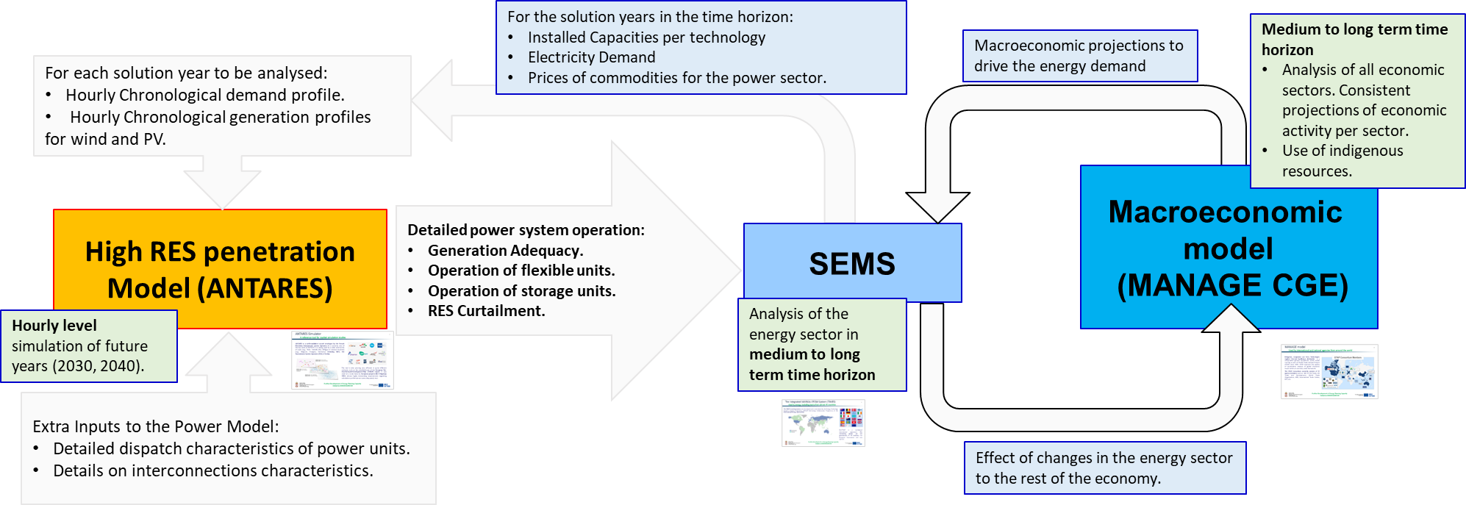

Projected evolution of main exogenous factors influencing energy system and GHG emission developments
This section presents briefly the main input parameters and underlying assumptions, which are utilised in the formulation of the WEM scenario for the energy system of the Republic of Serbia. This scenario is used as a reference for comparison with the projections presented in Chapter 5, where all the additional measures are included in order to reach the targets for emissions reduction, renewable energy penetration and energy efficiency. The With Existing Measures (WEM) scenario does not include carbon prices, while there is a low-RES ambition (fixed capacities for projects), allowing of up to 200MW of wind and 200MW of PV additions per 5 years after 2030. It also includes low share of RES in district heating (about 3% of heat by RES in 2030) and low ambition of energy efficiency.

Macroeconomic forecasts (GDP and population growth)
The most crucial drivers for the energy demand are the evolution of the GDP and the population trend until 2050. As shown in the Figure 4.2, the population of the Republic of Serbia decreased steadily over 2010-2020 from 7.3 million in 2010 to 6.93 million in 2020, while the annual GDP, at current prices, increased during the aforementioned period from €31.5 billion in 2010 to €466.8 billion in 2020.
Figure 4.2: Historical data of GDP and population over 2010-2020 (Sources: Statistical Office of the Republic of Serbia, Ministry of Finance, National Bank)
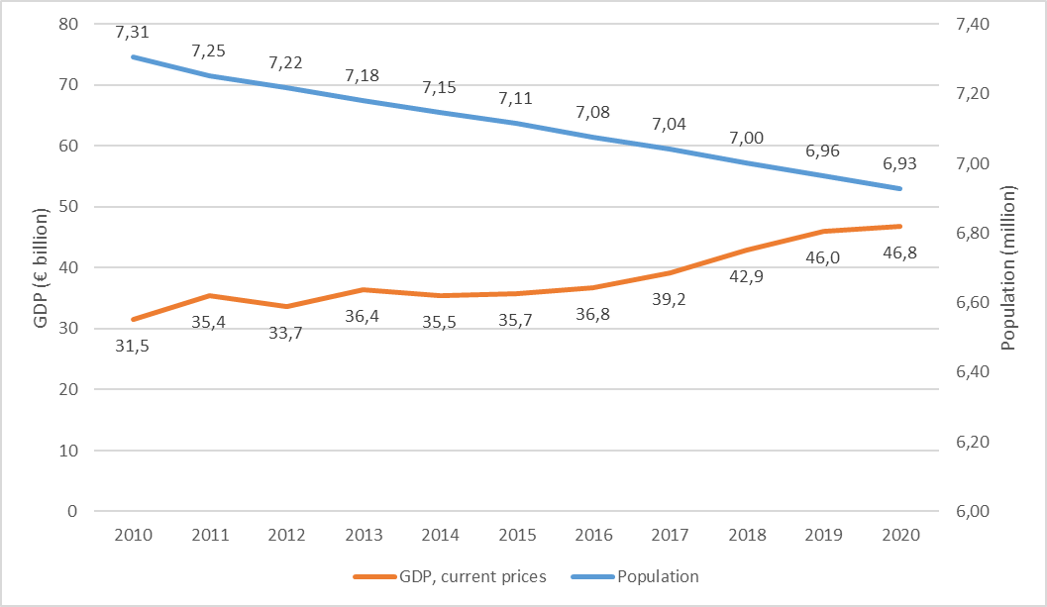

The projection of population is shown in Figure 4.3 and Table 4.1. based on the median scenario of the Statistical Office of the Republic of Serbia (SORS). The projection of the GDP for the short term (up to 2026) has been derived by the National Bank of Serbia, while the Shared Socioeconomic Pathways (SSP)scenarios has been taken into consideration for the medium to long term projections of the GDP.
Figure 4.3: Evolution of GDP (in constant Euro 2015) and population until 2050 (Sources: Statistical Office of the Republic of Serbia, Ministry of Finance, National Bank, projections based on SSP)
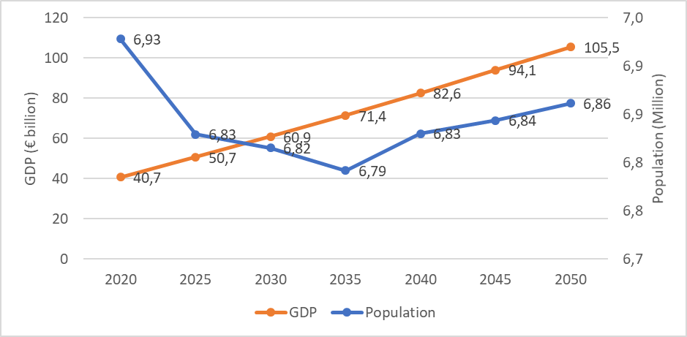
Table 4.1: Numerical evolution of GDP and population over 2020-2050 (Sources: Statistical Office of the Republic of Serbia, Ministry of Finance, National Bank, projections based on SSP)
 | 2020 | 2025 | 2030 | 2035 | 2040 | 2045 | 2050
Population (million) | 6928,0 | 6829,2 | 6815,0 | 6791,7 | 6830,0 | 6843,6 | 6861,3
GDP (€ billion) | 40676,2 | 50689,9 | 60866,5 | 71439,2 | 82595,9 | 94064,2 | 105515,0
Figure 4.4: Evolution of GVA for different sectors of economic activity until 2050 (Sources: Statistical Office of the Republic of Serbia, Ministry of Finance, National Bank, projections based on SSP)
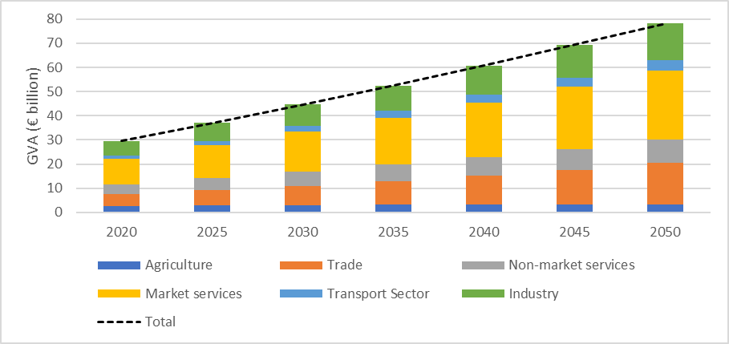
The projections of the Gross Value Added (GVA) per sector of economic activity, according to the output of the macroeconomic model for Serbia based on the MANAGE model, are displayed in the above Figure 4.4. It should be noted that there is a lack of macroeconomic analysis studies with a medium to long-term horizon in the Republic of Serbia sector and more specifically there no quantitative projections for the industrial sub-sector gross value added. Therefore, the projections from the MANAGE model were used, together with the overall GDP projection trajectories discussed in the previous paragraph.
For the energy intensive sectors of cement, iron and steel, copper, lead, zinc, other non-ferrous metals, glass, ceramics and other non-metallic minerals, the physical outputs have been used as the driver for energy demand in each subsector. The projection of physical output has been selected for the energy intensive sectors due to the fact that the physical quantity is considered as a more realistic driver for energy demand projections compared to the Value Added of the sector avoiding potential variation from other economic reasons (e.g. changes to the price of the product and not only to the actual change of the output).
For the other industrial subsectors, the Value Added has been used as the demand driver and the corresponding projections are shown per subsector in the Figure 4.5.

Figure 4.5: Evolution of value added of other industrial subsectors until 2050 (Sources: projections based on the SSP scenarios)
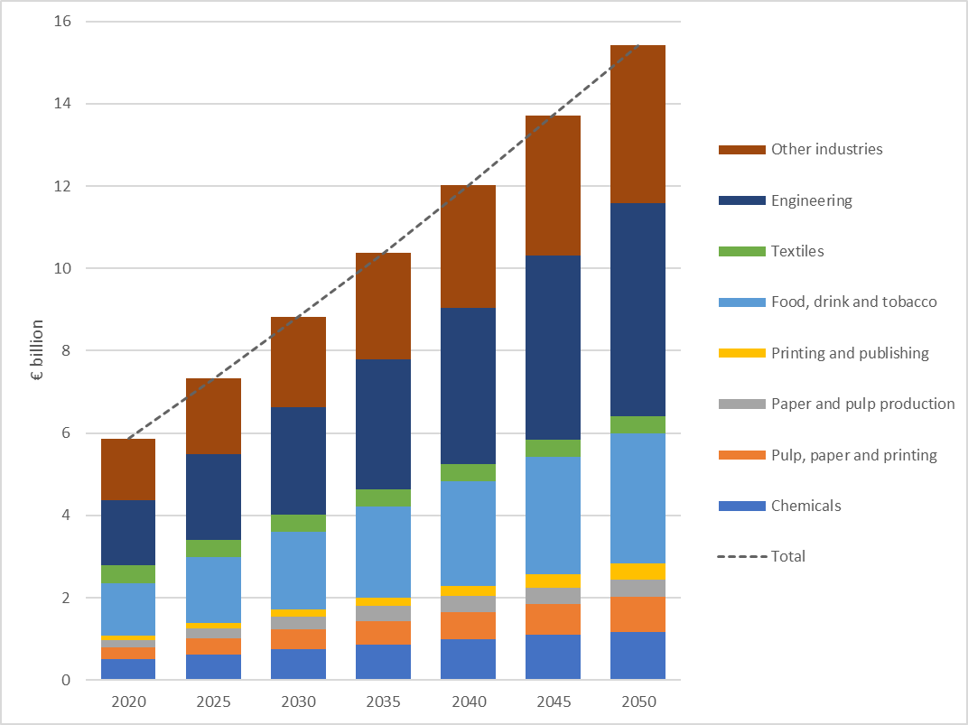

Sectorial changes expected to impact the energy system and GHG emissions
As can been seen in the previous section the evolution of GVA per sector does not foresee any significant sectorial changes that could impact the energy system and the GHG emissions.

Global energy trends, international fossil fuel prices, ETS carbon price
The latest developments within 2022 in the context of the war in Ukraine and the wider energy crisis in Europe make any price projection extremely uncertain. Within this uncertain situation, the INECP analysis was performed using the projections of international gas prices according to the study “Recommended parameters for reporting on GHG projections in 2023, EC DG Climate Action’’ which was provided by the EU in order to support Member States and other bodies in the EU (e.g. the EnC Secretariat) to revise their INECPs.
Table 4.3: International fuel prices projections to 2050
Euro2015/GJ | 2020 | 2025 | 2030 | 2035 | 2040 | 2045 | 2050
Crude Oil | 6.04 | 14.54 | 14.54 | 14.54 | 15.39 | 16.61 | 18.60
Natural Gas | 2.93 | 12.46 | 10.67 | 10.67 | 10.67 | 10.67 | 11.14
Hard Coal | 1.51 | 2.93 | 2.93 | 2.93 | 3.12 | 3.30 | 3.49
In the scenario analysis with existing measures (WEM) it is assumed that there are no carbon prices imposed in the Republic of Serbia.

Technology cost developments
The projection of investment costs of RES technologies for electricity generation, which are expected to be the technologies with the largest potential for reduction of costs, are shown in the following table. Three cost levels have been included for wind installations to model a “supply curve” for the wind potential. The underlying assumption is that the first cost level corresponds to sites which have easy access for installation (close to roads and the transmission network) and the next two cost levels are further away and therefore require ten per cent higher investment costs compared to the previous cost level.
Table 4.2: Overnight investment costs projection for renewable energy technologies
Overnight Investment costs in Euro/kW | 2025 | 2030 | 2040 | 2050
Solar PV – Plant size | 575 | 550 | 500 | 350
Rooftop Solar PV | 690 | 660 | 600 | 420
Wind plants Cost level 1 | 1150 | 1000 | 950 | 900
Wind Plants Cost level 2 | 1265 | 1100 | 1045 | 990
Wind Plants Cost level 3 | 1520 | 1320 | 1254 | 1188

Dimension Decarbonisation

GHG emissions and removals

Trends in current GHG emissions and removals in ETS, Effort Sharing Regulation and LULUCF sectors and different energy sectors
The evolution of the total GHG emissions, with and without LULUCF, follows a similar trend in the period 2010-2019. Although several fluctuations have been recorded over this decade, the total GHG emissions stood at 56.6 Mt CO_{2e} (including LULUCF) and at 61.5 Mt CO_{2e} (without LULUCF) in 2019, which are similar to 2010 levels at 57.2 Mt CO_{2e} (including LULUCF) and at 63.3 Mt CO_{2e} (without LULUCF), respectively, as presented in Figure 4.6, despite the considerable increase of the GDP. The further utilization of natural gas and the promotion of energy efficiency and RES technologies in all end-use sectors managed to restrain the increase of the GHG emissions.
Figure 4.6: Total GHG emissions (with and without LULUCF) over 2010-2019
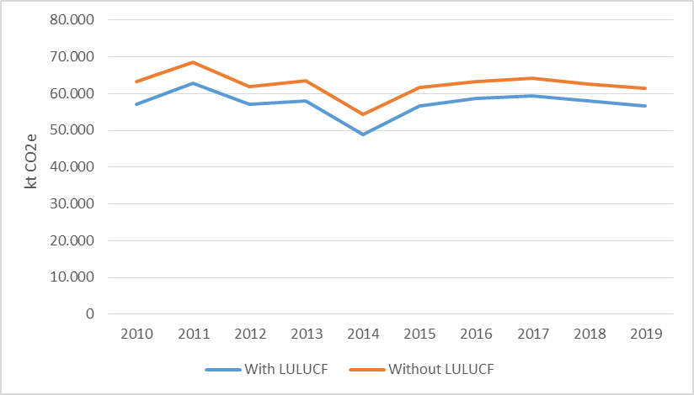

Projections of sectorial developments with existing national and EU policies and measures at least until 2040 (including for the year 2030)
As presented in Figure 4.7, the CO₂ emissions from energy use are projected to increase by 17.7% at 60.44 Mt CO₂ in 2030, and by 32.3% at 67.9 Mt CO₂ in 2040, compared to 2020 levels. An upward trend is foreseen between 2025 and 2045 mainly due to the economic development as demonstrated by the increase of the various parameters such as GDP, sectoral GVA and GDP per capita and the continuation of the use of lignite fired power plants. The decline of CO₂ emissions from 2045 to 2050 is explained by the considerable deployment of improved and advanced technologies and energy carriers that are less or no carbon-intensive, such as renewables and natural gas as part of the overall technological replacement. Finally, the CO₂ emissions are projected to be stabilised at the level of 66.9 Mt CO₂ in 2050.
The electricity sector has the highest contribution to the CO₂ emissions, and its share is projected to increase significantly from 35.0 Mt CO₂ in 2030 to 38.9 Mt CO₂ in 2040, connected to the continuation of the use of lignite fired power plants. Nevertheless, the contribution of the electricity sector to the CO₂ emissions decrease at 34.4 Mt CO₂ by 2050 mainly due to the further deployment of RES.
The CO₂ emissions from the industry and transport sectors are projected to rise from 2020 to 2050. More specifically, the CO₂ emissions for the industry sector will be almost doubled; from 7.99 Mt CO₂ in 2020 to 14.77 Mt CO₂ in 2050 and the same trajectory roughly stands for the transport sector; from 7.00 Mt CO₂ in 2020 to 10.77 Mt CO₂ in 2050. The CO₂ emissions of the industrial sector will increase, mainly due to the rise of the industrial sectors’ output and subsequently its increased activity. Similarly, the foreseen increase of the GDP will increase considerably also the transport activity. The implementation of energy efficiency measures and the utilization of environmentally friendly fuels, at the level considered in WEM, are not capable of restraining the increase of the CO₂ emissions.
Figure 4.7: CO2 emissions by sector over 2020-2050 in the scenario with existing measures (WEM)
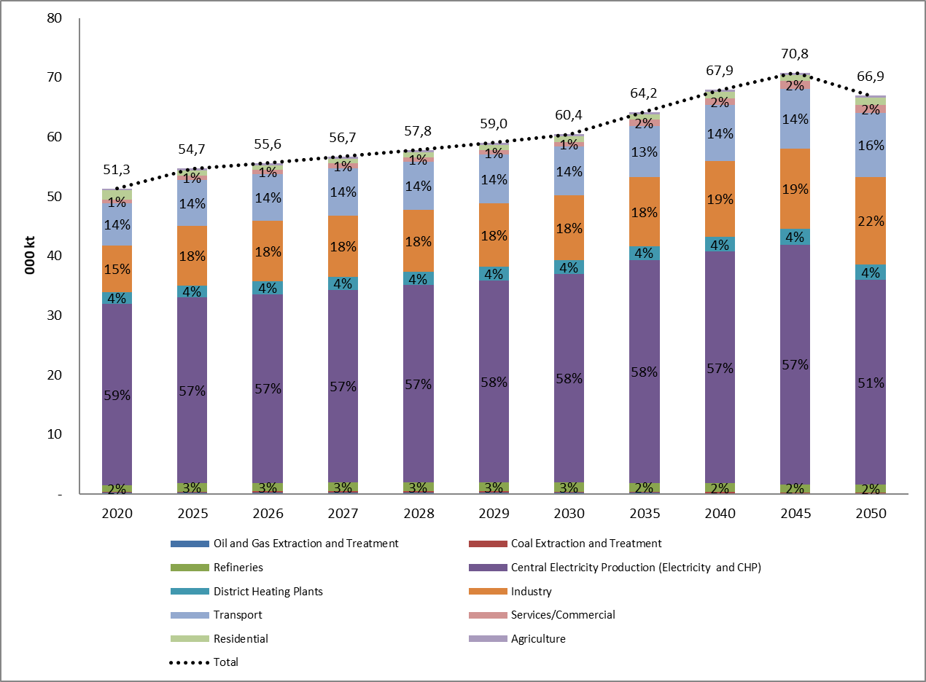

As presented in Figure 4.8, CH₄ emissions are expected to decrease considerably after 2027 due to the decarbonisation process, exhibiting an increase of 3.9% in 2030 and a reduction equal to 10.9% and 27% in 2040 and 2050 respectively, compared to 2020, resulting in 116.11 kt CH₄ in 2030 and 81.88 kt CH₄ in 2050. The coal extraction and treatment have the highest contribution to the CH₄ emissions (methane is released as a direct result of the physical process of coal extraction as layers of the coal face are removed), ranging from 48.9 kt CH₄ in 2020 to 53.088 kt CH₄ in 2050, followed by the oil and gas extraction and treatment, which presents a decrease from 39.9 kt CH₄ in 2020 to 8.55 kt CH₄ in 2050.

Figure 4.8: CH4 emissions by sector over 2020-2050 in the scenario with existing measures (WEM)
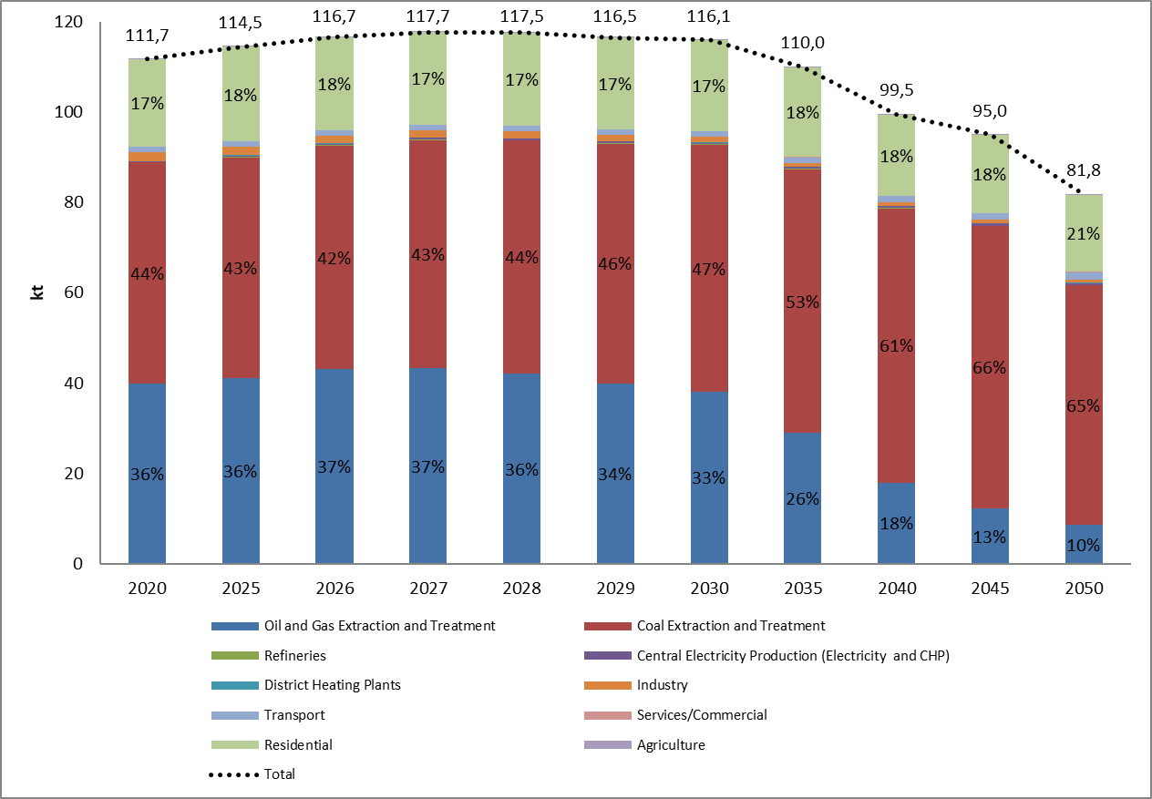
The N₂O emissions are anticipated to increase considerably in WEM, demonstrating a rise equal to 14.3%, 22.9% and 24.3% in 2030, 2040 and 2050 respectively, compared to 2020, resulting in 3.2 kt N₂O in 2030 and 3.5 kt N₂O in 2050, as shown in Figure 4.9. The N2O emissions of the industrial, transport and electricity production sectors appear the highest shares to the overall N₂O emissions in 2050 (63%, 15% and 14% respectively) presenting a constantly increasing trend.

Figure 4.9: N2O emissions by sector over 2020-2050 in the scenario with existing measures (WEM)
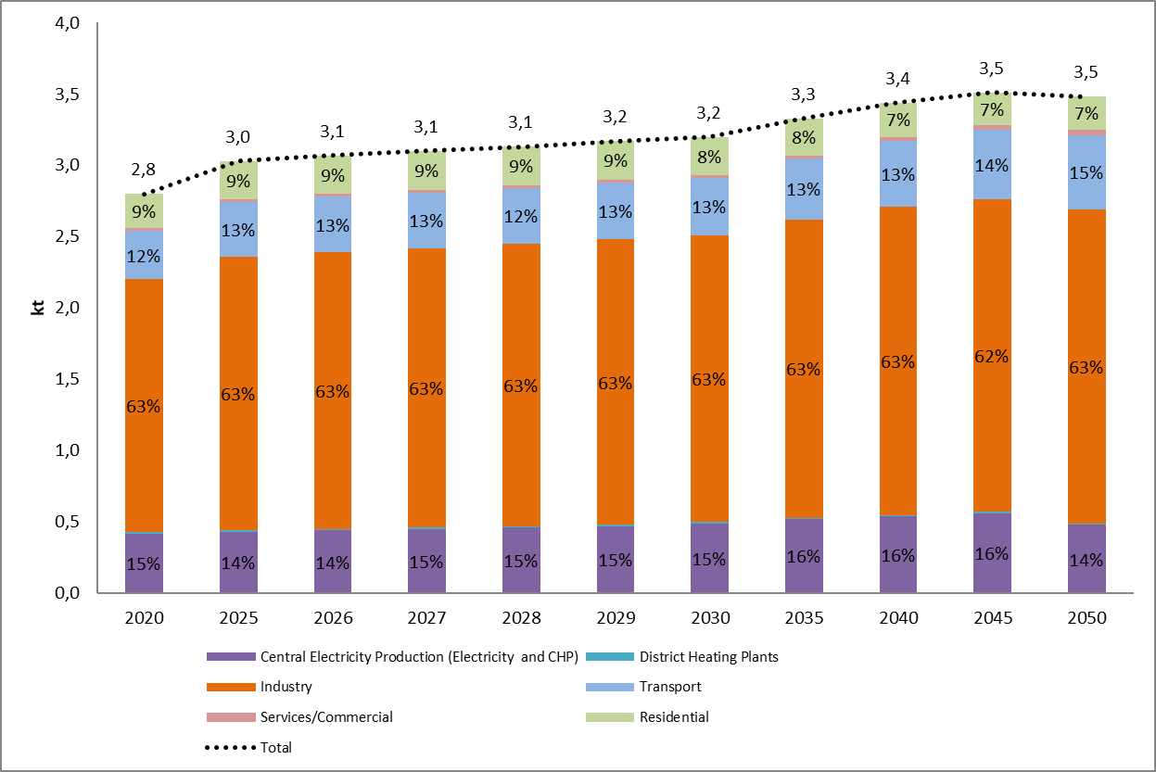
The total emissions including emissions from agriculture waste and LULUCF, are projected to increase in the WEM scenario towards 2030 by 15% compared to 2020 and by 30% in 2050.
Figure 4.10: Total GHG emissions 2020-2050 in the scenario with existing measures (WEM)
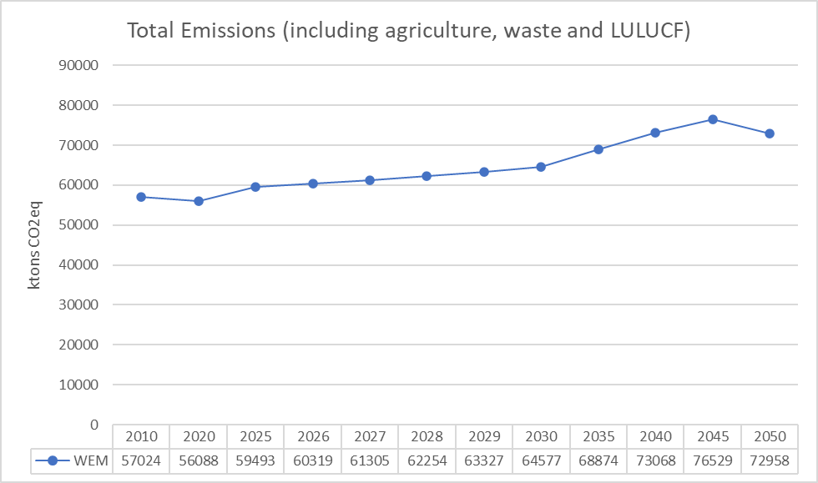
Emissions from agriculture are projected to decrease by 12% in 2030 compared to the 2020 levels reaching almost 4.5MtonCO2eq but continue to increase, reaching 5.4Mtons CO2eq by 2050. The emissions from waste is projected to be reduced by 14% in 2030 compared to 2020 at the level of 2.4MtonsCO2eq, and further decrease to 1.9MtonsCO2eq by 2050.
LULUCF is projected to contribute as a sink of GHG emissions for the whole time horizon towards 2050, but decreasing in volume, reaching -6.5MtonsCO2eq in 2030 and -4.4MtonsCO2eq in 2050.
Figure 4.11: GHG emissions 2020-2050 from non-energy related sectors in the scenario with existing measures (WEM)
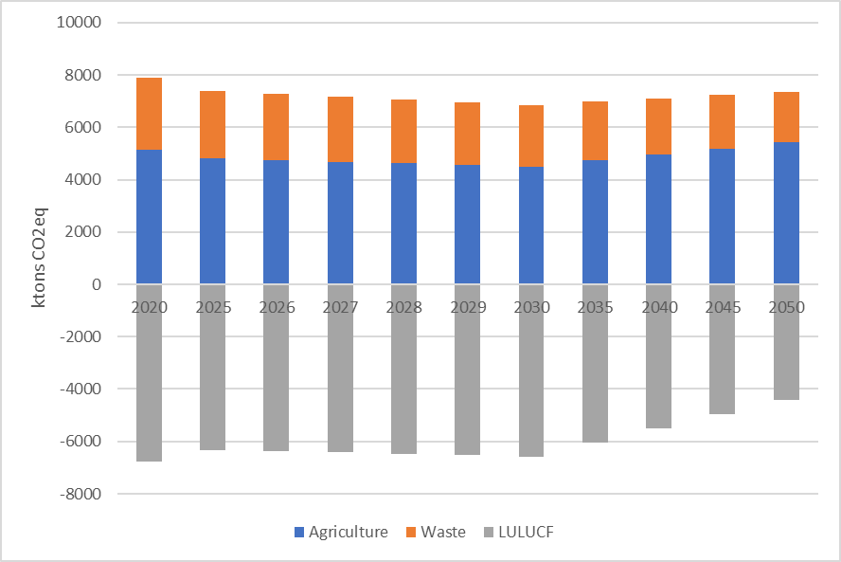
As shown in Figure 4.12, the CO₂ emissions intensity, which is the volume of CO₂ emissions per unit of GDP, is projected to decline considerably until 2050, as it is decreased by 20% in 2030, 34% in 2040 and 49% in 2050, compared to 2020. The CO₂ emissions intensity will be improved demonstrating that the energy system of the Republic of Serbia is gradually cleaner and efficient, at a relatively low pace, due to the technological progress and the deployment of energy efficiency and RES technologies in all end-use sectors.
Figure 4.12:CO2 emissions intensity per unit of GDP (kg CO2 from energy sources / € GDP) over 2020-2050 in the scenario with existing measures (WEM)
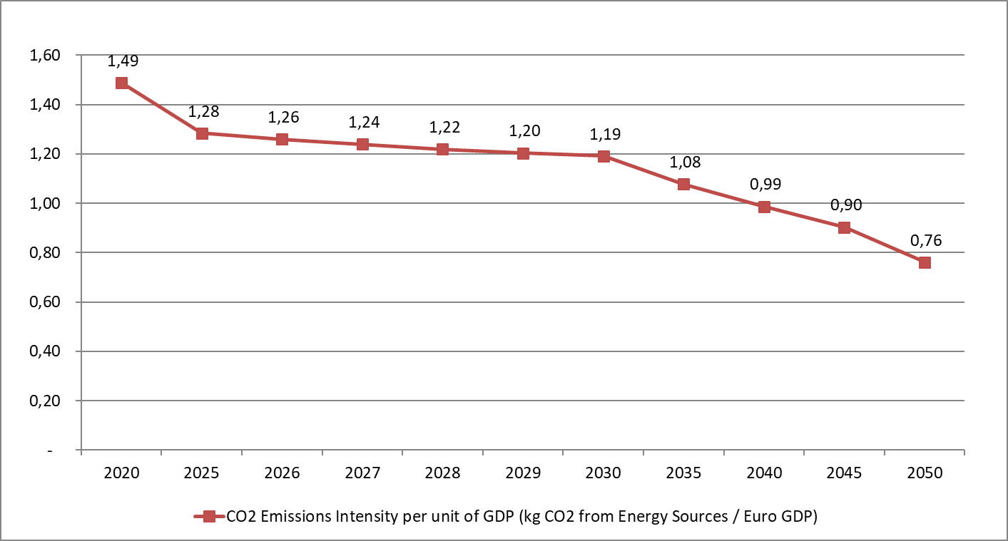

Renewable Energy

Current share of renewable energy in gross final energy consumption and in different sectors (heating and cooling, electricity and transport) as well as per technology in each of these sectors
As presented in Figure 4.13, the gross electricity production remained almost stable in 2020, compared to 2010 at about 3.3 Mtoe, despite several fluctuations within the period. Solid fossil fuels and RES (mainly hydro power) are the major sources contributing substantially to the gross electricity production over the last decade, by 65.7% and 33% in 2010 and by 70% and 29% in 2020, respectively.
Figure 4.13: Gross electricity production over 2010-2020 (Source: Eurostat, 2023)
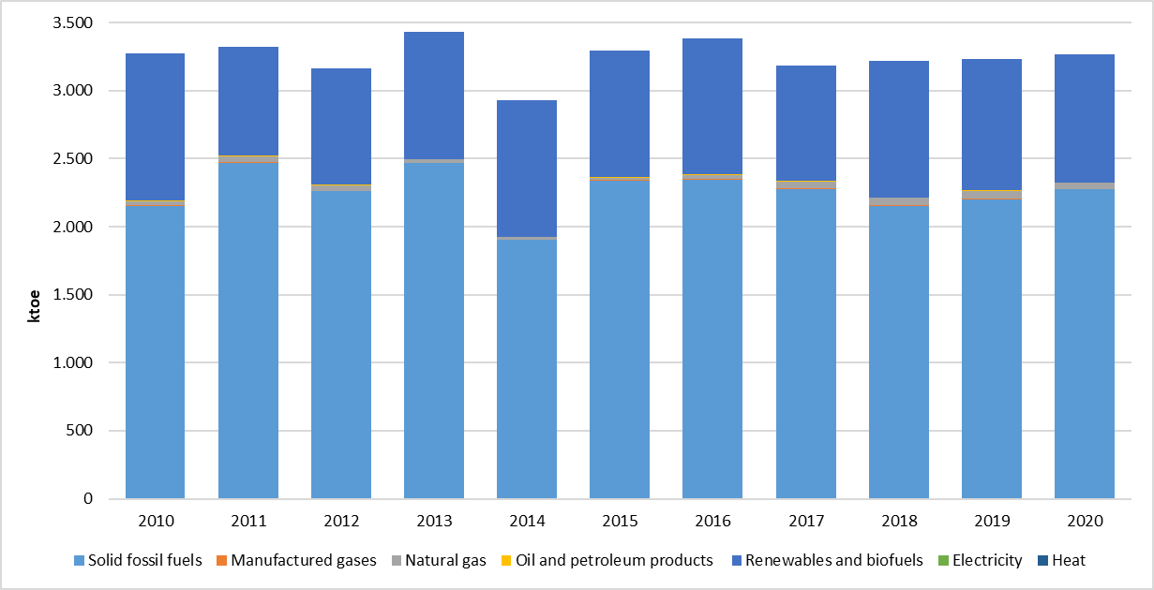
Furthermore, the gross heat production declined by 4.8% between 2010 and 2020; from 905.0 ktoe in 2010 to 861.1 ktoe in 2020, as shown in Figure 4.14. Natural gas and solid fossil fuels contributed substantially to the gross heat production over the last decade, by 48.88% and 16.88% in 2010 and by 66.09% and 17.01% in 2020, respectively.
Figure 4.14: Gross heat production over 2010-2020 (Source: Eurostat, 2023)
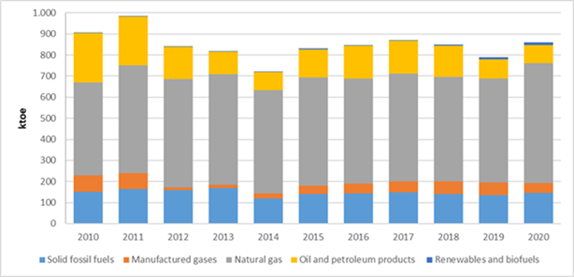
As illustrated in Figure 4.15, the share of RES in gross electricity consumption was increased over 2010-2020 from 28% in 2010 to 31% in 2020, while the share of energy from RES as a percentage of gross final energy consumption also increased from 19.8% in 2010 to 26.3% in 2020.
Figure 4.15: Shares of energy from RES over 2010-2020 (Source: Eurostat, 2023)
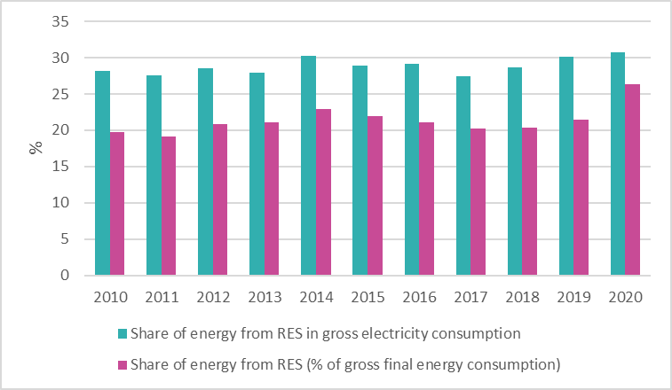

Projections of development with existing policies and measures at least until 2040 (including for the year 2030)
The share of RES in the gross final energy consumption (according to the Directive 2009/28/EC on the promotion of the use of energy from renewable energy sources) is expected to remain relatively constant between 2020 and 2050, ranging from 26% in 2020 to 27% in 2050, while a temporary decrease is expected between 2030 and 2045 (from 27% in 2030 to 24% in 2045), as presented in Figure 4.16.
Figure 4.16: Share of RES in gross final energy consumption over 2020-2050 in the scenario with existing measures (WEM)
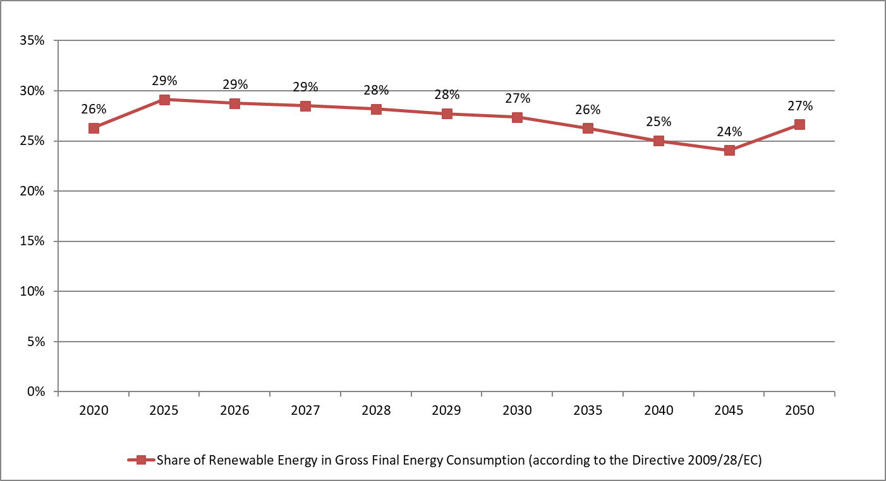
As shown in Figure 4.17, the share of RES in the total electricity production is projected to increase almost from 27% in 2020 to 38% in 2050 indicating the contribution of the existing policies and measures. Nevertheless, the penetration of RES will remain relatively stable approximately at 30% on average over 2025-2045.

Figure 4.17: Share of RES in total electricity production over 2020-2050 in the scenario with existing measures (WEM)
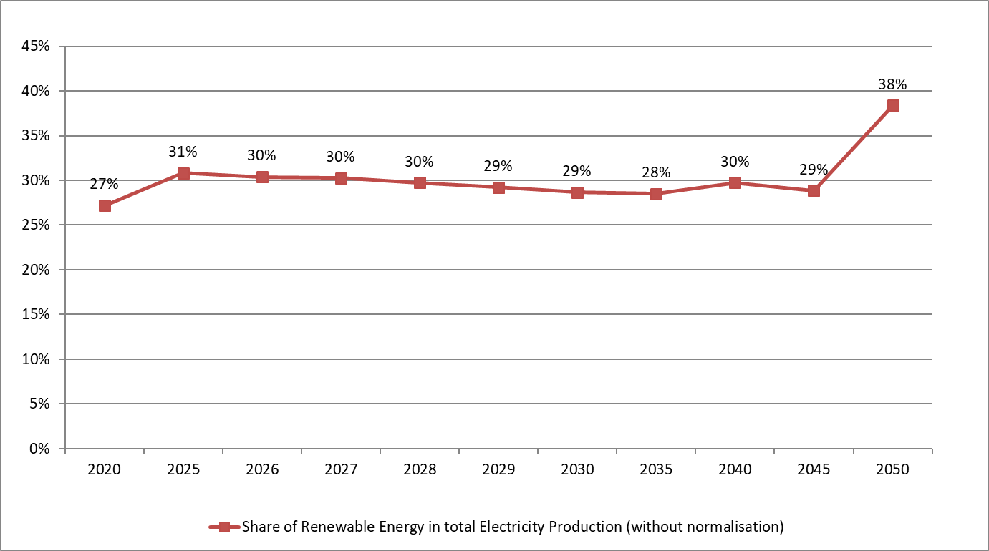
The total installed capacity for electricity production is projected to increase from 8.2 GW in 2020 and 9.3 GW in 2030 to 10.4 GW in 2040 and 13.4 GW in 2050, as presented in Figure 4.18. The expected increase is mainly attributed to the penetration of RES technologies for electricity generation, which generally have a lower utilization or capacity factor than conventional technologies and therefore require more capacity installed than conventional power plants for the same electricity production.
It is worth noting a greater transformation of the power sector will be exhibited with considerable reduction of conventional power plants and significant increase of renewables. More specifically, the installed capacity of electricity coming from lignite fired power plants is expected to increase at a low extent from 3.6 GW in 2020 to 4.5 GW in 2050 demonstrating the largest contribution in the overall installed capacity for electricity.
The contribution of RES technologies to the total installed capacity of the Republic of Serbia is projected to amount to 43% in 2030 and 54% in 2050 compared to 40% in 2020. The installed RES capacity is expected to increase from 3.55 GW in 202020 to 4.22 GW in 2030 and to 7.3 GW in 2050 (Figure 4.19). A small additional investment in hydro plants is foreseen during the examined period, with their installed capacity to be increased from 2.55 GW in 2020 to 2.9 GW in 2040 remaining relatively constant until 2050 (3.3 GW). Moreover, the installed capacity of wind and solar PV stations is projected to be about 1.8 GW each in 2050 compared to the very low level of 2020.
Figure 4.18: Installed capacity per technology in the power sector over 2020-2050 in the scenario with existing measures (WEM)
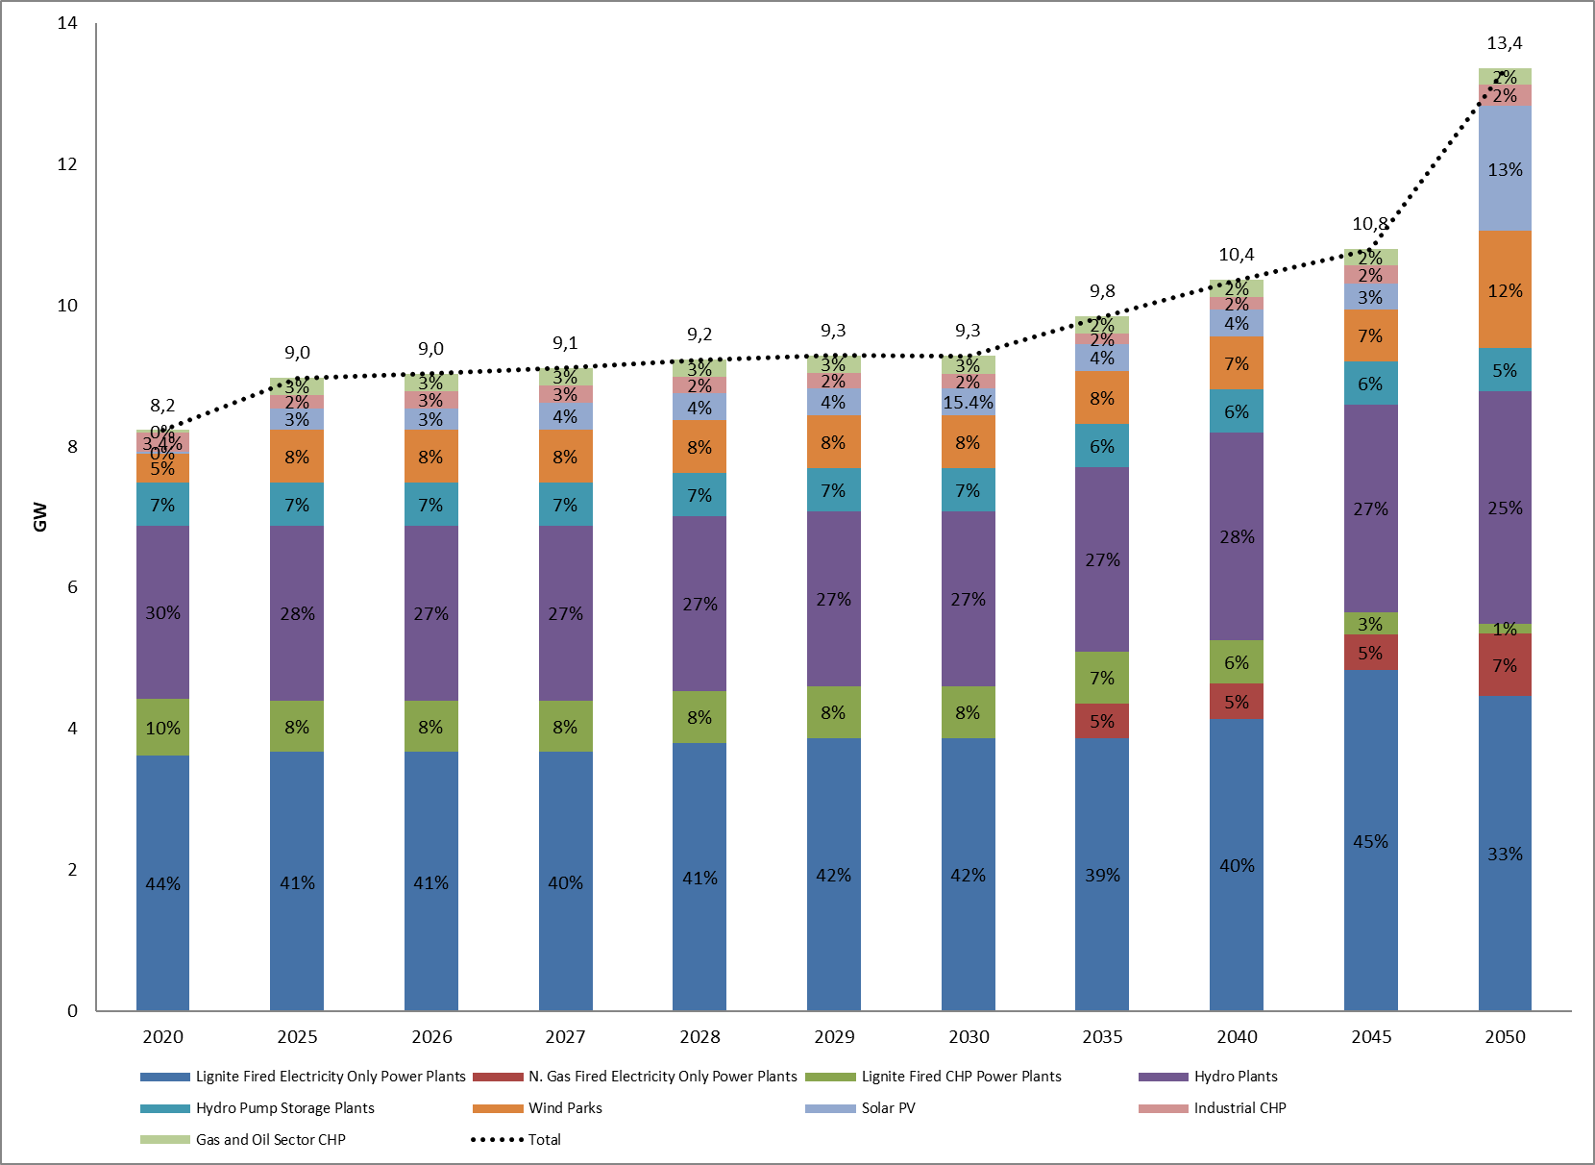
Figure 4.19: Installed RES capacity per technology over 2020-2050 in the scenario with existing measures (WEM)
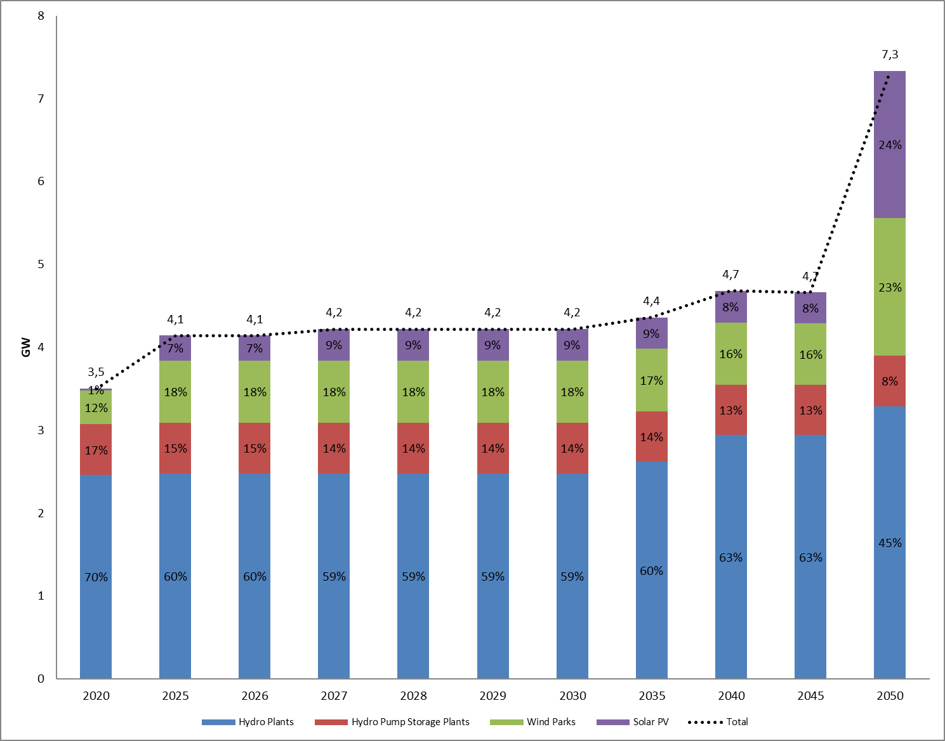
In addition, the share of RES in the heating and cooling sector is projected to increase from 35.7% in 2020 to 37.9% in 2030, before reaching to 30.3% in 2050, as presented in Figure 4.20, mainly due to the considerable exploitation of biomass for heating. In the WEM scenario there are no new measures foreseen after 2030 so the projected increase in the heating demand is covered by conventional fuels, leading to a decrease in the percentage of RES in heating.
Figure 4.20: Share of RES in Heating and Cooling over 2020-2050 in the scenario with existing measures (WEM)
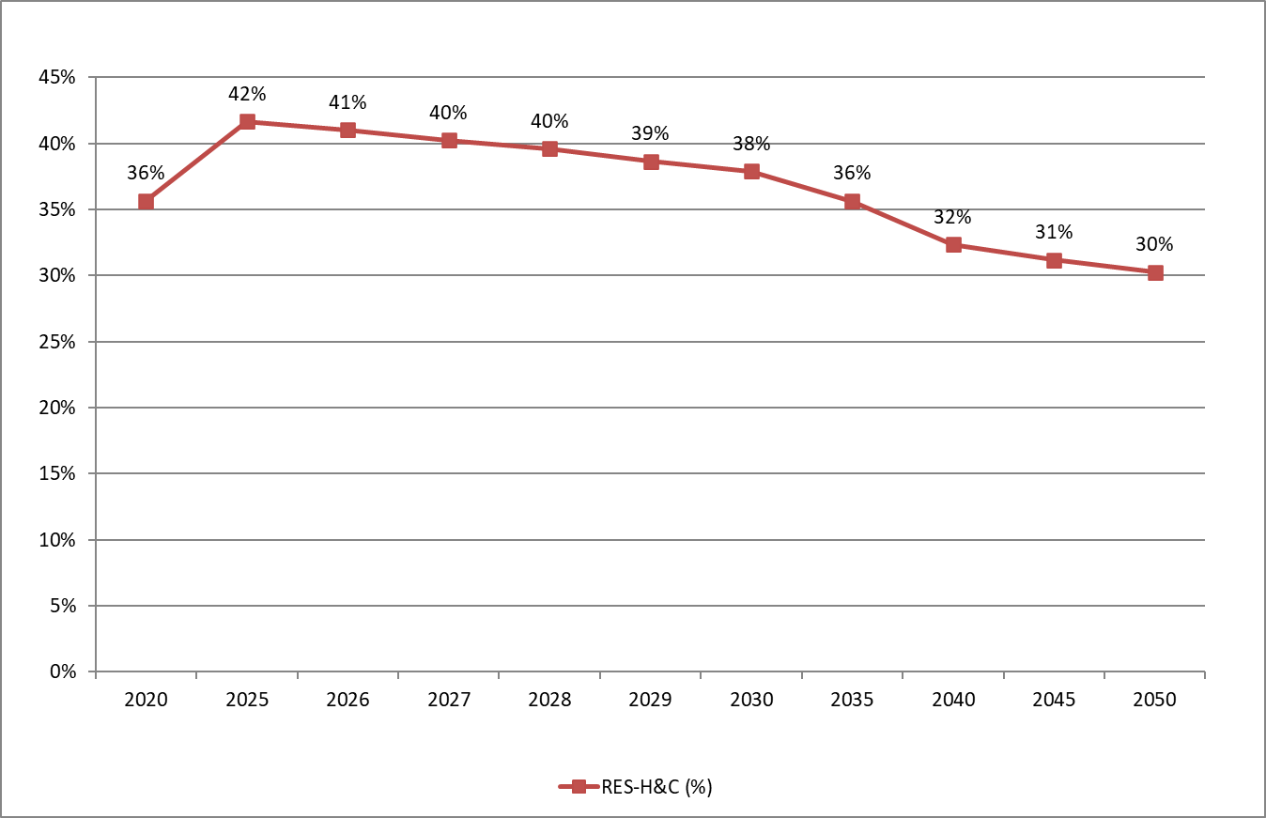
As presented in Figure 4.21, the share of RES in transportation (without multipliers) was negligible in 2020, before increasing at 3,7% in 2030, remaining stable at this level by 2045, reaching 5% in 2050. The electrification of the transport sector contributes to the increase of the share of RES in conjunction with the increase of the share of RES in electricity generation, which affects the electricity used in transport.
Figure 4.21: Share of RES in transportation (without multipliers) over 2020-2050 in the scenario with existing measures (WEM)
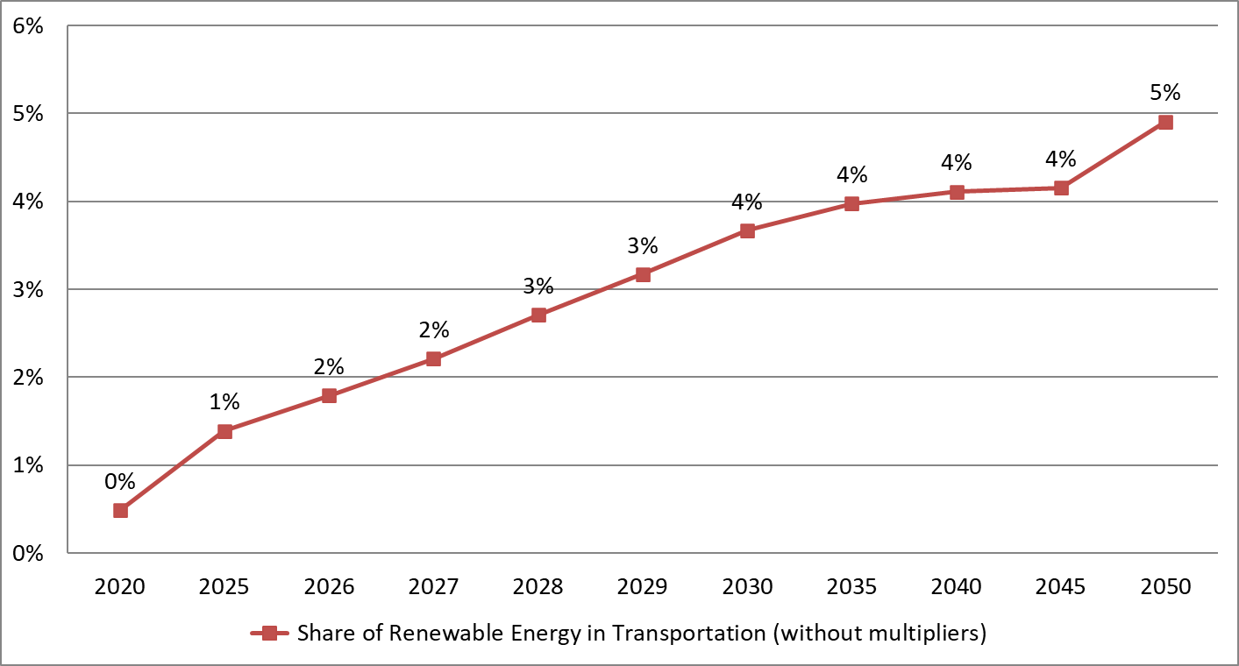

Moreover, the introduction of biofuels in transport sector will increase up to 2050 demonstrating a penetration equal to 73.33 ktoe in 2030 and 94.11 ktoe in 2050, compared to zero levels in 2020, as illustrated in Figure 4.22. The non-road RES electricity consumption in transport is expected to rise from 9.6 ktoe in 2020 to 13.6 ktoe in 2030 and to 19.2 ktoe in 2050, connected with the partial electrification of rail.
Figure 4.22: Electricity consumption from RES in transport over 2020-2050 in the scenario with existing measures (WEM)
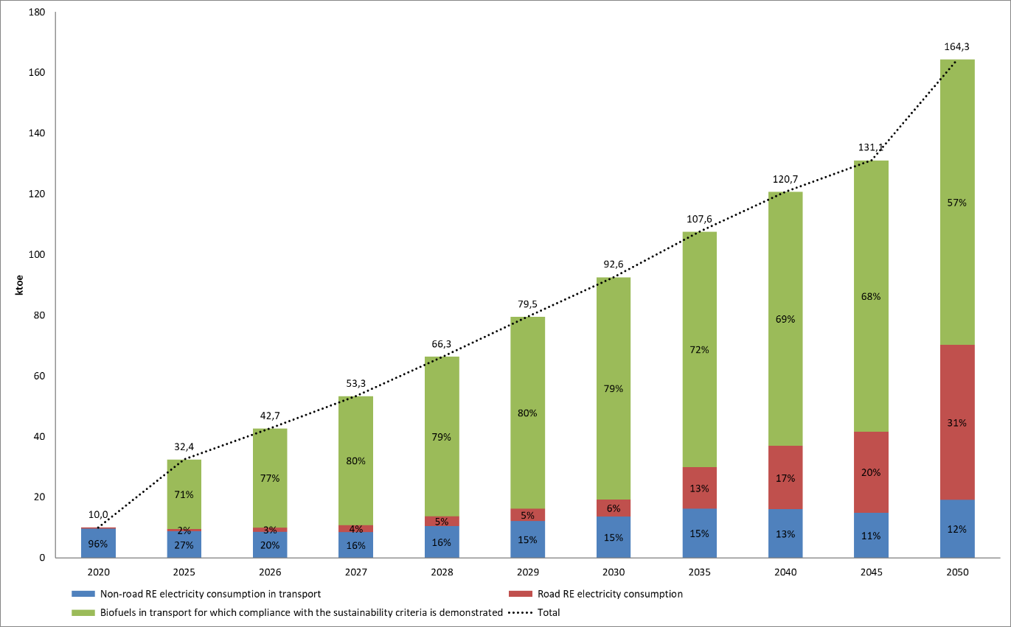
As regards the installed capacity per fuel source in district heating plants, natural gas will remain the dominant fuel throughout the examined period (2020-2050) and the shares of capacities of oil products and solid fuels will remain unchanged from 2020 to 2050, without additional measures for replacement.

Dimension Energy Efficiency

Current primary and final energy consumption in the economy and per sector (including industry, residential, service and transport)
Over 2010-2020, the gross inland energy consumption remained almost constant (from 15.6 Mtoe in 2010 to 15.99 Mtoe in 2020), recording only a sharp and temporary reduction in 2014 due to the temporary GDP decline. As presented in Figure 4.23, the solid fossil fuels and oil and petroleum products had a dominant role in the gross inland consumption, with respective shares of 50% and 25% in 2010 and 50% and 23% in 2020, while the penetration of RES and biofuels, as well as natural gas was lower at about 16% and 12% in 2020 correspondingly.
Figure 4.23: Gross inland consumption over 2010-2020 (Source: Eurostat, 2023)
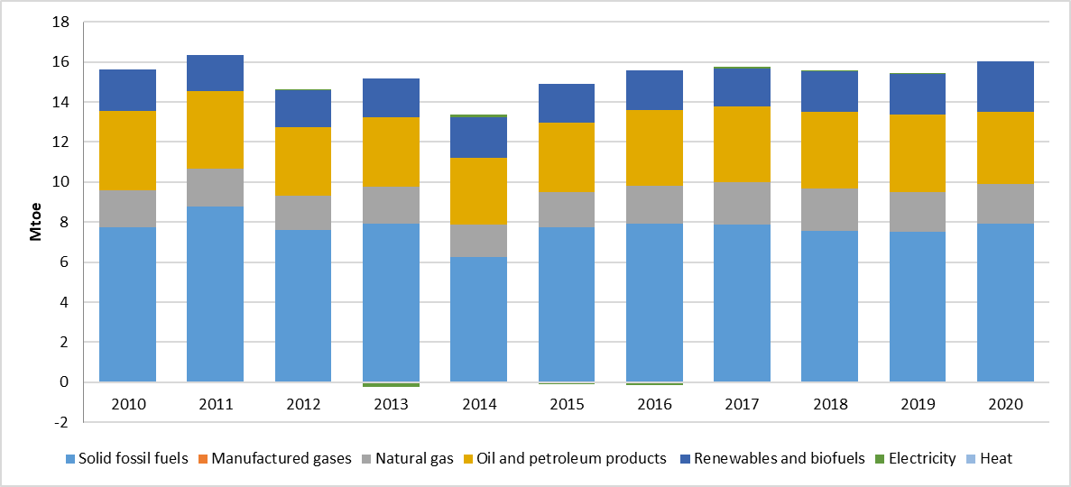
The primary and final energy consumption were stable at about 15.0 Mtoe and 9.0 Mtoe respectively during 2010-2020, as presented in Figure 4.24. More specifically, the primary and final energy consumption increased from 2010 to 2011 and then a downward trend was recorded by 2014. Since 2015, a slight increase was experienced until 2020; from 14.2 Mtoe in 2015 to 15.2 Mtoe in 2020 for primary energy consumption and from 8.2 Mtoe in 2015 to 9.110 Mtoe in 2020 for final energy consumption. It should be noted that the primary energy consumption is derived from the gross inland consumption, excluding all non-energy use of energy carriers (e.g. natural gas used not for combustion but for producing chemicals).
Figure 4.24: Primary and final energy consumption over 2010-2020 (Source: Eurostat, 2023)
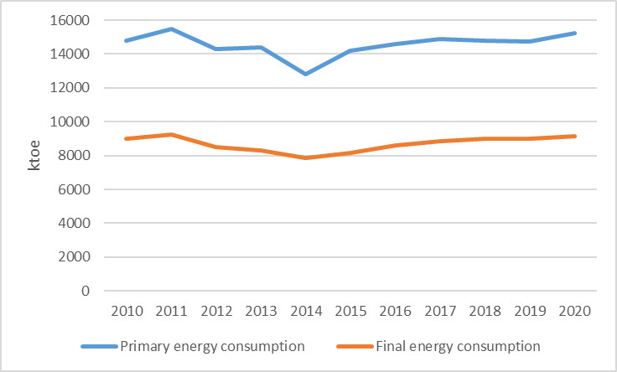
As shown in Figure 4.25, the final energy consumption decreased by 0.5% in the period 2010-2020. More specifically, the final energy consumption was reduced in the period 2012-2014 after a temporary increase in 2011, while an increasing trend has been observed from 2015 to 2020. The shares of the different energy carriers remained almost identical in 2020 in comparison with 2010.
The fact that the primary and final energy consumption remained relatively constant despite the considerable increase of the GDP is an indication for the contribution of the promoted energy efficiency technologies and equipment in all end-use sectors.
Figure 4.25: Final energy consumption by fuel over 2010-2020 (Source: Eurostat, 2023)
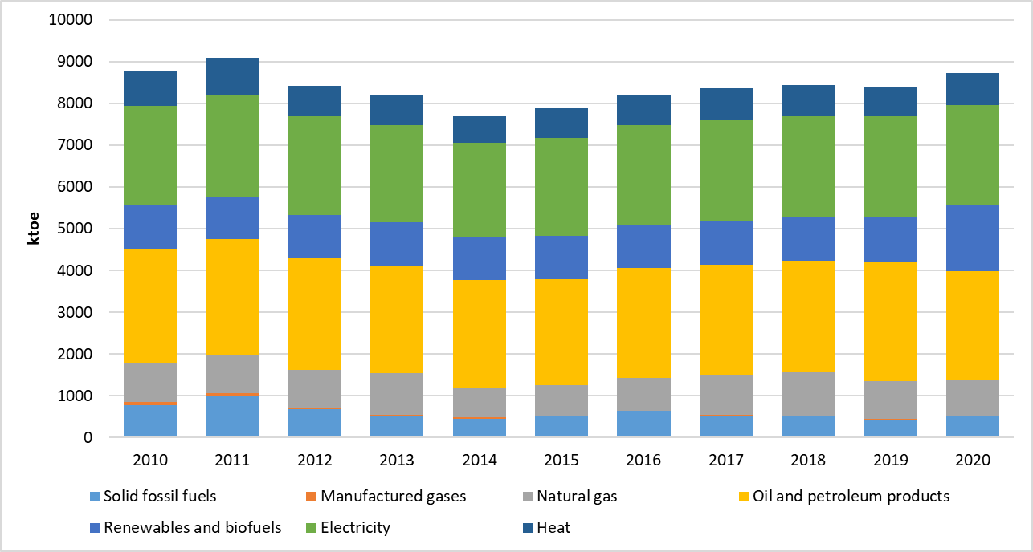
In 2020, the residential sector was responsible for 40% of the final energy consumption, while the industrial and transport sectors had shares equal to 23% and 25% respectively, as presented in Figure 4.26. The final energy consumption of the industrial and transport sectors decreased in the period 2010-2020 by 17% and 1.5% respectively, while the final energy consumption of the residential sector increased by 13.3% over the same period. The contribution of the services and agricultural sectors to the final energy consumption was considerably lower in the period 2010-2020 compared to the other end-use sectors.
Figure 4.26: Final energy consumption by end-use sector over 2010-2020 (Source: Eurostat, 2023)
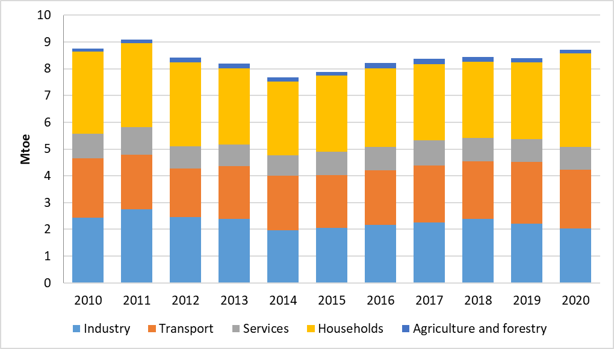

Current potential for the application of high-efficiency cogeneration and efficient district heating and cooling
District cooling is not considered as an option in the period until 2030.
High efficiency gas-fired cogeneration units are considered as an option for the district heating systems together with biomass and biogas fired units. The penetration in the WEM scenario is expected to be limited but in the scenario with addition measures, there is a potential of gas fired CHP covering up to 3% of total district heat production and a potential of heat produced in bioenergy CHPs to cover up to 5% of the total heat generation in DH systems.

Projections considering existing energy efficiency policies, measures and programmes as described under 1.2. ii) for primary and final energy consumption for each sector at least until 2040 (including for the year 2030)
As presented in Figure 4.27, both primary and final energy consumption are expected to follow almost the same upward trend in the period 2020-2050. More specifically, the final energy consumption is projected to increase from 8.99 Mtoe in 2020 to 10.8 Mtoe in 2030 and to 13.22 Mtoe in 2050, exhibiting a more stable upward trend, compared to the primary energy consumption, which will be characterized by a reduction from 19.6 Mtoe in 2045 to 19.3 Mtoe in 2050. However, the primary energy consumption is anticipated to rise from 15.0 Mtoe in 2020 to 17.55 Mtoe in 2030 and to 19.3 Mtoe in 2050 to cover the increased FEC. The slight reduction between 2045 and 2050 is mainly due to the penetration of RES for electricity production. Obviously, the implementation of the existing energy efficient policies and measures is not capable of restraining the impact of the increased GDP to the energy consumption, which is expected until 2050.
- Figure 4.27: Primary and final energy consumption over 2020-2050 in the scenario with existing measures (WEM)
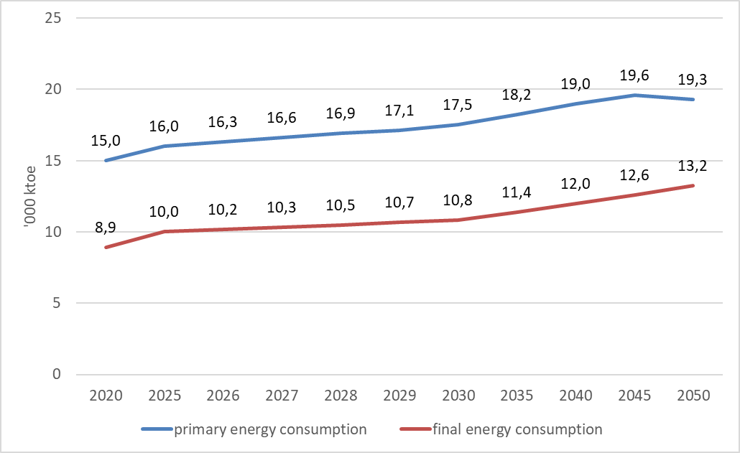
The final energy consumption is currently dominated by oil and petroleum products, which satisfy 33% of the total demand, followed by electricity that covers 26% in 2020 (Figure 4.28). The consumption of oil and petroleum products is expected to steadily rise from 2.9 Mtoe in 2020 to 3.33 Mtoe in 2030 and to 4.11 Mtoe in 2050 representing a slightly reduced share (2%). Similarly, the electricity consumption is expected to increase from 2.22 Mtoe in 2020 to 3.0 Mtoe in 2030 and to 3.6 Mtoe in 2050 leading to a 28% share. The share of RES in the final energy consumption remains relatively constant (around 17% on average) reaching to 1.6 Mtoe in 2050. Finally, the consumption of natural gas will increase from 938 ktoe in 2020 to 1.22 Mtoe in 2030 and to 2.2 Mtoe in 2050 reaching a 17% share in the final energy consumption in 2050.
Figure 4.28: Final energy consumption by fuel over 2020-2050 in the scenario with existing measures (WEM)
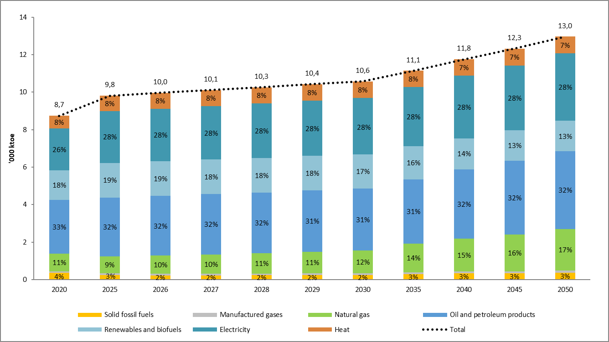
The final energy intensity is projected to decrease until 2050, as it will be reduced by 18% in 2030, 33% in 2040 and 42% in 2050, compared to 2020, as presented in Figure 4.29, highlighting the essential contribution of the existing energy efficiency policies and measures.
- Figure 4.29: Final energy intensity over 2020-2050 in the scenario with existing measures (WEM)
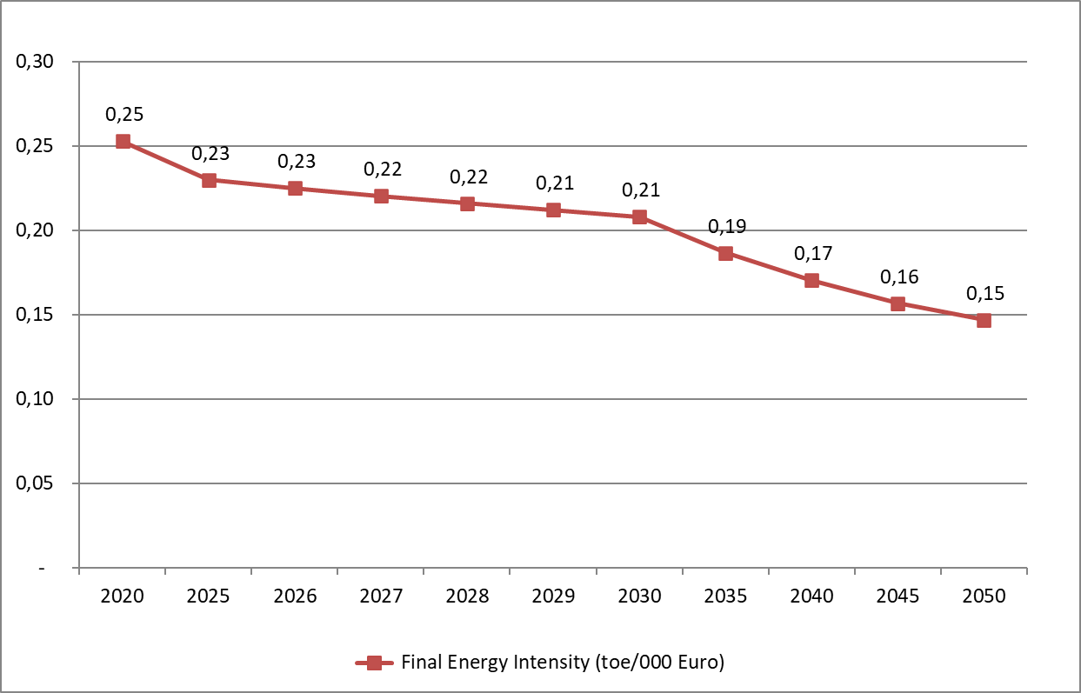
As illustrated in Figure 4.30, the gross inland consumption is expected to increase by 31% at 20.6 Mtoe by 2050, compared to 2020, recording only a temporary reduction between 2045 and 2050; from 20.99 Mtoe in 2045 to 20.6 Mtoe in 2050. Solid fossil fuels and oil and petroleum products have a dominant role in the gross inland consumption, with respective shares of 48% and 23% in 2020, 45% and 24% in 2030, 45% and 23% in 2040 and 39% and 26% in 2050. The penetration of natural gas as well as RES and Wastes is also anticipated to increase throughout the examined period; from 14% and 16% correspondingly in 2020 to 20% and 17% in 2050.
Figure 4.30: Gross inland consumption by fuel over 2020-2050 in the scenario with existing measures (WEM)
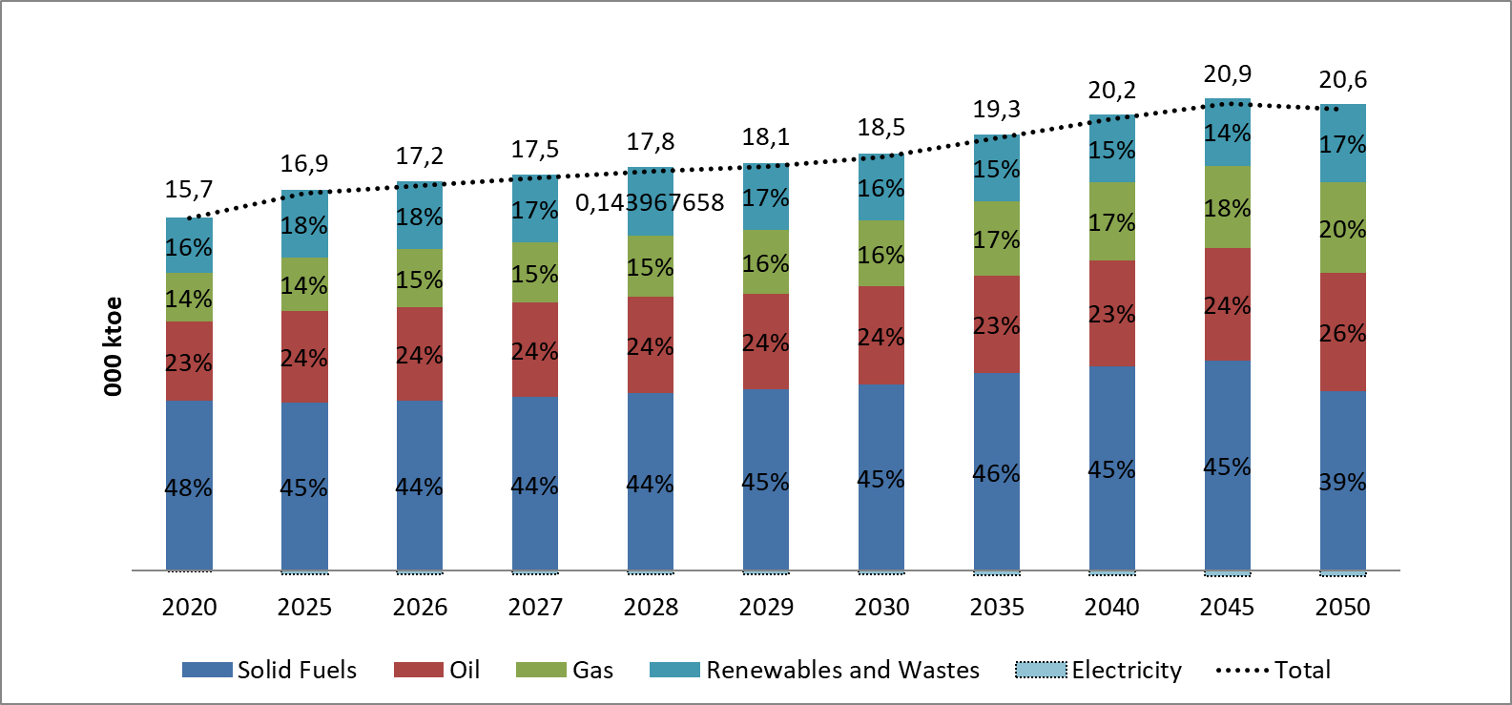
The final energy consumption per end-use sector will increase (21% in 2030, 35% in 2040 and 48% in 2050, compared to 2020), resulting in approximately 12.9 Mtoe in 2050, as shown in Figure 4.31. Transport, residential and industrial sectors retain the highest contribution the whole period 2020-2050 in the final energy consumption, reaching the levels of 3.77 Mtoe, 3.7 Mtoe and 3.8 Mtoe in 2050, respectively. It should be noted that the respective shares of the examined end-use sectors remain relatively constant.
- Figure 4.31: Final energy consumption by end-use sector over 2020-2050 in the scenario with existing measures (WEM)
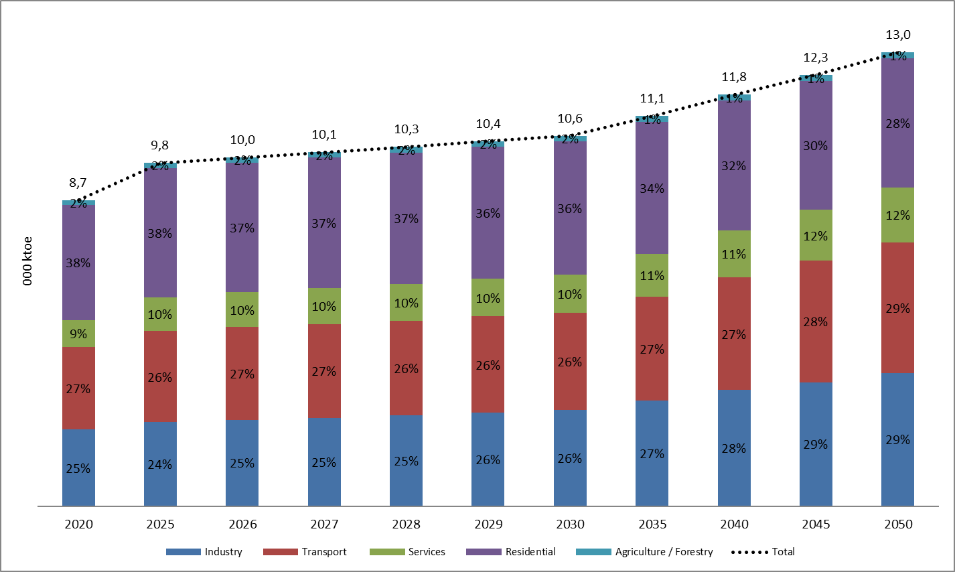
As presented in Figure 4.32, the final energy consumption by fuel in the industrial sector is expected to increase until 2050; from 2.22 Mtoe in 2020 to 2.77 Mtoe in 2030 and to 3.8 Mtoe in 2050. No significant differentiations are observed in the individual shares of most of the utilised fuels. Nevertheless, both natural gas and electricity increase their shares, being the most dominant fuels in industry. More specifically, the observed level of consumption of natural gas and electricity is 687 ktoe and 1.0 Mtoe in 2030 and 1.3 Mtoe and 1.2 Mtoe in 2050 respectively.
- Figure 4.32: Final energy consumption by fuel in the industrial sector over 2020-2050 in the scenario with existing measures (WEM)
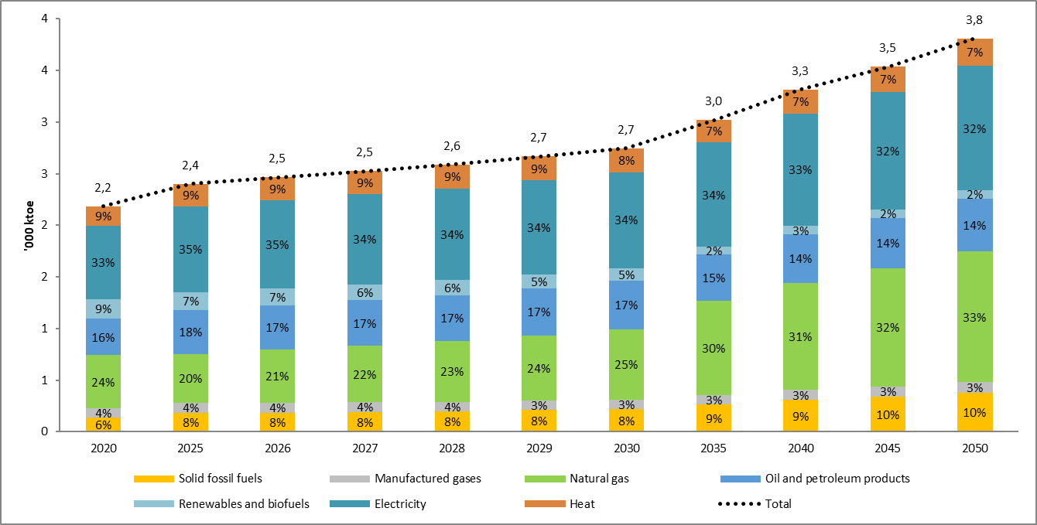
The final energy consumption of the different sub-sectors in the industrial sector is expected to increase until 2050, while the individual shares are expected to remain relatively stable until 2050, as presented in Figure 4.33. The largest share of the final energy consumption in the different sub-sectors stands for non-metallic minerals, including cement, glass, pottery and building materials, which stood at 436 ktoe in 2020 and are expected to almost double at 7988 ktoe in 2050.
Figure 4.33: Final energy consumption per sub-sector in the industrial sector over 2020-2050 in the scenario with existing measures (WEM)
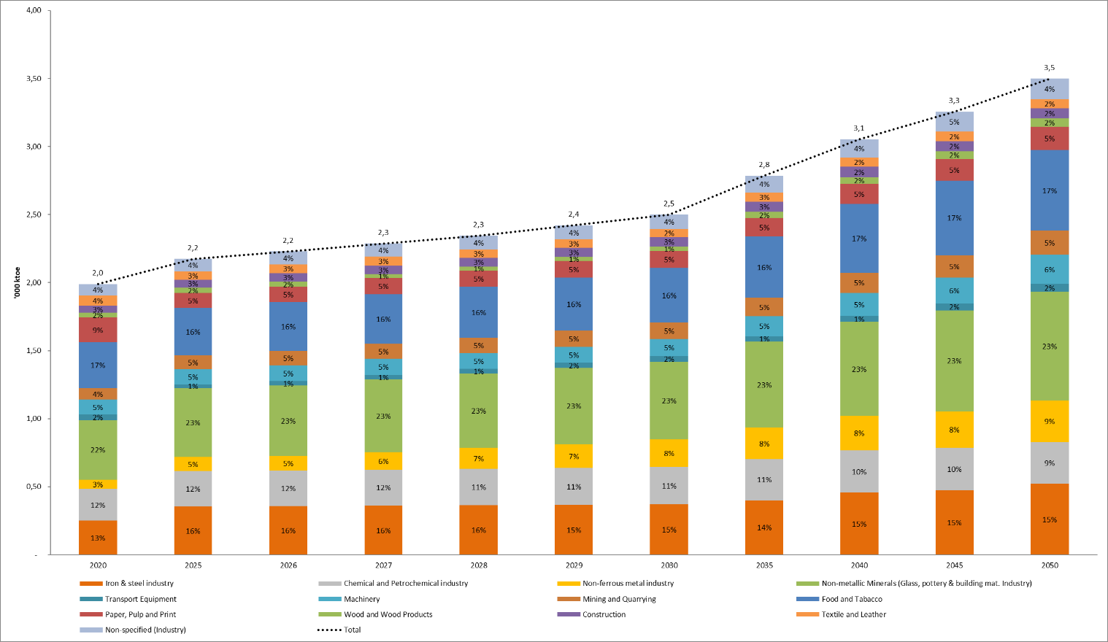
As presented in Figure 4.34, the final energy consumption of the transport sector by fuel is also expected to increase throughout the examined period; from 2.44 Mtoe in 2020 to 2.88 Mtoe in 2030 and to 3.77 Mtoe in 2050. The dominant consumption of oil and petroleum products, among other fuels, is observed in Figure 4.34and is anticipated to increase substantially; from 2.33 Mtoe in 2020 to 2.66 Mtoe in 2030 and to 3.44 Mtoe in 2050. The penetration of natural gas is rather low without managing to restrain the increased transport activity due to the continuous increase of the GDP until 2050. The same conclusion can be derived also for the new purchased vehicles, which are not capable of reducing considerably the final energy consumption.
Figure 4.34: Final energy consumption by energy source in the transport sector over 2020-2050 in the scenario with existing measures (WEM)
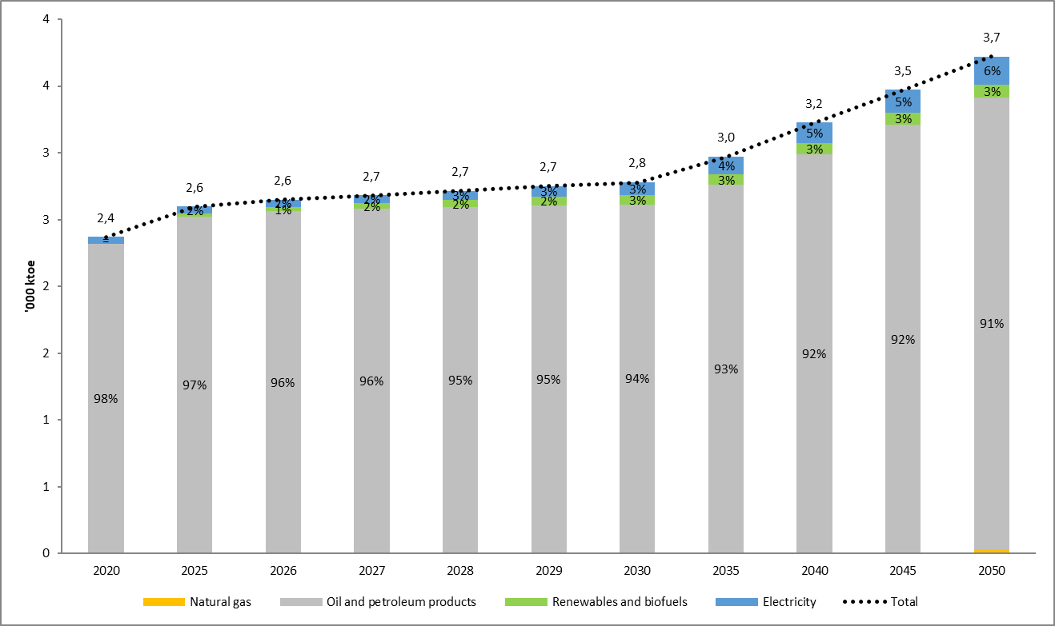
The final energy consumption of all transport modes is expected to increase significantly until 2050, compared to 2020, as shown in Figure 4.35; from 2.44 Mtoe in 2020 to 2.88 Mtoe in 2030 and to 3.77 Mtoe in 2050. The share of road transport, which is by far the largest contributor in the total final energy consumption, is expected to rise from 2.22 Mtoe in 2020 to 2.55 Mtoe in 2030 and to 3.33 Mtoe in 2050. However, in terms of its share in the total final energy consumption, road transport is anticipated to decline from 92% in 2020 to 90% in 2030 and to 88% in 2050.

Figure 4.35: Final energy consumption per sub-sector in the transport sector over 2020-2050 in the scenario with existing measures (WEM)
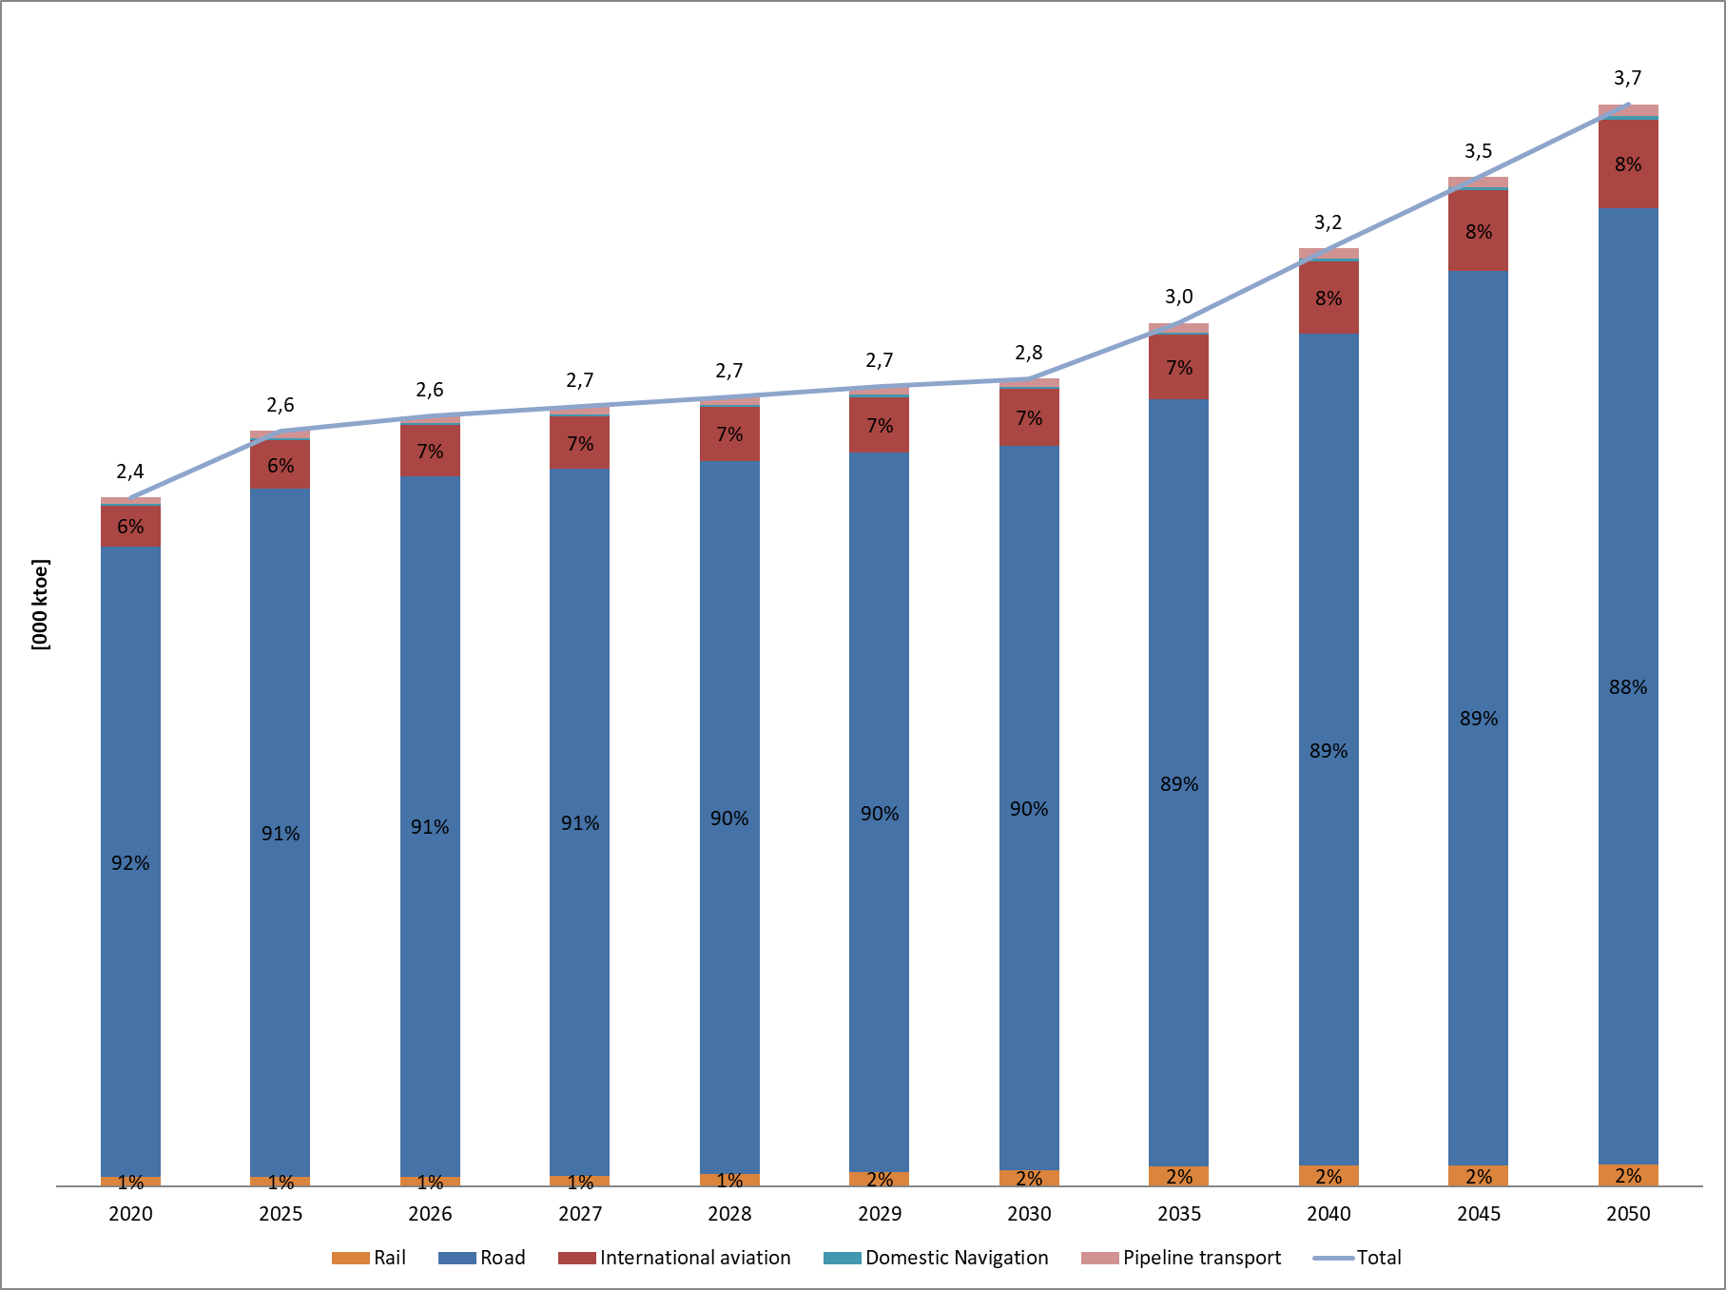
As reflected in Figure 4.36, the final energy consumption of the services sector by energy source is expected to increase from 760 ktoe in 2020 to 1.1 Mtoe in 2030 and to 1.6 Mtoe in 2050 despite the current energy efficiency policies and trends. The electricity consumption will continue to have the highest contribution by 2050 from 388 ktoe in 2020 to 584 ktoe in 2030 and 797 ktoe in 2050. Furthermore, natural gas remains the second most utilised fuel in the services sector until 2050, with a share ranging from 16% to 30% by 2050.
Figure 4.36: Final energy consumption by energy source in the services sector over 2020-2050 in the scenario with existing measures (WEM)
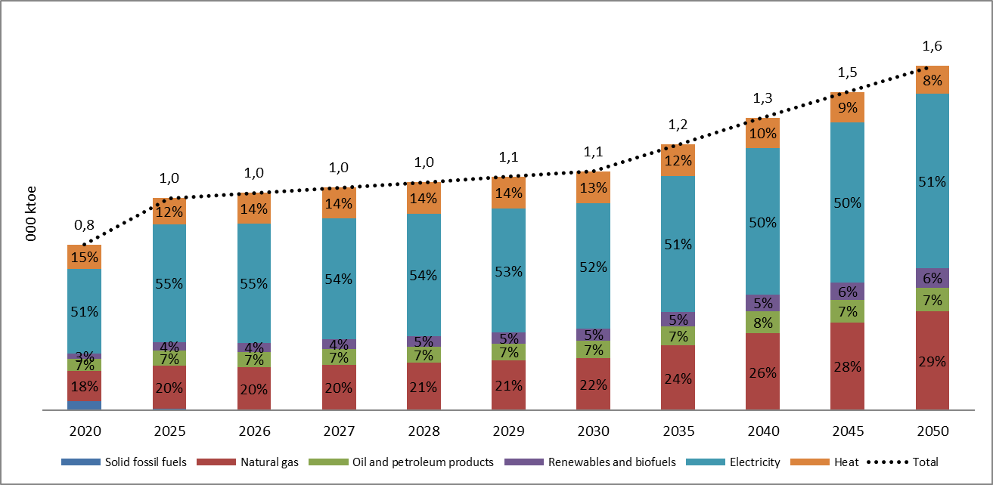
The final energy consumption by energy source in the residential sector is projected to increase throughout the analysed period from 3.3 Mtoe in 2020 to 3.7 Mtoe in 2050, as can be seen from Figure 4.37, despite the substitution of old technologies by more efficient ones using electricity, the adoption of energy conservation behaviour and the limited renovation of the building envelope. As regards the electricity consumption, a significant increase is expected until 2050, leading to a consumption equal to 1.4 Mtoe in 2030 and 1.3 Mtoe in 2050. Similarly, the consumption of renewables and biofuels is expected to rise by 16% in 2030 and decrease by 0.5% in 2050, compared to 2020, being the most utilised fuel in the residential sector until 2050, followed by electricity and derived heat. The consumption of derived heat will grow until 2030, compared to 2020, reaching the level of 506 ktoe, while a reduction is observed during 2030-2050, mainly due to the increased deployment of RES and natural gas. Regarding building refurbishment, in the two main building categories: commercial/services and public sector buildings and residential dwellings. In all scenarios the refurbishment of buildings that exist in 2020 is considered. The stock of existing commercial/services and public sector buildings in 2020 was 45,250,000 m2 and it is not projected to change in the period 2021-2050. For the residential dwellings a relative reduction to their number is projected due to the demolition of some of the oldest buildings towards 2050 (changing from the 2,365,000 dwellings existing in 2020 to 1,466,000 dwellings in 2050).
Figure 4.37: Final energy consumption by energy source in the residential sector over 2020-2050 in the scenario with existing measures (WEM)
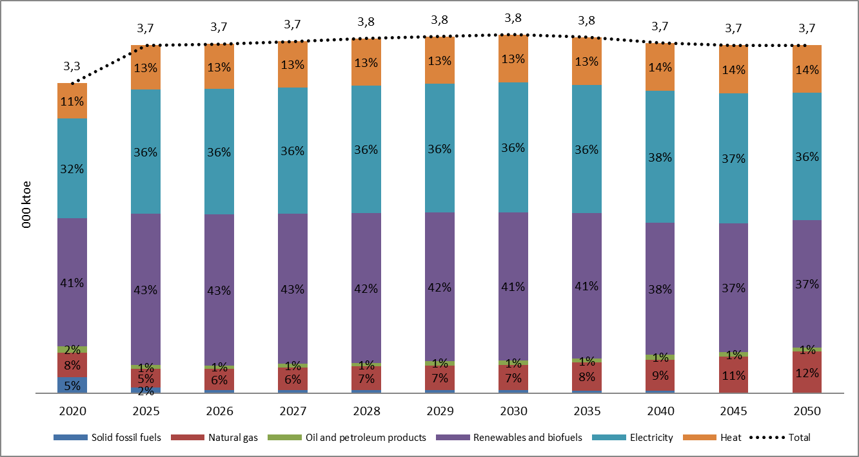
The final energy consumption of the agricultural/forestry sector is projected to increase ( 13% in 2030, 19% in 2040 and 20% in 2050, compared to 2020), resulting in approximately 169 ktoe in 2050, as expected by the increase of demand due to economic development (Figure 4.38) and the lack of targeted policies and measures. Oil and petroleum products continue to have the highest contribution by 2050 in the agricultural/forestry sector reaching the level of 96 ktoe in 2030 and 101 ktoe in 2050.
- Figure 4.38: Final energy consumption by energy source in the agriculture / forestry sector over 2020-2050 in the scenario with existing measures (WEM)
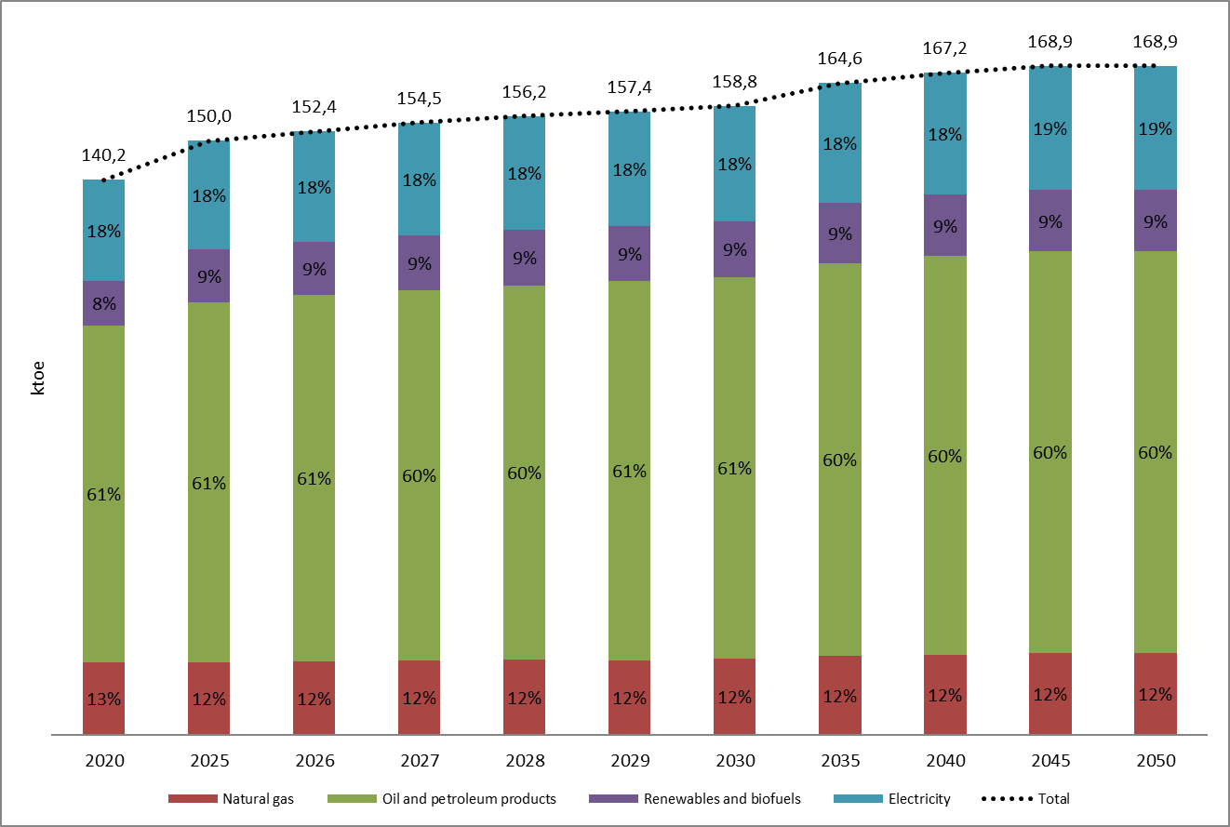

Cost-optimal levels of minimum energy performance requirements resulting from national calculations, according to Article 5 of Directive 2010/31/EU
The Long-term Strategy for encouraging investments in renovation of the national building stock of the Republic of Serbia until 2050 (Long Term Building Renovation Strategy LTBRS adopted in February 2022) aimed at defining energy efficiency measures and packages of measures for the renovation of buildings, based on the determined characteristics of the building stock, the defined reference buildings and the cost-optimal analyses performed for them.
In the Long Term Building Renovation Strategy, the constitution of the Renovation Scenario was based on the cost-optimal analyses for residential and non-residential buildings, which were conducted during 2019–2020. In accordance with the methodological principles adopted in the EU, the following types of buildings were defined: family housing and multifamily housing as well as three commercial buildings as representatives of public and commercial buildings for three different construction periods until 1960, the period between 1961 and 2012, and as the last, the construction period after the introduction of regulations on energy efficiency of buildings, starting in 2013.
The determination of the reference buildings in LTBRS was based on their construction material, physical and architectural characteristics. Moreover, energy efficiency measures were defined for all examined buildings and packages of measures that were identified. Five possible renovation scenarios were prepared within LTBRS, the first of which, the basic scenario, implied unsubsidised renovation and construction according to current regulations, and the last, most advanced one envisaged renovation of buildings at the level of nearly zero-energy buildings (not defined by valid regulations on energy efficiency).
The analysis of the examined scenarios presented in LTBRS was conducted through the calculation of various figures including also the effects on CO2 emissions and primary energy consumption until 2050. It was concluded that only scenarios 4 and 5 of the LTBRS led to a simultaneous reduction of CO2 emissions and a reduction of primary energy consumption. Taking into consideration the economic analysis, scenarios 4 and 5 of the LTBRS were resulted in the most considerable economic benefits, noting that the economic costs for LTBRS Scenario 5 are significantly higher compared to LTBRS Scenario 4. Excluding Scenario 5, Scenario 4 foresaw an increased exploitation of the adopted packages of measures leading to an increased reduction of CO2 emissions equal to 31% compared to 2020, while the reduction of primary energy consumption in 2050 amounted to 38% compared to 2020.
Finally, LTBRS Scenario 4 was proposed as the basis for the Strategic Goal of the Republic of Serbia. In order to achieve the level of savings envisaged by Scenario 4, it is necessary to facilitate the renovation of the existing building stock at the level of 4.1-6.0 million m², while the contribution of the expected floor area of newly constructed buildings has to reach the level of 2.2 million m² annually.

Dimension Energy Security

Current energy mix, domestic energy resources, import dependency, including relevant risks
Over 2010-2020, the primary production remained almost stable at about 10.5 Mtoe, apart from 2014, where a sharp and temporary decline was recorded, as shown in Figure 4.39. Solid fossil fuels, mainly lignite, constituted the prevailing fuels for primary production, with a minor decline of their share from 68.5% in 2010 to 65.7% in 2020. RES and biofuels possess an important role in primary production, while their contribution increased from 19.66% in 2010 to 22.9% in 2020.
Figure 4.39: Primary production over 2010-2020 (Source: Eurostat, 2023)
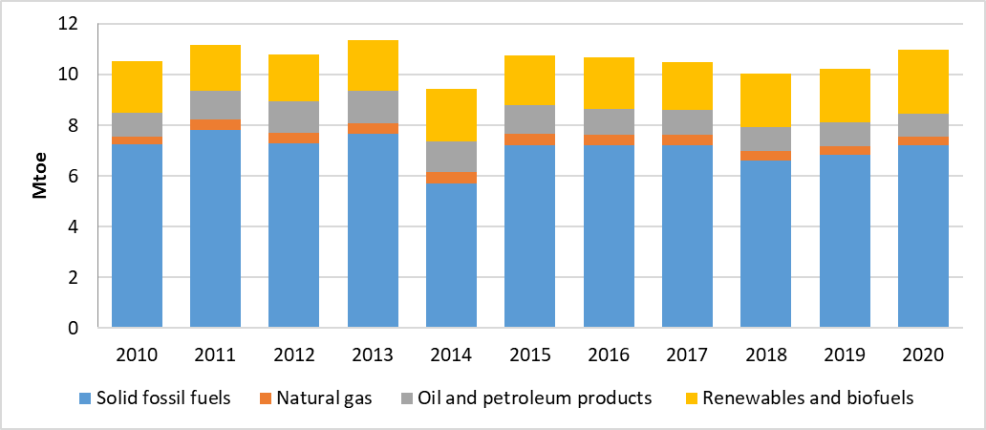
In 2020, the total transformation input in terms of energy use stood at 13.7 Mtoe, about 9.6% higher, compared to 2010 level (12.5 Mtoe), as illustrated in Figure 4.40. Solid fossil fuels and oil and petroleum products were the prevailing fuels in terms of transformation input (7.444 Mtoe and 4.4 Mtoe in 2020 respectively). In addition, the share of solid fossil fuels declined from 57.4% in 2010 to 53.7% in 2020, while the share of oil and petroleum products increased from 27.8% in 2010 to 32.44% in 2020.
Figure 4.40: Transformation input over 2010-2020 (Source: Eurostat, 2023)
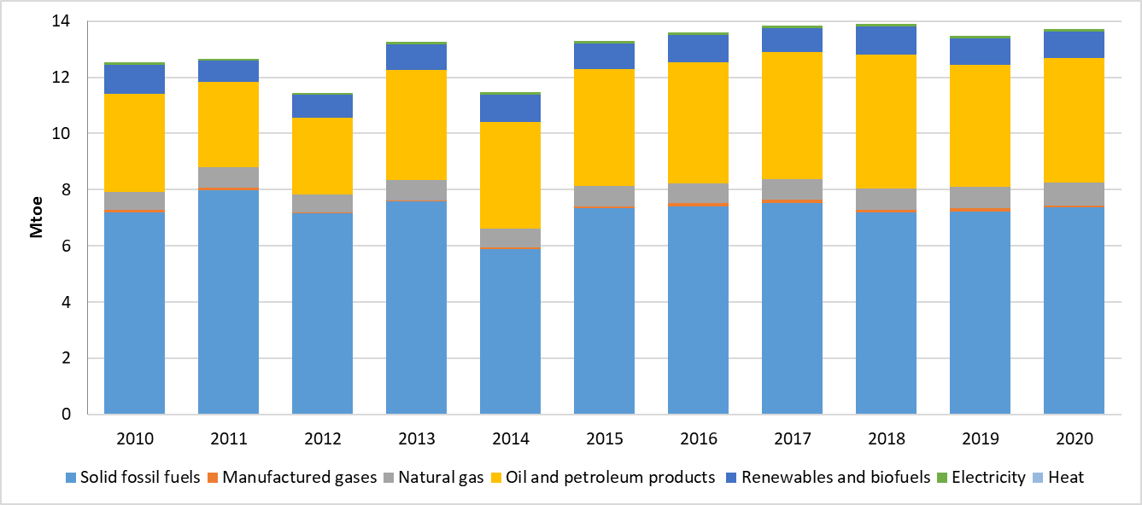
The same tendency was recorded also for the case of the transformation output (generation of electricity, heat and oil products from refineries), as shown in Figure 4.41. In 2020, the total transformation output in terms of energy use stood at 8.7 Mtoe, about 13% higher, compared to 2010 level (7.7 Mtoe). Electricity and oil and petroleum products amounted to 3.33 Mtoe and 4.22 Mtoe in 2020, respectively. Moreover, the share of electricity was reduced from 42.4% in 2010 to 37.4% in 2020, while the share of oil and petroleum products grew from 42.4% in 2010 to 37.4% in 2020.
Figure 4.41: Transformation output over 2010-2020 (Source: Eurostat, 2023)
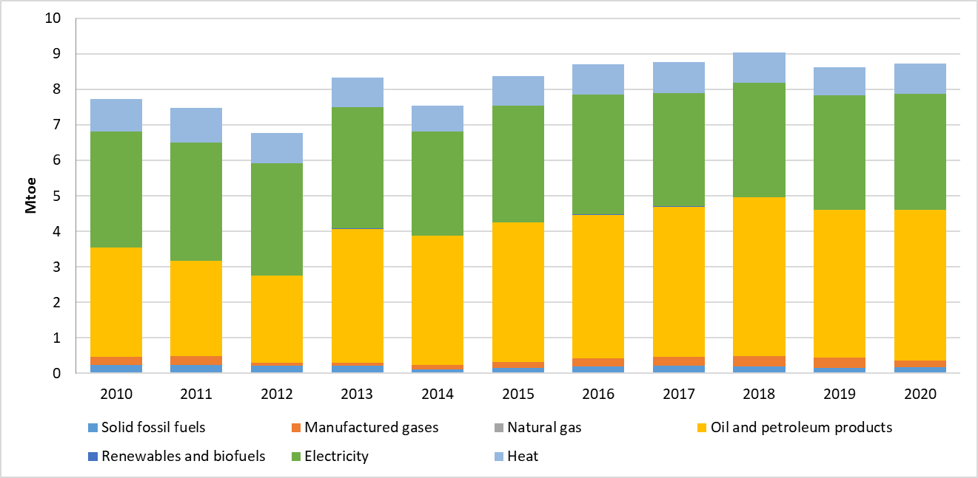

Projections of development with existing policies and measures at least until 2040 (including for the year 2030)
As presented in Figure 4.42, energy import dependency exhibits an increasing trend towards 2050, compared to 2020. More specifically, while energy import dependency in 2020 was 33%, it is expected to increase up to 36% in 2030 and up to 45% by 2050, mainly due to the increased use of natural gas and petroleum products.
Figure 4.42: Energy import dependency over 2020-2050 in the scenario with existing measures (WEM)
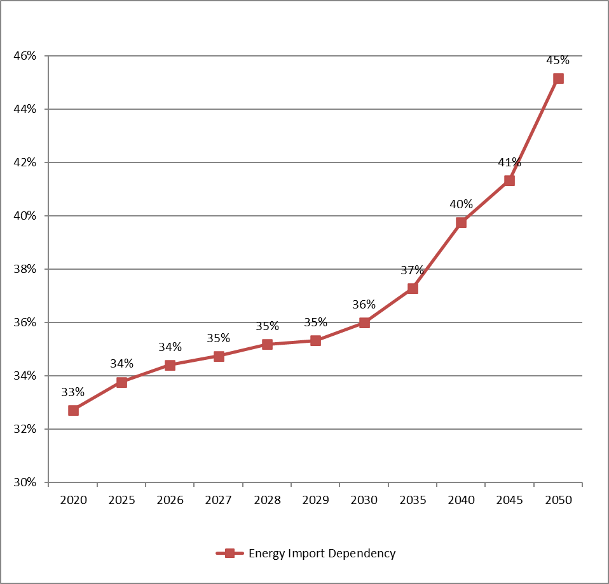
The import dependency of both oil and oil products as well as natural gas is expected to follow almost the same upward trend, as shown in Figure 4.43. However, the import dependency of electricity will move to negative percentages; from -1% in 2020 to -4% in 2030 and to -5% in 2050, indicating that the Republic of Serbia is expected to be a net electricity exporter by 2050.
Figure 4.43: Import dependency of oil and oil products, natural gas and electricity over 2020-2050 in the scenario with existing measures (WEM)
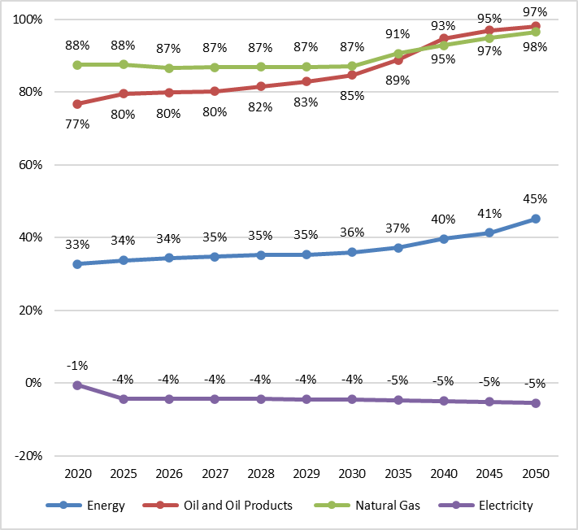
The primary production is expected to increase by 2050; from 10.55 Mtoe in 2020 to 11.88 Mtoe in 2030 and to 11.3 Mtoe in 2050, as presented in Figure 4.44. It should be noted that an increase is observed until 2045 (12.33 Mtoe), while a decline is foreseen until 2050. Solid fuels as well as RES and waste constitute the energy sources with the highest contribution by 2050 demonstrating a rise equal to 9% and 38% respectively compared to 2020.
Figure 4.44: Primary production over 2020-2050 in the scenario with existing measures (WEM)
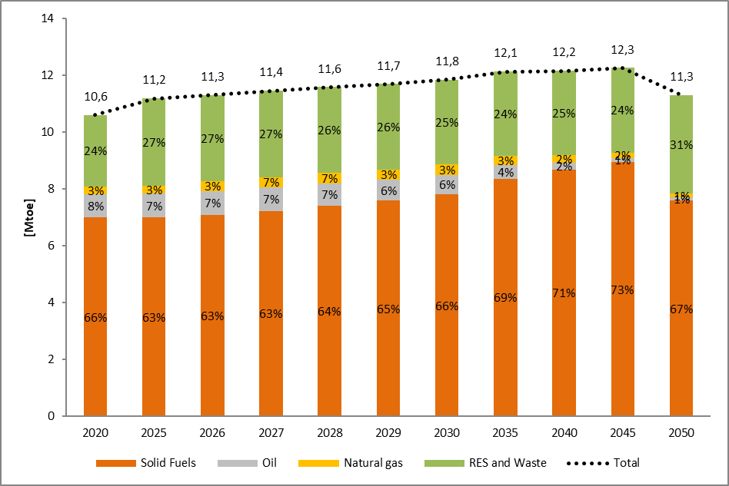
The domestic needs for energy supply will be supplemented by imported energy, considering also exports and stock changes. Generally, it is expected that energy imports will rise, and energy exports will decrease, resulting to an overall increase of total net imports, to complement the decrease of inland production for covering gross inland consumption. More specifically, imports of energy are projected to increase from 6.33 Mtoe in 2020 to 7.6 Mtoe in 2030 and at 9.8 Mtoe in 2050, as shown in Figure 4.45.
Figure 4.45: Energy imports per fuel over 2020-2050 in the scenario with existing measures (WEM)
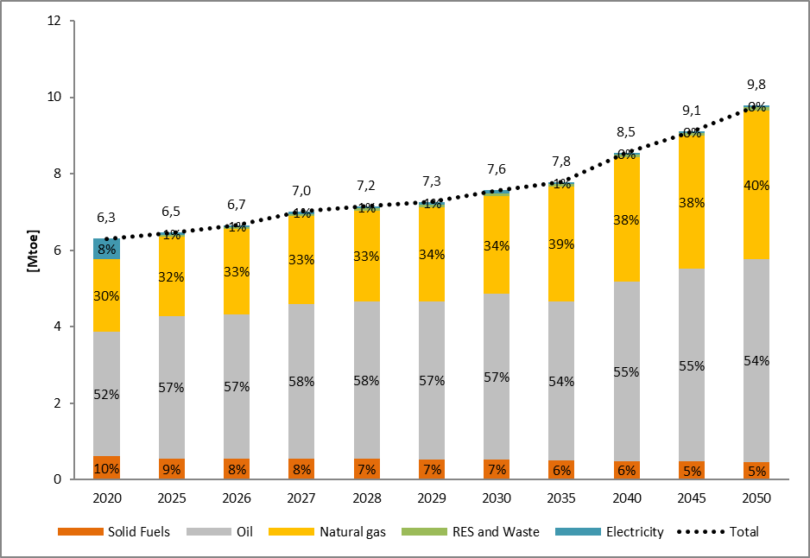
On the other hand, exports of energy are expected to decrease from 1.11 Mtoe in 2020 to 0.99 Mtoe in 2030 and at 0.5 Mtoe in 2050, as presented in Figure 4.46.
Figure 4.46: Energy exports per fuel over 2020-2050 in the scenario with existing measures (WEM)
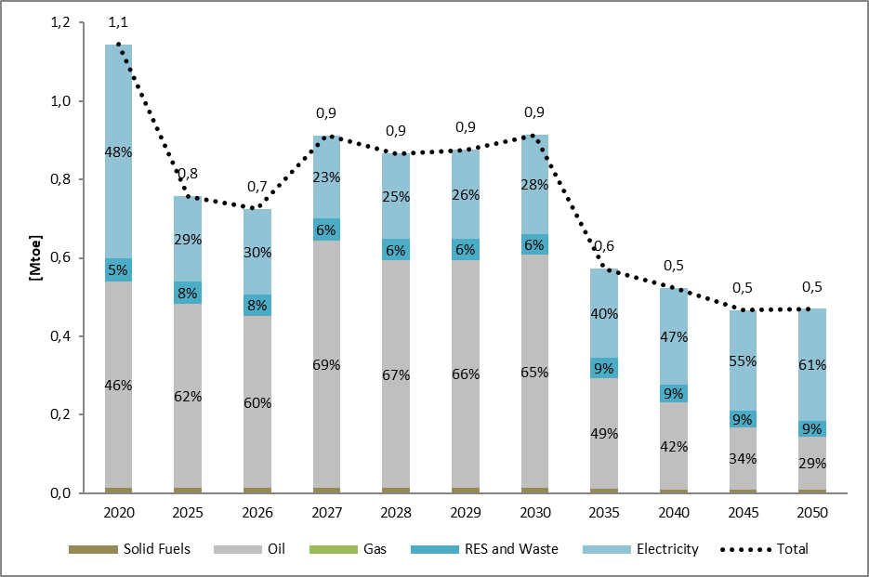
Therefore, it is deducted that net imports of energy are expected to increase from 5.22 Mtoe in 2020 to 6.77 Mtoe in 2030 and to 9.3 Mtoe in 2050, resulting in a 81% increase in 2050, compared to 2020, as illustrated in Figure 4.47.
Figure 4.47: Imports, exports and net imports over 2020-2050 in the scenario with existing measures (WEM)
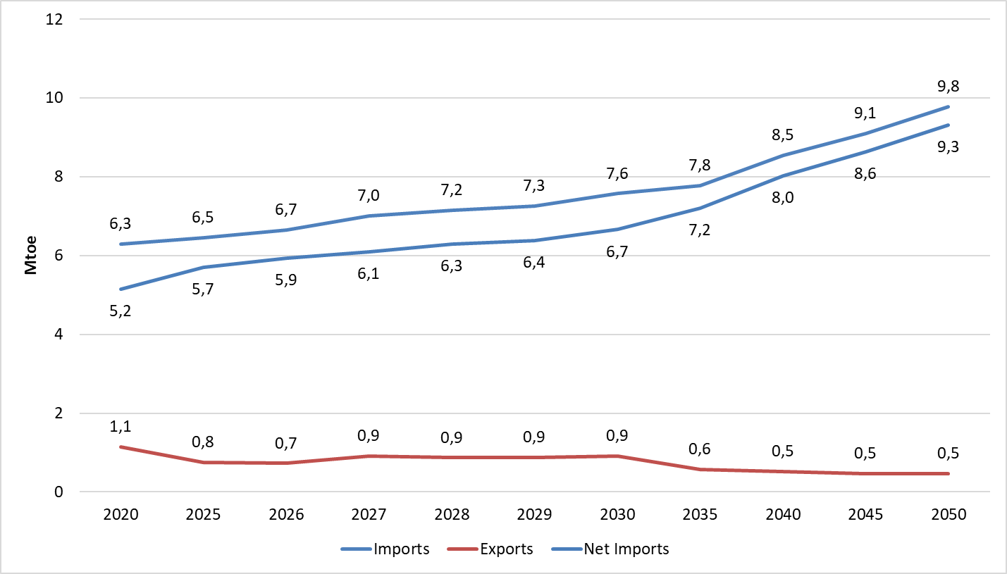
In 2020, the transformation input in electricity sector was equal to 6.99 Mtoe, while the respective figure will increase to 7.99 Mtoe in 2030 before reaching the level of 7.88 Mtoe in 2050. The share of Main Activity producers’ conventional thermal power plants will remain stable at about 98% throughout 2050.
Figure 4.48: Transformation input in electricity sector over 2020-2050 in the scenario with existing measures (WEM)
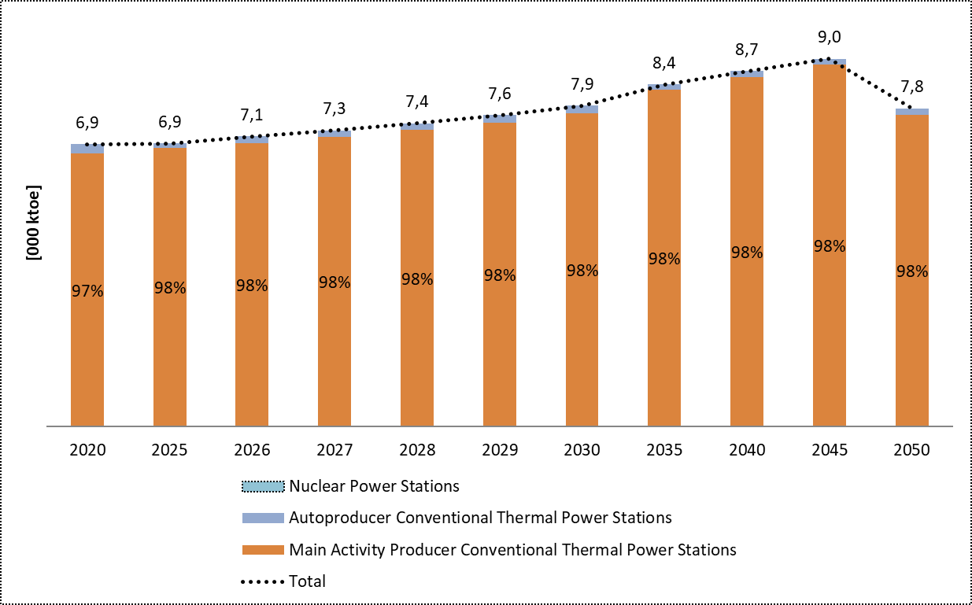
Similarly, the transformation output from the electricity sector was equal to 2.44 Mtoe in 2020, while it is anticipated to increase up to 3.3 Mtoe in 2045, before falling by 2050 at 3.0 Mtoe, as shown in Figure 4.49. The share of Main activity producers’ conventional thermal power plants is expected to be reduced to 94% in 2030 from 95% in 2020, before its final growth to 97% in 2050.
Figure 4.49: Transformation output in electricity sector over 2020-2050 in the scenario with existing measures (WEM)
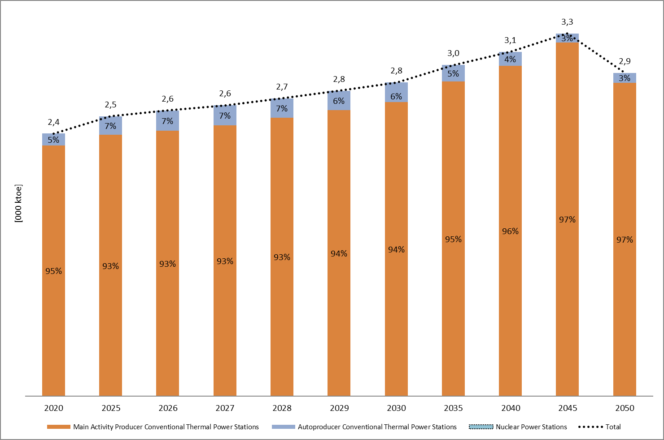
The efficiency of the national electricity grid is projected to be improved until 2050 through the implementation of projects for the enhancement of the electricity grid, as presented in Figure 4.50. More specifically, the electricity transmission network losses are anticipated to be slightly reduced by 0.1% in 2050 as a percentage of total generation, compared to 2020 (2.6%), while the electricity distribution network losses will be declined at 9.1% in 2050, compared to 2020 (11.23%).
Figure 4.50: Total electricity network losses over 2020-2050 in the scenario with existing measures (WEM)
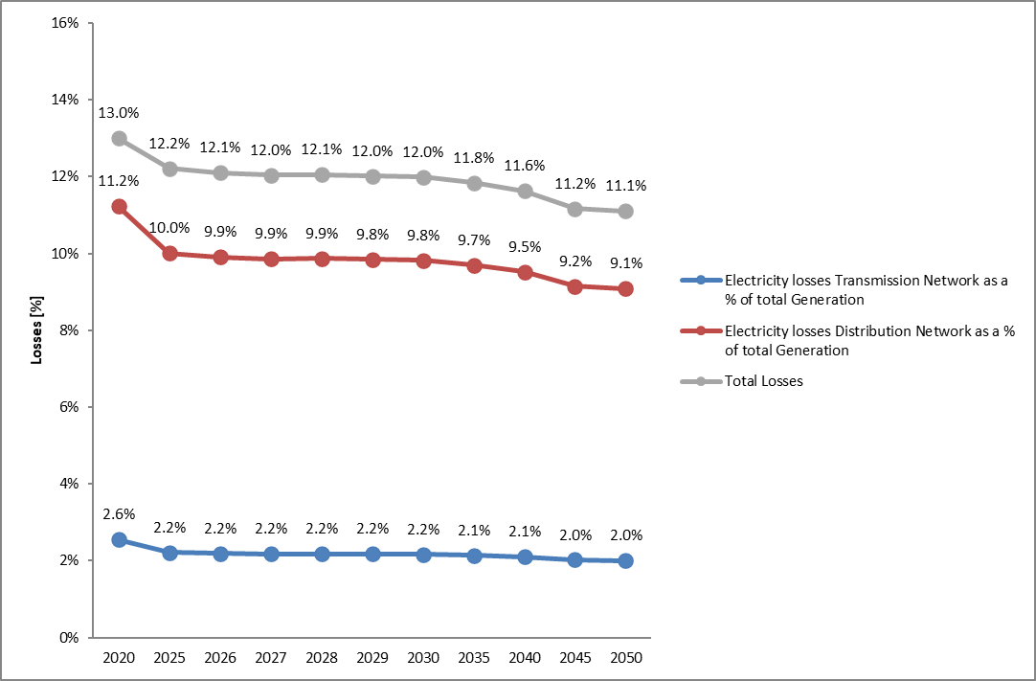
Similarly, the gas transportation network losses are expected to remain low as a percentage of total gas transferred, at a level close to 1% throughout the examined period.
Figure 4.51: Total gas network losses over 2020-2050 in the scenario with existing measures (WEM)
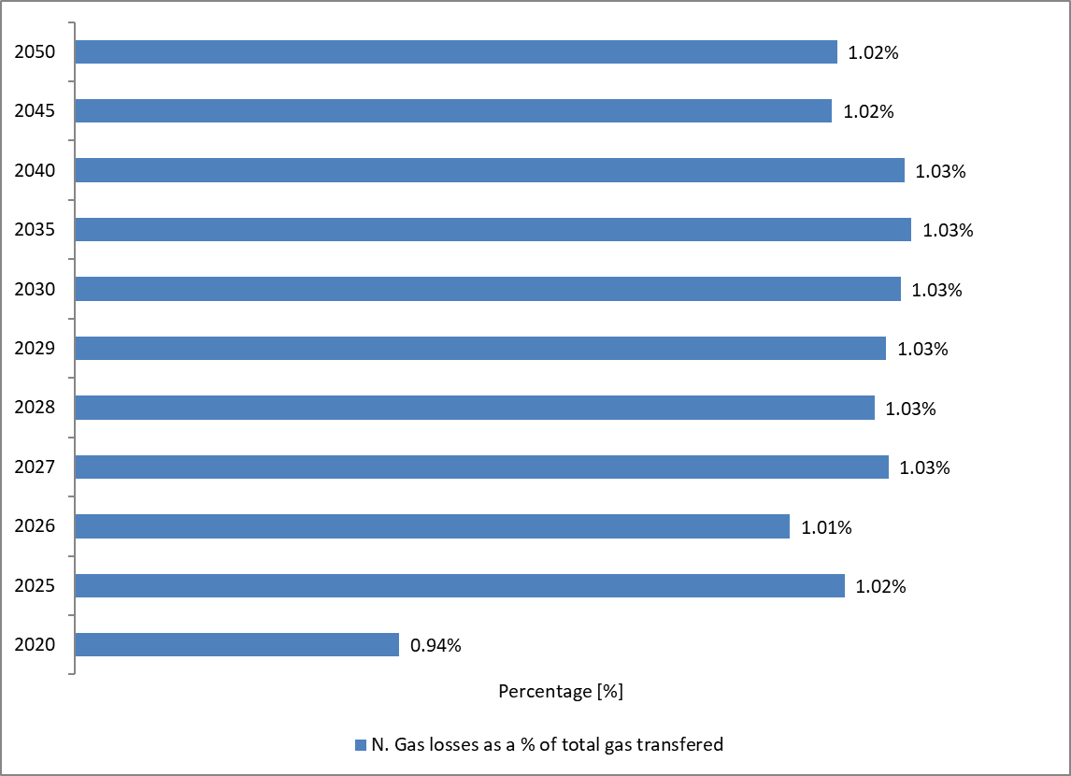

Dimension Internal Energy Market

Electricity interconnectivity

Current interconnection level and main interconnectors
The electricity transmission system network of the Republic of Serbia has a high interconnectivity level with all electricity systems of neighbouring countries. Serbia is connected with 400 kV, 220 kV and 110 kV cross-border overhead lines to all 8 neighbouring countries (Croatia, Hungary, Romania, Bulgaria, North Macedonia, Albania, Montenegro and Bosnia and Herzegovina). Due to its geographical position, the Serbian transmission system is a very important and integral part of the regional electricity system in the Balkans, and, as such the Serbian electricity market demonstrates a substantial activity bolstering the country as a key player for electricity trade in the region and supporting a gradually increasing electricity market integration.
Joint Stock Company "Elektromreza Srbije" (EMS) is the electricity Transmission system operator responsible for developing the transmission grid and manages four regional centres in order to assure the secure functioning of the entire electricity sector. EMS is also responsible for organization and administration of the balancing electricity market and for purchasing ancillary services for frequency and voltage regulation as well as for the coordination of cross-border power exchanges according to the ENTSO-E obligations.
The interconnectivity index of the Serbian transmission system (expressed as the ratio between the sum of the maximum NTC values on the borders and the total installed generation capacity) is reported at 50%, i.e. much higher than the corresponding target of 10% for 2020 for EU member states. This high level of interconnectivity is expected to be utilized more efficiently as regional electricity market integration advances. Realised physical electricity transit in 2020 amounted to 4,532 GWh.
In order to provide insight into the utilisation of interconnecting capacities, Table 4.3 provides an overview of capacities with every neighbouring electricity system. The capacities shown in this table represent the sum of the thermal limits of all transmission lines, and such, they differ for the winter and summer periods. It should be noted that the use of existing interconnecting transmission lines depends both on the limitations in the national transmission network and on the limitations set by the TSOs of neighbouring systems.
Table 4.3: Thermal capacities of interconnecting transmission lines by borders
Border | Summer capacity [MVA] | Winter capacity [MVA]
Albania -Serbia | 1675 | 1675
Montenegro – Serbia | 1874 | 2094
North Macedonia – Serbia | 2424 | 2548
Hungary – Serbia | 1206 | 1330
Bosnia and Herzegovina – Serbia | 1456 | 1631
Romania – Serbia | 901 | 1247
Bulgaria – Serbia | 1206 | 1330
Croatia - Serbia | 1206 | 1330

Projections of interconnector expansion requirements at least until 2040 (including for the year 2030)
Projections of interconnector expansion requirements are performed every two years as a part of ENTSO-E planning studies and are included in the pan-European TYNDP in the form of identification of system needs. In the latest version of the TYNDP 2020, scenarios for 2030 and 2040 lead to a determination of potential needs related to the increase of interconnecting capacities within ENTSO-E over the given timeframe. Figure 4.52 presents the outline of all system needs identified for years 2030 and 2040 in the Balkan region.
Figure 4.52: ENTSO-e TYNDP 2020 identification of system needs for 2030 and 2040 (source: ENTSO-E)
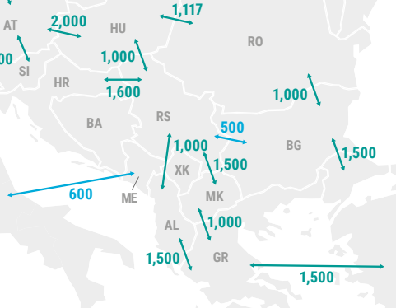 | 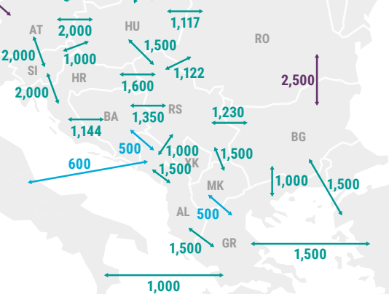
2030 | 2040
Moreover, cross-border capacities expected to be commissioned by 2025 are presented in Figure 4.53 based on the ENTSO-E TYNDP 2022.
Figure 4.53: Cross-border capacities increases by 2025 (source: ENTSO-E)
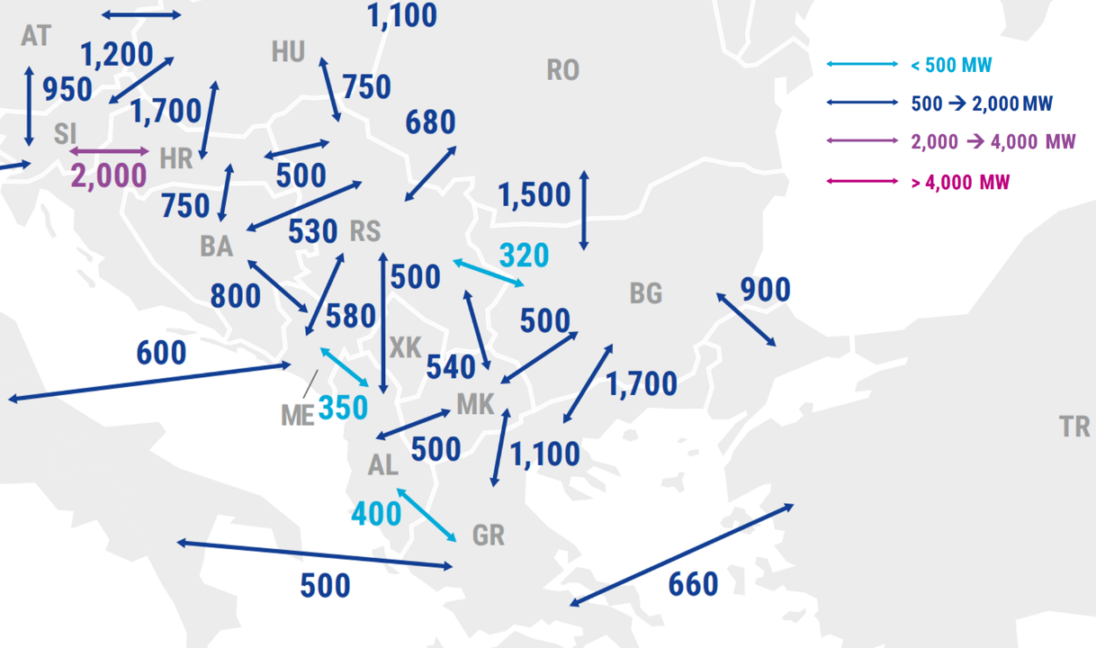
Similarly, and in coordination to the planning studies performed by the ENTSO-E, TYNDP in Serbia contains project as they have identified taking into account the expected system needs for the upcoming period. Serbia plans following power interconnections with neighbouring countries:
- Transbalkan Corridor,
- Pannonian Corridor,
- North Corridor,
- Central Balkan Corridor, and
- 400kV Serbia and Croatia interconnection line (SS Sombor – SS Ernestinovo)
Figure 4.54 shows the simplified grid topology of the electricity transmission network project corridors with all interconnections and transmission lines within the country.
Figure 4.54: Electricity transmission network project corridors (source: EMS)
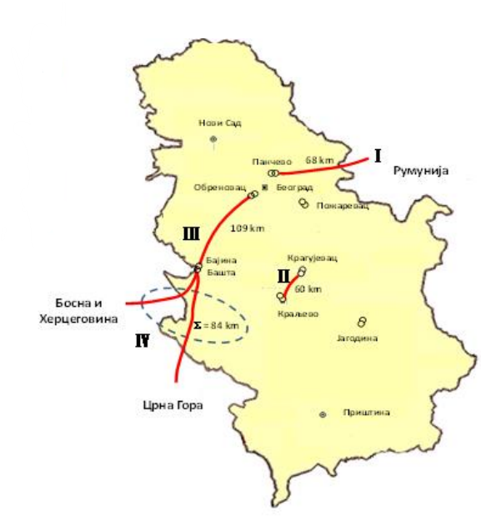  - Trans-Balkan Electricity Corridor | 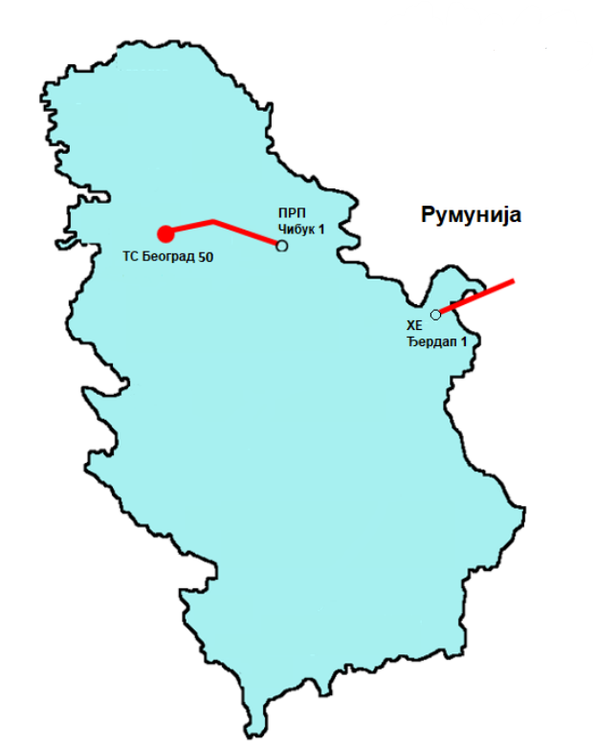  - North Corridor
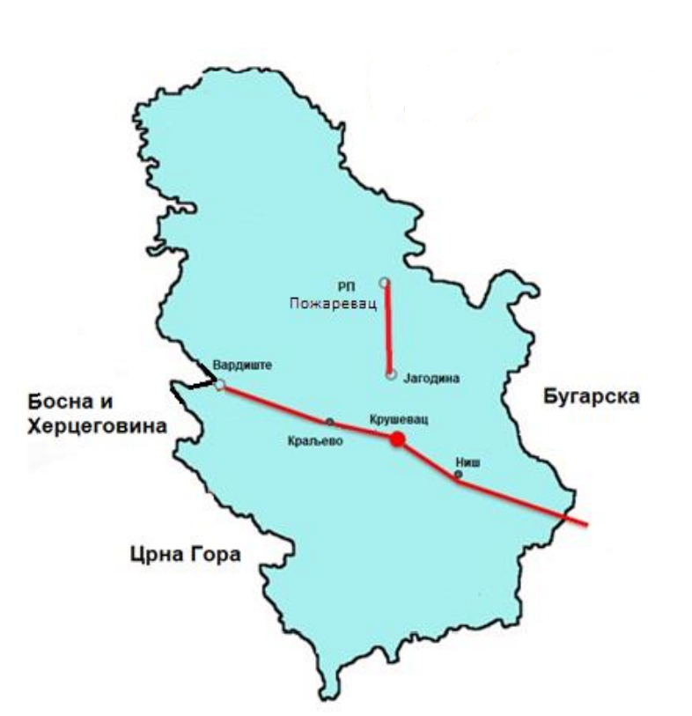  - Central Balkan Corridor | 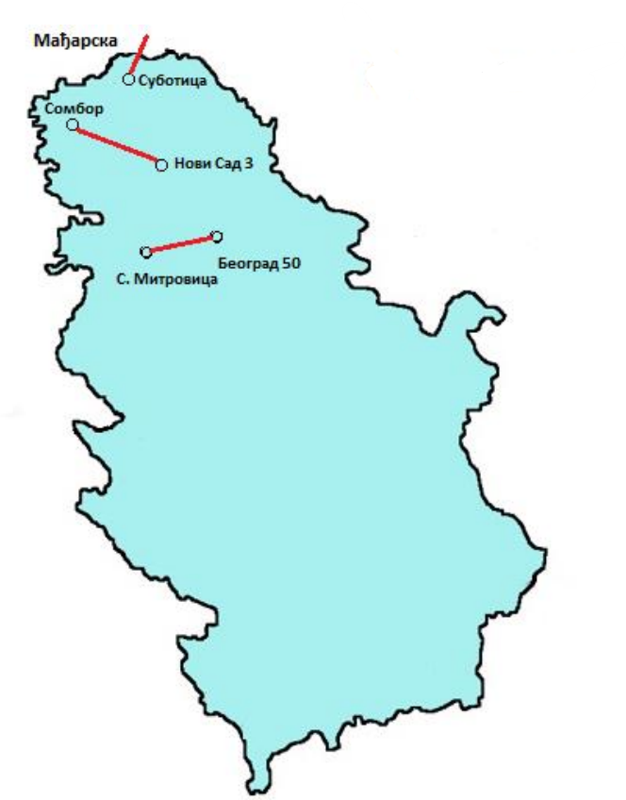  - Pannonian Corridor

Energy transmission infrastructure

Key characteristics of the existing transmission infrastructure for electricity and gas
Electricity transmission system network in the Republic of Serbia consists of lines, substations and other voltage equipment that operate at voltage levels of 400 kV, 220 kV and 110 kV. Total length of all voltage level lines stands at 10866 km in 2019 and there are around 42 substations and 74 transformers.
An overview of the electric transmission system of Serbia is shown in Figure 4.55. The total installed capacity of all substations and transformers was 17,624 MVA in 2019.
Figure 4.55: The Electric Power System of Serbia (source: EMS)
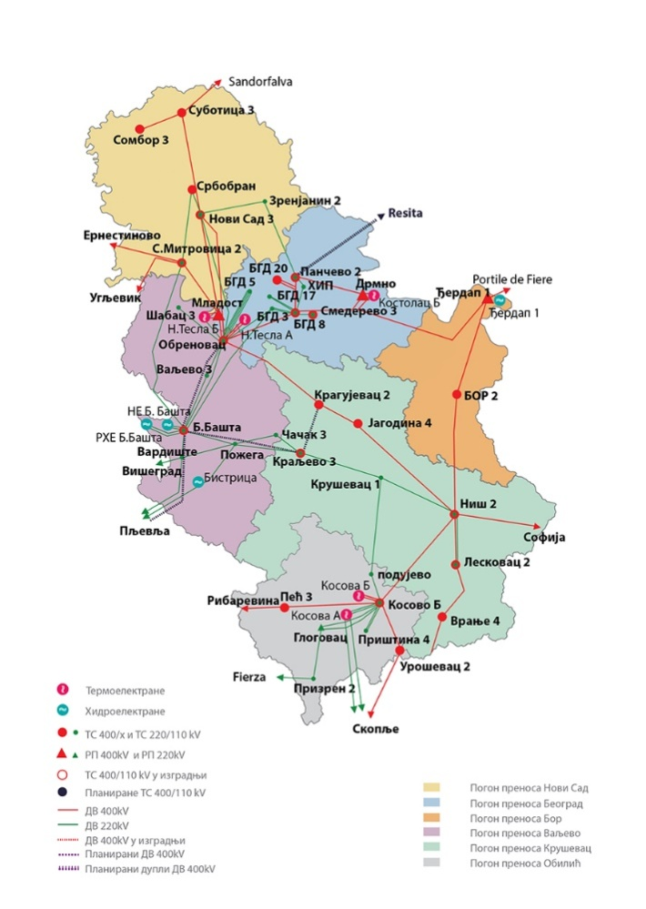
Reconstructions and adaptations of assets of the transmission network are constantly carried out for various reasons, such as the renewal of the useful life of the assets, increase in transmission capacity, increase in safety and reliability, as well as interoperability with other plant and apparatus of the grid. Evidently, based on the all key performing indicators, EMS carries out an adequate planning of the development of the transmission system leading to less faults and reduction of transmission losses.
The natural gas transmission network is operated by three transmission system operators. It is consisted of 2414 km of in north and central Serbia operated by the “Transportgas Srbija” and additional 125 km in southeast Serbia operated by the “Yugorosgaz transport”. Total of 2,483 million m³ of natural gas were consumed in 2020 and 2,708 million m3 of natural gas were available from: import, local production and underground storage.
Gastrans d.o.o. is an independent transmission operator of the interconnection gas pipeline from Bulgaria to Hungary with a length of 402 km.

Projections of network expansion requirements at least until 2040 (including for the year 2030)
Until 2030 and beyond, the electricity transmission network has scheduled and carries outcome mayor investments involving strengthening and new interconnections. On individual interconnection lines, additional new interconnections are under consideration:
- Serbia - Bosnia and Herzegovina 110 kV SS Ljubovija – SS Srebrenica
- Serbia – Montenegro – Bosnia and Herzegovina 2x400 kV Serbia-BH-MNE
- Serbia – Croatia 400 kV SS Sombor 3 – SS Ernestinovo
- Serbia – Bulgaria 400 kV SS Leskovac – SS Bobov Dol
- Serbia – Romania 400 kV SS Djerdap 1 – SS Portile de Fier
- Serbia – Montenegro 110 kV SS Tutin – SS Rozaje
- Serbia – Hungary 400 kV SS Subotica 2 – TS Sandorfalva
Due to the expected increase of renewable energy sources generation capacities and an increased need of transmission capacity improvement within the territory of Serbia, the following three projects are identified as part of the existing electricity transmission network Corridor projects:
- Implementation of Transbalkan Corridor: OHL SS Kragujevac (RS) - Kraljevo (RS)
- Implementation of Transbalkan Corridor: OHL Obrenovac (RS) - Bajina Basta (RS)
- Cluster of network infrastructure projects in the wider area of Belgrade (BEOGRID)
- Panonian Corridor project: OHL 400kV Sombor – Novi Sad 3 and OHL 2x400kV Belgrade 50 – Sremska Mitrovica 2
- Central Balkan Corridor project: OHL 400kV Niš 2 – Kruševac – Kraljevo – Požega – Vardište and OHL 400kV Požarevac 3 – Jagodina 4
EMS in the Transmission System Development Plan for the period 2023-2032 (Chapter Adequacy analysis of generation) states that there are submitted connection requests reaching the level of 19.3 GW of RES until 2032 (1.9 GW of which on the distribution system and 17.4GW on the transmission system), of which 0.8 GW (with EDS) and 4.5 GW (with EMS) entered in contractual relationship with the corresponding system operators.
The implementation of the Serbia-Bulgaria gas interconnection project is one of the most recent investment projects in the natural gas transmission network which is currently under development. The following interconnection projects are seen in future projections to foster diversification of natural gas supply and allow wider interconnection with neighbouring systems:
- Project for Serbia-Romania gas interconnection 85.5 km (out of which 12.8 km is on the territory of the Republic of Serbia), with a capacity of 1.2 billion m3/year
- Project for Serbia-Croatia gas interconnection (95 km, with a capacity of 1.5 billion m3/year)
- Project for Serbia-BiH gas interconnection 90 km, with a capacity of 1.2 billion m3/year
- Gas pipeline - interconnection with Montenegro
- Project for Serbia-Macedonia gas interconnection 70.7 km, with a capacity of 0.8 billion m3/year
- Project for Nis-Pristina gas pipeline construction 65 km, with a capacity of 0.8 billion m3/year

Within the country boarders the main gas pipeline RG 11-02 Leskovac-Vladicin Han-Vranje of 71 km length and with a capacity of 1.5 billion m3/year, shall be to enable gasification of the south Serbia.

Electricity and gas markets, energy prices

Current situation of electricity and gas markets, including energy prices
In Serbia the electricity day-ahead market is operated by South-Eastern European Power Exchange (SEEPEX) which was established in 2015 on the basis of partnership between EMS JSC and EPEX SPOT in France as a joint stock company with the majority ownership of the Serbian side. It is licenced for the operation of organized electricity markets. In 2020, the day-ahead electricity market operated in the power exchange had 22 participants registered / which amounted three participants more than 2019. In both years of reference, an average 18 participants were actively involved in the day-to-day trade activities.
In 2020, suppliers mainly competed and traded amongst themselves in the wholesale electricity market because non-EPS generation which comprise existing wind parks operate as privileged producers and sell electricity to the guaranteed supplier at fixed feed-in tariffs. The suppliers’ activity in the open market appears very active in the field of cross-border exchange, primarily with the purpose of enabling transit through Serbia. This opportunity appears as the dominant choice of suppliers organising transit exchanges due to central geographic position of the power system of Serbia in the region. As per Energy Agency Annual report in 2020, supplier activity amounted to around 14.7 TWh. There were 57 active market players and 11 suppliers dealing with final customers supply in the open market in 2020. The electricity supply activities are mostly related to the commercial consumers. There were 64 energy entities holding supply licences out of which 11 were active in supplying final consumers. The dominant electricity supplier is EPS with a market share corresponding to more than 95% of the electricity sold to final consumers. Figure 4.56 presents average retail prices in the competitive segment of the retail electricity market, net of VAT and duties. Households and small consumers are entitled to guaranteed supply which implies supply of electricity at regulated prices. Evolution of electricity prices for households is presented in Figure 4.57.
Figure 4.56: Average annual retail prices in the competitive electricity, excluding VAT and duties free (source: AERS)
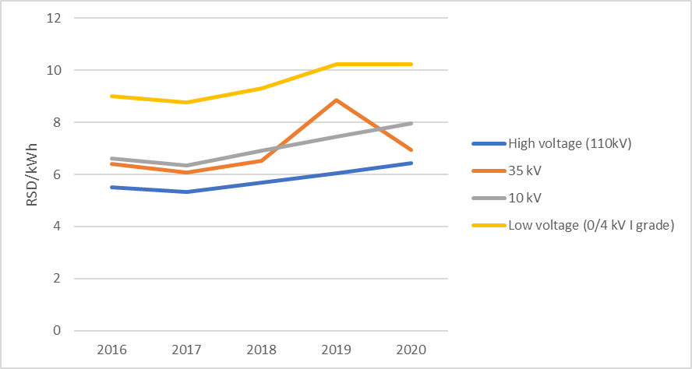
Figure 4.57: Average annual retail prices in the regulated market, excluding VAT and duties free (source: AERS)

In the natural gas wholesale market, there are three licenced natural gas suppliers and one producer which were active in 2020, while trading is carried out through bilateral contracts. Until a competitive natural gas market is established, the Government of the Republic of Serbia appoints the supplier of public suppliers. There were 26 active suppliers in the open market who dealt with retail in 2020 while there were 31 public suppliers who also acted as natural gas distributers. Historical data for natural gas public supply price and average weighted retail price in the regulated market are presented below.
Figure 4.58: Average approved natural gas public supply price in RSD/m³ (source: AERS)
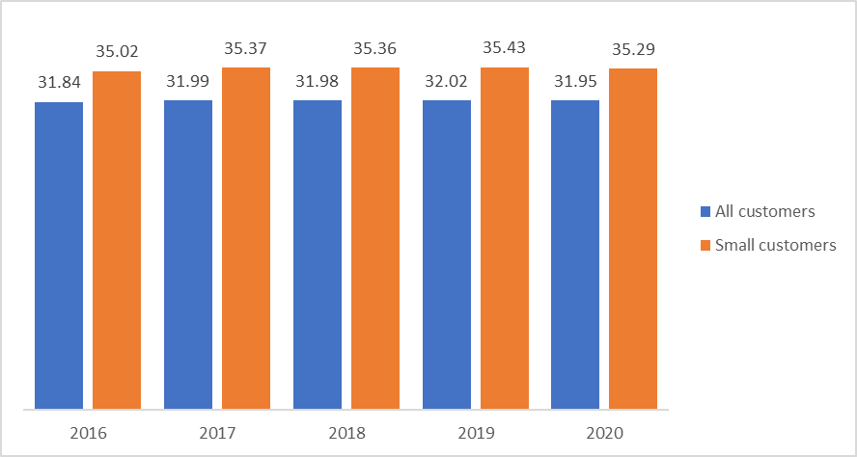
Figure 4.59: Average weighted retail price in the regulated market in RSD/m3(source: AERS)
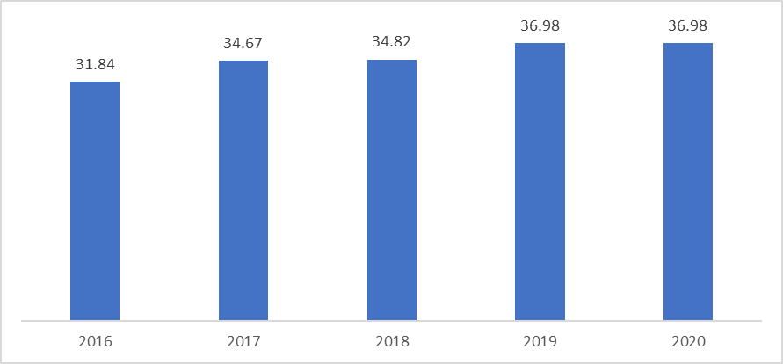

Projections of development with existing policies and measures until 2040 (including for the year 2030)
The main goal of the SEEPEX development in the coming years relates to market coupling of the day- ahead and intraday markets with organised markets in the neighbouring countries. According to announced plans the following projects should be completed by 2025:
- Day ahead market coupling between Serbia and the markets of Hungary and Romania;
- Day ahead market coupling between Serbia with the markets of Croatia and Bulgaria;
- Day ahead market coupling between Serbia with the Montenegrin market (and, implicitly, with the Italian market).
The estimation of evolution of the average electricity supply cost for the scenario with existing measures based on the expected development is shown in Figure 4.60. The estimation of these costs involved an analysis of the foreseeable investments pertinent to the construction of new power plants, as well as projections and assumptions on the fuel costs and other operating costs of all power plants. The estimate does not include the annuities of plants that are already in operation and does not include any carbon price, since this is not considered in the WEM analysis.
Figure 4.60: Estimated average electricity supply cost in the scenario with existing measures (WEM)
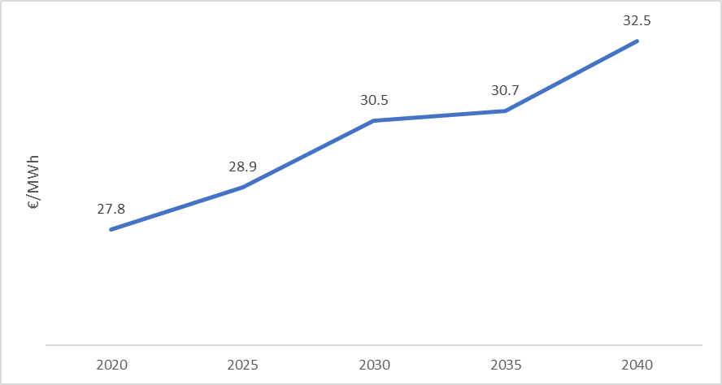
Natural gas sector in Serbia is expected to undergo a reform of the wholesale market with a view to foster competition, establish of a natural gas exchange and unbundle the supply from distribution activities.
In respect to natural gas price development projections, the average annual import prices are shown in the following figure. The projections of international gas prices follows the “Recommended parameters for reporting on GHG projections in 2023” by EC DG Climate Action which was provided by the EC in order to support Member States and other bodies (e.g. the EnC Secretariat) to revise their INECPs.
Figure 4.61: Natural gas average annual import prices in the scenario with existing measures (WEM)
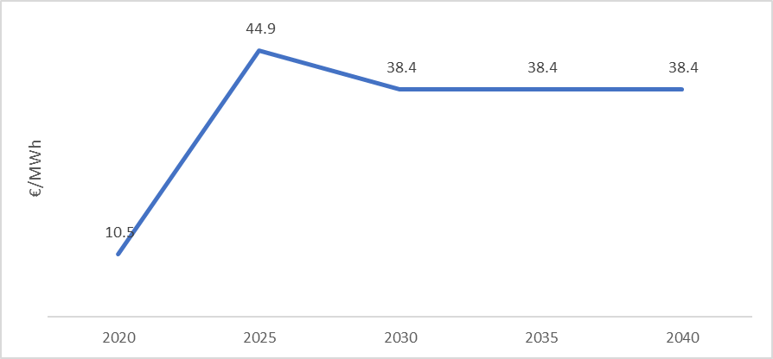

Breakdown of current price elements that make up the main three price components
Electricity
Based on the Methodology for determining price of power for guaranteed supply from the Energy Agency of the Republic of Serbia, the structure of the price of electricity consists of the fixed part and the consumption-based part, varying depending on the consumer type and category. Electricity tariff for public supply prescribes three consumer categories – low voltage consumption, households and public lighting. In case of low voltage consumption category, customers are obliged to pay public supplier charges which is fixed part, and consumption-based part for calculated and excessive power, reactive and excessive reactive energy, as well as active energy which are divided in high daily tariff and low daily tariff.
In case of households, the fixed part includes public supplier charges, while consumption-based part includes active energy and calculated power. Electricity consumed has several categories, based on metering principles - one-tariff metering, two-tariff metering, controlled consumption and controlled consumption with specific metering. The higher and lower tariff are differently calculated depending on part of country. Serbia is divided into three zones - Vojvodina, Belgrade and Central Serbia. Thus, the lower tariff applies in in period 22.00h – 06.00h for Central Serbia, in period 23.00h – 07.00h for Vojvodina, and in period 24.00h – 08.00h for Belgrade. Furthermore, electricity consumed is calculated as per three different pricing zones – green, blue and red. Those pricing zones define level of consumption, where green zone is up to 350 kWh, blue 351 - 1,600 kWh and red over 1,600 kWh.
When it comes to other elements, both fee for incentive of privileged electricity producers and fee for improvement of energy efficiency are applied as unit price in relation to consumption, as defined in Decree on the Amount of the Fee for Incentives for Privileged Electricity Producers and new Law on Fees for use of Public Goods. Finally, pricing includes excise tax (7.5%) and VAT (20%) as well.
In case of industry, pricing includes part for costs related to distribution system as defined per Pricelist for access to distribution system, electricity consumed, fees for privileged producers and energy efficiency, and excise tax and VAT. The electricity consumed for industry is calculated as per contracted price.
Natural gas
Transmission system connection costs are set by TSO on the basis of elements from the connection application and on the Methodology for Setting Costs of Connection to Natural Gas Transmission and Distribution System adopted by the AERS. Distribution system connection costs are set by DSO on the basis of elements from the connection application and on the Methodology for Setting Costs of Connection to Natural Gas Transmission and Distribution System adopted by the AERS. The variation in distribution use-of-system charges with different DSOs is the result of the size and features of the distribution systems, the structure and number of customers, the age of the distribution system and other factors.

Description of energy subsidies, including for fossil fuels
In Serbia, a system to encourage the use of renewable energy sources for the electricity production was introduced in 2009, enabling RES electricity producers to receive feed-in-tariffs for the kilowatt-hour of electricity produced, depending on the renewable energy source used and technology. Since 2021, with adoption of the Law on the Use of Renewable Energy Sources, the Decree on Market Premiums and Feed-in Tariffs and the Decree on the Model for Market Premium Agreement, Serbia set up new incentive framework in the form of premium system. In addition to the market premium, the Law on the Use of Renewable Energy Sources also envisages feed-in tariff system remaining available only for small plants and demonstration projects. The same law introduced concept of prosumers as well, enabling consumers to act as a producer and stipulating to deliver surplus to network. Furthermore, the Regulation on assuming balance responsibility and a contract model on assuming balance responsibility was formulated.
With aim to support energy transition through energy savings, Serbia introduced households-orientated mechanism, providing subsidies for increase of energy efficiency. In cooperation with local governments, by securing funds Government stimulates citizens to invest in replacement of doors and windows, the installation of insulation, the installation of boilers and stoves using cleaner fuels, as well as the installation of solar collectors and solar panels.
In 2023, Serbia adopted Decree on the conditions and the manner of carrying out a subsidized purchase of new electric and hybrid vehicles which prescribes incentive scheme for purchase of new environmentally friendly vehicles - electric and hybrid, providing a subsidy which ranges from 250 euro to 5,000 euro depending on the type of vehicle. System includes five categories of vehicles, covering mopeds and light tricycles, motorbikes, passenger cars and light trucks exclusively electricity-powered, vehicles running on hybrid traction with the obligation that recharging can be carried out from an external source of electricity, as well as electric vehicles with integrated composition to extend their range with CO2/km emissions of up to 50 g/km, and vehicles with hybrid traction which have at least one electric motor in addition to the internal combustion engine and can drive without running the internal combustion engine for a certain time and exclusively on electric traction, whereby the generation of electricity to recharge the battery is carried out inside the vehicle.

Dimension Research, Innovation and Competitiveness

Current situation of the low-carbon-technologies sector and its position on the global market
Currently, in Serbia there are limited activities regarding R&D in the energy sector and limited number of producers of low-carbon technologies. In recent years, there has been a strong focus on more extensive use of alternative sources, partly driven by environmental obligations that have provided impetus for new technological demand. Current key priorities of energy research in Serbia are energy efficiency and renewable energy, smart cities and mobility, as well as energy storage, but still, most of the companies in the energy sector are service-orientated, mainly in RES and EE. Therefore, there is a significant potential for scaling up low-carbon and energy-efficient solutions, starting from the demonstration and pivotal stage up to the market of renewable energy technologies and achieving more significant energy savings.

Current level of public and private research and innovation spending on low-carbon-technologies, current number of patents, and current number of researchers
Total expenditures for research and development activities in 2020 amounted to 0.91% of GDP. The share of total budgetary funds for R&D in GDP reached 0.46% in 2020. The largest percentage of budget funds for R&D went to the government sector (64.4%), followed by the higher education sector (23%). Funds from international organizations participate with 9.3% in the total funds for financing scientific research work, the non-financial (business) sector participates with 2.1%, while 1.1% of funds were allocated for the non-profit sector. In 2020, Serbia had 335 organizations active in research and development, with majority operational within business sector, while one-third belongs to tertiary education sector.
Figure 4.62: Breakdown of R&D organizations per sector (source: Statistical Office of the Republic of Serbia)

Looking at fields of science, most of organizations are focused on engineering and technology (128), together with social sciences (72) and natural sciences (63). Detailed breakdown is presented in Figure 4.63 below.
Figure 4.63: Breakdown of R&D organizations per fields of science (source: Statistical Office of the Republic of Serbia)

In 2020, Serbia had 23,524 full-time and part-time employees engaged in R&D activities, with 62.4% employed in tertiary education sector, 23.5% in government sector and 14.1% in business sector. Detailed breakdown of employees per sector and field is given in Figure 4.64 below.
Figure 4.64: Number of employees engaged in R&D activities (source: Statistical Office of the Republic of Serbia)

In 2020, the basic research works have dominated (54.3%), while applied research works has significant share (29.8%), and development research works the lowest (15.9%). However, tertiary education sector has been the most productive in terms of number of research works performed (7,731 projects and studies), followed by the government sector (3,860 projects and studies). In both sectors, the basic research works were priority, 60.2% in government sector and 59.2% in tertiary education sector. Finally, business sector has been applied-focused, with 54.7% of applied research works and 34.9% of development projects and studies. Figure 4.65 below presents country-level breakdown of research works per type and field.
Figure 4.65: Breakdown of research works by fields of science and type (source: Statistical Office of the Republic of Serbia)

As per official statistics, there were 21,877 enterprises in 2020, of which 84% are large enterprises, 13% medium enterprises and 3% small enterprises. The share of those business entities with at least one type of innovation is 54.79%. More than 69% of large business entities are innovative, about 58% of medium-sized business entities and about 54% small business entities. Figure 4.66 below presents breakdown of innovative enterprises per sector.
Figure 4.66: Breakdown of innovative enterprises per industry (source: Intellectual Property Office of the Republic of Serbia)

In 2020, the total number of patents registered were 1,546 patents including 56 granted according to the national procedure, 28 entered into the Register on the basis of the Cooperation and Extension Agreement with the European Patent Office and 1,462 on the basis of the law on the ratification of the Convention on the Grant of European Patents. Out of 56 granted patents, 52 were patents of residents and 4 of non-residents. Out of the total number of patents granted in the national procedure, 84.2% were those invented by natural persons and 15.8% those invented by legal entities.

IMPACT ASSESSMENT OF PLANNED POLICIES AND MEASURES
The impact assessment of the additional, planned policies and measures, quantified with the use of the modelling tools, is presented in the current chapter. As was mentioned before, this projection corresponds to the implementation of additional measures, aiming to reduce emissions and increase RES and EE by 2030 and is denoted as Scenario S in the following sections. In this scenario, a number of measures are put into place, aiming at a gradual reduction of emissions until 2030, and the process of decarbonization is intensified, afterwards targeting at low emissions level by 2050. A variation of scenario S, denoted as Scenario S-N considers the introduction of Nuclear Power Plants of a total capacity of 1,000 MW after 2040 in the Serbian power system, to examine their possible contribution to the decarbonisation pathway towards 2050. In the next sections the projections for Scenario S are compared with the projections of scenario WEM (described in detail in Chapter 4) in order to show the extra effort which is required in each dimension for the achievement of the targets and objectives of the INECP.
Some of the key inputs to this scenario include building renovations, which are actively promoted both for residential buildings (with 1% to 1.5% annual rate for multi-family buildings and 0.5% for single-family) and mainly public sector buildings (3.3% annual renovation rate until 2030) and other non-residential buildings (2.3% annual renovation rate until 2030) and is intensified toward 2050 by doubling the renovation rates. Electrification of heating and transport is coupled with increased share of RES in electricity generation, while renewable hydrogen is introduced initially in demonstration projects and after 2030 in larger quantities. Biomethane is gradually introduced in the thermal applications and included in blending with natural gas, together with renewable hydrogen after 2030.
Carbon pricing is included in this scenario for the sectors which are identified in the EU-ETS scheme according to the values in the following table. The background assumption of these prices is that carbon pricing is first introduced in Serbia in 2027 at a low rate of 4€/ton. It is subsequently increased to 40€/ton in 2030, corresponding to half of the EU-ETS price as projected in the document “Recommended parameters for reporting on GHG projections in 2023” (EC DG Climate Action), and reaches the full projected EU-ETS price, by 2045.
Table 5.1: Carbon pricing projections
 | 2030 | 2035 | 2040 | 2045 | 2050
Euro/tCO2 | 40 | 41 | 45 | 130 | 160

The assumptions regarding the key exogenous parameters that are driving the development of the energy sector and emissions as well as international fuel prices and evolution of costs of technologies are the same as those used in the WEM scenario, as shown in Chapter 4.1.

Impacts of planned policies and measures described on energy system and GHG emissions and removals
The overall GHG emissions, including agriculture, waste and LULUCF (The projection of emissions from agriculture, waste and LULUCF are taken from scenario M2 of the Climate Strategy and Action Plan, elaborated by the Ministry of Environmental Protection), present a different trend between WEM and scenarios S and S-N by 2050. More specifically, the overall GHG emissions in WEM are expected to increase from 2026 to 2045 before decreasing in 2050, while the total GHG emissions in scenarios S and S-N are moving constantly downwards over 2026-2050; at a lower pace by 2029 and at a higher one between 2030 and 2050.
The total GHG emissions, including agriculture, waste and LULUCF, stood at 47,765 ktons of CO2-eq in 2030 in both scenarios S and S-N (Figure 5.1). A reduction of 40% in 2030 has been recorded in scenarios S and S-N (Figure 5.2), compared to the 1990 levels due to the increased penetration of RES and the implementation of energy efficiency measures, while at the same time a reduction of 19% is recorded in 2030 in WEM scenario, compared to 1990.
In 2050, the total GHG emissions, including agriculture, waste and LULUCF, reach 21,330 ktons of CO2-eq in scenario S and 19,745 ktons of CO2-eq in scenario S-N. A reduction of 73% and 75% has been recorded in scenarios S and S-N respectively in 2050, compared to the 1990, while the corresponding decline in WEM scenario compared to 1990 is equal to 9% demonstrating the impact of the additional policies and measures.
Figure 5.1: Total GHG emissions (including agriculture, waste and LULUCF)
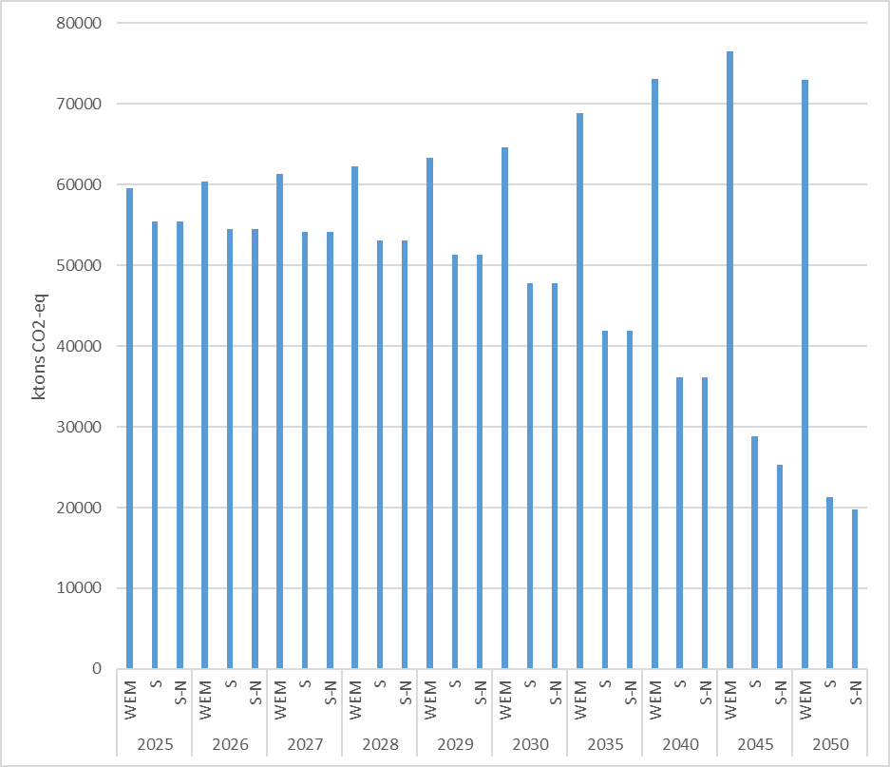
Figure 5.2: Total GHG emissions (including agriculture, waste and LULUCF) reductions as percentages with respect to 1990
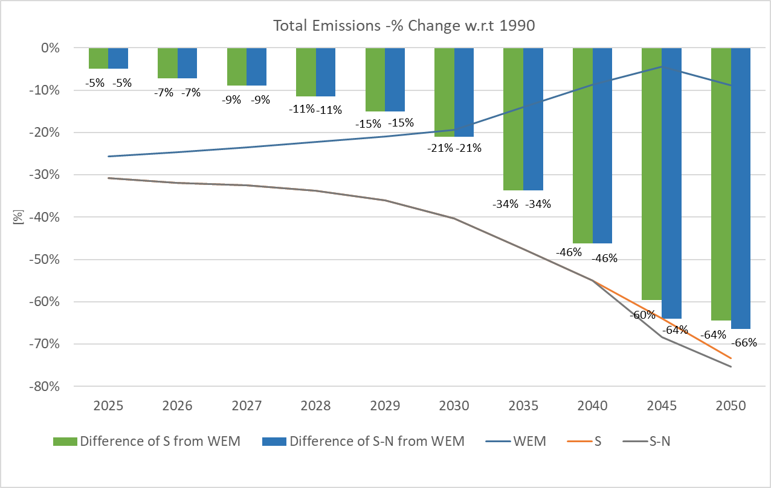
In scenarios S and S-N, the GHG emissions from energy use, processes, and fugitive emissions are equal to 47,477 ktons of CO2-eq in 2030. A reduction of 34% in 2030 has been noted in scenarios S and S-N, compared to the 1990 due to the increased penetration of RES and the implementation of energy efficiency measures, while at the same time a reduction of 10% is recorded in 2030 in WEM scenario, compared to the 1990.
Figure 5.3: GHG emissions from energy use, processes, and fugitive per sector
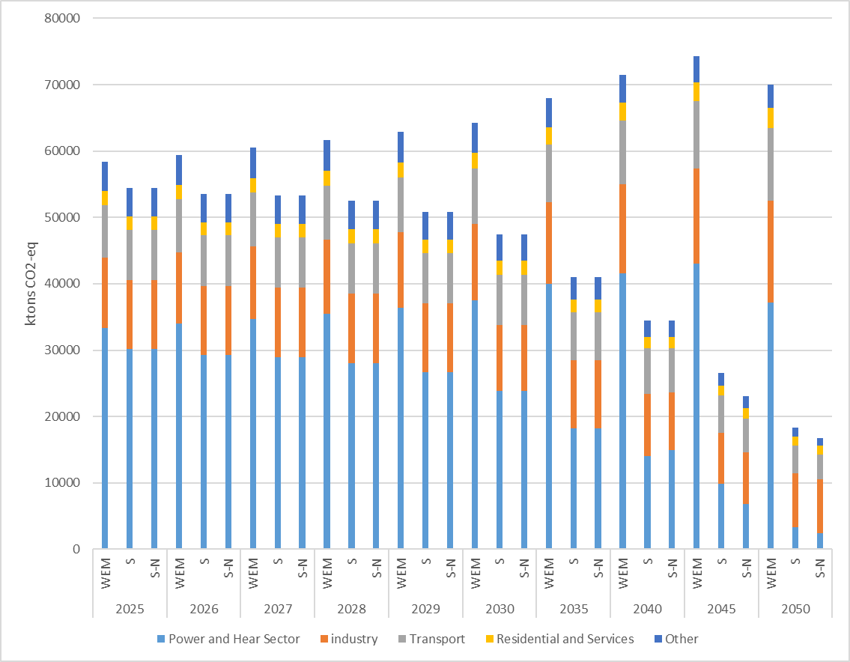
Although the projected GHG emissions from energy use, processes, and fugitive decrease by 52% in both scenarios S and S-N in 2040, compared to the 1990, they are differentiated in 2050 leading to 18,376 ktons of CO2-eq in scenario S and 16,791 ktons of CO2-eq in scenario S-N due to the introduction of the nuclear power plants in scenario S-N. A reduction of 74% and 77% has been recorded in scenarios S and S-N respectively in 2050, compared to the 1990, while the corresponding decline in WEM scenario compared to 1990 is equal to 2% demonstrating the impact of the additional policies and measures.
Figure 5.4: GHG emissions from energy use, processes, and fugitive reductions as percentages with respect to 1990
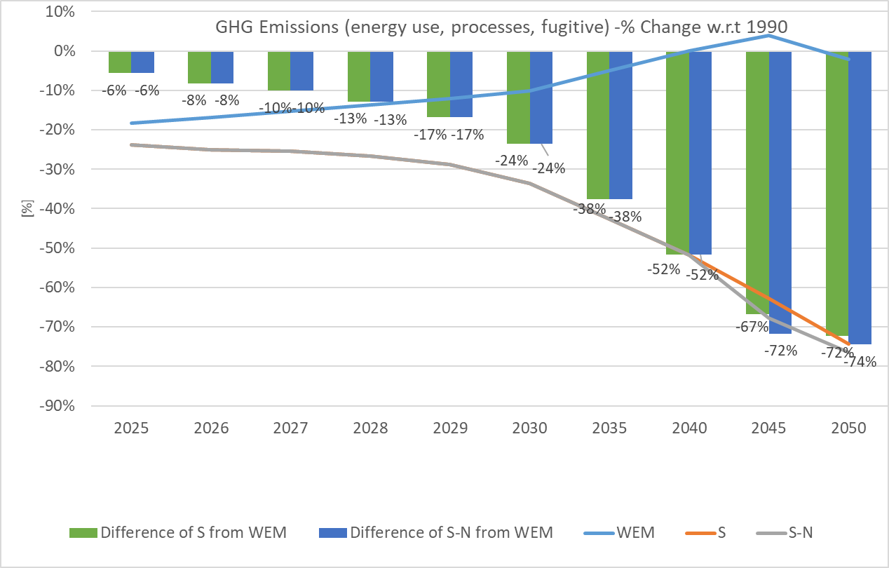
The total GHG emissions from energy use, processes, and fugitive for all sectors stand at 47,477 ktons of CO2-eq in scenarios S and S-N in 2030. More specifically, 23,865 ktons of CO2-eq are resulted by the power and heat sector, 9,858 ktons of CO2-eq by the industrial sector, 7,617 ktons of CO2-eq by the transport sector, 2,147 ktons of CO2-eq by the residential and services sectors and 3,990 ktons of CO2-eq by the other sectors. The total emissions from the above-mentioned sectors in scenarios S and S-N in 2030 are 26% lower, compared to the WEM scenario over the same year.
Similarly, in 2050, the total GHG emissions from energy use, processes, and fugitive for all sectors amount to 18,376 ktons of CO2-eq in scenario S and 16,791 ktons of CO2-eq in scenario S-N considerably less than the respective figures in 2040 depicting the intensification of the policies and measures for the promotion of decarbonization process. More specifically, 3,365 ktons of CO2-eq are derived by the power and heat sector, 8,045 ktons of CO2-eq by the industrial sector, 4,206 ktons of CO2-eq by the transport sector, 1,311 ktons of CO2-eq by the residential and services sectors and 1,448 ktons of CO2-eq by the other sectors for the case of scenario S. The respective figures for scenario S-N consist of 2,471 ktons of CO2-eq for the power and heat sector, 8,080 ktons of CO2-eq for the industrial sector, 3,736 ktons of CO2-eq for the transport sector, 1,300 ktons of CO2-eq for the residential and services sectors and 1,204 ktons of CO2-eq for the other sectors. The total emissions for the above-mentioned sectors in scenarios S and S-N in 2050 are 74% and 76% lower respectively, compared to the WEM scenario over the same year.
Figure 5.5: GHG emissions (from energy use, processes, and fugitive) per sector
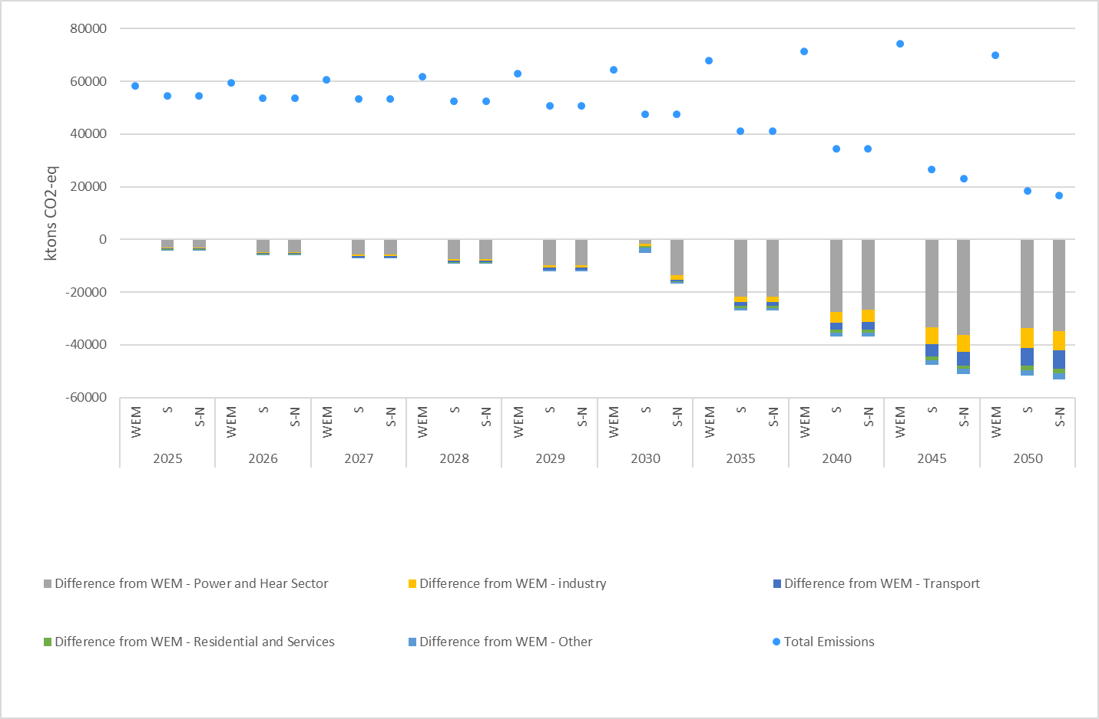
The non-energy related emissions from agriculture are projected to reach 4493 ktonsCO2eq in 2030 in the Scenario S and increase to a level of 5432 ktons CO2eq in 2050 (the same trajectory is followed in Scenario-SN). Emissions from waste would reach a level of 2371 ktons CO2eq in 2030 and would be reduced to 1936 ktonsCO2eq in 2050. Land Use, Land Use Change and forests are expected to contribute considerably to a reduction of emissions by -6576 ktons CO2eq in 2030. However, this contribution is expected to be reduced towards 2050, when it is projected to reach -4414 ktonsCO2eq.
Figure 5.6: GHG emissions from agriculture (non-energy related), waste and LULUCF
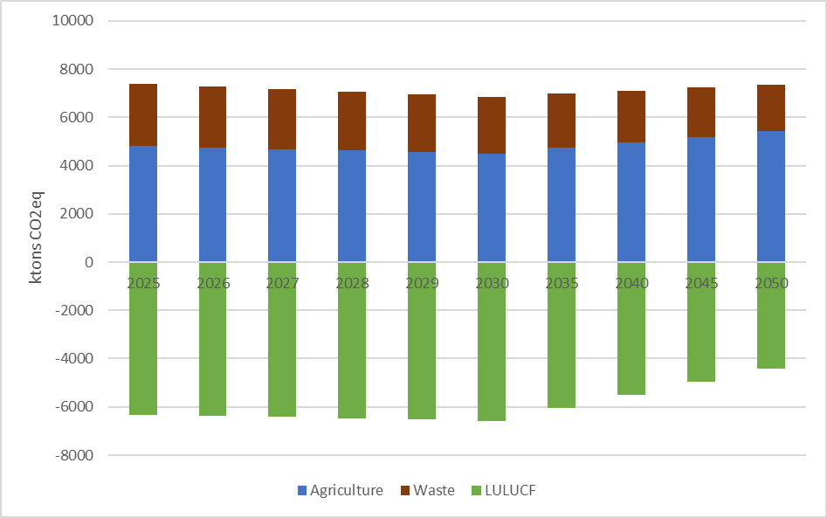
In WEM scenario, CO2 emissions are equal to 60.4 Mt in 2030, higher than 44.3 Mt in scenarios S and S-N over the same year. In 2050, total CO2 emissions will increase only in WEM scenario by 10.7% at 66.9 Mt, compared to 2030 level, while a 61.3% decrease (at 17.1 Mt) in scenario S and a 64.9% fall (at 15.6 Mt) in scenario S-N are anticipated. Electricity and CHP as well as industry are the sectors with the highest CO2 emissions in both 2030 and 2050 in all scenarios, followed by transport.
Figure 5.7: Total CO2 emissions per sector
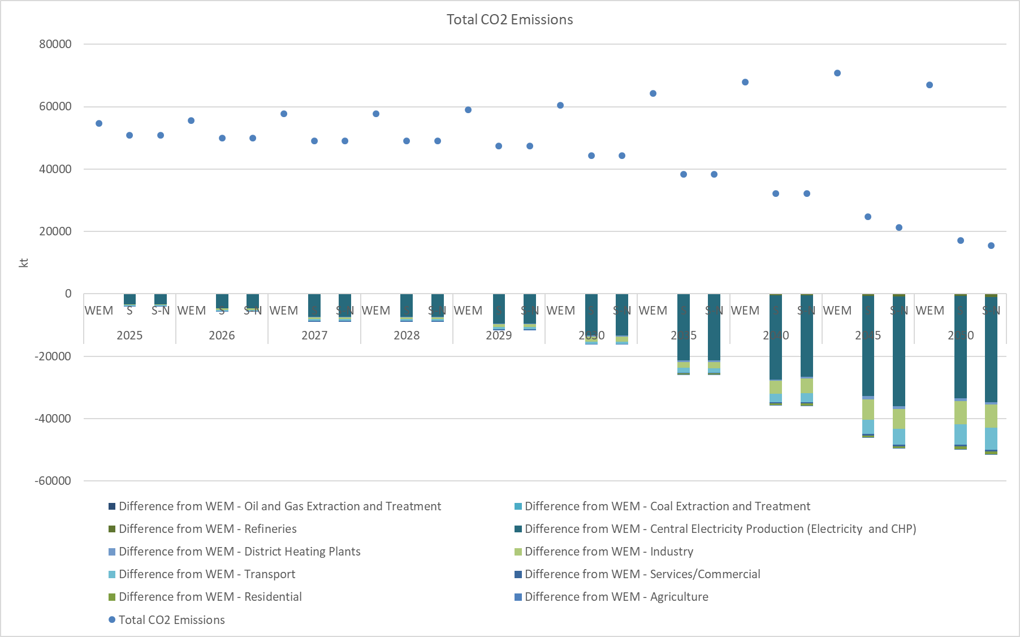
In WEM scenario, total CH4 emissions from energy use, fugitive and industrial products, are equal to 116 Mt in 2030, higher than 93 Mt in scenarios S and S-N over the same year. In 2050, total CH4 emissions will decrease by 29.5%, 79.9% and 80.3% in scenarios WEM, S and S-N respectively, compared to 2030 level. Coal extraction and treatment as well as oil and gas extraction and treatment are the sectors with the highest CH4 emissions in both 2030 and 2050 in all scenarios, followed by residential sector.
The CH4 emissions reduction from fugitive emissions in coal mines, oil and gas sector, is projected to decrease by 20% between 2020 and 2030 in Scenarios S and S-N. This part of methane emissions is estimated to be close to 30% of the total CH4 emissions in 2020. In view of the participation of Serbia in the Methane Pledge several policies and measures mentioned in Chapter 3 are expected to contribute to the reduction of CH4 emissions by at least 30% in 2030 compared to 2020 levels, through manure management, reduction of enteric fermentation of animals, composting, and utilisation of methane from sanitary landfills.
Figure 5.8: Total CH4 emissions per sector
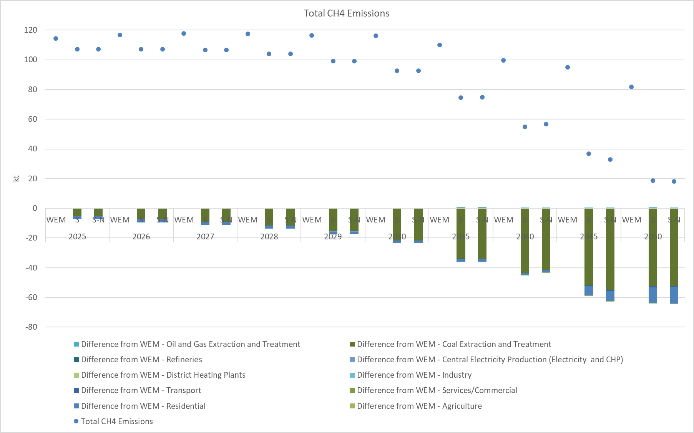
Similarly, total N2O emissions are equal to 3.2 kt in 2030 in WEM scenario, higher than 3.0 kt in scenarios S and S-N over the same year. In 2050, total N2O emissions will increase only in WEM scenario by 8.8% at 3.5 kt, compared to 2030 level, while a 10.2% decrease (at 2.7 kt) in scenario S and a 11.9% fall (at 2.6 kt) in scenario S-N are anticipated. Industry and transport are the sectors with the highest N2O emissions in both 2030 and 2050 in all scenarios, followed by electricity and CHP.

Figure 5.9: Total N2O emissions per sector
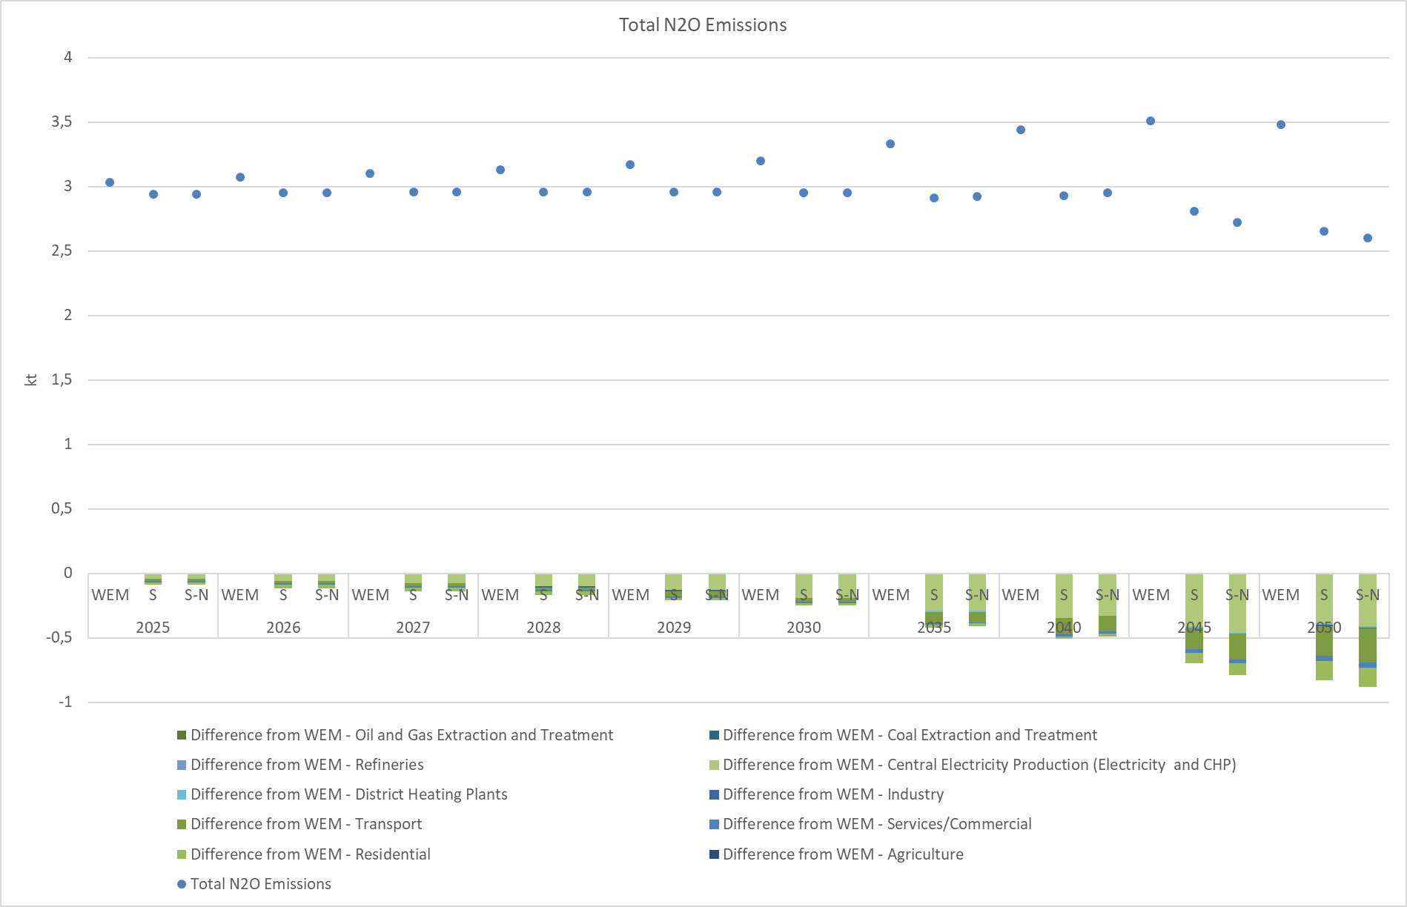
The share of RES in gross final energy consumption in scenarios S and S-N is equal to 33.6% in 2030 and approximately 62% in 2050 for scenario S and about 60% for scenario S-N. This means a 35% in scenario S and a 33% in scenario S-N higher penetration of RES in 2050 respectively, compared to the WEM scenario and a respective 6% higher RES penetration in 2030 for both scenarios.
The penetration of RES in the three sub-targets is higher in 2030 for both the examined scenarios S and S-N compared to WEM scenario by:
- At least 45% in the electricity generation sector as the result of the installation of additional PV and wind power plants.
- At least 3.2% in the transport sector (without multipliers) due to the increased penetration promotion of electrification.
- At least 41% in the heating sector, mainly as the result of the installation of heat pumps and the promotion of other type of RES in buildings, such as solar thermal and geothermal energy.
In 2050, the respective RES share in scenarios S and S-N is considerably higher than in the WEM scenario mainly due to the initiation of additional measures for the promotion of RES by:
- 94% and 87% in the electricity generation sector in scenarios S and S-N respectively.
- 45% and 49% in the transport sector (without multipliers) in scenarios S and S-N respectively.
- 39% in the heating sector in both scenarios S and S-N.
It should be noted that scenario S leads to higher deployment of RES in gross final energy consumption by 2050 due to the increased promotion of RES in electricity generation and transport sector.
Figure 5.10: Share of RES in GFEC
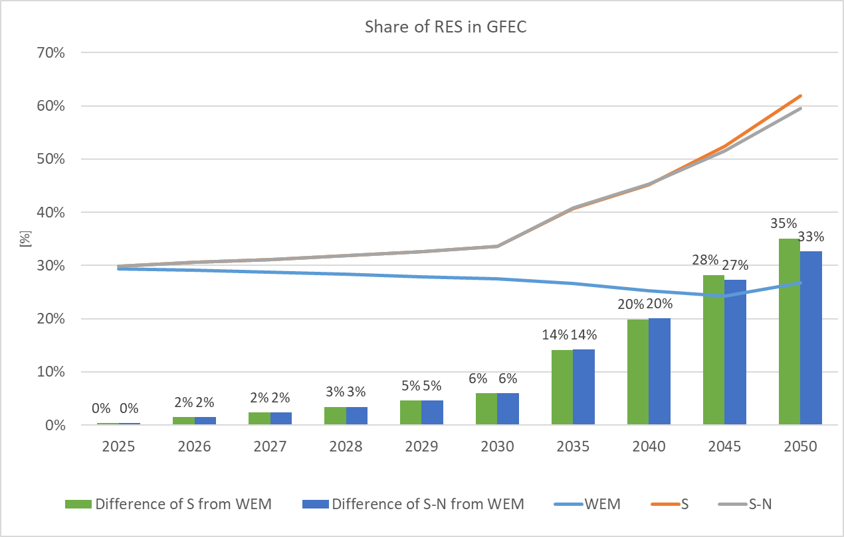
Figure 5.11: Share of RES in Electricity Generation
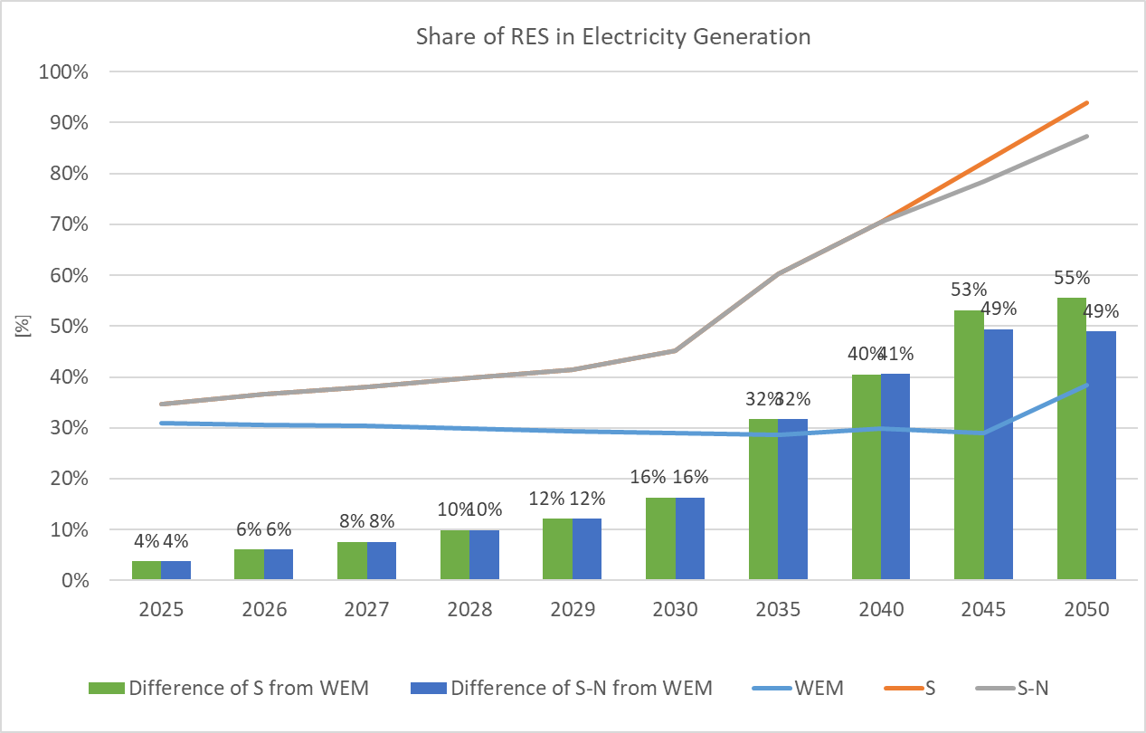
Figure 5.12: Share of RES in Transport (without multipliers)
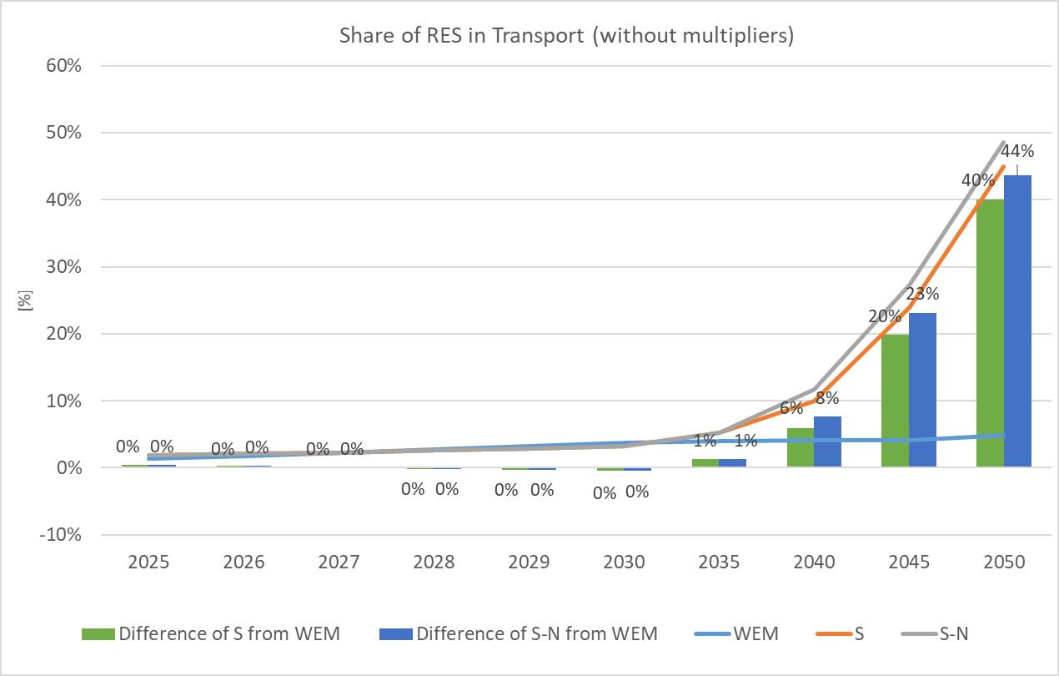
Figure 5.13: Share of RES in Heating
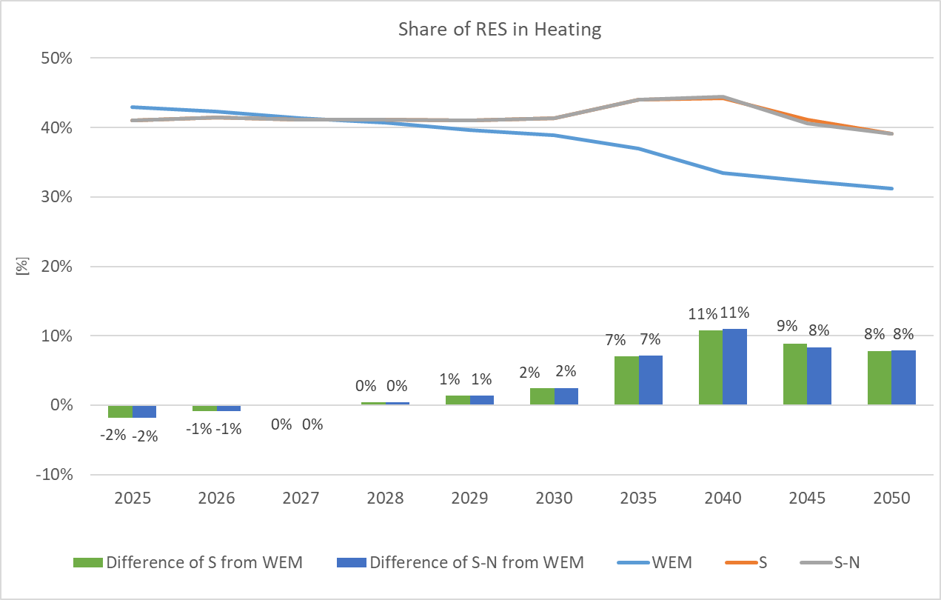
In WEM scenario, the total installed capacity for electricity production is projected to increase from 9 GW in 2025 and 10 GW in 2030 to 13 GW in 2050. The expected increase is mainly attributed to the penetration of RES technologies for electricity generation, which generally have a lower utilization or capacity factor than conventional technologies and therefore require more capacity installed than conventional power plants for the same electricity production.
Similarly, in both scenarios S and S-N, the total installed capacity for electricity production is expected to rise from 10 GW in 2025 and 11 GW in 2030 to about 36 GW in 2050.
In WEM scenario, the total installed RES capacity is projected to reach 4 GW in 2025 and 2030 and 7 GW in 2050 (Figure 5.14). Similarly, in both scenarios S and S-N, the total installed RES capacity is expected to rise from 6 GW, excluding hydro pump storage plants, in 2030 to about 30 GW in 2050. Solar and wind are anticipated to have the largest contribution in all scenarios in 2030 and 2050. It must be noted that the capacity of RES projected for 2030 is considered as a minimum for renewable energy penetration.
Figure 5.14: Installed RES capacity per technology
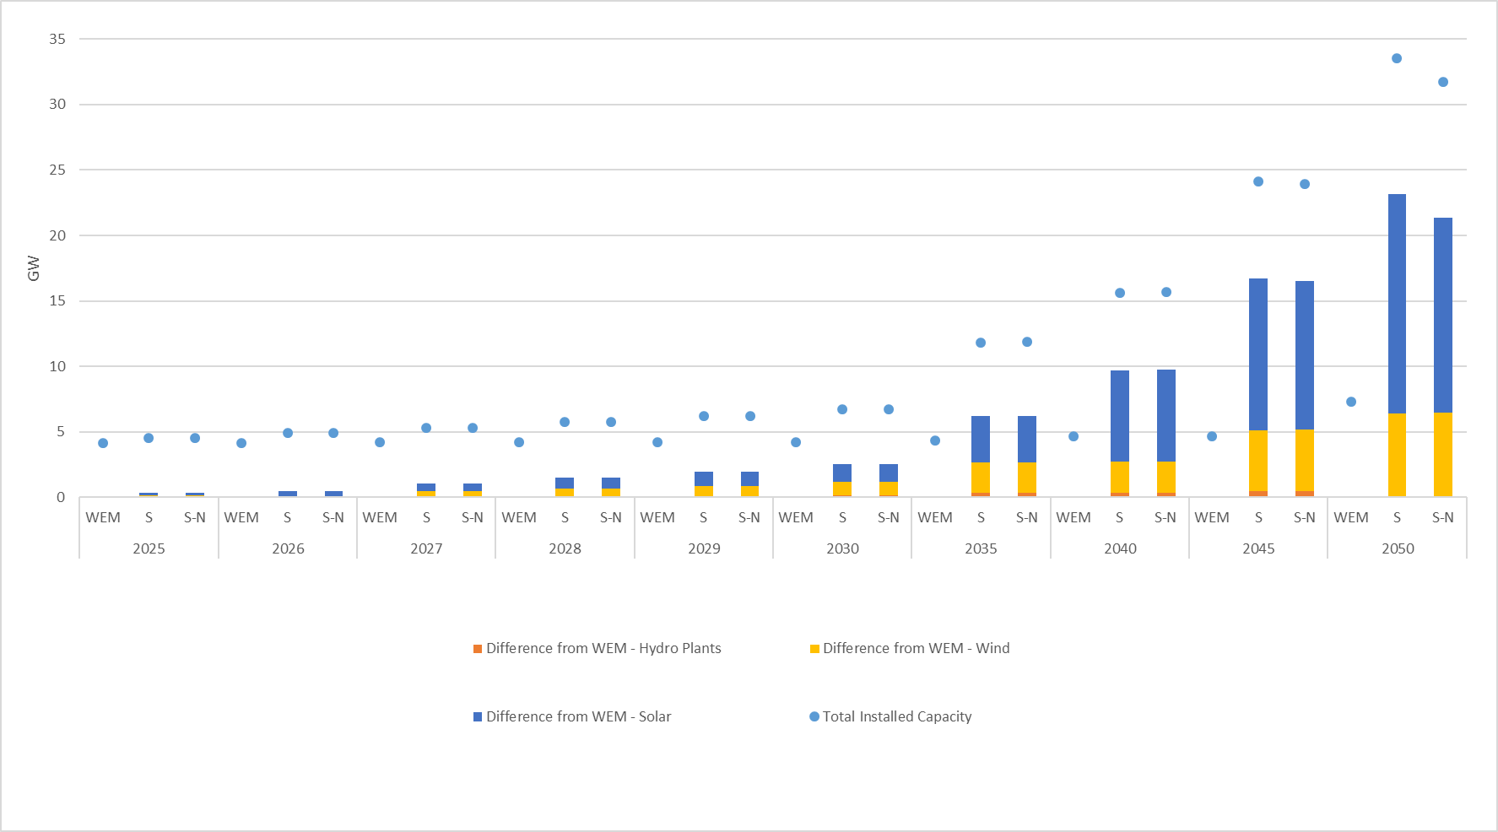

Table 5.2: Installed RES capacity per technology per scenario
 |  | Hydro Plants | Wind | Solar
2025 | WEM | 2,48 | 0,75 | 0,30
 | S | 2,48 | 0,90 | 0,51
 | S-N | 2,48 | 0,90 | 0,51
2026 | WEM | 2,48 | 0,75 | 0,30
 | S | 2,48 | 1,05 | 0,75
 | S-N | 2,48 | 1,05 | 0,75
2027 | WEM | 2,48 | 0,75 | 0,38
 | S | 2,48 | 1,21 | 0,99
 | S-N | 2,48 | 1,21 | 0,99
2028 | WEM | 2,48 | 0,75 | 0,38
 | S | 2,52 | 1,38 | 1,23
 | S-N | 2,52 | 1,38 | 1,23
2029 | WEM | 2,48 | 0,75 | 0,38
 | S | 2,52 | 1,57 | 1,48
 | S-N | 2,52 | 1,57 | 1,48
2030 | WEM | 2,48 | 0,75 | 0,38
 | S | 2,62 | 1,77 | 1,73
 | S-N | 2,62 | 1,77 | 1,73
2035 | WEM | 2,62 | 0,75 | 0,38
 | S | 2,95 | 3,07 | 3,93
 | S-N | 2,95 | 3,11 | 3,93
2040 | WEM | 2,94 | 0,75 | 0,38
 | S | 3,27 | 3,12 | 7,36
 | S-N | 3,27 | 3,16 | 7,37
2045 | WEM | 2,94 | 0,74 | 0,37
 | S | 3,39 | 5,42 | 11,98
 | S-N | 3,39 | 5,46 | 11,70
2050 | WEM | 3,29 | 1,66 | 1,77
 | S | 3,39 | 7,97 | 18,50
 | S-N | 3,39 | 8,01 | 16,66

The electricity generation by source type in Scenario S can be seen in the Figure 5.15. As can be seen there is no generation from lignite fired power plants by 2050, and only a small amount of generation from gas fired power plants continues to exist for generation adequacy reason.
Figure 5.15: Electricity generation by source in Scenario S

A detailed analysis of the operation of the power system under the S scenario, on an hourly basis was performed for two milestone years (2030 and 2040) using the ANTARES software (Annex II). For 2030 the results indicate that the unsupplied energy is practically zero, which means that the generation adequacy of the system is robust. Furthermore, there is no spilled energy (no curtailment of electricity generation from variable renewables), therefore the system is flexible enough to accommodate the modelled variable RES capacities, at least at the Day-Ahead market level. The analysis for 2040, indicates that unsupplied energy is zero, signifying generation adequacy of the system. There is some spilled energy in 2040 but the level is negligible and does not exceed 0.01% of the total available wind and solar generation. This means that the system is flexible enough to accommodate the modelled variable RES capacities for 2040, at least at the Day-Ahead market level.
In WEM scenario, the non-road RE electricity consumption in transport is expected to reach 14 ktoe in 2030, while it will stand at 11 ktoe in both scenarios S and S-N over the same year (Figure 5.16). In 2050, an increase of the non-road RE electricity consumption in transport is anticipated in WEM scenario, reaching 19 ktoe, compared to scenarios S and S-N, where it will significantly rise to 41 ktoe in scenario S and 38 ktoe in scenario S-N respectively. The increase is even higher for road RE electricity consumption, especially for scenarios S and S-N, where a rise from 13 ktoe in 2030 to 415 ktoe in scenario S in 2050 and from 13 ktoe in 2030 to 422 ktoe in 2050 in scenario S-N is expected.
Figure 5.16: Electricity consumption from RES in transport
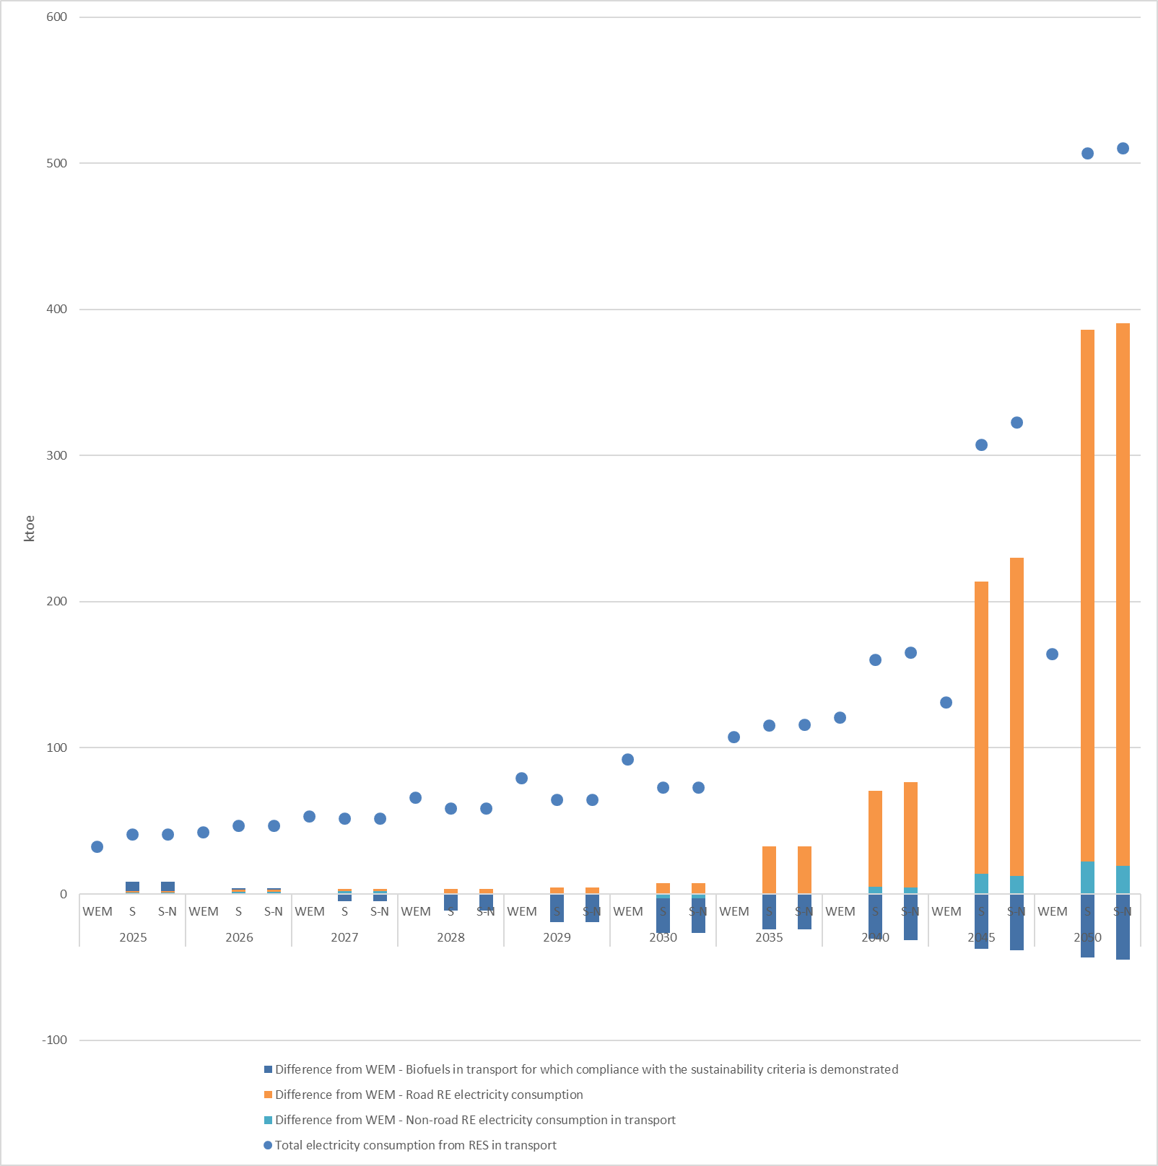
In WEM scenario, the total installed capacity in the district heating sector is projected to reach 8 GW in 2030 and 6 GW in 2050. Similarly, it will reach 8 GW in scenarios S and S-N in 2030 and 7 GW in scenario S and 8 GW in scenario S-N in 2050 (Figure 5.17). Natural gas is anticipated to have the largest contribution in all scenarios in 2030 and 2050, as a transitional fuel, replacing the polluting solid fuels used in heat stations and respecting the sustainable utilisation of biomass in Serbia. The options of centralised heat pumps and other clean technologies for centralised heat production were included in the analysis but their relative costs remain high within the considered time period.
Figure 5.17: Installed capacity per technology in the district heating sector
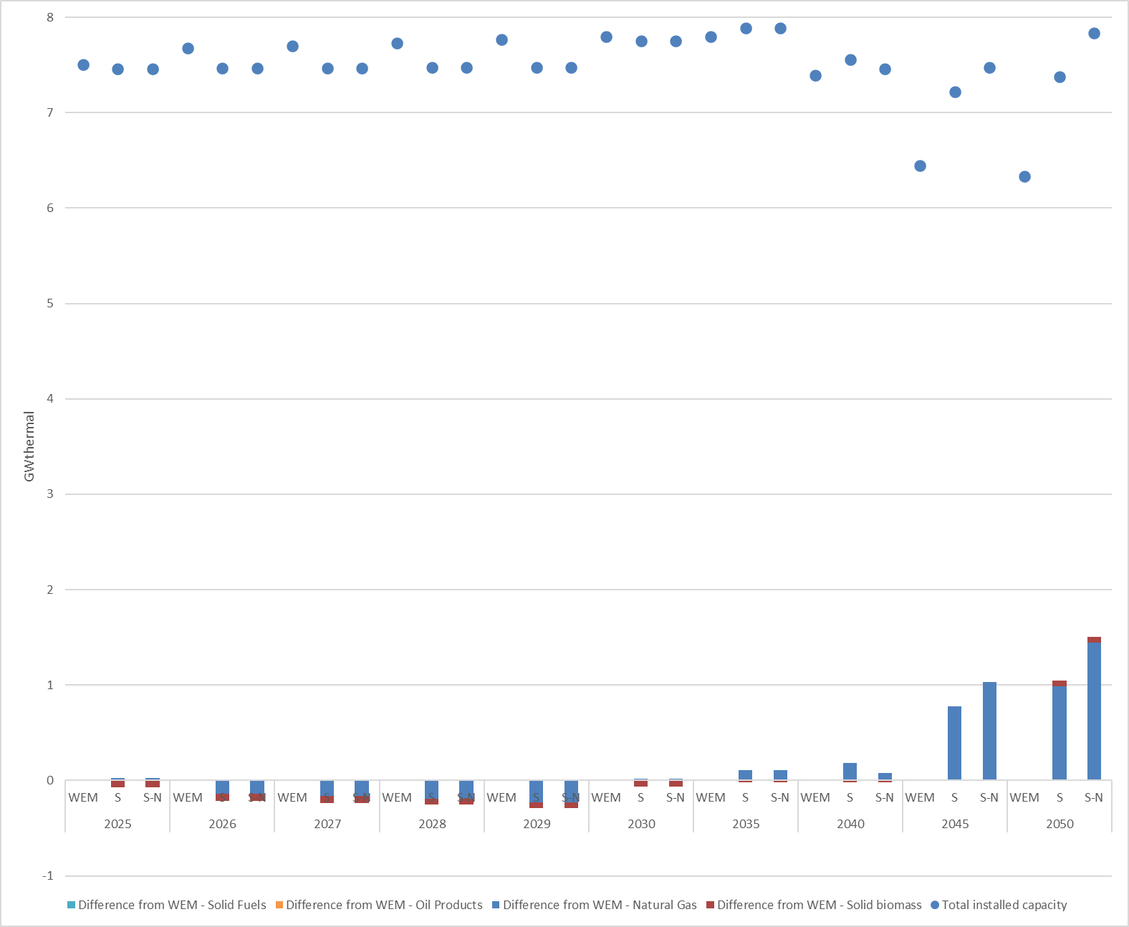
In 2030, the primary and the final energy consumption are equal to 14.68 Mtoe and 9.7 Mtoe respectively in scenarios S and S-N leading to lower levels by 17% and 9% respectively compared to the WEM scenario. The reduction in the primary and final energy consumption is mostly due to the implementation of additional policies and measures for the promotion of energy efficiency and RES. The difference in the final energy consumption among WEM and scenarios S and S-N is distributed on average among the residential (36%), industry (27%) and transport (26%) sectors in 2030.
In 2050, the primary energy consumption is equal to 11.5 Mtoe and 12.5 Mtoe in scenarios S and S-N respectively leading to reduced levels by 40% and 35% compared to the WEM scenario. The same tendency is observed for the case of final energy consumption leading to approximately identical level (9.5 Mtoe presenting 27% reduction compared to WEM scenario). The reduction in the primary and final energy consumption is mostly due to the intensified implementation of additional policies and measures for the promotion of energy efficiency and RES.
Figure 5.18: Primary Energy Consumption
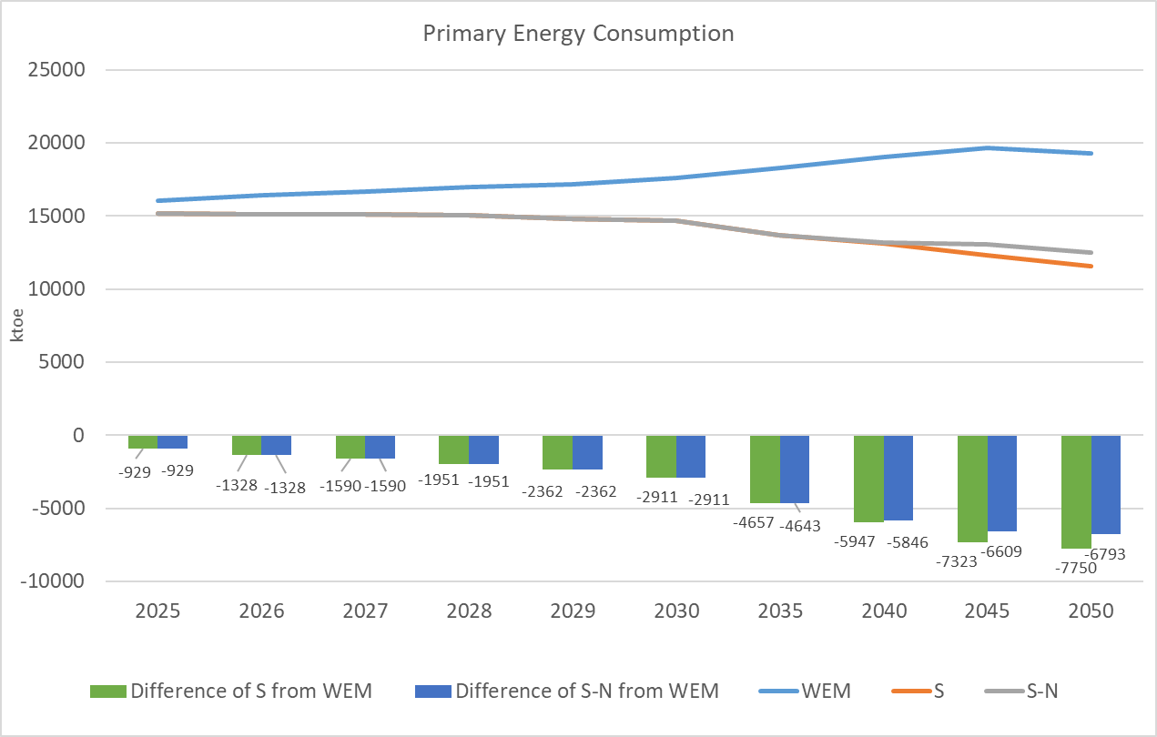
Figure 5.19: Final Energy Consumption
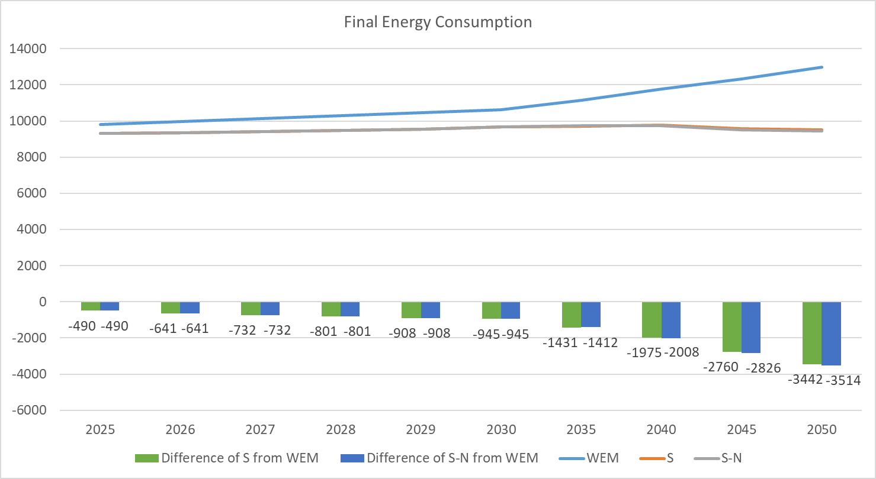

The final energy consumption of the industrial sector stands at 2,547 ktoe in 2030 in scenarios S and S-N leading to 9% lower consumption compared to WEM scenario due to the promotion of energy efficient equipment, the further development of energy management systems and the exploitation of the waste heat. The respective reduction will be increased to 11% in 2050 compared to WEM scenario as the final energy consumption will be equal to about 3.4 Mtoe due to the intensification of the energy efficiency measures counterbalancing the increased industrial output due to the GDP’s growth. Electricity, natural gas and oil products consist the fuels with the highest contribution in scenarios S and S-N for both 2030 and 2050.
Figure 5.20: FEC Industry by energy source
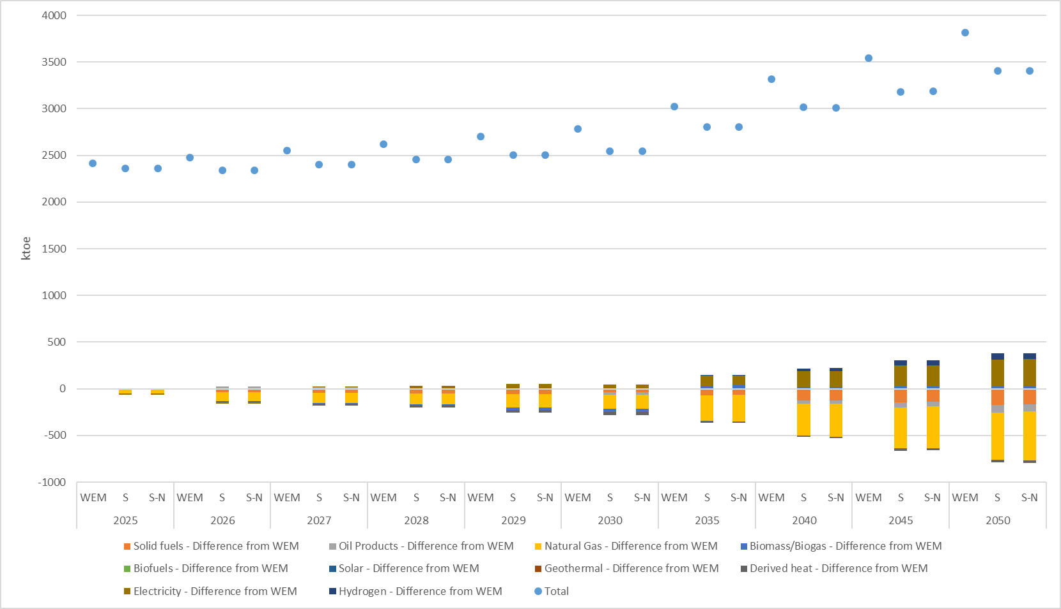
In residential sector, the final energy consumption amounts to 3,798 ktoe in WEM scenario and about 3,523 ktoe in scenarios S and S-N in 2030 mainly due to the increased energy renovation of the buildings, the installation of aerothermal heat pumps and the promotion of energy efficient appliances and lighting. The reduction of the final energy consumption is higher in 2050 for the case of scenarios S and S-N reaching 2.5 Mtoe compared to 3.7 Mtoe in WEM scenario due to the enhanced implementation of energy efficiency measures. Biomass/biogas, electricity and derived heat present the highest contribution in both 2030 and 2050.
Figure 5.21: FEC Residential by energy source
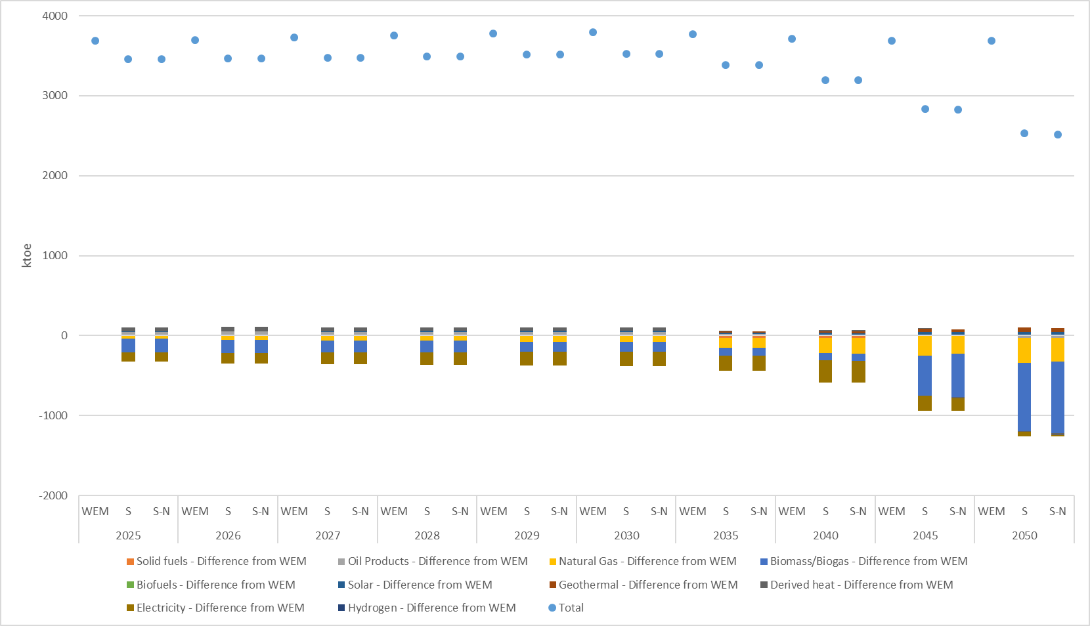
The final energy consumption of the tertiary sector in 2030 is equal to 1,097 ktoe in WEM scenario, while a meaningful reduction up to 17% is observed in scenarios S and S-N reaching 910 ktoe in absolute levels due to the increased energy renovation of the buildings, the installation of aerothermal and geothermal heat pumps and the promotion of energy efficient appliances and lighting. The intensification of the energy efficiency measures leads to a 24% reduction in 2050, as the final energy consumption reaches 1,579 ktoe in WEM scenario and about 1,200 ktoe in scenarios S and S-N (21). Electricity and natural gas comprise the fuels with the highest contribution in both 2030 and 2050 retaining also almost identical shares in scenarios S and S-N.
Figure 5.22: FEC Services by energy source
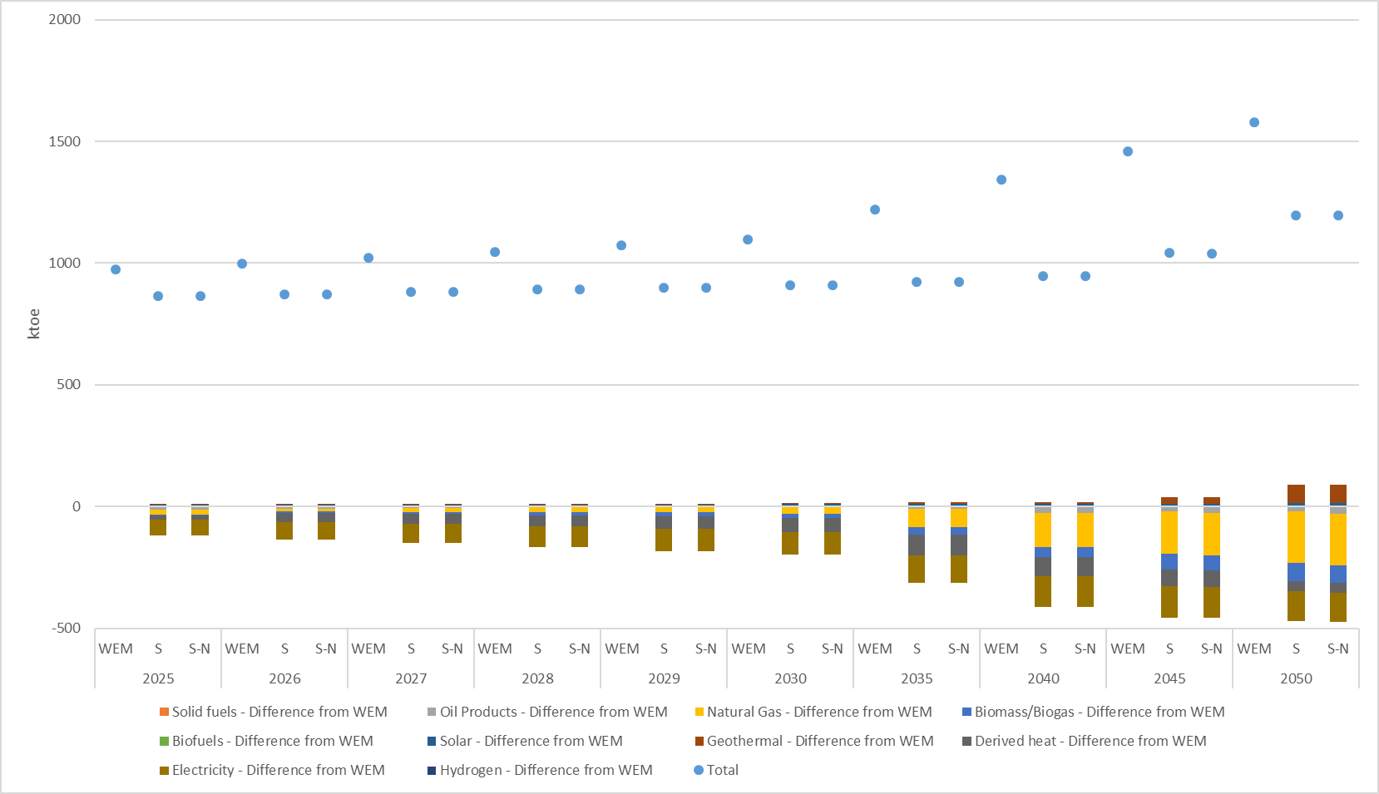
The final energy consumption of the transport sector in 2030 stands at 2,748 ktoe in WEM scenario, which is 9% higher compared to scenarios S and S-N (2,512 ktoe) due to the promotion of electromobility and the further penetration of hybrid diesel and gasoline vehicles in scenarios S and S-N. The final energy consumption is reduced by approximately 40% in 2050 for the case of scenarios S and S-N (about 2.2 Mtoe) compared to WEM scenario ( 3.7 Mtoe) due to the further deployment of electromobility and the promotion of hydrogen (22). Oil products is the most prevailing fuel in scenarios S and S-N for both 2030 and 2050.
Figure 5.23: FEC Transport by Fuel
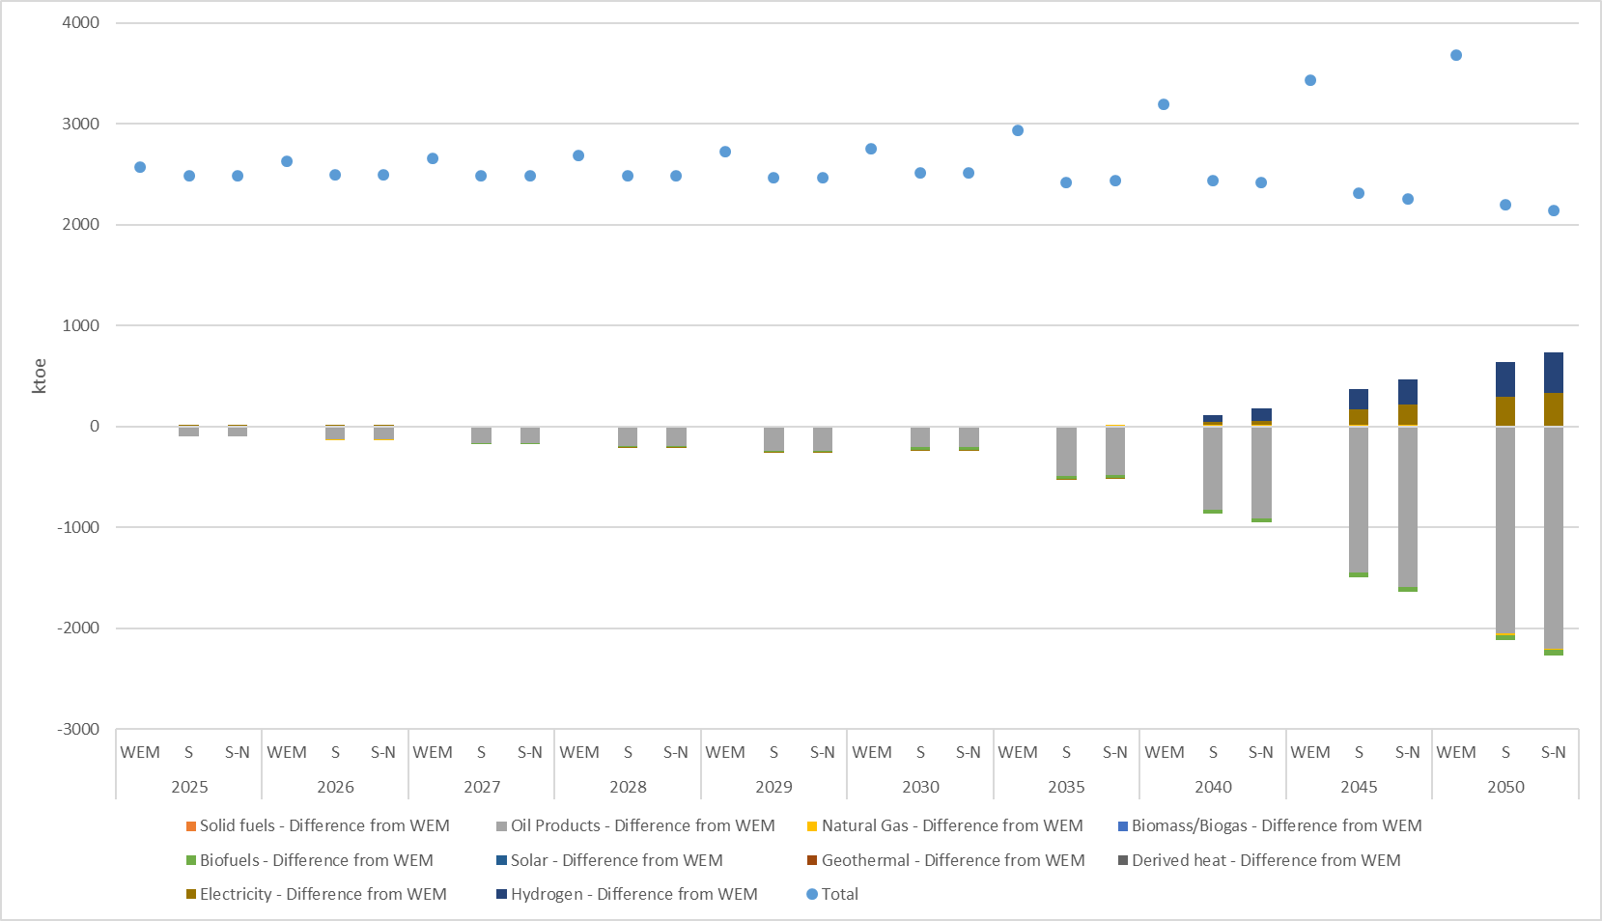
In agriculture sector, the final energy consumption amounts to 159 ktoe in WEM scenario and 150 ktoe in scenarios S and S-N in 2030 due to the promotion of energy efficient machinery and the installation of energy efficiency equipment in greenhouses and pumping stations. The final energy consumption is increased slightly in 2050, as it will reach 169 ktoe in WEM scenario and 159 ktoe in scenarios S and S-N. Oil products and electricity consist the fuels with the highest contribution in both 2030 and 2050 in scenarios S and S-N retaining identical shares.
Figure 5.24: FEC Agriculture by Fuel
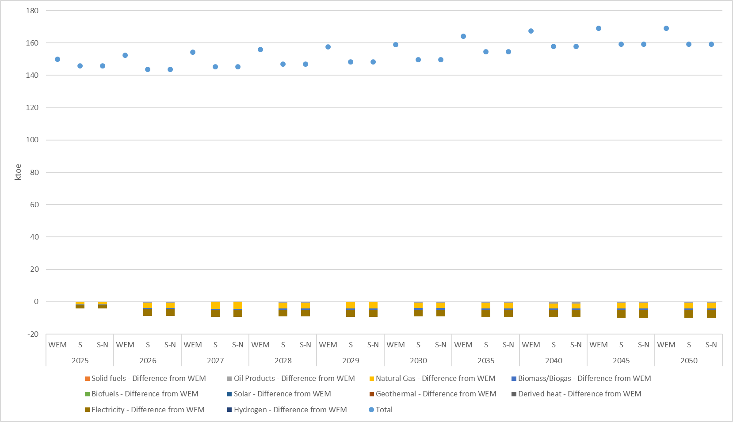
In WEM scenario, the final energy intensity is equal to 0.17 toe/000 Euro in 2030, almost similar to 0.16 toe/000 Euro, which corresponds to scenarios S and S-N over the same year. Similarly, the final energy intensity is equal to 0.12 toe/000 Euro in 2050 in WEM scenario, compared to about 0.09 toe/000 Euro in scenarios S and S-N.
Figure 5.25: Final energy intensity
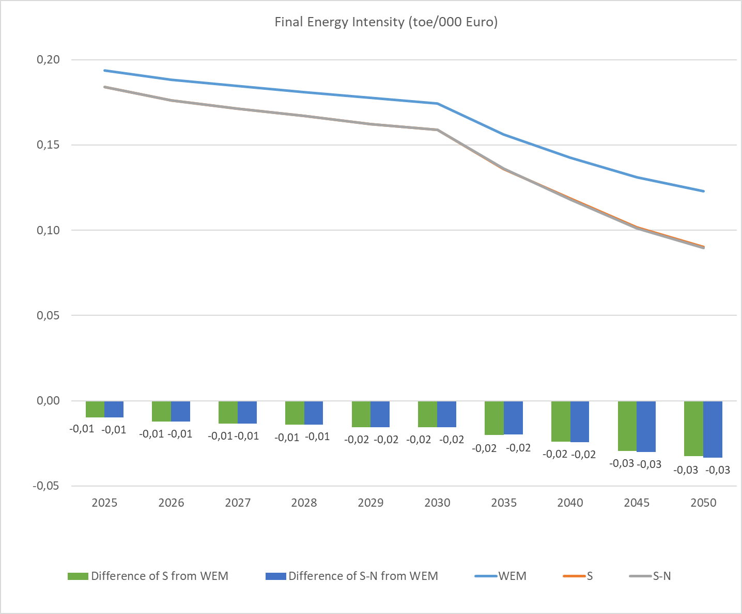
In WEM scenario, gross inland consumption is equal to 18.5 Mtoe in 2030, higher than 15.5 Mtoe, which corresponds to scenarios S and S-N over the same year. Similarly, gross inland consumption is equal to 20.6 Mtoe in 2050 in WEM scenario, compared to 12.7 Mtoe in scenario S and 11.8 Mtoe in scenario S-N. Solid fuels as well as renewables and wastes comprise the fuels with the highest contribution in both 2030 and 2050.
Figure 5.26: Gross inland consumption by fuel
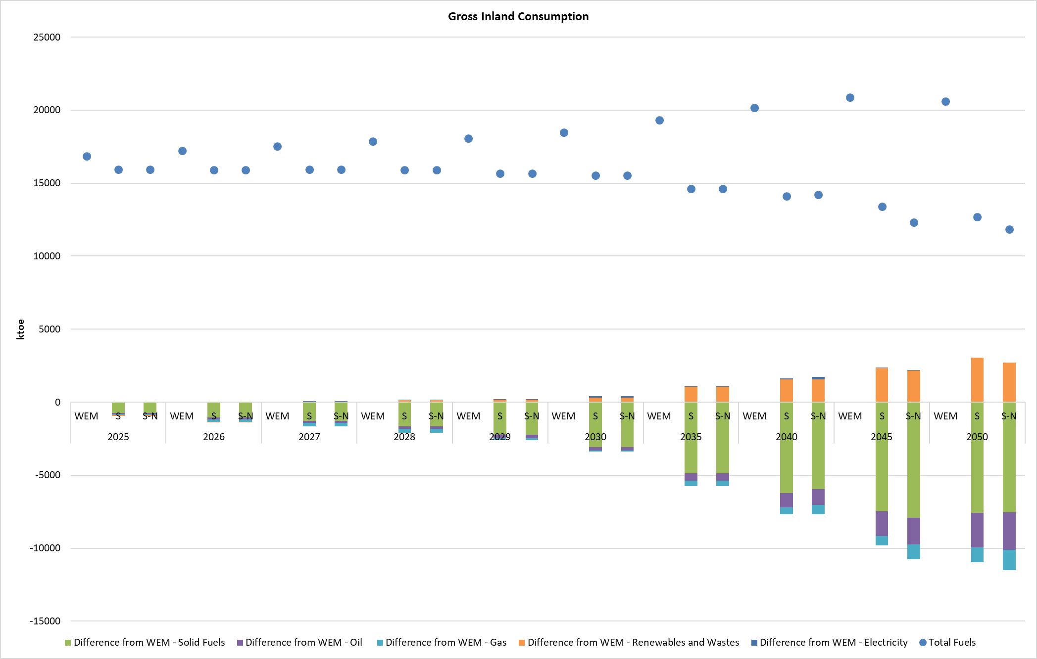
For the case of residential buildings, the renovation rate of the building envelope is similar and almost stable in all examined scenarios over 2025-2030. A doubling of the annual renovation rate is seen in scenarios S and S-N after 2030 towards 2050. It is important to note that in the Figure 5.27 until 2030 the renovation rates presented are annual, while after 2030 the renovation rates presented correspond to 5-year periods.
Figure 5.27: Refurbishment in residential buildings
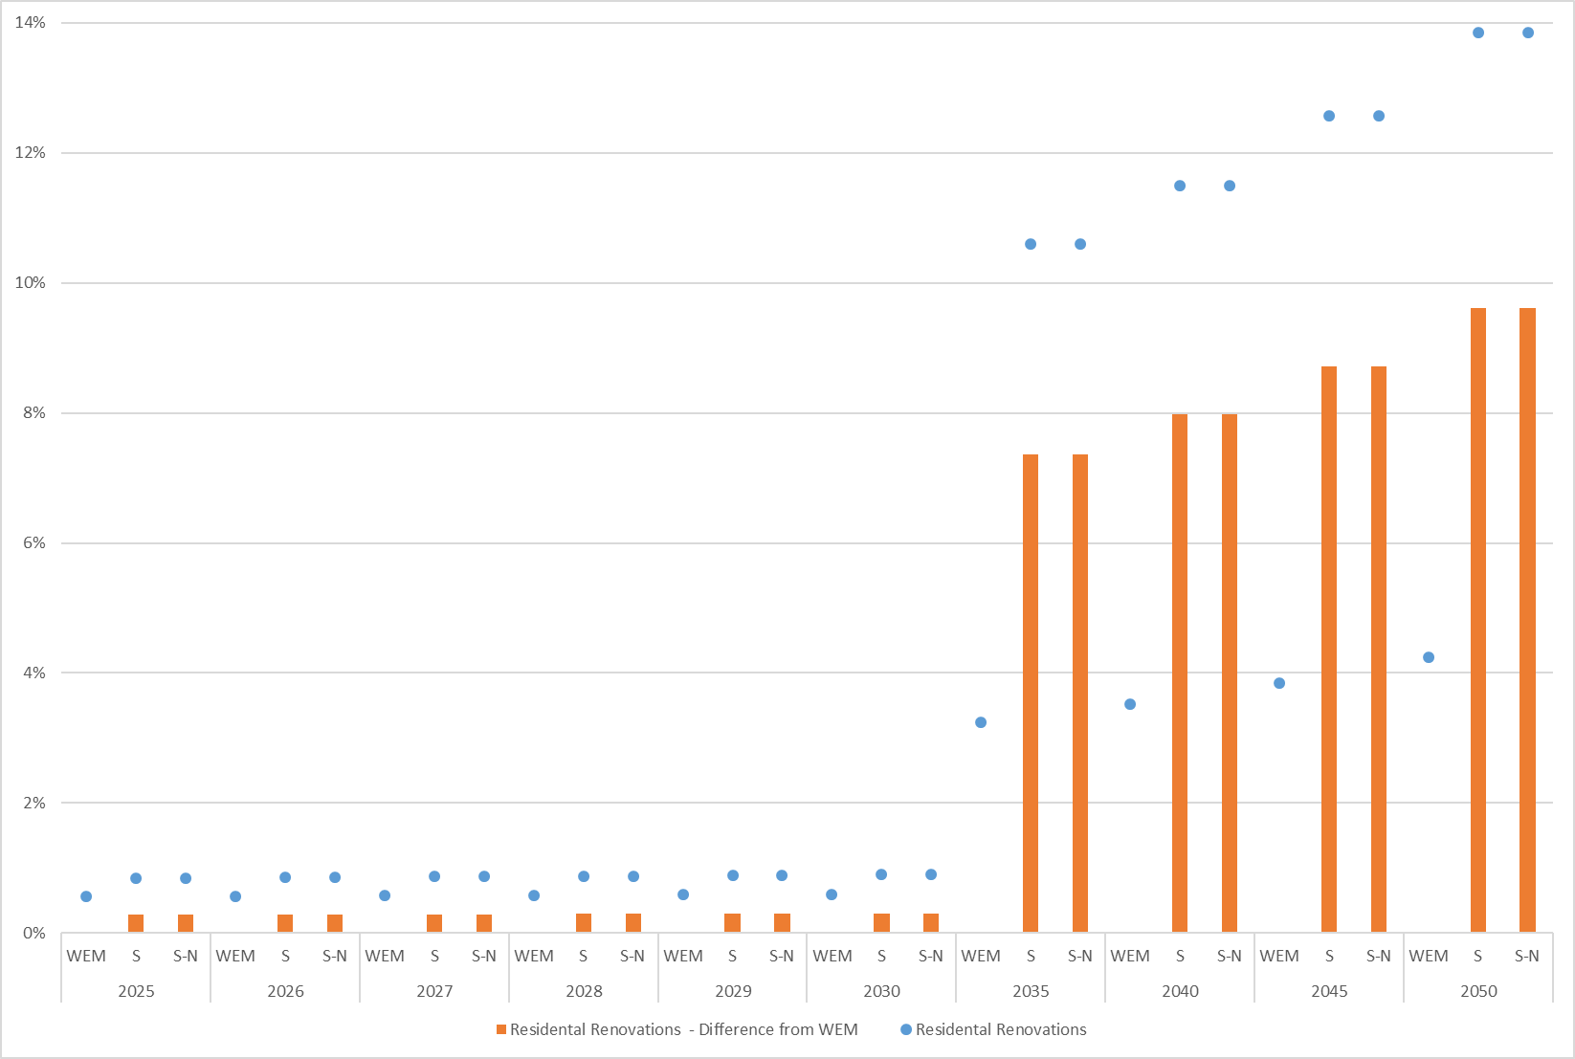
the renovation rates until 2030 are annual, while after 2030 they correspond to 5-year periods.
For the case of buildings in the tertiary sector, several variations in renovation rate for the different building types are observed. In WEM scenario, the renovation rate is stable at 0.5% for all building types over 2025-2030, while a renovation rate of 2.5% is expected between 2035 and 2050. In scenarios S and S-N, an intensification of the renovation rate is observed in the period 2035-2050, consistent with the renovation rates foreseen in the Long Term Building Renovation Strategy, corresponding to 2.3% per year for private sector buildings and 3.3% for public sector buildings, indicating the exemplary role of the public sector in building renovation. As mentioned earlier, the renovation rates shown in the Figure 5.28 until 2030 are annual, while after 2030 they correspond to 5-year periods.
Figure 5.28: Refurbishment in commercial buildings
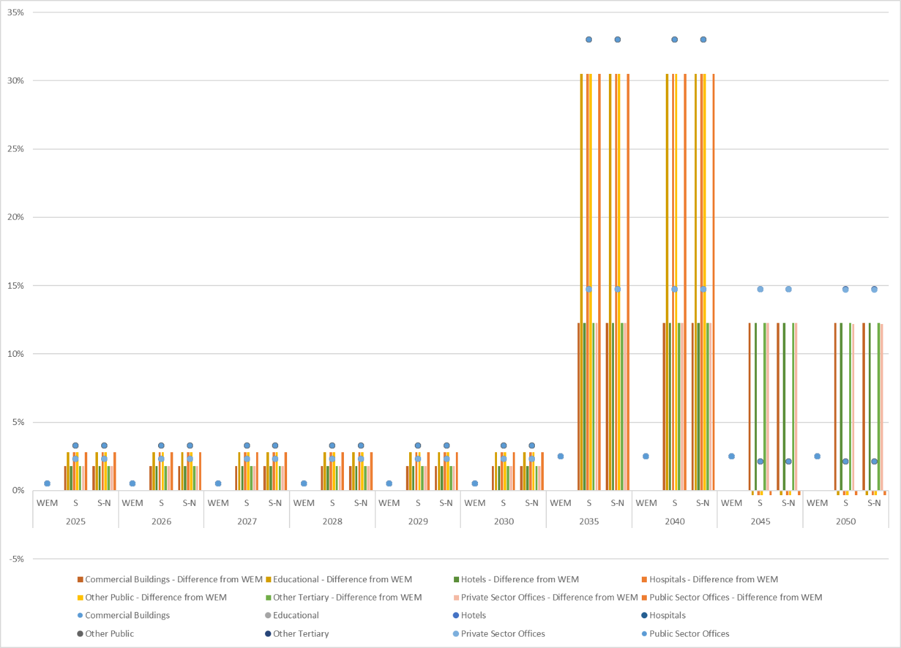
the renovation rates until 2030 are annual, while after 2030 they correspond to 5-year periods.
Focussing in the change of unit consumption, in WEM scenario, the unit consumption of existing commercial buildings is projected to increase from 0.02 ktoe/m² in 2025 to 0.035 ktoe/m² in 2050, while it is maintaining almost stable level in the other two scenarios at about 0.02 ktoe/m² over 2025-2040, as a higher rise is expected over 2045-2050, reaching 0.023 ktoe/m² in 2045 and 0.026 ktoe/m² in 2050. Similarly, the unit consumption of residential dwellings existing in 2020 increases with almost the same growth rate between scenarios S and S-N over 2025-2050, from 1.56 ktoe/’000 dwellings in 2025 to about 1.72 ktoe/’000 dwellings in 2050, while the scenario WEM follows a higher growth rate; from 1.66 ktoe/’000 dwellings in 2025 to 2.52 ktoe/’000 dwellings in 2050. The growth in the unit consumption is connected to the increase in heat comfort conditions in the existing buildings, connected with the increase of available income per capita, as the corresponding GDP per capita increases.
Figure 5.29: Unit consumption of commercial buildings
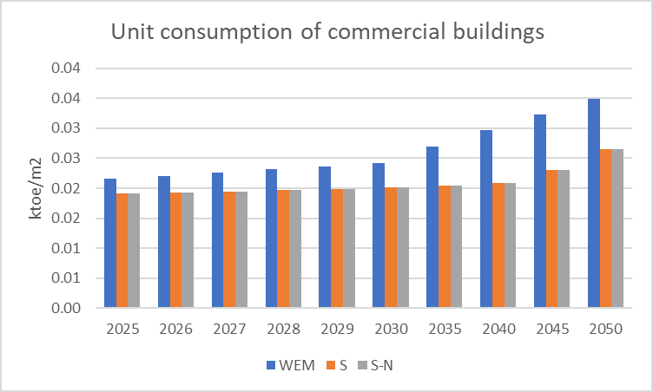
Figure 5.30: Unit consumption of residential dwellings
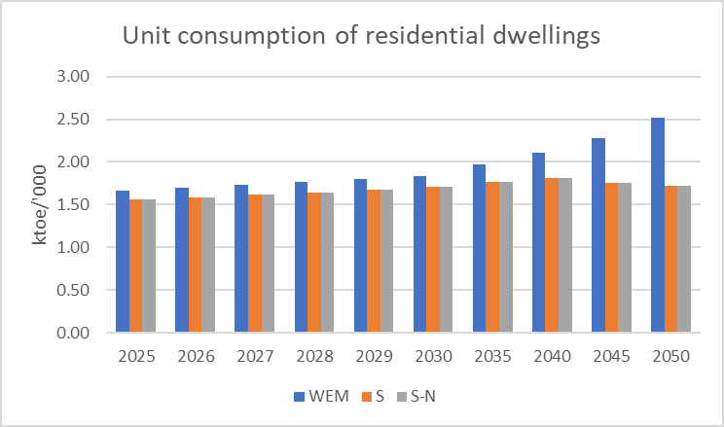
The penetration of heat pumps is expected to reach 7.05 GWth in 2030 (2.03 GWth in residential sector and 5.02 GWth in tertiary sector). A substantial growth is expected from 2035 onwards up to 2050 in all the scenarios. The residential heat pumps will increase from 4.34 GWth in 2035 in scenarios S and S-N to 24.88 GWth in scenario S and 25.16 GWth in scenario S-N in 2050. Similarly, the heat pumps in the tertiary sector will increase from 8.42 GWth in 2035 in scenarios S and S-N to 31.62 GWth in scenario S and 31.51 GWth in scenario S-N in 2050. As can be seen in the following figures, which show the capacity additions per year until 2030 and over five-year periods after 2030, the capacity additions are expected to increase considerably after 2040 and mainly towards 2050.
Figure 5.31: Annual capacity additions of heat pumps per sector, technology, and scenario until 2030 and capacity additions for five-year periods after 2030
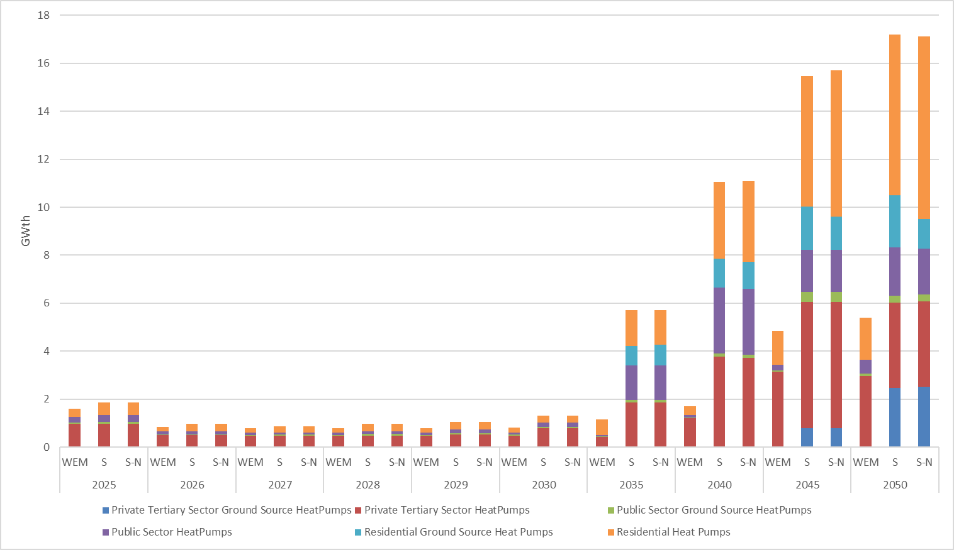
Figure 5.32: Annual capacity additions of heat pumps per sector, technology, and scenario (with differences from WEM) until 2030 and for five-year periods after 2030
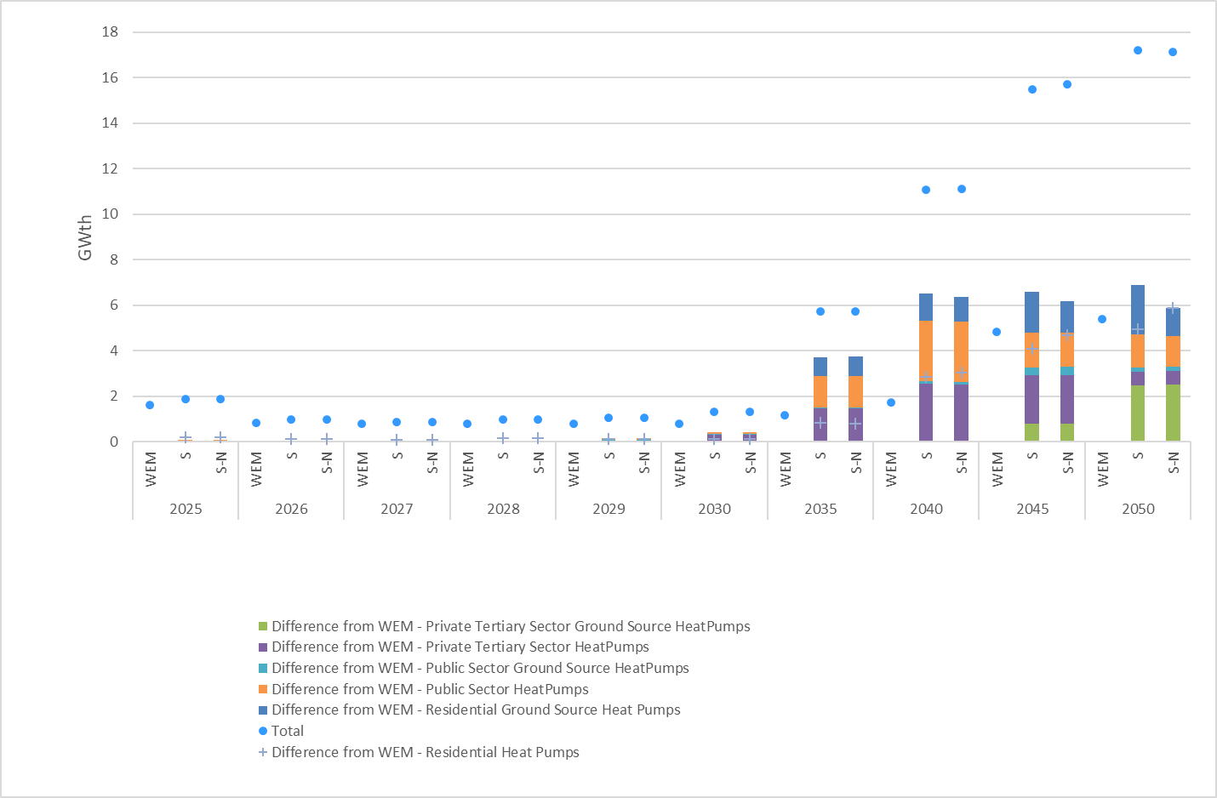
The cumulative number of electric vehicles is equal to 45 thousand, 507 thousand and about 2,000 thousand in 2030, 2040 and 2050 respectively in both scenarios S and S-N indicating the impact of the targeted policies and measures for the promotion of electromobility (8). A huge deployment in EVs is anticipated from 2030 to 2050 in both scenarios S and S-N, compared to an insignificant one in WEM scenario.
Figure 5.33: Number of EVs
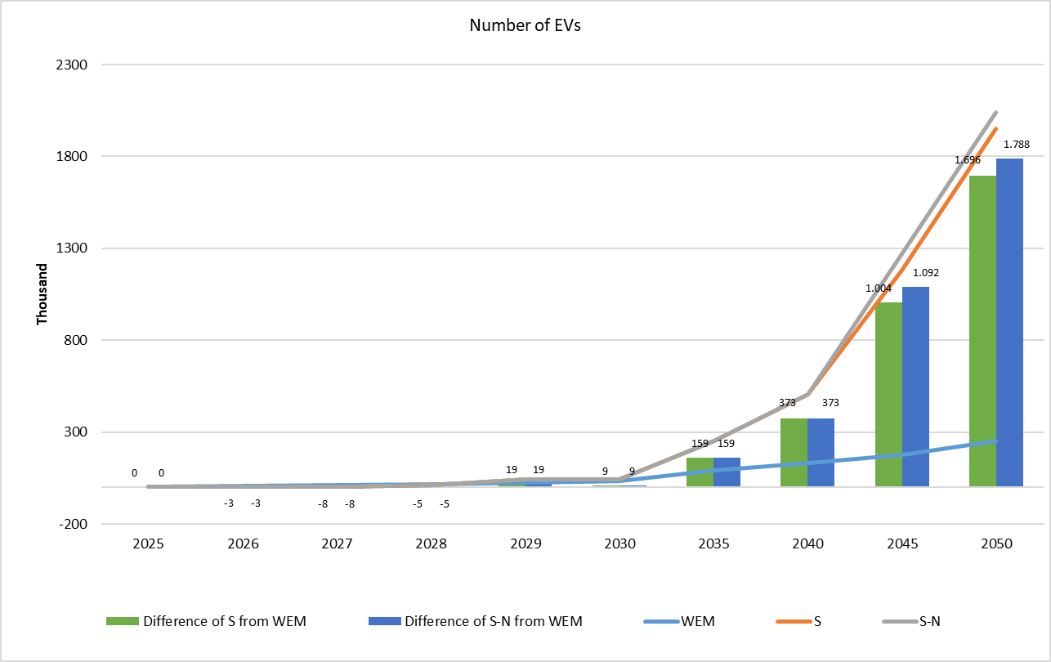
Furthermore, the energy import dependency is equal in 2030 to 35% in WEM and 41% in scenarios S and S-N, depicting that the reduced utilization of lignite for electricity production is counterbalanced by the combination of the increased penetration of RES and the promotion of energy efficiency. In Scenario S energy import dependency is increased towards 44% in 2050. In Scenario S-N energy import dependency in 2050 remains at the level of 37% due to the introduction of the nuclear plants for electricity production (According to the Eurostat energy balance reporting rules, nuclear heat used in electricity generation is not considered as import but as primary production (local production)). Overall, the main reason of lower energy import dependency in the medium-term time horizon in WEM is the use of local lignite instead of imported gas which however leads to a significant increase of GHG emissions. In the Scenarios S the transitional role of gas in the medium term leads to an increase on import dependency until the local renewable energy resources are extensively utilised, leading to a stabilisation and slight reduction of import dependency towards 2050.
Figure 5.34: Energy Import Dependency
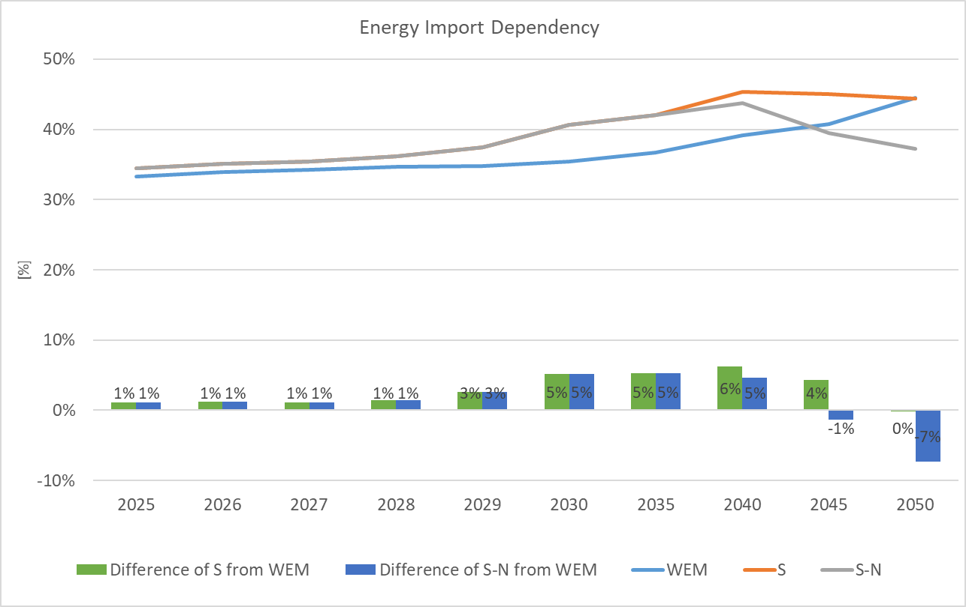
In WEM scenario, primary production is equal to 11.8 Mtoe in 2030, higher than 9.1 Mtoe, which corresponds to scenarios S and S-N over the same year. In 2050, primary production will decrease by 4.5% at 11.3 Mtoe in WEM scenario, compared to 2030 level, while a 23.9% fall in scenario S at 6.9 Mtoe and a 27.1% decline in scenario S-N at about 6.6 Mtoe are anticipated. Solid fuels as well as renewables and wastes comprise the fuels with the highest contribution in both 2030 and 2050.

Figure 5.35: Primary production
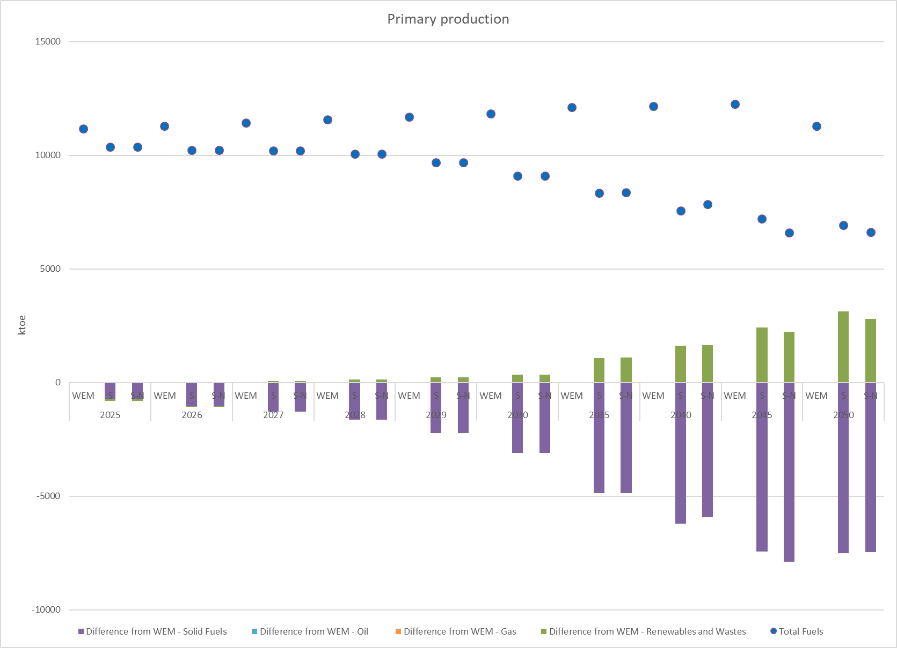
In all scenarios, total energy imports are equal to 7.6 Mtoe in 2030 (Figure 5.36). In 2050, total energy imports will increase only in WEM scenario by 29.2% at 9.8 Mtoe, compared to 2030 level, while a 11% fall (at 6.7 Mtoe) in scenario S and a 18.2% decline (at 6.1 Mtoe) in scenario S-N are anticipated. Oil and natural gas are the fuels with the highest contribution in both 2030 and 2050 in scenarios S and S-N.
Figure 5.36: Energy imports per fuel
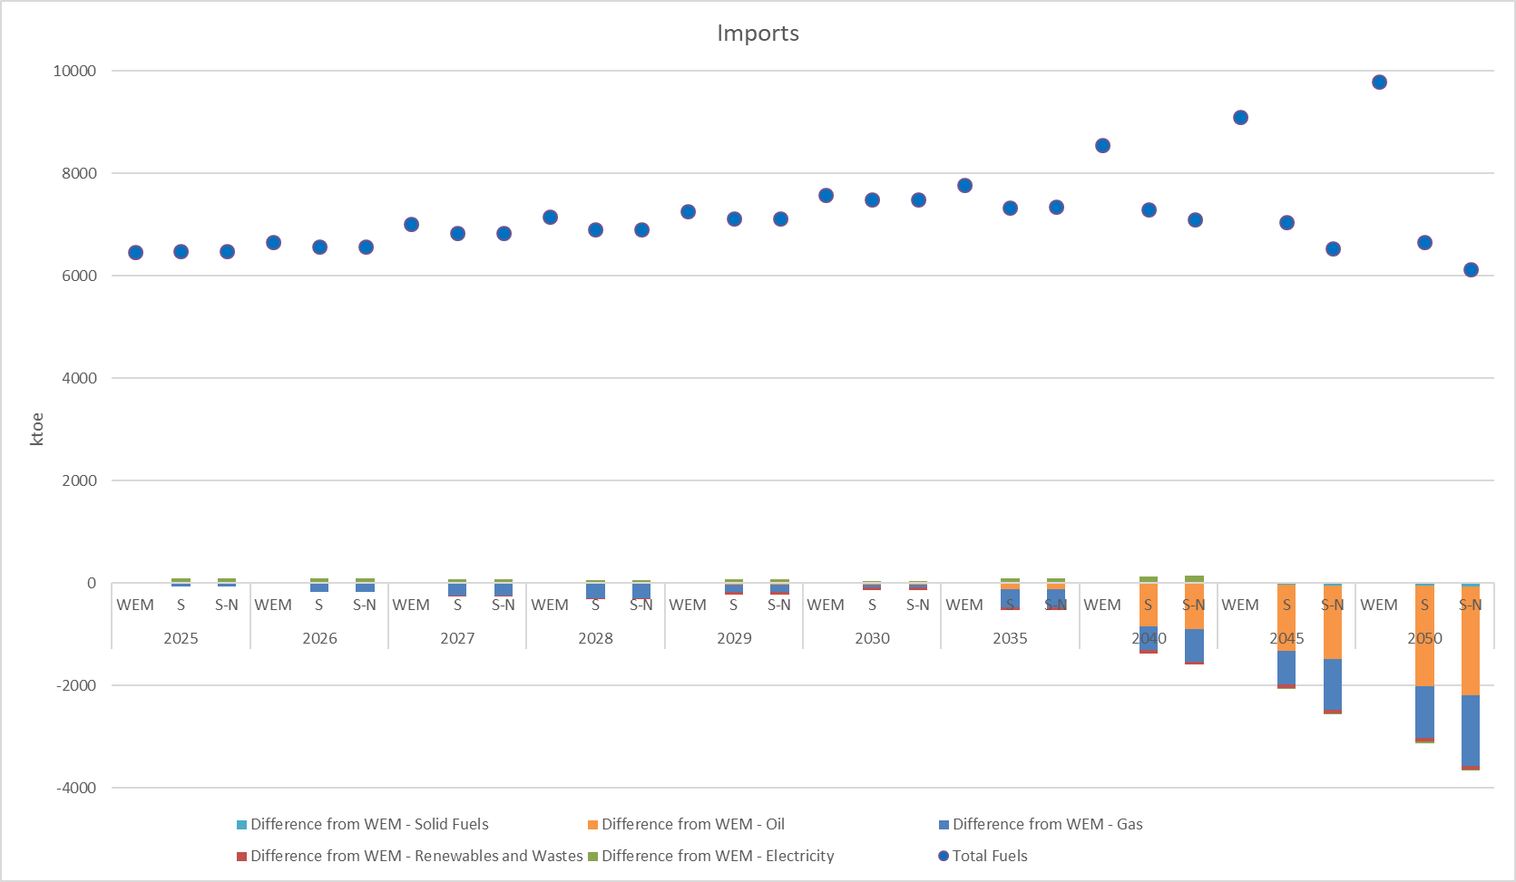
Similarly, in WEM scenario, total energy exports are equal to 914 ktoe in 2030, about 12% lower than 1,034 ktoe in scenarios S and S-N over the same year (Figure 5.37). In 2050, total energy exports will decrease by 48.6%, 15.8% and 12.7% at 470 ktoe, 870 ktoe and 903 ktoe in scenarios WEM, S and S-N respectively. Electricity and oil are the fuels with the highest contribution in both 2030 and 2050 in all scenarios, while it is worth noting the increase of solid fuels in total energy exports in 2050 in scenario S-N.
Figure 5.37: Energy exports per fuel
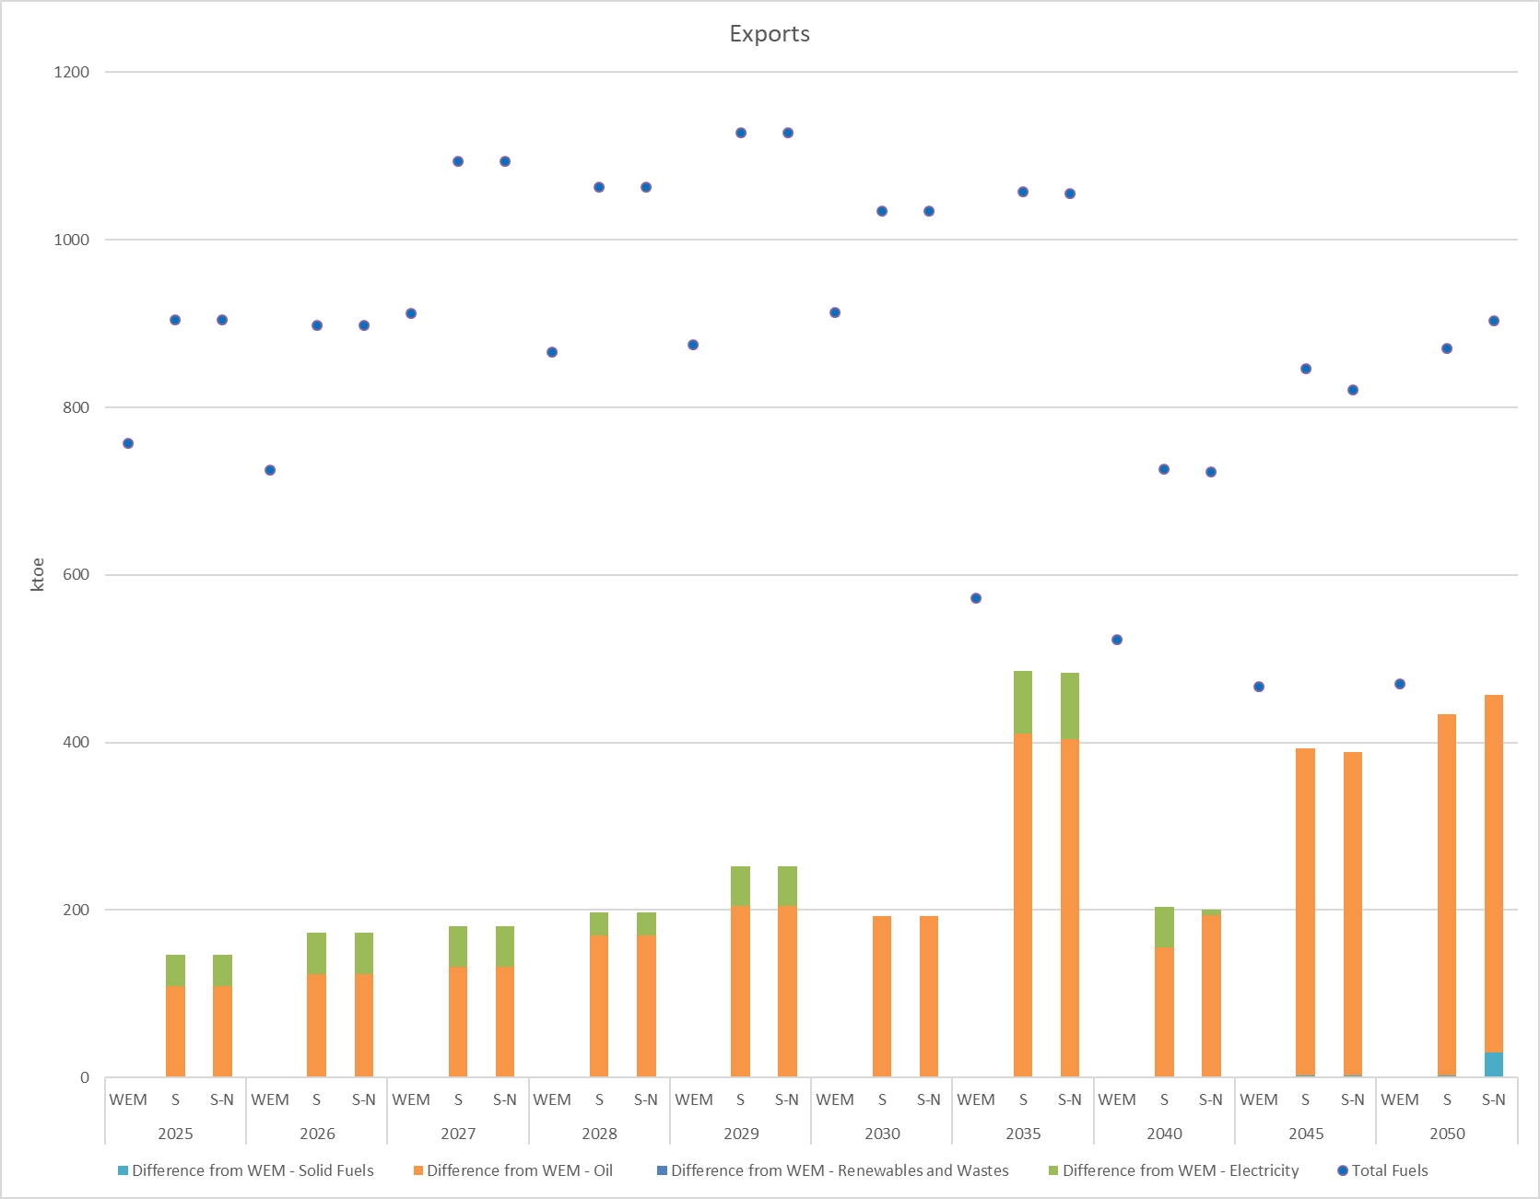
Total net energy imports in WEM scenario are equal to 6.7 Mtoe in 2030, almost the same, compared with scenarios S and S-N over the same year (Figure 5.38). In 2050, total net energy imports will increase only in WEM scenario by 39.9% at 9.3 Mtoe, compared to 2030 level, while a 10.2% fall (at 5.8 Mtoe) in scenario S and a 19.1% decline (at 3.7 Mtoe) in scenario S-N are anticipated.
Figure 5.38: Imports, exports and net imports
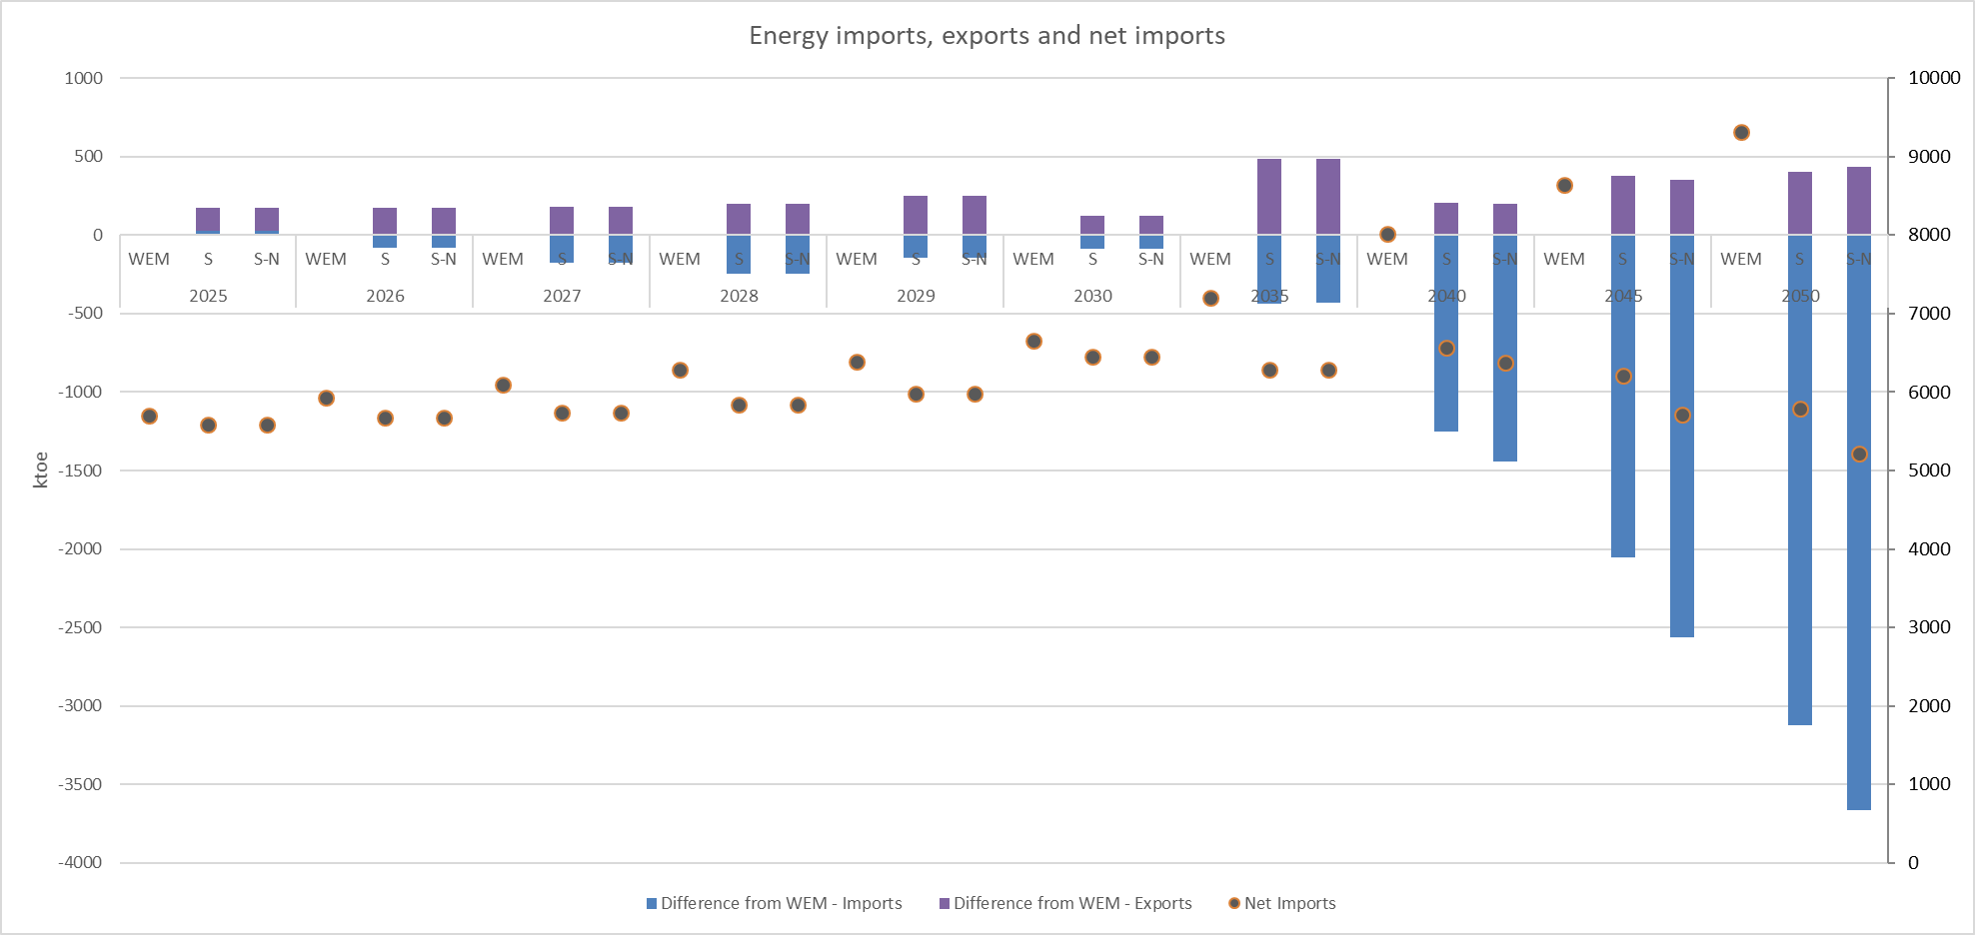
In WEM scenario, total transformation input in electricity sector reaches 7.9 Mtoe in 2030, decreasing by 0.9% at 7.8 Mtoe in 2050 (Figure 5.39). It should be noted that this refers only to conventional and bioenergy fuel inputs to the electricity plants, while wind, solar and hydro plants are not included, as they do not have any fuel input. By 2050, total transformation input in electricity sector decreases substantially in scenarios S and S-N by 77.5% and 86.7% respectively, reaching 1.1 Mtoe and 670 ktoe accordingly. Main activity producer’ conventional thermal power stations contributes the majority of the transformation input in electricity sector throughout the projection period.
Figure 5.39: Transformation input in electricity sector
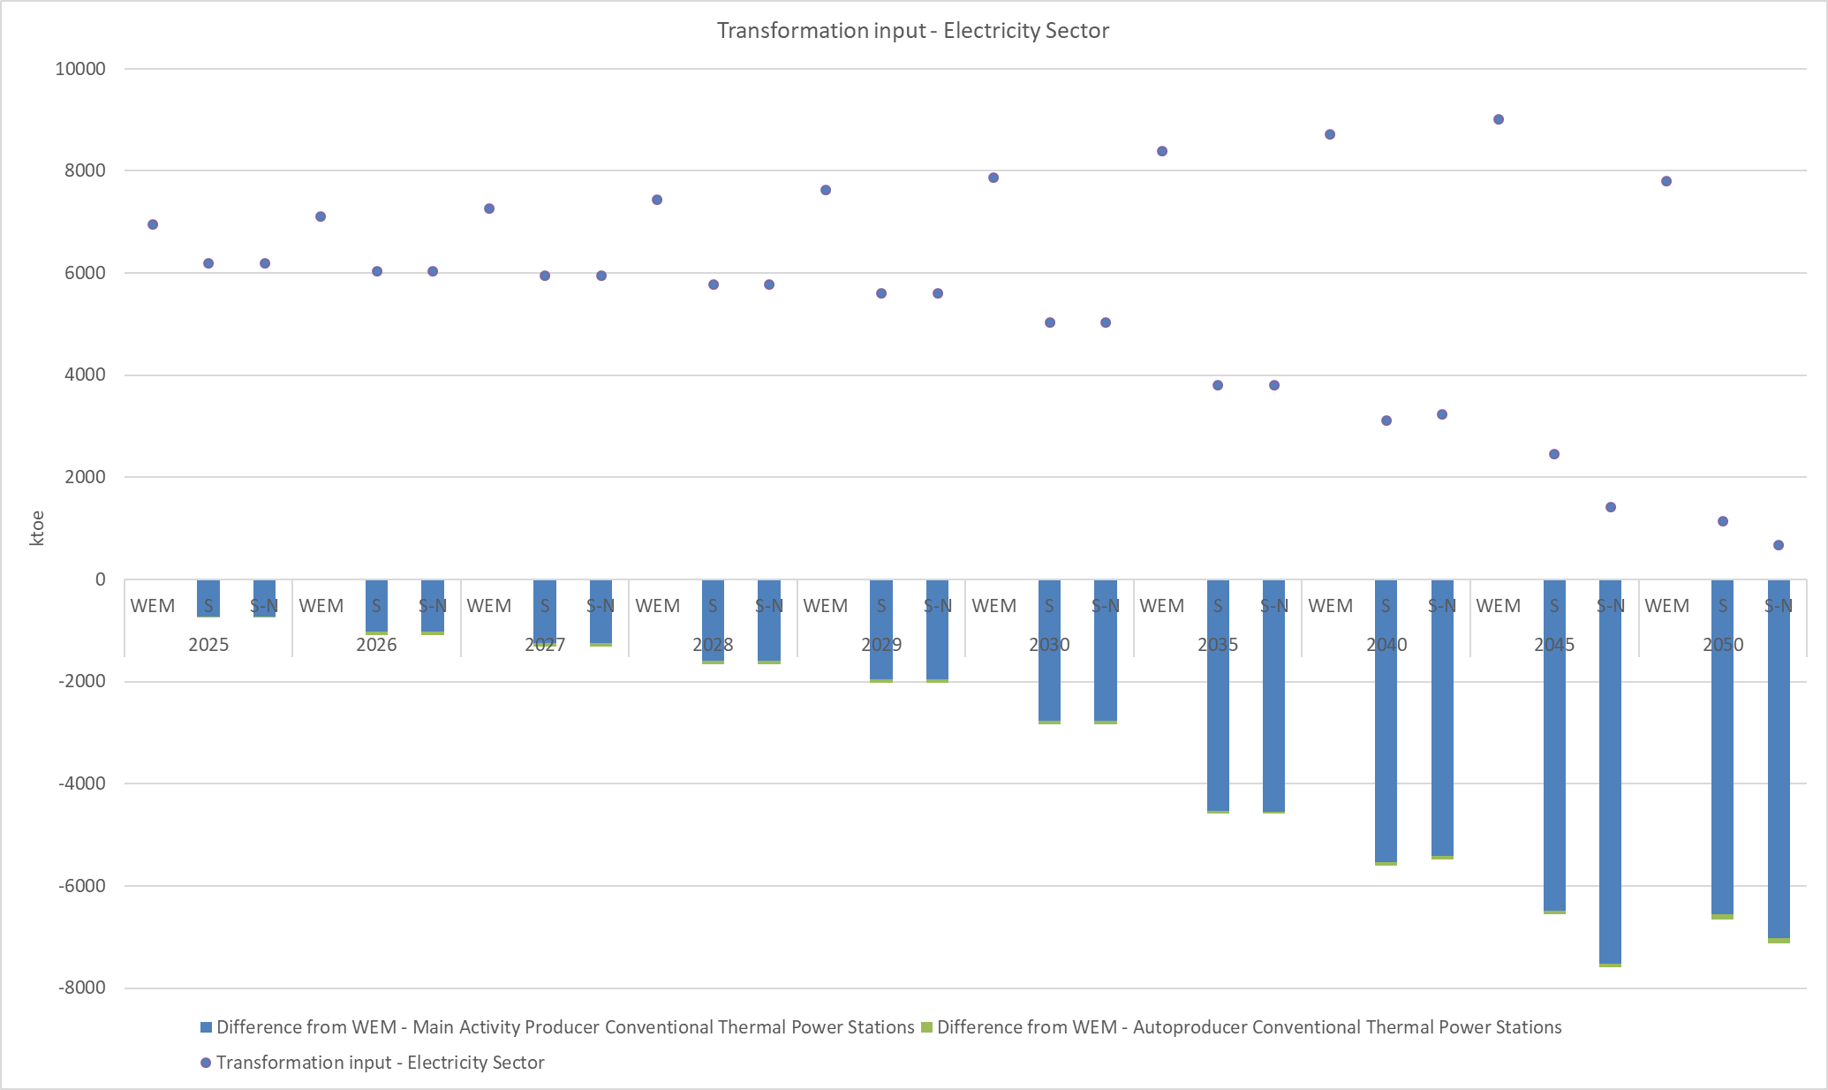
Similarly, total transformation output in electricity sector in WEM scenario reaches 2.8 Mtoe in 2030, increasing by 3% at 2.9 Mtoe in 2050 (Figure 5.40). By 2050, total transformation output in electricity sector decreases substantially in scenarios S and S-N by 71.7% and 84.6% respectively, reaching 551 ktoe and 300 ktoe accordingly. Main activity producer’ conventional thermal power stations contribute the majority of the transformation output in electricity sector throughout the projection period. It should be noted that this refers only to conventional and bioenergy fired plants outputs and does not include the output of wind, solar and hydro plants.
Figure 5.40: Transformation output in electricity sector
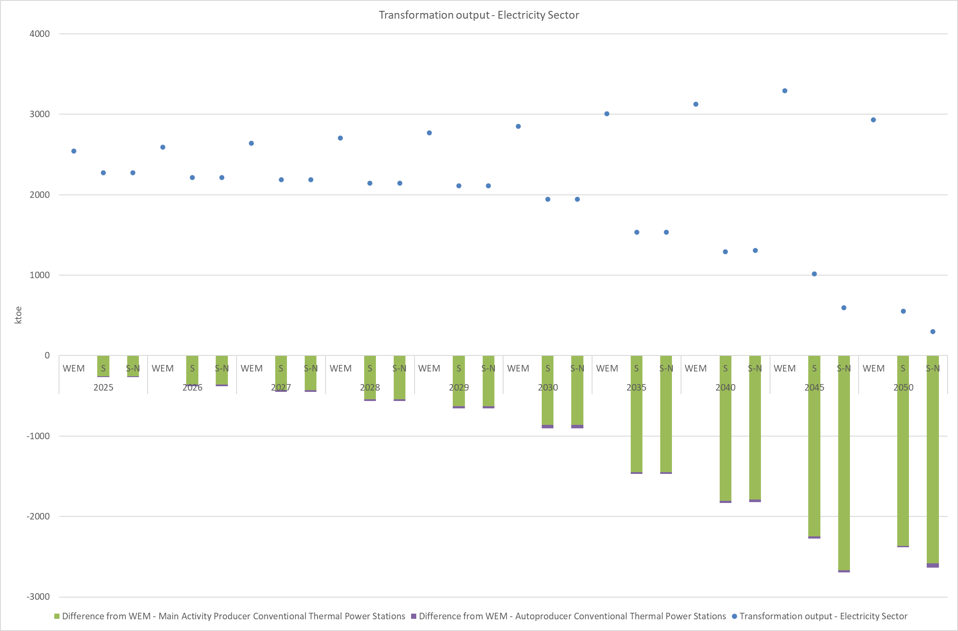
In scenarios S and S-N, total electricity network losses as a percentage of total electricity generation reach about 14% in 2030, while decreasing by 2050 at about 10% (Figure 5.41). In WEM scenario, total electricity network losses remain stable at 12% in 2030, 2035 and 2040 and at 11% in 2045 and 2050. Distribution network losses contribute the majority of the total electricity network losses throughout the projection period.
Figure 5.41: Total electricity network losses
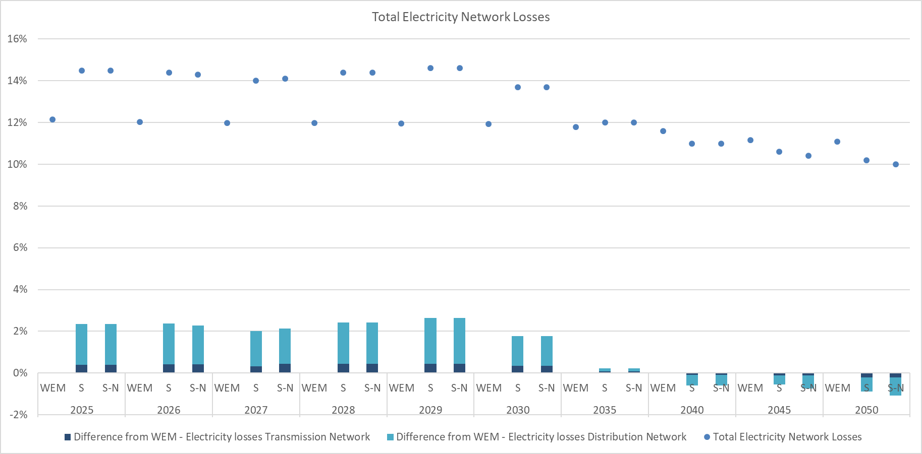
In all scenarios, total gas network losses as a percentage of total gas transferred reach 1% in 2030, remaining stable by 2050 (Figure 5.42). Gas losses’ LP Network contribute the majority of the total gas network losses throughout the projection period.
Figure 5.42: Total gas network losses
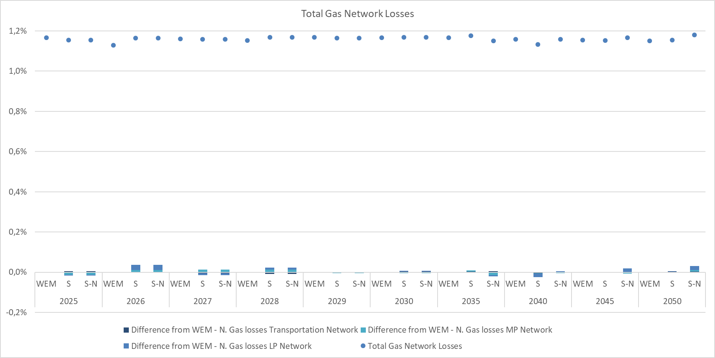

Macroeconomic and, to the extent feasible, the health, environmental, employment and education, skills and social impacts, of the planned policies and measures
As readily shown in Figure 5.43, until 2030, Scenario S (WAM) leads to a continuous increase of the GDP with respect to WEM. Then, the positive change becomes more aggressive by 2045 (slightly oscillating between +1.7% and +2.2%) and presents a negligible descent between 2045 and 2050. However, the change is always greater than +1.2%, with respect to the WEM scenario, through the whole-time horizon. This means that the policy and technology options included in the WAM scenario have a positive impact on the economy leading to higher GDP growth rates compared to the WEM scenario. In the post 2040 period, Scenario S-N (the nuclear option of Scenario S) leads to an almost constant moderate slow-down, due to the emerged costs of relying on the nuclear power technology in conjunction with the posed high mitigation targets.
The situation regarding GDP’s growth rates is quite clear. The implementation of scenario S tends to increase GDP, with respect to the WEM scenario. On the other hand, the introduction of nuclear power generation leads to a moderate reduction in GDP, with respect to the WEM scenario, which follows a constant downward trajectory after 2040. In general, it is costlier to rely on nuclear power (including higher operational and construction costs) therefore, forcing to rely also on this more expensive technology, in conjunction with ambitious mitigation targets, restrains GDP’s growth in some extent.
Figure 5.43: Impact of scenarios S and S-N implementation on the GDP of Serbian economy over the 2025-2050 period

Figure 5.44 shows how the scenarios under consideration are projected to impact the unemployment levels of Serbian economy. In general, the impact on the aggregated unemployment is limited.
Regarding scenario S, the impacts are observed prior to 2030 (where a Just Transition Plan is expected to minimise the consequences of such impact). Regarding scenario S-N, we observe a slight increase in the unemployment in the medium to long term towards 2045 (less than 0.4% compared to WEM levels). This fact is somehow expected, since the present study relies on a computable general equilibrium framework, which is actually a demand-driven approach. Nuclear option constitutes an expensive alternative mainly due to the construction, operational, and maintenance costs. Under this situation, market clearing constraints of the modelling direct the demand to slow-down until the adjustment. The downward demand in conjunction with the high mitigation targets that have been set – thus causing recession to the carbon-intensive activities – and the fact that alternatives such as solar and wind power technologies are less labor-intensive, lead to a slight employment decrease. However, the overall impact is extremely small (less than 0.4%).
Figure 5.44: Impact of Scenarios’ S and S-N implementation on the unemployment rate of Serbian economy over the 2025-2050 period

Figure 5.45 illustrates the estimated impact under scenario S on the employment of key sectors of the Serbian economy in terms of thousand employees. We observe that coal mining sector demands constantly less employees in the labor market, which is an expected result of the process of decarbonization. Petroleum products follow the pattern of coal mining, however, in a quite lower scale. Electricity sector also reduces its labor force, which is an impact of the change of the generation mix of electricity demand towards 2050, from labor intensite lignite fired power plants to less labor intensive renewable energy technologies. Heavy manufacturing is affected negatively only in the long term (2050). Based on the outcomes of the macroeconomic analysis tool, the greater part of lost jobs in sectors where employment is reduced moves towards the services sector. A more detailed analysis on the employment effects in the specific regions will be considered in the Just Transition Diagnostics Study.
Figure 5.45: Impact on employment by sector under the implementation of Scenario S

It is also interesting to investigate the job creation specifically from power generation technologies. Those jobs are linked either to the manufacturing and installation of power generation technologies or to the O&M of the power plants. The jobs estimated to be created in scenario S due to the deployment of new RES capacity for solar PV, wind and biomass (It is assumed that the installation of a large-scale PV plant on average is 1 year, wind plant 2 years and biomass plant 2 years) have been calculated. The results are illustrated in Figure 5.46.
Figure 5.46: Estimation of the number of jobs created in scenario S due to the deployment of new RES capacity for solar PV, wind and biomass
It must be noted that the values presented in Figure 5.46 refer to the upper and lower limit of full-time jobs created in the entire country to install, operate and maintain new RES capacity until 2030 (from the beginning of 2023 until end of 2030). Out of these jobs, it is anticipated that a large number if not all of them for solar and biomass plants can be created in the impacted lignite territories, while jobs related to wind farms which will be deployed in areas with high wind potential. It is also anticipated that the jobs to be created in general and in the lignite regions specifically will be retained due to the constantly expanding RES sector. From the analysis it is derived that up to 3300 and 4900 jobs can be created in the region due to the deployment of new solar and biomass plants.
Scenario S will also impact the average generation (electricity supply) cost that includes the fuel, variable and fixed operating costs plus the annualised investment costs of new investments (after 2016) only. This influence is presented in Figure 5.47 and it can be shown that scenario S will specifically lead to an overall increase in the costs towards 2050. It is important to note that average electricity supply cost is not equivalent to the wholesale electricity prices.
Figure 5.47: Evolution of the average electricity supply cost in scenario S

Overview of investment needs
The Serbian INECP includes bold efforts towards the decarbonization of the energy sector, associated as expected with high costs. The overall investment needs (referring both to public and own fund CAPEX needs) included under the additional cost of the WAM scenario amount to approximately 13.79 billion EUR until 2030, while overall investments needs under WEM scenario are 16.76 billion EUR until 2030. It should be highlighted that the implementation of INECP can be achieved with the deployment of additional measures as foreseen in the WAM scenario, which complement the measures foreseen in the WEM scenario.
The Total overall investment needs for implementation of INECP are estimated of approx. 30.55 billion EUR, taking into consideration that some key measures that need further studies are still under budget examination.
In addition, it is necessary to highlight links and dependencies with the “Basic Principles of Energy Infrastructure Development Plan and Energy Efficiency Measures for the period until 2028 with projections until 2030“ (Government’s Conclusion on adoption 05 no. 312-5262/2023-1 from 15/6/2023) - “EIDP&EEM”.
The aforementioned “EIDP&EEM” includes the basic directions of strategic development until 2030 and 2050. The “EIDP&EEM” refers to various projects at different stages of development and maturity. Due to volatile circumstances in the energy sector worldwide, a lot of these projects could potentially progress to implementation, while other projects are still at the initial stages of development and some even at the very early conceptual stage.
However, this only reinforces the commitment of the Government of the Republic Serbia to go above and beyond regarding the safe and reliable supply of energy (including its quality).
In order to highlight the strategic direction that the Government of the Republic of Serbia needs to take to fulfil its energy transition ambitions, an indicative estimate of the additional investment costs from the Infrastructure Development Plan compared to INECP is presented in Annex IV.
Following to Annex IV, the investment costs for the period up to 2030 are in the range of 4.71 billion EUR, while the investment costs for the period after 2030 and up to 2050 are in the range 3.14 billion EUR.
The deployment of new large-scale projects shall also create the respective OPEX needs which are however not included in the present analysis. Figure 5.48 illustrates the distribution of implementation costs per dimension.
As it can be obtained, the related measures included in the Energy Efficiency dimension account for the vast majority of the implementation costs representing around 68.54% of them. This is reasonable considering that projects categorized under this dimension are related to massive investments required for the promotion of energy efficiency in the industrial, transport sectors as well as the building sector. These sectors need intensive investments in the form of support schemes through subsidies for the energy renovation of existing commercial, public and residential buildings, as well as the construction of new ones, subsidies and tax advantages for the purchase of energy efficient commercial vehicles and financial/fiscal measures for the replacement of the conventional light-duty and heavy-duty vehicles for the freight transport as well as for the modernization of the existing railway infrastructure in the country.
It is important to mention that out of the total cost of 20.94 billion EUR, the 19.07% (5.83 billion) refers to measures that affect also the Decarbonization dimension, but the implementation cost has not been double counted. More specifically, it affects measures PM_D29, PM_D30, PM_D35 and PM_D43. Further to that cost, investment needs related to Decarbonization, more specifically to GHG emissions and renewable energy amount to approximately 5.19 billion EUR until 2030.
Figure 5.48: Distribution of implementation costs per dimension

An overview of the individual measures listed under the 5 dimensions (i.e. Decarbonization, Energy Efficiency, Energy Security, Internal Energy Market, Research, Innovation and Competitiveness), alongside their implementation costs are summarized in Figure 5.49, while the detailed list of measures is included in Annex I. In the cases that the measure is implemented partially under WEM and WAM scenarios, it has been assumed that implementation costs are split between WEM and WAM, according to the specific measure provisions. It can be obtained that in the WEM cost is approximately 16.76 billion EUR of investments are included, while the additional WAM cost 13.79 billion EUR.
This allocation essentially indicates that already under the WEM scenario considerable decarbonization efforts were included (Figure 5.49). It should be stressed also that large part of the costs of the WAM scenario shall come from private sector investments, implying that the feasibility of the scenario is strongly related to affordability for consumers and the ability of the private sector to deliver projects.

Figure 5.49: Distribution of implementation costs per WEM /WAM

Table 5.3: Dimension of Measures and implementation costs (Extended table with measures and their respective costs is included in Annex I)
Dimension of Measures | Implementation Cost (billion €) | Planned public aid (billion €) | Own funds  (billion €) | Own funds over total implementation cost | CAPEX WEM (billion €) | CAPEX WAM (billion €)
Decarbonisation | 5.19 | 1.19 | 4.00 | 77% | 1.16 | 4.03
Energy Efficiency | 20.94 | 8.12 | 12.82 | 61.2% | 12.31 | 8.62
Energy Security | 3.13 | 1.32 | 1.80 | 57.6% | 1.99 | 1.14
Internal Energy Market | 1.19 | 0.18 | 1.01 | 85.0% | 1.19 | 0.00
Research Innovation and Competitiveness | 0.11 | 0.06 | 0.05 | 45.7% | 0.11 | 0.00
Total (billion €) | 30.55 | 10.87 | 19.68 | 64.4% | 16.76 | 13.79
Out of the cumulative investment needs of 30.57 billion EUR up to 2030, approximately 35.6% refers to public sector investments (Figure 5.50) The remaining almost 64.4% shall come from own funds investments including the projects promoted by the Transmission and Distribution System Operators that will be eventually socialized through the tariffs. Particularly, large scale transmission projects will be further assessed with respect to the financial capacity of the project promoters to implement them, as well as with respect to their stress on the transmission and distribution tariffs.
Figure 5.50: Distribution of implementation costs per for public and private (own resources) investments

The blending of private (own resources) and public funds will be the prevalent option for the financing of those measures subject to public budget and private sector affordability constraints. Part of the investment needs related to green transition can be covered by the earmarking of public revenues from the imposition of the carbon pricing. Also, the instrument of Public and Private Partnerships could be key to leveraging private sector investments.
In this context, the role of IFIs is critical to support the green transition of the Serbian energy sector. Whereas there is a number of green financing activities in terms of grants and loans, these are quite limited compared to the overall investment needs. An indicative overview of available green funding instruments for Serbia and the entire Western Balkans regions is presented in Table 5.4.
Table 5.4: Indicative Overview of Serbia's green transition support programs
Donor | Field | Description
WB,EBRD,  KfW | Type of aid | Directorate for Financing and Promoting Energy Efficiency
 | Amount | The fund is allocated from the central budget of the Government of Serbia, on an annual basis, in the approximate amount of EUR 20 million. As of 2019, an EE levy has been introduced on energy bills.
 | Purpose | Support the implementation of EE measures in energy efficiency in public buildings, households and commercial facilities
 | Duration | n.a
UNDP | Type of aid | Advancing Medium and Long-Term Adaptation Planning in the Republic of Serbia
 | Amount | n.a
 | Purpose | - Strengthening legal and institutional framework for climate change adaptation (CCA);  - Assessing and addressing immediate national and subnational CCA policy and institutional capacity gaps;  - Developing of the National Climate Change Adaptation Plan (NAP) and integration of the CCA into national and subnational planning processes;  - Improving of the Nationally Determined Contributions (NDC);  - Developing of web-based application and platform for Climate Change Vulnerability Assessments and Adaptation (CCA)
 | Duration | Till2023
KfW | Type of aid | Supporting Sustainable National Guarantee Institutions
 | Amount | Up to EUR 50 million
 | Purpose | Unlocking EUR 140+ millions of financing, Reaching 4700+MSMEs and Entrepreneurs and Investing in a sustainable recovery
 | Duration | ongoing support
EC | Type of aid | Instrument for Pre-accession Assistance III (IPA III)
 | Amount | Up to EUR 9 billion
 | Purpose | Reinforcing instruments to foster public and private- sector investment (support economic convergence with the EU through investments and support to competitiveness and inclusive growth, sustainable connectivity, and the twin green and digital transition)
 | Duration | 2021-2027
EC | Type of aid | Instrument for Pre-accession Assistance III (IPA III)
 | Amount | Over EUR 14 billion
 | Purpose | Increasing public and private investment in the region by the EIB, EBRD and other IFIs, DFIs, the Western Balkans governments and private investors, including foreign direct investment, as well as integrating markets
 | Duration | 2021-2027
EC | Type of aid | Facilitating the increase of energy efficiency - in the context of the EU Green Deal, EU renovation wave support will be extended
 | Amount | so far enabled green investments of a total of EUR 700 million
 | Purpose | Purpose is: transition from coal to sustainable and clean energy. Commission proposes to expand the “EU renovation wave” to the region of the Western Balkans. A refurbished and improved building stock will help pave the way for a decarbonized and clean energy system, as the building sector is one of the largest energy consumers in Europe. For this purpose, the EU will use, among others, the existing platforms such as Green for Growth Fund and Regional Energy Efficiency Programme
 | Duration | 4 years for contractual commitments and 5-7 years for implementation
EC | Type of aid | Western Balkans Guarantee facility
 | Amount | Mobilizing cca EUR 20 billion of investments
 | Purpose | Improvement of the investment capacity of the region: reducing the cost of financing for both public and private investments and reducing the risk for investors, support the green and digital twin transitions; increase competitiveness of the private sector, boost innovation and development of social sectors, connecting economies through strengthened regional economic integration and integration with the EU.
 | Duration | 2022-2032
EIB | Type of aid | - €88million for the health and water sectors  - €761million for the socioeconomic recovery (€385 million from it to ensure survival in the short- term, and recovery in the medium-term of businesses in the private sector)  - €750million macro-financial assistance (Western Balkan governments support in payment crisis)  - €1.7 billion of EIB investment (for additional loans for public sector investments, and further credit to enterprises, to help safeguard jobs for the many people working in SMEs in the region)
 | Amount | over EUR 3.3 billion
 | Purpose | Bringing under control coronavirus health crisis and post-pandemic socio- economic recovery
 | Duration | Ongoing support
EBRD,KfW,  EU | Type of aid | BOX 2:  IFI/Donor programmes in the region of the Western Balkans (ECS Donor Coordination Platform)  It is a regional programme blending IFI financing from the EBRD and KfW with EU grant financing to support an integrated package of targeted policy dialogue (transposition of the EU Energy Performance of Buildings directive), technical assistance, and financing with the aim to Stimulate sustainable growth
 | Amount | EUR 45 million EBRD with EUR 6.7 million of EU grant co-financing; up to EUR 85 million KfW financing and EUR 15.6 million of EU grants
 | Purpose | Public Finance Window finances EE renovations of public buildings owned by municipalities or governments (schools, hospitals, central and local administration offices). This window comprises of: up to EUR 45 million EBRD financing
 | Duration | n.a.
EIB | Type of aid | BOX 2:  IFI/Donor programmes in the region of the Western Balkans (ECS Donor Coordination Platform)  It is a regional programme blending IFI financing from the EBRD and KfW with EU grant financing to support an integrated package of targeted policy dialogue (transposition of the EU Energy Performance of Buildings directive), technical assistance, and financing with the aim to Stimulate sustainable growth
 | Amount | EUR 135 million EBRD credit line supported by technical assistance and incentives and provided through local financial institutions, EUR 35,1 million grants from donors
 | Purpose | Western Balkans Green Economy Financing Facility (WBGEFF I and II) promotes EE renovations in the residential sector and the construction of new high performing buildings
 | Duration | 2021-2027
EIB,EC | Type of aid | n.a.
 | Amount | EUR 80 million
 | Purpose | The Private Financing for Energy Efficiency (PF4EE) is a joint initiative between the EIB and the European Commission. Through the LIFE Programme the instrument’s credit risk protection and expert support services will be funded. The EIB leverages this amount, making a minimum of EUR 480 million available in long-term financing
 | Duration | 2021-2027
EC,EEFIG | Type of aid | n.a.
 | Amount | Horizon EU's EUR 95.5 billion worth research and innovation programme in total
 | Purpose | Through EU Horizon 2020, the Commission has setup a series of facilities funding Project Development Assistance (PDA) to support public authorities - regions, cities, municipalities and public bodies in developing bankable sustainable energy projects.  The Commission, in collaboration with the Energy Efficiency Financial Institutions Group (EEFIG), has developed products that aim to inform financial institutions, investors and project promoters about the real benefits and risks of energy efficiency investments
 | Duration | 2021-2027
EC,EEFIG | Type of aid | n.a.
 | Amount | n.a.
 | Purpose | The De-risking Energy Efficiency Platform (DEEP) is a pan-EU open-source database containing detailed information and analysis of over 10,000 industrial and buildings-related EE projects. It builds performance track records and helps project developers, financiers, and investors better assess the risks and benefits of energy efficiency investments.
 | Duration | n.a.
It is noted that as of today, a draft Just Transition Action Plan should be finalised and adopted by the Government of RS during 2024. As regards to its development, the following principles are used to drive decisions under the assessment for infrastructures and interventions needed:
- Public infrastructure investment decisions will be aligned with the policies and strategies set by the government such as INECP, especially the major time milestones
- Only some economic inclusion problems can be effectively addressed by infrastructures, while targeted intangible interventions are being considered, although further reforms are being explored.
- Fit-for-purpose, accessibility and affordability are key variables in the assessment process for the selection of the actions.
- Individuals, enterprises and the community must have the capacity, capability and willingness to access/support the infrastructures and any interventions.
- Flexibility to meet the complex and changing nature of the impacts due to transition over the time schedule.
- Infrastructure investments should leverage the comparative advantages of enterprises operating in the territories and support those that are required to transform their activities so that to demonstrate the potential to grow in the future.
As a result of the aforementioned methodology, the proposed Action Plan encompasses actions across a number of pillars, such as Governance, Policy & Reforms (Laws/Regulations), Investments/Interventions and capacity building. Specifically with respect to investments, those are linked to infrastructure (e.g., energy transition, green transition, building of infrastructure, etc.), innovation & research, entrepreneurship, labour force skilling, social inclusion, as well as to regeneration of brownfields. According to the same Draft Action Plan, the modes of financing for those investments can be either of public or of private (own resources) origin or a combination of both.

Impacts of planned policies and measures on other Contracting Parties of the Energy Community and Member States of the European Union, and regional cooperation

Impacts on the energy system in neighbouring and other Member States in the region to the extent possible
The Serbian energy market is the largest in the Balkan region of the EnC. The energy sector is highly dependent on fossil fuels, which are mostly used in inefficient infrastructure, such as power plants, heat plants and passenger vehicles.
Nevertheless, Serbia has a well meshed Transmission System designed as the backbone of a much larger system. The Transmission System does not exhibit “structural constraints” and the fact that Serbia has 8 electrical Borders with a large interconnection capacity is a measure of how well the Serbian System can integrate a relatively large level of variable RES. On the other hand, the relatively inflexible generation fleet, calls for enhanced Flexibility solutions (like for example Energy Storage) in order to cope with increased capacity levels of variable RES.
EMS plans extensive investments for the upgrade of existing infrastructure as well as for new transmission capacities. Such infrastructure will improve the security of supply of the transmission system users and increase cross-border capacities. This is of great importance since Serbia is connected with eight neighbouring countries (Romania, Hungary, Croatia, Bosnia, Montenegro, Northern Macedonia, Albania, Bulgaria). The existing and the planned interconnectors, are highlighting the role of Serbia as an energy transit country in the Balkans and potentially energy hub.

Impacts on energy prices, utilities and energy market integration
The import dependency of oil and oil products is projected to increase from 76% in 2019 to 97% in 2050, while the import dependency of natural gas is projected to follow a similar upward trend from 84% in 2019 to 94% in 2050. The import dependency of electricity is projected to be at the levels observed until now, ranging between 0% in 2019 to small negative numbers in the period until 2050, ensuring the self-sufficiency of the Republic of Serbia in electricity. This is achieved through the utilisation of the lignite fired power plants in the medium term until 2030 and the gradual shift to RES (mainly wind and solar PV) in the period until 2050.
Moreover, the organised day-ahead market/power exchange in Serbia (JSC “SEEPEX”) (established in February 2016 on the basis of partnership between EMS and European Power Exchange), could play a significant role in further promoting regional market integration, particularly in the absence of exchanges in neighbouring markets.

Where relevant impacts on regional cooperation
The importance of regional cooperation is emphasized throughout the INECP and reflected on a number of cross-border interconnection projects which will enhance the country’s energy security and create new energy flows within the Balkan area. The development and implementation of such complex projects constitutes an excellent example of regional cooperation either at national or TSO level.
Table 5.5: List of most important regional cooperation-related projects
Policy Measure Code | Policy Measure Name
PM_IEM3 | Transbalkan Corridor: OHL B.Basta (RS) – Visegrad (BA) – Pljevlja (ME)
PM_IEM4 | Interconnection between Resita (RO) and Pancevo (RS)
PM_IEM5 | Pannonian Corridor
PM_IEM6 | Central Balkan Corridor
PM_IEM7 | RES integration cluster of projects - North Corridor
PM_IEM8 | Regional connection through the implementation of interconnection projects
PM_IEM8.1 | Serbia-Bulgaria gas interconnection project
PM_IEM8.2 | Serbia-Romania gas interconnection
PM_IEM8.3 | Serbia-Croatia gas interconnection
PM_IEM8.4 | Serbia-BiH gas interconnection
PM_IEM8.5 | Regional gas pipeline Leskovac-Vladicin Han-Vranje
PM_IEM8.6 | Gas pipeline - interconnection with Montenegro
PM_IEM8.7 | Serbia-Macedonia gas interconnection
PM_IEM8.8 | Nis-Pristina gas pipeline
Similarly, at market level, the South-East European Gas (SEEGAS) Initiative, launched by the Energy Community Secretariat in December 2020, is a response to stakeholders’ increasing interest to establish organized gas exchanges and improve cross-border trading. The initiative aims to foster closer cooperation between national gas exchanges and TSOs in the region to enable further market opening, better services for traders and ultimately benefit end-consumers through increased competition in gas trading.

Annex: Summary Table of Measures with implementation cost
Table I.1: Decarbonisation policy measures
Dimension | PAM number | Name of policy or measure | Type of measure | Synergetic effects | Implementation Cost (million €) | Planned public aid (million €) | own Funds (million €) | Projections scenario in which the PAM is included | CAPEX WEM (million €) | CAPEX WAM (million €)
Decarbonisation | PM_D1 | Introduction of carbon pricing on energy | Reform |  | 0.20 | 0.20 | 0.00 | WAM | 0.00 | 0.20
 | PM_D2 | Monitoring and revision of the Low-carbon Development Strategy and implementation of the Climate Change Adaptation Programme with Action Plan | Reform |  | 1.40 | 1.40 | 0.00 | WEM | 1.40 | 0.00
 | PM_D3 | Promoting circular economy | Reform |  | 4.50 | 4.50 | 0.00 | WEM | 4.50 | 0.00
 | PM_D4 | Organizing awareness campaigns for better information dissemination about climate change | Reform |  | under examination |  |  | WEM | under examination | 0.00
 | PM_D6 | Monitoring and revision of Just Transition Plan | Reform |  | 2.00 | 1.00 | 1.00 | WEM | 2.00 | 0.00
 | PM_D5 | Implementation of best available technologies in production processes in specific industries | Investment |  | 29.00 | 29.00 | 0.00 | WEM | 29.00 | 0.00
 | PM_D5.1 | Measures for the reduction of emissions of fluorinated gases with greenhouse effect in the refrigeration and air conditioning equipment | Investment |  | under examination |  |  | WEM | under examination | 0.00
 | PM_D14 | Improvement of wastewater treatment and discharge system | Investment |  | 90.00 | 90.00 | 0.00 | WEM | 90.00 | 0.00
 | PM_D15 | Improvement of municipal waste management system, through increased recycling rates, reduced disposal of biodegradable waste on landfills and unsanitary landfills | Investment |  | 80.00 | 80.00 | 0.00 | WEM | 80.00 | 0.00
 | PM_D16 | Higher percentage of municipal solid waste treated by biological treatment options | Investment |  | 85.00 | 85.00 | 0.00 | WEM | 85.00 | 0.00
 | PM_D17 | Utilisation of the entire amount of methane (CH4) generated from all the dumped quantities of waste that end up in sanitary landfills | Investment |  | 48.00 | 48.00 | 0.00 | WEM | 48.00 | 0.00
 | PM_D18 | Promotion of composting in both centralised and household perspectives | Investment |  | 60.00 | 60.00 | 0.00 | WEM | 60.00 | 0.00
 | PM_D7 | Sustainable forest management (forest land remaining forest land) | Investment |  | 354.00 | 354.00 | 0.00 | WEM | 354.00 | 0.00
 | PM_D8 | Waste lands conversion to croplands | Investment |  | 8.50 | 8.50 | 0.00 | WEM | 8.50 | 0.00
 | PM_D9 | Increase the tree-planted areas (groves / parks / green roofs, sanitary protection zones around mines and industrial buildings, wind protection belts and green zones next to highways) | Investment |  | 6.50 | 6.50 | 0.00 | WEM | 6.50 | 0.00
 | PM_D10 | Measures for the reduction of CH4 emissions from the enteric fermentation of animals | Reform |  | 0.50 | 0.50 | 0.00 | WEM | 0.50 | 0.00
 | PM_D11 | Improvement of manure management for the reduction of CH4 and N2O emissions | Investment |  | 9.00 | 9.00 | 0.00 | WEM | 9.00 | 0.00
 | PM_D12 | Measures for the reduction of direct and indirect N2O emissions from managed soils | Investment |  | 6.00 | 6.00 | 0.00 | WEM | 6.00 | 0.00
 | PM_D13 | Measures for reducing emissions from fertilizers use | Investment |  | 28.00 | 28.00 | 0.00 | WEM | 28.00 | 0.00
 | PM_D19 | Provision of operation aid for electricity production from renewable stations based on auctions and strategic partnerships | Investment |  | 3000.00 | 0.00 | 3000.00 | WEM, WAM (enhancement, adjustment) | 344.82 | 2651.18
 | PM_D20 | Development of the legislative framework for the participation of the RES producers in electricity market | Reform |  | 0.20 | 0.20 | 0.00 | WEM, WAM (enhancement, adjustment) | 0.20 | 0.00
 | PM_D21 | Supporting electricity production from renewable stations that will not participate into the auctions including the deployment of renewables power purchase agreements | Investment |  | 700.00 | 0.00 | 700.00 | WEM, WAM (enhancement, adjustment) | 0.00 | 700.00
 | PM_D22 | Provision of economic support to innovative and demonstration pilot RES projects | Investment | Be integrated into PM_D21 |  |  |  | WAM
 | PM_D23 | Fostering the further utilization of guarantees of origin for energy from RES in all end-uses | Reform |  | 0.10 | 0.10 | 0.00 | WEM | 0.10 | 0.00
 | PM_D24 | Updating, simplifying and optimizing the authorization, certification, permit-granting and licensing procedures - Establishment of One stop shop | Reform |  | 0.20 | 0.20 | 0.00 | WAM | 0.00 | 0.20
 | PM_D25 | Updating, simplifying and optimizing the grid connection procedures and setting detailed methodology and allocation rules for RES grid connection costs | Reform |  | 0.10 | 0.10 | 0.00 | WAM | 0.00 | 0.10
 | PM_D26 | Fostering the self-consumption of the produced electricity | Investment | Be integrated into PM_D21 |  |  |  | WAM
 | PM_D27 | Operating publicly accessible registries for RES electricity producers | Reform |  | 0.50 | 0.50 | 0.00 | WEM, WAM (enhancement, adjustment) | 0.50 | 0.00
 | PM_D28 | Adaptation, enhancement and expansion of the grid networks for avoiding congestions and enabling the optimal penetration of RES | Reform |  | under examination |  |  | WAM | 0.00 | 0.00
 | PM_D29 | Promotion of RES for heating and cooling in new and renovated buildings | Investment | Budget incorporated into energy efficiency dimension measures (PM_EE1-PM_EE8) |  |  |  | WAM
 | PM_D30 | Provision of fiscal and economic incentives to foster RES in heating and cooling | Investment | Budget incorporated into energy efficiency dimension measures (PM_EE1-, PM_EE8) - 2518 M€ for heat pumps and 637 M€ for solar thermal systems |  |  |  | WAM
 | PM_D31 | Facilitating the penetration of RES into district heating networks | Investment | 8 M€ for biomass  443 M€ for solar energy | 451 | 225.5 | 225.5 | WAM | 0.00 | 451.00
 | PM_D32 | Fostering the production of advanced biofuels for use in transport sector | Investment |  | 100.00 | 50.00 | 50.00 | WAM | 0.00 | 100.00
 | PM_D33 | Fostering the consumption of biofuels in transport sector | Reform |  | 0.50 | 0.50 | 0.00 | WAM | 0.00 | 0.50
 | PM_D34 | Development of the required infrastructure for recharging electric vehicles | Investment | be integrated into energy efficiency dimension | 85.00 | 85.00 | 0.00 | WAM | 0.00 | 85.00
 | PM_D35 | Provision of fiscal and economic incentives to foster the further deployment of electric vehicles | Reform | Budget incorporated into energy efficiency dimension measures (PM_EE12, PM_EE14, PM_EE18) - 570 M€ for electric vehicles, 1596 M€ for electric LDV and 505 M€ for electric buses |  |  |  | WEM, WAM (enhancement, adjustment)
 | PM_D36 | Promotion of renewable energy communities | Investment | Be integrated into PM_D21 |  |  |  | WAM
 | PM_D37 | Development of the legislative framework for the promotion of energy storage technologies | Reform |  | 1.00 | 0.00 | 1.00 | WAM | 0.00 | 1.00
 | PM_D38 | Supporting demonstration projects for the promotion of biomethane and renewable hydrogen | Investment |  | 35.00 | 17.50 | 17.50 | WAM | 0.00 | 35.00
 | PM_D39 | Development of the required legislative framework and the required infrastructure for the deployment of biomethane and renewable hydrogen | Reform |  | 0.80 | 0.80 | 0.00 | WAM | 0.00 | 0.80
 | PM_D40 | Development of effective supply chains for the exploitation of the available potential of biofuels, bioliquids and biomass | Investment | Be integrated into PM_D29 and PM_D33 |  |  |  | WAM
 | PM_D41 | Specification of the sustainability and greenhouse gas emissions saving criteria for biofuels, bioliquids and biomass fuels including the required monitoring and verification activities | Reform |  | 0.20 | 0.20 | 0.00 | WEM, WAM (enhancement, adjustment) | 0.20 | 0.00
 | PM_D42 | Conduction of information and training activities to all relevant actors for the use of RES | Reform | contribution to all implemented measures | 0.20 | 0.20 | 0.00 | WAM | 0.00 | 0.20
 | PM_D43 | Promotion of RES through public procurement procedures | Investment | Budget incorporated into energy efficiency dimension measures (PM_EE33) |  |  |  | WEM
 | PM_D44 | Development of a scheme for the qualification, accreditation and certification of RES professionals | Reform |  | 0.20 | 0.20 | 0.00 | WAM | 0.00 | 0.20
 | PM_D45 | Updating and optimizing the spatial planning framework | Reform |  | 0.10 | 0.10 | 0.00 | WAM |  | 0.10
 |  | TOTAL FOR DECARBONISATION (INCLUDING RES) |  |  | 5.19 | 1.19 | 4.00 |  | 1.16 | 4.03

Table I.2: Energy Efficiency policy measures
Dimension | PAM number | Name of policy or measure | Type of measure | Synergetic effects | Implementation Cost (million €) | Planned public aid (million €) | own Funds (million €) | Projections scenario in which the PAM is included | CAPEX WEM (million €) | CAPEX WAM (million €)
Energy Efficiency | PM_EE1 | Supporting financially the energy renovation of residential buildings | Investment |  | 1711.00 | 855.50 | 855.50 | WEM, WAM (enhancement, adjustment) | 1063.32 | 647.77
 | PM_EE2 | Support financially the energy renovation of public buildings | Investment |  | 1016.29 | 1016.29 | 0.00 | WEM, WAM (enhancement, adjustment) | 633.57 | 382.72
 | PM_EE3 | Support financially the energy renovation of non-residential buildings (not public) | Investment |  | 1601.52 | 800.76 | 800.76 | WEM, WAM (enhancement, adjustment) | 764.15 | 806.37
 | PM_EE4 | Completion of legislative framework in alignment with Directive 2018/844/EU and regulatory measures to promote near-zero energy buildings (nZEBs) | Reform | Contribution to PM_EE1-PM_EE2-PM_EE3 |  |  |  | WEM
 | PM_EE5 | Financial support for the construction and energy renovation of buildings exceeding minimum energy requirements | Investment | Contribution to PM_EE1-PM_EE2-PM_EE3 |  |  |  | WAM
 | PM_EE6 | Mandatory installation of solar thermal systems in new buildings and in buildings undergoing major renovation | Reform |  | 636.74 | 318.37 | 318.37 | WAM | 0.00 | 636.74
 | PM_EE7 | Enhancing the role of the energy performance certificates | Reform | Contribution to PM_EE1-PM_EE2-PM_EE3 |  |  |  | WEM
 | PM_EE8 | Overcoming split incentive barrier | Reform | Contribution to PM_EE1-PM_EE2-PM_EE3 |  |  |  | WAM
 | PM_EE9 | Promotion of energy efficient appliances in households | Investment |  | 1493.81 | 373.45 | 1120.35 | WEM, WAM (enhancement, adjustment) | 0.00 | 1493.81
 | PM_EE10 | Promotion of energy efficient passenger and light-heavy duty vehicles | Investment |  | 3803.00 | 0.00 | 3803.00 | WEM | 3803.00 | 0.00
 | PM_EE11 | Ensuring the energy efficiency in imported used passenger cars | Reform | Contribution to PM_EE10-PM_EE12-PM_EE14 |  |  |  | WEM
 | PM_EE12 | Financing programs for the promotion of energy efficiency passenger vehicles | Investment |  | 570.23 | 142.56 | 427.68 | WAM | 0.00 | 570.23
 | PM_EE13 | Development of the required infrastructure for the promotion of alternative fuels | Investment | Be integrated into PM_EE10, PM_EE12 and PM_EE14 |  |  |  | WAM
 | PM_EE14 | Promotion of energy efficiency of the freight transport | Investment |  | 1596.00 | 399.00 | 1197.00 | WEM, WAM (enhancement, adjustment) | 596.41 | 999.59
 | PM_EE15 | Promotion of modal shift both for passenger and freight transport - Enabling ‘Mobility as a Service’ (MaaS) | Reform | Be integrated into PM_EE10, PM_EE12 and PM_EE14 |  |  |  | WEM
 | PM_EE16 | Promotion of energy efficiency in inland waterways transport | Investment |  | under examination |  |  | WAM
 | PM_EE17 | Promotion of energy efficiency in rail transport | Investment |  | 255.77 | 255.77 | 0.00 | WEM | 255.77 | 0.00
 | PM_EE18 | Continuous enhancement and extension of the relative infrastructure for public transport | Investment |  | 505.39 | 252.70 | 252.70 | WEM | 505.39 | 0.00
 | PM_EE19 | Development of sustainable regional or municipal mobility plans | Reform | Be integrated into PM_EE10, PM_EE12 and PM_EE14 |  |  |  | WAM
 | PM_EE20 | Supplementary actions for the promotion of energy efficiency in transport sector | Reform | Be integrated into PM_EE10, PM_EE12 and PM_EE14 |  |  |  | WEM
 | PM_EE21 | Support schemes for the promotion of energy efficiency in industrial sector | Investment |  | 3366.00 | 1346.40 | 2019.60 | WEM, WAM (enhancement, adjustment) | 2957.11 | 408.89
 | PM_EE22 | Regulatory measures for the promotion of energy efficiency in industrial sector | Reform | Budget incorporated into PM_EE21 |  |  |  | WAM
 | PM_EE23 | Supplementary actions for the promotion of energy efficiency in industrial sector | Investment | Budget incorporated into PM_EE21 |  |  |  | WAM
 | PM_EE24 | Support schemes for the promotion of energy efficiency in agricultural sector | Investment |  | 2678.00 | 669.50 | 2008.50 | WAM | 0.00 | 2678.00
 | PM_EE25 | Advisory services and energy audits for farmers | Investment | Budget incorporated into PM_EE24 |  |  |  | WAM
 | PM_EE26 | Promotion of energy services and energy performance contracts through targeted financing programs | Reform | Contribution to all end-use measures |  |  |  | WAM
 | PM_EE27 | Promotion of energy services and energy services contracts through supplementary activities | Reform | Contribution to PM_EE1-PM_EE2-PM_EE3 |  |  |  | WAM
 | PM_EE28 | Mandatory conduction of energy audits and development of energy management systems | Reform | Budget incorporated into all end-use measures – savings under consideration |  |  |  | WEM
 | PM_EE29 | Promotion of energy audits in SMEs and in households | Investment | Be integrated into PM_EE1 and PM_EE3 |  |  |  | WAM
 | PM_EE30 | Financing programs for the energy upgrading of street lighting | Investment |  | 1668.81 | 1668.81 | 0.00 | WEM | 1668.81 | 0.00
 | PM_EE31 | Conduction of awareness raising activities | Reform | Budget incorporated into all end-use measures |  |  |  | WEM
 | PM_EE32 | Promotion of energy-efficient products through the implementation of energy labelling and eco-design Directives | Reform | Be integrated into PM_EE1, PM_EE2, PM_EE3, PM_EE10 and measures for industrial sector |  |  |  | WEM
 | PM_EE33 | Promotion of green public procurements | Reform | Be integrated into PM_EE2, PM_EE4, PM_EE5, PM_EE6, PM_EE7, PM_EE12, PM_EE14 and PM_EE18 |  |  |  | WEM
 | PM_EE34 | Regulatory measures and financing programs for promoting/modernizing high efficient CHP units and district heating/cooling networks | Reform |  | 35.00 | 17.50 | 17.50 | WEM | 35.00 | 0.00
 | PM_EE35 | Improvement and further development of a scheme for the qualification, accreditation and certification of energy efficiency professionals | Reform | Budget incorporated into all end-use measures – under consideration |  |  |  | WAM
 | PM_EE36 | Promotion of energy efficiency in water supply, distribution and consumption | Investment |  | Under examination |  |  | WAM
 | PM_EE37 | Strengthening the technical and administrative capacity of the involved policy makers | Reform | Budget incorporated into all end-use measures |  |  |  | WEM
 | PM_EE38 | Development of sustainable and innovative financing of energy efficiency projects | Reform | Budget incorporated into all end-use measures |  |  |  | WEM
 | PM_EE39 | Improve the bankability of energy efficiency projects | Reform | Budget incorporated into all end-use measures |  |  |  | WAM
 | PM_EE40 | Deployment of smart meters (synergies with energy market dimension) | Investment | Budget incorporated into all end-use measures |  |  |  | WAM
 | PM_EE41 | Promotion of smart and carbon neutral cities | Investment | Budget incorporated into all end-use measures |  |  |  | WAM
 | PM_EE42 | Promotion of measures for improving energy efficiency in electricity infrastructure | Reform |  | under examination |  |  | WEM, WAM (enhancement, adjustment) | 0.00 | 0.00
 | PM_EE43 | Promotion of measures for improving energy efficiency in natural gas infrastructure | Reform |  | Under examination |  |  | WEM, WAM (enhancement, adjustment) | 0.00 | 0.00
 | PM_EE44 | Promotion of demand response and dynamic pricing and tariffs | Reform | Budget incorporated into all end-use measures |  |  |  | WAM
 | PM_EE45 | Preparation of comprehensive assessment for promoting efficiency in heating and cooling | Reform |  | 0.50 | 0.50 | 0.00 | WAM | 0.00 | 0.50
 | PM_EE46 | Monitoring the provisions for metering billing information | Reform |  | 0.50 | 0.50 | 0.00 | WEM | 0.50 | 0.00
 |  | TOTAL FOR ENERGY EFFICIENCY |  |  | 20.94 | 8.12 | 12.82 |  | 12.31 | 8.62

Table I.3: Energy Security policy measures
Dimension | PAM number | Name of policy or measure | Type of measure | Synergetic effects | Implementation Cost (million €) | Planned public aid (million €) | own Funds (million €) | Projections scenario in which the PAM is included | CAPEX WEM (million €) | CAPEX WAM (million €)
Energy Security | PM_ES2 | Enhancement of regional electricity and gas interconnections | Investment |  | 187.20 | 28.08 | 159.12 | WEM | 187.20 | 0.00
 | PM_ES3 | Building capacities for electricity storage | Reform |  | 1.00 | 1.00 | 0.00 | WEM | 1.00 | 0.00
 | PM_ES3.1 | Banatski dvor, natural gas storage expansion | Investment |  | 100.00 | 15.00 | 85.00 | WEM | 100.00 | 0.00
 | PM_ES3.2 | Creating mandatory reserves of oil and petroleum products | Reform |  | 0.50 | 0.50 | 0.00 | WEM | 0.50 | 0.00
 | PM_ES4 | Creating operational reserves of oil, coal and other energy derivatives | Reform |  | 0.50 | 0.50 | 0.00 | WEM | 0.50 | 0.00
 | PM_ES5 | Creating mandatory natural gas reserves | Reform |  | 0.50 | 0.50 | 0.00 | WEM | 0.50 | 0.00
 | PM_ES6 | Electricity Risk Preparedness plan | Reform |  | 0.50 | 0.50 | 0.00 | WEM | 0.50 | 0.00
 | PM_ES7 | Update in Security of supply regulation (at least at a national level) | Reform |  | 0.50 | 0.50 | 0.00 | WEM | 0.50 | 0.00
 | PM_ES8 | Oil product pipeline from Pančevo refinery to Novi Sad, Sombor, Belgrade and Niš, through Smederevo and Jagodina | Investment |  | 400.00 | 60.00 | 340.00 | WEM | 400.00 | 0.00
 | PM_ES9 | Development of a pumped storage project in Bistrica | Investment |  | 835.00 | 417.50 | 417.50 | WAM | other | 835.00
 | PM_ES10 | Development of additional dispatchable generation from natural gas | Investment |  | 300.00 | 150.00 | 150.00 | WAM | other | 300.00
 | PM_ES11 | Modernisation of the coal mining industry | Investment |  | 1300.00 | 650.00 | 650.00 | WEM | 1300.00 | 0.00
 |  | TOTAL FOR ENERGY SECURITY |  |  | 3.13 | 1.32 | 1.80 |  | 1.99 | 1.14

Table I.4: Internal Energy Market policy measures
Dimension | PAM number | Name of policy or measure | Type of measure | Synergetic effects | Implementation Cost (million €) | Planned public aid (million €) | own Funds (million €) | Projections scenario in which the PAM is included | CAPEX WEM (million €) | CAPEX WAM (million €)
Internal Energy Market | PM_IEM2 | Implementation of Transbalkan Corridor: OHL Obrenovac (RS) - Bajina Basta (RS) | Investment |  | 89.68 | 13.45 | 76.23 | WEM | 89.68 | 0.00
 | PM_IEM3 | Implementation of Transbalkan Corridor: OHL B.Basta (RS) – Visegrad (BA) – Pljevlja (ME) | Investment |  | 52.32 | 7.85 | 44.47 | WEM | 52.32 | 0.00
 | PM_IEM4 | Interconnection between Resita (RO) and Pancevo (RS) (PCI 3.22.1) | Investment | Project completed from the Serbian end | 0.00 | None required | None required | WEM | 0.00 | 0.00
 | PM_IEM5 | Pannonian corridor | Investment |  | 108.00 | 16.20 | 91.80 | WEM | 108.00 | 0.00
 | PM_IEM6 | Central Balkan Corridor | Investment |  | 214.07 | 32.11 | 181.96 | WEM | 214.07 | 0.00
 | PM_IEM7 | RES integration cluster of projects – North Corridor | Investment |  | 84.00 | 12.60 | 71.40 | WEM | 84.00 | 0.00
 | PM_IEM8 | Regional gas connection through the implementation of interconnection projects | Investment |  | 224.00 | 33.60 | 190.40 | WEM | 224.00 | 0.00
 | PM_IEM8.2 | Project for Serbia-Romania gas interconnection 85.5 km (out of which 12.8 km is on the territory of the Republic of Serbia), with a capacity of 1.2 billion m3/year | Investment |  | 16.00 | 2.40 | 13.60 | WEM | 16.00 | 0.00
 | PM_IEM8.3 | Project for Serbia-Croatia gas interconnection (95 km, with a capacity of 1.5 billion m3/year) | Investment |  | 144.00 | 21.60 | 122.40 | WEM | 144.00 | 0.00
 | PM_IEM8.4 | Project for Serbia-BiH gas interconnection 90 km, with a capacity of 1.2 billion m3/year | Investment |  | 47.00 | 7.05 | 39.95 | WEM | 47.00 | 0.00
 | PM_IEM8.5 | Distribution gas pipeline RG 11-02 Leskovac-Vladicin Han-Vranje 71 km | Investment |  | 50.00 | 7.50 | 42.50 | WEM | 50.00 | 0.00
 | PM_IEM8.6 | Gas pipeline - interconnection with Montenegro | Investment |  | 60.00 | 9.00 | 51.00 | WEM | 60.00 | 0.00
 | PM_IEM8.7 | Project for Serbia-Macedonia gas interconnection 70.7 km, with a capacity of 0.8 billion m3/year | Investment |  | 20.00 | 3.00 | 17.00 | WEM | 20.00 | 0.00
 | PM_IEM8.8 | Project for Niš-Priština gas pipeline construction 65 km, with a capacity of 0.8 billion m3/year | Investment |  | 30.00 | 4.50 | 25.50 | WEM | 30.00 | 0.00
 | PM_IEM9 | Investments related to the digitalisation of the networks aiming at increasing RES integration and improvement of quality of supply | Investment |  | 10.00 | 1.50 | 8.50 | WEM | 10.00 | 0.00
 | PM_IEM11 | Smart meters roll out in electricity Elektrodistribucija Srbije d.o.o. Beograd EPS | Investment |  | 32.20 | 0.00 | 32.20 | WEM | 32.20 | 0.00
 | PM_IEM12 | Feasibility studies for smart meters roll out in natural gas distribution | Reform |  | 1.00 | 0.00 | 1.00 | WEM | 1.00 | 0.00
 | PM_IEM13 | Design and implement market and network data management model | Reform |  | 0.40 | 0.40 | 0.00 | WEM | 0.40 | 0.00
 | PM_IEM14 | Promotion of demand response for the end-users by use of the dynamic tariff system | Reform |  | 0.20 | 0.20 | 0.00 | WEM | 0.20 | 0.00
 | PM_IEM15 | Equipping gas distribution systems with metering and data collection devices (measuring equipment, measuring and operational platform, SCADA) necessary for the functioning and development of the gas market | Investment |  | 3.50 | 0.00 | 3.50 | WEM | 3.50 | 0.00
 | PM_IEM17 | Development of the regulatory framework for the operation of the “producer-consumer” (prosumer) (Article 169 in accordance to the amendments of the Energy Law and Article 58 to 61 of the Law on the use of RES) | Reform |  | 0.20 | 0.20 | 0.00 | WEM | 0.20 | 0.00
 | PM_IEM18 | Development of the regulatory framework for the operation of the “electricity storage” (Article 169 in accordance to the amendments of the Energy Law) | Reform |  | 0.20 | 0.20 | 0.00 | WEM | 0.20 | 0.00
 | PM_IEM19 | Development of the regulatory framework for the operation of the “aggregator” (Article 169 in accordance to the amendments of the Energy Law) | Reform |  | 0.20 | 0.20 | 0.00 | WEM | 0.20 | 0.00
 | PM_IEM20 | Development of the regulatory framework for the operation of the Renewable Energy Communities (RECs) and Citizen Energy Communities (CECs) (Article 62 to 66 and Article 77 of the Law on the use of RES) | Reform |  | 0.20 | 0.20 | 0.00 | WEM | 0.20 | 0.00
 | PM_IEM21 | Implementation of EU Network Codes and Guidelines on electricity through appropriate amendments of the secondary legislation and adoption of additional rules, decisions and acts, where applicable. | Reform |  | 0.20 | 0.20 | 0.00 | WEM | 0.20 | 0.00
 | PM_IEM22 | Unbundling and Certification of Transmission System Operators | Reform |  | 0.20 | 0.20 | 0.00 | WEM | 0.20 | 0.00
 | PM_IEM23 | Implementation of Regulation (EU) 2017/459 | Reform |  | 0.20 | 0.20 | 0.00 | WEM | 0.20 | 0.00
 | PM_IEM24 | Implementation of Regulation (EU) 2017/460 | Reform |  | 0.20 | 0.20 | 0.00 | WEM | 0.20 | 0.00
 | PM_IEM25 | Implementation of Regulation (EU) 2014/312 | Reform |  | 0.20 | 0.20 | 0.00 | WEM | 0.20 | 0.00
 | PM_IEM26 | Reform of the Wholesale market to foster competition | Reform |  | 0.20 | 0.20 | 0.00 | WEM | 0.20 | 0.00
 | PM_IEM27 | Further development of Retail market opening | Reform |  | 0.20 | 0.20 | 0.00 | WEM | 0.20 | 0.00
 | PM_IEM28 | Development of the Grid Code of Transportgas Serbia. Development of a grid code for Yugorosgaz Transport | Reform |  | 0.20 | 0.20 | 0.00 | WEM | 0.20 | 0.00
 | PM_IEM10 | Intensify gasification efforts in Serbia | Reform |  | 0.20 | 0.20 | 0.00 | WEM | 0.20 | 0.00
 | PM_IEM29 | Development of regulatory framework for biomethane | Reform |  | 0.20 | 0.20 | 0.00 | WEM | 0.20 | 0.00
 | PM_IEM30 | Market coupling to the Single Day Ahead Market (SDAC) | Reform |  | 0.20 | 0.20 | 0.00 | WEM | 0.20 | 0.00
 | PM_IEM31 | Market coupling to the Single Intra Day Market (SIDC) | Reform |  | 0.20 | 0.20 | 0.00 | WEM | 0.20 | 0.00
 | PM_IEM32 | Preparation and adoption of an action plan to ensure achievement for energy poverty reduction | Reform |  | 0.20 | 0.20 | 0.00 | WEM | 0.20 | 0.00
 | PM_IEM33 | Regulatory measures for the protection of energy poor households and provision of allowances for the short-term alleviation of the energy poverty (i.e. energy card or social tariff) | Reform |  | Under examination |  |  | WAM | 0.00 | 0.00
 | PM_IEM34 | Preparation of special programs for the application of energy efficiency measures and the promotion of RES among energy vulnerable customers for the long-term confrontation of the energy poverty | Reform |  | Under examination |  |  | WAM | 0.00 | 0.00
 | PM_IEM35 | Facilitate access to alternative energy sources among energy vulnerable and other customers in order to reduce energy poverty | Investment |  | Under examination |  |  | WAM | 0.00 | 0.00
 | PM_IEM36 | Improvement of the tools and methodology for collecting data relevant to monitoring of energy poverty | Investment |  | 1.50 | 1.50 |  | WAM | 0.00 | 1.50
 | PM_IEM37 | Awareness and information measures for the alleviation of energy poverty | Reform |  | 0.70 | 0.35 | 0.35 | WAM | 0.00 | 0.70
 |  | TOTAL FOR INTEGRATION ENERGY MARKETS |  |  | 1.19 | 0.18 | 1.01 |  | 1.19 | 0.00

Table I.5: Research, Innovation and Competitiveness policy measures
Dimension | PAM number | Name of policy or measure | Type of measure | Synergetic effects | Implementation Cost (million €) | Planned public aid (million €) | own Funds (million €) | Projections scenario in which the PAM is included | CAPEX WEM (million €) | CAPEX WAM (million €)
Research, Innovation and Competitiveness | PM_RIC1 | Enhancement of the legal framework to encourage Research and Innovation | Reform |  | 0.10 | 0.10 | 0.00 | WEM | 0.10 | 0.00
 | PM_RIC2 | Establishment of a Joint State Aid Action on Research and Innovation in the field of Εnergy | Investment |  | 2.70 | 2.70 | 0.00 | WEM | 2.70 | 0.00
 | PM_RIC3 | Establishment of a Multiannual Investment Plan for the strengthening of R&I infrastructures | Reform |  | 0.10 | 0.10 | 0.00 | WEM | 0.10 | 0.00
 | PM_RIC4 | Integration of Serbia into the European Research Area and enhanced participation in EU’s funded Energy R&I Programs | Reform |  | 0.10 | 0.10 | 0.00 | WEM | 0.10 | 0.00
 | PM_RIC5 | Development of Innovation Hubs / Clusters, Start-ups, Spin-offs/Spin-outs | Investment |  | 5.40 | 2.70 | 2.70 | WEM | 5.40 | 0.00
 | PM_RIC6 | Development of specialised Competence Centers | Investment |  | 3.60 | 1.80 | 1.80 | WEM | 3.60 | 0.00
 | PM_RIC7 | Facilitation of the establishment of regional centres of research excellence | Investment |  | 3.40 | 1.70 | 1.70 | WEM | 3.40 | 0.00
 | PM_RIC8 | Establishment and networking of Technology Transfer Offices of research organisations / institutes and Science Technology Parks | Investment |  | 15.30 | 7.65 | 7.65 | WEM | 15.30 | 0.00
 | PM_RIC9 | Support the cooperation between research institutes and businesses in the technology transfer and exploitation of research results | Investment |  | 3.20 | 3.20 | 0.00 | WEM | 3.20 | 0.00
 | PM_RIC10 | Development of innovative energy-saving technologies | Investment |  | 7.20 | 2.16 | 5.04 | WEM | 7.20 | 0.00
 | PM_RIC11 | Development of innovative decarbonisation technologies, with emphasis on RES for electricity, heating/cooling production, hydrogen production, detection of emissions, carbon capture, storage and utilisation (CCUS) technologies | Investment |  | 25.20 | 12.60 | 12.60 | WEM | 25.20 | 0.00
 | PM_RIC12 | Research on the digitization of energy networks and the development of smart grids | Investment |  | 9.00 | 4.50 | 4.50 | WEM | 9.00 | 0.00
 | PM_RIC13 | Development of innovative technologies in transport and applications for micro-mobility | Investment |  | 10.90 | 5.45 | 5.45 | WEM | 10.90 | 0.00
 | PM_RIC14 | Development of innovative energy storage applications | Investment |  | 9.00 | 4.50 | 4.50 | WEM | 9.00 | 0.00
 | PM_RIC15 | Promote the inter-sectoral and geographical mobility of researchers | Investment |  | 1.60 | 1.60 | 0.00 | WEM | 1.60 | 0.00
 | PM_RIC16 | Enhancing education / training to support the energy transition | Investment |  | 2.20 | 2.20 | 0.00 | WEM | 2.20 | 0.00
 | PM_RIC17 | Promotion of entrepreneurship through research and innovation actions which are embedded in market functions | Investment |  | 1.80 | 1.80 | 0.00 | WEM | 1.80 | 0.00
 | PM_RIC18 | Optimising support framework and schemes for promoting investments with a view to strengthening competitiveness | Reform |  | 0.10 | 0.10 | 0.00 | WEM | 0.10 | 0.00
 | PM_RIC19 | Strengthening competitiveness through the establishment and operation of Special Target Funds | Reform |  | 0.10 | 0.10 | 0.00 | WEM | 0.10 | 0.00
 | PM_RIC20 | Promoting innovative circular economy technologies to improve businesses competitiveness | Investment |  | 4.50 | 2.25 | 2.25 | WEM | 4.50 | 0.00
 |  | TOTAL FOR RIC |  |  | 0.11 | 0.06 | 0.05 |  | 0.11 | 0.00

Annex: Detailed analysis of the power system operation
The “High RES penetration market tool” (RES-Tool) developed in ANTARES has been used to verify the feasibility of system configurations according to scenarios developed with SEMS. Target Years are 2030 and 2040, with more emphasis on the former, as it is the final year of the INECP under development. The modelled perimeter in the RES Tool consists of the South-East Europe region. Such an extensive regional model allows for the adequate representation of the high interconnectivity of the Serbian electricity system and its participation in the European electricity market. The models of the market zones except Serbia are based on publicly available data of ENTSO-E for TYNDP 2020, NT (National Trends) scenario for target years 2030 and 2040. The following sections present the key results for Scenario S for 2030 and 2040.

Scenario-S analysis for 2030
The main input parameters to the RES Tool are the net capacities, of all the power plants in the Serbian system. According to the scenario results there is one Pump-Storage Plant (PSP) available, namely:
- PHPP Bajina Basta (616 MW turbining capacity)
Based on the RES capacities and the recent study on RES integration in Serbia (D. Orlic et al. “Large-Scale RES Integration in Serbia”, EKC, prepared for USAID and USEA, Jul. 2022), the value of the hourly day-ahead reserves requirements provided to the model was 1250 MW.
The main results can be seen in Table II.1. All results shown refer to the Serbian power system, except for the total simulated region cost, which is also the target cost minimized by the simulation algorithm. Unsupplied energy is practically zero, signifying generation adequacy of the system. Note that hydro generation refers to generation from hydro inflows (pump storage hydro (PSP) is not included). It can be seen that no spilled energy occurs at all, therefore the system is flexible enough to accommodate the modelled variable RES capacities, at least at the Day-Ahead market level. Interconnectivity of the Serbian system provides important flexibility. On an annual basis, the Serbian system exports 0.6 TWh, or 73 MWh on average hourly.
Table II.1: Scenario S average general results for Target Year 2030
Title | Scenario S
 | GWh
Demand | 37,685.9
Lignite | 16,832.9
Gas | 2,679.5
Hydro | 10,818.5
Wind | 4,608.8
Solar | 2,335.6
Small CHP, Biomass, etc. | 1,058.7
 | GWh
Spilled Energy | 0.0
Storage losses | 13.8
Unsupplied Energy | 0.1
Net annual exports | 634.2
 | MW
Average Net Exports | 72.6
 | Tons
CO2 Emissions | 20,146,493
 | M€
Total simulated region annual Operational Cost | 8,820
Table II.2: Scenario S PSP average annual results for Target Year 2030
 | Turbine Power [MW] | Annual turbining [MWh]
PSP
PHPP Bajina Basta | 616 | 33,855

Scenario-S analysis for 2040
For the analysis in 2040, the variable RES capacities, lignite capacities and net annual generation of lignite plants are used as an input to the hourly model.
There are three pump-hydro storage units available in the system in 2040:
- PHPP Bajina Basta (616 MW turbining capacity)
- PHPP Bistrica (680 MW turbining capacity)
- Djerdap 3 (600MW turbining capacity)
The main results can be seen in Table II.3. Unsupplied energy is zero, signifying generation adequacy of the system. The annual lignite-based generation is 10.6 TWh. It can be seen that the spilled energy is negligible (0.01% of the total available wind and solar generation), therefore the system is flexible enough to accommodate the modelled variable RES capacities, at least at the Day-Ahead market level. On an annual basis, the Serbian system exports 1.1 TWh, or 128 MWh on average hourly.
Table II.3: Scenario S average general results for Target Year 2040
Title | Scenario S
 | GWh
Demand | 44,575.7
Lignite | 10,630.9
Gas | 2,837.7
Hydro | 13,604.0
Wind | 8,114.0
Solar | 9,939.5
Small CHP, Biomas, etc.) | 1,501.7
 | GWh
Spilled Energy | 2.5
Storage losses | 929.4
Unsupplied Energy | 0.0
Net annual exports | 1,120.3
 | MW
Average Net Exports | 128.2
 | Tons
CO2 Emissions | 12,855,223
 | M€
Total simulated region annual Operational Cost | 7,523
Table II.4: Scenario S PSP average annual results for Target Year 2040
PSP & BESS | Turbine Power [MW] | Annual turbining [MWh]
PHPP Bajina Basta | 616 | 721,320
PHPP Bistrica | 680 | 998,582
PSPP Djerdap 3 | 600 | 905,672

Lignite plants operation under security of supply considerations.
Security of supply is not only an issue of generation adequacy (i.e. if there is enough generation capacity, which has been analysed in the scenarios examined), but a broader aspect that also includes the availability of fuel among others (e.g. imported gas compared to domestic lignite). Taking this into account, as well as the key outputs from the analysis of all the different scenarios presented in the previous sections, the proposal presented in the following table is considered reasonable for a resilient power system.
The key consideration is that the lignite fired power plant capacities will be maintained and will not be dismantled until 2045. The older units TENTA1, TENTA2, TEKOA1 and TEKOA2 will remain in cold reserve after 2040, while the units TENTA3-A6 will operate only during the heating season to cover the needs of the district heating. The new unit TPP Kostolac B3 could operate at high capacity factors and the remaining TENTB and TEKOB units operate at technical minimum in 2045. Some capacities remain as reserves in the system for 2050 but do not generate electricity. It must be noted that this approach is not a least cost economic configuration, but only a configuration that covers the risks associated with the uncertainties of the energy field internationally.
Table II.5: Capacities under supply security considerations
Capacities in MW | 2025 | 2030 | 2035 | 2040 | 2045 | 2050
Tesla A1 | 191 | 191 | 191 | 191 | 191
Tesla A2 | 191 | 191 | 191 | 191 | 191
Tesla A3 | 305 | 305 | 305 | 305 | 305
Tesla A4 | 305 | 305 | 305 | 305 | 305
Tesla A5 | 310 | 310 | 310 | 310 | 310
Tesla A6 | 320 | 320 | 320 | 320 | 320
Tesla B1 | 610 | 610 | 610 | 610 | 610
Tesla B2 | 610 | 610 | 610 | 610 | 610 | 610
Kolubara A3 | 58
Kolubara A5 | 100
Kostolac A1 | 90 | 90 | 90 | 90 | 90
Kostolac A2 | 191 | 191 | 191 | 191 | 191
TE Morava | 108
Kostolac B1 | 316 | 316 | 316 | 316 | 316
Kostolac B2 | 316 | 316 | 316 | 316 | 316 | 316
Kostolac B3 | 350 | 350 | 350 | 350 | 350 | 350
Table II.6: Generation under supply security considerations
Generation in TWh | 2025 | 2030 | 2035 | 2040 | 2045 | 2050
Tesla A1 | .970 | .586 | .535 | .251 | - | -
Tesla A2 | .970 | .586 | .535 | .251 | - | -
Tesla A3 | 2.137 | 1.069 | 1.015 | .802 | .390 | -
Tesla A4 | 2.137 | 1.069 | 1.015 | .802 | .387 | -
Tesla A5 | 1.575 | 1.559 | 1.141 | .815 | .394 | -
Tesla A6 | 1.626 | 1.609 | 1.177 | .841 | .406 | -
Tesla B1 | 2.942 | 2.737 | 2.405 | 1.791 | 1.010 | -
Tesla B2 | 2.942 | 3.421 | 2.405 | 2.137 | 1.325 | -
Kolubara A3 | .112
Kolubara A5 | .508 | - | - | - | - | -
Kostolac A1 | .512 | .276 | .252 | .158 | - | -
Kostolac A2 | 1.071 | .586 | .535 | .335 | - | -
TE Morava | .322 | - | - | - | - | -
Kostolac B1 | 1.716 | 1.614 | 1.444 | .969 | .554 | -
Kostolac B2 | 1.975 | 1.614 | 1.522 | 1.107 | .692 | -
Kostolac B3 | 2.453 | 2.453 | 2.391 | 2.453 | 1.533 | -
Table II.7: Capacity factors under supply security considerations
Capacity factor per unit | 2025 | 2030 | 2035 | 2040 | 2045 | 2050
Tesla A1 | 58% | 35% | 32% | 15% |  | -
Tesla A2 | 58% | 35% | 32% | 15% |  | -
Tesla A3 | 80% | 40% | 38% | 30% | 15% | -
Tesla A4 | 80% | 40% | 38% | 30% | 15% | -
Tesla A5 | 58% | 57% | 42% | 30% | 15% | -
Tesla A6 | 58% | 57% | 42% | 30% | 15% | -
Tesla B1 | 55% | 51% | 45% | 34% | 19% | -
Tesla B2 | 55% | 64% | 45% | 40% | 25% | -
Kolubara A3 | 22%
Kolubara A5 | 58% |  |  |  |  | -
Kostolac A1 | 65% | 35% | 32% | 20% |  | -
Kostolac A2 | 64% | 35% | 32% | 20% |  | -
TE Morava | 34% |  |  |  |  | -
Kostolac B1 | 62% | 58% | 52% | 35% | 20% | -
Kostolac B2 | 71% | 58% | 55% | 40% | 25% | -
Kostolac B3 | 80% | 80% | 78% | 80% | 50% | -
It is considered that this configuration can cover the uncertainties related to the security of supply issues, providing a secure electricity supply option utilising a domestic resource. At the same time the reduction of generation from lignite leads to the reduction of GHG emissions and the introduction of higher capacities of indigenous renewable energy sources.

Annex: QUANTITATIVE ANALYSIS TOOLS

Serbian Energy Modelling System (SEMS)
SEMS is a technology-rich demand-driven tool generated in TIMES and can be used to explore the evolution of the entire energy system of Serbia over a time horizon that can be extended or shortened depending on the analysis needs. Therefore, the data needs of SEMS are extensive in order to represent the current situation in detail and project the development of the energy system under alternative scenario formulations. The input data are stored and manipulated in a set of excel workbooks, called templates. This gives to the modeller the flexibility to view and analyse the data and the model structure in a user-friendly way.
A detailed presentation of the structure of SEMS is given in the “SEMS Model Reference Report” delivered in the project Development of Energy Planning Capacity Project, (IPA 2013 Contract no: 480000176//2014-28). A short overview is presented in the following paragraphs for the representation of the energy system of Serbia in the Reference Energy System which is used in the TIMES model. The energy system is divided into supply, transformation and demand, and then further subdivided based on the energy commodity that is being supplied and the sector in which energy commodities are consumed. Emissions of CO₂, CH₄ and N₂O are tracked through the energy system and an accounting is done for emissions in each sector, in order to be consistent with the definitions of Emissions Trading Scheme (ETS) and non-ETS sectors in EU. The calculation of emissions is done using the coefficients per fuel defined by IPCC and national coefficients for lignite.
Figure III.1 presents an aggregated overview of Reference Energy System that is included in the model. Indigenous conventional resources (oil, natural gas and coal) are produced through mining in the country, while renewable energy sources are represented as potentials in order to include the limitations of the existing potential. Imports and exports of energy commodities are represented as separate processes. For the special case of crude oil and natural gas the transportation and distribution pipelines are also included in order to account for the losses and their own consumption. The transformation sector includes power and CHP plants, district heating plants, refineries, blast furnaces in the iron industry, briquettes plants (BKB plants), biomass pellet production plants and charcoal production installations. The electricity network is modelled using two levels, namely the transmission system (high voltage lines) and the distribution system (medium voltage and low voltage lines) in order to account for the losses and show the advances of distributed generation. The natural gas network is modelled using two levels as well, namely transmission and distribution networks. The heat networks correspond to the existing district heating networks per region, with the option for extensions. Energy consumption is broken into the standard five sectors, namely agriculture, residential, tertiary (which includes services, commercial and public sector), industry and transport. Each one of these sectors is further divided in sub-sectors and end-uses. In all the processes that are included in the model, the emissions of CO₂, CH₄, and N₂O are calculated and accounted per sector in order to be able to calculate the effect of abatement actions per sub-sector of the energy system.

Figure III.1: Overview of the reference energy system for the SEMS model
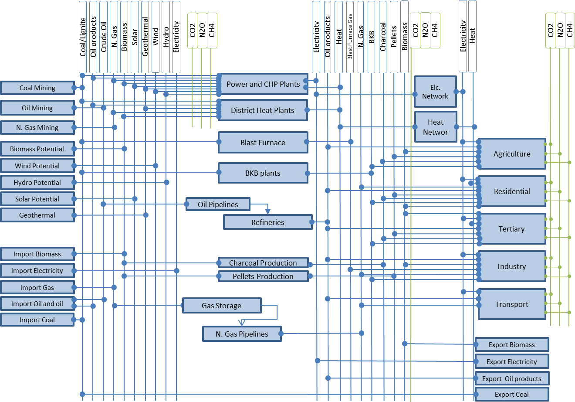

The breakdown of the final energy consumption sectors within SEMS is the following:
- Industry, separated in the following subsectors:
- Iron and Steel.
- Chemical and petrochemical.
- Non-ferrous metals.
- Non-metallic minerals.
- Transport equipment.
- Machinery.
- Mining (excluding energy producing industries) and quarrying.
- Food, beverages and tobacco.
- Pulp, paper and printing.
- Wood and wood products (other than pulp and paper).
- Construction.
- Textile and leather.
- Not elsewhere specified Industry.
- Residential, divided into six typologies and seven construction periods according to the TABULA project.
Figure III.2: Residential sector typologies according to TABULA
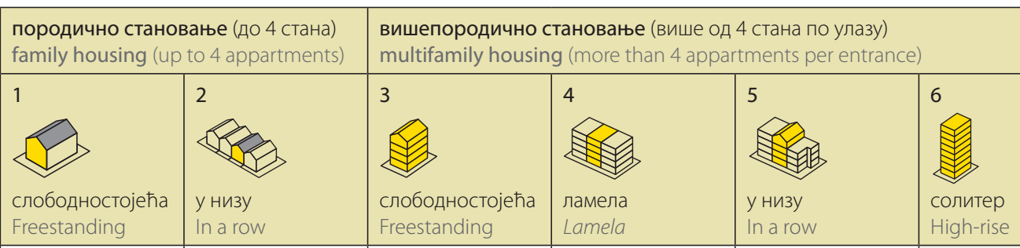
Furthermore, dwellings within each of the typologies are allocated to a number of construction periods according to the Table III.1.
Table III.1: Construction periods for residential typologies
Typologies of Dwellings
Construction periods
<1919
1919-1945
1946-1960
1961-1970
1971-1980
1981-1990
1991-2011
For each one of the dwelling types nine energy service demands are considered: Demand for Space Heating, Demand for Space Cooling, Demand for Hot Water, Demand for Cooking, Demand for Lighting, Demand for Refrigerating, Demand for Cloth Washing, Demand for Dish Washing, Demand for Appliances.
- Tertiary Sector which includes commercial and public services and is further divided into the following subsectors:
- Hotels& Food and beverage service activities (NACE Rev. 2 sectors: 55 and 56).
- Hospitals (NACE Rev. 2 sectors: 86).
- Commercial Buildings (NACE Rev. 2 sectors: 45, 46, 47).
- Educational (NACE Rev. 2 sectors: 85).
- Public Sector Offices (NACE Rev. 2 sectors: 84).
- Private Sector Offices (NACE Rev. 2 sectors: 53, 61, 62, 63, 64, 65, 66, 68, 69, 70, 71, 72, 73, 74, 75, 77, 78, 79).
- Other Tertiary (NACE Rev 2 sectors: 52, 53, 58, 59, 60, 61, 62, 63, 81, 82, 90, 91).
- Other Public (NACE Rev 2 sectors: 36, 37, 38, 39, 93, 95, 96).
- Public (street) Lighting.
Refurbishment options are included in the model for both residential and tertiary sector buildings. Three options are considered: i) Replacement of windows, ii) replacement of windows plus 5cm wall insulation and iii) replacement of windows plus 10cm wall insulation. The level of energy savings for each refurbishment action depends on the typology of the building and is taken from the results of the TABULA project.
The evolution of the installation cost of building related technologies is taken into consideration for the examined period. Generally, it is expected that the installation cost in the period 2025-2030 will remained constant compared to the respective levels before the energy crisis.
- Agriculture, which covers the energy use for agriculture, forestry and fishing.
- Transportation, divided at a first level according to the following list and further subdivided for each mode:
- Road transport
- Rails transport
- Domestic Aviation
- International Aviation
- Domestic Navigation
- International Navigation – Bunkers
During the development of the INECP the Serbian Energy Modelling System (SEMS) was updated through a data collection process to collect the current statistics and a calibration process in order to include the latest available statistical data in the model. Details of all these updates are presented in the “Report on updated version of SEMS” of the project “Further Development of Energy Planning Capacity”, EuropeAid/135625/IH/SER/RS Contract no: 48-00-00140/2019-28.

Macro-economic Analysis Tool (MANAGE)
The macroeconomic analysis tool - Mitigation, Adaptation and New Technologies Applied General Equilibrium (MANAGE) computable general equilibrium (CGE) model, is coded in the General Algebraic Modelling System (GAMS), which is a high-level modelling system for mathematical programming and optimization. It consists of a language compiler and a set of integrated high-performance solvers.
Key inputs to the model include the Social Accounting Matrix (SAM), which describes monetary flows across key economic agents (producers, households, government, and the Rest of the World). The SAM was adjusted to reflect a more complete balance of payments account, as the latter was modified to allow for fairly significant inward flows of remittances and outward interest payments, and a small inflow of official development assistance. For the modifications, data provided by the National Bank of Serbia was used.
Additional data inputs to the model included energy flows (based on the International Energy Agency data) and emission accounts (estimated using the IPCC methodology) – both are extracted from the Global Trade Analysis Project (GTAP) database and harmonized with SEMS. The reference year SAM is used to calibrate many of the model parameters—such as the cost structure of production and consumer preference parameters. The calibration of these parameters needs not only the SAM, but also values for key model parameters such as the substitution between capital and labour, the income elasticity for goods such as food, energy substitution elasticities, etc. Most of these parameters are sourced from the standard parameters of the GTAP and Envisage models. The SAM, combined with the key elasticities, are the only inputs needed to run the comparative static version of the model.
The dynamic model needs additional data to project the economy forward from the reference year to a terminal year. The key drivers of the economy are demographic (total and working age population), savings and depreciation rates, which drive capital accumulation, and changes in technology and preferences. These inputs are extracted primarily form the national data sources and complemented by the data inputs from international agencies, as described in the report.
The Ministry of Mining and Energy has at its disposal the MANAGE model and the corresponding data for running both comparative static and dynamic simulations. In the case of the latter, MoME can regularly update the reference simulation with the most recent information on GDP and population growth, and other exogenous elements of the model such as policy changes. The tool allows for significant flexibility to analyse a broad suite of policies from energy taxes and subsidies, other forms of taxes and subsidies, for example in agriculture, and potential changes to the trading regime—for example adherence to the European Union. Beyond updating the dynamic drivers, the core, or reference data is also subject to updates, for example, with the soon-to-be-released V11 of the GTAP database with a 2017 reference year. In addition, with sufficient local information, the model’s key elasticities, such as income and substitution elasticities could be econometrically estimated, providing a sounder basis for model behaviour and coupled with confidence intervals, the ability to use Monte Carlo techniques to provide a sense of the robustness of the model results. The core database can also be expanded to include multiple representative households, for example by decile, to be able to highlight potential distributional implications of policy changes—for example the impact across households of implementing a carbon tax.
Representing a complete coverage of both demand and supply sides of the economy, the MANAGE model provides a wide range of outputs that could be used to support the decision-making process. The key endogenous variables of the model can be grouped into six categories: macroeconomic, producer-related, final users (household-related), government indicators, trade variables and environmental indicators (Figure III.3). It should be noted that this grouping of the variables is used only for the presentation purposes and is not something implied by the model. We do not aim to provide a full list of variables in this section, but rather to highlight key outputs that the model generates, while for the full list of variables an interested reader is referred to the corresponding technical report with the documentation of the modelling tool.
Figure III.3: Key model outputs by category
Apart from the indicators outlined above, it is possible to estimate additional derived indicators, taking combination of variables reported by the model. For instance, one can estimate the carbon intensity of final consumption by commodities or the share of carbon revenue in the total tax revenue (or government income), etc. Since in most cases, it is relevant to measure policy impacts relative to the baseline scenario (rather than in absolute levels), for the case of most variables listed on the Figure III.3 it is relevant to apply the same approach. For instance, in the case of impacts of the carbon pricing policies on producers, one would be interested in the changes of production volumes and sectoral value added relative to the baseline scenario rather than the absolute values of these variables.
More details on the macro-economic model implementation are provided in the “Report on developed, installed and tested tool for macroeconomic analysis”, of the project Further Development of Energy Planning Capacity, EuropeAid/135625/IH/SER/RS, Contract no: 48-00-00140/2019-28.

High-RES penetration power system analysis tool
The High-RES penetration market tool has been developed using the ANTARES simulator and includes a detailed representation of the Serbian power system, as well as an adequate representation of the regional power system of South-East Europe. The RES tool was designed to simulate the power system on an hourly basis, in selected years (e.g. 2030, 2040), using all the extra input which is required for this simulation and includes inter alia technical and economic characteristics of the power generation units and other flexibility resources such as storage units and interconnections with neighbouring systems. The detailed simulation of the power system in the RES tool provides insights on generation adequacy, details on the operation of dispatchable units and the storage units and the level of curtailment of RES generation which is expected. This will provide inputs to SEMS in the form of new generation profiles from RES, incorporating curtailment, and other information on the necessity of flexibility options for the proper operation of the power system.
Based on the achieved results, the RES tool provides the following type of conclusions:
- Suitability of high RES integration in the power system in the expected capacity mix
- Economic efficiency of a specific scenario for the Serbian power system
- Power system flexibility needs on hourly variability for achievement of RES penetration targets
- Level of CO2 emissions of a specific scenario
The High-RES penetration market tool was developed using the ANTARES simulator and includes a detailed representation of the Serbian power system and an adequate representation of the regional power system, as the electric power system of Serbia is very well interconnected to its neighbouring countries. Figure III.4 shows the geographical extend of this region, which comprises the rest of Western Balkans (Croatia, Bosnia and Herzegovina, Montenegro, Albania and North Macedonia), as well as Hungary, Slovenia, Greece, Bulgaria and Romania. In the RES tool, the Serbian system is represented as two areas, one for the same system modelled in SEMS (RS01) and another one for the Autonomous Province of Kosovo and Metohija (RS02). As per the standard modelling approach, it is assumed that there are no transmission constraints inside each area (“copper plate” approach), as each TSO develops the transmission system accordingly. Therefore, each area is modelled as a single node with specific generation and demand profiles, while transmission limitations will be accounted for in the system borders, through the Net Transfer Capacities between the modelled zones.
Figure III.4: Geographical scope of regional model
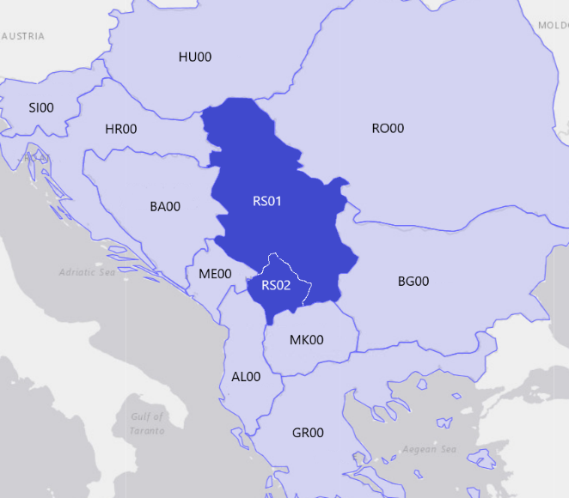
For the zones that will be modelled apart from Serbia, ENTSO-E MAF 2020 and TYNDP2020 (which use pan-European models) were the main sources for model parameters. These neighbouring systems remain unchanged, during the analysis of scenarios for the Serbian system, while the latter will be modelled according to each scenario provided by SEMS.
Figure III.5: Hourly results for RS01, MC year 2, week n.10
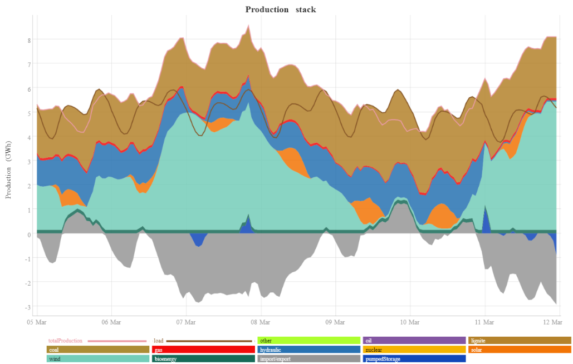
The results of the RES tool simulations mainly comprise fuel shares, system marginal cost and total operational cost, CO2 emissions and generation curtailments (also referred to as “spilled energy”) for the Serbian system, and a detailed dispatch on an hourly level (Figure III.5). The fast algorithm of ANTARES for the power system economical operation allows the enhanced modelling of stochastic parameters, such as the variable RES generation. Also, the long-term RES generation uncertainty is addressed as simulations of different “Climate Years” and average annual results will be reported. In ENTSO-E TYNDP2020 three climate years have been used (1982, 1984 and 2007) and the same climate years were used for the analysis for the Serbian INECP.
More details on the High-RES penetration analysis model are provided in the “Report on developed, installed and tested high RES market penetration tool”, of the project Further Development of Energy Planning Capacity, EuropeAid/135625/IH/SER/RS, Contract no: 48-00-00140/2019-28.

Annex: LIST OF PROJECTS FROM INFRASTRUCTURE PLAN
Table IV.1: Table of additional Projects from the Infrastructure Development Plan of the Republic Serbia
Sector | Project | Estimated Completion Date | Estimated Cost (€m) – 2030 | Estimated Cost (€m) - 2050
Generation | Refurbishment of existing Thermal Power Plants (TENT A1, TENT A2, TEKO A1, TEKO A2, TEKO B1, TEKO B2, TENT A A3-A6, TENT A5) | 2030 | 2.000
 | Refurbishment of existing Hydro Power Plants (Djerdap 2, Vlasinska, Potpec, Bistrica) | 2035 |  | 369
 | New Pumped Storage Djerdap 3 of 1800MW | 2038 |  | 1.400
 | Construction of self-balanced solar power plants – Battery storage systems up to 400 MW. Estimated cost is for the battery system | 2028 | 350
 | Natural gas plant in Nis of 150 MW | 2030 | 250
Transmission | 2x400kV TS Jagodina - TS Pozarevac | 2030 | 56
 | Increasing the capacity of the Bor region (TS 400/110kV, 400kV OHL) | 2025 | 61
Distribution | Automation of MV network | 2027 | 144
 | Smart meters | 2029 | 505
 | Remote monitoring | 2027 | 80
 | Updating measurement systems AMI, AMM and MDM/R | 2029 | 511
 | Refurbishment & Upgrade of various parts and equipment | 2030 | 602
Natural gas sector | Underground storage sites in Itebej and Tilva | TBC |  | 240
 | Gas pipelines (transmission and distribution) | TBC |  | 990
 | Gasification of regions (Pirot, Vranje, Leskovac, Aleksandrovac - Tutin) | TBC |  | 137
Oil sector | Pipeline Serbia – Hungary | 2027 | 100
 | Storage facility in Kovin | 2027 | 23
Heating Sector | Encouraging the development of renewable energy - development of the biomass market in Serbia, phase II (2024-28). (Funds will be provided by KfW from a loan of 20 million and 10 million from a grant) | 2028 | 30
 |  | Total | 4.712 | 3.136

Annex: Detailed tables

Energy Use, Fugitive and Process Emissions
Please note that these tables do not include non-energy emissions from Agriculture, Waste or LULUCF.
Table V.1: Energy Industry - emissions in ktons of CO2-eq
Energy Industry  emissions [ktons of CO2-eq] | 2020 | 2025 | 2026 | 2027 | 2028 | 2029 | 2030 | 2035 | 2040 | 2045 | 2050
WEM | 32580 | 33349 | 33996 | 34690 | 35494 | 36361 | 37485 | 40010 | 41549 | 43066 | 37142
Scenario-S | 32572 | 30129 | 29301 | 28939 | 28028 | 26626 | 23865 | 18190 | 14041 | 9809 | 3365
Scenario-S-N | 32572 | 30129 | 29301 | 28939 | 28028 | 26626 | 23865 | 18170 | 14954 | 6807 | 2471
Table V.2: Power Sector - emissions in ktons of CO2-eq
Power Sector emissions [ktons of CO2-eq] | 2020 | 2025 | 2026 | 2027 | 2028 | 2029 | 2030 | 2035 | 2040 | 2045 | 2050
WEM | 30671 | 31307 | 31857 | 32503 | 33311 | 34133 | 35189 | 37678 | 39095 | 40462 | 34552
Scenario-S | 30664 | 27990 | 27163 | 26795 | 26009 | 24657 | 21843 | 16365 | 12118 | 8174 | 1708
Scenario-S-N | 30664 | 27990 | 27163 | 26795 | 26009 | 24657 | 21843 | 16354 | 13030 | 5009 | 649
Table V.3: Manufacturing industries and construction: Energy Use, Fugitive and Process Emissions - emissions in ktons of CO2-eq
Manufacturing industries and construction emissions [ktons of CO2-eq] | 2020 | 2025 | 2026 | 2027 | 2028 | 2029 | 2030 | 2035 | 2040 | 2045 | 2050
WEM | 8462 | 10587 | 10755 | 10957 | 11130 | 11360 | 11541 | 12219 | 13491 | 14252 | 15406
Scenario-S | 8439 | 10366 | 10354 | 10431 | 10515 | 10460 | 9858 | 10336 | 9379 | 7777 | 8045
Scenario-S-N | 8439 | 10366 | 10354 | 10431 | 10515 | 10460 | 9858 | 10312 | 8712 | 7812 | 8080
Table V.4: Transport - emissions in ktons of CO2-eq
Transport emissions [ktons of CO2-eq] | 2020 | 2025 | 2026 | 2027 | 2028 | 2029 | 2030 | 2035 | 2040 | 2045 | 2050
WEM | 7166 | 7880 | 8031 | 8119 | 8189 | 8270 | 8320 | 8796 | 9526 | 10218 | 10859
Scenario-S | 7166 | 7578 | 7618 | 7579 | 7564 | 7470 | 7617 | 7195 | 6831 | 5547 | 4206
Scenario-S-N | 7166 | 7578 | 7618 | 7579 | 7564 | 7470 | 7617 | 7244 | 6588 | 5114 | 3736
Table V.5: Residential Sector - emissions in ktons of CO2-eq
Residential Sector emissions [ktons of CO2-eq] | 2020 | 2025 | 2026 | 2027 | 2028 | 2029 | 2030 | 2035 | 2040 | 2045 | 2050
WEM | 2076 | 1437 | 1374 | 1407 | 1430 | 1476 | 1484 | 1509 | 1553 | 1538 | 1656
Scenario-S | 2159 | 1411 | 1330 | 1347 | 1361 | 1377 | 1379 | 1097 | 955 | 764 | 517
Scenario-S-N | 2159 | 1411 | 1330 | 1347 | 1361 | 1377 | 1379 | 1096 | 937 | 814 | 532
Table V.6: Commercial Sector - emissions in ktons of CO2-eq
Commercial Sector emissions [ktons of CO2-eq] | 2020 | 2025 | 2026 | 2027 | 2028 | 2029 | 2030 | 2035 | 2040 | 2045 | 2050
WEM | 696 | 752 | 720 | 752 | 781 | 808 | 842 | 1007 | 1188 | 1302 | 1439
Scenario-S | 720 | 659 | 659 | 689 | 716 | 743 | 767 | 781 | 747 | 764 | 794
Scenario-S-N | 720 | 659 | 659 | 689 | 716 | 743 | 767 | 778 | 747 | 751 | 768
Table V.7: Other Sectors: Energy Use, Fugitive and Process Emissions - emissions in ktons of CO2-eq
Other Sectors- emissions [ktons of CO2-eq] | 2020 | 2025 | 2026 | 2027 | 2028 | 2029 | 2030 | 2035 | 2040 | 2045 | 2050
WEM | 3986 | 4415 | 4527 | 4622 | 4628 | 4608 | 4616 | 4379 | 4140 | 3865 | 3502
Scenario-S | 3985 | 4262 | 4303 | 4355 | 4289 | 4154 | 3990 | 3388 | 2525 | 1897 | 1448
Scenario-S-N | 3985 | 4262 | 4303 | 4355 | 4289 | 4154 | 3990 | 3388 | 2541 | 1715 | 1204

Power Sector
Table V.8: Electricity Generation per source (TWh)
Electricity Generation per source (TWh) | Year | Nuclear | Solid Fuels | Oil Products | Natural Gas | Bioenergy & Waste | Hydro power | Wind | Solar | Total (TWh)
WEM | 2019 | 0.00 | 25.45 | 0.05 | 0.73 | 0.16 | 9.46 | 0.90 | 0.01 | 36.75
 | 2025 | 0.00 | 27.73 | 0.04 | 1.46 | 0.23 | 10.41 | 1.92 | 0.40 | 42.19
 | 2026 | 0.00 | 28.15 | 0.03 | 1.66 | 0.22 | 10.41 | 1.92 | 0.40 | 42.80
 | 2027 | 0.00 | 28.66 | 0.03 | 1.68 | 0.22 | 10.44 | 1.92 | 0.51 | 43.47
 | 2028 | 0.00 | 29.44 | 0.02 | 1.66 | 0.22 | 10.44 | 1.92 | 0.51 | 44.22
 | 2029 | 0.00 | 30.21 | 0.03 | 1.68 | 0.22 | 10.44 | 1.92 | 0.51 | 45.00
 | 2030 | 0.00 | 31.05 | 0.03 | 1.71 | 0.22 | 10.44 | 1.92 | 0.51 | 45.89
 | 2035 | 0.00 | 32.85 | 0.00 | 1.79 | 0.21 | 11.06 | 1.92 | 0.51 | 48.33
 | 2040 | 0.00 | 34.50 | 0.00 | 1.50 | 0.21 | 12.50 | 1.92 | 0.50 | 51.14
 | 2045 | 0.00 | 36.85 | 0.00 | 0.98 | 0.20 | 12.50 | 1.91 | 0.49 | 52.94
 | 2050 | 0.00 | 32.15 | 0.00 | 1.39 | 0.21 | 13.79 | 4.20 | 2.36 | 54.10
Scenario-S | 2019 | 0.00 | 25.55 | 0.05 | 0.73 | 0.16 | 9.46 | 0.90 | 0.01 | 36.85
 | 2025 | 0.00 | 24.27 | 0.02 | 1.41 | 0.21 | 10.41 | 2.32 | 0.68 | 39.31
 | 2026 | 0.00 | 23.52 | 0.01 | 1.52 | 0.21 | 10.41 | 2.71 | 1.00 | 39.38
 | 2027 | 0.00 | 23.25 | 0.01 | 1.50 | 0.20 | 10.42 | 3.14 | 1.32 | 39.85
 | 2028 | 0.00 | 22.74 | 0.01 | 1.50 | 0.21 | 10.57 | 3.60 | 1.64 | 40.27
 | 2029 | 0.00 | 21.18 | 0.01 | 2.74 | 0.28 | 10.57 | 4.09 | 1.97 | 40.83
 | 2030 | 0.00 | 19.16 | 0.01 | 2.92 | 0.35 | 10.84 | 4.61 | 2.30 | 40.19
 | 2035 | 0.00 | 14.69 | 0.01 | 2.68 | 0.49 | 12.31 | 7.95 | 5.23 | 43.34
 | 2040 | 0.00 | 10.22 | 0.01 | 3.68 | 0.98 | 13.63 | 8.07 | 9.78 | 46.37
 | 2045 | 0.00 | 6.11 | 0.01 | 4.07 | 1.52 | 14.06 | 14.03 | 15.92 | 55.73
 | 2050 | 0.00 | 0.00 | 0.00 | 4.11 | 2.14 | 14.06 | 20.71 | 24.59 | 65.61
Scenario-S-N | 2019 | 0.00 | 25.55 | 0.05 | 0.73 | 0.16 | 9.46 | 0.90 | 0.01 | 36.85
 | 2025 | 0.00 | 24.27 | 0.02 | 1.41 | 0.21 | 10.41 | 2.32 | 0.68 | 39.31
 | 2026 | 0.00 | 23.52 | 0.01 | 1.52 | 0.21 | 10.41 | 2.71 | 1.00 | 39.38
 | 2027 | 0.00 | 23.25 | 0.01 | 1.50 | 0.20 | 10.42 | 3.14 | 1.32 | 39.85
 | 2028 | 0.00 | 22.74 | 0.01 | 1.50 | 0.21 | 10.57 | 3.60 | 1.64 | 40.27
 | 2029 | 0.00 | 21.18 | 0.01 | 2.74 | 0.28 | 10.57 | 4.09 | 1.97 | 40.83
 | 2030 | 0.00 | 19.16 | 0.01 | 2.92 | 0.35 | 10.84 | 4.61 | 2.30 | 40.19
 | 2035 | 0.00 | 14.69 | 0.01 | 2.68 | 0.48 | 12.31 | 8.05 | 5.23 | 43.44
 | 2040 | 0.00 | 11.39 | 0.01 | 2.63 | 0.98 | 13.63 | 8.17 | 9.80 | 46.61
 | 2045 | 7.01 | 4.02 | 0.01 | 1.84 | 1.05 | 14.06 | 14.14 | 15.56 | 57.68
 | 2050 | 7.01 | 0.00 | 0.00 | 1.63 | 1.84 | 14.06 | 20.82 | 22.14 | 67.50

Indicators and Final Energy Consumption
Table V.9: Final Energy Consumption [ktoe]
Final Energy Consumption [ktoe] | 2020 | 2025 | 2026 | 2027 | 2028 | 2029 | 2030 | 2035 | 2040 | 2045 | 2050
WEM | 8887 | 9823 | 9976 | 10139 | 10295 | 10461 | 10615 | 11149 | 11765 | 12327 | 12969
Scenario-S | 8887 | 9333 | 9335 | 9407 | 9493 | 9554 | 9670 | 9718 | 9790 | 9567 | 9528
Scenario-S-N | 8887 | 9333 | 9335 | 9407 | 9493 | 9554 | 9670 | 9737 | 9757 | 9501 | 9455
Table V.10: Primary Energy Supply [ktoe]
Primary Energy Supply [ktoe] | 2020 | 2025 | 2026 | 2027 | 2028 | 2029 | 2030 | 2035 | 2040 | 2045 | 2050
WEM | 15954 | 17100 | 17468 | 17781 | 18115 | 18321 | 18757 | 19615 | 20468 | 21190 | 20926
Scenario-S | 15955 | 16170 | 16140 | 16190 | 16163 | 15960 | 15846 | 14948 | 14466 | 13773 | 13052
Scenario-S-N | 15955 | 16170 | 16140 | 16190 | 16163 | 15960 | 15846 | 14963 | 14567 | 14487 | 14009
Table V.11: Primary Energy Consumption [ktoe]
Primary Energy Consumption [ktoe] | 2020 | 2025 | 2026 | 2027 | 2028 | 2029 | 2030 | 2035 | 2040 | 2045 | 2050
WEM | 15083 | 16079 | 16416 | 16702 | 17010 | 17190 | 17600 | 18323 | 19044 | 19653 | 19298
Scenario-S | 15083 | 15149 | 15088 | 15112 | 15059 | 14829 | 14689 | 13665 | 13097 | 12330 | 11548
Scenario-S-N | 15083 | 15149 | 15088 | 15112 | 15059 | 14829 | 14689 | 13680 | 13198 | 13044 | 12505
Table V.12: Energy Import Dependency [%]
Energy Import Dependency [%] | 2020 | 2025 | 2026 | 2027 | 2028 | 2029 | 2030 | 2035 | 2040 | 2045 | 2050
WEM | 32.3% | 33.3% | 33.9% | 34.3% | 34.7% | 34.8% | 35.5% | 36.7% | 39.2% | 40.8% | 44.5%
Scenario-S | 32.3% | 34.5% | 35.2% | 35.4% | 36.1% | 37.5% | 40.7% | 42.0% | 45.4% | 45.0% | 44.4%
Scenario-S-N | 32.3% | 34.5% | 35.2% | 35.4% | 36.1% | 37.5% | 40.7% | 42.0% | 43.8% | 39.5% | 37.2%
Table V.13: Electricity Import Dependency [%]
Energy Import Dependency [%] | 2020 | 2025 | 2026 | 2027 | 2028 | 2029 | 2030 | 2035 | 2040 | 2045 | 2050
WEM | -0.5% | -4.2% | -4.3% | -4.3% | -4.4% | -4.4% | -4.4% | -4.6% | -4.8% | -5.1% | -5.4%
Scenario-S | -0.5% | -3.6% | -3.7% | -3.9% | -3.9% | -4.1% | -1.6% | -4.7% | -3.4% | -4.5% | -4.3%
Scenario-S-N | -0.5% | -3.6% | -3.7% | -3.9% | -3.9% | -4.1% | -1.6% | -4.6% | -1.5% | -4.4% | -4.2%
Table V.14: Total Emissions (including agriculture, waste and LULUCF) in ktons of CO2eq
Total Emissions (with a. w. LULUCF) [ktons of CO2eq] | 1990 | 2010 | 2020 | 2025 | 2026 | 2027 | 2028 | 2029 | 2030 | 2035 | 2040 | 2045 | 2050
WEM | 80094 | 57024 | 56163 | 59493 | 60319 | 61305 | 62254 | 63327 | 64577 | 68874 | 73068 | 76529 | 72958
Scenario-S | 80094 | 57024 | 56163 | 55478 | 54480 | 54099 | 53073 | 51274 | 47765 | 41942 | 36098 | 28846 | 21330
Scenario-S-N | 80094 | 57024 | 56163 | 55478 | 54480 | 54099 | 53073 | 51274 | 47765 | 41943 | 36100 | 25300 | 19745
Table V.15: % reduction of total emissions with respect to the 1990 level
Total Emissions reduction w.r.t. 1990 [%] | 2010 | 2020 | 2025 | 2026 | 2027 | 2028 | 2029 | 2030 | 2035 | 2040 | 2045 | 2050
WEM | -28.80% | -29.97% | -25.72% | -24.69% | -23.46% | -22.27% | -20.93% | -19.37% | -14.01% | -8.77% | -4.45% | -8.91%
Scenario-S | -28.80% | -29.88% | -30.73% | -31.98% | -32.46% | -33.74% | -35.98% | -40.36% | -47.63% | -54.93% | -63.99% | -73.37%
Scenario-S-N | -28.80% | -29.88% | -30.73% | -31.98% | -32.46% | -33.74% | -35.98% | -40.36% | -47.63% | -54.93% | -68.41% | -75.35%
Table V.16: Share of RES in Gross Final Energy Consumption [%]
Share of RES in GFEC [%] | 2020 | 2025 | 2026 | 2027 | 2028 | 2029 | 2030 | 2035 | 2040 | 2045 | 2050
WEM | 26.3% | 29.4% | 29.1% | 28.7% | 28.4% | 27.9% | 27.6% | 26.6% | 25.2% | 24.2% | 26.8%
Scenario-S | 26.3% | 29.8% | 30.6% | 31.2% | 31.9% | 32.6% | 33.6% | 40.8% | 45.1% | 52.5% | 61.8%
Scenario-S-N | 26.3% | 29.8% | 30.6% | 31.2% | 31.9% | 32.6% | 33.6% | 40.8% | 45.3% | 51.6% | 59.5%
Table V.17: Share of RES in Electricity Generation [%]
Share of RES in Electricity Generation [%] | 2020 | 2025 | 2026 | 2027 | 2028 | 2029 | 2030 | 2035 | 2040 | 2045 | 2050
WEM | 29.0% | 30.9% | 30.5% | 30.4% | 29.9% | 29.4% | 29.0% | 28.6% | 29.9% | 29.0% | 38.4%
Scenario-S | 29.0% | 34.7% | 36.7% | 38.0% | 39.8% | 41.5% | 45.2% | 60.2% | 70.3% | 82.1% | 93.9%
Scenario-S-N | 29.0% | 34.7% | 36.7% | 38.0% | 39.8% | 41.5% | 45.2% | 60.3% | 70.4% | 78.4% | 87.4%
Table V.18: Share of RES in Transport (without multipliers) [%]
Share of RES in Transport (without multipliers) [%] | 2020 | 2025 | 2026 | 2027 | 2028 | 2029 | 2030 | 2035 | 2040 | 2045 | 2050
WEM | 0.5% | 1.4% | 1.8% | 2.2% | 2.7% | 3.2% | 3.7% | 4.0% | 4.1% | 4.1% | 4.9%
Scenario-S | 0.5% | 1.8% | 2.1% | 2.3% | 2.6% | 2.9% | 3.2% | 5.3% | 9.9% | 23.9% | 45.0%
Scenario-S-N | 0.5% | 1.8% | 2.1% | 2.3% | 2.6% | 2.9% | 3.2% | 5.3% | 11.7% | 27.3% | 48.6%
Table V.19: Share of RES in Transport (with multipliers) [%]
Share of RES in Transport (with multipliers) [%] | 2020 | 2025 | 2026 | 2027 | 2028 | 2029 | 2030 | 2035 | 2040 | 2045 | 2050
WEM | 1.2% | 2.3% | 2.8% | 3.4% | 4.1% | 4.7% | 5.5% | 6.5% | 7.1% | 7.4% | 9.9%
Scenario-S | 1.2% | 2.9% | 3.3% | 3.7% | 4.4% | 6.0% | 6.8% | 12.5% | 21.4% | 44.8% | 68.1%
Scenario-S-N | 1.2% | 2.9% | 3.3% | 3.7% | 4.4% | 6.0% | 6.8% | 12.5% | 23.8% | 48.9% | 71.1%
Table V.20: Share of RES in Heating [%]
Share of RES in Heating [%] | 2020 | 2025 | 2026 | 2027 | 2028 | 2029 | 2030 | 2035 | 2040 | 2045 | 2050
WEM | 35.7% | 42.9% | 42.3% | 41.3% | 40.7% | 39.6% | 38.9% | 37.0% | 33.4% | 32.3% | 31.3%
Scenario-S | 35.7% | 41.1% | 41.5% | 41.2% | 41.1% | 41.0% | 41.4% | 44.0% | 44.2% | 41.1% | 39.1%
Scenario-S-N | 35.7% | 41.1% | 41.5% | 41.2% | 41.1% | 41.0% | 41.4% | 44.1% | 44.4% | 40.6% | 39.1%
Table V.21: Installed Capacity of Wind Power Plants [GW]
Installed Capacity of Wind PP [GW] | 2020 | 2025 | 2026 | 2027 | 2028 | 2029 | 2030 | 2035 | 2040 | 2045 | 2050
WEM | 0.407 | 0.745 | 0.745 | 0.745 | 0.745 | 0.745 | 0.745 | 0.745 | 0.745 | 0.745 | 1.659
Scenario-S | 0.407 | 0.895 | 1.045 | 1.208 | 1.383 | 1.570 | 1.770 | 3.067 | 3.117 | 5.415 | 7.969
Scenario-S-N | 0.407 | 0.895 | 1.045 | 1.208 | 1.383 | 1.570 | 1.770 | 3.109 | 3.158 | 5.457 | 8.010
Table V.22: Installed Capacity of PV Power Plants [GW]
Installed Capacity of PV PP [GW] | 2020 | 2025 | 2026 | 2027 | 2028 | 2029 | 2030 | 2035 | 2040 | 2045 | 2050
WEM | 0.016 | 0.301 | 0.301 | 0.381 | 0.381 | 0.381 | 0.381 | 0.381 | 0.378 | 0.366 | 1.772
Scenario-S | 0.016 | 0.512 | 0.749 | 0.989 | 1.232 | 1.479 | 1.729 | 3.929 | 7.357 | 11.975 | 18.495
Scenario-S-N | 0.016 | 0.512 | 0.749 | 0.989 | 1.232 | 1.479 | 1.729 | 3.929 | 7.370 | 11.702 | 16.656
Table V.23: Final Energy Consumption by Fuel [ktoe]
FEC by Fuel [ktoe] | Year | Solid fuels | Oil Products | Natural Gas | Biomass/Biogas | Biofuels | Solar | Geothermal | Derived heat | Electricity | Hydrogen
WEM | 2020 | 356 | 2879 | 1021 | 1571 | 0 | 3 | 6 | 670 | 2214 | 0
 | 2025 | 253 | 3156 | 988 | 1818 | 23 | 0 | 8 | 805 | 2749 | 0
 | 2026 | 223 | 3187 | 1062 | 1809 | 33 | 0 | 8 | 843 | 2787 | 0
 | 2027 | 228 | 3247 | 1111 | 1794 | 43 | 0 | 9 | 855 | 2826 | 0
 | 2028 | 235 | 3271 | 1173 | 1786 | 53 | 0 | 9 | 869 | 2872 | 0
 | 2029 | 246 | 3310 | 1237 | 1766 | 63 | 0 | 10 | 881 | 2920 | 0
 | 2030 | 253 | 3328 | 1310 | 1755 | 73 | 0 | 10 | 887 | 2971 | 0
 | 2035 | 299 | 3429 | 1623 | 1687 | 78 | 0 | 12 | 865 | 3122 | 0
 | 2040 | 336 | 3716 | 1842 | 1554 | 84 | 0 | 13 | 879 | 3306 | 0
 | 2045 | 339 | 3947 | 2062 | 1524 | 90 | 0 | 14 | 891 | 3423 | 0
 | 2050 | 376 | 4156 | 2319 | 1520 | 94 | 0 | 14 | 898 | 3552 | 0
Scenario-S | 2020 | 358 | 2910 | 1030 | 1571 | 0 | 3 | 6 | 736 | 2400 | 0
 | 2025 | 251 | 3077 | 893 | 1637 | 30 | 12 | 9 | 841 | 2559 | 0
 | 2026 | 185 | 3116 | 903 | 1635 | 34 | 15 | 9 | 847 | 2568 | 0
 | 2027 | 189 | 3137 | 920 | 1620 | 38 | 17 | 10 | 844 | 2607 | 0
 | 2028 | 187 | 3116 | 982 | 1616 | 41 | 19 | 11 | 846 | 2651 | 0
 | 2029 | 190 | 3124 | 993 | 1598 | 45 | 22 | 12 | 847 | 2697 | 0
 | 2030 | 214 | 3145 | 1055 | 1577 | 49 | 24 | 12 | 833 | 2732 | 0
 | 2035 | 196 | 2949 | 1159 | 1587 | 46 | 33 | 27 | 765 | 2918 | 0
 | 2040 | 181 | 2828 | 1181 | 1440 | 45 | 42 | 43 | 792 | 3097 | 102
 | 2045 | 191 | 2425 | 1206 | 985 | 43 | 51 | 85 | 802 | 3484 | 256
 | 2050 | 202 | 1967 | 1274 | 618 | 41 | 61 | 147 | 822 | 3944 | 412
Scenario-S-N | 2020 | 358 | 2910 | 1030 | 1571 | 0 | 3 | 6 | 736 | 2400 | 0
 | 2025 | 251 | 3077 | 893 | 1637 | 30 | 12 | 9 | 841 | 2559 | 0
 | 2026 | 185 | 3116 | 903 | 1635 | 34 | 15 | 9 | 847 | 2568 | 0
 | 2027 | 189 | 3137 | 920 | 1620 | 38 | 17 | 10 | 844 | 2607 | 0
 | 2028 | 187 | 3116 | 982 | 1616 | 41 | 19 | 11 | 846 | 2651 | 0
 | 2029 | 190 | 3124 | 993 | 1598 | 45 | 22 | 12 | 847 | 2697 | 0
 | 2030 | 214 | 3145 | 1055 | 1577 | 49 | 24 | 12 | 833 | 2732 | 0
 | 2035 | 206 | 2957 | 1157 | 1590 | 46 | 33 | 28 | 759 | 2925 | 0
 | 2040 | 181 | 2744 | 1170 | 1440 | 44 | 42 | 43 | 793 | 3113 | 152
 | 2045 | 198 | 2286 | 1229 | 945 | 42 | 51 | 80 | 779 | 3552 | 304
 | 2050 | 208 | 1813 | 1276 | 586 | 40 | 61 | 135 | 803 | 4038 | 459
Table V.24: Final Energy Consumption per Sector - Industry [ktoe]
FEC Industry [ktoe] | 2020 | 2025 | 2026 | 2027 | 2028 | 2029 | 2030 | 2035 | 2040 | 2045 | 2050
WEM | 2188 | 2417 | 2477 | 2555 | 2622 | 2706 | 2784 | 3027 | 3319 | 3541 | 3814
Scenario-S | 2187 | 2358 | 2341 | 2399 | 2454 | 2504 | 2547 | 2803 | 3019 | 3182 | 3403
Scenario-S-N | 2187 | 2358 | 2341 | 2399 | 2454 | 2504 | 2547 | 2805 | 3011 | 3184 | 3406
Table V.25: Final Energy Consumption per Sector - Transport [ktoe]
FEC Transport [ktoe] | 2020 | 2025 | 2026 | 2027 | 2028 | 2029 | 2030 | 2035 | 2040 | 2045 | 2050
WEM | 2347 | 2573 | 2623 | 2654 | 2687 | 2721 | 2748 | 2935 | 3190 | 3434 | 3679
Scenario-S | 2347 | 2481 | 2494 | 2480 | 2482 | 2461 | 2512 | 2427 | 2444 | 2316 | 2208
Scenario-S-N | 2347 | 2481 | 2494 | 2480 | 2482 | 2461 | 2512 | 2445 | 2420 | 2265 | 2149
Table V.26: Final Energy Consumption per Sector - Services [ktoe]
FEC Services [ktoe] | 2020 | 2025 | 2026 | 2027 | 2028 | 2029 | 2030 | 2035 | 2040 | 2045 | 2050
WEM | 761 | 974 | 998 | 1022 | 1047 | 1072 | 1097 | 1219 | 1342 | 1459 | 1579
Scenario-S | 842 | 864 | 870 | 881 | 891 | 901 | 910 | 922 | 946 | 1041 | 1198
Scenario-S-N | 842 | 864 | 870 | 881 | 891 | 901 | 910 | 922 | 947 | 1041 | 1197
Table V.27: Final Energy Consumption per Sector - Residential [ktoe]
FEC Residential [ktoe] | 2020 | 2025 | 2026 | 2027 | 2028 | 2029 | 2030 | 2035 | 2040 | 2045 | 2050
WEM | 3284 | 3685 | 3700 | 3728 | 3756 | 3777 | 3798 | 3771 | 3711 | 3686 | 3687
Scenario-S | 3497 | 3462 | 3463 | 3477 | 3495 | 3513 | 3523 | 3382 | 3193 | 2838 | 2528
Scenario-S-N | 3497 | 3462 | 3463 | 3477 | 3495 | 3513 | 3523 | 3381 | 3192 | 2824 | 2517
Table V.28: Final Energy Consumption per Sector - Agriculture [ktoe]
FEC Agriculture [ktoe] | 2020 | 2025 | 2026 | 2027 | 2028 | 2029 | 2030 | 2035 | 2040 | 2045 | 2050
WEM | 140 | 150 | 152 | 154 | 156 | 157 | 159 | 164 | 168 | 169 | 169
Scenario-S | 140 | 146 | 144 | 145 | 147 | 148 | 150 | 155 | 158 | 159 | 159
Scenario-S-N | 140 | 146 | 144 | 145 | 147 | 148 | 150 | 155 | 158 | 159 | 159

Official Gazette of RS, no. 40/21
Official Gazette of RS, no. 40/21
Official Gazette of RS, no. 40/21
Official Gazette of RS, no. 35/23
Official Gazette of RS, no. 40/21
Official Gazette of RS, no. 26/21
Official Gazette of RS, no. 46/23
https://www.berlinprocess.de/uploads/documents/declaration-on-energy-security-and-green-transition-in-the-western-balkans_1686662540.pdf
2018/1/MC-EnC
PG 03/2018
Ministerial Council Decision 2021/14/MC-EnC of November 2021
As per Ministerial Council Decisions 2022/02/MC-EnC and 2022/03/MC-EnC.
Official Gazette of RS, no. 49/22
Decision D/2018/2/MC-EnC of the Energy Community Ministerial Council amending Decision 2012/04/MC-EnC of 18 October 2012 on the implementation of Directive 2009/28/EC and amending Article 20 of the Energy Community Treaty
Note: Data for BA not available for 2005 on Eurostat
Note: Data for BA are from 2018, as data for 2019 is not available on Eurostat
Note: Data for MN are from 2018, as data for 2019 is not available on Eurostat, and data for AL is not available
Note: Data for BA is not available on Eurostat
Note: Data for MN are from 2018, as data for 2019 is not available on Eurostat; data for Albania not available on Eurostat
Official Gazette of RS, no. 135/04, 36/09, 36/09, 72/09, 43/11, 14/16, 76/18 and 95/18
Official Gazette of RS, no. 26/21
Official Gazette of RS, no. 88/10
Official Gazette of RS, no. 35/20
Official Gazette of the Republic of Serbia, no. 17/09
Official Gazette of RS, no. 145/14, 95/18 and 40/21 and 35/23-other law
Official Gazette of RS, no. 56/16, 60/17, 44/18 - other law, 54/19, 112/21 - other decree
Official Gazette of RS, no. 56/16, 60/17, 91/18
Official Gazette of RS, no. 56/16, 61/17 and 106/20
Official Gazette of RS, no. 12/16
Official Gazette of RS, no. 112/21
Official Gazette of RS, no. 45/23
Official Gazette of RS, no. 45/23
Official Gazette of RS, no. 40/21
Official Gazette of RS, no. 35/23
Official Gazette of RS, no. 40/21 and 35/23
Official Gazette of RS, no. 40/21
Official Gazette of RS, no. 71/19
Official Gazette of RS, no. 73/19
Official Gazette of RS, no. 89/19
Official Gazette of RS, no. 37/20
Official Gazette of RS, no. 40/21
Official Gazette of RS, no. 25/13
Transposition included revisions of EED with Directive 2013/12/ЕU, Directive (EU) 2018/844, Directive (EU) 2018/2002, Regulation (EU) 2018/1999, Delegated Directive of Commission (EU) 2019/826 and Directive (EU) 2019/944.
Official Gazette of RS, no. 30/22
Official Gazette of RS, no. 44/22
Official Gazette of RS, no. 59/22
Official Gazette of RS, no. 43/23
Official Gazette of RS, no. 72/09, 81/09 – correction, 64/10 – CC, 24/11, 121/12, 42/13 – CC, 50/13 – CC, 98/13 – CC, 132/14, 145/ 14, 83/18, 31/19, 37/19 – other law, 9/20, 52/21, 62/23
Official Gazette of RS, no. 83/18
https://www.crep.gov.rs/EnergetskiPasosi.aspx
Official Gazette of RS, no. 9/20
Official Gazette of RS, no. 27/22
Official Gazette of RS, no. 104/16 and 09/20
Official Gazette of RS, no. 61/11
Official Gazette of RS, no. 69/12
Official Gazette of RS, no. 91/19
Official Gazette of RS, no. 30/18
Official Gazette of RS, no. 95/18, 49/19 and 86/19
Official Gazette of RS, no. 41/19
Official Gazette of RS nο. 104/17
Official Gazette of RS, no. 145/14, 95/18 and 40/21
https://www.aers.rs/Files/AktiAERS/AERSDajeSaglasnost/2020-04-16_PRAVILA%20O%20RADU%20PRENOSNOG_SISTEMA%20-%20Mart%202020.pdf
https://www.aers.rs/FILES/AktiAERS/AERSDajeSaglasnost/2017-07-19_Pravila%20o%20radu%20ED-ODS%20EPS%20distr.pdf
Energy Community website: https://www.energy-community.org/news/Energy-Community-News/2021/02/15.html
Official Gazette of RS, no. 40/21
Official Gazette of RS, no. 35/23
Official Gazette of RS, no. 40/21
Official Gazette of RS, no. 113/15, 48/16, 88/16, 49/17, 104/17, 36/18, 59/18, 88/18, 34/19, 82/19, 76/20, 144/20 and 51/21
Official Gazette of RS, no. 137/22 and 46/23
Official Gazette of RS, no. 145/14, 95/18 and 40/21
Official Gazette of the RS, no. 104/13, 145/14 and 95/18
Official Gazette of RS, no. 87/18
Official Gazette of the RS, no. 63/13, 91/18
Official Gazette of the RS, no. 47/06, 3/10 and 48/10
Official Gazette of the RS, no. 63/19
Official Gazette of the RS, no. 50/16 and 48/21
Official Gazette of the RS, no. 48/21
Official Gazette of the RS, no. 55/21
Official Gazette of the RS, no. 102/18
Official Gazette of the RS, no. 102/18
Official Gazette of the RS, no. 59/20
Official Gazette of the RS, no. 63/19
Official Gazette of the RS, no. 101/15
Official Gazette of RS, no. 06/16, 94/17 and 77/19
Official Gazette of RS, no. 94/16
Official Gazette of RS, no. 53/17
Official Gazette of RS, no. 94/16
Official Gazette of FRY, no. 19/95 and Official Gazette of RS, no. 85/05 – other law
Official Gazette of RS, no. 25/16
Official Gazette of RS, no. 21/20
Official Gazette of RS, no. 95/18
Official Gazette of RS, no. 49/19
Official Gazette of RS, no. 10/21
Official Gazette of RS, no. 47/19
Official Gazette of RS, no. 27/22
Official Gazette of the RS, No. 26/21
https://ec.europa.eu/neighbourhood-enlargement/serbia-report-2021_en
https://circulareconomy.europa.eu/platform/sites/default/files/roadmap-for-circular-economy-in-serbia.pdf
Official Gazette of RS, no. 12/22
Official Gazette of RS, no. 84/23
https://ec.europa.eu/neighbourhood-enlargement/serbia-report-2021_en
Official Gazette of RS, no. 3/17
Official Gazette of RS, no. 33/23
Official Gazette of RS, no. 30/10, 93/12, 101/16, 95/18 and 95/2018 – other law
https://www.paragraf.rs/propisi/zakon_o_poljoprivredi_i_ruralnom_razvoju.html
https://www.paragraf.rs/propisi/zakon_o_podsticajima_u_poljoprivredi_i_ruralnom_razvoju.html
Official Gazette of RS, no. 67/21
https://data.stat.gov.rs/Home/Result/130401?languageCode=en-US
http://www.fao.org/faolex/results/details/en/c/LEX-FAOC143404
http://www.fao.org/forestry/16159-0f033f89b9da00ac3d5a3c81cda247f26.pdf
Ratknic, M., Rakonjac, Lj., Braunovic, S., Miletic, Z., Ratknic, T. (2015), “The Republic of Serbia’s afforestation strategy with an action plan”, Reforesta. pp. 13-22.
Albania, Bosnia and Herzegovina, Kosovo*, North Macedonia, Montenegro, Republic of Serbia. Throughout INECP, Kosovo’s* designation is without prejudice to positions on status, and is in line with UNSCR 1244 and the ICJ Opinion on the Kosovo* declaration of independence.
Official Gazette of RS, no. 61/11
Official Gazette of RS, no. 26/01, 80/02, 43/04, 132/04, 112/05, 114/06, 118/07, 114/08, and 31/09
The long-term strategy for encouraging investment in the renovation of the national building fund of the Republic of Serbia until 2050 was adopted on February 25, 2022. ("Official Gazette of RS", number 27/22).
Official Gazette of RS, no. 3/14 and 66/20
Official Gazette of RS, no. 83/21 and 74/22
Official Gazette of RS, no. 2/23
Official Gazette of RS, no. 2/23
Official Gazette of RS, no. 104/22
Official Gazette of RS, no. 104/22
Official Gazette of RS, no. 95/22
Official Gazette of RS, no. 84/22
These are long term socioeconomic projections (GDP projections) per country, performed by IIASA for the IPCC scenarios. Details can be found on the website https://iiasa.ac.at/models-tools-data/ssp
Note that the investment in balancing technologies and/or storage technologies is not included implicitly in the cost of renewable energy technologies, but it is calculated explicitly per kW of balancing or storage technology that is included in the system.
The latest available data for GHG emissions are for 2019.
Energy Community Secretariat, “Electricity Interconnection Targets in the Energy Community Contracting Parties”, Feb. 2021
Source: Ten Year Network Development plan 2021-2030 of the Republic of Serbia
“Elektromreza Srbije”, transmission system operator of Serbia, website: https://ems.rs/en/organisation-3/
2020 Energy Agency Annual Report, Belgrade, May 2021 (website: https://www.aers.rs/Index.asp?l=2&a=53)
Official Gazette of RS, No. 45/23
Official Gazette of RS, no. 18/23
Final energy intensity is the final energy consumption at a specific branch/variable per unit of activity level.
https://episcope.eu/building-typology/country/rs/

